**Chap 10: Analysis of financial statement**

➤ What are the major financial statements provided by firms, and what specific information does each of them contain? **(Các báo cáo tài chính chính được cung cấp bởi các công ty là gì và mỗi báo cáo đó chứa thông tin cụ thể gì?)**

* The major financial statements provides by firms are: the balance sheet, the income statement, the statement of cash flows.

1. Balance sheet (Bảng cân đối kế toán) :

* Purpose: provides a snapshot of a firm’s financial position (what resources (assets) the firm controls and how it has financed these asset) at a specific point in time (the end of the fiscal year or the end of a quarter).
* Key Components:

+ Assets: Resources owned by the firm

++ Current assets (Tài sản lưu động): ngắn hạn và thường xuyên luân chuyển such as cash, accounts receivable, inventories

++ Noncurrent assets (Tài sản không lưu động): such as property, plant, and equipment

+ Liabilities: (Current and Noncurrent )Obligations or debts owned by the firm, including short-term or long-term debt, accounts payable, accrued expenses, income taxes and other liabilities.

+ Shareholders’ Equity: The residual in the assets of the firm after deducting liabilities. It includes preferred stock, common stock, and retained earnings.

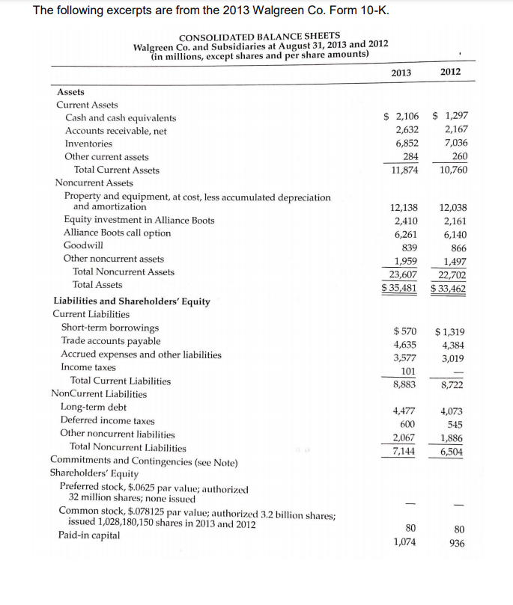

1. Income statement:

* Purpose: contains information on the profitability of the firm during some period of time (a quarter or a year).
* Key Components:

+ Revenue: the total amount of money earned from the sale of goods and services.

+ Expense: The costs associated with generating revenue, including operating expenses, interest and taxses.

+ Net income (Profit or Loss): Calculated by subtracting total expense from total revenue. Positive net income indicates a profit, while negative net income indicates a loss.

1. Statement of cash flows:

* Purpose: provides details that is lacking in the balance sheet and income statement about a firm’s cash inflows and outflows over a specific period, categorizing them into operating, investing and financing activities.
* Key Components:

+ Operating activities: enumerate the sources and uses of cash that arise from the normal operations of a firm.

* Cash flow from operating activities = Net Income + Noncash Revenue and Expenses + Changes in Net Working Capital Items

+ Investing activities: provided insights into a firm’s use of cash for non-current assets and investments in other entities.

* Positive cash flows from investing activities may indicate a source of funds for the firm, while negative cash flows sugget significant capital expenditures or investments

+ Financing activities: show how a firm obtains and uses cash to support its capital structure.

* Cash flow from Financing activities = financing sources – financing uses
* Cash inflows arise from activities that increase notes payable, long-term, liabilities, and equity accounts, such as issuing bonds or stocks.
* Cash outflows include decreases in such accounts (that is, the paydown of liability and debt accounts or the repurchase of common shares), in this category often result from dividend payments to equityholders

+ Net cash flow: the sum total of the cash flows from operating, investing and financing activities

+ Free cash flow: modifies cash flow from operations to recognize that some investing and financing activities are critical to the firm.

* For firms involved in leveraged buyouts, this free cash flow number is critical because the new owners typically want to use the firm’s free cash flow as funds available for retiring out-standing deb.
* It is not unusual for a firm’s free cash flow to be a negative value.
* Free cash flow value or a variation of it will be used in the sub-sequent cash flow valuations models.

➤ Why do we use financial ratios to examine the performance of a firm, and why is it important to examine performance relative to the economy and to a firm’s industry? **(Tại sao chúng ta sử dụng các tỷ số tài chính để kiểm tra hiệu quả hoạt động của một công ty và tại sao việc kiểm tra hiệu suất so với nền kinh tế và ngành của công ty lại quan trọng?)**

1. We use financial ratios to examine the performance of a firm because:

* Relationships: ratios are intended to provide meaningful relationships between individual values in the financial statements

VD: Knowing that a firm earned a net income of $100,000 is less informative than also knowing the sales figure that generated this income ($1 million or $10 million) and the assets or capital com-mitted to the enterprise

* Selective and categorizing: limit your examination to the most relevant ratios and categorize them into groups that will provide information on important economic characteristics of the firm

VD: the major financial statements include numerous individual items, it is possible to produce a vast number of potential ratios, many of which will have little value.

1. Examining performance relative to the economy and to a firm’s industry is important because: For example, even the best-managed steel firm experiences a decline in sales and profit margins during a recession. In such a case, the relevant question is not whether sales and margins declined but how bad was the decline and how did the firm perform relative to other steel firms? Comparing with the economy helps understand the firm's reaction to economic cycles, enabling estimations of future performance. Additionally, comparing a firm's ratios to its industry provides valuable insights into how different industries affect firms within them and allows for a more accurate assessment of a firm's performance relative to its peers.

➤ What are the major categories for financial ratios, and what questions are answered by the ratios in these categories? **(Các loại tỷ số tài chính chính là gì và những câu hỏi nào được các nhà trị liệu trả lời trong các loại này?)**

* The five categories are:

1. **Common size statement (Báo cáo kích thước chung):**

- Common-size statements are financial statements that express each line item as a percentage of a base figure, making it easier to compare the financial performance and structure of different-sized companies. Common-size statements are particularly useful for analyzing trends within a single company over time or comparing multiple companies within the same industry. (balance sheet and income statement)

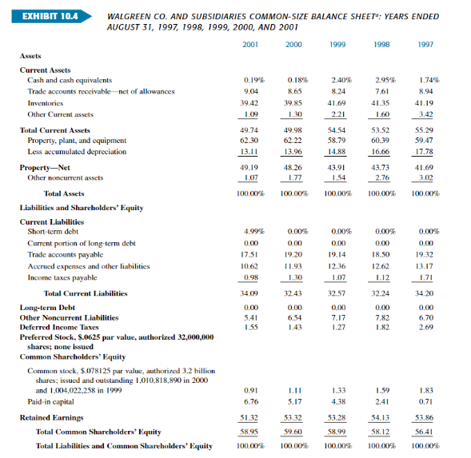

1. **Internal liquidity (solvency) (Thanh khoản nội bộ - khả năng thanh toán):**

- Indicate the ability of the firm to meet future short-term financial obligations.

**a) Current Ratio**: is a financial metric that measures a firm’s ability to cover its short-term obligations with its short-term assets.

>1 : has the ability to cover its short-term obligations.

<1 : has difficulty meeting its short-term obligations with its current assets.

=1 : has a relatively balanced position between current assets and current liabilities.

**b) Quick Ratio:** is a financial metric that measures a company's ability to meet its short-term obligations with its most liquid assets. It is a more stringent measure than the current ratio because it excludes inventory, which may not be as easily converted to cash**.**

>1 : has enough quick assets to cover its short-term liabilities.

<1 : has difficulty meeting its short-term obligations with its most liquid assets.

=1 : has a relatively balanced position between quick assets and current liabilities.

**c) Cash ratio:** is a financial metric that measures a company's ability to cover its short-term liabilities with its most liquid assets, which are typically only cash and cash equivalents

>1 : has enough cash to cover its short-term liabilities

<1 : may not has sufficient cash to cover its short-term obligations.

=1 : has a relatively balanced position between cash and current liabilities.

**d) Receivables Turnover**: is a financial metric that measures how efficiently a company manages its accounts receivable. It is an indicator of how many times, on average, a company collects its accounts receivable during a specific period, usually a year.

**A higher receivables turnover ratio** suggests that a firm is collecting its receivables more efficiently, indicating effective credit and collection practices.

**A lower ratio** may indicate that the firm is struggling with collections or has a longer average collection period.

**e) Inventory Turnover:** is a financial ratio that measures how efficiently a company manages its inventory. It indicates the number of times a company sells and replaces its inventory during a specific period, typically a year.

 CGS (Cost of Goods Sold)

**A higher inventory turnover ratio** indicates that a firm is selling and replenishing its inventory more frequently, which is often seen as a positive sign of efficient operations.

**A lower ratio** may suggest slower inventory turnover, which could be due to overstocking, slow sales, or inefficient inventory management.

**f) Cash convertion cycle:** is a financial metric that measures the time it takes for a company to convert its investments in inventory and other resources into cash flows from sales. It represents the number of days it takes for a company to sell inventory, collect receivables, and pay its accounts payable. The goal is to minimize the cash conversion cycle to improve liquidity and efficiency.

This represents the average number of days it takes for a company to pay its suppliers.

**A shorter cash conversion cycle** indicates that a company is efficient in managing its working capital and can convert its investments into cash more quickly.

**A longer cash conversion cycle** may suggest inefficiencies in managing inventory, collecting receivables, or paying payables, which can tie up cash.

**3. Operating performance (Hiệu suất hoạt động):** indicate how well the management is operating the business

**a. Operating efficiency (Hiệu quả hoạt động):** Effi-ciency ratios examine how the management uses its assets and capital, measured in terms of the dollars of sales generated by various asset or capital categories

**+ Total Asset Turnover:** is a financial ratio that measures a company's efficiency in using its total assets to generate revenue. It indicates how well a company is utilizing its assets to generate sales

**A higher total asset turnover ratio** indicates that a company is generating more sales per dollar of assets, suggesting efficient utilization of its assets.

**A lower ratio** may indicate that the company is not effectively using its assets to generate sales.

**+ Net Fixed Asset Turnover:** is a financial ratio that measures a company's efficiency in generating sales from its net fixed assets. Net fixed assets represent the long-term assets that are used in the production of goods and services, excluding accumulated depreciation.

**A higher Net Fixed Asset Turnover ratio** indicates that a company is generating more sales relative to its investment in net fixed assets, suggesting efficient use of its fixed assets.

**A lower ratio** may indicate that the company is not effectively utilizing its fixed assets to generate sales.

**+ Equity Turnover:** is a financial ratio that measures a company's ability to generate sales from its equity (shareholders' equity). It evaluates how efficiently a company utilizes its equity capital to generate revenue.

**A higher Equity Turnover ratio** indicates that a company is generating more sales relative to its shareholders' equity, suggesting efficient use of equity capital.

**A lower ratio** may indicate that the company is not effectively utilizing its equity to generate sales.

**b. Operating profitability (Lợi nhuận hoạt động):** Profitability ratios analyze the profits as a percentage of sales and as a percentage of assets and capital employed. **1) the rate of profit on sales (profit margin)**

**+ Gross profit margin:** is a financial metric that expresses the percentage of revenue that exceeds the cost of goods sold (COGS). It is a profitability ratio that assesses a company's ability to generate profit from its core operational activities.



**A higher gross profit margin** indicates that a company is effectively managing its production costs and is more efficient at converting sales into profits.

**A lower margin** may suggest that the company faces challenges in controlling production costs or faces pricing pressures.

**+ Operating profit margin:** is a financial metric that measures the profitability of a company's core operating activities. It represents the percentage of revenue that remains as operating profit after deducting operating expenses, but before considering interest and taxes.

**A higher operating profit margin** indicates that a company is efficiently managing its operating expenses and generating a larger percentage of profit from its core business operations.

**A lower margin** may suggest that the company faces challenges in controlling operating expenses or has lower profitability from its primary activities.

**+ Net profit margin:** is a financial metric that measures the percentage of profit a company earns from its total revenue after deducting all expenses, including taxes and interest. It is a key profitability ratio and provides insight into a company's overall financial health and efficiency in managing its expenses.



**A higher net profit margin** indicates that a company is effectively managing its expenses and generating a larger percentage of profit from its total revenue.

**A lower margin** may suggest that the company has higher expenses relative to its revenue, leading to lower profitability.

**2) the percentage return on capital employed.**

**+ Common – Size Income Statement:**

**+ Return on Total Capital:** is a financial metric that measures a company's profitability in relation to its total capital, which includes both debt and equity. It provides insight into how well a company generates returns on the total capital invested in its operations.



**A higher Return on Total Capital** indicates that a company is generating a higher percentage of profit relative to its total capital, suggesting efficient utilization of both debt and equity.

**A lower ROTC** may suggest that the company is not effectively utilizing its capital to generate returns.

**+ Return on Total Capital including Leases:** provides a more comprehensive view of a company's return on all forms of capital, including the impact of lease financing. It considers the capital tied up in both equity and debt, as well as the obligations arising from lease agreements.



Two methods for estimating the discounted value of future lease payments:

**++ Multiple of Forthcoming Minimum Lease Payments:**

Suppose the minimum lease payment for year t + 1 is $10.000

Using the traditional multiple technique:Discounted value = 10.000 x 8 = $80.000

**++ Discounted Value of Future Minimum Lease Payments at the Cost of Long Term Debt**

Suppose the future minimum lease payments for each year are $8,000, $9,000, and $10,000 for years t+1, t+2, t+3 respectively

The company's cost of long-term debt is 6%.

Using the discounted cash flow formula: DiscountedValue = + +

**++ Handling Lump Sum "Later" Payments**

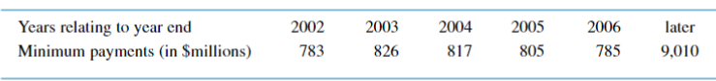

A liberal assumption of amortizing the later payment over 15 years, implying an annual payment of $601 million.

An alternative estimate derived by dividing the lump sum payment by the payment in the latest year (2006), resulting in an estimate of 11.5 years. Rounded up to 12 years, this implies an annual payment of $751 million.

**+ Implied Interest for Leased Assets:** is the interest rate that, when applied to the future lease payments, results in a present value equal to the initial carrying amount (cost) of the leased asset.

**++ Implied Interest in ROTC Calculation for Leased Assets:**

When calculating ROTC and including leased assets, it's necessary to incorporate the implied interest expense related to lease obligations.

Two estimation techniques are mentioned: a rule-of-thumb approach and an interest rate applied to the discounted value of minimum lease payments.

The rule-of-thumb technique suggests that interest is equivalent to one-third of the lease payment during the specific year.

**Specific Example:**

An example is provided for the year 2001, where implied interest is estimated using the rule-of-thumb technique. If the lease payment in 2001 is $730 million, then the implied interest for that year would be estimated at $243 million ($730/3).

**++ Implied Depreciation on Leased Assets:** refers to the hypothetical depreciation expense that would be recognized if the assets were owned rather than leased. It is an estimation of the portion of the asset's value that is assumed to be used up or "depreciated" over a specific period, reflecting the wear and tear or obsolescence of the asset.

Two common approaches are:

1. **Using the Lease Term:**

Estimate implied depreciation by considering the typical term of the lease or the weighted average term. For example, if most leases have a duration of 20 years, the implied depreciation could be calculated based on this term.

1. **Percentage of Net Fixed Assets:**



For instance, if the depreciation expense is $230 million and the net fixed assets at the beginning of the year are $2,594 million, the implied depreciation rate would be 0.089 (230/2,594), representing the proportion of assets assumed to be depreciated during that period.

**+ Return on Owner’s Equity:** is a financial metric that measures the profitability of a company in relation to its shareholders' equity. It provides insight into how effectively a company generates profits from the capital invested by its shareholders.

**A higher ROE** indicates that the company is effectively utilizing the capital contributed by its shareholders to generate profits.

**A lower ROE** may suggest that the company is not generating sufficient returns on the shareholders' investment.

**4. Risk analysis (Phân tích rủi ro):** is the process of assessing and identifying potential risks or uncertainties that may impact the achievement of objectives or the success of a project, investment, or business operation. It involves the systematic evaluation of potential events or situations that could have adverse effects on an organization, and it aims to quantify and manage those risks to enhance decision-making.

**a. Business risk (Kinh doanh):** is the uncertainty of income arising from the variability of a firm's industry, which, in turn, is influenced by fluctuations in sales and production costs. For instance, a steel firm's earnings may exhibit more variability compared to a grocery chain due to the steel industry's higher sales volatility over the business cycle and the significant fixed production costs (operating leverage) in the steel business.

The measurement of business risk typically involves assessing the variability of a firm's operating income over time. This variability is quantified using the standard deviation of historical operating earnings. To standardize this measure and enable comparisons across firms of different sizes, investors use the coefficient of variation (CV).

The CV of operating earnings facilitates meaningful comparisons of business risk among firms, accounting for differences in size. To compute the CV, a historical dataset of operating earnings spanning at least 5 to about 10 years is recommended. Less than 5 years may lack significance, while data exceeding 10 years may be outdate.

In addition to assessing overall business risk, it is valuable to analyze the two contributing factors to operating earnings variability: sales variability and operating leverage.

**+ Sales variability:** Sales variability, a key factor influencing earnings variability, is primarily determined by a firm's industry and is often beyond the control of management. Industries with economic cycles, such as automobiles or steel, tend to experience more volatile sales over the business cycle compared to industries like retail food or hospital supplies. The variability of a firm's sales is commonly measured by the Coefficient of Variation (CV) of sales over the most recent 5 to 10 years.

**+ Operating Leverage:** refers to the impact of fixed production costs on the variability of a firm's operating earnings relative to changes in sales. In a scenario without fixed production costs, operating profits would directly vary with sales, and the operating profit margin would remain constant. However, in reality, most firms have fixed production costs, such as buildings, machinery, or permanent personnel, leading to variations in operating profits beyond changes in sales.

The utilization of fixed production costs results in operating profits fluctuating more significantly than sales over the business cycle. Greater operating leverage, caused by a higher proportion of fixed production costs, makes the operating earnings series more volatile compared to the sales series. Operating leverage is measured as the percentage change in operating earnings relative to the percentage change in sales over a specified period.

Taking the absolute value of the percentage changes is necessary because the two series (operating earnings and sales) can move in opposite directions. The direction of the change is not crucial, but the relative size of the change is relevant. Essentially, the greater the volatility of operating earnings compared to sales, the higher the firm's operating leverage.

**b. Financial risk (Tài chính): r**efers to the potential for adverse financial outcomes or losses that a business may face due to its financial structure, decisions, or market conditions. It is associated with the use of financial leverage, which involves using debt or other financial instruments to increase the potential return on investment. While financial leverage can amplify profits, it also magnifies the impact of losses.

**1. Proportion of debt (balance sheet) ratios:** refers to financial ratios that assess the level of debt in relation to other components on a company's balance sheet.

**+ Debt to Equity Ratio:** This ratio measures the proportion of a company's financing that comes from debt compared to equity. A higher ratio indicates a higher level of financial risk, as the company relies more on borrowed funds.

**+ Long-Term Debt/Total Capital Ratio:** This ratio focuses on long-term debt and assesses the proportion of long-term debt relative to the total capitalization of the company (long-term debt plus equity)

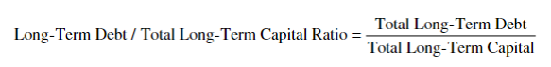

**+ Total Debt Ratios:** The debt ratio expresses the percentage of a company's assets that are financed by debt. A higher debt ratio suggests a greater reliance on borrowed funds, potentially increasing financial risk.

**2. Earning flow ratios:** A higher ratio of available earnings relative to fixed financial charges indicates lower financial risk.

**+ Interest Coverage:** indicates a company's ability to cover its interest obligations. A higher ratio implies a lower risk of financial distress due to interest payments. The standard interest coverage ratio is computed as follows:

** For example, a coverage ratio of 5 means that earnings could decline by 80 percent (1 minus 1/5), and the firm could still pay its fixed financial charges.

The standard interest coverage ratio is computed as follows:



**3. Cash flow ratios:** Cash flow ratios are financial metrics that assess a company's ability to generate and manage cash.

**+ Cash flow coverage ratios:** This ratio measures the company's ability to cover its interest payments with its operating income. A higher ratio indicates better coverage and a lower risk of default on interest payments.

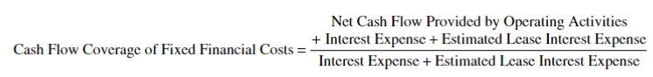

**+ Cash Flow/Long-Term Debt Ratio:** is a financial metric that assesses a company's ability to cover its long-term debt obligations using its cash flow.



**+ Cash Flow/Total Debt Ratio:** is a financial metric that assesses a company's ability to cover its total debt obligations using its cash flow



**c. Liquidity risk (Thanh khoản):** refers to the potential for an individual or entity to encounter difficulties in buying or selling financial instruments in the market without causing a significant impact on their prices.

**+ External Liquidity Defined:** refers to a company's ability to meet its short-term financial obligations by accessing external sources of funds.

- Key indicators of external liquidity include the company's ability to secure credit lines, tap into financial markets, or quickly raise capital when needed.

- Companies with strong external liquidity are better positioned to navigate economic downturns, industry fluctuations, or unexpected events.

- External liquidity is often assessed through various financial ratios, such as the current ratio, quick ratio, and measures related to a company's ability to secure credit or issue debt instruments

**+ Determinants of Market Liquidity:** refers to the ease with which an asset can be bought or sold in the market without causing a significant impact on its price

1. **Bid-Ask Spread:**
   * + The difference between the highest price a buyer is willing to pay (bid) and the lowest price a seller is willing to accept (ask) is known as the bid-ask spread. A narrower spread generally indicates higher liquidity.
2. **Trading Volume:**
   * + The total number of shares or contracts traded in a specific security or market over a given period reflects the level of trading activity. Higher trading volumes often correlate with higher liquidity.
3. **Market Depth:**
   * + Market depth refers to the quantity of buy and sell orders at different price levels. A deep market with many buyers and sellers at various price points typically indicates higher liquidity.
4. **Price Impact:**
   * + The extent to which executing a large trade affects the asset's price is a measure of price impact. Lower price impact suggests higher market liquidity.
5. **Volatility:**
   * + Excessive price fluctuations and high volatility can deter market participants, reducing liquidity. More stable markets often attract a broader range of investors.
6. **Information Availability:**
   * + Markets with timely and transparent information tend to be more liquid. Investors are more confident in making trading decisions when they have access to accurate and up-to-date information.
7. **Market Makers:**
   * + The presence of market makers, who are entities that facilitate trading by continuously quoting buy and sell prices, can enhance liquidity. Market makers contribute to narrowing bid-ask spreads and providing liquidity to the market.
8. **Regulatory Environment:**
   * + Regulations and market structure can impact liquidity. Well-regulated markets with clear rules and protections often attract more participants, contributing to liquidity.
9. **Transaction Costs:**
   * + High transaction costs, such as fees and taxes, can hinder liquidity. Lower transaction costs encourage trading activity and liquidity.
10. **Macroeconomic Conditions:**
    * + Economic factors, such as interest rates, inflation, and overall economic stability, can influence market liquidity. Economic uncertainties may reduce investor confidence and impact liquidity.
11. **Asset-Specific Factors:**
    * + Characteristics of the asset itself, such as its size, issuer reputation, and the ease with which it can be valued, also affect liquidity.

**5. Growth analysis (Phân tích tăng trưởng):** is the process of evaluating and assessing the growth prospects and performance of a company or investment.

* The growth of a business depends on the proportion of earnings retained and reinvested, as well as the rate of return earned on those reinvested resources. The potential growth rate (g) can be expressed as the product of the percentage of earnings retained (retention rate or RR) and the return on equity (ROE)

* The retention rate is determined by the board of directors based on available investment opportunities, and it is advisable to retain and reinvest earnings as long as the expected rate of return on the investment exceeds the firm's cost of capital.
* The DuPont system breaks down the firm's ROE into three components: net profit margin, total asset turnover, and financial leverage. A firm can increase its ROE by improving its profit margin, enhancing efficiency (increasing total asset turnover), or employing more financial leverage. Analyzing and estimating each of these components is crucial when evaluating a firm's ROE.
* For a more detailed analysis of sustainable growth potential, the process begins by examining the retention rate (RR), typically calculated by the board of directors based on investment opportunities available to the firm

➤ What specific ratios help determine a firm’s internal liquidity, operating performance, risk profile, and growth potential? **(Những tỷ lệ cụ thể nào giúp xác định tính thanh khoản nội bộ, hiệu suất hoạt động, rủi ro và tiềm năng tăng trưởng của một công ty?)**

1. Internal liquidity: Current ratios, Quick ratios, Cash ratios
2. Operating performance: Return on Assets (ROA), Return on Equity (ROE), Gross Profit Margin
3. Risk profile: Debt-to-Equity Ratio, Interest Coverage Ratio
4. Growth potential: Earnings per Share (EPS) Growth, Sales Growth

➤ How can the DuPont analysis help evaluate a firm’s past and future return on equity? **(Phân tích của DuPont có thể giúp đánh giá lợi nhuận trên vốn chủ sở hữu trong quá khứ và tương lai của công ty như thế nào?)**

**The Dupont system:** is a financial analysis framework that breaks down the Return on Equity (ROE) into its components to provide a more detailed understanding of a company's profitability. The analysis was developed by the DuPont Corporation in the early 20th century. The DuPont System decomposes ROE into three key components: profitability, efficiency, and financial leverage.



1. **Net Profit Margin**:

* **Definition:** Net Profit Margin measures the percentage of profit a company earns from its total revenue after accounting for all expenses.
* **Evaluation**: A high net profit margin indicates efficient cost management and pricing strategies, contributing positively to ROE. DuPont analysis helps identify whether changes in net profit margin have been a significant driver of ROE changes over time.

1. **Asset Turnover:**

* **Definition:** Asset Turnover measures how efficiently a company uses its assets to generate sales.
* **Evaluation:** A high asset turnover suggests efficient asset utilization, contributing positively to ROE. DuPont analysis helps assess whether changes in asset turnover have influenced ROE trends.

1. **Financial Leverage:**

* **Definition:** Financial Leverage measures the extent to which a company uses debt to finance its operations.
* **Evaluation:** Financial leverage can amplify ROE when the return on assets (ROA) is higher than the cost of debt. DuPont analysis helps identify the impact of changes in financial leverage on ROE.

**Analyzing Past Performance:**

* DuPont analysis allows analysts to identify which component (net profit margin, asset turnover, or financial leverage) has been the primary driver of changes in ROE over historical periods.
* It helps identify trends and patterns in each component, allowing for a more comprehensive understanding of the factors influencing ROE

**Evaluating Future Performance:**

* By understanding the historical drivers of ROE, analysts can make informed projections about future performance. For example, if past ROE growth was primarily driven by improved net profit margins, projections may consider factors influencing profitability in the future.
* Analysts can use DuPont analysis to set targets for each component based on industry benchmarks and company goals.

➤ What is a “quality” balance sheet or income statement? **(Bảng cân đối kế toán hoặc báo cáo thu nhập “có chất lượng” là gì?)**

* A "quality" balance sheet or income statement refers to financial statements that provide a clear, accurate, and reliable representation of a company's financial position and performance. These statements are considered high-quality when they adhere to certain characteristics and standards, ensuring transparency and credibility.
* **Quality Balance Sheet:**

**+ Accuracy and Completeness:**

* + The balance sheet should accurately reflect the company's assets, liabilities, and equity at a specific point in time.
  + All assets and liabilities, including contingent ones, should be properly recognized and disclosed.

**+ Consistency:**

* + The balance sheet should be prepared using consistent accounting policies and methods, allowing for meaningful period-to-period comparisons.

**+ Fair Valuation:**

* + Assets and liabilities should be valued fairly, reflecting their true market or economic value.
  + Proper accounting for impairments and adjustments ensures the balance sheet accurately represents the financial health of the company.

**+ Transparency:**

* + The balance sheet should provide sufficient detail and breakdowns to allow stakeholders to understand the composition of assets and liabilities.
  + Off-balance sheet items and contingent liabilities should be disclosed transparently.

**+ Liquidity and Solvency:**

* + It should clearly indicate the company's liquidity position, showcasing the ability to meet short-term obligations.
  + Solvency measures, such as debt ratios, should be transparently presented.
* **Quality Income Statement:**

**+ Accuracy and Reliability:**

* + The income statement should accurately capture the company's revenues, expenses, gains, and losses for a specific period.
  + Proper recognition and matching principles should be followed.

**+ Consistency:**

* + The income statement should be prepared using consistent accounting principles to enable meaningful comparisons over time.

**+ Transparency:**

* + Clear categorization of revenues and expenses allows stakeholders to understand the sources of income and areas of expenditure.

**+ Non-recurring Items:**

* + Extraordinary or non-recurring items should be clearly identified and disclosed separately to provide a more accurate portrayal of ongoing business operations.

**+ Earnings Quality:**

* + Quality earnings reflect sustainable and repeatable sources of income rather than relying on one-time gains or unsustainable practices.

**+ Comprehensive:**

* + The income statement should present a comprehensive view of the company's financial performance, including operating and non-operating activities.

➤ Why is financial statement analysis done if markets are efficient and forward-looking? **(Tại sao phân tích báo cáo tài chính được thực hiện nếu thị trường hiệu quả và hướng tới tương lai?)**

1. **Imperfect Information:**

* While the efficient market hypothesis suggests that prices reflect all available information, in reality, information is not always perfect or immediately incorporated into stock prices. Financial statement analysis helps investors uncover relevant information that may not be fully reflected in market prices.

1. **Assessment of Historical Performance:**

* Financial statements provide a historical record of a company's performance. Investors and analysts use this historical data to assess how well a company has performed in the past. This information can offer insights into management effectiveness, business trends, and financial stability.

1. **Understanding Risks and Opportunities:**

* Financial statement analysis helps identify potential risks and opportunities that may impact a company's future performance. By examining financial ratios, trends, and key metrics, analysts can assess a company's ability to navigate challenges and capitalize on opportunities.

1. **Comparative Analysis:**

* Investors often compare a company's financial performance with industry peers or competitors. This comparative analysis allows for a better understanding of a company's competitive position and its relative strengths and weaknesses within the industry.

1. **Long-Term Investment Decision-Making:**

* Investors, particularly those with a long-term investment horizon, may use financial statement analysis to make informed decisions about whether to buy, hold, or sell a particular investment. Fundamental analysis, including financial statement analysis, is often crucial for long-term investment strategies.

1. **Valuation:**

* Financial statement analysis is essential for valuation purposes. Investors use various valuation models, such as discounted cash flow (DCF) analysis or price-to-earnings ratios, which rely on financial statement information to estimate the intrinsic value of a security.

1. **Management Evaluation:**

* Investors and analysts assess the effectiveness of a company's management by analyzing financial statements. Key metrics, profitability ratios, and operational efficiency indicators help gauge management's ability to generate returns for shareholders.

1. **Forecasting Future Performance:**

* While markets are forward-looking, financial statement analysis aids in forecasting a company's future performance. Analysts use historical trends, growth rates, and industry dynamics to make projections about a company's future financial health.

1. **Behavioral Biases:**

* Behavioral biases and investor sentiment can lead to market inefficiencies. Financial statement analysis allows investors to take advantage of potential mispricings resulting from market overreactions or underreactions to news and events.

➤ What major financial ratios are used by analysts in the following areas: stock valuation, estimating and evaluating systematic risk, predicting the credit ratings on bonds, and predicting bankruptcy? **(Những tỷ số tài chính chính nào được các nhà phân tích sử dụng trong các lĩnh vực sau: định giá cổ phiếu, ước tính và đánh giá rủi ro hệ thống, dự đoán xếp hạng tín dụng đối với trái phiếu và dự đoán phá sản?)**

1. **Stock Valuation:**

* **Price-to-Earnings Ratio (P/E):** Compares a company's stock price to its earnings per share, indicating the market's expectations for future earnings growth.
* **Price-to-Book Ratio (P/B):** Compares a company's market value to its book value, providing insights into the valuation of its assets.
* **Dividend Yield:** Compares a company's annual dividend per share to its stock price, helping assess the income generated for investors.

1. **Estimating and Evaluating Systematic Risk:**

* **Beta:** Measures a stock's sensitivity to market movements, indicating its systematic risk relative to the market.
* **Alpha:** Evaluates a stock's risk-adjusted performance, considering its expected return relative to its beta.

1. **Predicting Credit Ratings on Bonds:**

* **Interest Coverage Ratio:** Assesses a company's ability to cover its interest expenses, a crucial factor for bondholders.
* **Debt-to-Equity Ratio:** Compares a company's total debt to its equity, indicating its capital structure and potential credit risk.
* **Current Ratio:** Measures a company's ability to cover short-term liabilities with its short-term assets.

1. **Predicting Bankruptcy:**

* **Altman Z-Score:** Combines multiple financial ratios to predict the probability of a company facing financial distress or bankruptcy.
* **Debt Ratio:** Evaluates the proportion of a company's assets financed by debt, providing insights into its financial risk.
* **Quick Ratio:** Assesses a company's ability to cover immediate liabilities with its most liquid assets.