+123-456-7890

# TIẾN ĐẠT

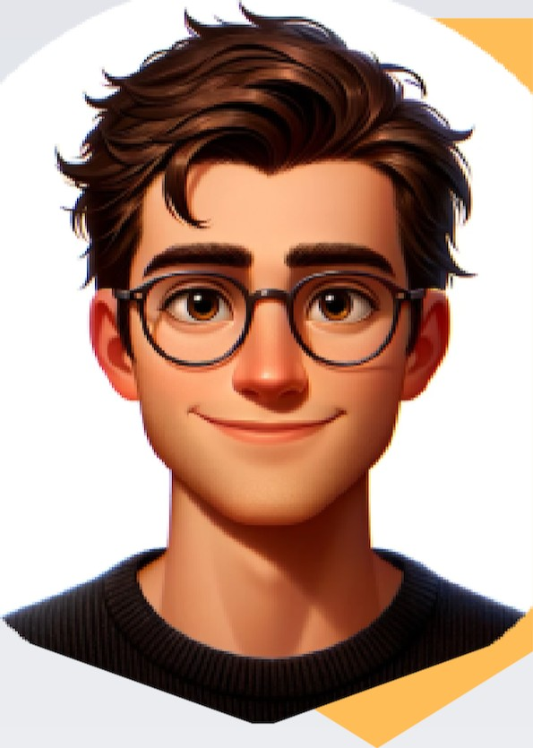SOFTWARE DEVELOPER

## EDUCATION

Borcelle High School

123 Anywhere St., Any City

2008-2011

Fauget University

Computer Science

2010-2014

Fauget Company

Web Design &

Development

2021

 hello@reallygreatsite.com 123 Anywhere St., Any City www.reallygreatsite.com

## SKILLS

WORK

### EXPERIENCE

Web Developer

Liceria & Co. / 2019 - Present

Lorem ipsum dolor sit amet, consectetur adipiscing elit. Praesent erat lacus, condimentum quis hendrerit at, convallis ac quam. Nam faucibus quis dui vel mollis. Cras tincidunt ligula nec nisi vulputate ornare.

Web Designer

Borcelle Company / 2016-2018

Lorem ipsum dolor sit amet, consectetur adipiscing elit. Praesent erat lacus, condimentum quis hendrerit at, convallis ac quam. Nam faucibus quis dui vel mollis. Cras tincidunt ligula nec nisi vulputate ornare.

Web Development Intern

Fauget / 2014-2015

Lorem ipsum dolor sit amet, consectetur adipiscing elite Praesent erat lacus, condimentum quis hendrerit at, convallis ac quam. Nam faucibus quis dui vel mollis. Cras tincidunt

Time management

#### COURSE

Borcelle Tech

Web Design &

Development

2019

Fauget Corp

Web Design &

Development

2020

#### AWARDS

Liceria & Co.

Best Web Designer and

Developer

08/2021

Databases

 Networking basics

 Operating Systems

 Cross-platform software

Encryption

Unit testing

 Integration testing

System testing

 Critical Thinking

ligula nec nisi vulputate ornare.