**MINISTRY OF EDUCATION AND TRAINING**

**UNIVERSITY OF TECHNOLOGY AND EDUCATION**

# **FACULTY OF INFORMATION TECHNOLOGY**

# **--------------------**

**Web Programing**

**SHOP ONLINE**

**STUDENT LIST:**

1. **NGUYỄN MẠNH TIẾN 17145370**
2. **LÊ TUẤN ĐẠT 17110019**
3. **NGUYỄN HOÀNG TRƯỜNG MINH**

**LECTURER: Nguyễn Đức Khoan**

# **Ho Chi Minh City** **– 2019**

**MINISTRY OF EDUCATION AND TRAINING**

**UNIVERSITY OF TECHNOLOGY AND EDUCATION**

# **FACULTY OF INFORMATION TECHNOLOGY**

# **--------------------**

**Web Programing**

**SHOP ONLINE**

**STUDENT LIST:**

1. **NGUYỄN MẠNH TIẾN 17145370**
2. **LÊ TUẤN ĐẠT 17110019**
3. **NGUYỄN HOÀNG TRƯỜNG MINH**

**LECTURER: Nguyễn Đức Khoan**

# 

# **‘Ho Chi Minh City** **– 2019**

**Lecturer's evaluation**

*Ho Chi Minh City, Jun, 2019*

**Lecturer**

# **Thanks**

The success of a student more or less always accompanies a lecturer. We would like to express our sincere thanks to Mr. Nguyen Duc Khoan, who directly supported the group, give us suggestions, comments and suggestions as well as provide tips to help us make the best project. Thanks to his instructions, help our team understand the knowledge to do, the presentation as well as the implementation of the project so we have completed the schedule with a lot of experience that we learn. Again, our team would like to thank the lecturer.

Projects are made within 8 weeks, just enough to complete it, However, due to many new knowledge as well as the time we do through each week is not optimal, the project will have many errors, that is inevitable. We are looking forward to receiving all the comments of our teachers to help our limited knowledge better. Sincerely thanks.

# **Preface**

The purpose and objective of this training and particularly the content is really time-being and with this training we have gained some confidence regarding to introduce the application. We also belief that way we gained some sorts of IT knowledge and if we practice much and having some expertise in the field then we will be able to survive smartly in today’s competitive environment.

The effort to write the report is a partial fulfillment to complete the course. In the report I try my best to represent all the content which we learnt in a great deal in the program in a systematic and presentable order. I divided each of the topics as an individual chapter to reflect the entire topic more prominently and clearly. In the reference I have used citation method in the entire report. Finally, I am very hopeful that the structure and topic of the report will be a useful print material to all the reader especially to the user.

**Chapter 1 : Basic Knowledge**

* 1. **Web design language**
     1. **Html**
* HTML (HyperText Markup Language), also known as hypertext markup language, was created to structure a website with pieces of information presented on the World Wide Web.

|  |
| --- |
| <html>  <head>  <title>Hello world </title>  </head> <body>  <p> Hello world !</p> </body> </html> |

* A web page starts with an <html> opening tag and ends with a closing </html> tag. Which includes two main content: header information is declared in <head> </head> tag, website content is declared in <body> </body> tag.
  + 1. **CSS**
* CSS (Cascading Style Sheet). The website is made up of html tags but with html tags only shows the frame of the website. To align and present beautifully, we need to use the CSS language. This is a language used a lot in web programming, often associated with html language.
* We have 3 ways to insert CSS into the HTML page
* Insert CSS content into the <style> </style> tag in the <head </head> section of the webpage.
* Insert directly inside the HTML tag.
* Link to an external .css file.
* In fact, the third way is the most used by programmers due to its usability and flexibility.
* Example I use the first insert CSS into products View

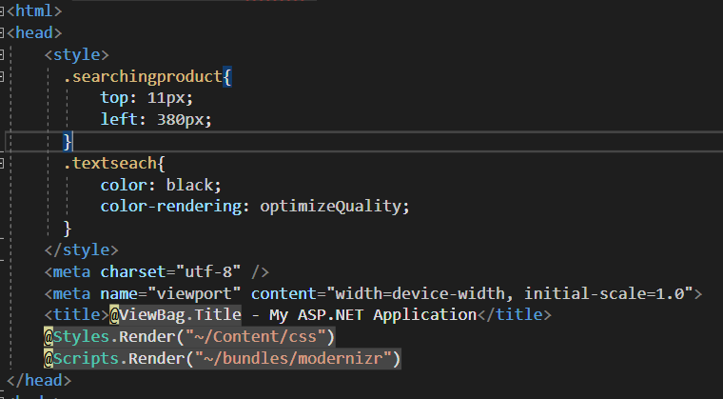

* + 1. **C#**
* C# (C-Sharp) is a programming language developed by Microsoft that runs on the .NET Framework.
* C# is used to develop web apps, desktop apps, mobile apps, games and much more.
* 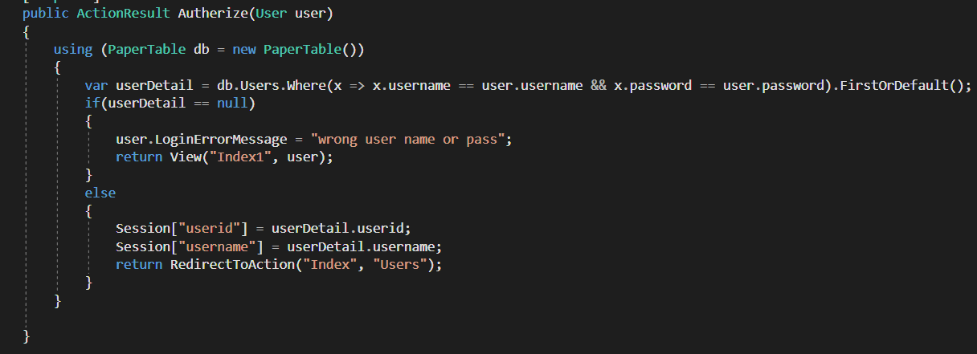Example in LoginController
  1. **Architecture**

**1.2.1 Client/Sever**

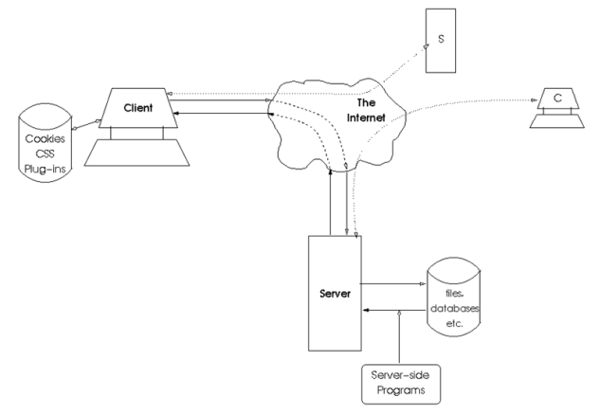

Client / Server architecture is a famous architecture in computer networks, most websites operate based on this architecture. Where the Client is the client that sends the request to the Server. Here, the Server listens for requests from the Client, receives information from the Client, then processes and returns the results to the Client.

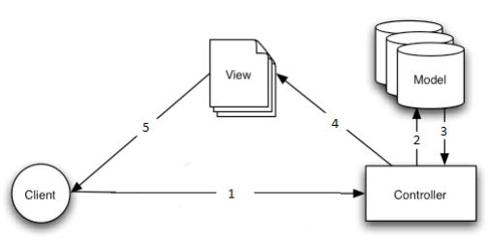**1.2.2 Model MVC**

MVC model (Model - View - Controller) is one of the design models used in software development techniques, helping developers to split the application into three parts - Model - View - Controller. Each component has a separate task and function, help developing applications fast, easy to maintain, and upgrade the system

* **Model:** The component contains all the logic business, processing methods, database access, data description objects, relational constraints ...
* **View:** Ensuring the display of information, interaction with users, which contains all GUI objects such as textboxes, images ...
* **Controller:** Is the most important part in MVC model. Play the role of receiving requests from the client, processing information and then returning information to the client.

**How the MVC model works**

* When a client machine interacts with a view (using browsers on PC or Mobile). Send a request to the server. The controller will receive the request, process the request, if the information is related to the database, the controller calls the model to retrieve data. Then return the result after processing toView. The view displays information as HTML tags to the user.

**Chapter 2: System Analysis**

**2.1 Funtions of the website**

**2.1.1 Funtion for user/guest**

|  |  |  |
| --- | --- | --- |
| STT | Funtion | Describtion |
| 1 | View | User can view colors, products,categories,order and users table. |
| 2 | Order | User can order products on website and click order the product user want. |
| 3 | Cart | allow users to edit their orders, update the number or order new product |

**2.1.2 Detail of funtion for user/guest**

1/ View

User login the username and password and choose what type user want to see

* Input: The information of table user click
* Output : The view of the table user want to see

2/Order

* Input : Information about the product that customers want to buy
* Output : The information of the item is in the cart

3/Cart

* Input : Information of the items that customers have ordered, quantity products that customers want to buy
* Output : Cart information including product, quantity, total price ...

**2.1.3 Funtion Diagram for user**

****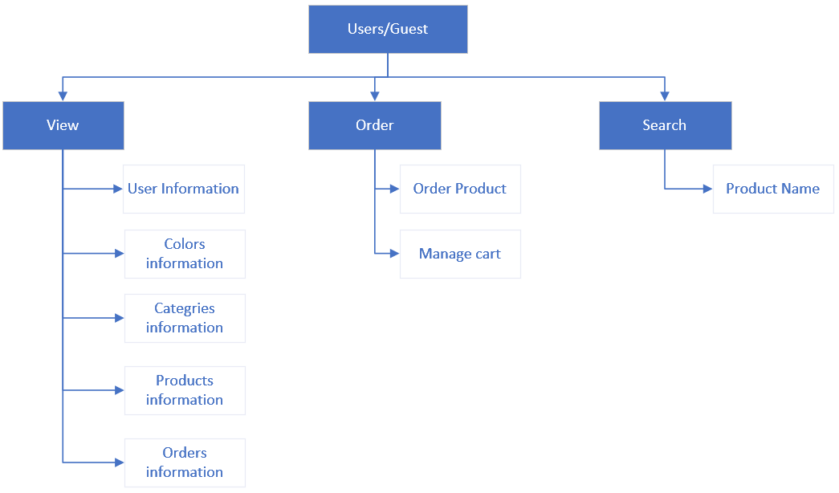

**2.1.4 Funtion for admin**

|  |  |  |
| --- | --- | --- |
| Stt | Funtion | Describtion |
| 1 | Product Management | Information management of product images, administrators can upload product images, enter feature description information product, price, quantity |
| 2 | Categories management | Information management of category each product |
| 3 | Customer management | Add, edit, delete user information |
| 4 | Order Detail | Display order details including information  About customers, information about the products in the order, order fulfillment staff, order status,  administrator notes |

**2.1.5 Detail of funtion for admin**

1/Products management

* Input : Information of products name,colors,price…… ( add, edit, delete each product)
* Output : Information of each product after modify it.

2/ Categories management

* Input : Information of categories (add, edit, delete each category)
* Output : Information of category after modify it

3/User management

* Input : Information of users (username, fullname, DOB,…)
* Output : Information of users after modify it

4/Order detail

* Input : The information of order (address, number of products the user want to buy)
* Output : The information of order

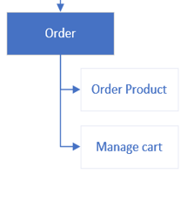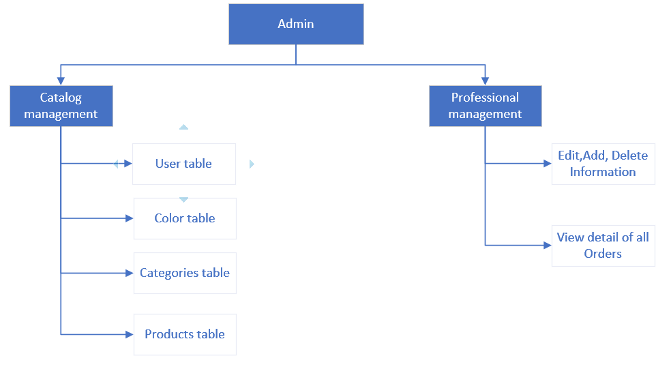**2.1.6 Funtion Diagram for admin**

**2.1.7 Funtion Diagram for Guest**

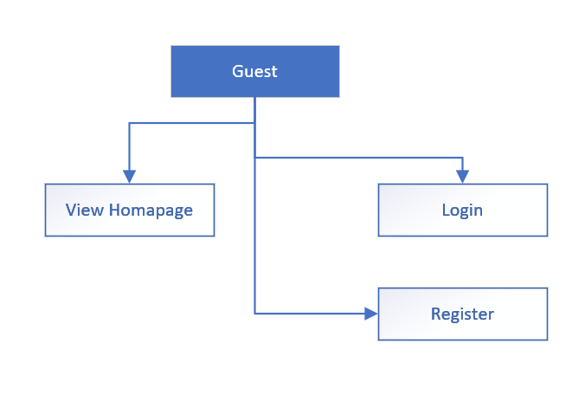

**2.1.8 Usecase Diagram For WebSite**

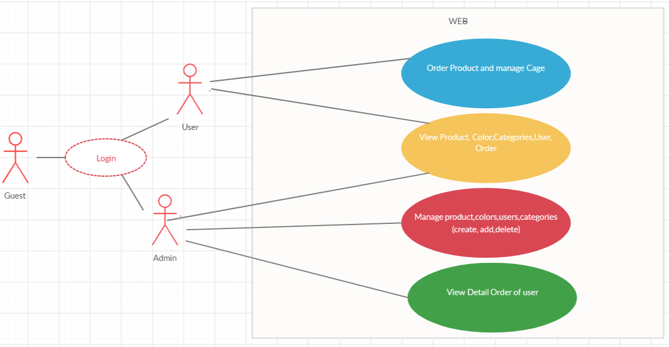

**Chapter 3 : DataBase Design**

**3.1. Entity–relationship model**

**3.1.1 List Entity**

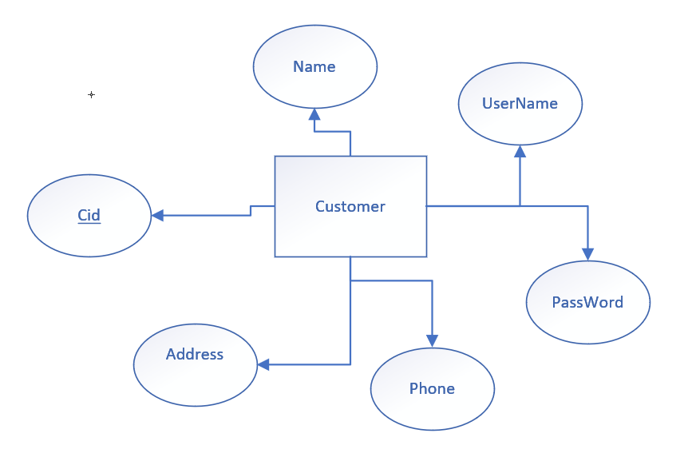a/ Users entity

b/Category entity

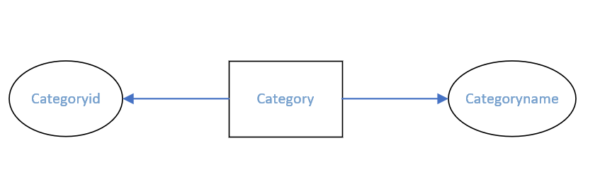

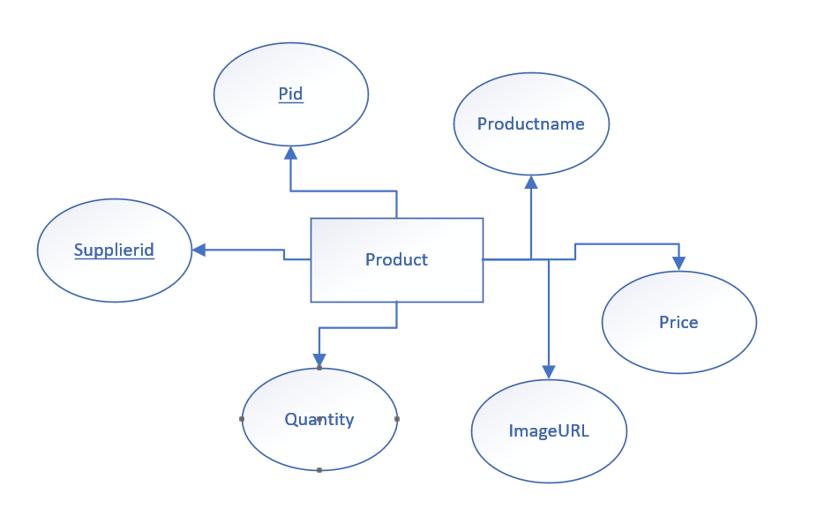c/Product entity

e/Staff entity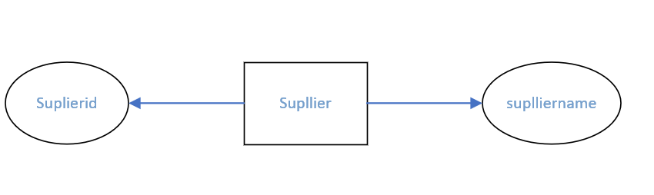

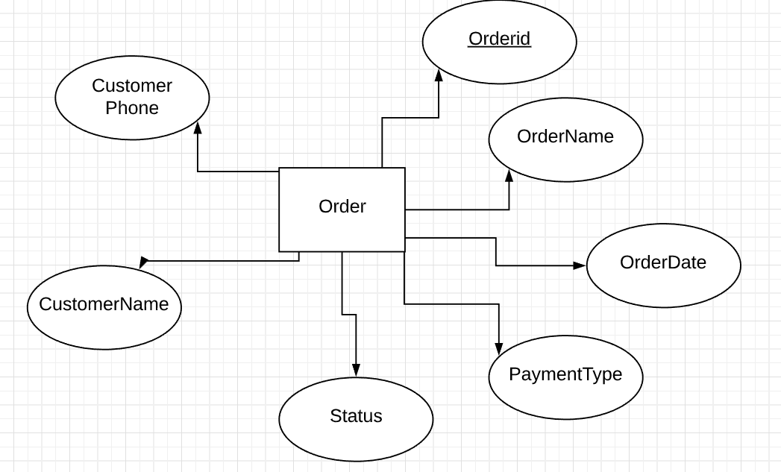f/Order entity

g/OrderDetail entity

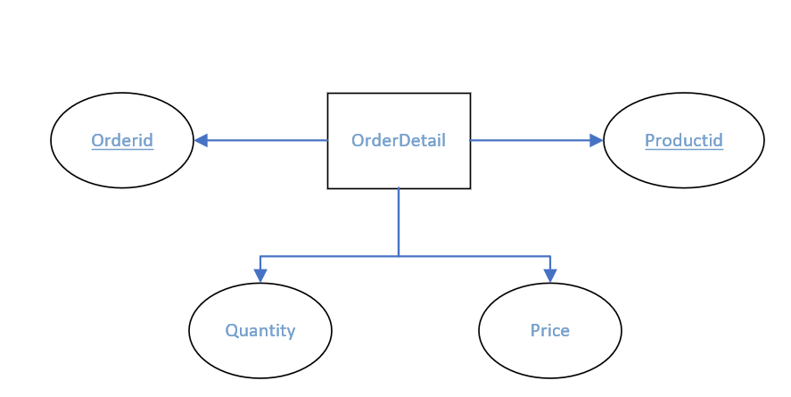

**3.1.2 Entity Relationship model**

Cart

Search

Products

User

**n**

**1**

Create

Customer

**1**

**N 1**

Have

**1 1**

Send

Buy

**1 n**

**1**

Depart Store

**n**

**1**

View Order

Include

Order

**11 n**

**n 1**

Selling products

**n**

Admin

**3.2 Design database**

- Database Table

|  |  |  |
| --- | --- | --- |
| STT | TABLE NAME | SUBSTANCE |
| 1 | Customer | Customer table info |
| 2 | Supplier | Detail Supplier |
| 3 | Order Detail | Detail orders table of each customer |
| 4 | Order | Order Table of each customer |
| 5 | Category | Category of product |
| 6 | Products | Detail content of each product |
| 7 | ProductCategory | Connect 2 table Product and category |

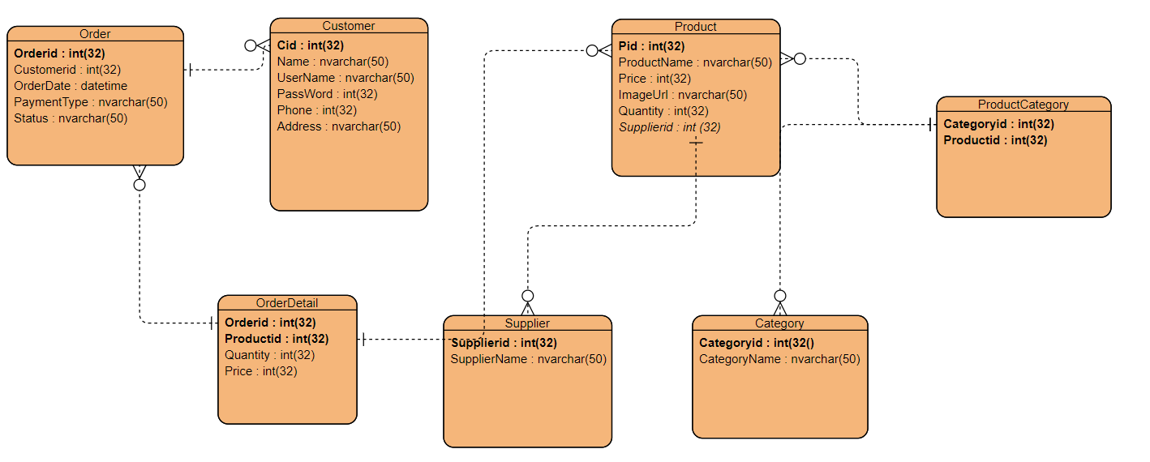**3.2.1 ERD**

**3.2.2 Connect the tables in the database**

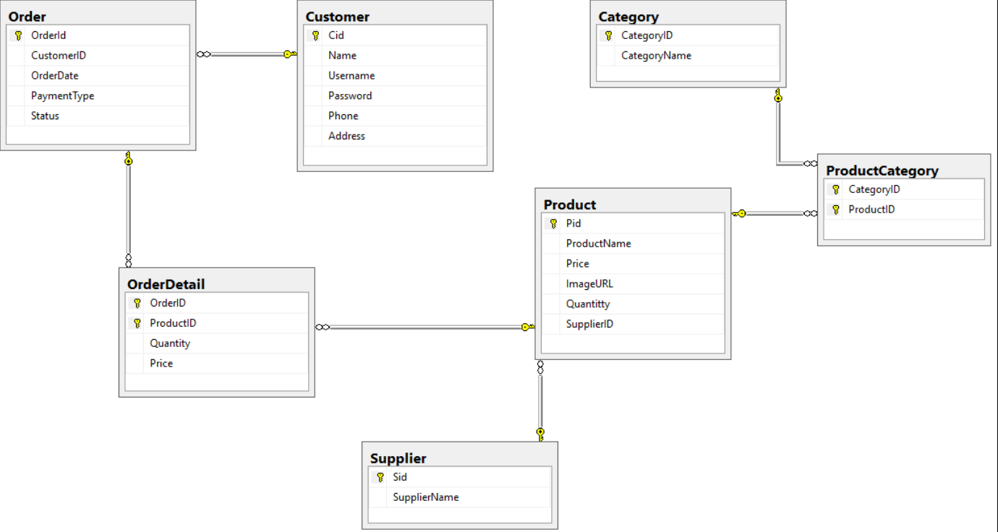

**3.2.3. Design Table**

Order Table

|  |  |  |  |  |
| --- | --- | --- | --- | --- |
| stt | Datafield name | explain | Datatype | Key |
| 1 | Orderid | Id order | Int(32) | Primary key |
| 2 | Customerid | Id of customer | Int(32) | Foreign key |
| 3 | Orderdate | Date of the order | Nvarchar(50) |  |
| 4 | Paymenttype | Type of payment you choose | Nvarchar(50) |  |
| 5 | status | Status of the order | Nvarchar(50) |  |

Customer table

|  |  |  |  |  |
| --- | --- | --- | --- | --- |
| stt | Datafield name | Explain | datatype | key |
| 1 | Cid | Id of each customer | Int(32) | Primary key |
| 2 | Name | Name of each customer | Nvarchar(50) |  |
| 3 | Username | Username to enter web | Nvarchar(50) |  |
| 4 | Password | Password to enter web | Nvarchar(50) |  |
| 5 | Phone | Phone number | Int(32) |  |
| 6 | Address | Address of each member | Nvarchar(50) |  |

Product table

|  |  |  |  |  |
| --- | --- | --- | --- | --- |
| stt | Datafield name | Explain | datatype | key |
| 1 | Pid | Id of each product | Int(32) | Primary key |
| 2 | productname | Name of each product | Nvarchar(50) |  |
| 3 | Price | Price of each product | Int(32) |  |
| 4 | Quantity | Quantity of product | Nvarchar(50) |  |
| 5 | ImageURL | Image of product | Nvarchar(50) |  |
| 6 | Supplier | Supplier of product | Int(32) |  |

ProductCategory

|  |  |  |  |  |
| --- | --- | --- | --- | --- |
| stt | Datafield name | Explain | datatype | key |
| 1 | Productid | Id of product | Int(32) | Primary key |
| 2 | Categoryid | Id of category | Int(32) | Primary key |

Category

|  |  |  |  |  |
| --- | --- | --- | --- | --- |
| stt | Datafield name | Explain | datatype | key |
| 1 | categoryid | Id of category | Int(32) | Primary key |
| 2 | Categoryname | name of category | Nvarchar(50) |  |

Supplier

|  |  |  |  |  |
| --- | --- | --- | --- | --- |
| stt | Datafield name | Explain | datatype | key |
| 1 | Supplierid | Id of supplier | Int(32) | Primary key |
| 2 | Suppliername | Name of supplier | Nvarchar(50) |  |

Orderdetail

|  |  |  |  |  |
| --- | --- | --- | --- | --- |
| stt | Datafield name | Explain | datatype | key |
| 1 | Orderid | Id of order | Int(32) | Primary key |
| 2 | Productid | Id of product | Int(32) | Primarykey |
| 3 | Quantity | Quantity of oderdetail | Int(32) |  |
| 4 | Price | Price of produc | Int(32) |  |

**Chapter 4: Design**

**4.1 Design Controller**

|  |  |  |
| --- | --- | --- |
| STT | Controlerr | Purpose |
| 1 | Cart Controller | User can add irtems, delete item and admin only view all the cart |
| 2 | Category controller | Admin can add. Del,view,edit category and user only view the category |
| 3 | Customer controller | Admin can add. Del,view,edit customer and user only change only account they apply |
| 4 | Login Controller | To login the web and web use role to choose who admin who user |
| 5 | Order Controler | To make the user order the product they want |
| 6 | Product controller | Admin can add. Del,view,edit product and user only view the category |
| 7 | PublicPage | Show the product of each category |
| 8 | Register | User and admin can register and make the role for |
| 9 | Supplier | Admin can add. Del,view,edit supplier and user only view the supplier |

**4.2 Handel Funtion**

|  |  |  |  |
| --- | --- | --- | --- |
| **STT** | **Method** | **Purpose** | **The line contains the declaration** |
| 1  2  3  4  5  6 | [HttpPost]  public JsonResult LoginUser(UserViewModel userViewModel)  public ActionResult AddItem(int? id)  private int isExistingCheck(int? id)  public ActionResult ProcessOrder(FormCollection frc)  public ActionResult UpdateCart(FormCollection frc)  public JsonResult Register(UserViewModel userViewModel) | Login to the website, the system will check if ur account have role 1 you will be admin and role 0 you will be user  AddItem for user into cart  Check if the shopping cart exists  Save products in cart into order table  Update product into cart when user add item  Register for guest | LoginController(line37)  CartController(line 30)  CartController(line 63)  CartController (line 107)  CartController(line 88)  RegisterController(line 36) |
|  |  |  |  |

**Chapter 5 :** **Installation and testing**

|  |  |  |
| --- | --- | --- |
| **TT** | **Situation** | **Purpose** |
| 1 | Input : data from database  Output : show data from index | Check the program can assign the database yes or not |
| 2 | Input : the data edit, delete the data, add the data  Output : change of data when adding, editing or deleting data | Check the code make sure that user can edit, add and del the data, and the data must change when user do that |
| 3 | Input : Login with admin or user  Output : decentralized user | Make sure that admin can add, del, edit some table that support for admin and user only view table |
| 4 | Input : Login with user  Output : User can order products | Make sure that user can order and modify item in the Cart |

|  |  |
| --- | --- |
| **Difficulties** | **Solution** |
| Adding ShoppingCart by user | <https://www.youtube.com/watch?v=h_jfcLICk_8&fbclid=IwAR3HXmtyNYmvubMNBnyP1MzMmwwyfpYiIsRwjHjTfhepx5rDUHOA4DHSH0Y> |
| Assign authority to controller and controller | <https://lethanhname.blogspot.com/2016/12/aspnet-mvc-5-authentication-filters.html>   * And with teacher help |

**CHAPTER 6. Conclude**

**6.1 Difficulties and solution**

**6.2. For further implementation**

1. Users can sort products alphabetically
2. Make the theme more beautifuller and easy for user to use

**6.3. Advantages**

1. Simple easy-to-use software for drawing genealogy
2. Know more about how to solve the problem
3. Users can manage their products

**6.4. Limit**

1. The interface is not yet beautiful

**Chapter 7 : Assignment of work**

|  |  |  |
| --- | --- | --- |
| STT | Name | assignment |
| 1 | Le Tuan Dat | Homepage,Category,  Word Report, PP Report,Delete |
| 2 | Nguyen Manh Tien | Login (user authentication), Add, Category Listing |
| 3 | Nguyen Hoang Truong Minh | Order ( add to cart),  Register,Detail |