ARGOCD
The official documentation for install argocd on k8s can be reference here
Getting Started - Argo CD - Declarative GitOps CD for Kubernetes
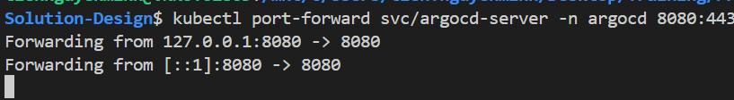
Get the password
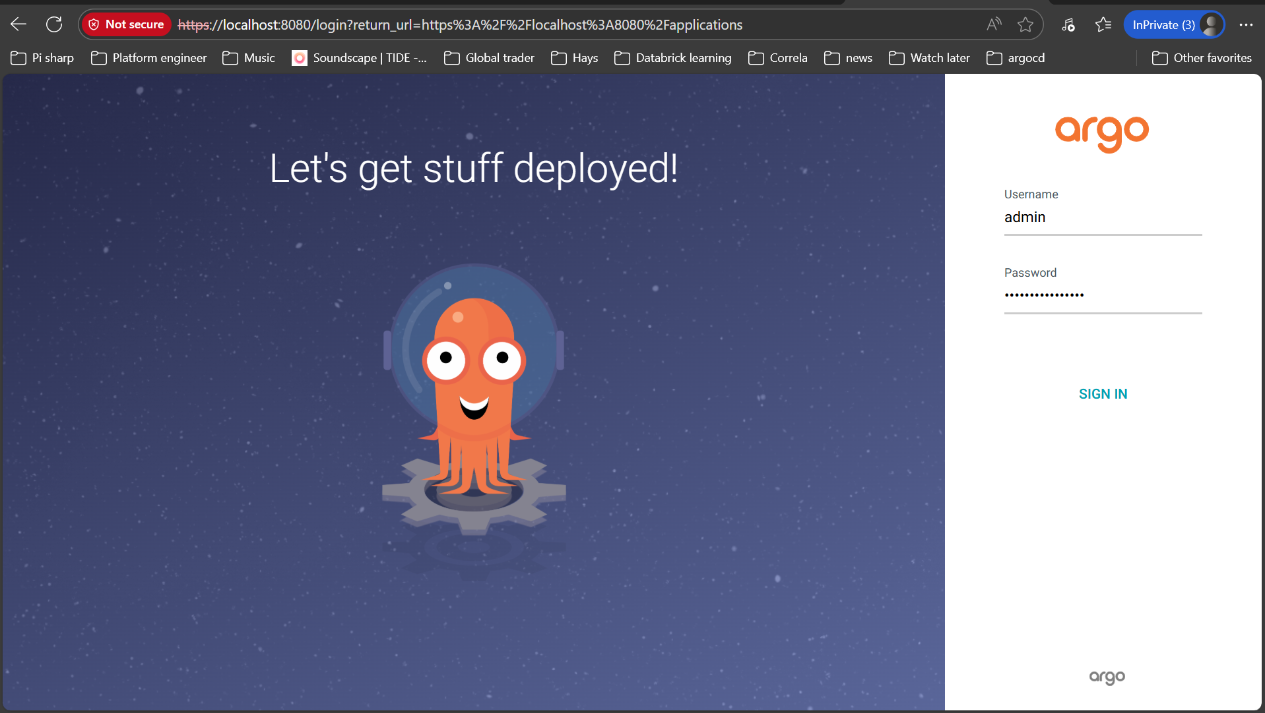
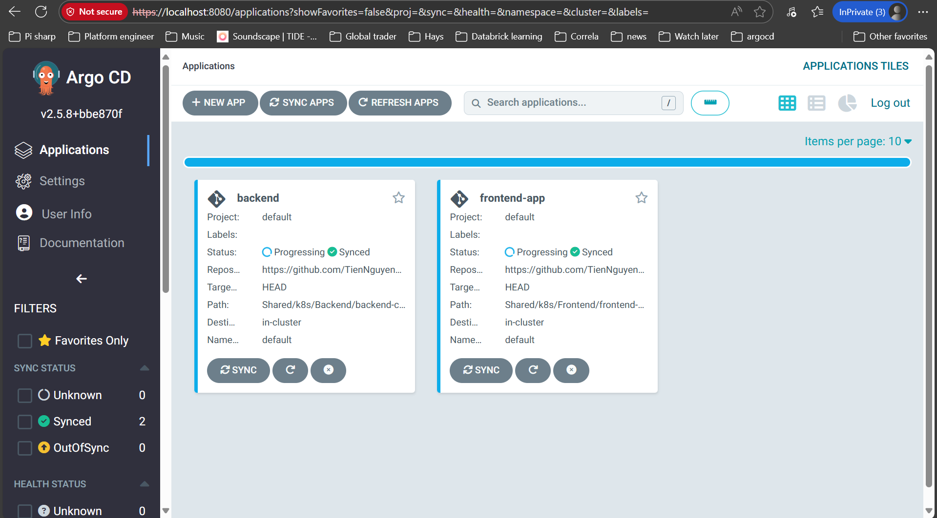
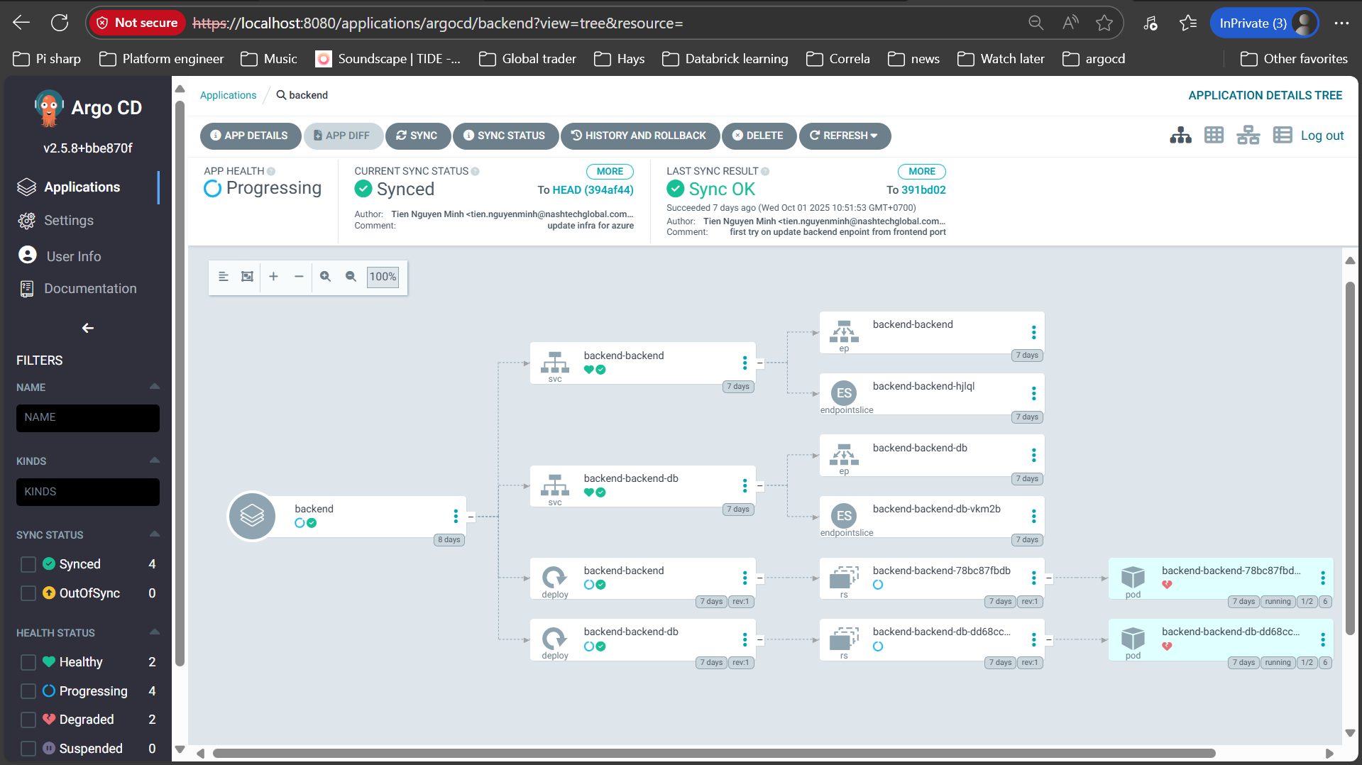
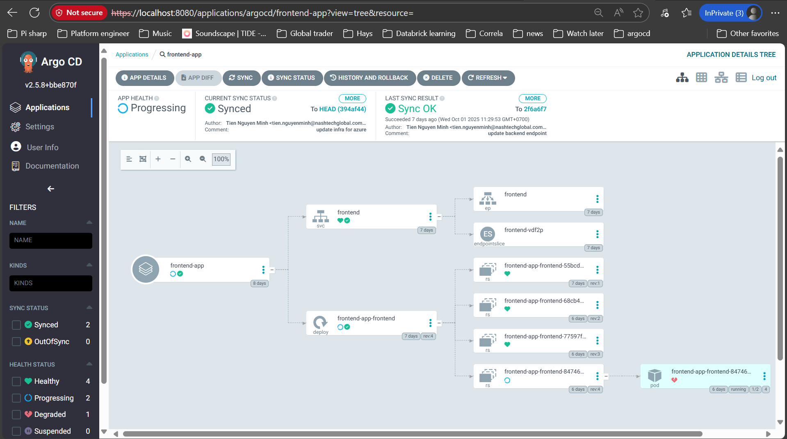
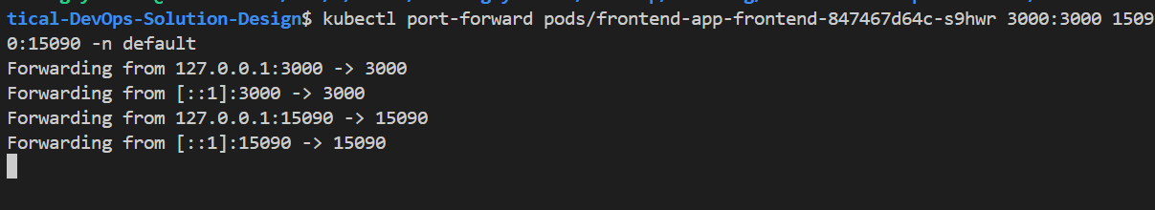
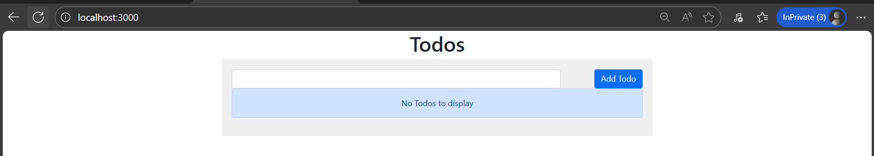
The detail helm chart was in PS src\Shared\k8s
