B2 – Level
GRAMMAR REVISION
1 - If you like modern art, you ______ really visit the new exhibition at the museum.
- Must
- Should
- Can
2 - Please will you pass me ________ grapes?
- Little
- Few
- some

3 - I don't have ______ time today but I'll do it by the end of the week.
- Much
- Long
- Some
4 - I heard the police ________ dozens of people before they made an arrest. [dozen(n): 1 chục]
- Were interviewed
- Have been interviewing
- Had interviewed
5 - I ______ Julia to tell her as soon as we arrive at the hotel.
A. going to call
B. ‘ll call
C. ‘m calling
6 - That's such a nice piece of furniture. I wish it ______ fit in my apartment.
- Could
- Was able
- Might
7 - What a noise! You fed the cat, _____ you?
- Did
- Didn’t
- Won’t
8 - You're so late! What __________________ you?
- Kept
- Is keeping
- Was keeping
9 - I could talk to him but he doesn't come here often, _____ he?
- Doesn’t
- Does
- Do
10 - My brother got lost in ______ Alps and had to be rescued.
- The
- X
- A
11 - Did you see ___ moon last night?
A. X
B. the
C. a
12 - I'm sorry, I _________ to get to change that money for you, I was too busy.
- Couldn’t
- Weren’t
- Didn’t manage
13 - She asked him _____ he wanted to go to the race course.
- As soon as
- Unless
- Whether
14 - You have taken the rubbish out, _______ you?
- Haven’t
- Didn’t
- Have
15 - ________, he didn't do as well as expected in the exam. The teachers wondered why.
- Definitely
- Interestingly
- Surprisingly
16 - I _________ enjoy going horse-riding when I was younger.
- Had
- Would
- Used to
17 - You ________ show photo identification at the check-in.
- Shouldn’t
- Must
- Don’t have to
18 - If he ______ a second time, he wouldn't have succeeded.
- Wasn’t tried
- Wouldn’t have tried
- Hadn’t tried

19 - What did you _______ do in your last employment?
- Used to
- Would
- Use to
20 - If you have any valuables, you _______ leave them in the hotel safe.
- Need to
- Don’t have to
- Shouldn’t
21 - _______ Pyrinees Mountain range separates France and Spain. [separate(V): tách rời]
- A
- X
- The
22 - I had a friend at college who was very gifted with languages. She ________ speak four or five!
- Was able to
- Was able
- Was too able
23 - It happened ages ago. I ______ in New York at the time.
- Worked
- Was working
- Had worked
24 - Your horse is ______ than ours.
- More bigger
- Much bigger
- So bigger
25 - I wish I ________ home earlier last night. I'm so tired today.
- Went
- Was going
- Had gone
26 - Paris has some great museums _____ you can see the impressionist painters.
- Which
- Where
- That
27 - Are you going to the club tonight? You _____ pay an entrance charge if you arrive before 8pm.
- Mustn’t
- Shouldn’t
- Don’t have to
28 - We used to meet at the bus stop because we weren't _______ to go to town on our own.
- Let
- Made
- Allow
29 - If they'd wanted some assistance, they _______ asked.
- Have
- Would
- Would’ve
30 - Don't forget to post the letters _________ you go out.
- After
- If
- As soon as
31 - I wish all airlines would _______ children fly for free.
- Make
- Allow
- Let
32 - I think people nowadays are a lot more technically-minded than they _______ be.
- Used to
- Use to
- Would
33 - I bought a new iPod so I can listen to ___ music I like when I'm at the gym.
- A
- X
- The
34 - She ________ me Steve had lost his job.
- Said
- Say to
- Told
35 - You _____________ told me! I wouldn't have written to her if I'd known!
- Should’ve
- Must’ve
- Would’ve
36 - He wouldn't be very happy if he _______ his daughter had been in trouble again.
- ‘d heard
- Heard
- Hear
37 - I'm looking forward to my holiday! I _____ to spend the whole week on a boat!
- ‘m going
- ‘ll go
- Will
38 - Do you know if your company is recruiting any IT technicians? John _________ to change his job so I said I would ask.
- Had liked
- Would like
- Is liking
39 - I was rather put out when I heard my daughter's teacher _______ her run twenty times around the playground!
- Let
- Made
- Allowed
40 - Congratulations on your latest test results. You did much ____ than you did the previous time.
- Better
- Best
- Good
41 - A: What's your new boss ____? B: He seems OK. He lets her get on with the job.
- Look like
- Seem like
- Like
42 - I believe mobile phones __________ change the way we live.
- Certainly could
- Will definitely
- May definitely
43 - She woke with a bad stomach ache. It _______ something she'd eaten.
- Should’ve been
- Must’ve been
- Would’ve been
44 - If only she ______ what she was doing!
- Know
- Known
- Knew
45 - I wish I could go camping with you next weekend, it sounds fun. _________ though I have to work.
- Basically
- Unfortunately
- Hopefully

READING
PART 01
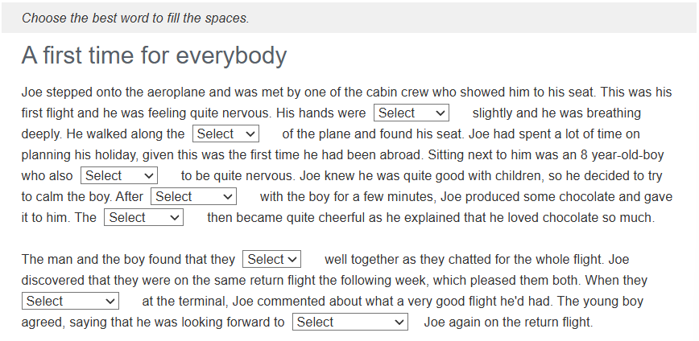
1 A. moving B. trembling C. jumping D. rattling
2 A. corridor B. path C. lane D. aisle
3 A. was B. appeared C. sat D. shown
4 A. conversing B. discussing C. debating D. negotiating
5 A. young B. youth C. juvenile D. youngster
6 A. got on B. were C. got to D. got so
7 A. disembarked B. took off C. left D. boarded
8 A. bumping into B. catching up with C. getting on with D. keeping up with

Tremble (V): run rẩy
Rattle (V): kêu lách cách, lạo xạo | (n): cái lục lạc của trẻ em
Corridor (n): hành lang
Path (n): đường mòn
Aisle (n): lối đi nhỏ giữa hang ghế
Negotiate (V) đàm phán
Junvenile (n): trẻ vị thành niên
Disembark (V): xuống tàu/máy bay
Bump into (phrasal verb): tình cờ | không cố ý

PART 02
Fill in the gaps and type one word in each gap
The Goulburn Valley
The Goulburn Valley is situated in the south-east corner of the Australian continent, in the state of Victoria. Because _______of________ the introduction of irrigation over a century ago, primary industry flourished, resulting in a multitude of orchards _______________ market gardens. After World War II, migrants flocked to the area in search of work on the farms, and in _______________ cases, establishing a property of their own.
Unfortunately, the region has taken a turn for the worse over the past decade. The irrigation water that was _______________ plentiful has now been rationed, and many farmers have been forced the land. The main source of water is from the Goulburn River, with several reservoirs located along its stretch to the mighty Murray River. Dam capacities have fallen to dangerous levels, resulting in some farmers having _______________ inadequate supply of irrigation water.
______In_________ the recent hardships, some farmers have continued to eke an existence out of the land. Many have become _____more__________ ingenious, devising new ways to utilize water plus finding special niches to service the ever-changing urban needs. Perhaps the Goulburn Valley can return to its prosperous times again.
PART 03
Read the text below. Use the word given in capitals at the end of some of the lines to form a word that fits in the gap in the same line.

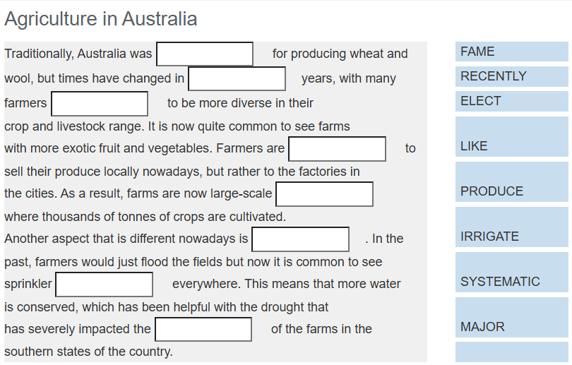
- Famous
- Recent
- Election (n): sự bầu chọn Elect (v): bầu chọn
- Likely
- Majority
- Irrigation (n): sự tưới tiêu Irrigate (v): tưới nước cho cây
- System
- Productive
PART 04
Complete the sentences with the given words.
1 - You must ____________________ instructions exactly. | CARRY
2 - Susan went to the gym three times a week _____________________ fit for the skiing. | ORDER
3 - There ______________________ in inviting her to the party. She will never come. | POINT
4 - She had to stay in _______________ her homework. | UNTIL
5 - The film _______________ had expected. | BETTER
6 - Patrick will never pass his driving test _______________ some more lessons. | DOES

PART 05
Answer all the questions and check your answers at the end.
SOCIAL NETWORKS
Business applications
Social networks connect people at low cost; this can be beneficial for entrepreneurs and small businesses looking to expand their contact base. These networks often act as a customer relationship management tool for companies selling products and services. Companies can also use social networks for advertising in the form of banners and text ads. Since businesses operate globally, social networks can make it easier to keep in touch with contacts around the world.
Medical applications
Social networks are beginning to be adopted by healthcare professionals as a means to manage institutional knowledge, disseminate peer to peer knowledge and to highlight individual physicians and institutions. The advantage of using a dedicated medical social networking site is that all the members are screened against the state licensing board list of practitioners. The role of social networks is especially of interest to pharmaceutical companies who spend approximately "32 percent of their marketing dollars" attempting to influence the opinion leaders of social networks.
Languages, nationalities and academia
Various social networking sites have sprung up catering to different languages and countries. The popular site Facebook has been cloned for various countries and languages and some specializing in connecting students and faculty.
Social networks for social good
Several websites are beginning to tap into the power of the social networking model for social good. Such models may be highly successful for connecting otherwise fragmented industries and small organizations without the resources to reach a broader audience with interested and passionate users. Users benefit by interacting with a like-minded community and finding a channel for their energy and giving.
Business model
Few social networks currently charge money for membership. In part, this may be because social networking is a relatively new service, and the value of using them has not been firmly established in customers' minds. Companies such as MySpace and Facebook sell online advertising on their site. Hence, they are seeking large memberships, and charging for membership would be counter productive. Some believe that the deeper information that the sites have on each user will allow much better targeted advertising than any other site can currently provide. Sites are also seeking other ways to make money, such as by creating an online marketplace or by selling professional information and social connections to businesses.
Privacy issues
On large social networking services, there have been growing concerns about users giving out too much personal information and the threat of sexual predators. Users of these services need to be aware of data theft or viruses. However, large services, such as MySpace, often work with law enforcement to try to prevent such incidents. In addition, there is a perceived privacy threat in relation to placing too much personal information in the hands of large corporations or governmental bodies, allowing a profile to be produced on an individual's behavior on which decisions, detrimental to an individual, may be taken.
Investigations
Social network services are increasingly being used in legal and criminal investigations. Information posted on sites such as MySpace and Facebook, has been used by police, probation, and university officials to prosecute users of said sites. In some situations, content posted on MySpace has been used in court.
1 According to the text, social networks .......
- advertise on business web sites.
- are being used by businesses for marketing.
- are about friendships.
- can damage business reputations.

2 Why do advertisers like social nework sites?
- Detailed information on each user allows targeted ads.
- They are cost-effective to advertise on.
- Most users have high disposable income.
- They can influence consumer behaviour.
3 What does the word 'Few' at the beginning of paragraph 6 mean?
- Hardly any
- Not any
- Some
- Only

4 What should users not do on social networks?
- upload copyrighted music
- be too free with their personal information
- download viruses
- contact predators
5 Personal information on social network sites .......
- is sold to the government
- is translated into many languages
- can be used in court
- gives a good description of the user's personality
6 Social networking is great for ......
- academic organizations
- people who write too much information about themselves
- the law enforcement agencies
- groups of people separated over wide areas

PART 06
You are keen to study English in London. Read the school advertisement and the notes from your teacher. Then write an email to Mr Williams at the Big Ben Language School asking for details.
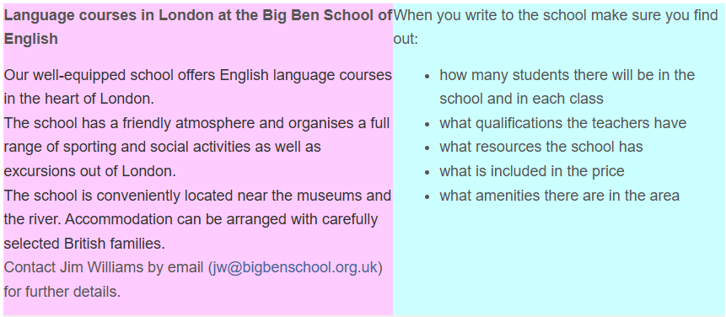
To jw@bigbenschool.org.uk
My Language courses in London at the Big Ben School of English
Hi Mr Williams,
Long time no see, how’s you going? My start-learning day was absolutely surprised, there are about 21k students study at this school, divide equally in each class has 60 to 65 students. Teachers here are also passion and enthusiastic, this morning when I had problem with the paperwork , they ready to handle it and showed me the best way to solve.
Although the fees quite high costs, it has a friendly atmosphere and organizes a full range of sporting and social activities as well as excursions out of London, so I think it suitable to spend my money for it. The school is conveniently located near the museums and the river. Accommodation can be arranged with carefully selected British families. That’s all my first day that I find out. What’s about yours? Hope your letters back soon!
See you!
Nhan

LISTENING
Audio: https://englishpracticetest.net/practice-listening-test-for-b2-with-answer-and-audioscript-test-01/
PART 01
You will hear people talking in eight different situations.
For questions 1-8, choose the best answer A, B or C.
1 You hear a restaurant manager talking about the cooks who work for him.
What does he say about them?
A They dislike cleaning tasks.
B They have a choice of jobs.
C They help to decide the menu.
2 You hear a woman talking about a new book.
What does she particularly like about the book?
A It is educational.
B It is well organised.
C It is enjoyable.
3 You hear the writer of a television soap opera being interviewed about the programme.
What will happen next in the story?
A Someone will make an important decision.
B Someone will go away unexpectedly.
C Someone will learn the truth at last.
4 You hear part of a radio interview.
Who is speaking?
A a taxi driver
B a porter
C a tourist guide
5 You hear a woman talking about how she keeps fit.
Why did she decide to take up line dancing?
A She thought the pace would suit her.
B She had heard about it on television.
C She wanted to try exercising to music.
6 You overhear a conversation in a restaurant.
What does the woman think about the food she has just eaten?
A It was expensive.
B It was delicious.
C It looked wonderful.
7 You turn on the radio and hear a man talking.
What is he talking about?
A drawing pictures
B writing fiction
C composing music
8 You overhear a student phoning her parents.
What is her opinion of the place she is living in while at college?
A She is not sure she will have enough room to study.
B She has difficulty in working because of the noise.
C She does not get on well with her room-mates.

PART 02
You will hear an interview with Elizabeth Holmes about her experience working in Africa.
For questions 9-18, complete the sentences with a word or short phrase.
Volunteering in Africa
Elizabeth worked for a (9) ……………………………… before she went to Africa.
Elizabeth first found out about working as a volunteer from a (10) ……………………………… she saw at the dentist’s.
The course in London that Elizabeth attended was called (11) ………………………………
Elizabeth’s job in Africa was to teach (12) ……………………………… how to market their goods.
On arrival in Africa, Elizabeth spent (13) ……………………………… doing a training course with other volunteers.
Elizabeth used a (14) ……………………………… to travel short distances in Africa.
Elizabeth feels that she got on best with (15) ……………………………… in the area of Africa where she lived.
Back in England, Elizabeth found that she was disturbed by the (16) ……………………………… in the city.
At the moment, Elizabeth buys and sells (17) ……………………………… from Africa.
Nowadays, Elizabeth spends more time on her favourite pastime, which is (18) ………………………………

PART 03
You will hear five different employees talking about what makes a good boss.
For questions 19-23, choose which of the opinions (A-F) each speaker expresses.
Use the letters only once. There is one extra letter which you do not need to use.
A good boss should
A allow staff to take decisions.
B encourage staff to work in teams.
C listen to complaints from staff.
D give information on individual progress.
E have good qualifications.
F set an example of hard work.

19 Speaker 1
20 Speaker 2
21 Speaker 3
22 Speaker 4
23 Speaker 5

PART 04
You will hear an interview with Trina Trevose, a pop singer who is only fifteen.
For questions 24-30, choose the best answer (A, B or C).
24 When Trina went to the USA, she
A thought the records she made would be unsuccessful.
B knew her friends would be jealous of her.
C didn’t tell many people why she was going.
25 When Trina was in the USA, she wrote songs about
A her home.
B the weather.
C people she met.
26 Where was Trina performing when she was noticed by the record company?
A in London
B near her home
C in the USA
27 Why did Trina sing with David Pearson?
A He needed some help.
B She wrote a song for him.
C The record company asked her to.
28 Trina was asked to return to the USA to
A re-do some work.
B appear on TV again.
C record a new song.
29 Why isn’t Trina popular in Britain?
A Her kind of music isn’t popular in Britain.
B The company don’t want to sell her records in Britain.
C Her records haven’ been available in Britain.
30 How does Trina see her future?
A She will continue making records in the USA.
B She may make singing her career eventually.
C She wants to study music at college.

