**FIND BUGS**

1. How many bugs can you find on this buggy windows calculator?  
   Bug Count: Over 5

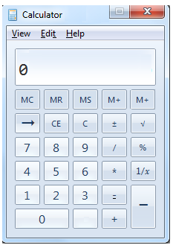

**Example:**

**Bug List**

|  |  |  |
| --- | --- | --- |
| **ID** | **Summary** | **Expected result** |
| 001 | The ‘Edit’ button has two characters underlined | Remove underline character ‘t’ |
| 002 | Missing minimize button | Add minimize button |
| 003 | button has no content | Add “.” |
| 004 | button wrong position | Change position of 2 buttons |
| 005 | 2 buttons have the same function | Remove 1 function |

1. One of the trainee developers has developed a **text pad kind of application**. Below is one of the screenshots of the application. **Can you list out bugs/issues, which the trainee developer should take care of?**

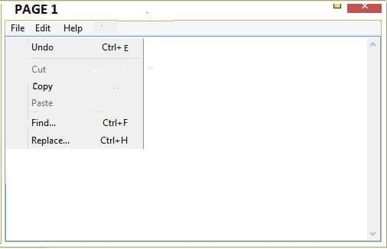

**Sample Answer as a hint:**

The name of the application does not appear in Title space.

**Bug List**

| **ID** | **Summary** | **Expected result** |
| --- | --- | --- |
| 001 | Wrong button format | Change button format |
| 002 | Blurred button | Change button format to bold |
| 003 | Charracter “E” is deviated | Change character format "E" |
| 004 | Border left is not valid | Delete border left |

|  |  |  |
| --- | --- | --- |
| 005 | Lack of bottom border | Add border bottom |

1. Weather app has 2 screens, screen 1 displays the weather forecast for first 5 days of the week and screen 2 shows weather forecast for further 5 days. How many bugs can you find on this Weather Forecast screenlet?   
   Bug Count: Over 10

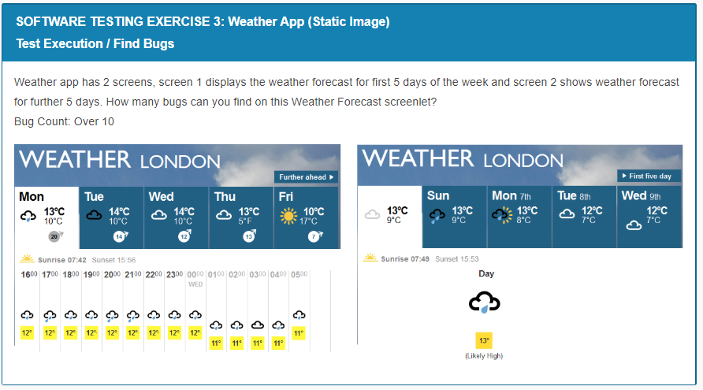

1. As a software tester, what do you do? Of course, testing the software, you would say………Okay, can you find out defects on the page shown below?

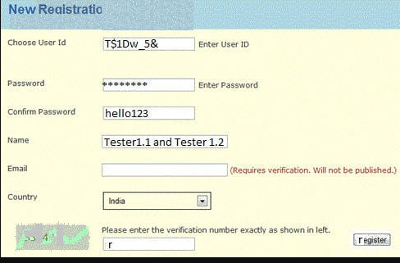

**Bug List**

|  |  |  |
| --- | --- | --- |
| **ID** | **Summary** | **Expected result** |
| 001 | Wrong font | Fix ‘r’ |
| 002 | The code is hidden  C:\Users\DELL\AppData\Local\Microsoft\Windows\INetCache\Content.MSO\F4AA2553.tmp | clearly show the code  C:\Users\DELL\AppData\Local\Microsoft\Windows\INetCache\Content.MSO\48FDDDD9.tmp |
| 003 | extra space | delete extra space |
| 004 | Misplaced | move right |
| 005 | lack of captions | need more explanation |
| 006 | display incomplete characters | Need to display full characters |
| 007 | The description does not match the input format | replace "choose" with the word "import" |