EFOOD

Software Development Plan (Small Project)

Version <1.0>

Revision History

| **Date** | **Version** | **Description** | **Author** |
| --- | --- | --- | --- |
| 10/11/2022 | <1.0> | Write Project Organization, risk management | Trần Dũng Tiến |
| 11/11/2022 | <1.1> | Write introduction and project overview (project purpose, scope, objectives, assumptions and constraints, project deliverables) | Trần Bảo Long |
| 11/11/2022 | <1.2> | Draw Gantt chart, Project Estimates | Nguyễn Trung Kiên |
| 11/11/2022 | <1.3> | Write Risk management | Đinh Cao Hồng Phước |

Table of Contents

**1.** **Introduction 4**

*1.1* *Purpose 4*

*1.2* *Scope 4*

*1.3* *Overview 4*

**2.** **Project Overview 4**

*2.1* *Project Purpose, Scope, and Objectives 4*

*2.2* *Assumptions and Constraints 4*

*2.3* *Project Deliverables 5*

**3.** **Project Organization 5**

*3.1* *Organizational Structure 5*

*3.2* *Roles and Responsibilities 5*

**4.** **Management Process** 6

*4.1* *Project Estimates* 6

*4.2* *Project Plan* 6

4.2.1 Phase Plan 6

4.2.2 Iteration Objectives 6

4.2.3 Releases 6

4.2.4 Project Schedule 6

4.2.5 Project Resourcing 6

*4.3* *Project Monitoring and Control* 8

4.3.1 Requirements Management 8

4.3.2 Reporting and Measurement 8

4.3.3 Risk Management 9

4.3.4 Configuration Management 9

Software Development Plan (Small Project)

# 

# Introduction

The introduction of the **Software Development Plan** provides an overview of the entire document. It includes the purpose, scope, definitions, acronyms, abbreviations, references, and overview of this **Software Development Plan**.

## Purpose

The purpose of the *Software Development Plan* is to gather all information necessary to control the project. It describes the approach to the development of the software and is the top-level plan generated and used by managers to direct the development effort.

The following users of the *Software Development Plan*:

* The **project manager** uses it to plan the project schedule and resource needs, and to track progress against the schedule.
* **Project team members** use it to understand what they need to do, when they need to do it, and what other activities they are dependent upon.

## Scope

This *Software Development Plan* describes the overall plan to be used by the web food delivery project, including deployment of the product. The details of the individual iterations will be described in the Iteration Plans.  
The plans as outlined in this document are based upon the product requirements as defined in the *Vision Document*.

## Overview

This *Software Development Plan* contains the following information:

Project Overview — provides a description of the project's purpose, scope, and objectives.  It also defines the deliverables that the project is expected to deliver.

Project Organization — describes the organizational structure of the project team.

# Project Overview

## Project Purpose, Scope, and Objectives

[A brief description of the purpose and objectives of this project and a brief description of what deliverables the project is expected to deliver.] [Mô tả ngắn gọn về mục đích và mục tiêu của dự án này và mô tả ngắn gọn về những gì mà dự án dự kiến ​​sẽ cung cấp.]

Web applications are all the rage in the world today because of the immense profits bringing in the process of branding, supporting business growth, and more. With web applications, businesses effortlessly maintain an efficacious communication channel with functions of customers and partners. And in this project, my group has the opportunity to create a food delivery website (EFOOD)**.** This is an awesome occasion for the team not only to apply what we have learned, but also to learn new knowledge and gain more practical experience through this real project. This website has some features: Menu, Filter, Search, Order, Cancel order, Suggesting best seller products, Feedback, Register, Login, Forget passwords, User profile, Follow user orders, Manage order..

## Assumptions and Constraints

A list of assumptions and constraints:

| **Features** | **TIME** | **COST** |
| --- | --- | --- |
| Register | 14h | 28$ |
| Shopping cart | 20h | 40$ |
| Search | 6h | 12$ |
| Suggest best seller | 12h | 24$ |
| Rate | 6h | 12$ |
| Feedback | 12h | 24$ |
| History payment | 4h | 8$ |
| **Total** | **74h** | **148$** |

## Project Deliverables

Deliverables for each project phase are identified in the Development Case.  Deliverables are delivered towards the end of the iteration, as specified in section *4.2.4 Project Schedule*.

# Project Organization

## Organizational Structure

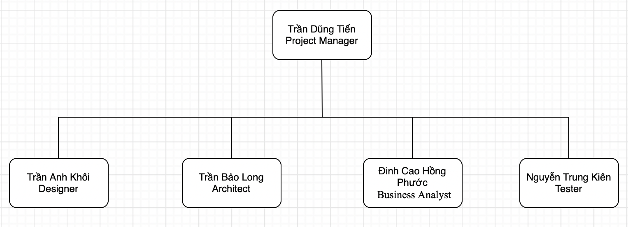

## Roles and Responsibilities

| Person | Role |
| --- | --- |
| Trần Dũng Tiến, Project Manager | Responsible for maintaining the Project store management, keeping the project team focused on the right goal. |
| Trần Anh Khôi, Designer | The designer creates the interface of the software, and defines the operations, attributes and relationships of entities or classes. |
| Trần Bảo Long, Architect | Identify the overall structure for the project, provide design sketches and details, and prepare a budget. |
| Đinh Cao Hồng Phước, Business Analyst | Working directly with customers, get the requirements from them and transfer to the team; analyze the effect of changings to the process. |
| Nguyễn Trung Kiên, Tester | Responsible for executing testing, detecting the bug, evaluation and recovery system from errors. |

# Management Process

## Project Estimates

The Inception phase of the project will take 1 week.

The Elaboration phase of the project will take 2 weeks.

The Construction phase of the project will take 5 weeks.

The Transition phase of the project will take 2 weeks.

## Project Plan

WBS of project:

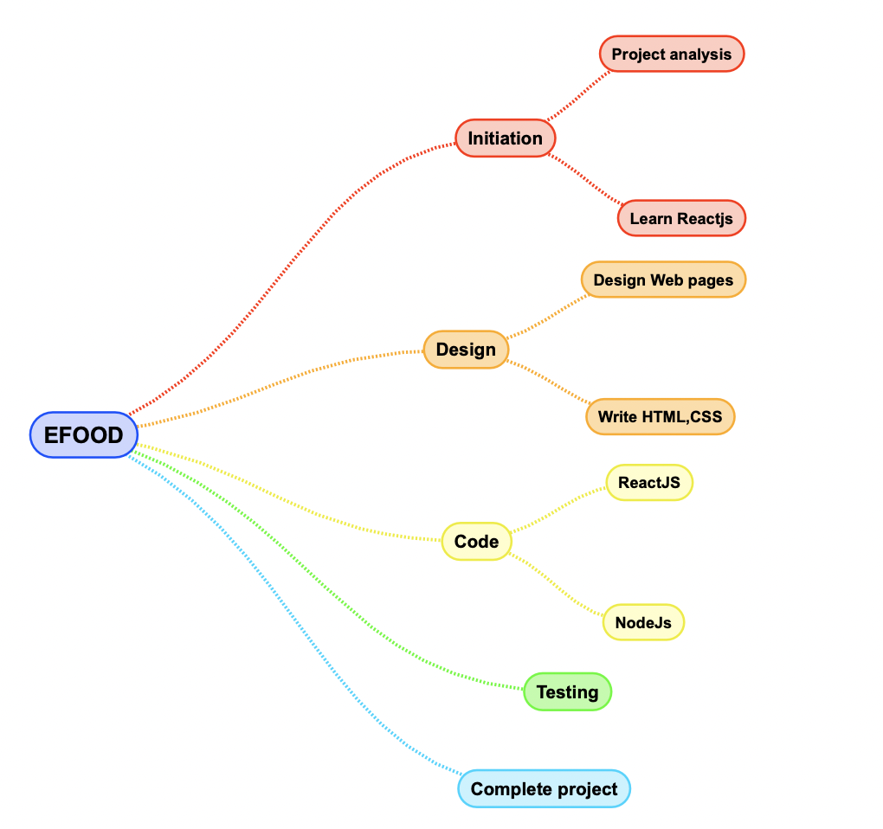

Timeline:

* Design UI Web pages: 10/10/2022 – 16/10/2022 – Assigned to: Trần Anh Khôi
* Learn ReactJS + NodeJS: 22/10/2022 - 21/11/2022 - Assigned to: All members
* Write HTML, CSS: 31/10/2022 – 06/11/2022
* Header Website: Trần Dũng Tiến, Trần Bảo Long.
* Slider Website: Trần Bảo Long.
* Content: Đinh Cao Hồng Phước, Nguyễn Trung Kiên.
* Footer: Trần Anh Khôi.
* Coding front-end (ReactJS): 07/11/2022 – 21/11/2022
  + Header Website: Trần Dũng Tiến, Trần Bảo Long.
  + Slider Website: Trần Bảo Long.
  + Content: Đinh Cao Hồng Phước, Nguyễn Trung Kiên.
  + Footer: Trần Anh Khôi.
* Coding back-end (Node-JS): 21/11/2022 – 5/12/2022 – Assigned to: All members.
* Testing: 5/12/2022 – 8/12/2022 – Assigned to : Nguyễn Trung Kiên

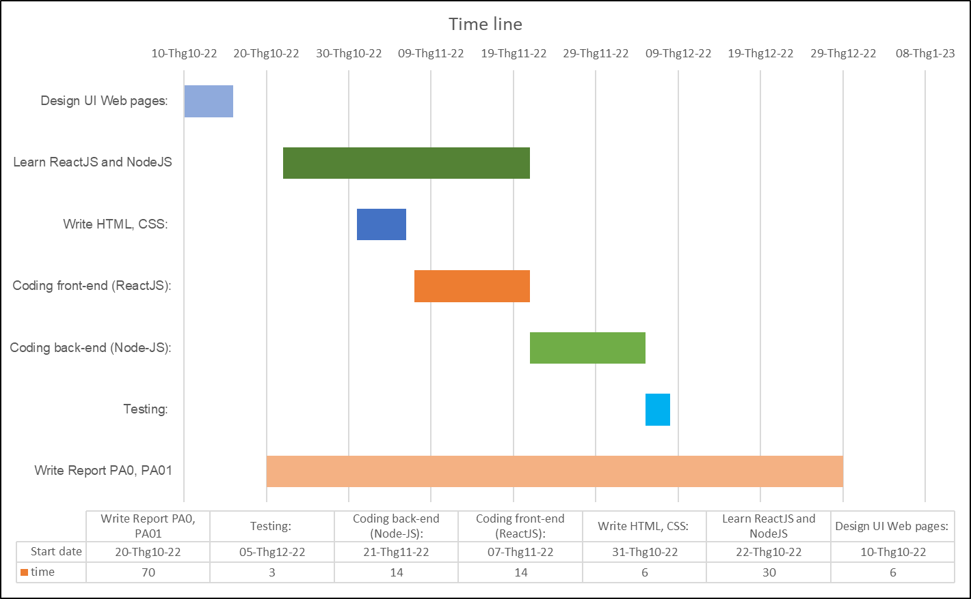

## Project Monitoring and Control

### Requirements Management

The requirements for this system are captured in the Vision document. Requested changes to requirements are captured in Change Requests, and are approved as part of the Configuration Management process.

### Reporting and Measurement

Updated cost and schedule estimates, and metrics summary reports, will be generated at the end of each iteration.

The Minimal Set of Metrics, as described in the RUP Guidelines: Metrics, will be gathered on a weekly basis. These include:

Earned value for completed tasks. This is used to re-estimate the schedule and budget for the remainder of the project, and/or to identify need for scope changes.

Total defects open and closed – shown as a trend graph. This is used to help estimate the effort remaining to correct defects.

Acceptance test cases passing – shown as a trend graph. This is used to demonstrate progress to stakeholders.

In addition, overall costs will be monitored against the project budget.

### Risk Management

Risks will be identified in the Inception Phase using the steps identified in the RUP for Small Projects activity “Identify and Assess Risks”. Project risk is evaluated at least once per iteration and documented in this table. The risks of the greatest magnitude are listed first in the table.

| **Risk Ranking (High, Medium, Low)** | **Risk Description and Impact** | **Mitigation Strategy and/or Contingency Plan** |
| --- | --- | --- |
| High | Not knowing about the software process leads to the deadline delay. | Read the PAs in advance and ask the supervisor |
| High | Little knowledge of ReactJS and no knowledge of the backend leads to not knowing how to program and affect the project. | Learning from other groups or group members can help each other learn. Dividing the work into small pieces logically, so that the amount of knowledge each person has to learn during the project will be significantly less.  Finding subject material. |
| High | The pressure of other courses' projects. The team members have to do several projects at the same time. So that they are under a lot of stress and may not have enough time and miss the deadline. | Make a good plan, effective time management to increase productivity, reduce the stress level and make the work more easy. |
| Medium | Members could confront the difficulty of grasping each other. So, they may misunderstand the problem. | Frequently team meetings to improve team communication. |
| Medium | The difference between the abilities of each team member. One person may not catch up with others. Because of that they’re not completing their work. | United we stand, divided we fall. So, the members who have good performance should help the worse ones. However, the worse ones have to make an effort to catch up with the project process and shouldn’t rely too much on others' help. |
| Low | Members may drop out of the course leading to a manpower shortage. | Make sure all members understand each other's work. So when one member drops out of the course the others can know what to do. |

### Configuration Management

None