EFOOD

Vision Document

Version <1.4>

Revision History

| **Date** | **Version** | **Description** | **Author** |
| --- | --- | --- | --- |
| 08/11/2022 | <1.0> | Write Introduction, Positioning Stakeholder and User Descriptions. | Trần Dũng Tiến |
| 09/11/2022 | <1.1> | Write Product perspective | Trần Anh Khôi |
| 09/11/2022 | <1.2> | Write Product Features | Nguyễn Trung Kiên |
| 09/11/2022 | <1.3> | Write Assumptions and Dependencies | Đinh Cao Hồng Phước |
| 09/11/2022 | <1.4> | Write non-functional requirements | Trần Bảo Long |

Table of Contents

1. Introduction 4

1.1 References 4

2. Positioning 4

2.1 Problem Statement 4

2.2 Product Position Statement 4

3. Stakeholder and User Descriptions 4

3.1 Stakeholder Summary 4

3.2 User Summary 5

3.3 User Environment 5

3.4 Summary of Key Stakeholder or User Needs 5

3.5 Alternatives and Competition 6

4. Product Overview 6

4.1 Product Perspective 6

4.2 Assumptions and Dependencies 7

5. Product Features 7

6. Other Product Requirements 8

Vision (Small Project)

# Introduction

## References

Applicable references are:

1. <http://sce.uhcl.edu/helm/RationalUnifiedProcess/examples/csports/ovu_webex.htm>.
2. <https://www.ibm.com/docs/en/elm/7.0.0?topic=requirements-vision-document>
3. <https://shopeefood.vn>
4. <https://www.grab.com/sg/food/>

# Positioning

## Problem Statement

| The problem of | Going to the restaurant to buy food is inconvenient for customers. The restaurant may be overloaded if there are too many customers waiting. |
| --- | --- |
| affects | Customers, restaurant, shippers |
| the impact of which is | A slow process combined with dissatisfied restaurant and customers |
| a successful solution would be | Improve the image of the restaurant, attract more customers, and help the shippers to increase incomes |

## Product Position Statement

| For | Restaurant, Customers. |
| --- | --- |
| Who | Search, Order, administer menu dishes |
| The (product name) | is a website (EFOOD) |
| That | Faster user interaction, extractive more customers, convenience in recording customer menus |
| Unlike | Ordering food at restaurant |
| Our product | Provides up-to-date information on all dishes, and users can order and rate dishes from any device via the internet. |

# Stakeholder and User Descriptions

This section describes the users of the food delivery website. There are 2 types of users of the website: customer , admin(restaurant).

## Stakeholder Summary

| **Name** | **Description** | **Responsibilities** |
| --- | --- | --- |
| Development Team | All members | Responsible for the programming of the entire website. |
| Theory Teacher | Supervisors | Supervising and answering project questions for groups of students. Help students to make software. |
| Customers | Customers | Ensures that the website will meet the needs of customers. |
| Admin | Restaurant | Represents the interests of the restaurant |

## User Summary

| **Name** | **Description** | **Responsibilities** | **Stakeholder** |
| --- | --- | --- | --- |
| Customers | Entering a website for ordering food. | Ordering food, rating food, comment feedback. | Self-represented |
| Restaurant | Selects dishes to sell. Accept the orders. | Adding dishes, remove dishes, block spam users, reply customer comments. | Self-represented |

## User Environment

The users are computer/mobile literate and in most cases own personal phones. The ability to access websites via personal phone and to order food.

The initial release of the food delivery website will be suitable for anyone who can use the internet browsers. Marketing menu of that restaurant. As a result, this website will be designed to be expandable and popular for many regions, ages.

## Summary of Key Stakeholder or User Needs

| **Need** | **Priority** | **Concerns** | **Current Solution** | **Proposed Solutions** | |
| --- | --- | --- | --- | --- | --- |
| Ordering food | High | Ordering food is slow and inefficient when restaurant overcrowded | Currently customers must wait for the food done at the restaurant. Customers spend a lot of time waiting for food. At this point, any dish is wrong will cause problems that are difficult to solve for | | Customers would like to have online access to quickly order food. |
| Receive orders | Medium | Staff have to do it many times. | When the restaurant is too crowded, the staff has to take many orders, there will be times when the staff will order the wrong dish for that customer. | | Staff will receive orders sent from the restaurant's website. |

## Alternatives and Competition

The shopeefood has many affiliated stores, so its menu will be more diverse, food is not only for people but also for pets. Has high information security function. Customers can contact directly through the consultant. It also have advertisement

# Product Overview

## Product Perspective

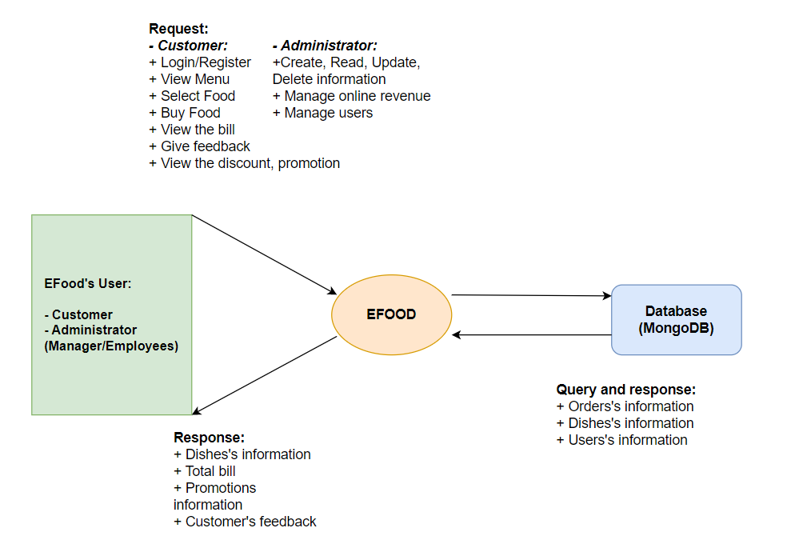

***Image_ 1***

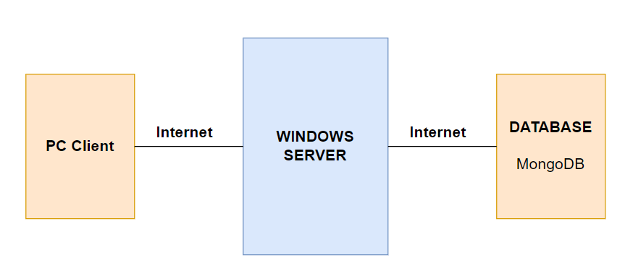

***Image_ 2***

- EFood is an online food store, which is a suitable way to choose a variety of dishes everyday for everyone. The way of making this system popularizes customers quickly, updates dishes' image, information conveniently and makes it easier to manage this store.

- EFood will consist of a client component and server component. The server component resides on the Windows server. The server component is supported by database MongoDB. (Image_ 2).

- Any computer or mobile device can access this web EFood by Internet. Users have to log in to EFood before having service on this website.

## Assumptions and Dependencies

The following assumptions and dependencies relate to the capabilities of the food delivery website as outlined in this Vision Document:

* The website will be up and running non-stop. The users can always be able to access the website as long as they have the internet.
* Responsive: Users can open on mobile, tablet, laptop,…
* Simultaneous Access By Multiple Users.
* The website can open on low-spec devices.

# Product Features

This section defines and describes the features of the food delivery website. Features are the high-level capabilities of the system that are necessary to deliver benefits to the users

* Logon: Users shall provide a valid ID and password for entry to the website. Users are assigned their ID and a password at the time they register. The system shall enable a user to change theri temporary password.
* Order food : Customers shall choose the food from the website. Restaurant receives the order and delivers it to the customer.
* Comment (feedback): Customers shall feedback their feeling about the restaurant’s food. Restaurant can know what they need to fix in the dishes or menu… Restaurant can also reply to confirm the customer’s feedback.
* Filter: Customers can use the filter to search for food ( nearest - price - evaluate - sale …).
* ReOrder: Users can review their order history and reorder.
* Rating: Users after buying the dish can feedback it.
* Wishlist: Users can add the dish to their personal favorites list.
* Reward points: Users can earn points after using the item and the points will be used to get promotional vouchers or valuable rewards.
* Multi-order: The shopping cart module allows customers to order multiple products at the same time on the web in 1 transaction. The shopping cart will be sent to the admin page and sent to the admin's personal email.
* Order management: The admin page can view the full customer cart or view the cart list of purchased customers. Can change the administrative email to receive new orders that customers place.

# Non-Functional Requirements

Because the design patterns of the Online Ordering System are pretty much the standard for a web application, the non-functional requirements of the system are very straightforward. Although written using React, the application is cross-compiled to HTML and JSX, , along with a Node js backend, all of which are supported by any reasonably well maintained web server.

All of the application data is stored in MongoDB. Therefore, a MongoDB server must also be installed on the host computer. This software is freely available and can be installed and run under most operating systems.

The server hardware can be any computer capable of running both the web and database servers and handling the expected traffic. For a restaurant that is not expecting to see much web traffic, or possibly doing only a limited test run, an average personal computer may be appropriate. Once the site starts generating more hits, though, it will likely be necessary to upgrade to a dedicated host to ensure proper performance. The exact cutoffs will need to be determined through a more thorough stress testing of the system.

If the employee has entered the wrong password more than 3 times, staff must wait a period of time to continue. Such attempts should be reported to the security administrator.

The software should be portable. So moving from one OS to another OS does not create any problems.

With feature search product information no more than 3 second