EFOOD

Software Development Plan (Small Project)

Version <1.3>

Revision History

| **Date** | **Version** | **Description** | **Author** |
| --- | --- | --- | --- |
| 10/11/2022 | <1.0> | Write Project Organization, risk management | Trần Dũng Tiến |
| 11/11/2022 | <1.1> | Write introduction and project overview (project purpose, scope, objectives, assumptions and constraints, project deliverables) | Trần Bảo Long |
| 11/11/2022 | <1.2> | Draw Gantt chart, Project Estimates | Nguyễn Trung Kiên |
| 11/11/2022 | <1.3> | Write Risk management | Đinh Cao Hồng Phước |

Table of Contents

**1.** **Introduction 4**

*1.1* *Purpose 4*

*1.2* *Scope 4*

*1.3* *Overview 4*

**2.** **Project Overview 4**

*2.1* *Project Purpose, Scope, and Objectives 4*

*2.2* *Assumptions and Constraints 4*

*2.3* *Project Deliverables 5*

**3.** **Project Organization 5**

*3.1* *Organizational Structure 5*

*3.2* *Roles and Responsibilities 5*

**4.** **Management Process** 6

*4.1* *Project Estimates* 6

*4.2* *Project Plan* 6

4.2.1 Phase Plan 6

4.2.2 Iteration Objectives 6

4.2.3 Releases 6

4.2.4 Project Schedule 6

4.2.5 Project Resourcing 6

*4.3* *Project Monitoring and Control* 8

4.3.1 Requirements Management 8

4.3.2 Reporting and Measurement 8

4.3.3 Risk Management 9

4.3.4 Configuration Management 9

Software Development Plan (Small Project)

# 

# Introduction

The introduction of the **Software Development Plan** provides an overview of the entire document. It includes the purpose, scope, definitions, acronyms, abbreviations, references, and overview of this **Software Development Plan**.

## Purpose

The purpose of the *Software Development Plan* is to gather all information necessary to control the project. It describes the approach to the development of the software and is the top-level plan generated and used by managers to direct the development effort.

The following users of the *Software Development Plan*:

* The **project manager** uses it to plan the project schedule and resource needs, and to track progress against the schedule.
* **Project team members** use it to understand what they need to do, when they need to do it, and what other activities they are dependent upon.

## Scope

This *Software Development Plan* describes the overall plan to be used by the web food delivery project, including deployment of the product. The details of the individual iterations will be described in the Iteration Plans.  
The plans as outlined in this document are based upon the product requirements as defined in the *Vision Document*.

## Overview

This *Software Development Plan* contains the following information:

Project Overview — provides a description of the project's purpose, scope, and objectives.  It also defines the deliverables that the project is expected to deliver.

Project Organization — describes the organizational structure of the project team.

# Project Overview

## Project Purpose, Scope, and Objectives

[A brief description of the purpose and objectives of this project and a brief description of what deliverables the project is expected to deliver.] [Mô tả ngắn gọn về mục đích và mục tiêu của dự án này và mô tả ngắn gọn về những gì mà dự án dự kiến ​​sẽ cung cấp.]

Web applications are all the rage in the world today because of the immense profits bringing in the process of branding, supporting business growth, and more. With web applications, businesses effortlessly maintain an efficacious communication channel with functions of customers and partners. And in this project, my group has the opportunity to create a food delivery website (EFOOD)**.** This is an awesome occasion for the team not only to apply what we have learned, but also to learn new knowledge and gain more practical experience through this real project. This website has some features: Menu, Filter, Search, Order, Cancel order, Suggesting best seller products, Feedback, Register, Login, Forget passwords, User profile, Follow user orders, Manage order..

## Assumptions and Constraints

A list of assumptions and constraints:

| **Features** | **TIME** | **COST** |
| --- | --- | --- |
| Register | 14h | 28$ |
| Shopping cart | 20h | 40$ |
| Search | 6h | 12$ |
| Suggest best seller | 12h | 24$ |
| Rate | 6h | 12$ |
| Feedback | 12h | 24$ |
| History payment | 4h | 8$ |
| **Total** | **74h** | **148$** |

## Project Deliverables

Deliverables for each project phase are identified in the Development Case.  Deliverables are delivered towards the end of the iteration, as specified in section *4.2.4 Project Schedule*.

# Project Organization

## Organizational Structure

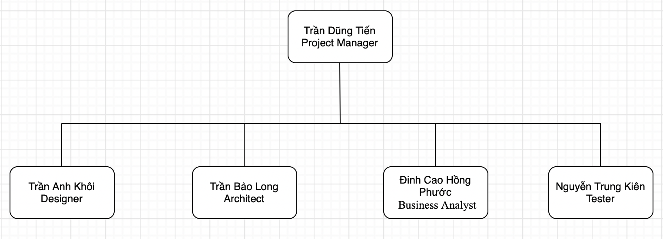

## Roles and Responsibilities

| Person | Role |
| --- | --- |
| Trần Dũng Tiến, Project Manager | Responsible for maintaining the Project store management, keeping the project team focused on the right goal. |
| Trần Anh Khôi, Designer | The designer creates the interface of the software, and defines the operations, attributes and relationships of entities or classes. |
| Trần Bảo Long, Architect | Identify the overall structure for the project, provide design sketches and details, and prepare a budget. |
| Đinh Cao Hồng Phước, Business Analyst | Working directly with customers, get the requirements from them and transfer to the team; analyze the effect of changings to the process. |
| Nguyễn Trung Kiên, Tester | Responsible for executing testing, detecting the bug, evaluation and recovery system from errors. |

# Management Process

## Project Estimates

The Inception phase of the project will take 1 week.

The Elaboration phase of the project will take 2 weeks.

The Construction phase of the project will take 5 weeks.

The Transition phase of the project will take 2 weeks.

## Project Plan

WBS of project:

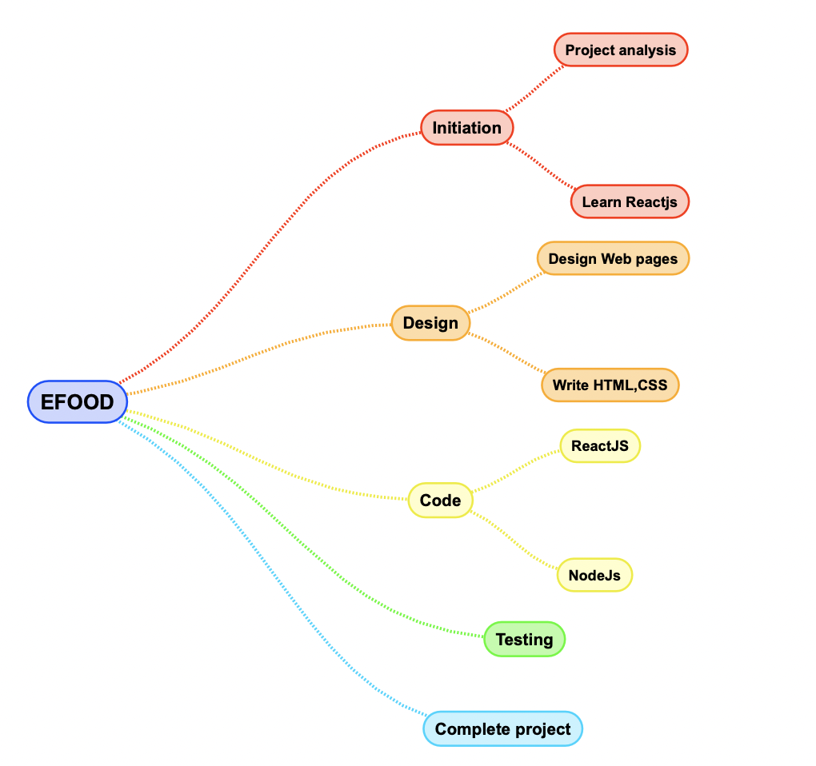

**- Phase 1:**

**+ Start:** 20/10/2022

**+ End**: 29/10/2022

**+ Task:**

| **No.** | **Task** | **Responsibility** |
| --- | --- | --- |
| 1 | Review Meeting | All members |
| 2 | List web functions ideas | All members |
| 3 | Setup team workspace: Google Drive, Github | Dung Tien |
| 4 | Gather team ideas | Dung Tien |
| 5 | Research how to deploy web by Heroku | Hong Phuoc |
| 6 | Review how to use Jira, Github | All members |
| 7 | FIGMA basic design (Customer) | Anh Khoi |
| 8 | Weekly Report 1 | All members |
| 9 | Improve HTML/CSS/JavaScript | All members |
| 10 | Weekly Report 2 | All members |
| 11 | PA0:   * Write report * Find the project’s key feature * Searching information about server hosting * Create file reports and features | Dung Tien  Anh Khoi, Bao Long  Hong Phuoc  Trung Kien |
| 12 | Gantt Chart | Trung Kien |
| 13 | Complete PA0 | Dung Tien |

**+ Gantt Chart**:

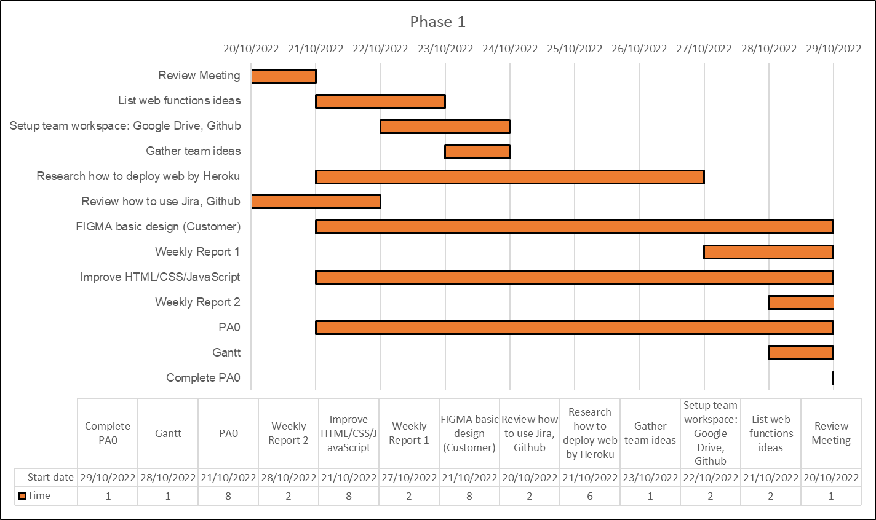

**+ Output**: PA0, Project plan, FIGMA pages (Home page, Menu page, Header page, Contact US).

**- Phase 2:**

**+ Start:** 29/10/2022

**+ End**: 12/11/2022

**+ Task:**

| **No.** | **Task** | **Responsibility** |
| --- | --- | --- |
| 1 | Review Meeting | All members |
| 2 | Get feedbacks from Customer | Bao Long |
| 3 | Setup team workspace: Jira | Dung Tien |
| 4 | Training basic NodeJS | Dung Tien |
| 5 | UI:   * Header * Slider * Content * Footer | Dung Tien, Bao Long  Bao Long  Hong Phuoc, Trung Kien  Anh Khoi |
| 6 | Review how to use Jira, Github | All members |
| 7 | Continue FIGMA design (Customer) | Anh Khoi |
| 8 | Weekly Report 3 | All members |
| 9 | Learning ReactJS | All members |
| 10 | Weekly Report 4 | All members |
| 11 | PA1   * Part 1: * Assignment & Write Report base * Product Perspective (RUP_Vision) * Risk Management (Project Plan) * Non-Functional Requirement(RUP_Vision) * Product Features (RUP_vision) * Part 2: * Complete Project organization, risk management(Project Plan), Introduction, Positioning Stakeholder and User Descriptions(RUP_Vision) * Complete non-functional requirement(RUP_Vision), introduction and project overview(Project plan) * Complete risk management (Project plan), Assumption and dependencies(RUP_Vision) * Complete Product perspective (RUP_Vision) * Complete Gantt chart, product estimates (Project plan), Product features(RUP_Vision) | * Part 1: * Dung Tien * Anh Khoi * Hong Phuoc * Bao Long * Trung Kien * Part 2: * Dung Tien * Bao Long   + Hong Phuoc  + Anh Khoi  + Trung Kien |
| 12 | Gantt Chart | Trung Kien |
| 13 | Complete PA1 | Dung Tien |

**+ Gantt Chart**:

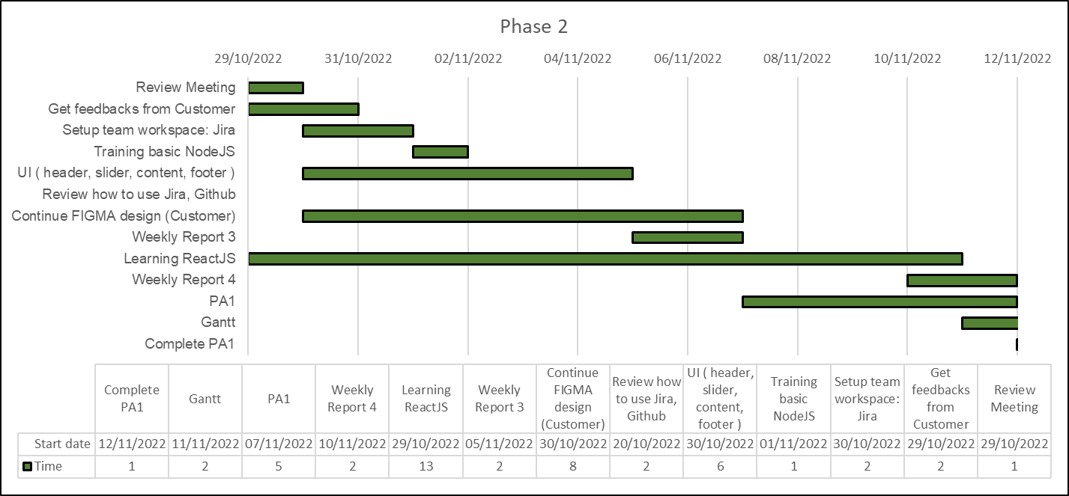

**+ Output**: PA1 (Vision Document, Project plan), FIGMA User Profile, UI header, UI slider, UI footer, UI content

**- Phase 3:**

**+ Start:** 13/11/2022

**+ End**: 27/11/2022

**+ Task:**

| **No.** | **Task** | **Responsibility** |
| --- | --- | --- |
| 1 | Review Meeting | All members |
| 2 | Continue to training NodeJS | Dung Tien |
| 3 | Logistic:   * Header * Slider * Content * Footer | Dung Tien, Bao Long  Bao Long  Hong Phuoc, Trung Kien  Anh Khoi |
| 4 | Use-case model | Dung Tien |
| 5 | Use-case specification | All members |
| 6 | Continue FIGMA design (Customer) | Anh Khoi |
| 7 | Weekly Report 5 | All members |
| 8 | Continue to learning ReactJS | All members |
| 9 | * Weekly Report 6 | All members |
| 10 | PA2   * Revised Project Plan * Detailed Vision Document | All members |
| 11 | Gantt Chart | Trung Kien |
| 12 | Complete PA2 | Dung Tien |

**+ Gantt Chart**:

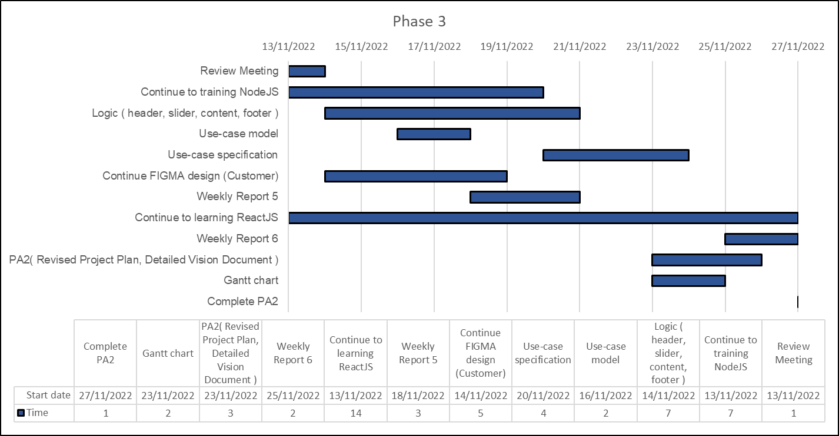

**+ Output**: PA2 ,FIGMA Location, FIGMA contact US, UI Component Sidebar, User-case model, Logic UI

**- Phase 4:**

**+ Start:** 27/11/2022

**+ End**: 10/12/2022

**+ Task:**

| **No.** | **Task** | **Responsibility** |
| --- | --- | --- |
| 1 | Review Meeting | All members |
| 2 | Create API Products | Dung Tien |
| 3 | UI Admin:   * Sidebar * Dashboard * Products * User | Anh Khoi  Dung Tien  Bao Long  Bao Long |
| 4 | Payment Handle | Trung Kien |
| 5 | Shopping Handle | Anh Khoi |
| 6 | Use-case specification | All members |
| 7 | FIGMA design (Admin) | Anh Khoi |
| 8 | Weekly Report 7 | All members |
| 9 | Learning ReactJS: (Advanced Redux, real-time processing) | All members |
| 10 | Weekly Report 8 | All members |
| 11 | PA3   * Revised the use-case model * Define software architecture * Class Diagrams | All members |
| 12 | Gantt Chart | Trung Kien |
| 13 | Complete PA3 | Dung Tien |

**+ Gantt Chart**:

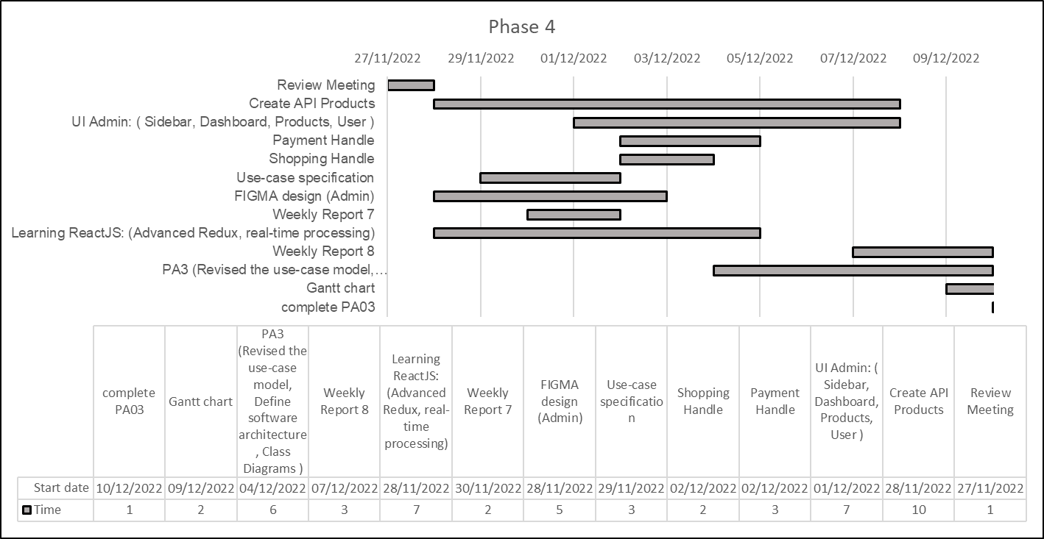

**+ Output**: PA3 ,Payment Page, FIGMA admin, UI Admin

**- Phase 5:**

**+ Start:** 11/12/2022

**+ End**: 24/12/2022

**+ Task:**

| **No.** | **Task** | **Responsibility** |
| --- | --- | --- |
| 1 | Review Meeting | All members |
| 2 | Complete API Admin | Bao Long, Dung Tien |
| 3 | Logistic:   * Dashboard * Products, User * Sidebar | Bao Long  Dung Tien  Anh Khoi |
| 4 | Weekly Report 9 | All members |
| 5 | Unit testing and report issues | Hong Phuoc |
| 6 | Weekly Report 10 | All members |
| 7 | PA4   * Revised SAD * UI Prototype | All members |
| 8 | Gantt Chart | Trung Kien |
| 9 | Complete PA4 | Dung Tien |

**+ Gantt Chart**:

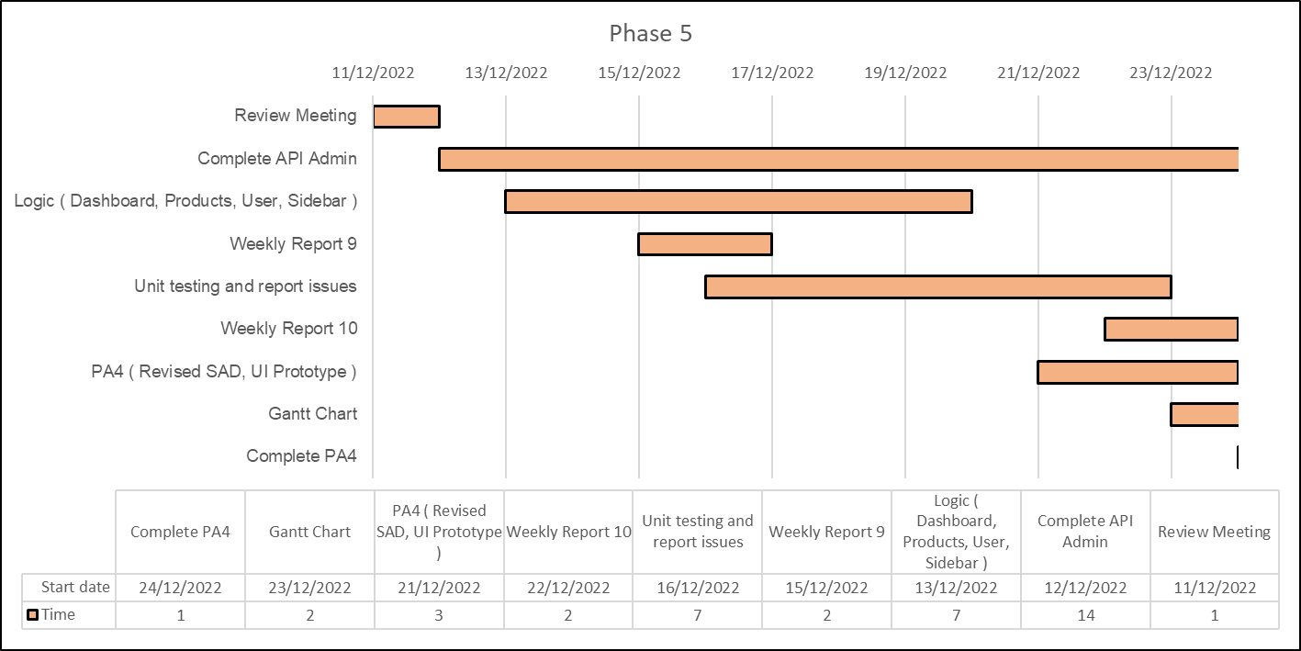

**+ Output**: PA4 ,Complete API Admin , Admin Page Logistic , Test case, Draft version release of product

**- Phase 6:**

**+ Start:** 25/12/2022

**+ End**: 31/12/2022

**+ Task:**

| **No.** | **Task** | **Responsibility** |
| --- | --- | --- |
| 1 | Review Meeting | All members |
| 2 | Overall Testing | Trung Kien |
| 3 | Fix bugs and issues detected from previous sprints | All members |
| 4 | PA5:   * Revised SAD * UI Prototype | All members |
| 5 | Deploy web application on the Internet | Hong Phuoc |
| 6 | Table of specific tasks of members and % contribution | Dung Tien |
| 7 | Weekly Report 11 | All members |
| 8 | Final Submission | Dung Tien |

**+ Gantt Chart**:

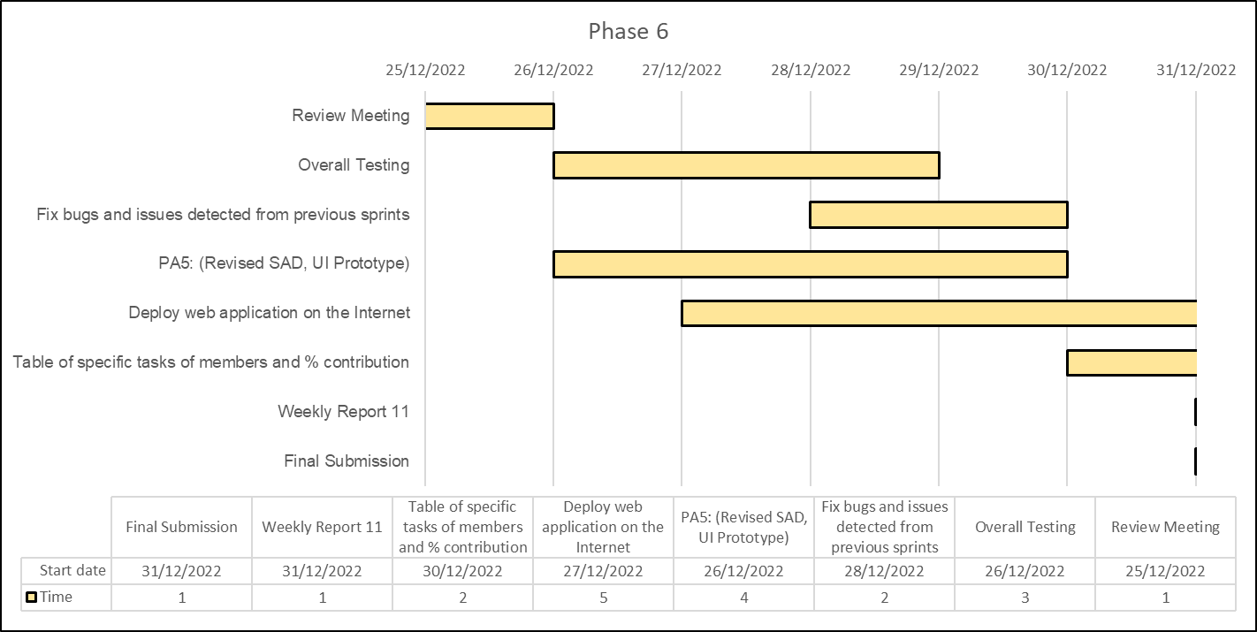

**+ Output**: PA5 ,Assignment sheet , Fix bug, Final version of product

## Project Monitoring and Control

### Requirements Management

The requirements for this system are captured in the Vision document. Requested changes to requirements are captured in Change Requests, and are approved as part of the Configuration Management process.

### Reporting and Measurement

Updated cost and schedule estimates, and metrics summary reports, will be generated at the end of each iteration.

The Minimal Set of Metrics, as described in the RUP Guidelines: Metrics, will be gathered on a weekly basis. These include:

Earned value for completed tasks. This is used to re-estimate the schedule and budget for the remainder of the project, and/or to identify need for scope changes.

Total defects open and closed – shown as a trend graph. This is used to help estimate the effort remaining to correct defects.

Acceptance test cases passing – shown as a trend graph. This is used to demonstrate progress to stakeholders.

In addition, overall costs will be monitored against the project budget.

### Risk Management

Risks will be identified in the Inception Phase using the steps identified in the RUP for Small Projects activity “Identify and Assess Risks”. Project risk is evaluated at least once per iteration and documented in this table. The risks of the greatest magnitude are listed first in the table.

| **Risk Ranking (High, Medium, Low)** | **Risk Description and Impact** | **Mitigation Strategy and/or Contingency Plan** |
| --- | --- | --- |
| High | Not knowing about the software process leads to the deadline delay. | Read the PAs in advance and ask the supervisor |
| High | Little knowledge of ReactJS and no knowledge of the backend leads to not knowing how to program and affect the project. | Learning from other groups or group members can help each other learn. Dividing the work into small pieces logically, so that the amount of knowledge each person has to learn during the project will be significantly less.  Finding subject material. |
| High | The pressure of other courses' projects. The team members have to do several projects at the same time. So that they are under a lot of stress and may not have enough time and miss the deadline. | Make a good plan, effective time management to increase productivity, reduce the stress level and make the work more easy. |
| Medium | Members could confront the difficulty of grasping each other. So, they may misunderstand the problem. | Frequently team meetings to improve team communication. |
| Medium | The difference between the abilities of each team member. One person may not catch up with others. Because of that they’re not completing their work. | United we stand, divided we fall. So, the members who have good performance should help the worse ones. However, the worse ones have to make an effort to catch up with the project process and shouldn’t rely too much on others' help. |
| Low | Members may drop out of the course leading to a manpower shortage. | Make sure all members understand each other's work. So when one member drops out of the course the others can know what to do. |

### Configuration Management

None