EFOOD

Use-Case Specification

Version <1.2>

*[Note: The following template is provided for use with the Rational Unified Process. Text enclosed in square brackets and displayed in blue italics (style=InfoBlue) is included to provide guidance to the author and should be deleted before publishing the document. A paragraph entered following this style will automatically be set to normal (style=Body Text).]*

*[To customize auto*

*matic fields in Microsoft Word (which display a gray background when selected), select File>Properties and replace the Title, Subject and Company fields with the appropriate information for this document. After closing the dialog, automatic fields may be updated throughout the document by selecting Edit>Select All (or Ctrl-A) and pressing F9, or simply click on the field and press F9. This must be done separately for Headers and Footers. Alt-F9 will toggle between displaying the field names and the field contents. See Word help for more information on working with fields.]*

Revision History

| **Date** | **Version** | **Description** | **Author** |
| --- | --- | --- | --- |
| 17/11/2022 | 1.0 | Write Use case specifications | Trần Dũng Tiến  Trần Bảo Long  Trần Anh Khôi  Đinh Cao Hồng Phước |
| 23/11/2022 | 1.1 | Draw Use case model | Trần Dũng Tiến |
| 25/11/2022 | 1.2 | Fix Use case model | Đinh Cao Hồng Phước |

Table of Contents

**Table of Contents**

***1. Use-case Model 3***

***2. Use-case Specifications 3***

**2.1.** **Register 3**

**2.2** **Log in 3**

**2.3** **Log out 4**

**2.4** **Change password 4**

**2.5** **Orders 5**

**2.6** **Feedback 5**

**2.7** **User profile edit 5**

**2.8** **View User Profile 6**

**2.9** **View products 6**

**2.10** **View history payment 7**

**2.11** **Search 7**

**2.12** **Filter 8**

**2.13** **View orders ( for admin ) 8**

**2.14** Register, Login, Logout, View orders, View income **8**

**2.15** **Edit users role (for admin) 9**

**2.16** **Delete Users (for admin) 9**

**2.17** **View Cart 10**

**2.18** **Add to cart 10**

**2.19** **Delete from cart 10**

**2.20** **View income (for admin) 11**

**2.21** **View products list (for admin) 11**

**2.22** **Add products (for admin) 11**

**2.23** **Edit products (for admin) 12**

**2.24** **Delete products (for admin) 13**

# Use-case Model

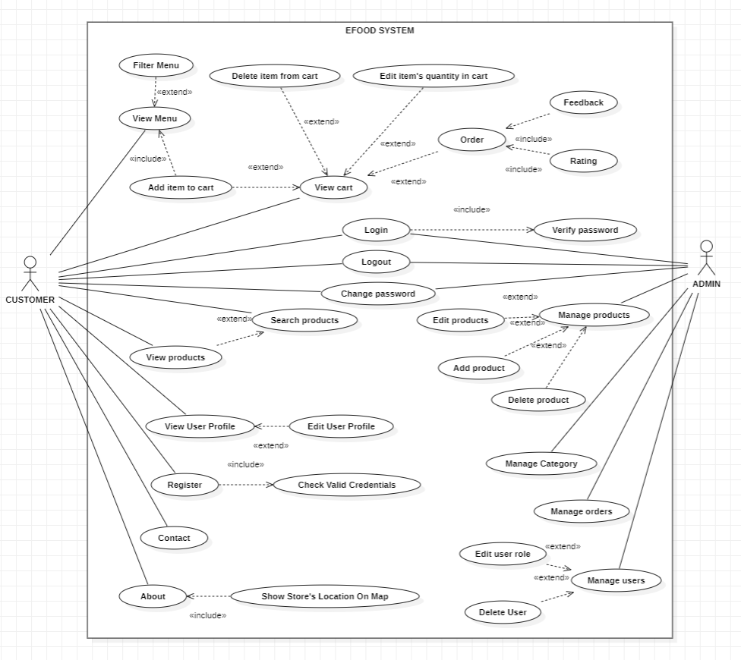

# Use-case Specifications

* 1. **Register**

| **Use Case ID** | **U01** |
| --- | --- |
| **Use Case Name** | Register |
| **Brief Descriptions** | Users can create an account to be booking dishes on the website. |
| **Actors** | Customer |
| **Pre-conditions** | Users have an account gmail |
| **Post-conditions** | The account is registered |
| **Main flow** | 1. Users access the website 2. Choose the register feature 3. Enter the user’s gmail and password into the form 4. After that, the user clicks on the sign-up 5. Notification register complete |
| **Alternative flow** | If the gmail account does not exist or the password is wrong, alert to error. |
| **Non- functional Constraints** | 1. The gmail account must be corrected 2. When users re-enter passwords, it must be similar. 3. The page must be loaded within 10 seconds. |

* 1. **Log in**

| **Use Case ID** | **U02** |
| --- | --- |
| **Use Case Name** | Login |
| **Brief Descriptions** | Users can login to the website with a client role or an admin role. |
| **Actors** | Customer, Admin |
| **Pre-conditions** | Users have an account which is registered |
| **Post-conditions** | Display the UI website is logged in |
| **Main flow** | 1. Users access the website 2. Choose the login feature 3. Enter the user’s gmail and password into the form 4. After that, the user clicks on the sign-in 5. The UI website is displayed 6. Users can use the features on the website |
| **Alternative flow** | At step 3, if the user hasn't an account, you will click on sign up to register the account.  At step 4, If the user forgot password, you will click on forgot password to change your password |
| **Non- functional Constraints** | 1. The user must to enter gmail and password, if not, show error under input 2. The user must to have an account on the web, if not, show notification 3. The page must be loaded within 10 seconds. |

* 1. **Log out**

| **Use Case ID** | **U03** |
| --- | --- |
| **Use Case Name** | Logout |
| **Brief Descriptions** | User can log-out the account |
| **Actors** | Customer, Admin |
| **Pre-conditions** | Users is logged in |
| **Post-conditions** | Show the UI website haven’t use the account |
| **Main flow** | 1. The user clicks on icon profile 2. Menu option is shown 3. The user chooses the option logout 4. After choosing, the website will display in the interface default. |
| **Alternative flow** | None |
| **Non- functional Constraints** | 1. The user must to be logged in 2. The page must be loaded within 10 seconds. |

* 1. **Change password**

| **Use Case ID** | **U04** |
| --- | --- |
| **Use Case Name** | Change password |
| **Brief Descriptions** | Users can change password to update security |
| **Actors** | Customer, Admin |
| **Pre-conditions** | Users have to log in first |
| **Post-conditions** | Password is changed and updated after that |
| **Main flow** | 1. Users access the website by logging in 2. The user clicks the avatar symbol in the right corner of the navigation bar. 3. User choose change password tab 4. The change password tab is displayed after that. 5. The user have to input current password, new password and input new password again 6. After inputting, user click save button 7. Save button displays successful mode |
| **Alternative flow** | If user input new password too short or same as current password, or enter again wrong new password, the system notice errors |
| **Non- functional Constraints** | The page must be loaded within 10 seconds. |

* 1. **Orders**

| **Use Case ID** | **U05** |
| --- | --- |
| **Use Case Name** | Order food |
| **Brief Descriptions** | Customer can choose their favorite dishes and order |
| **Actors** | Customer |
| **Pre-conditions** | Users have to log in first |
| **Post-conditions** | Choose dishes and order them immediately after |
| **Main flow** | 1. Users logged into the website 2. The user clicks on the Menu in the navigation bar 3. Move the cursor to the desired dish and click the cart icon 4. Place your order by clicking the cart icon in the right corner of the navigation bar 5. Enter address 6. Click the Order button |
| **Alternative flow** | In step 5, if the customer does not enter enough information, the system show notice detail errors |
| **Non- functional**  **Constraints** | The page must be loaded within 3 seconds. |

* 1. **Feedback**

| **Use Case ID** | **U06** |
| --- | --- |
| **Use Case Name** | Feedback |
| **Brief Descriptions** | Customer can leave a review after using the dish |
| **Actors** | Customer |
| **Pre-conditions** | Customers have ordered the previous successful food |
| **Post-conditions** | Customers can leave comments about the service or food and rating |
| **Main flow** | 1. Users logged into the website 2. The user clicks on the Menu in the navigation bar 3. Move the cursor to the desired dish and click the cart icon 4. Place your order by clicking the cart icon in the right corner of the navigation bar 5. Enter address 6. Click the Order button 7. After confirming the successful delivery, the survey panel will appear, users can leave a review or click on the x in the right corner of the window to skip 8. If feedback is complete click the confirm button to finish |
| **Alternative flow** | if step 7, If the user does not enter the information but click confirm instead of the x to ignore, the system show notice detail errors |
| **Non- functional**  **Constraints** | The page must be loaded within 8 seconds. |

* 1. **View and update User Profile**

| **Use Case ID** | **U08** |
| --- | --- |
| **Use Case Name** | View User Profile |
| **Brief Descriptions** | Users can view their informations |
| **Actors** | Customer, Admin |
| **Pre-conditions** | Users have to log in first |
| **Post-conditions** | View, edit and update user’s information |
| **Main flow** | 1. Users access the website by logging in 2. The user clicks the avatar symbol in the right corner of the navigation bar. 3. The user profile displays after that. 4. The user can see their information on that and be able to change their information with valid data inputted. 5. After updating, user click save button 6. Save button displays successful mode |
| **Alternative flow** | If input invalid value, system show notice detail errors |
| **Non- functional Constraints** | The page must be loaded within 5 seconds. |

* 1. **View products**

| **Use Case ID** | **U09** |
| --- | --- |
| **Use Case Name** | View products |
| **Brief Descriptions** | User can view their view products |
| **Actors** | Admin, Customer |
| **Pre-conditions** | Users have to log in first |
| **Post-conditions** | The list of food item is displayed |
| **Main flow** | 1. Users access the website by logging in 2. The user clicks the Menu in the navigation bar. 3. Move the mouse pointer to the product to view |
| **Alternative flow** | none |
| **Non- functional**  **Constraints** | The page must be loaded within 3 seconds. |

* 1. **View history payment**

| **Use Case ID** | **U10** |
| --- | --- |
| **Use Case Name** | View history payment |
| **Brief Descriptions** | Users can view their history payment |
| **Actors** | Customer, Admin |
| **Pre-conditions** | Users have to log in first |
| **Post-conditions** | The list of payment history is displayed |
| **Main flow** | 1. Users access the website by logging in 2. The user clicks the avatar symbol in the right corner of the navigation bar. 3. User choose payment history tab 4. The payment history tab is displayed after that. 5. The user will see history tab with order number, method, list name of foods, quantities and total money 6. The user can scroll name list to see all dishes |
| **Alternative flow** | If there are no orders, the system notices no payment! |
| **Non- functional Constraints** | The page must be displayed within 3 seconds. |

* 1. **Search**

| **Use Case ID** | **U11** |
| --- | --- |
| **Use Case Name** | Search |
| **Brief Descriptions** | Users can search for products with corresponding keywords |
| **Actors** | Customer, Admin |
| **Pre-conditions** | None |
| **Post-conditions** | The information corresponding to the search “keyword” is displayed |
| **Main flow** | 1. Users access the website. 2. The user clicks the “search bar” in the navigation bar. 3. The user enters the product keyword. 4. The system responds to the corresponding product list. |
| **Alternative flow** | At step 3, if the user type invalid keyword (which does not exist): System returns message “The requested product could not be found” |
| **Non- functional Constraints** | The page must be loaded within 5 seconds. |

* 1. **Filter**

| **Use Case ID** | **U12** |
| --- | --- |
| **Use Case Name** | Filter |
| **Brief Descriptions** | Customers can filter food |
| **Actors** | Customer, Admin |
| **Pre-conditions** | Users have to log in first |
| **Post-conditions** | Food will be displayed by category |
| **Main flow** | 1. Admin accesses the website. 2. The user clicks the Menu in the navigation bar. 3. Users click on options filter |
| **Alternative flow** | none |
| **Non- functional**  **Constraints** | The page must be loaded within 3 seconds. |

* 1. **View orders ( for admin )**

| **Use Case ID** | **U13** |
| --- | --- |
| **Use Case Name** | View orders |
| **Brief Descriptions** | View the orders list |
| **Actors** | Admin |
| **Pre-conditions** | Admin account must exist and the admin successfully logged in. |
| **Post-conditions** | List information of orders |
| **Main flow** | 1. Admin accesses the website. 2. The admin logs in to the website by inputting email and password. 3. The system returns the admin panel page. 4. The admin selects the “Dashboard management” page. 5. The system displays a list of information about orders. |
| **Alternative flow** | At step 2, if the authorization process failed. Reinputting email and password. |
| **Non- functional Constraints** | 1. The page must be loaded within 10 seconds. 2. Sensitive data must be encrypted before being transmitted |

* 1. **View users ( for admin )**

| **Use Case ID** | **U14** |
| --- | --- |
| **Use Case Name** | View users |
| **Brief Descriptions** | View the users list |
| **Actors** | Admin |
| **Pre-conditions** | Admin account must exist and the admin successfully logged in. |
| **Post-conditions** | List information of users |
| **Main flow** | 1. Admin accesses the website. 2. The admin logs in to the website by inputting email and password. 3. The system returns the admin panel page. 4. The admin selects the “Users management” page. 5. The system returns a list of information of users. |
| **Alternative flow** | At step 2, if the authorization process failed. Reinputting email and password. |
| **Non- functional Constraints** | 1. The page must be loaded within 10 seconds. 2. Sensitive data must be encrypted before being transmitted. |

* 1. **Edit users role (for admin)**

| **Use Case ID** | **U15** |
| --- | --- |
| **Use Case Name** | Edit users role |
| **Brief Descriptions** | Edit the role for the user (admin, customer) |
| **Actors** | Admin |
| **Pre-conditions** | Admin account must exist and the admin successfully logged in. |
| **Post-conditions** | Admin successfully changed the role for one user. |
| **Main flow** | 1. Admin accesses the website. 2. The admin logs in to the website by inputting email and password. 3. The system return the admin panel page 4. The admin selects the “Users management” page. 5. The system returns a list of information of users. 6. Press the edit button corresponding to the user who wants to edit. 7. Choose a role for the user. 8. Press the save button. |
| **Alternative flow** | At step 2, if the authorization process failed. Reinputting email and password.  At step 7, if you don't want to change the role of the user, you can press the cancel button. |
| **Non- functional Constraints** | 1. The page must be loaded within 10 seconds. |

* 1. **Delete Users (for admin)**

| **Use Case ID** | **U16** |
| --- | --- |
| **Use Case Name** | Delete Users |
| **Brief Descriptions** | Choose a user who wants to delete an account. |
| **Actors** | Admin |
| **Pre-conditions** | Admin account must exist and the admin successfully logged in. |
| **Post-conditions** | Admin successfully deleted the user. |
| **Main flow** | 1. Admin accesses the website. 2. The admin logs in to the website by inputting email and password. 3. The system return the admin panel page 4. The admin selects the “Users management” page. 5. The system returns a list of information of users. 6. Press the delete button corresponding to the user who wants to delete. |
| **Alternative flow** | At step 2, if the authorization process failed. Reinputting email and password. |
| **Non- functional Constraints** | 1. The page must be loaded within 10 seconds. |

* 1. **View Cart**

| **Use Case ID** | **U17** |
| --- | --- |
| **Use Case Name** | View cart |
| **Brief Descriptions** | Allow customers to view the items they add to cart. |
| **Actors** | Customer |
| **Pre-conditions** | Customers have to login first. |
| **Post-conditions** | Display a list of items that the customer added to the cart. |
| **Main flow** | 1. Customers access the website. 2. Customer logins by their account. 3. Customer selects the items they want to buy and adds them to the cart. 4. Customer clicks on the cart icon on the navbar. 5. System displays a list of items that the customer added to the cart. |
| **Alternative flow** | At step 2, if the username or password is incorrect, the system notifies and requires customer logins again.  At step 4, if the cart has nothing and the customer clicks on the cart symbol, the system has to display a text or an icon for the customer to know that the cart is blank. |
| **Non- functional Constraints** | 1. The cart page must be loaded in under 10 seconds. 2. System has to save the state of the cart even if customers refresh the website. |

* 1. **Add to cart**

| **Use Case ID** | **U18** |
| --- | --- |
| **Use Case Name** | Add to cart |
| **Brief Descriptions** | Allow customers to add the item they want to buy to the cart. |
| **Actors** | Customer |
| **Pre-conditions** | Customers have to login first. |
| **Post-conditions** | Customers successfully added items. |
| **Main flow** | 1. Customers access the website. 2. Customer logins by their account. 3. Customer selects the item and quantity they want to buy. 4. Customers click on the “add to cart” button. 5. System notifies that the item has been successfully added. 6. The Items which customers added appear in the cart. |
| **Alternative flow** | At step 2, if the username or password is incorrect, the system notifies and requires customer logins again.  At step 3, customers can open their cart and increase item quantity by clicking on plus icon next to respective item.  At step 6, if the item is already in the cart, the quantity of it has to be added to the current quantity in the cart. |
| **Non- functional Constraints** | 1. Request and response time total is under 3s. 2. System has to save the state of the cart even if customers refresh the website. |

* 1. **Delete from cart**

| **Use Case ID** | **U19** |
| --- | --- |
| **Use Case Name** | Delete from cart |
| **Brief Descriptions** | Allow customers to delete the particular item from the cart. |
| **Actors** | Customer |
| **Pre-conditions** | 1. Customers have to login first. 2. There must be at least one item in the cart. |
| **Post-conditions** | Customers successfully deleted products. |
| **Main flow** | 1. Customers access the website. 2. Customer logins by their account. 3. Customer clicks on the cart icon on the navbar to view the cart. 4. Customer clicks on the delete button next to the item they want to delete. 5. A notification appears askes customer whether they want to delete the item. 6. If customer chooses “Yes”:    1. System notifies that the item has successfully been deleted.    2. Items have disappeared from the cart. 7. On contrary, if they choose “No”:    1. The notification disappears. |
| **Alternative flow** | At step 2, if the username or password is incorrect, the system notifies and requires customer logins again.  At step 4, customers can click on the minus icon next to a particular item to decrease the quantity of it. When the quantity is down to 0, the item disappears from the cart. |
| **Non- functional Constraints** | 1. Request and response time total is under 3s. 2. System has to save the state of the cart even if customers refresh the website. |

* 1. **View income (for admin)**

| **Use Case ID** | **U20** |
| --- | --- |
| **Use Case Name** | View income |
| **Brief Descriptions** | System views the income |
| **Actors** | Admin |
| **Pre-conditions** | Admin account must exist and the admin successfully logged in. |
| **Post-conditions** | The earnings received from selling products. |
| **Main flow** | 1. Admin accesses the website. 2. The admin logs in to the website by inputting email and password. 3. The system returns the admin panel page. 4. The admin selects the “Dashboard management” page. 5. The system displays the income under a list of information about orders. |
| **Alternative flow** | At step 2, if the username or password is incorrect, the system notifies and requires customer logins again. |
| **Non- functional Constraints** | 1. The page must be loaded within 10 seconds. |

* 1. **View products list (for admin)**

| **Use Case ID** | **U21** |
| --- | --- |
| **Use Case Name** | View products |
| **Brief Descriptions** | System views the products list |
| **Actors** | Admin |
| **Pre-conditions** | Admin account must exist and the admin successfully logged in. |
| **Post-conditions** | List information of products |
| **Main flow** | 1. Admin accesses the website. 2. The admin logs in to the website by inputting email and password. 3. The system returns the admin panel page. 4. The admin selects the “Products management” page. 5. The system returns a list of information of users. |
| **Alternative flow** | At step 2, if the data is invalid, System requires the admin to input again. |
| **Non- functional Constraints** | 1. The page must be loaded within 10 seconds. 2. Sensitive data must be encrypted before being transmitted. |

* 1. **Add products (for admin)**

| **Use Case ID** | **U22** |
| --- | --- |
| **Use Case Name** | Add products |
| **Brief Descriptions** | Admin add product. |
| **Actors** | Admin |
| **Pre-conditions** | Admin account must exist and the admin successfully logged in. |
| **Post-conditions** | Admin successfully added products. |
| **Main flow** | 1. Admin accesses the website. 2. The admin logs in to the website by inputting email and password. 3. The system return the admin panel page 4. The admin selects the “Product management” page. 5. The system returns a list of information about products. 6. Press the Add new button. 7. Admin input the product information. 8. Display the new product into the list of products. |
| **Alternative flow** | At step 2, if the data is invalid, System requires the admin to input again.  At step 7, if the data is invalid, the admin must input again. |
| **Non- functional Constraints** | 1. Data is valid to respond to customers. 2. Request and response time total is under 5s. |

* 1. **Edit products (for admin)**

| **Use Case ID** | **U23** |
| --- | --- |
| **Use Case Name** | Edit products |
| **Brief Descriptions** | Admin edit products |
| **Actors** | Admin |
| **Pre-conditions** | Admin account must exist and the admin successfully logged in. |
| **Post-conditions** | Admin successfully edited products. |
| **Main flow** | 1. Admin accesses the website. 2. The admin logs in to the website by inputting email and password. 3. The system return the admin panel page 4. The admin selects the “Product management” page. 5. The system returns a list of information about products. 6. Press the edit button at a specific product. 7. Admin edit the product information. 8. Press the save button to save the edited information. 9. Display the edited product into the list of products. |
| **Alternative flow** | At step 2, if the data is invalid, System requires the admin to input again.  At step 7, if the data is invalid, the admin must input again. |
| **Non- functional Constraints** | 1. Data is valid to respond to customers. 2. Request and response time total is under 5s. |

* 1. **Delete products (for admin)**

| **Use Case ID** | **U24** |
| --- | --- |
| **Use Case Name** | Delete products |
| **Brief Descriptions** | Admin delete products. |
| **Actors** | Admin |
| **Pre-conditions** | Admin account must exist and the admin successfully logged in. |
| **Post-conditions** | Admin successfully deleted products. |
| **Main flow** | 1. Admin accesses the website. 2. The admin logs in to the website by inputting email and password. 3. The system return the admin panel page 4. The admin selects the “Product management” page. 5. The system returns a list of information about products. 6. Press the delete button at a specific product. 7. Display the list of products without the deleted product. |
| **Alternative flow** | At step 2, if the data is invalid, System requires the admin to input again. |
| **Non- functional Constraints** | 1. Data is valid to respond to customers. 2. Request and response time total is under 5s. |