Quote Data vs. Exposure & Loss Ratios - 3 years look back

2023-04-21

# Intro

It has been over three years since we started collecting data from prospective clients. We conducted two separate studies to compare the distributions of quote and book data for the periods of 2020-2022 and 2022-2023. It would be more helpful to examine the Exposure and Loss Ratio Relativity, along with the trends in Sold/Unsold quotes by variable and its categories, and observe how they have changed over time. Therefore, this report has been created.

# Data

Quote data is from

* Auto_Adhoc.[QUOTES].[Auto_Quotes_Limits_PREprocessed]

Exposure & Loss data is from:

* Auto_Experience.dbo. OLEP_CALC_202212
* Auto_Experience.dbo.OLEP_CALC_CA_202212

To account for the possibility that the column names may differ between the tables, a table is provided that lists the column names from the three tables side-by-side in the Appendix section. The quote data between April 1, 2022, and March 31, 2023, is categorized as the "Current Year." The exposure and loss data for the year 2022 are also considered part of the "Current Year." On the other hand, the quote records that occurred before April 1, 2022, and the exposure and loss data for the years 2020 and 2021 combined are classified as the "Previous 2 Years."

# Navigation

35 variables studied are placed into 4 sections:

* Variables rated as policy level
* Limit & Deductible options
* Variables rated as vehicle level
* Variables in Quote data but has no Exposure & Loss Ratio data

Since there are numerous graphs under Graphs section, it’s recommended using the Navigation pane to quickly move to the rating variable that you are most interested in. To turn on the Navigation pane, you need to go to View tab from the Ribbon and check the box Navigation Pane under Show section (refer to screenshot below). Once it is selected, the Navigation pane will show up on the left side of the screen.

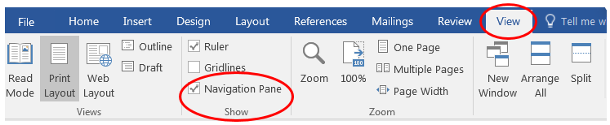

Graph structure explanation:

We used bar, point and line charts depicted all in one graph to tell more stories.

For quote data, beside showing the comparison for CA and non-CA states combined, we also displayed the graphs for 18 individual states side by side to see if there were similar patterns. The bars show the frequency distribution of the categories in the variable. The sum of the heights of all the bars of the same color is equal to 1. The addition of point and line for cumulative percentage is helpful to immediately see if the distributions of the compared objects are similar or different; when they are the same or similar, the lines are close or on top of each other. For Exposure & Loss Ratio graphs, we showed the comparison for CA & non-CA GW states combined for 4 main coverages: BI, PD, Comp & Coll. The bars indicate the exposure while point and lines indicate the loss ratio.

On these graphs, there are 2 y axes, the left one is for bar chart and the right is for point and line charts. Chart legends & color coding are also briefly explained at the right bottom of each graph.

For each variable, graphs are displayed on 4 pages:

* the 1st & 2nd page show the distributions of Quote data, Exposure & Loss Ratio for CA & CW, respectively.
* the 3rd & 4th page show the distributions of Quote data for 18 GW states.

In the graphs displaying the quote data distribution, we included most, if not all, of the variable's options or categories. However, for the Exposure and LR graphs, we removed a few categories with small exposures as they have the tendency to cause significant fluctuations in the LR.

# Analysis

We are comparing Loss Ratio (LR) & Loss Ratio Relativity (LR Rel.) under the 2 assumptions: we will have the same loss we experienced as in the 2 years prior the current year or as in current year.

* **Average Loss Ratio**: When our future loss assumption shifts from the former to the latter we observe the following trends:
  + For CA, average LR slightly decreased for BI & Comp, slightly increased for PD and increased from 0.5 to 0.68 for Coll.
  + For CW, average LR slightly decreased for BI, slightly increased for PD & Comp and significantly increased for Coll (from 0.38 to 0.69).
* **Number of Rated Drivers**: Based on the Quote Data, we have observed a higher number of policies sold with 1 rated driver in all states over the past three years. However, in our book, we have a larger exposure for policies with 2 rated drivers. In the case of CA, if we experience the same losses in the current year instead of the losses from the previous two years, we will see improvements in pricing for the category of 5+ drivers for BI coverage. Specifically, we will be offering a very competitive price with a Loss Ratio Relativity (LR Rel.) of 0.6, compared to being very underpriced with a relativity of 1.5. However, we will be underpricing the 5+_rated-drivers category for Coll coverage. In the case of CW, if we also assume that we will experience the same losses in the current year instead of the losses from the previous two years, we will indeed see improvements in pricing. Specifically: For BI and Comp coverage, we will observe pricing improvements in the categories of 4 and 5+ drivers. In the categories of 3 and 5+ drivers for PD coverage, our pricing will also improve. However, despite these improvements, we will still be underpricing the 4-driver group for PD coverage. Additionally, the 5+ driver group for Coll coverage will be even more underpriced with a rel. of 1.4, compared to the previous rel. of 1.3.
* **Number of Rated Vehicles**: We have experienced an increase in the number of policies sold with 1 rated vehicle, and this trend has remained consistent over the past three years in both CA and CW. When comparing CA and CW, the proportion of policies sold with 1 vehicle is smaller in CA, while the proportion of policies sold with 2 vehicles is larger in CA compared to CW. Regarding the LR Rel. for BI in CA, in the category of 5+ vehicles, the relativity will be 1.5 instead of 1.1 if our future loss is similar to the current year’s loss. The pricing is relatively stable across the categories of 1 and 2 rated vehicles, with relativity around 1, indicating that we are pricing them adequately. However, as the number of vehicles increases, we observe a trend of underpricing. For CW, if we were to have the same loss as the current year, the pricing across categories will be flatter, with the LR Rel. around 1. This indicates that the pricing would be more balanced and aligned with the expected losses. However, if we were to have the same loss as the previous two years, we would still have overpriced and underpriced categories, indicating inconsistencies in pricing across different vehicle categories.
* **BI Limit**: The distributions of BI limits remain relatively consistent throughout the years in both CA and CW, as observed in both quote and exposure data. Under either loss assumption, the LR Rel. shows minimal variation for both CA and CW, except in the case of the category 15/30 for CW. In this particular category, we are significantly underpricing in both assumptions, and the underpricing becomes even more pronounced if we experience the same loss as in the current year.
* **Annual Mileage**: In both CA & CW, the LR Rel. exhibits fluctuations within the range of 0.8 to 1.1 across the categories and coverages when switching from one loss assumption to another. Certain categories have wider ranges of variation, particularly in CA, such as the 3000, 60000, and 20000 groups in BI, the 19000 group in PD, Comp, and Coll, as well as the 1000 and 14000 groups in Comp. Similarly, for CW, notable ranges can be observed in the following groups: 6000 and 17000+ in BI, and 19000 in PD, Comp, and Coll.
* **Vehicle Make**: The distributions between the current year and the previous two years do not vary significantly, and this observation holds true for both CA and CW. It is important to note that we are presenting the distributions for the top 19 most popular vehicle makes based on their presence in the data. The remaining makes are grouped together under the "OTHER" category. Among the different makes, Toyota, Honda, Ford, and Chevrolet are the most popular types in CA, representing approximately 20%, 15%, 10%, and 8% respectively of all vehicles. In CW, these four makes continue to be the most popular, with similar proportions for Dodge and Chevrolet compared to CA. However, the proportions for Toyota and Honda are slightly lower at 15% and 12% respectively.

# Conclusion

xyz

# Graphs: policy-level variables

### Number of Rated Drivers

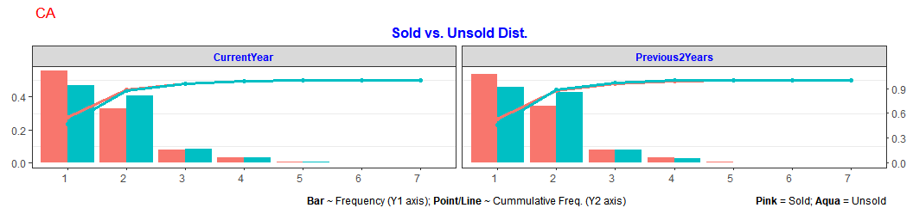

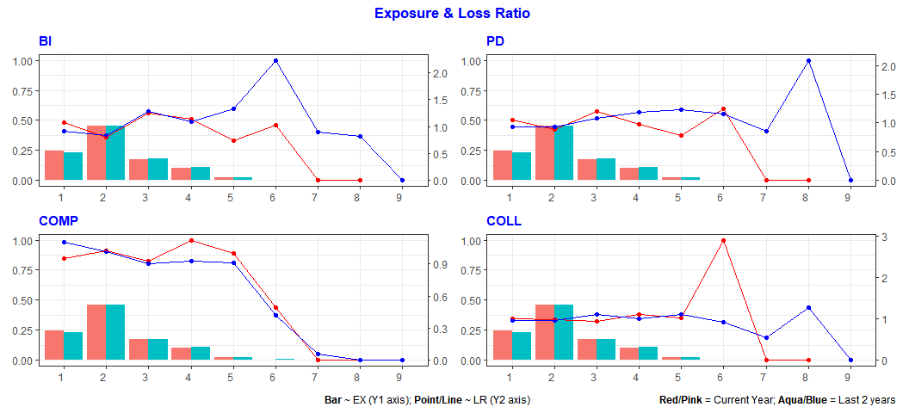

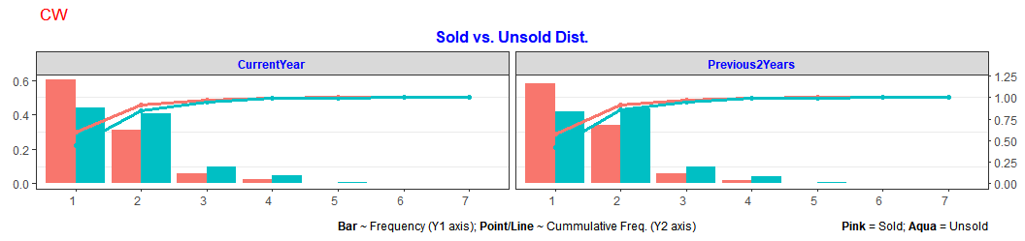

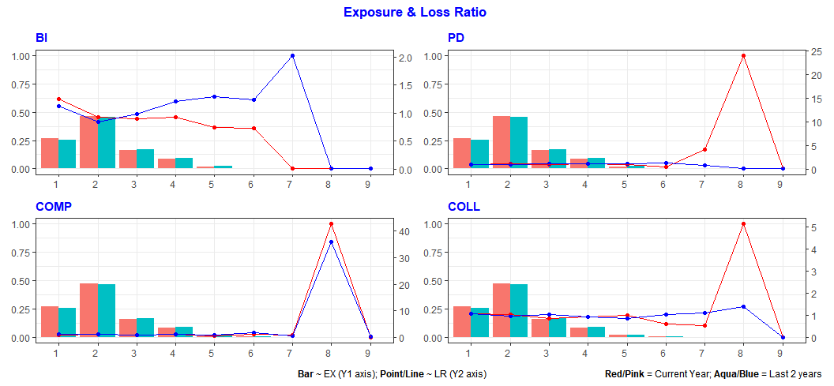

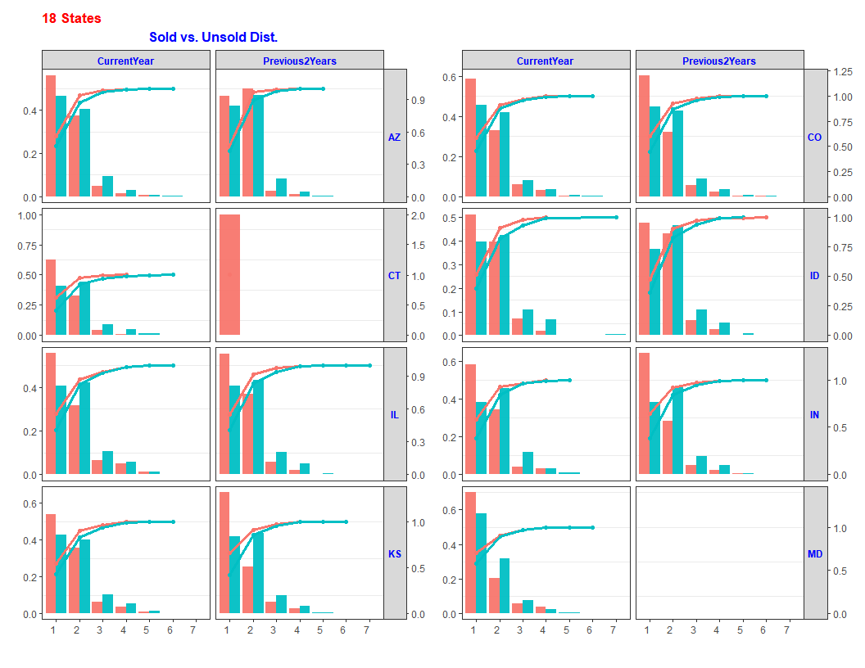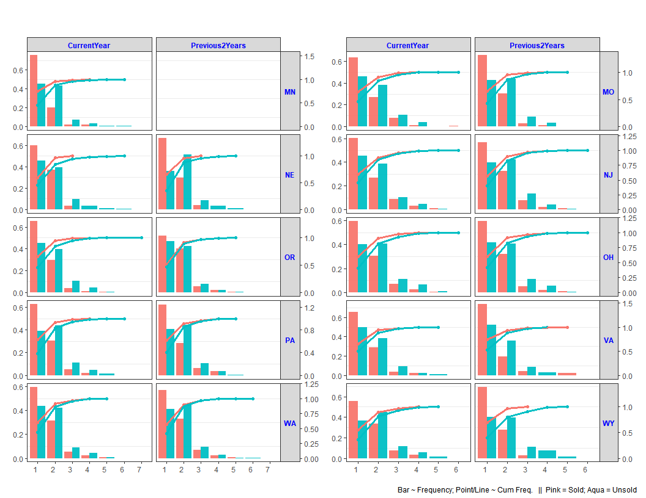

## Number Of Rated Vehicles

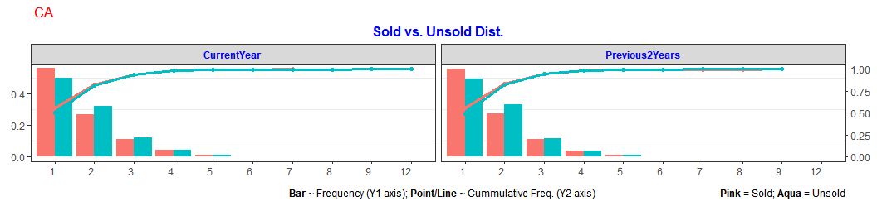

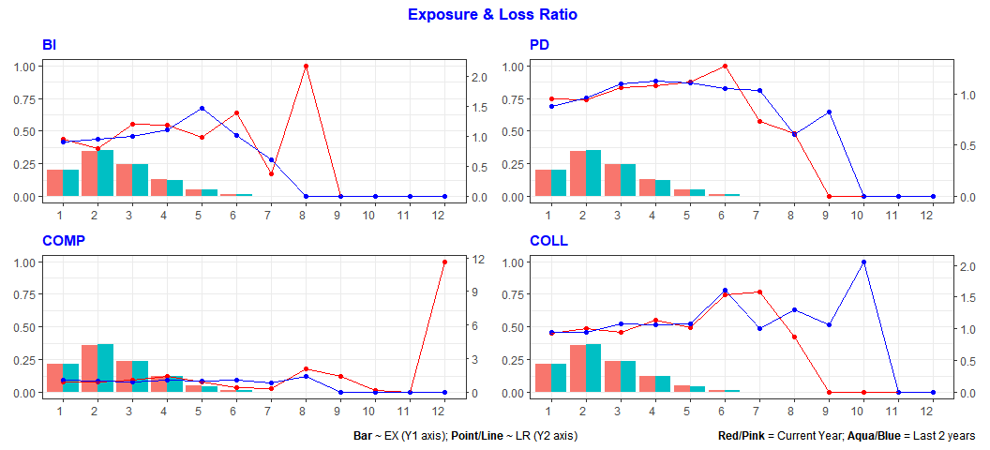

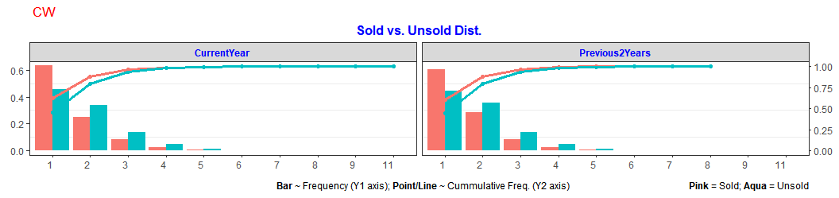

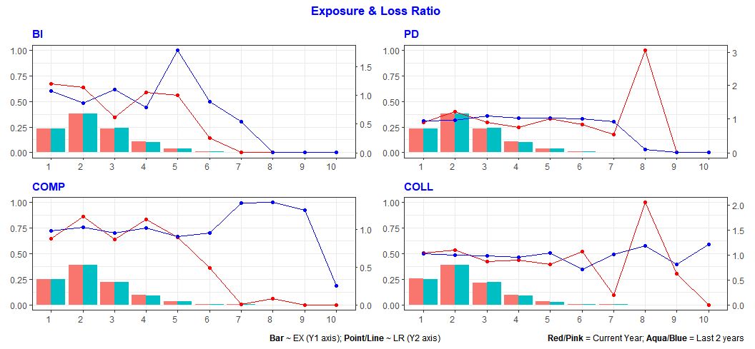

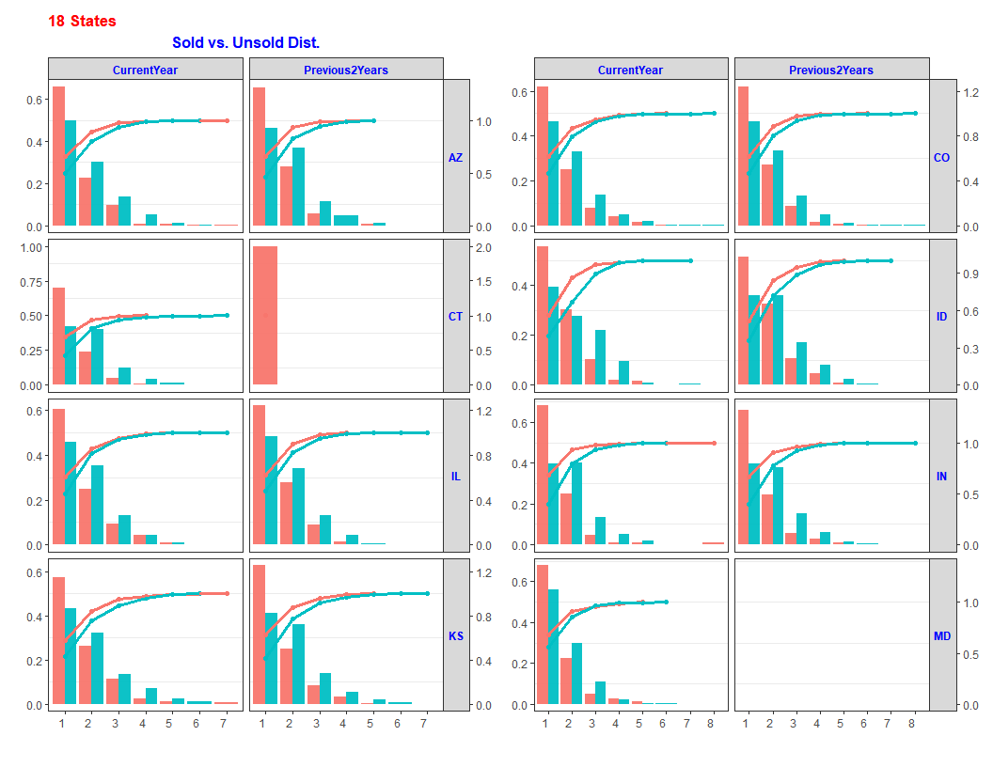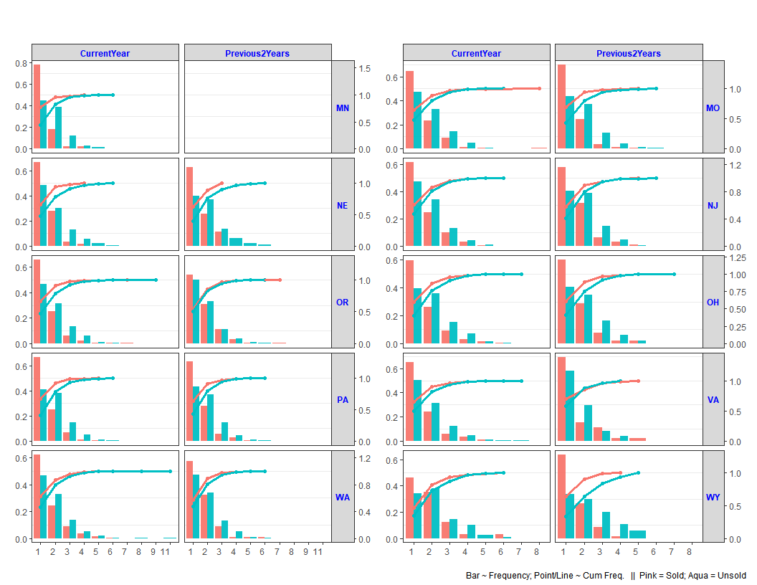

# Graphs: Coverage Limit/Deductible

## BI Limit

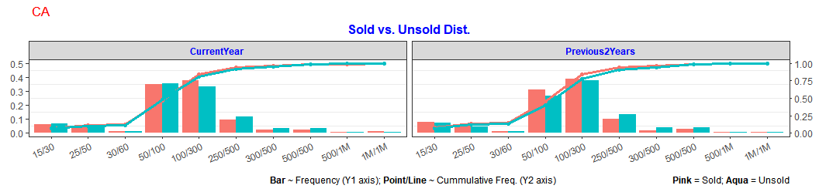

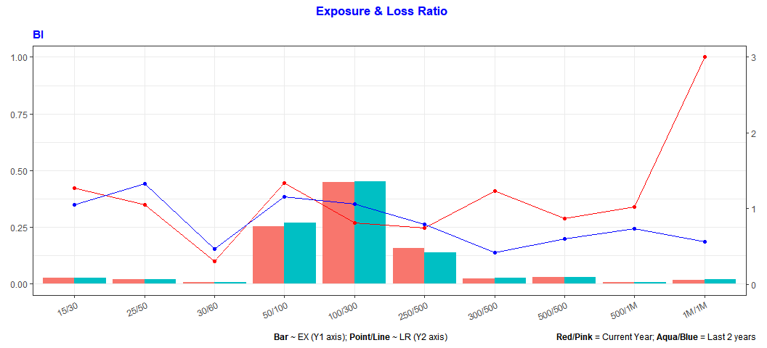

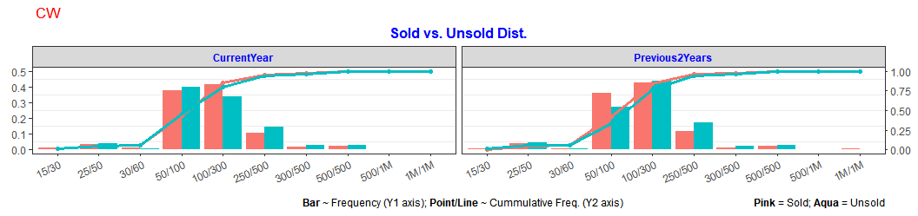

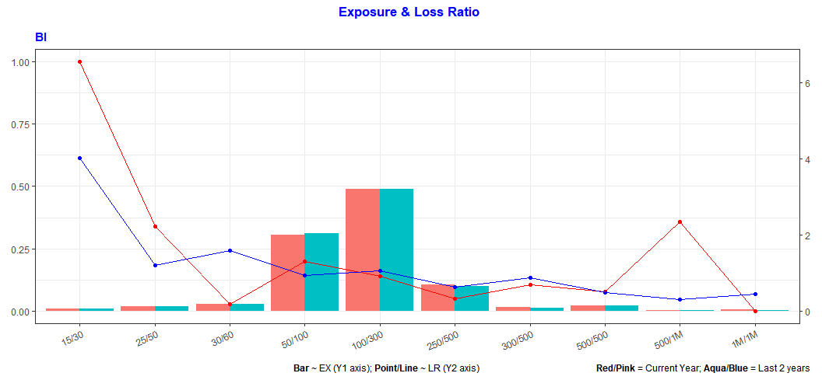

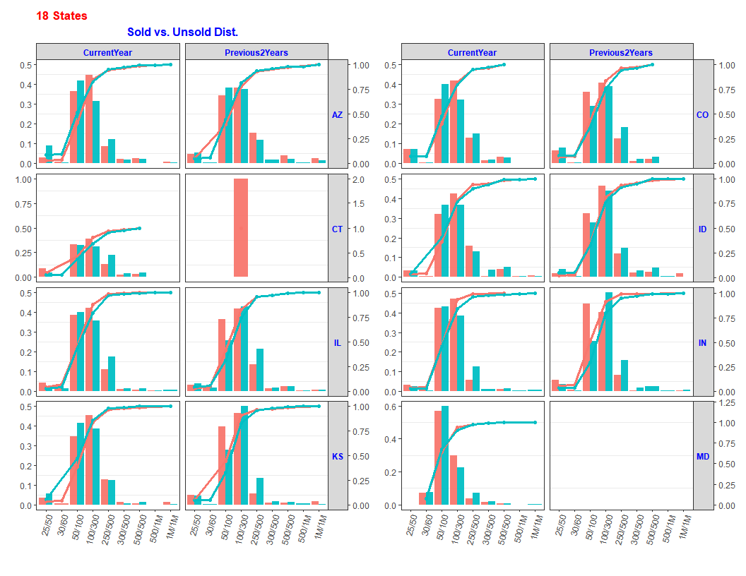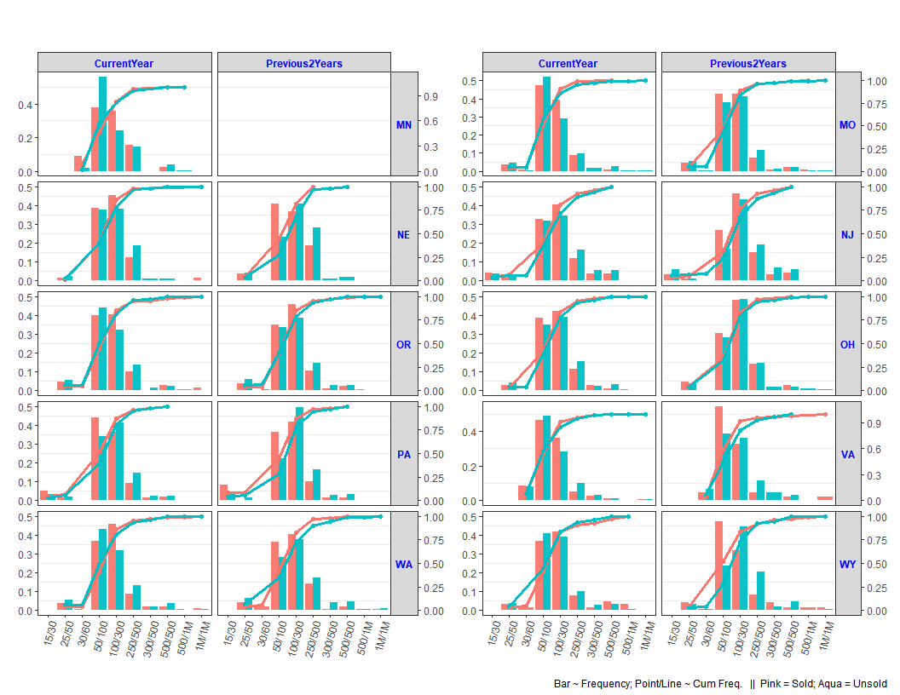

# Graphs: vehicle-level variables

## Annual Mileage

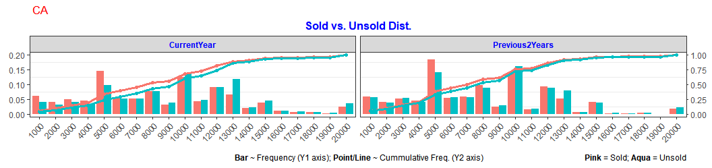

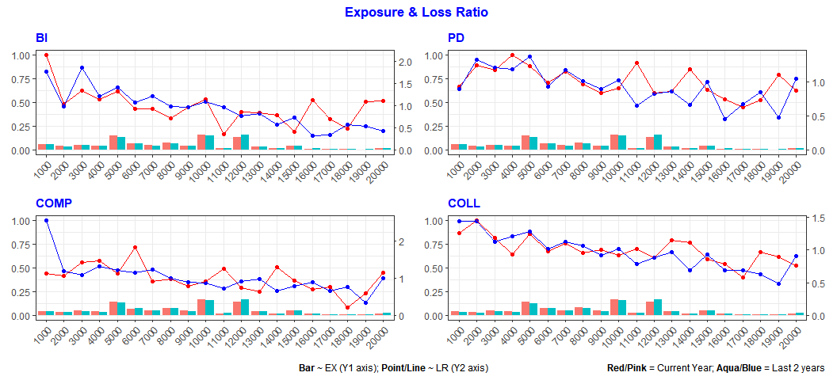

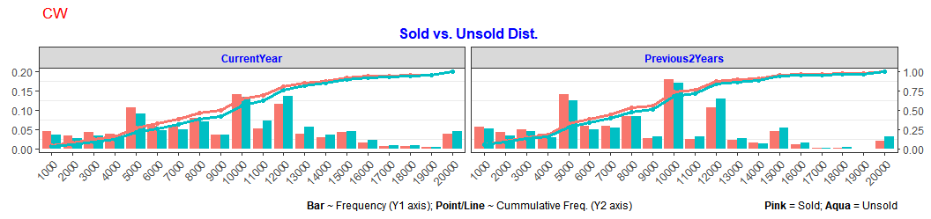

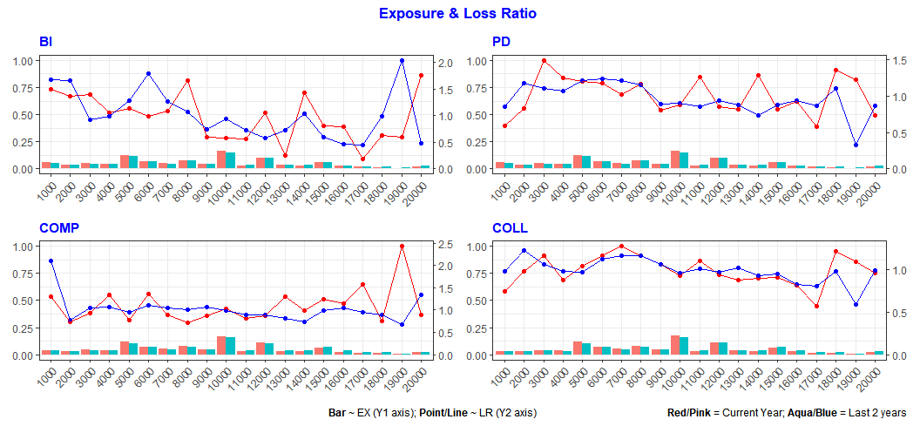

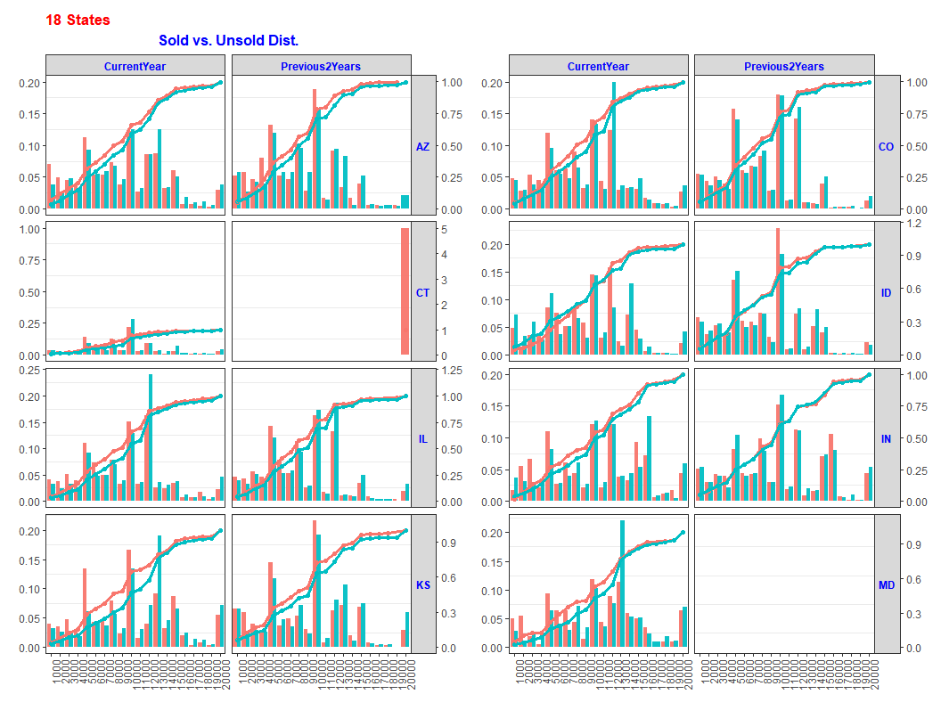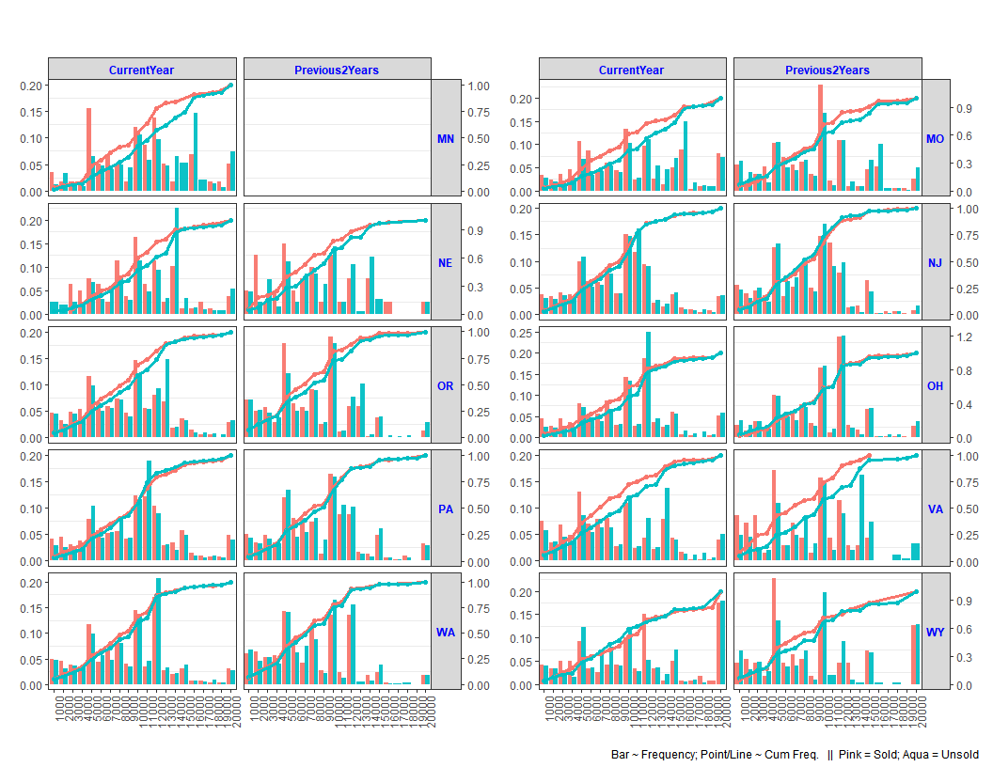

# Appendix

| **Var Names in R report** | **Quote DB columns** | **OLEP columns** | **OLEP CA columns** | **Data Transformation /Notes** |
| --- | --- | --- | --- | --- |
| ***--#Policy level*** |  |  |  |  |
| Number_Of_Rater_Drivers | NO_OF_RATED_DRIVER | NBR_OF_DRIVERS | RTNG_NBR_OF_DRIVERS |  |
| Number_Of_Rated_Vehicles | NO_OF_RATED_VEHICLES | NBR_VEHICLES | RTNG_NBR_VEHICLES | removed records where # of Vehicles = 0 (quote & olep), NA (olep), >12 (CA olep) before graphing |
|  |  |  |  |  |
| ***--#Vehicle level*** |  |  |  |  |
| Annual_Mileage | ANNUAL_MILEAGE | ANNUAL_MILES | ANNUAL_MILES | AM is capped to 20,000, including 50000Plus (OLEP) & 50000+ (Quote) |
|  |  |  |  |  |
| ***--#Coverage Limit/Deductible*** | |  |  |  |
| BI_Limit | BI_LIMIT | COVERAGE_LIMIT | COVERAGE_LIMIT |  |
|  |  |  |  |  |
| ***--#Variables that show quote data only*** | |  |  |  |
| LN_Current_Carrier | rtrim(LTRIM(carrier1)) | n/a | n/a |  |
| Vehicle_Make | VEH_MAKE | n/a | n/a |  |
|  |  |  |  |  |
| ***--#Variables may be used in future*** | |  |  |  |
| LapseLevel | NO_LAPSE_OF_COVG | n/a | n/a |  |
| Pol_Has_Excess_Vehicle | EXCESS_VEHICLE | EXCESS_VEH_IND | EXCESS_VEH_IND |  |
| Rated_Driver_Age | RATED_DRV_AGE | DRIVER_AGE_OPRT | DRIVER_AGE_OPRT |  |
| Rated_Marital_Status | RATED_MARITAL_ST | MARITAL_STATUS | MARITAL_STATUS |  |
| ISO_Symbol | ISO_SYMBOL | SYMBOL | SYMBOL |  |
| PI_PD_Symbol | BI_PD_SYMBOL | BI_PD_LIA_SYM | BI_PD_LIA_SYM |  |
| PIP_MED_Symbol | PIP_MP_SYMBOL | PIP_MED_PMT_SYM | PIP_MED_PMT_SYM |  |
| COMP_Symbol | CMP_SYMBOL | COMP_SYMBOL | COMP_SYMBOL |  |
| COLL_Symbol | COL_SYMBOL | COLL_SYMBOL | COLL_SYMBOL |  |
| Current_Carrier_Input | rtrim(LTRIM(PRIOR_POL_NAME)) | n/a | n/a |  |
| MLG_CUST_OVERRIDE | MLG_CUST_OVERRIDE | n/a | n/a |  |
| Loyalty_Years | LOYALTY_YEARS | LOYALTY_YEARS | n/a |  |
|  |  |  |  |  |
| ***--#Other Variables used for programming*** | |  |  |  |
| UNIT | UNIT_NO_FOR_AUTO | do not need | do not need | set UNIT=1 to get row counts for Variables at Policy level. There are 46 AUTO_POLICY_NBR whose minimum UNIT_NO_FOR_AUTO <> 1. Since this is minimal, we don't reconcile it. |
| PC_CREATETIME | PC_CREATETIME | do not need | do not need | records created after |
|  |  |  |  |  |
| ***--#Variables that are more state specific, thus not included*** | | |  |  |
|  | COV_OPTION |  |  |  |
|  | INSURED_OPTION |  |  |  |
|  | NJ_EXT_MED_LIMIT |  |  |  |
|  | PIP_MED_OPTION |  |  |  |
|  | UMB_LSMPROV_STACKED | |  |  |
|  | PIPOTH_DED |  |  |  |
|  | DEDUCT |  |  |  |
|  | WORK_LOSS_INCLUDED |  |  |  |