**Breakdown of the query**

1. Quick view of data

select * from warehouse

order by event_type, event_datetime;

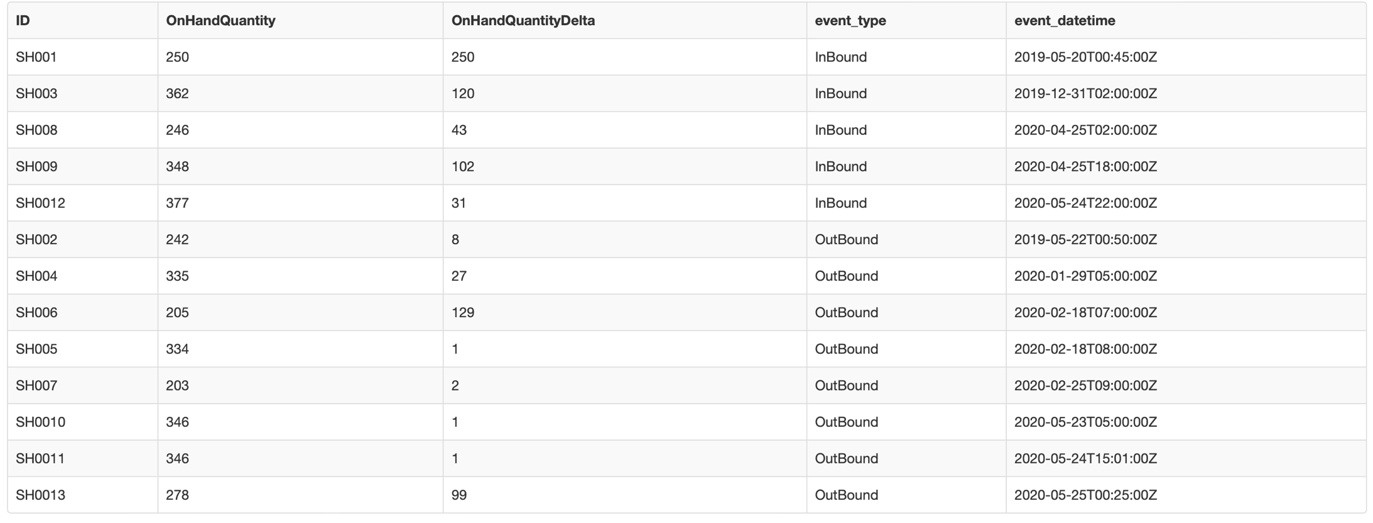

1. Calculate total sold items

declare @totalSales as varchar(1000)

set @totalSales = (select sum(onhandquantitydelta) from warehouse

where event_type = 'OutBound');

select @totalSales;



1. Show the inventory count by date (result of the inner query of the cte)

declare @currentdate as date

set @currentdate = '2020-05-25'; (this date is to be replaced by future date)

select *

,datediff(day, convert(DATE,event_datetime),@currentdate) as days_inventory_stay_in_wh

,grp = case

when datediff(day, convert(DATE,event_datetime),@currentdate) <= 90 then 'a_0-90 days old'

when datediff(day, convert(DATE,event_datetime),@currentdate) <= 180 then 'b_91-180 days old'

when datediff(day, convert(DATE,event_datetime),@currentdate) <= 270 then 'c_181-270 days old'

else 'd_271+ days old' end

from warehouse

where event_type = 'InBound'

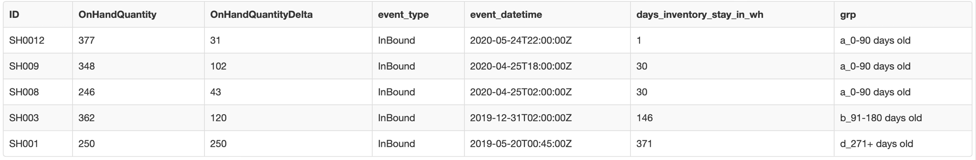

1. Show the inventory by period, add columns for the cumulative inventory, inventory from previous and next immediate period for to calculate the remaining inventory in the next step

declare @currentdate as date

set @currentdate = '2020-05-25';

with inventory_tbl_cte as (

select grp, sum(onhandquantitydelta) as inbound

from (

select *

, grp = case

when datediff(day, convert(DATE,event_datetime),@currentdate) <= 90 then 'a_0-90 days old'

when datediff(day, convert(DATE,event_datetime),@currentdate) <= 180 then 'b_91-180 days old'

when datediff(day, convert(DATE,event_datetime),@currentdate) <= 270 then 'c_181-270 days old'

else 'd_271+ days old' end

from warehouse

where event_type = 'InBound'

) a

group by grp)

select *

,lag(inbound) over (order by grp desc) lag

,lead(inbound) over (order by grp desc) lead

,sum(inbound) over (order by grp desc ROWS BETWEEN UNBOUNDED PRECEDING AND CURRENT ROW) cum

from inventory_tbl_cte;

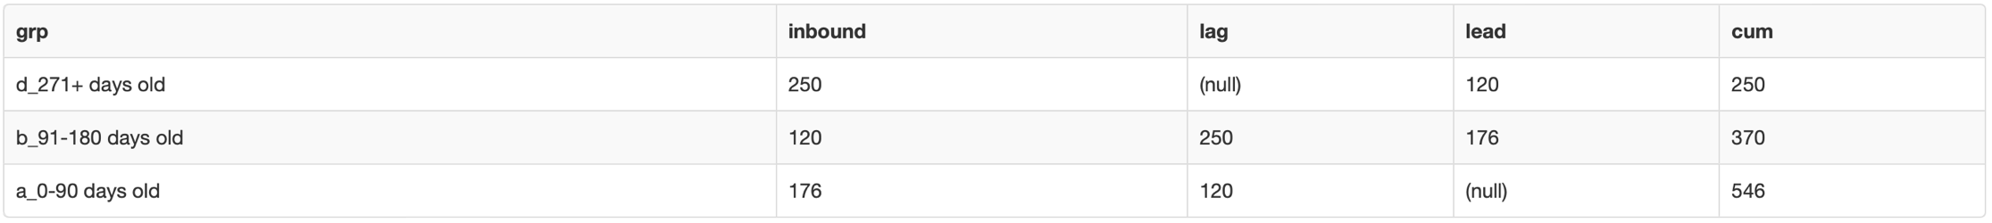

1. Do the calculation

declare @totalSales as varchar(1000)

set @totalSales = (select sum(onhandquantitydelta) from warehouse

where event_type = 'OutBound');

declare @currentdate as date

set @currentdate = '2020-05-25';

with inventory_tbl_cte as (

select grp, sum(onhandquantitydelta) as inbound

from (select *, grp = case

when datediff(day, convert(DATE,event_datetime),@currentdate) <= 90 then 'a_0-90 days old'

when datediff(day, convert(DATE,event_datetime),@currentdate) <= 180 then 'b_91-180 days old'

when datediff(day, convert(DATE,event_datetime),@currentdate) <= 270 then 'c_181-270 days old'

else 'd_271+ days old' end

from warehouse

where event_type = 'InBound') a

group by grp)

--use CTE & the totalSales for calculation

select *,

unused_inventory = iif(@totalSales > cum, 0, iif(lead is null, inbound, inbound - (@totalSales - lag)))

from (

select *,

lag(inbound) over (order by grp desc) lag

,lead(inbound) over (order by grp desc) lead

,sum(inbound) over (order by grp desc ROWS BETWEEN UNBOUNDED PRECEDING AND CURRENT ROW) cum

from inventory_tbl_cte

) b

order by grp;

