# **Android - Overview**

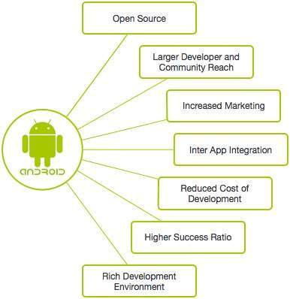What is Android?

* An open source and Linux-based **Operating System** for mobile devices such as smartphones and tablet computers.
* The first beta version of the Android Software Development Kit (SDK) was released by Google in 2007 where as the first commercial version, Android 1.0, was released in September 2008.

## Features of Android

|  |  |
| --- | --- |
| **Feature** | **Description** |
| Beautiful UI | Android OS basic screen provides a beautiful and intuitive user interface. |
| Connectivity | GSM/EDGE, IDEN, CDMA, EV-DO, UMTS, Bluetooth, Wi-Fi, LTE, NFC and WiMAX. |
| Storage | SQLite, a lightweight relational database, is used for data storage purposes. |
| Media support | H.263, H.264, MPEG-4 SP, AMR, AMR-WB, AAC, HE-AAC, AAC 5.1, MP3, MIDI, Ogg Vorbis, WAV, JPEG, PNG, GIF, and BMP |
| Messaging | SMS and MMS |
| Web browser | Based on the open-source WebKit layout engine, coupled with Chrome's V8 JavaScript engine supporting HTML5 and CSS3. |
| Multi-touch | Android has native support for multi-touch which was initially made available in handsets such as the HTC Hero. |
| Multi-tasking | User can jump from one task to another and same time various application can run simultaneously. |
| Resizable widgets | Widgets are resizable, so users can expand them to show more content or shrink them to save space |
| Multi-Language | Supports single direction and bi-directional text. |
| GCM | Google Cloud Messaging (GCM) is a service that lets developers send short message data to their users on Android devices, without needing a proprietary sync solution. |
| Wi-Fi Direct | A technology that lets apps discover and pair directly, over a high-bandwidth peer-to-peer connection. |
| Android Beam | A popular NFC-based technology that lets users instantly share, just by touching two NFC-enabled phones together. |

## Categories of Android applications

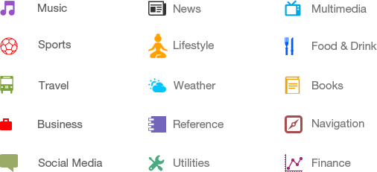

## History of Android

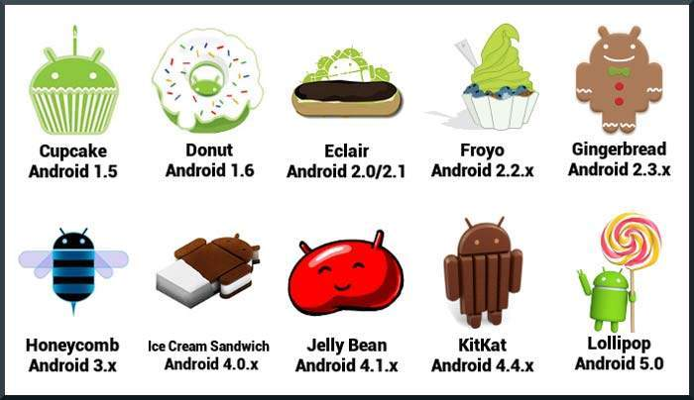

## What is API level?

API Level is an integer value that uniquely identifies the framework API revision offered by a version of the Android platform.

|  |  |  |  |
| --- | --- | --- | --- |
| **Platform Version** | **API Level** | **VERSION_CODE** |  |
| Android 5.1 | 22 | LOLLIPOP_MR1 |  |
| Android 5.0 | 21 | LOLLIPOP |  |
| Android 4.4W | 20 | KITKAT_WATCH | KitKat for Wearables Only |
| Android 4.4 | 19 | KITKAT |  |
| Android 4.3 | 18 | JELLY_BEAN_MR2 |  |
| Android 4.2, 4.2.2 | 17 | JELLY_BEAN_MR1 |  |
| Android 4.1, 4.1.1 | 16 | JELLY_BEAN |  |
| Android 4.0.3, 4.0.4 | 15 | ICE_CREAM_SANDWICH_MR1 |  |
| Android 4.0, 4.0.1, 4.0.2 | 14 | ICE_CREAM_SANDWICH |  |
| Android 3.2 | 13 | HONEYCOMB_MR2 |  |
| Android 3.1.x | 12 | HONEYCOMB_MR1 |  |
| Android 3.0.x | 11 | HONEYCOMB |  |
| Android 2.3.4  Android 2.3.3 | 10 | GINGERBREAD_MR1 |  |
| Android 2.3.2  Android 2.3.1  Android 2.3 | 9 | GINGERBREAD |  |
| Android 2.2.x | 8 | FROYO |  |
| Android 2.1.x | 7 | ECLAIR_MR1 |  |
| Android 2.0.1 | 6 | ECLAIR_0_1 |  |
| Android 2.0 | 5 | ECLAIR |  |
| Android 1.6 | 4 | DONUT |  |
| Android 1.5 | 3 | CUPCAKE |  |
| Android 1.1 | 2 | BASE_1_1 |  |
| Android 1.0 | 1 | BASE |  |

# **Android - Environment Setup**

First is OS:

* Microsoft® Windows® 8/7/Vista/2003 (32 or 64-bit).
* Mac® OS X® 10.8.5 or higher, up to 10.9 (Mavericks)
* GNOME or KDE desktop

Second is tools:

* Java JDK5 or later version
* Android SDK
* Java Runtime Environment (JRE) 6
* Android Studio (Best choice)
* Eclipse IDE for Java Developers (optional)
* Android Development Tools (ADT) Eclipse Plug-in (optional)

## Set-up Java Development Kit (JDK)

set PATH=C:\jdk1.7.0_75\bin;%PATH%

set JAVA_HOME=C:\jdk1.7.0_75

setenv PATH /usr/local/jdk1.7.0_75/bin:$PATH

setenv JAVA_HOME /usr/local/jdk1.7.0_75

# **Android - Architecture**

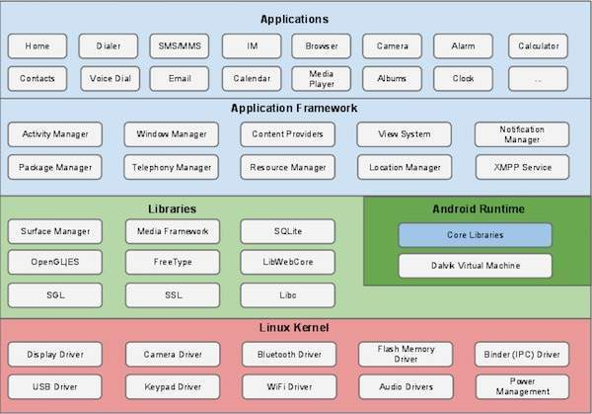

## Linux kernel

At the bottom of the layers is Linux - Linux 3.6 with approximately 115 patches. This provides a level of abstraction between the device hardware and it contains all the essential hardware drivers like camera, keypad, display etc. Also, the kernel handles all the things that Linux is really good at such as networking and a vast array of device drivers, which take the pain out of interfacing to peripheral hardware.

## Libraries

On top of Linux kernel there is a set of libraries including open-source Web browser engine WebKit, well known library libc, SQLite database which is a useful repository for storage and sharing of application data, libraries to play and record audio and video, SSL libraries responsible for Internet security etc.

## Android Libraries

This category encompasses those Java-based libraries that are specific to Android development. Examples of libraries in this category include the application framework libraries in addition to those that facilitate user interface building, graphics drawing and database access. A summary of some key core Android libraries available to the Android developer is as follows −

* **android.app** − Provides access to the application model and is the cornerstone of all Android applications.
* **android.content** − Facilitates content access, publishing and messaging between applications and application components.
* **android.database** − Used to access data published by content providers and includes SQLite database management classes.
* **android.opengl** − A Java interface to the OpenGL ES 3D graphics rendering API.
* **android.os** − Provides applications with access to standard operating system services including messages, system services and inter-process communication.
* **android.text** − Used to render and manipulate text on a device display.
* **android.view** − The fundamental building blocks of application user interfaces.
* **android.widget** − A rich collection of pre-built user interface components such as buttons, labels, list views, layout managers, radio buttons etc.
* **android.webkit** − A set of classes intended to allow web-browsing capabilities to be built into applications.

Having covered the Java-based core libraries in the Android runtime, it is now time to turn our attention to the C/C++ based libraries contained in this layer of the Android software stack.

## Android Runtime

This is the third section of the architecture and available on the second layer from the bottom. This section provides a key component called **Dalvik Virtual Machine** which is a kind of Java Virtual Machine specially designed and optimized for Android.

The Dalvik VM makes use of Linux core features like memory management and multi-threading, which is intrinsic in the Java language. The Dalvik VM enables every Android application to run in its own process, with its own instance of the Dalvik virtual machine.

The Android runtime also provides a set of core libraries which enable Android application developers to write Android applications using standard Java programming language.

## Application Framework

The Application Framework layer provides many higher-level services to applications in the form of Java classes. Application developers are allowed to make use of these services in their applications.

The Android framework includes the following key services −

* **Activity Manager** − Controls all aspects of the application lifecycle and activity stack.
* **Content Providers** − Allows applications to publish and share data with other applications.
* **Resource Manager** − Provides access to non-code embedded resources such as strings, color settings and user interface layouts.
* **Notifications Manager** − Allows applications to display alerts and notifications to the user.
* **View System** − An extensible set of views used to create application user interfaces.

## Applications

You will find all the Android application at the top layer. You will write your application to be installed on this layer only. Examples of such applications are Contacts Books, Browser, Games etc.

# **Android - Application Components**

|  |  |
| --- | --- |
| **Components** | **Description** |
| Activities | They dictate the UI and handle the user interaction to the smart phone screen |
| Services | They handle background processing associated with an application. |
| Broadcast Receivers | They handle communication between Android OS and applications. |
| Content Providers | They handle data and database management issues. |

## Activities

An activity represents a single screen with a user interface,in-short Activity performs actions on the screen. For example, an email application might have one activity that shows a list of new emails, another activity to compose an email, and another activity for reading emails. If an application has more than one activity, then one of them should be marked as the activity that is presented when the application is launched.

An activity is implemented as a subclass of **Activity** class as follows −

public class MainActivity extends Activity {

}

Services

A service is a component that runs in the background to perform long-running operations. For example, a service might play music in the background while the user is in a different application, or it might fetch data over the network without blocking user interaction with an activity.

A service is implemented as a subclass of **Service** class as follows −

public class MyService extends Service {

}

Broadcast Receivers

Broadcast Receivers simply respond to broadcast messages from other applications or from the system. For example, applications can also initiate broadcasts to let other applications know that some data has been downloaded to the device and is available for them to use, so this is broadcast receiver who will intercept this communication and will initiate appropriate action.

A broadcast receiver is implemented as a subclass of **BroadcastReceiver**class and each message is broadcaster as an **Intent** object.

public class MyReceiver extends BroadcastReceiver {

public void onReceive(context,intent){}

}

Content Providers

A content provider component supplies data from one application to others on request. Such requests are handled by the methods of the *ContentResolver*class. The data may be stored in the file system, the database or somewhere else entirely.

A content provider is implemented as a subclass of **ContentProvider** class and must implement a standard set of APIs that enable other applications to perform transactions.

public class MyContentProvider extends ContentProvider {

public void onCreate(){}

}

We will go through these tags in detail while covering application components in individual chapters.

Additional Components

There are additional components which will be used in the construction of above mentioned entities, their logic, and wiring between them. These components are −

|  |  |
| --- | --- |
| **Components** | **Description** |
| Fragments | Represents a portion of user interface in an Activity. |
| Views | UI elements that are drawn on-screen including buttons, lists forms etc. |
| Layouts | View hierarchies that control screen format and appearance of the views. |
| Intents | Messages wiring components together. |
| Resources | External elements, such as strings, constants and drawable pictures. |
| Manifest | Configuration file for the application. |