TIEN VINH NGUYEN |  | 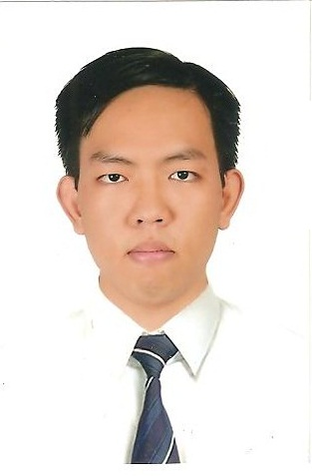
 +(84) 90-888-1066   Ho Chi Minh, VN | +1 (626) 988-3765  Pico Rivera, California, USA   B6248009 – Visa F1
https://www.linkedin.com/in/tien-nguyen-88851710b/
 tien.workinfo@gmail.com

Technical Expertise

Technology / Classification | JAVA – ANDROID

Primary Skills | Experience (Months) | Secondary Skills | Experience (Months)
Java | 60 | MS SQL Server (2008, 2012) | 22
Spring | 30 | Oracle (11g, 12c) | 20
Android | 18 | Liquibase | 5
Servlet and JSP | 28 | Test (Junit, TestNG) | 15
Struts | 6 | Reporting (Jasper, SVF) | 10
Hibernate | 8 | Building (Ant, Maven, Gradle) | 10
HTML5, JavaScript, jQuery, CSS | 25 | Boostrap | 5
Mainframe (Cobol, Assembly) | 8 | AWS, Azure, Google Cloud | 5

Additional Skills | Microsoft Office, CS6, Apache Tomcat, Ajax, Json, Ivy, Maskat, AWS, IDE (Android Studio, Eclipse, STS, IntelliJ IDEA, VS), Source Control (GIT, SVN, FileZilla, Bitbucket), Jira, Scrum.

Education

Degree | Qualification | College / University / Institution | Year of Passing
Intro to Self-Driving Car | Nano Degree | UDACITY | 01/2018
Android Basic Nanodegree by Google | Nano Degree | UDACITY + GOOGLE | 07/2016
College | Higher Degree | FPT APTECH | 2013

Professional Activities, Certifications & Training attended

Course / Certification Name | Institution | Year of Passing
(B2) BULATS Reading & Listening | Cambridge | 02/2017
(B1-High) BULATS Speaking | Cambridge | 02/2017
(705) TOEIC Certificate | IIG Viet Nam | 02/2017
(N5) Certificate | Japanese Nat Test | 07/2014

Work Experience

Project Name | FuturEdge QTE | Start Date | 03rd Jun 2015
Client | NTTComware, Honda, Daito (Japanese) | End Date | 23th Jul 2017
Project Location | Ho Chi Minh City | Team Size | 26
Project Description:
- Q-TE transforms corporate legacy systems into independent, contemporary technology platforms, without the use of middleware. Incorporates automation capability in the transformation process. Builds Metadata during each iteration, metadata used to interpret source language and transform it to target language.
Role / Responsibilities | Software Developer/Onshore Coordinator  - General have legacy and open system experience.  - Able to set up and execute client code through QTE, able to assess client code base, identify QTE gaps, report issues to QTE product team.  - Able to contribute to client Discovery, not lead.  - Able to assist with design of QTE transformation solutions.  - Able to develop QTE transformation solutions.  - Release, deploy, execute, report and support.  - Mentor new employees.  - Involving grooming meeting.  - Tracking the issues, reporting the result & assign tasks.
Environment:
- Java 7.0, SVN-1.8.11, spring-tool-suite-3.6.4, grepWin64-1.6.8, IE 11, FF 39, Chrome 46, AWS Linux, English, Japanese, Windows 7, Windows 8, Mainframe.
Skills:
- Java J2SE, Spring, Junit, Assembly, Cobol, Maven, WinSCP, Oracle.

Employment History

Company Name | Designation | Start date | End Date
DXC Vietnam Co, Ltd | Java Software Engineer | 01th Jul, 2015 | 23th Jul 2017
DXC Vietnam Co, Ltd | Java Associate Software Engineer | 25th Jul, 2014 | 01th Jul, 2015
Fujinet Co, Ltd | Java Junior Software Engineer | 29th Jul, 2013 | 24th Jul, 2014
Vo Minh Co, Ltd | Sale (part time) | Apr, 2012 | Apr, 2013

