Daily Signal Review Report V2
Binance Futures Signal Bot · Manual Trading Review
Date: 2026-04-04 | Generated: 2026-04-04 14:48:17
Health status: ⚠ ISSUES FOUND — check Semantic Health panel before conclusions

A. Data Quality Gate
Report date: 2026-04-04
Total pending rows: 46
Status breakdown: CONFIRMED=5 | EXPIRED_WAIT=8 | INVALIDATED=32 | PENDING=1

Metric | Count | Of total | Status
Confirmed (is_confirmed=Y) | 5 | 11% | OK
Sent (is_sent_signal=Y) | 0 | 0% | OK
Clean confirmed | 5 | 11% | OK
Broken confirmed (excluded) | 0 | 0% | OK
Outcome 2h available | 38 | 83% | OK
Timestamps trustworthy | Y |  | OK

B. Semantic Health Panel
✗ Semantic issues found — do not use optimization counts from broken rows.

✓ Confirmed rows with confirmed_ts_ms: 5
✓ Confirmed rows missing confirmed_ts_ms: 0
✓ Sent rows missing sent_ts_ms: 0
✗ Closed rows missing close_reason: 1
✓ Rows with semantic_consistency=N: 0
✗ missing_unexpected: pre_pending: 1
✗ missing_unexpected: pending_open: 1
✓ missing_unexpected: entry_or_confirm: 0
✓ missing_unexpected: case_close: 0

C. Confirm Path Integrity Board
'not_reached_yet' is explicit — never substituted with a fake timestamp.
Symbol | Side | confirmed_at | sent_at | closed_at | Integrity
1000SHIBUSDT | SHORT | 08:30:58 | not_sent | not_reached_yet | OK
WIFUSDT | SHORT | 08:31:00 | not_sent | not_reached_yet | OK
WIFUSDT | SHORT | 08:31:00 | not_sent | not_reached_yet | OK
RENDERUSDT | SHORT | 09:15:12 | not_sent | not_reached_yet | OK
WIFUSDT | SHORT | 09:01:26 | not_sent | not_reached_yet | OK

D. Executive Decision Summary
BTC regime (mode): neutral
Market regime (mode): RANGE
Cases detected today: 46
Confirmed path cases: 5
Sent signals: 0
Long detected / confirmed: 39 / 0 (0%)
Short detected / confirmed: 7 / 5 (71%)
WAIT_TOO_SHORT_CANDIDATE: 11
KILL_CORRECT: 22
Regret-valid (regret_valid=Y): 11

→ Next action: Fix semantic health first — broken confirmed-path rows make strategy conclusions unreliable.

E. Strategy Outcome Matrix
Truth-clean subset only. Broken confirmed rows excluded.
Strategy | Side | Det. | Conf. | Sent | KILL_OK | WAIT_SHORT | NO_MOVE | avg Score
long_breakout_retest | LONG | 39 | 0 | 0 | 20 | 10 | 1 | 95.0
short_exhaustion_retest | SHORT | 7 | 5 | 0 | 2 | 1 | 4 | 57.3

F. Missed Opportunity Board
Cases bot killed/expired but market moved strongly in expected direction afterwards (WAIT_TOO_SHORT_CANDIDATE).
Symbol | Side | Strategy | Status | Fav 2h% | Adv 2h% | Close reason
SIRENUSDT | LONG | long_breakout_retest | EXPIRED_WAIT | 89.24 | 0.00 | retest wait expired
SIRENUSDT | LONG | long_breakout_retest | INVALIDATED | 58.35 | 7.57 | retest invalidated
SIRENUSDT | LONG | long_breakout_retest | INVALIDATED | 36.32 | 13.95 | retest invalidated
STOUSDT | LONG | long_breakout_retest | EXPIRED_WAIT | 28.09 | 0.00 | retest wait expired
ONGUSDT | LONG | long_breakout_retest | EXPIRED_WAIT | 16.70 | 0.00 | retest wait expired
BRUSDT | LONG | long_breakout_retest | EXPIRED_WAIT | 11.51 | 2.47 | retest wait expired
KERNELUSDT | LONG | long_breakout_retest | INVALIDATED | 9.02 | 0.00 | acceptance_floor_lost 0.120520<0.122759
BARDUSDT | LONG | long_breakout_retest | EXPIRED_WAIT | 5.69 | 0.39 | retest wait expired
CTSIUSDT | LONG | long_breakout_retest | INVALIDATED | 4.06 | 3.10 | retest invalidated
YBUSDT | LONG | long_breakout_retest | EXPIRED_WAIT | 2.65 | 1.99 | retest wait expired
WIFUSDT | SHORT | short_exhaustion_retest | CONFIRMED | 1.33 | 0.00 | signal confirmed

G. Bad Loss Filter Board
KILL_CORRECT = kill justified. Bad loss = killed but market moved >1.5% in favour after kill.
KILL_CORRECT: 22
Bad loss (fav >1.5% after kill): 10
NO_MEANINGFUL_MOVE: 5

KILL_CORRECT by close reason:
retest invalidated: 20
acceptance_floor_lost 0.053720<0.054342: 1
acceptance_floor_lost 0.033620<0.033961: 1

Bad loss cases — inspect for rule improvement:
Symbol | Side | Strategy | Fav 2h% | Adv 2h% | Close reason
SIRENUSDT | LONG | long_breakout_retest | 89.24 | 0.00 | retest wait expired
SIRENUSDT | LONG | long_breakout_retest | 58.35 | 7.57 | retest invalidated
SIRENUSDT | LONG | long_breakout_retest | 36.32 | 13.95 | retest invalidated
STOUSDT | LONG | long_breakout_retest | 28.09 | 0.00 | retest wait expired
ONGUSDT | LONG | long_breakout_retest | 16.70 | 0.00 | retest wait expired
BRUSDT | LONG | long_breakout_retest | 11.51 | 2.47 | retest wait expired
KERNELUSDT | LONG | long_breakout_retest | 9.02 | 0.00 | acceptance_floor_lost 0.120520<0.122759
BARDUSDT | LONG | long_breakout_retest | 5.69 | 0.39 | retest wait expired
CTSIUSDT | LONG | long_breakout_retest | 4.06 | 3.10 | retest invalidated
YBUSDT | LONG | long_breakout_retest | 2.65 | 1.99 | retest wait expired

H. Decision Trace Coverage
Field | Populated | Coverage | Status
regime_label (3A set) | 46 | 100% | OK
regime_fit_for_strategy | 46 | 100% | OK
dispatch_action | 0 | 0% | GAPS
setup_quality_band | 46 | 100% | OK

Regime label distribution:
trend_continuation_friendly ✓: 41
unclear_mixed ✓: 5

Fit distribution:
HIGH: 34
LOW: 7
MEDIUM: 5

I. Human Review Queue
Priority: regret_valid=Y first, then outcome available, then score desc.
Symbol | Side | Strategy | Status | Score | Regret? | Outcome code
BARDUSDT | LONG | long_breakout_retest | EXPIRED_WAIT | 100.0 | Y | WAIT_TOO_SHORT_CANDIDATE
BRUSDT | LONG | long_breakout_retest | EXPIRED_WAIT | 100.0 | Y | WAIT_TOO_SHORT_CANDIDATE
ONGUSDT | LONG | long_breakout_retest | EXPIRED_WAIT | 100.0 | Y | WAIT_TOO_SHORT_CANDIDATE
SIRENUSDT | LONG | long_breakout_retest | INVALIDATED | 100.0 | Y | WAIT_TOO_SHORT_CANDIDATE
KERNELUSDT | LONG | long_breakout_retest | INVALIDATED | 100.0 | Y | WAIT_TOO_SHORT_CANDIDATE
STOUSDT | LONG | long_breakout_retest | EXPIRED_WAIT | 100.0 | Y | WAIT_TOO_SHORT_CANDIDATE
SIRENUSDT | LONG | long_breakout_retest | EXPIRED_WAIT | 91.8 | Y | WAIT_TOO_SHORT_CANDIDATE
CTSIUSDT | LONG | long_breakout_retest | INVALIDATED | 88.9 | Y | WAIT_TOO_SHORT_CANDIDATE
YBUSDT | LONG | long_breakout_retest | EXPIRED_WAIT | 80.7 | Y | WAIT_TOO_SHORT_CANDIDATE
SIRENUSDT | LONG | long_breakout_retest | INVALIDATED | 73.0 | Y | WAIT_TOO_SHORT_CANDIDATE
WIFUSDT | SHORT | short_exhaustion_retest | CONFIRMED | 62.0 | Y | WAIT_TOO_SHORT_CANDIDATE
GASUSDT | LONG | long_breakout_retest | INVALIDATED | 100.0 | N | KILL_CORRECT
ONGUSDT | LONG | long_breakout_retest | INVALIDATED | 100.0 | N | KILL_CORRECT
DUSDT | LONG | long_breakout_retest | INVALIDATED | 100.0 | N | KILL_CORRECT
NOMUSDT | LONG | long_breakout_retest | INVALIDATED | 100.0 | N | KILL_CORRECT
HEMIUSDT | LONG | long_breakout_retest | INVALIDATED | 100.0 | N | KILL_CORRECT
CUSDT | LONG | long_breakout_retest | EXPIRED_WAIT | 100.0 | N | NO_MEANINGFUL_MOVE
币安人生USDT | LONG | long_breakout_retest | INVALIDATED | 100.0 | N | KILL_CORRECT
ONGUSDT | LONG | long_breakout_retest | INVALIDATED | 100.0 | N | KILL_CORRECT
DUSDT | LONG | long_breakout_retest | INVALIDATED | 100.0 | N | KILL_CORRECT

J. Case Registry Preview
Case ID | Symbol | Side | Strategy | Status | Outcome
GASUSDT-LONG-1775260800000 | GASUSDT | LONG | long_breakout_retest | INVALIDATED | KILL_CORRECT
KERNELUSDT-SHORT-EXH-1775260800000 | KERNELUSDT | SHORT | short_exhaustion_retest | INVALIDATED | KILL_CORRECT
GUAUSDT-SHORT-EXH-1775260800000 | GUAUSDT | SHORT | short_exhaustion_retest | INVALIDATED | KILL_CORRECT
ONGUSDT-LONG-1775261400000 | ONGUSDT | LONG | long_breakout_retest | INVALIDATED | KILL_CORRECT
BARDUSDT-LONG-1775262000000 | BARDUSDT | LONG | long_breakout_retest | EXPIRED_WAIT | WAIT_TOO_SHORT_CANDIDATE
BRUSDT-LONG-1775262300000 | BRUSDT | LONG | long_breakout_retest | EXPIRED_WAIT | WAIT_TOO_SHORT_CANDIDATE
YBUSDT-LONG-1775263200000 | YBUSDT | LONG | long_breakout_retest | EXPIRED_WAIT | WAIT_TOO_SHORT_CANDIDATE
DUSDT-LONG-1775264100000 | DUSDT | LONG | long_breakout_retest | INVALIDATED | KILL_CORRECT
NOMUSDT-LONG-1775264400000 | NOMUSDT | LONG | long_breakout_retest | INVALIDATED | KILL_CORRECT
ONGUSDT-LONG-1775265000000 | ONGUSDT | LONG | long_breakout_retest | EXPIRED_WAIT | WAIT_TOO_SHORT_CANDIDATE
1000SHIBUSDT-SHORT-EXH-1775264400000 | 1000SHIBUSDT | SHORT | short_exhaustion_retest | CONFIRMED | NO_MEANINGFUL_MOVE
WIFUSDT-SHORT-EXH-1775264400000 | WIFUSDT | SHORT | short_exhaustion_retest | CONFIRMED | NO_MEANINGFUL_MOVE
WIFUSDT-SHORT-EXH-1775264400000 | WIFUSDT | SHORT | short_exhaustion_retest | CONFIRMED | NO_MEANINGFUL_MOVE
SIRENUSDT-LONG-1775265300000 | SIRENUSDT | LONG | long_breakout_retest | EXPIRED_WAIT | WAIT_TOO_SHORT_CANDIDATE
HEMIUSDT-LONG-1775265600000 | HEMIUSDT | LONG | long_breakout_retest | INVALIDATED | KILL_CORRECT
RENDERUSDT-SHORT-EXH-1775265300000 | RENDERUSDT | SHORT | short_exhaustion_retest | CONFIRMED | NO_MEANINGFUL_MOVE
WIFUSDT-SHORT-EXH-1775265300000 | WIFUSDT | SHORT | short_exhaustion_retest | CONFIRMED | WAIT_TOO_SHORT_CANDIDATE
BRUSDT-LONG-1775265900000 | BRUSDT | LONG | long_breakout_retest | INVALIDATED | KILL_CORRECT
HEMIUSDT-LONG-1775266200000 | HEMIUSDT | LONG | long_breakout_retest | INVALIDATED | KILL_CORRECT
CUSDT-LONG-1775267100000 | CUSDT | LONG | long_breakout_retest | EXPIRED_WAIT | NO_MEANINGFUL_MOVE
SIRENUSDT-LONG-1775267700000 | SIRENUSDT | LONG | long_breakout_retest | INVALIDATED | WAIT_TOO_SHORT_CANDIDATE
KERNELUSDT-LONG-1775268600000 | KERNELUSDT | LONG | long_breakout_retest | INVALIDATED | WAIT_TOO_SHORT_CANDIDATE
币安人生USDT-LONG-1775268600000 | 币安人生USDT | LONG | long_breakout_retest | INVALIDATED | KILL_CORRECT
ONGUSDT-LONG-1775268900000 | ONGUSDT | LONG | long_breakout_retest | INVALIDATED | KILL_CORRECT
SIRENUSDT-LONG-1775268900000 | SIRENUSDT | LONG | long_breakout_retest | INVALIDATED | WAIT_TOO_SHORT_CANDIDATE
DUSDT-LONG-1775269200000 | DUSDT | LONG | long_breakout_retest | INVALIDATED | KILL_CORRECT
FIDAUSDT-LONG-1775269500000 | FIDAUSDT | LONG | long_breakout_retest | INVALIDATED | KILL_CORRECT
CTSIUSDT-LONG-1775272800000 | CTSIUSDT | LONG | long_breakout_retest | INVALIDATED | WAIT_TOO_SHORT_CANDIDATE
FIDAUSDT-LONG-1775272800000 | FIDAUSDT | LONG | long_breakout_retest | INVALIDATED | KILL_CORRECT
POLYXUSDT-LONG-1775273100000 | POLYXUSDT | LONG | long_breakout_retest | INVALIDATED | KILL_CORRECT
CTSIUSDT-LONG-1775273100000 | CTSIUSDT | LONG | long_breakout_retest | INVALIDATED | KILL_CORRECT
STOUSDT-LONG-1775274600000 | STOUSDT | LONG | long_breakout_retest | EXPIRED_WAIT | WAIT_TOO_SHORT_CANDIDATE
POLYXUSDT-LONG-1775275500000 | POLYXUSDT | LONG | long_breakout_retest | INVALIDATED | KILL_CORRECT
HEMIUSDT-LONG-1775277600000 | HEMIUSDT | LONG | long_breakout_retest | INVALIDATED | KILL_CORRECT
FIDAUSDT-LONG-1775277600000 | FIDAUSDT | LONG | long_breakout_retest | INVALIDATED | KILL_CORRECT
PUFFERUSDT-LONG-1775277600000 | PUFFERUSDT | LONG | long_breakout_retest | INVALIDATED | KILL_CORRECT
PUFFERUSDT-LONG-1775278500000 | PUFFERUSDT | LONG | long_breakout_retest | INVALIDATED | KILL_CORRECT
PUFFERUSDT-LONG-1775278500000 | PUFFERUSDT | LONG | long_breakout_retest | INVALIDATED | KILL_CORRECT
PUFFERUSDT-LONG-1775278800000 | PUFFERUSDT | LONG | long_breakout_retest | EXPIRED_WAIT | retest wait expired
PUFFERUSDT-LONG-1775281200000 | PUFFERUSDT | LONG | long_breakout_retest | INVALIDATED | retest invalidated
NOMUSDT-LONG-1775283000000 | NOMUSDT | LONG | long_breakout_retest | INVALIDATED | retest invalidated
PUFFERUSDT-LONG-1775283900000 | PUFFERUSDT | LONG | long_breakout_retest | INVALIDATED | retest invalidated
FIDAUSDT-LONG-1775283900000 | FIDAUSDT | LONG | long_breakout_retest | INVALIDATED | retest invalidated
PUFFERUSDT-LONG-1775285100000 | PUFFERUSDT | LONG | long_breakout_retest | INVALIDATED | retest invalidated
SIRENUSDT-LONG-1775286000000 | SIRENUSDT | LONG | long_breakout_retest | INVALIDATED | retest invalidated
NOMUSDT-LONG-1775287800000 | NOMUSDT | LONG | long_breakout_retest | PENDING

Case 1: GASUSDT-LONG-1775260800000
Summary | GASUSDT | LONG | long_breakout_retest | status=INVALIDATED | close_reason=retest invalidated
Times | signal=2026-04-04 07:00:00 | created=2026-04-04 07:08:31 | confirmed= | sent= | close=2026-04-04 07:27:25 | fallback_due=2026-04-04 11:08:31
Semantics | is_confirmed=N | is_sent_signal=N | review_eligible=Y | semantic_consistency=Y
Review integrity | review_exclusion_reason= | semantic_issue=
Close anchoring | case_close_type=true_close | close_anchor_time=2026-04-04 07:27:25 | close_capture_basis=true_close
Regime / dispatch | regime_label=trend_continuation_friendly | fit=HIGH | dispatch=not_evaluated [not_evaluated]
Tradeability | entry_feasible=Y | slippage=0.0000 | regret_valid=N | outcome=KILL_CORRECT

Pre Pending
Stage status: capture_failed | Content type: none
Note: pre_fix_backfill_v2 — was missing_unexpected, snapshot was never taken (Sprint 3A.2 bug)

Pending Open
Stage status: capture_failed | Content type: none
Note: pre_fix_backfill_v2 — was missing_unexpected, snapshot was never taken (Sprint 3A.2 bug)

Entry Or Confirm
Stage status: not_applicable | Content type: none

Case Close
Stage status: captured | Content type: chart_snapshot
close_trigger_detail: retest invalidated
invalidation_detail: retest invalidated
Note: retest invalidated
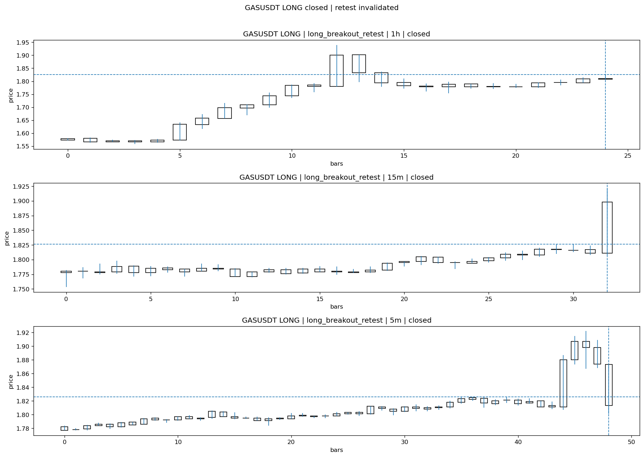
GASUSDT_LONG_long_breakout_retest_closed_1775262445411.png

Post-Close Outcome
1h outcome | available=Y | favor=3.2311 | adverse=4.5455
2h outcome | available=Y | favor=4.9288 | adverse=4.5455
4h reference | favor=4.9288 | adverse=4.5455
Reclaim | 2h=Y | 4h=Y
Execution | entry_feasible=Y | window=10m | note=entry still reachable within 10m
Time-to-move | to_favor=113m | to_adverse=3m
Regret filter | regret_valid=N | reason=adverse_too_large
Conclusion | KILL_CORRECT | notes=entry_ref_from_breakout_level

Review placeholders
human_review_status=PENDING | verdict_code= | root_cause_code= | action_candidate_code=

Case 2: KERNELUSDT-SHORT-EXH-1775260800000
Summary | KERNELUSDT | SHORT | short_exhaustion_retest | status=INVALIDATED | close_reason=retest invalidated
Times | signal=2026-04-04 07:00:00 | created=2026-04-04 07:16:55 | confirmed= | sent= | close=2026-04-04 07:30:14 | fallback_due=2026-04-04 11:16:55
Semantics | is_confirmed=N | is_sent_signal=N | review_eligible=Y | semantic_consistency=Y
Review integrity | review_exclusion_reason= | semantic_issue=
Close anchoring | case_close_type=true_close | close_anchor_time=2026-04-04 07:30:14 | close_capture_basis=true_close
Regime / dispatch | regime_label=trend_continuation_friendly | fit=LOW | dispatch=not_evaluated [not_evaluated]
Tradeability | entry_feasible=Y | slippage=0.0000 | regret_valid=N | outcome=KILL_CORRECT

Pre Pending
Stage status: capture_failed | Content type: none
Note: pre_fix_backfill_v2 — was missing_unexpected, snapshot was never taken (Sprint 3A.2 bug)

Pending Open
Stage status: capture_failed | Content type: none
Note: pre_fix_backfill_v2 — was missing_unexpected, snapshot was never taken (Sprint 3A.2 bug)

Entry Or Confirm
Stage status: not_applicable | Content type: none

Case Close
Stage status: captured | Content type: chart_snapshot
close_trigger_detail: retest invalidated
invalidation_detail: retest invalidated
Note: retest invalidated
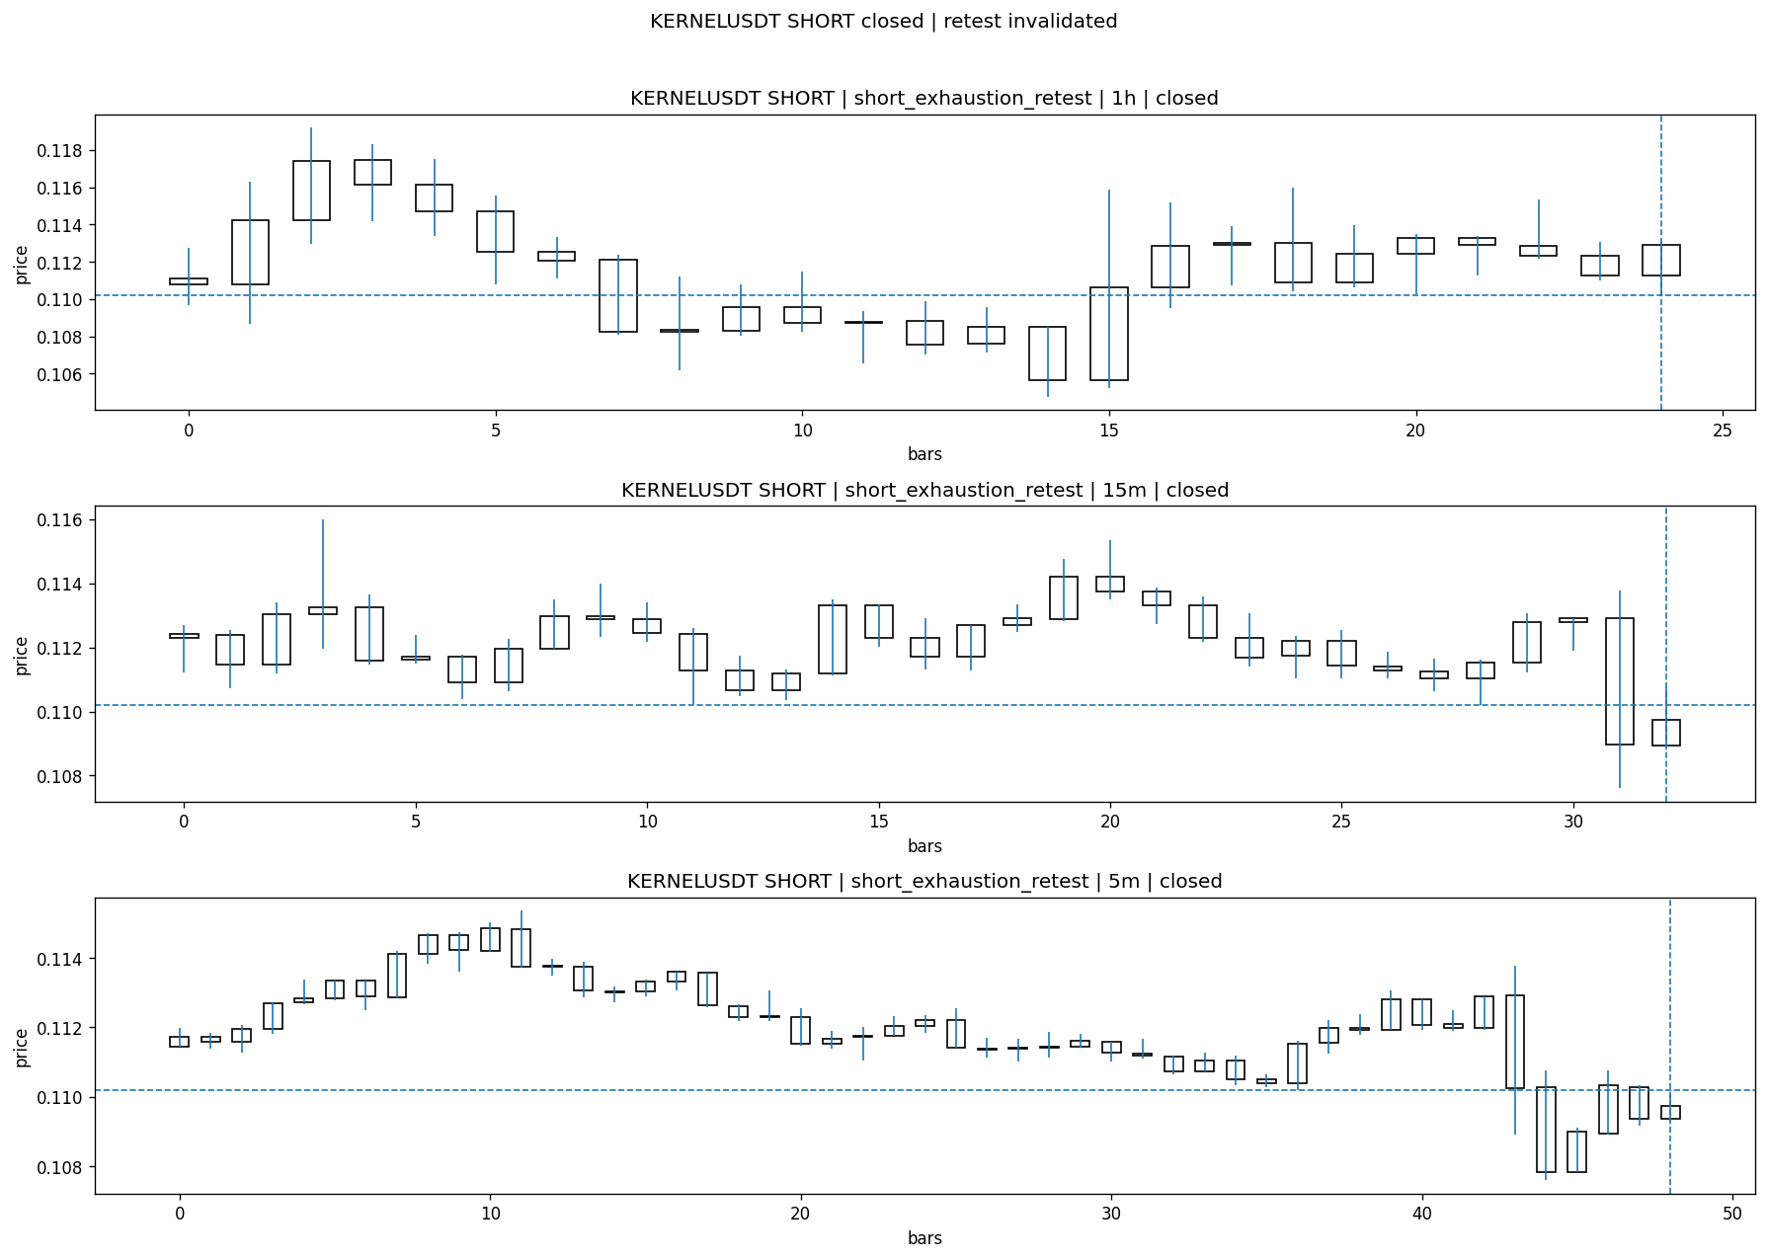
KERNELUSDT_SHORT_short_exhaustion_retest_closed_1775262614020.png

Post-Close Outcome
1h outcome | available=Y | favor=0.3539 | adverse=6.0532
2h outcome | available=Y | favor=0.3539 | adverse=13.1319
4h reference | favor=0.3539 | adverse=19.7205
Reclaim | 2h=Y | 4h=Y
Execution | entry_feasible=Y | window=10m | note=entry still reachable within 10m
Time-to-move | to_favor=5m | to_adverse=120m
Regret filter | regret_valid=N | reason=adverse_too_large
Conclusion | KILL_CORRECT | notes=entry_ref_from_breakout_level

Review placeholders
human_review_status=PENDING | verdict_code= | root_cause_code= | action_candidate_code=

Case 3: GUAUSDT-SHORT-EXH-1775260800000
Summary | GUAUSDT | SHORT | short_exhaustion_retest | status=INVALIDATED | close_reason=retest invalidated
Times | signal=2026-04-04 07:00:00 | created=2026-04-04 07:17:03 | confirmed= | sent= | close=2026-04-04 07:30:11 | fallback_due=2026-04-04 11:17:03
Semantics | is_confirmed=N | is_sent_signal=N | review_eligible=Y | semantic_consistency=Y
Review integrity | review_exclusion_reason= | semantic_issue=
Close anchoring | case_close_type=true_close | close_anchor_time=2026-04-04 07:30:11 | close_capture_basis=true_close
Regime / dispatch | regime_label=trend_continuation_friendly | fit=LOW | dispatch=not_evaluated [not_evaluated]
Tradeability | entry_feasible=Y | slippage=0.0000 | regret_valid=N | outcome=KILL_CORRECT

Pre Pending
Stage status: capture_failed | Content type: none
Note: pre_fix_backfill_v2 — was missing_unexpected, snapshot was never taken (Sprint 3A.2 bug)

Pending Open
Stage status: capture_failed | Content type: none
Note: pre_fix_backfill_v2 — was missing_unexpected, snapshot was never taken (Sprint 3A.2 bug)

Entry Or Confirm
Stage status: not_applicable | Content type: none

Case Close
Stage status: captured | Content type: chart_snapshot
close_trigger_detail: retest invalidated
invalidation_detail: retest invalidated
Note: retest invalidated
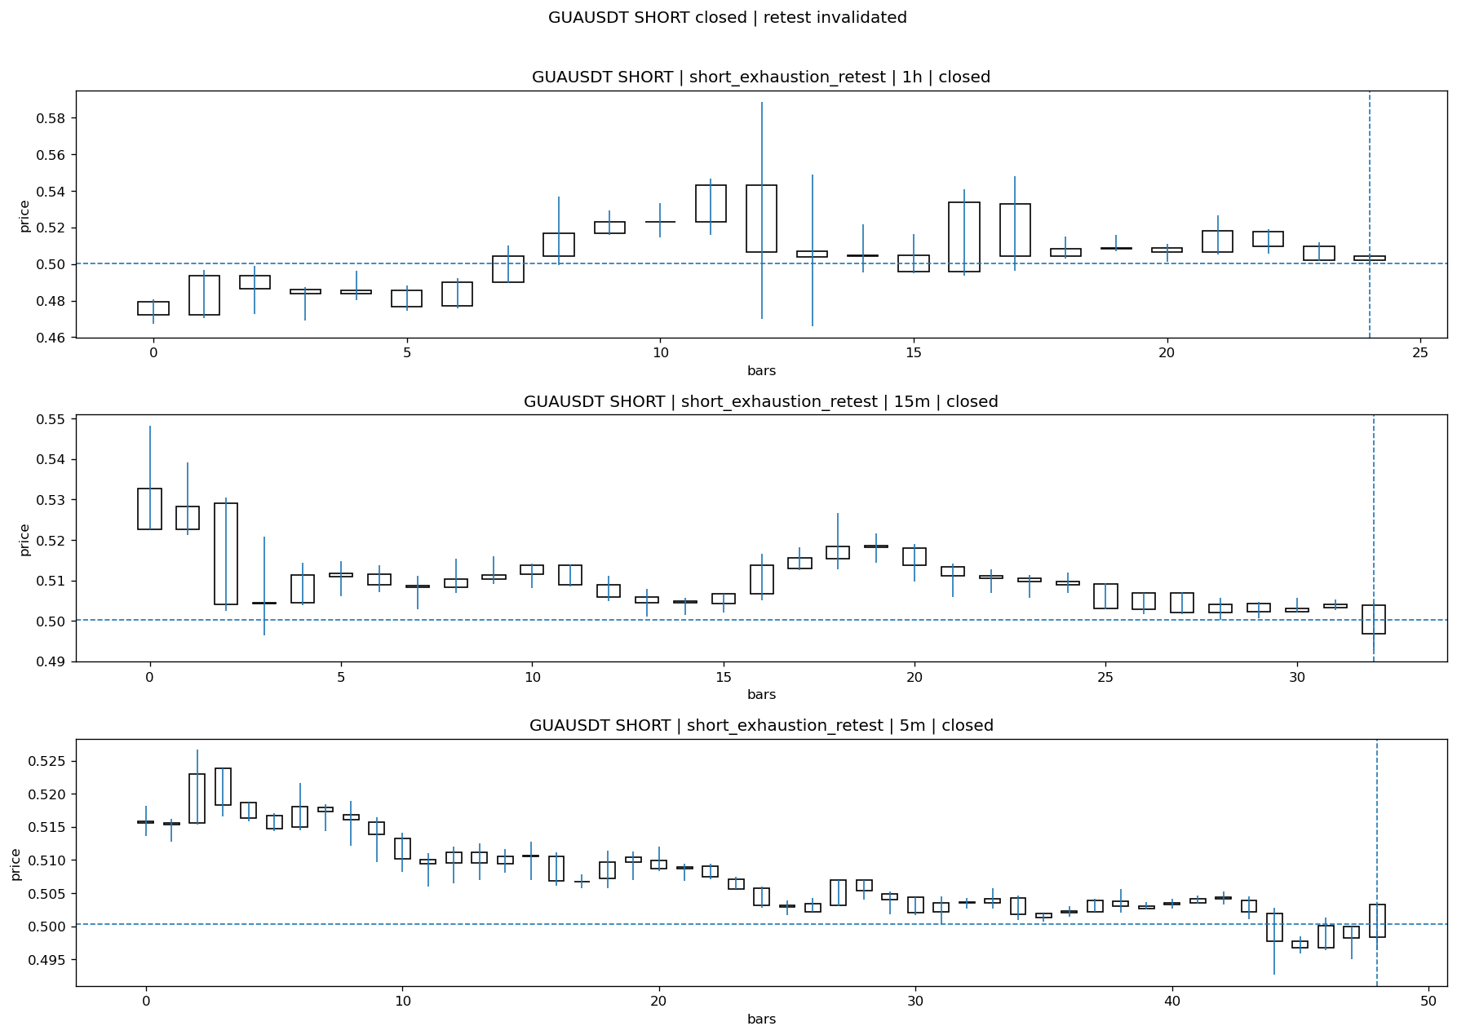
GUAUSDT_SHORT_short_exhaustion_retest_closed_1775262611819.png

Post-Close Outcome
1h outcome | available=Y | favor=0.0000 | adverse=4.7131
2h outcome | available=Y | favor=0.0000 | adverse=4.7131
4h reference | favor=0.0000 | adverse=4.7131
Reclaim | 2h=Y | 4h=Y
Execution | entry_feasible=Y | window=10m | note=entry still reachable within 10m
Time-to-move | to_favor=20m | to_adverse=35m
Regret filter | regret_valid=N | reason=adverse_too_large
Conclusion | KILL_CORRECT | notes=entry_ref_from_breakout_level

Review placeholders
human_review_status=PENDING | verdict_code= | root_cause_code= | action_candidate_code=

Case 4: ONGUSDT-LONG-1775261400000
Summary | ONGUSDT | LONG | long_breakout_retest | status=INVALIDATED | close_reason=retest invalidated
Times | signal=2026-04-04 07:10:00 | created=2026-04-04 07:19:13 | confirmed= | sent= | close=2026-04-04 07:21:52 | fallback_due=2026-04-04 11:19:13
Semantics | is_confirmed=N | is_sent_signal=N | review_eligible=Y | semantic_consistency=Y
Review integrity | review_exclusion_reason= | semantic_issue=
Close anchoring | case_close_type=true_close | close_anchor_time=2026-04-04 07:21:52 | close_capture_basis=true_close
Regime / dispatch | regime_label=trend_continuation_friendly | fit=HIGH | dispatch=not_evaluated [not_evaluated]
Tradeability | entry_feasible=Y | slippage=0.0000 | regret_valid=N | outcome=KILL_CORRECT

Pre Pending
Stage status: capture_failed | Content type: none
Note: pre_fix_backfill_v2 — was missing_unexpected, snapshot was never taken (Sprint 3A.2 bug)

Pending Open
Stage status: capture_failed | Content type: none
Note: pre_fix_backfill_v2 — was missing_unexpected, snapshot was never taken (Sprint 3A.2 bug)

Entry Or Confirm
Stage status: not_applicable | Content type: none

Case Close
Stage status: captured | Content type: chart_snapshot
close_trigger_detail: retest invalidated
invalidation_detail: retest invalidated
Note: retest invalidated
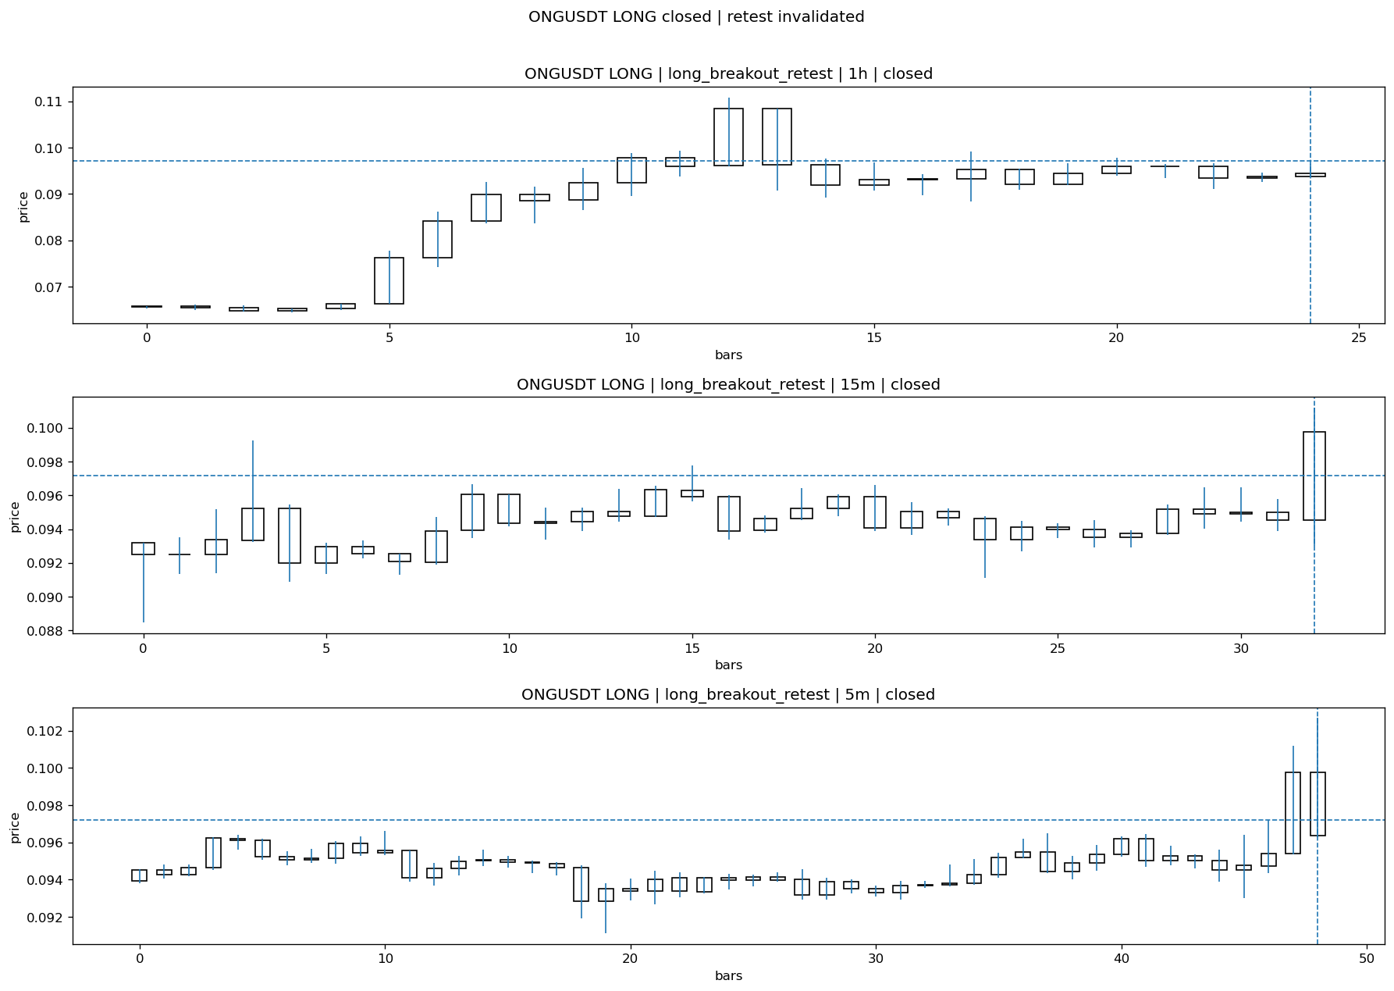
ONGUSDT_LONG_long_breakout_retest_closed_1775262112396.png

Post-Close Outcome
1h outcome | available=Y | favor=11.9572 | adverse=12.5849
2h outcome | available=Y | favor=23.3073 | adverse=12.5849
4h reference | favor=23.3073 | adverse=12.5849
Reclaim | 2h=Y | 4h=Y
Execution | entry_feasible=Y | window=10m | note=entry still reachable within 10m
Time-to-move | to_favor=118m | to_adverse=3m
Regret filter | regret_valid=N | reason=no_meaningful_fast_move
Conclusion | KILL_CORRECT | notes=entry_ref_from_breakout_level

Review placeholders
human_review_status=PENDING | verdict_code= | root_cause_code= | action_candidate_code=

Case 5: BARDUSDT-LONG-1775262000000
Summary | BARDUSDT | LONG | long_breakout_retest | status=EXPIRED_WAIT | close_reason=retest wait expired
Times | signal=2026-04-04 07:20:00 | created=2026-04-04 07:27:55 | confirmed= | sent= | close=2026-04-04 08:06:03 | fallback_due=2026-04-04 11:27:55
Semantics | is_confirmed=N | is_sent_signal=N | review_eligible=Y | semantic_consistency=Y
Review integrity | review_exclusion_reason= | semantic_issue=
Close anchoring | case_close_type=true_close | close_anchor_time=2026-04-04 08:06:03 | close_capture_basis=true_close
Regime / dispatch | regime_label=trend_continuation_friendly | fit=HIGH | dispatch=not_evaluated [not_evaluated]
Tradeability | entry_feasible=Y | slippage=0.0000 | regret_valid=Y | outcome=WAIT_TOO_SHORT_CANDIDATE

Pre Pending
Stage status: capture_failed | Content type: none
Note: pre_fix_backfill_v2 — was missing_unexpected, snapshot was never taken (Sprint 3A.2 bug)

Pending Open
Stage status: capture_failed | Content type: none
Note: pre_fix_backfill_v2 — was missing_unexpected, snapshot was never taken (Sprint 3A.2 bug)

Entry Or Confirm
Stage status: not_applicable | Content type: none
confirm_fail_detail: retest wait expired

Case Close
Stage status: captured | Content type: chart_snapshot
close_trigger_detail: retest wait expired
Note: retest wait expired
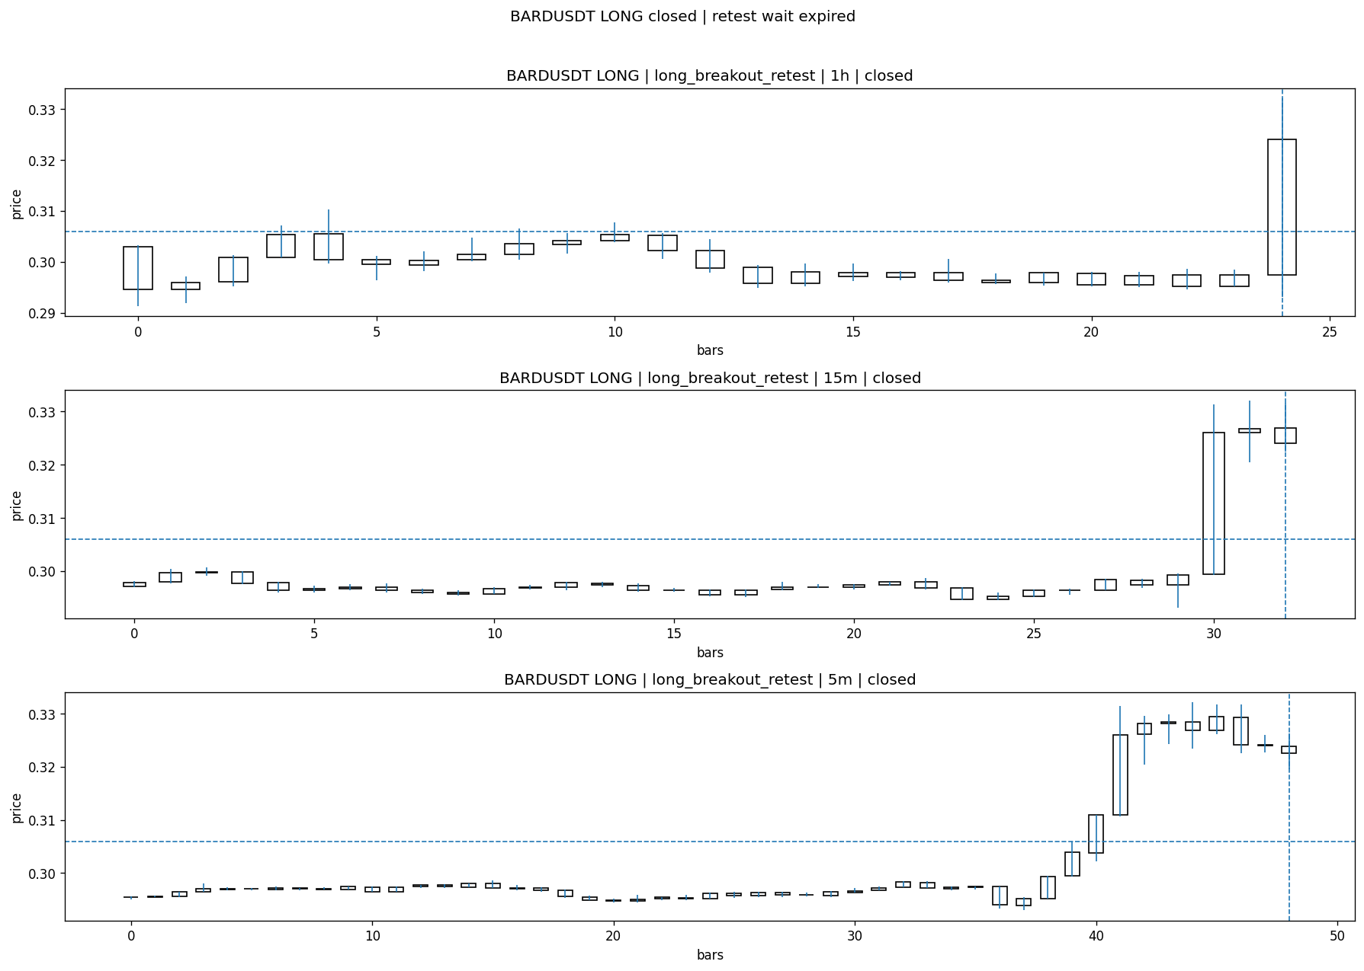
BARDUSDT_LONG_long_breakout_retest_closed_1775264763129.png

Post-Close Outcome
1h outcome | available=Y | favor=5.6881 | adverse=0.0000
2h outcome | available=Y | favor=5.6881 | adverse=0.3923
4h reference | favor=5.6881 | adverse=0.3923
Reclaim | 2h=Y | 4h=Y
Execution | entry_feasible=Y | window=10m | note=entry still reachable within 10m
Time-to-move | to_favor=4m | to_adverse=74m
Regret filter | regret_valid=Y | reason=valid_missed_continuation
Conclusion | WAIT_TOO_SHORT_CANDIDATE | notes=entry_ref_from_breakout_level

Review placeholders
human_review_status=PENDING | verdict_code= | root_cause_code= | action_candidate_code=

Case 6: BRUSDT-LONG-1775262300000
Summary | BRUSDT | LONG | long_breakout_retest | status=EXPIRED_WAIT | close_reason=retest wait expired
Times | signal=2026-04-04 07:25:00 | created=2026-04-04 07:33:17 | confirmed= | sent= | close=2026-04-04 08:11:37 | fallback_due=2026-04-04 11:33:17
Semantics | is_confirmed=N | is_sent_signal=N | review_eligible=Y | semantic_consistency=Y
Review integrity | review_exclusion_reason= | semantic_issue=
Close anchoring | case_close_type=true_close | close_anchor_time=2026-04-04 08:11:37 | close_capture_basis=true_close
Regime / dispatch | regime_label=trend_continuation_friendly | fit=HIGH | dispatch=not_evaluated [not_evaluated]
Tradeability | entry_feasible=Y | slippage=0.0000 | regret_valid=Y | outcome=WAIT_TOO_SHORT_CANDIDATE

Pre Pending
Stage status: capture_failed | Content type: none
Note: pre_fix_backfill_v2 — was missing_unexpected, snapshot was never taken (Sprint 3A.2 bug)

Pending Open
Stage status: capture_failed | Content type: none
Note: pre_fix_backfill_v2 — was missing_unexpected, snapshot was never taken (Sprint 3A.2 bug)

Entry Or Confirm
Stage status: not_applicable | Content type: none
confirm_fail_detail: retest wait expired

Case Close
Stage status: captured | Content type: chart_snapshot
close_trigger_detail: retest wait expired
Note: retest wait expired
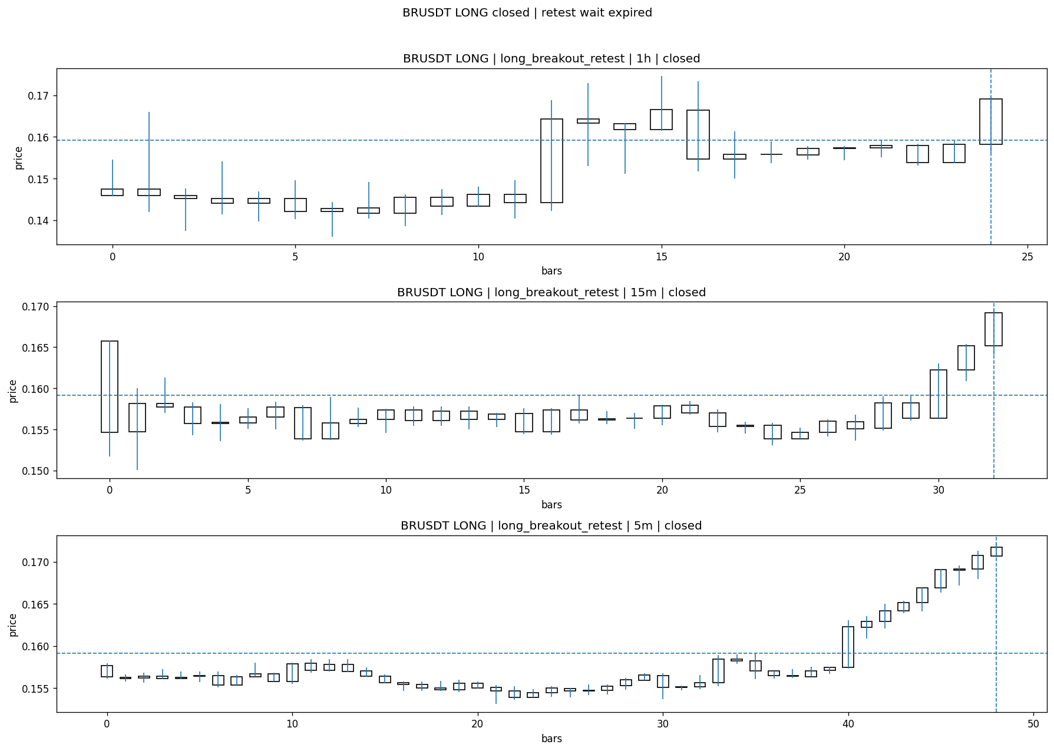
BRUSDT_LONG_long_breakout_retest_closed_1775265097040.png

Post-Close Outcome
1h outcome | available=Y | favor=11.5126 | adverse=2.4697
2h outcome | available=Y | favor=11.5126 | adverse=2.4697
4h reference | favor=12.3233 | adverse=2.4697
Reclaim | 2h=Y | 4h=Y
Execution | entry_feasible=Y | window=10m | note=entry still reachable within 10m
Time-to-move | to_favor=18m | to_adverse=53m
Regret filter | regret_valid=Y | reason=valid_missed_continuation
Conclusion | WAIT_TOO_SHORT_CANDIDATE | notes=entry_ref_from_breakout_level

Review placeholders
human_review_status=PENDING | verdict_code= | root_cause_code= | action_candidate_code=

Case 7: YBUSDT-LONG-1775263200000
Summary | YBUSDT | LONG | long_breakout_retest | status=EXPIRED_WAIT | close_reason=retest wait expired
Times | signal=2026-04-04 07:40:00 | created=2026-04-04 07:46:59 | confirmed= | sent= | close=2026-04-04 08:25:27 | fallback_due=2026-04-04 11:46:59
Semantics | is_confirmed=N | is_sent_signal=N | review_eligible=Y | semantic_consistency=Y
Review integrity | review_exclusion_reason= | semantic_issue=
Close anchoring | case_close_type=true_close | close_anchor_time=2026-04-04 08:25:27 | close_capture_basis=true_close
Regime / dispatch | regime_label=trend_continuation_friendly | fit=HIGH | dispatch=not_evaluated [not_evaluated]
Tradeability | entry_feasible=Y | slippage=0.0000 | regret_valid=Y | outcome=WAIT_TOO_SHORT_CANDIDATE

Pre Pending
Stage status: capture_failed | Content type: none
Note: pre_fix_backfill_v2 — was missing_unexpected, snapshot was never taken (Sprint 3A.2 bug)

Pending Open
Stage status: capture_failed | Content type: none
Note: pre_fix_backfill_v2 — was missing_unexpected, snapshot was never taken (Sprint 3A.2 bug)

Entry Or Confirm
Stage status: not_applicable | Content type: none
confirm_fail_detail: retest wait expired

Case Close
Stage status: captured | Content type: chart_snapshot
close_trigger_detail: retest wait expired
Note: retest wait expired
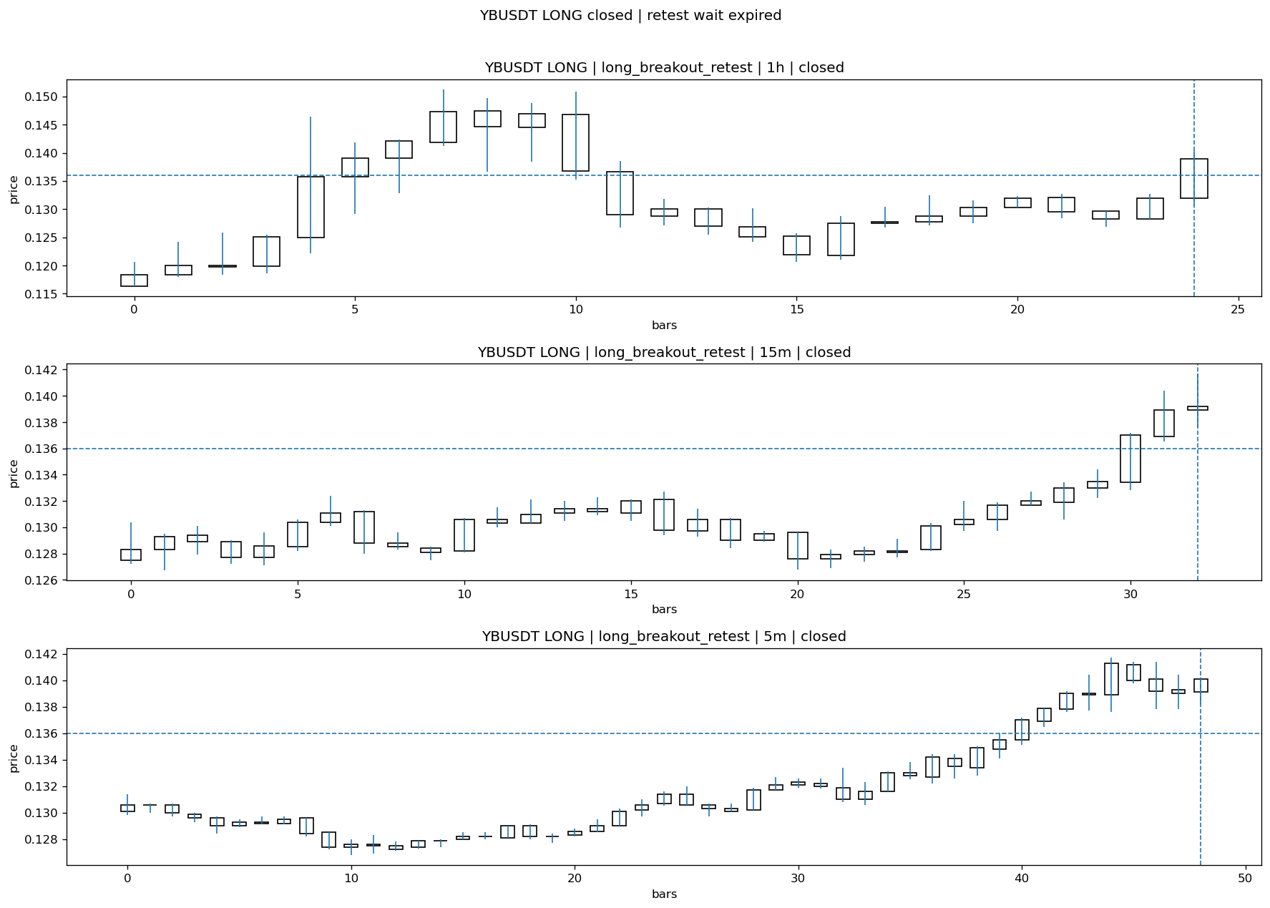
YBUSDT_LONG_long_breakout_retest_closed_1775265927832.png

Post-Close Outcome
1h outcome | available=Y | favor=2.6471 | adverse=1.9853
2h outcome | available=Y | favor=2.6471 | adverse=1.9853
4h reference | favor=2.6471 | adverse=9.0441
Reclaim | 2h=Y | 4h=Y
Execution | entry_feasible=Y | window=10m | note=entry still reachable within 10m
Time-to-move | to_favor=5m | to_adverse=25m
Regret filter | regret_valid=Y | reason=valid_missed_continuation
Conclusion | WAIT_TOO_SHORT_CANDIDATE | notes=entry_ref_from_breakout_level

Review placeholders
human_review_status=PENDING | verdict_code= | root_cause_code= | action_candidate_code=

Case 8: DUSDT-LONG-1775264100000
Summary | DUSDT | LONG | long_breakout_retest | status=INVALIDATED | close_reason=retest invalidated
Times | signal=2026-04-04 07:55:00 | created=2026-04-04 08:00:46 | confirmed= | sent= | close=2026-04-04 08:06:04 | fallback_due=2026-04-04 12:00:46
Semantics | is_confirmed=N | is_sent_signal=N | review_eligible=Y | semantic_consistency=Y
Review integrity | review_exclusion_reason= | semantic_issue=
Close anchoring | case_close_type=true_close | close_anchor_time=2026-04-04 08:06:04 | close_capture_basis=true_close
Regime / dispatch | regime_label=trend_continuation_friendly | fit=HIGH | dispatch=not_evaluated [not_evaluated]
Tradeability | entry_feasible=Y | slippage=0.0000 | regret_valid=N | outcome=KILL_CORRECT

Pre Pending
Stage status: capture_failed | Content type: none
Note: pre_fix_backfill_v2 — was missing_unexpected, snapshot was never taken (Sprint 3A.2 bug)

Pending Open
Stage status: capture_failed | Content type: none
Note: pre_fix_backfill_v2 — was missing_unexpected, snapshot was never taken (Sprint 3A.2 bug)

Entry Or Confirm
Stage status: not_applicable | Content type: none

Case Close
Stage status: captured | Content type: chart_snapshot
close_trigger_detail: retest invalidated
invalidation_detail: retest invalidated
Note: retest invalidated
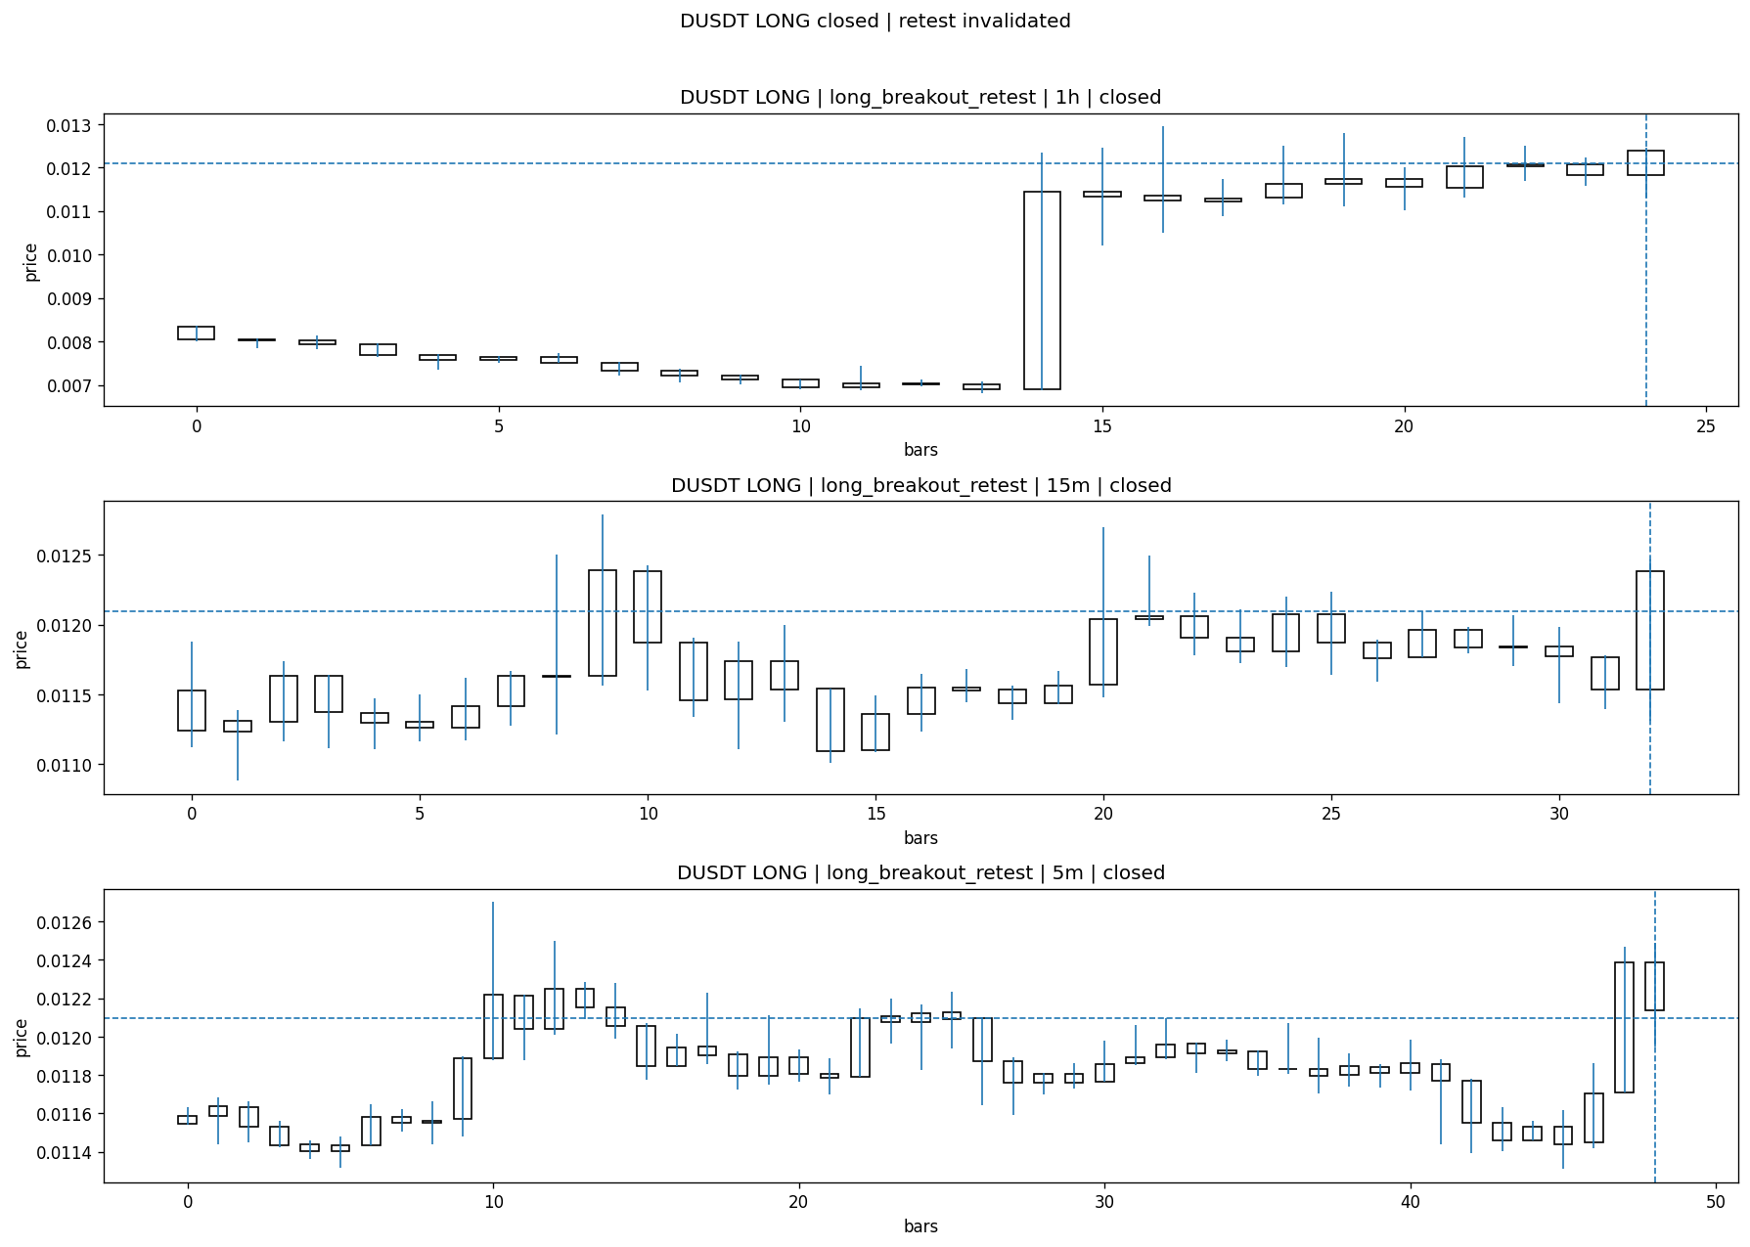
DUSDT_LONG_long_breakout_retest_closed_1775264764153.png

Post-Close Outcome
1h outcome | available=Y | favor=1.6697 | adverse=3.1493
2h outcome | available=Y | favor=6.3812 | adverse=5.3563
4h reference | favor=6.4969 | adverse=14.8620
Reclaim | 2h=Y | 4h=Y
Execution | entry_feasible=Y | window=10m | note=entry still reachable within 10m
Time-to-move | to_favor=79m | to_adverse=84m
Regret filter | regret_valid=N | reason=adverse_too_large
Conclusion | KILL_CORRECT | notes=entry_ref_from_breakout_level

Review placeholders
human_review_status=PENDING | verdict_code= | root_cause_code= | action_candidate_code=

Case 9: NOMUSDT-LONG-1775264400000
Summary | NOMUSDT | LONG | long_breakout_retest | status=INVALIDATED | close_reason=retest invalidated
Times | signal=2026-04-04 08:00:00 | created=2026-04-04 08:09:03 | confirmed= | sent= | close=2026-04-04 08:11:38 | fallback_due=2026-04-04 12:09:03
Semantics | is_confirmed=N | is_sent_signal=N | review_eligible=Y | semantic_consistency=Y
Review integrity | review_exclusion_reason= | semantic_issue=
Close anchoring | case_close_type=true_close | close_anchor_time=2026-04-04 08:11:38 | close_capture_basis=true_close
Regime / dispatch | regime_label=trend_continuation_friendly | fit=HIGH | dispatch=not_evaluated [not_evaluated]
Tradeability | entry_feasible=Y | slippage=0.0000 | regret_valid=N | outcome=KILL_CORRECT

Pre Pending
Stage status: capture_failed | Content type: none
Note: pre_fix_backfill_v2 — was missing_unexpected, snapshot was never taken (Sprint 3A.2 bug)

Pending Open
Stage status: capture_failed | Content type: none
Note: pre_fix_backfill_v2 — was missing_unexpected, snapshot was never taken (Sprint 3A.2 bug)

Entry Or Confirm
Stage status: not_applicable | Content type: none

Case Close
Stage status: captured | Content type: chart_snapshot
close_trigger_detail: retest invalidated
invalidation_detail: retest invalidated
Note: retest invalidated
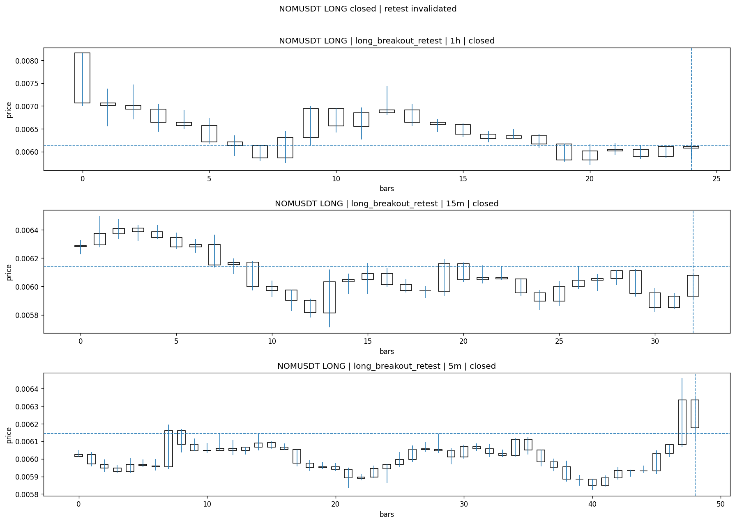
NOMUSDT_LONG_long_breakout_retest_closed_1775265098020.png

Post-Close Outcome
1h outcome | available=Y | favor=6.9184 | adverse=0.3419
2h outcome | available=Y | favor=8.9696 | adverse=0.3419
4h reference | favor=8.9696 | adverse=0.3419
Reclaim | 2h=Y | 4h=Y
Execution | entry_feasible=Y | window=10m | note=entry still reachable within 10m
Time-to-move | to_favor=68m | to_adverse=3m
Regret filter | regret_valid=N | reason=no_meaningful_fast_move
Conclusion | KILL_CORRECT | notes=entry_ref_from_breakout_level

Review placeholders
human_review_status=PENDING | verdict_code= | root_cause_code= | action_candidate_code=

Case 10: ONGUSDT-LONG-1775265000000
Summary | ONGUSDT | LONG | long_breakout_retest | status=EXPIRED_WAIT | close_reason=retest wait expired
Times | signal=2026-04-04 08:10:00 | created=2026-04-04 08:17:15 | confirmed= | sent= | close=2026-04-04 08:55:54 | fallback_due=2026-04-04 12:17:15
Semantics | is_confirmed=N | is_sent_signal=N | review_eligible=Y | semantic_consistency=Y
Review integrity | review_exclusion_reason= | semantic_issue=
Close anchoring | case_close_type=true_close | close_anchor_time=2026-04-04 08:55:54 | close_capture_basis=true_close
Regime / dispatch | regime_label=trend_continuation_friendly | fit=HIGH | dispatch=not_evaluated [not_evaluated]
Tradeability | entry_feasible=Y | slippage=0.0000 | regret_valid=Y | outcome=WAIT_TOO_SHORT_CANDIDATE

Pre Pending
Stage status: capture_failed | Content type: none
Note: pre_fix_backfill_v2 — was missing_unexpected, snapshot was never taken (Sprint 3A.2 bug)

Pending Open
Stage status: capture_failed | Content type: none
Note: pre_fix_backfill_v2 — was missing_unexpected, snapshot was never taken (Sprint 3A.2 bug)

Entry Or Confirm
Stage status: not_applicable | Content type: none
confirm_fail_detail: retest wait expired

Case Close
Stage status: captured | Content type: chart_snapshot
close_trigger_detail: retest wait expired
Note: retest wait expired
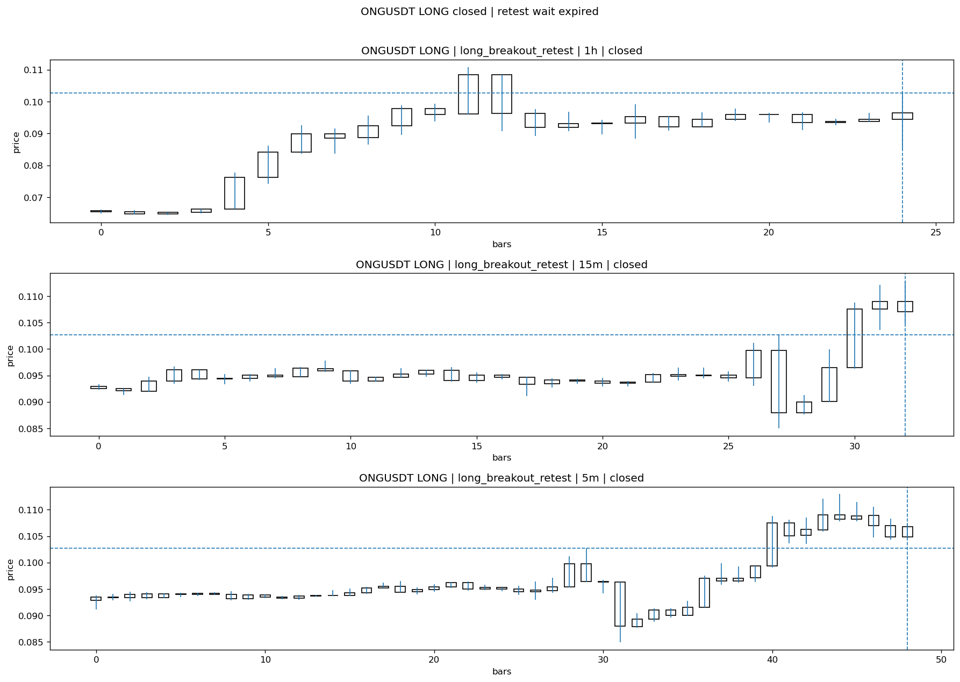
ONGUSDT_LONG_long_breakout_retest_closed_1775267754093.png

Post-Close Outcome
1h outcome | available=Y | favor=16.7024 | adverse=0.0000
2h outcome | available=Y | favor=16.7024 | adverse=0.0000
4h reference | favor=16.7024 | adverse=0.0000
Reclaim | 2h=N | 4h=N
Execution | entry_feasible=Y | window=10m | note=entry still reachable within 10m
Time-to-move | to_favor=24m | to_adverse=9m
Regret filter | regret_valid=Y | reason=valid_missed_continuation
Conclusion | WAIT_TOO_SHORT_CANDIDATE | notes=entry_ref_from_breakout_level

Review placeholders
human_review_status=PENDING | verdict_code= | root_cause_code= | action_candidate_code=

Case 11: 1000SHIBUSDT-SHORT-EXH-1775264400000
Summary | 1000SHIBUSDT | SHORT | short_exhaustion_retest | status=CONFIRMED | close_reason=signal confirmed
Times | signal=2026-04-04 08:00:00 | created=2026-04-04 08:17:40 | confirmed=2026-04-04 08:30:58 | sent= | close=not_reached_yet | fallback_due=2026-04-04 12:17:40
Semantics | is_confirmed=Y | is_sent_signal=N | review_eligible=Y | semantic_consistency=Y
Review integrity | review_exclusion_reason= | semantic_issue=
Close anchoring | case_close_type=not_due_yet | close_anchor_time= | close_capture_basis=not_due_yet
Regime / dispatch | regime_label=trend_continuation_friendly | fit=LOW | dispatch=not_evaluated [not_evaluated]
Tradeability | entry_feasible=Y | slippage=0.0000 | regret_valid=N | outcome=NO_MEANINGFUL_MOVE

Pre Pending
Stage status: capture_failed | Content type: none
Note: pre_fix_backfill_v2 — was missing_unexpected, snapshot was never taken (Sprint 3A.2 bug)

Pending Open
Stage status: capture_failed | Content type: none
Note: pre_fix_backfill_v2 — was missing_unexpected, snapshot was never taken (Sprint 3A.2 bug)

Entry Or Confirm
Stage status: captured | Content type: chart_snapshot
Note: signal confirmed
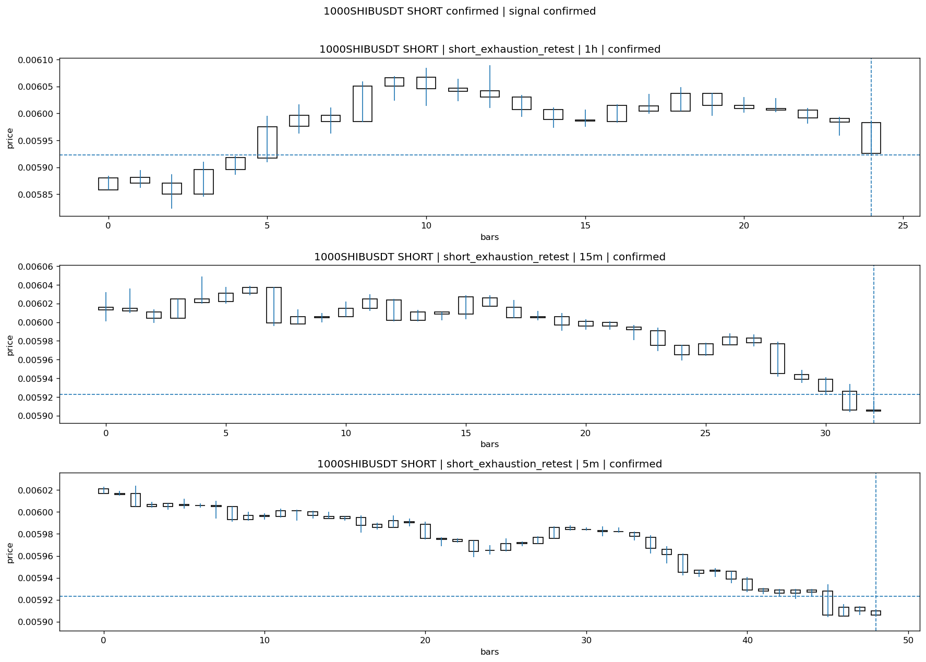
1000SHIBUSDT_SHORT_short_exhaustion_retest_confirmed_1775266258580.png

Case Close
Stage status: not_reached_yet | Content type: none
close_trigger_detail: signal confirmed
Note: NOT REACHED YET

Post-Close Outcome
1h outcome | available=Y | favor=0.3714 | adverse=0.0338
2h outcome | available=Y | favor=0.6585 | adverse=0.0338
4h reference | favor=0.6585 | adverse=0.1013
Reclaim | 2h=Y | 4h=Y
Execution | entry_feasible=Y | window=10m | note=entry still reachable within 10m
Time-to-move | to_favor=79m | to_adverse=24m
Regret filter | regret_valid=N | reason=no_meaningful_fast_move
Conclusion | NO_MEANINGFUL_MOVE | notes=entry_ref_from_breakout_level

Review placeholders
human_review_status=PENDING | verdict_code= | root_cause_code= | action_candidate_code=

Case 12: WIFUSDT-SHORT-EXH-1775264400000
Summary | WIFUSDT | SHORT | short_exhaustion_retest | status=CONFIRMED | close_reason=signal confirmed
Times | signal=2026-04-04 08:00:00 | created=2026-04-04 08:17:46 | confirmed=2026-04-04 08:31:00 | sent= | close=not_reached_yet | fallback_due=2026-04-04 12:17:46
Semantics | is_confirmed=Y | is_sent_signal=N | review_eligible=Y | semantic_consistency=Y
Review integrity | review_exclusion_reason= | semantic_issue=
Close anchoring | case_close_type=not_due_yet | close_anchor_time= | close_capture_basis=not_due_yet
Regime / dispatch | regime_label=trend_continuation_friendly | fit=LOW | dispatch=not_evaluated [not_evaluated]
Tradeability | entry_feasible=Y | slippage=0.0000 | regret_valid=N | outcome=NO_MEANINGFUL_MOVE

Pre Pending
Stage status: capture_failed | Content type: none
Note: pre_fix_backfill_v2 — was missing_unexpected, snapshot was never taken (Sprint 3A.2 bug)

Pending Open
Stage status: capture_failed | Content type: none
Note: pre_fix_backfill_v2 — was missing_unexpected, snapshot was never taken (Sprint 3A.2 bug)

Entry Or Confirm
Stage status: captured | Content type: chart_snapshot
Note: signal confirmed
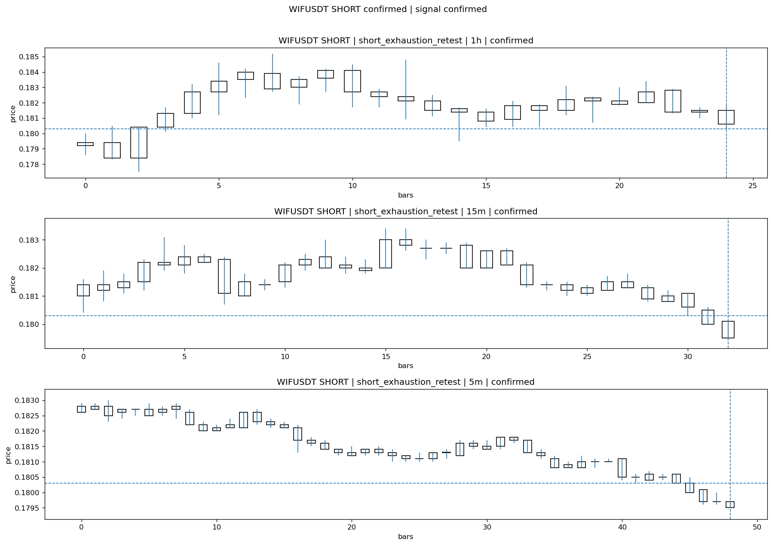
WIFUSDT_SHORT_short_exhaustion_retest_confirmed_1775266260818.png

Case Close
Stage status: not_reached_yet | Content type: none
close_trigger_detail: signal confirmed
Note: NOT REACHED YET

Post-Close Outcome
1h outcome | available=Y | favor=0.7765 | adverse=0.0000
2h outcome | available=Y | favor=1.4975 | adverse=0.0000
4h reference | favor=1.4975 | adverse=0.0000
Reclaim | 2h=N | 4h=N
Execution | entry_feasible=Y | window=10m | note=entry still reachable within 10m
Time-to-move | to_favor=89m | to_adverse=24m
Regret filter | regret_valid=N | reason=no_meaningful_fast_move
Conclusion | NO_MEANINGFUL_MOVE | notes=entry_ref_from_breakout_level

Review placeholders
human_review_status=PENDING | verdict_code= | root_cause_code= | action_candidate_code=

Case 13: WIFUSDT-SHORT-EXH-1775264400000
Summary | WIFUSDT | SHORT | short_exhaustion_retest | status=CONFIRMED | close_reason=signal confirmed
Times | signal=2026-04-04 08:00:00 | created=2026-04-04 08:17:46 | confirmed=2026-04-04 08:31:00 | sent= | close=not_reached_yet | fallback_due=2026-04-04 12:17:46
Semantics | is_confirmed=Y | is_sent_signal=N | review_eligible=Y | semantic_consistency=Y
Review integrity | review_exclusion_reason= | semantic_issue=
Close anchoring | case_close_type=not_due_yet | close_anchor_time= | close_capture_basis=not_due_yet
Regime / dispatch | regime_label=trend_continuation_friendly | fit=LOW | dispatch=not_evaluated [not_evaluated]
Tradeability | entry_feasible=Y | slippage=0.0000 | regret_valid=N | outcome=NO_MEANINGFUL_MOVE

Pre Pending
Stage status: capture_failed | Content type: none
Note: pre_fix_backfill_v2 — was missing_unexpected, snapshot was never taken (Sprint 3A.2 bug)

Pending Open
Stage status: capture_failed | Content type: none
Note: pre_fix_backfill_v2 — was missing_unexpected, snapshot was never taken (Sprint 3A.2 bug)

Entry Or Confirm
Stage status: captured | Content type: chart_snapshot
Note: signal confirmed

WIFUSDT_SHORT_short_exhaustion_retest_confirmed_1775266260818.png

Case Close
Stage status: not_reached_yet | Content type: none
close_trigger_detail: signal confirmed
Note: NOT REACHED YET

Post-Close Outcome
1h outcome | available=Y | favor=0.7765 | adverse=0.0000
2h outcome | available=Y | favor=1.4975 | adverse=0.0000
4h reference | favor=1.4975 | adverse=0.0000
Reclaim | 2h=N | 4h=N
Execution | entry_feasible=Y | window=10m | note=entry still reachable within 10m
Time-to-move | to_favor=89m | to_adverse=24m
Regret filter | regret_valid=N | reason=no_meaningful_fast_move
Conclusion | NO_MEANINGFUL_MOVE | notes=entry_ref_from_breakout_level

Review placeholders
human_review_status=PENDING | verdict_code= | root_cause_code= | action_candidate_code=

Case 14: SIRENUSDT-LONG-1775265300000
Summary | SIRENUSDT | LONG | long_breakout_retest | status=EXPIRED_WAIT | close_reason=retest wait expired
Times | signal=2026-04-04 08:15:00 | created=2026-04-04 08:20:09 | confirmed= | sent= | close=2026-04-04 09:01:25 | fallback_due=2026-04-04 12:20:09
Semantics | is_confirmed=N | is_sent_signal=N | review_eligible=Y | semantic_consistency=Y
Review integrity | review_exclusion_reason= | semantic_issue=
Close anchoring | case_close_type=true_close | close_anchor_time=2026-04-04 09:01:25 | close_capture_basis=true_close
Regime / dispatch | regime_label=trend_continuation_friendly | fit=HIGH | dispatch=not_evaluated [not_evaluated]
Tradeability | entry_feasible=Y | slippage=0.0000 | regret_valid=Y | outcome=WAIT_TOO_SHORT_CANDIDATE

Pre Pending
Stage status: capture_failed | Content type: none
Note: pre_fix_backfill_v2 — was missing_unexpected, snapshot was never taken (Sprint 3A.2 bug)

Pending Open
Stage status: capture_failed | Content type: none
Note: pre_fix_backfill_v2 — was missing_unexpected, snapshot was never taken (Sprint 3A.2 bug)

Entry Or Confirm
Stage status: not_applicable | Content type: none
confirm_fail_detail: retest wait expired

Case Close
Stage status: captured | Content type: chart_snapshot
close_trigger_detail: retest wait expired
Note: retest wait expired
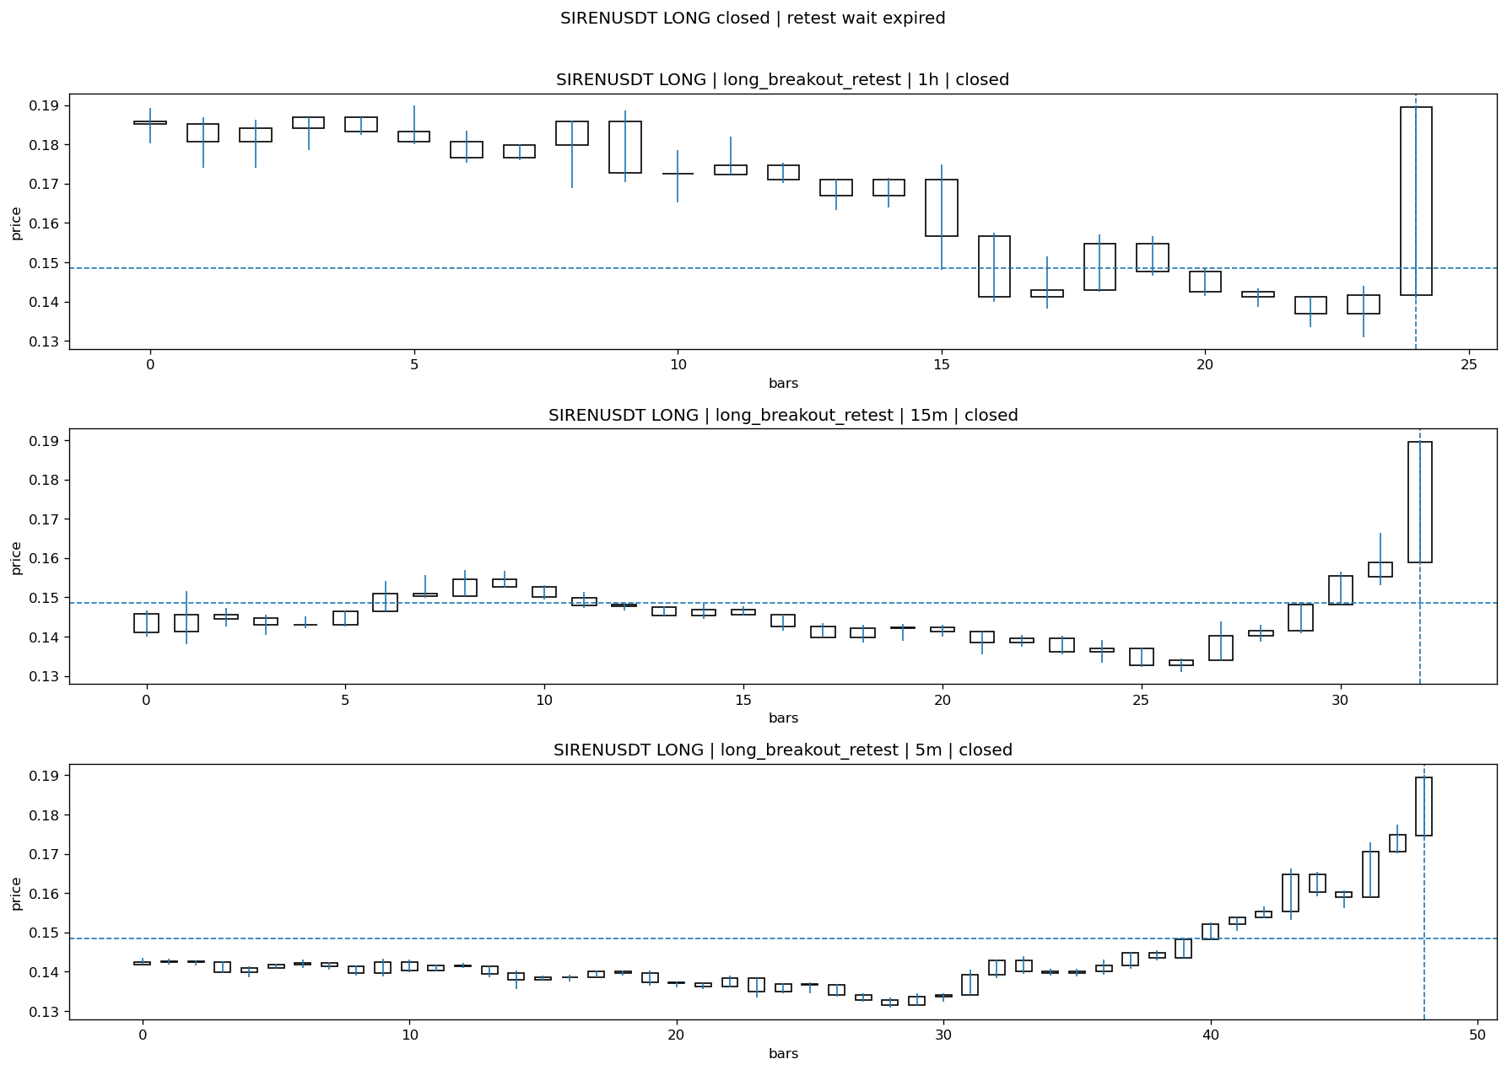
SIRENUSDT_LONG_long_breakout_retest_closed_1775268085424.png

Post-Close Outcome
1h outcome | available=Y | favor=89.2383 | adverse=0.0000
2h outcome | available=Y | favor=89.2383 | adverse=0.0000
4h reference | favor=89.2383 | adverse=0.0000
Reclaim | 2h=N | 4h=N
Execution | entry_feasible=Y | window=10m | note=entry still reachable within 10m
Time-to-move | to_favor=44m | to_adverse=59m
Regret filter | regret_valid=Y | reason=valid_missed_continuation
Conclusion | WAIT_TOO_SHORT_CANDIDATE | notes=entry_ref_from_breakout_level

Review placeholders
human_review_status=PENDING | verdict_code= | root_cause_code= | action_candidate_code=

Case 15: HEMIUSDT-LONG-1775265600000
Summary | HEMIUSDT | LONG | long_breakout_retest | status=INVALIDATED | close_reason=retest invalidated
Times | signal=2026-04-04 08:20:00 | created=2026-04-04 08:26:08 | confirmed= | sent= | close=2026-04-04 08:31:01 | fallback_due=2026-04-04 12:26:08
Semantics | is_confirmed=N | is_sent_signal=N | review_eligible=Y | semantic_consistency=Y
Review integrity | review_exclusion_reason= | semantic_issue=
Close anchoring | case_close_type=true_close | close_anchor_time=2026-04-04 08:31:01 | close_capture_basis=true_close
Regime / dispatch | regime_label=trend_continuation_friendly | fit=HIGH | dispatch=not_evaluated [not_evaluated]
Tradeability | entry_feasible=Y | slippage=0.0000 | regret_valid=N | outcome=KILL_CORRECT

Pre Pending
Stage status: capture_failed | Content type: none
Note: pre_fix_backfill_v2 — was missing_unexpected, snapshot was never taken (Sprint 3A.2 bug)

Pending Open
Stage status: capture_failed | Content type: none
Note: pre_fix_backfill_v2 — was missing_unexpected, snapshot was never taken (Sprint 3A.2 bug)

Entry Or Confirm
Stage status: not_applicable | Content type: none

Case Close
Stage status: captured | Content type: chart_snapshot
close_trigger_detail: retest invalidated
invalidation_detail: retest invalidated
Note: retest invalidated
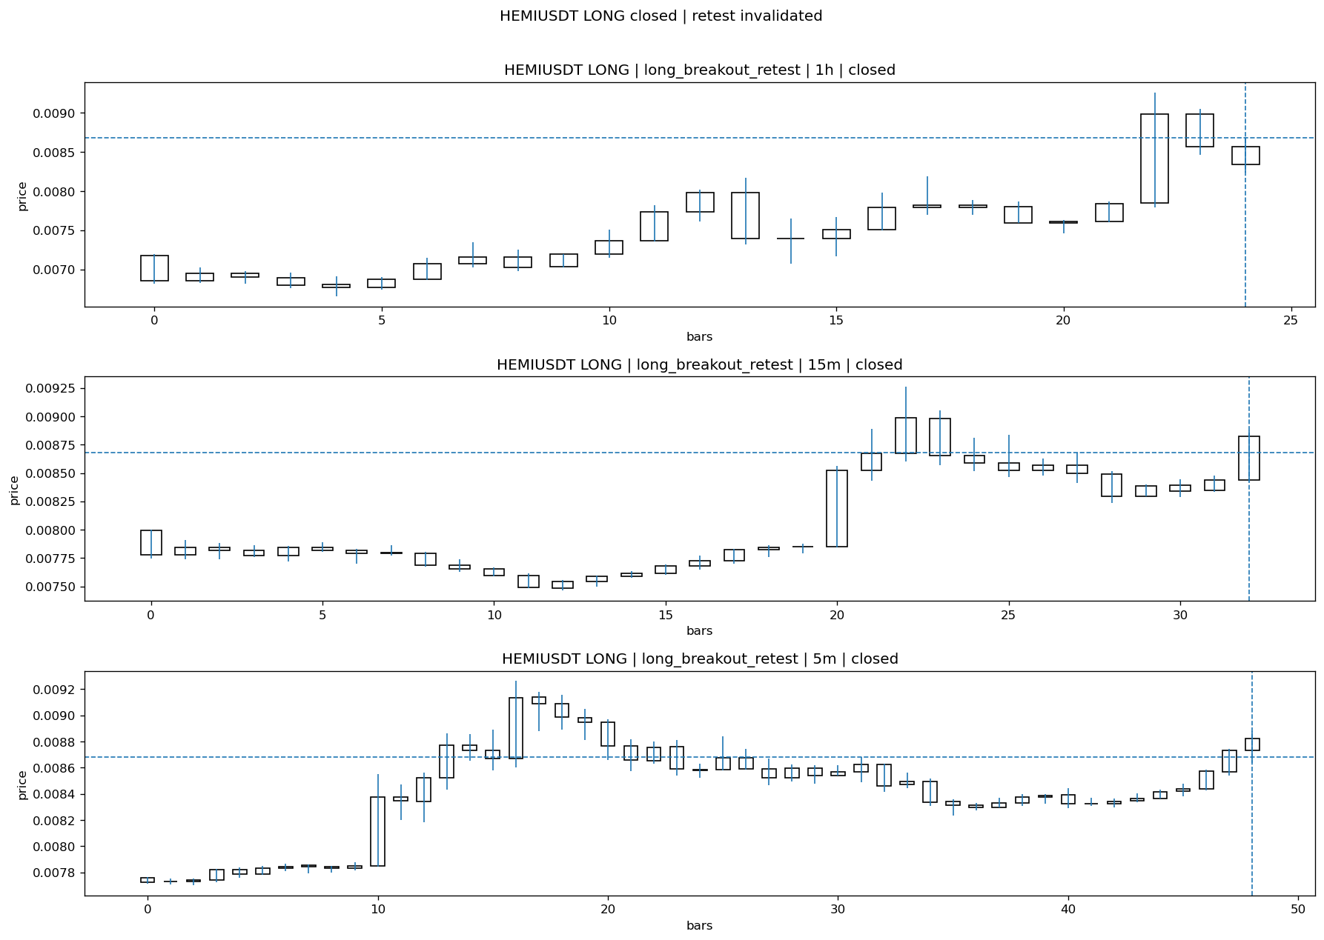
HEMIUSDT_LONG_long_breakout_retest_closed_1775266261780.png

Post-Close Outcome
1h outcome | available=Y | favor=2.9381 | adverse=1.7514
2h outcome | available=Y | favor=2.9381 | adverse=6.1643
4h reference | favor=2.9381 | adverse=7.1552
Reclaim | 2h=Y | 4h=Y
Execution | entry_feasible=Y | window=10m | note=entry still reachable within 10m
Time-to-move | to_favor=4m | to_adverse=109m
Regret filter | regret_valid=N | reason=adverse_too_large
Conclusion | KILL_CORRECT | notes=entry_ref_from_breakout_level

Review placeholders
human_review_status=PENDING | verdict_code= | root_cause_code= | action_candidate_code=

Case 16: RENDERUSDT-SHORT-EXH-1775265300000
Summary | RENDERUSDT | SHORT | short_exhaustion_retest | status=CONFIRMED | close_reason=signal confirmed
Times | signal=2026-04-04 08:15:00 | created=2026-04-04 08:31:31 | confirmed=2026-04-04 09:15:12 | sent= | close=not_reached_yet | fallback_due=2026-04-04 12:31:31
Semantics | is_confirmed=Y | is_sent_signal=N | review_eligible=Y | semantic_consistency=Y
Review integrity | review_exclusion_reason= | semantic_issue=
Close anchoring | case_close_type=not_due_yet | close_anchor_time= | close_capture_basis=not_due_yet
Regime / dispatch | regime_label=trend_continuation_friendly | fit=LOW | dispatch=not_evaluated [not_evaluated]
Tradeability | entry_feasible=Y | slippage=0.0000 | regret_valid=N | outcome=NO_MEANINGFUL_MOVE

Pre Pending
Stage status: capture_failed | Content type: none
Note: pre_fix_backfill_v2 — was missing_unexpected, snapshot was never taken (Sprint 3A.2 bug)

Pending Open
Stage status: capture_failed | Content type: none
Note: pre_fix_backfill_v2 — was missing_unexpected, snapshot was never taken (Sprint 3A.2 bug)

Entry Or Confirm
Stage status: captured | Content type: chart_snapshot
Note: signal confirmed
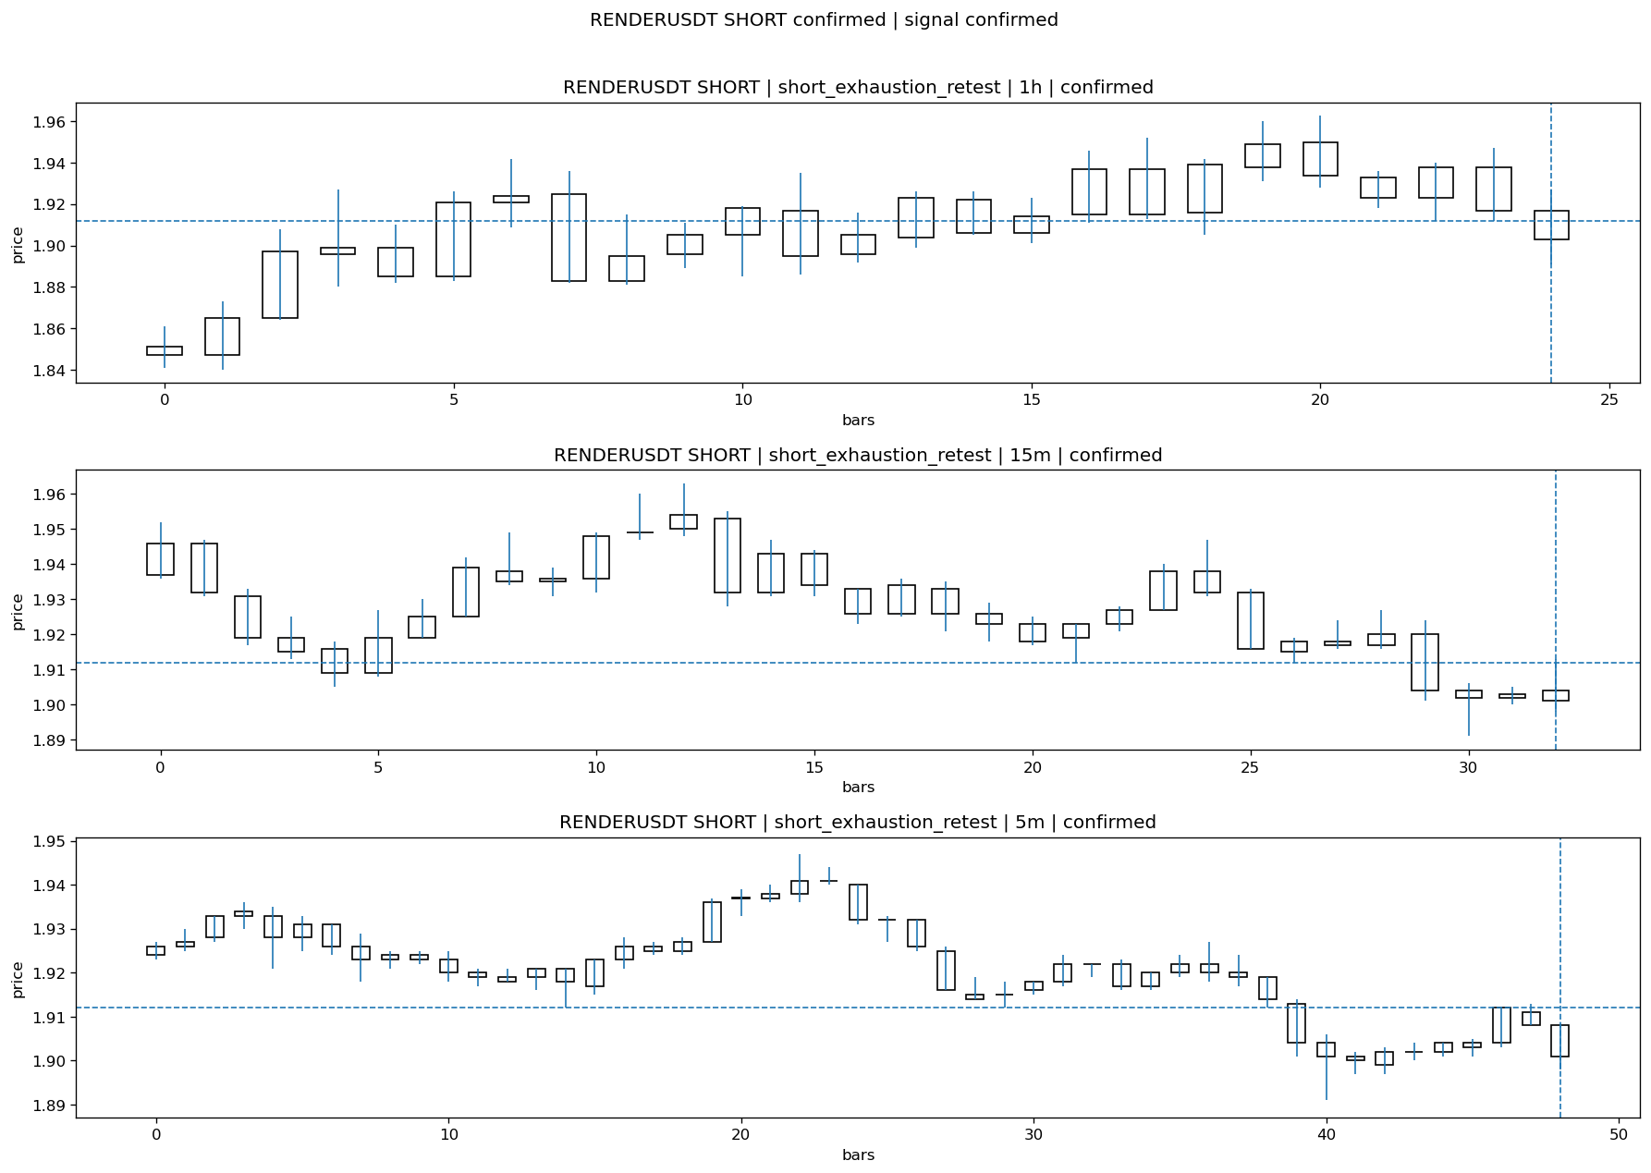
RENDERUSDT_SHORT_short_exhaustion_retest_confirmed_1775268912727.png

Case Close
Stage status: not_reached_yet | Content type: none
close_trigger_detail: signal confirmed
Note: NOT REACHED YET

Post-Close Outcome
1h outcome | available=Y | favor=0.5753 | adverse=0.4707
2h outcome | available=Y | favor=0.5753 | adverse=0.7322
4h reference | favor=0.8891 | adverse=0.7322
Reclaim | 2h=Y | 4h=Y
Execution | entry_feasible=Y | window=10m | note=entry still reachable within 10m
Time-to-move | to_favor=5m | to_adverse=95m
Regret filter | regret_valid=N | reason=no_meaningful_fast_move
Conclusion | NO_MEANINGFUL_MOVE | notes=entry_ref_from_breakout_level

Review placeholders
human_review_status=PENDING | verdict_code= | root_cause_code= | action_candidate_code=

Case 17: WIFUSDT-SHORT-EXH-1775265300000
Summary | WIFUSDT | SHORT | short_exhaustion_retest | status=CONFIRMED | close_reason=signal confirmed
Times | signal=2026-04-04 08:15:00 | created=2026-04-04 08:31:40 | confirmed=2026-04-04 09:01:26 | sent= | close=not_reached_yet | fallback_due=2026-04-04 12:31:40
Semantics | is_confirmed=Y | is_sent_signal=N | review_eligible=Y | semantic_consistency=Y
Review integrity | review_exclusion_reason= | semantic_issue=
Close anchoring | case_close_type=not_due_yet | close_anchor_time= | close_capture_basis=not_due_yet
Regime / dispatch | regime_label=trend_continuation_friendly | fit=LOW | dispatch=not_evaluated [not_evaluated]
Tradeability | entry_feasible=Y | slippage=0.0000 | regret_valid=Y | outcome=WAIT_TOO_SHORT_CANDIDATE

Pre Pending
Stage status: capture_failed | Content type: none
Note: pre_fix_backfill_v2 — was missing_unexpected, snapshot was never taken (Sprint 3A.2 bug)

Pending Open
Stage status: capture_failed | Content type: none
Note: pre_fix_backfill_v2 — was missing_unexpected, snapshot was never taken (Sprint 3A.2 bug)

Entry Or Confirm
Stage status: captured | Content type: chart_snapshot
Note: signal confirmed
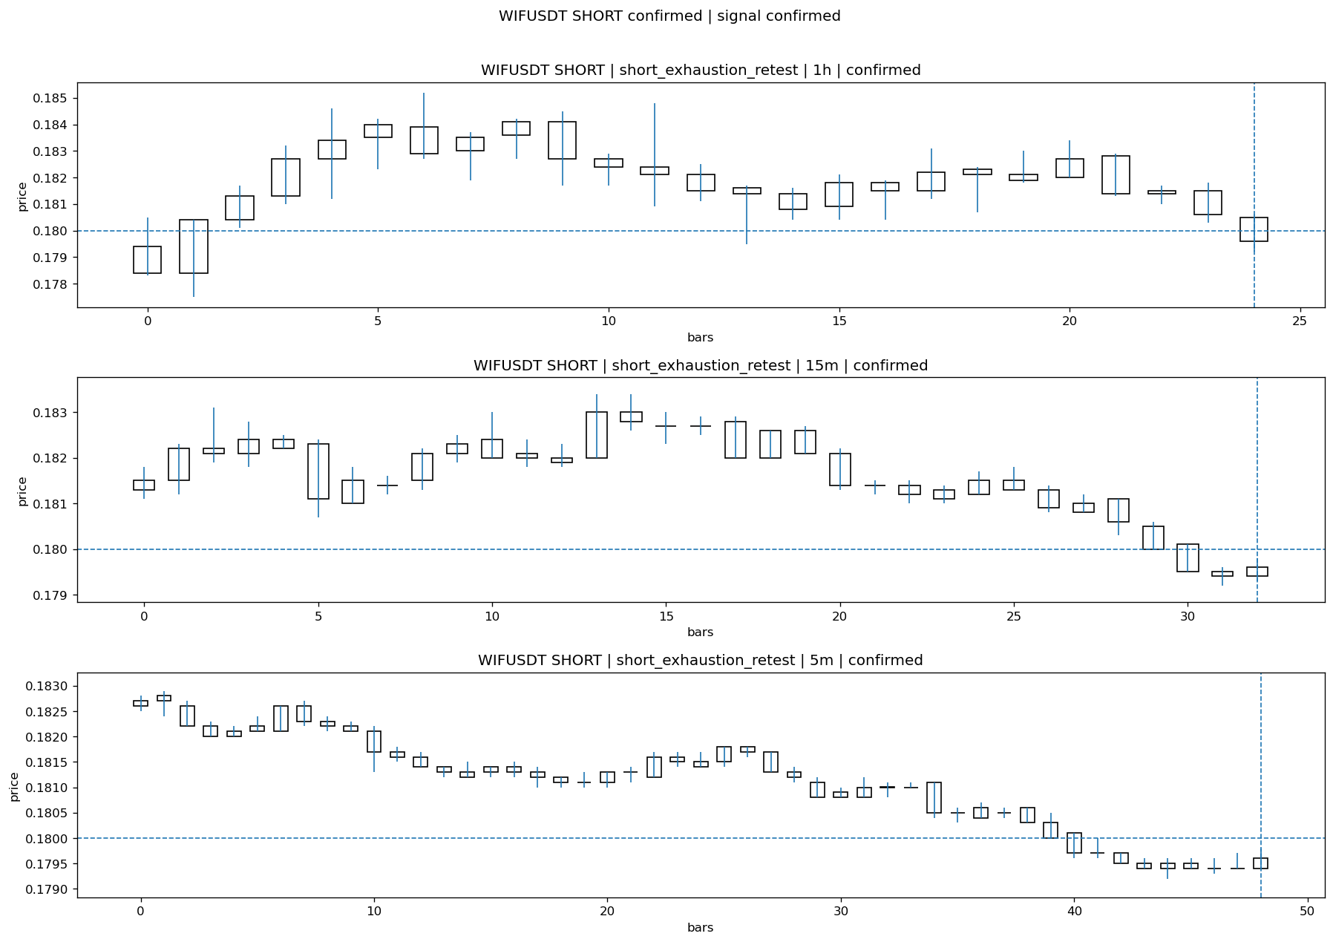
WIFUSDT_SHORT_short_exhaustion_retest_confirmed_1775268086635.png

Case Close
Stage status: not_reached_yet | Content type: none
close_trigger_detail: signal confirmed
Note: NOT REACHED YET

Post-Close Outcome
1h outcome | available=Y | favor=1.3333 | adverse=0.0000
2h outcome | available=Y | favor=1.3333 | adverse=0.0000
4h reference | favor=1.3333 | adverse=0.1111
Reclaim | 2h=N | 4h=Y
Execution | entry_feasible=Y | window=10m | note=entry still reachable within 10m
Time-to-move | to_favor=59m | to_adverse=4m
Regret filter | regret_valid=Y | reason=valid_missed_continuation
Conclusion | WAIT_TOO_SHORT_CANDIDATE | notes=entry_ref_from_breakout_level

Review placeholders
human_review_status=PENDING | verdict_code= | root_cause_code= | action_candidate_code=

Case 18: BRUSDT-LONG-1775265900000
Summary | BRUSDT | LONG | long_breakout_retest | status=INVALIDATED | close_reason=retest invalidated
Times | signal=2026-04-04 08:25:00 | created=2026-04-04 08:34:07 | confirmed= | sent= | close=2026-04-04 08:36:34 | fallback_due=2026-04-04 12:34:07
Semantics | is_confirmed=N | is_sent_signal=N | review_eligible=Y | semantic_consistency=Y
Review integrity | review_exclusion_reason= | semantic_issue=
Close anchoring | case_close_type=true_close | close_anchor_time=2026-04-04 08:36:34 | close_capture_basis=true_close
Regime / dispatch | regime_label=trend_continuation_friendly | fit=HIGH | dispatch=not_evaluated [not_evaluated]
Tradeability | entry_feasible=Y | slippage=0.0000 | regret_valid=N | outcome=KILL_CORRECT

Pre Pending
Stage status: capture_failed | Content type: none
Note: pre_fix_backfill_v2 — was missing_unexpected, snapshot was never taken (Sprint 3A.2 bug)

Pending Open
Stage status: capture_failed | Content type: none
Note: pre_fix_backfill_v2 — was missing_unexpected, snapshot was never taken (Sprint 3A.2 bug)

Entry Or Confirm
Stage status: not_applicable | Content type: none

Case Close
Stage status: captured | Content type: chart_snapshot
close_trigger_detail: retest invalidated
invalidation_detail: retest invalidated
Note: retest invalidated
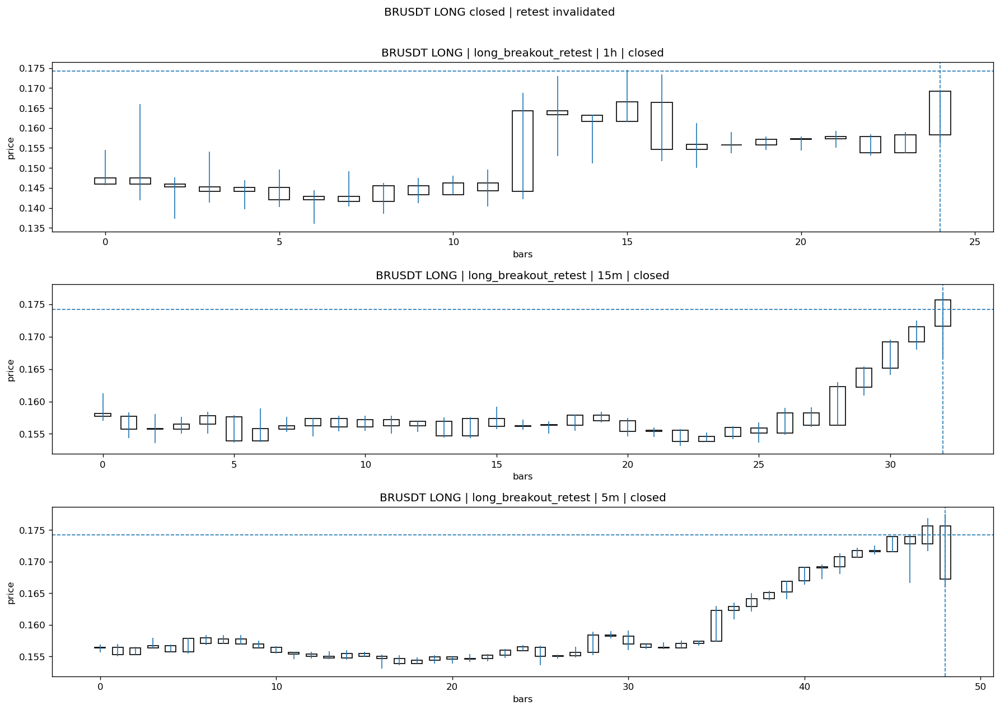
BRUSDT_LONG_long_breakout_retest_closed_1775266594485.png

Post-Close Outcome
1h outcome | available=Y | favor=0.0000 | adverse=10.9070
2h outcome | available=Y | favor=0.0000 | adverse=10.9070
4h reference | favor=2.6062 | adverse=10.9070
Reclaim | 2h=Y | 4h=Y
Execution | entry_feasible=Y | window=10m | note=entry still reachable within 10m
Time-to-move | to_favor=58m | to_adverse=28m
Regret filter | regret_valid=N | reason=adverse_too_large
Conclusion | KILL_CORRECT | notes=entry_ref_from_breakout_level

Review placeholders
human_review_status=PENDING | verdict_code= | root_cause_code= | action_candidate_code=

Case 19: HEMIUSDT-LONG-1775266200000
Summary | HEMIUSDT | LONG | long_breakout_retest | status=INVALIDATED | close_reason=retest invalidated
Times | signal=2026-04-04 08:30:00 | created=2026-04-04 08:37:16 | confirmed= | sent= | close=2026-04-04 08:42:07 | fallback_due=2026-04-04 12:37:16
Semantics | is_confirmed=N | is_sent_signal=N | review_eligible=Y | semantic_consistency=Y
Review integrity | review_exclusion_reason= | semantic_issue=
Close anchoring | case_close_type=true_close | close_anchor_time=2026-04-04 08:42:07 | close_capture_basis=true_close
Regime / dispatch | regime_label=trend_continuation_friendly | fit=HIGH | dispatch=not_evaluated [not_evaluated]
Tradeability | entry_feasible=Y | slippage=0.0000 | regret_valid=N | outcome=KILL_CORRECT

Pre Pending
Stage status: capture_failed | Content type: none
Note: pre_fix_backfill_v2 — was missing_unexpected, snapshot was never taken (Sprint 3A.2 bug)

Pending Open
Stage status: capture_failed | Content type: none
Note: pre_fix_backfill_v2 — was missing_unexpected, snapshot was never taken (Sprint 3A.2 bug)

Entry Or Confirm
Stage status: not_applicable | Content type: none

Case Close
Stage status: captured | Content type: chart_snapshot
close_trigger_detail: retest invalidated
invalidation_detail: retest invalidated
Note: retest invalidated
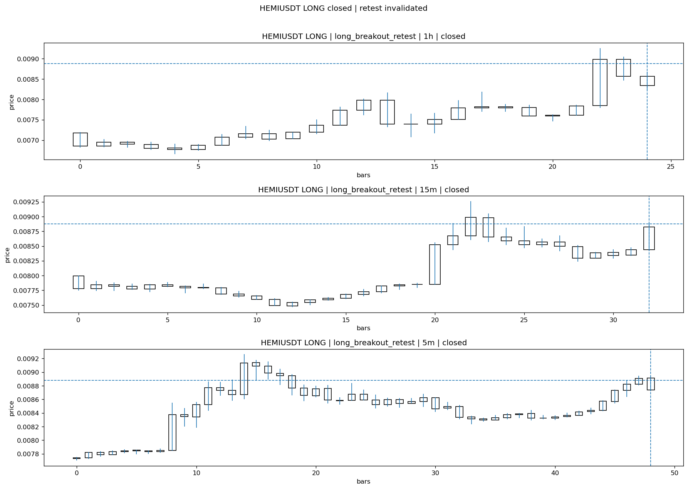
HEMIUSDT_LONG_long_breakout_retest_closed_1775266927226.png

Post-Close Outcome
1h outcome | available=Y | favor=0.5745 | adverse=3.9536
2h outcome | available=Y | favor=0.5745 | adverse=8.2676
4h reference | favor=0.5745 | adverse=9.2363
Reclaim | 2h=Y | 4h=Y
Execution | entry_feasible=Y | window=10m | note=entry still reachable within 10m
Time-to-move | to_favor=38m | to_adverse=98m
Regret filter | regret_valid=N | reason=adverse_too_large
Conclusion | KILL_CORRECT | notes=entry_ref_from_breakout_level

Review placeholders
human_review_status=PENDING | verdict_code= | root_cause_code= | action_candidate_code=

Case 20: CUSDT-LONG-1775267100000
Summary | CUSDT | LONG | long_breakout_retest | status=EXPIRED_WAIT | close_reason=retest wait expired
Times | signal=2026-04-04 08:45:00 | created=2026-04-04 08:53:31 | confirmed= | sent= | close=2026-04-04 09:31:45 | fallback_due=2026-04-04 12:53:31
Semantics | is_confirmed=N | is_sent_signal=N | review_eligible=Y | semantic_consistency=Y
Review integrity | review_exclusion_reason= | semantic_issue=
Close anchoring | case_close_type=true_close | close_anchor_time=2026-04-04 09:31:45 | close_capture_basis=true_close
Regime / dispatch | regime_label=trend_continuation_friendly | fit=HIGH | dispatch=not_evaluated [not_evaluated]
Tradeability | entry_feasible=Y | slippage=0.0000 | regret_valid=N | outcome=NO_MEANINGFUL_MOVE

Pre Pending
Stage status: capture_failed | Content type: none
Note: pre_fix_backfill_v2 — was missing_unexpected, snapshot was never taken (Sprint 3A.2 bug)

Pending Open
Stage status: capture_failed | Content type: none
Note: pre_fix_backfill_v2 — was missing_unexpected, snapshot was never taken (Sprint 3A.2 bug)

Entry Or Confirm
Stage status: not_applicable | Content type: none
confirm_fail_detail: retest wait expired

Case Close
Stage status: captured | Content type: chart_snapshot
close_trigger_detail: retest wait expired
Note: retest wait expired
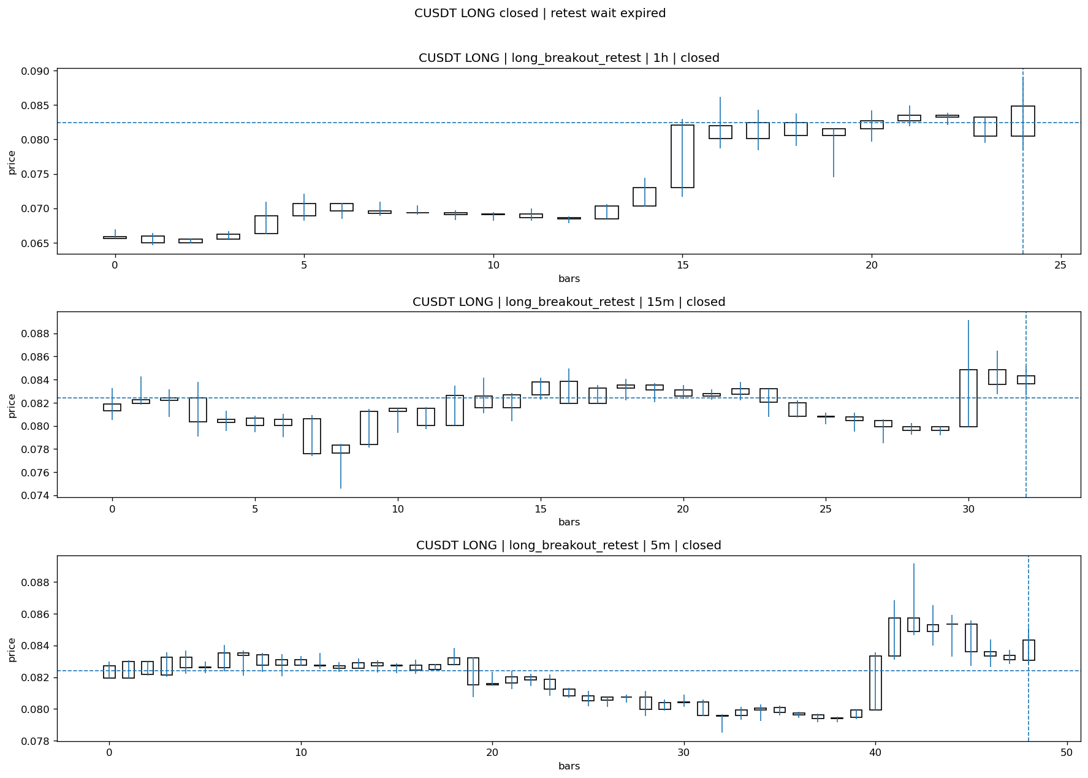
CUSDT_LONG_long_breakout_retest_closed_1775269905573.png

Post-Close Outcome
1h outcome | available=Y | favor=0.8250 | adverse=2.7906
2h outcome | available=Y | favor=0.8250 | adverse=5.3264
4h reference | favor=0.8250 | adverse=7.1099
Reclaim | 2h=Y | 4h=Y
Execution | entry_feasible=Y | window=10m | note=entry still reachable within 10m
Time-to-move | to_favor=3m | to_adverse=108m
Regret filter | regret_valid=N | reason=adverse_too_large
Conclusion | NO_MEANINGFUL_MOVE | notes=entry_ref_from_breakout_level

Review placeholders
human_review_status=PENDING | verdict_code= | root_cause_code= | action_candidate_code=

Case 21: SIRENUSDT-LONG-1775267700000
Summary | SIRENUSDT | LONG | long_breakout_retest | status=INVALIDATED | close_reason=retest invalidated
Times | signal=2026-04-04 08:55:00 | created=2026-04-04 09:01:37 | confirmed= | sent= | close=2026-04-04 09:12:27 | fallback_due=2026-04-04 13:01:37
Semantics | is_confirmed=N | is_sent_signal=N | review_eligible=Y | semantic_consistency=Y
Review integrity | review_exclusion_reason= | semantic_issue=
Close anchoring | case_close_type=true_close | close_anchor_time=2026-04-04 09:12:27 | close_capture_basis=true_close
Regime / dispatch | regime_label=trend_continuation_friendly | fit=HIGH | dispatch=not_evaluated [not_evaluated]
Tradeability | entry_feasible=Y | slippage=0.0000 | regret_valid=Y | outcome=WAIT_TOO_SHORT_CANDIDATE

Pre Pending
Stage status: capture_failed | Content type: none
Note: pre_fix_backfill_v2 — was missing_unexpected, snapshot was never taken (Sprint 3A.2 bug)

Pending Open
Stage status: capture_failed | Content type: none
Note: pre_fix_backfill_v2 — was missing_unexpected, snapshot was never taken (Sprint 3A.2 bug)

Entry Or Confirm
Stage status: not_applicable | Content type: none

Case Close
Stage status: captured | Content type: chart_snapshot
close_trigger_detail: retest invalidated
invalidation_detail: retest invalidated
Note: retest invalidated
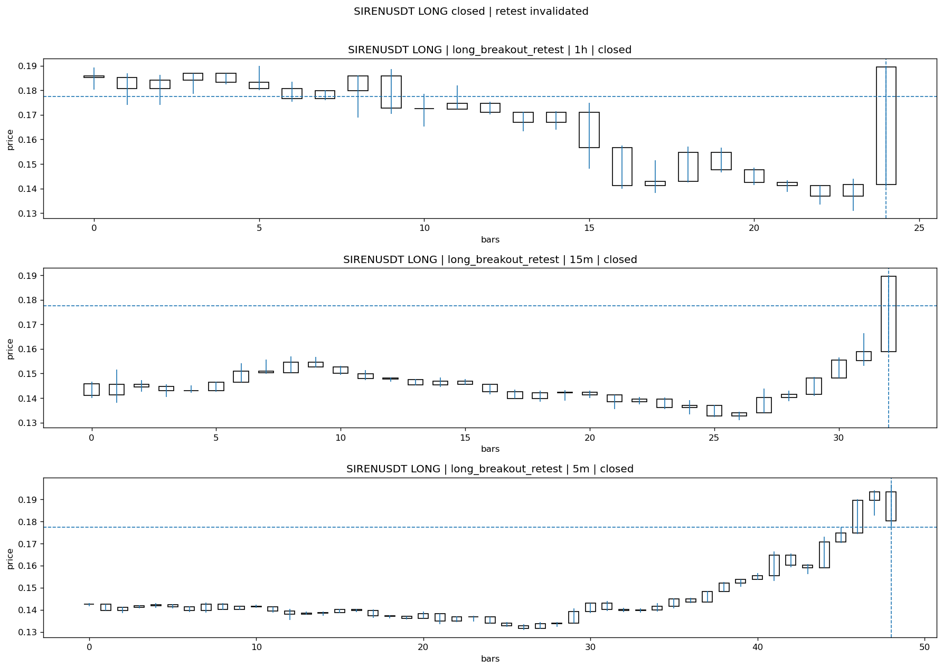
SIRENUSDT_LONG_long_breakout_retest_closed_1775268747349.png

Post-Close Outcome
1h outcome | available=Y | favor=58.3545 | adverse=7.5683
2h outcome | available=Y | favor=58.3545 | adverse=7.5683
4h reference | favor=58.3545 | adverse=7.5683
Reclaim | 2h=Y | 4h=Y
Execution | entry_feasible=Y | window=10m | note=entry still reachable within 10m
Time-to-move | to_favor=33m | to_adverse=48m
Regret filter | regret_valid=Y | reason=valid_missed_continuation
Conclusion | WAIT_TOO_SHORT_CANDIDATE | notes=entry_ref_from_breakout_level

Review placeholders
human_review_status=PENDING | verdict_code= | root_cause_code= | action_candidate_code=

Case 22: KERNELUSDT-LONG-1775268600000
Summary | KERNELUSDT | LONG | long_breakout_retest | status=INVALIDATED | close_reason=acceptance_floor_lost 0.120520<0.122759
Times | signal=2026-04-04 09:10:00 | created=2026-04-04 09:15:47 | confirmed= | sent= | close=2026-04-04 09:26:13 | fallback_due=2026-04-04 13:15:47
Semantics | is_confirmed=N | is_sent_signal=N | review_eligible=Y | semantic_consistency=Y
Review integrity | review_exclusion_reason= | semantic_issue=
Close anchoring | case_close_type=true_close | close_anchor_time=2026-04-04 09:26:13 | close_capture_basis=true_close
Regime / dispatch | regime_label=trend_continuation_friendly | fit=HIGH | dispatch=not_evaluated [not_evaluated]
Tradeability | entry_feasible=Y | slippage=0.0000 | regret_valid=Y | outcome=WAIT_TOO_SHORT_CANDIDATE

Pre Pending
Stage status: capture_failed | Content type: none
Note: pre_fix_backfill_v2 — was missing_unexpected, snapshot was never taken (Sprint 3A.2 bug)

Pending Open
Stage status: capture_failed | Content type: none
Note: pre_fix_backfill_v2 — was missing_unexpected, snapshot was never taken (Sprint 3A.2 bug)

Entry Or Confirm
Stage status: not_applicable | Content type: none

Case Close
Stage status: captured | Content type: chart_snapshot
close_trigger_detail: acceptance_floor_lost 0.120520<0.122759
invalidation_detail: acceptance_floor_lost 0.120520<0.122759
Note: acceptance_floor_lost 0.120520<0.122759
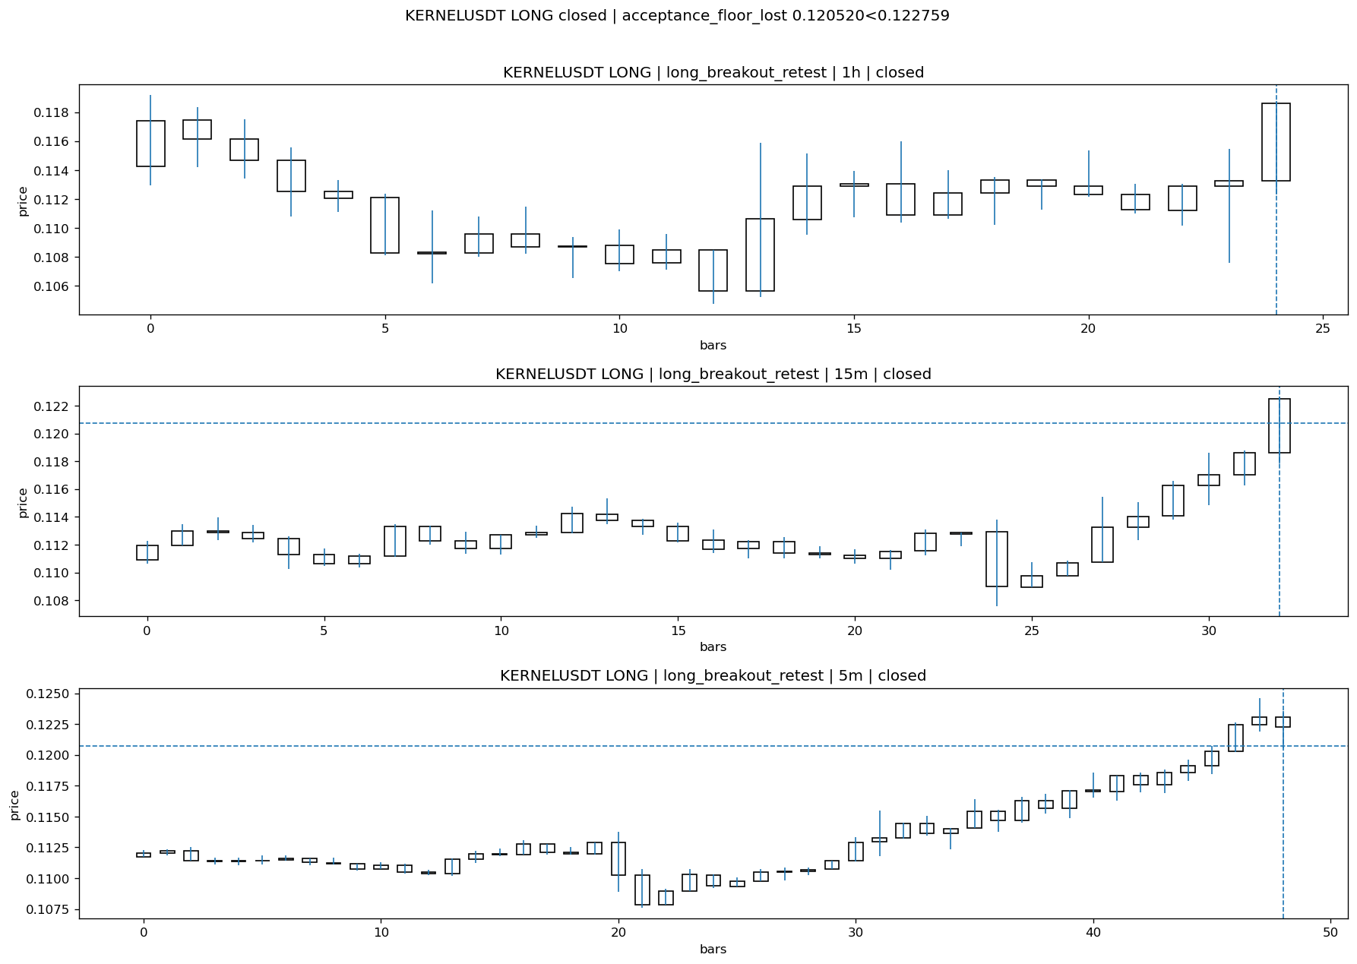
KERNELUSDT_LONG_long_breakout_retest_closed_1775269573615.png

Post-Close Outcome
1h outcome | available=Y | favor=9.0194 | adverse=0.0000
2h outcome | available=Y | favor=9.0194 | adverse=0.0000
4h reference | favor=9.2596 | adverse=1.6896
Reclaim | 2h=N | 4h=Y
Execution | entry_feasible=Y | window=10m | note=entry still reachable within 10m
Time-to-move | to_favor=24m | to_adverse=9m
Regret filter | regret_valid=Y | reason=valid_missed_continuation
Conclusion | WAIT_TOO_SHORT_CANDIDATE | notes=entry_ref_from_breakout_level

Review placeholders
human_review_status=PENDING | verdict_code= | root_cause_code= | action_candidate_code=

Case 23: 币安人生USDT-LONG-1775268600000
Summary | 币安人生USDT | LONG | long_breakout_retest | status=INVALIDATED | close_reason=retest invalidated
Times | signal=2026-04-04 09:10:00 | created=2026-04-04 09:18:21 | confirmed= | sent= | close=2026-04-04 09:26:14 | fallback_due=2026-04-04 13:18:21
Semantics | is_confirmed=N | is_sent_signal=N | review_eligible=Y | semantic_consistency=Y
Review integrity | review_exclusion_reason= | semantic_issue=
Close anchoring | case_close_type=true_close | close_anchor_time=2026-04-04 09:26:14 | close_capture_basis=true_close
Regime / dispatch | regime_label=trend_continuation_friendly | fit=HIGH | dispatch=not_evaluated [not_evaluated]
Tradeability | entry_feasible=Y | slippage=0.0000 | regret_valid=N | outcome=KILL_CORRECT

Pre Pending
Stage status: capture_failed | Content type: none
Note: pre_fix_backfill_v2 — was missing_unexpected, snapshot was never taken (Sprint 3A.2 bug)

Pending Open
Stage status: capture_failed | Content type: none
Note: pre_fix_backfill_v2 — was missing_unexpected, snapshot was never taken (Sprint 3A.2 bug)

Entry Or Confirm
Stage status: not_applicable | Content type: none

Case Close
Stage status: captured | Content type: chart_snapshot
close_trigger_detail: retest invalidated
invalidation_detail: retest invalidated
Note: retest invalidated
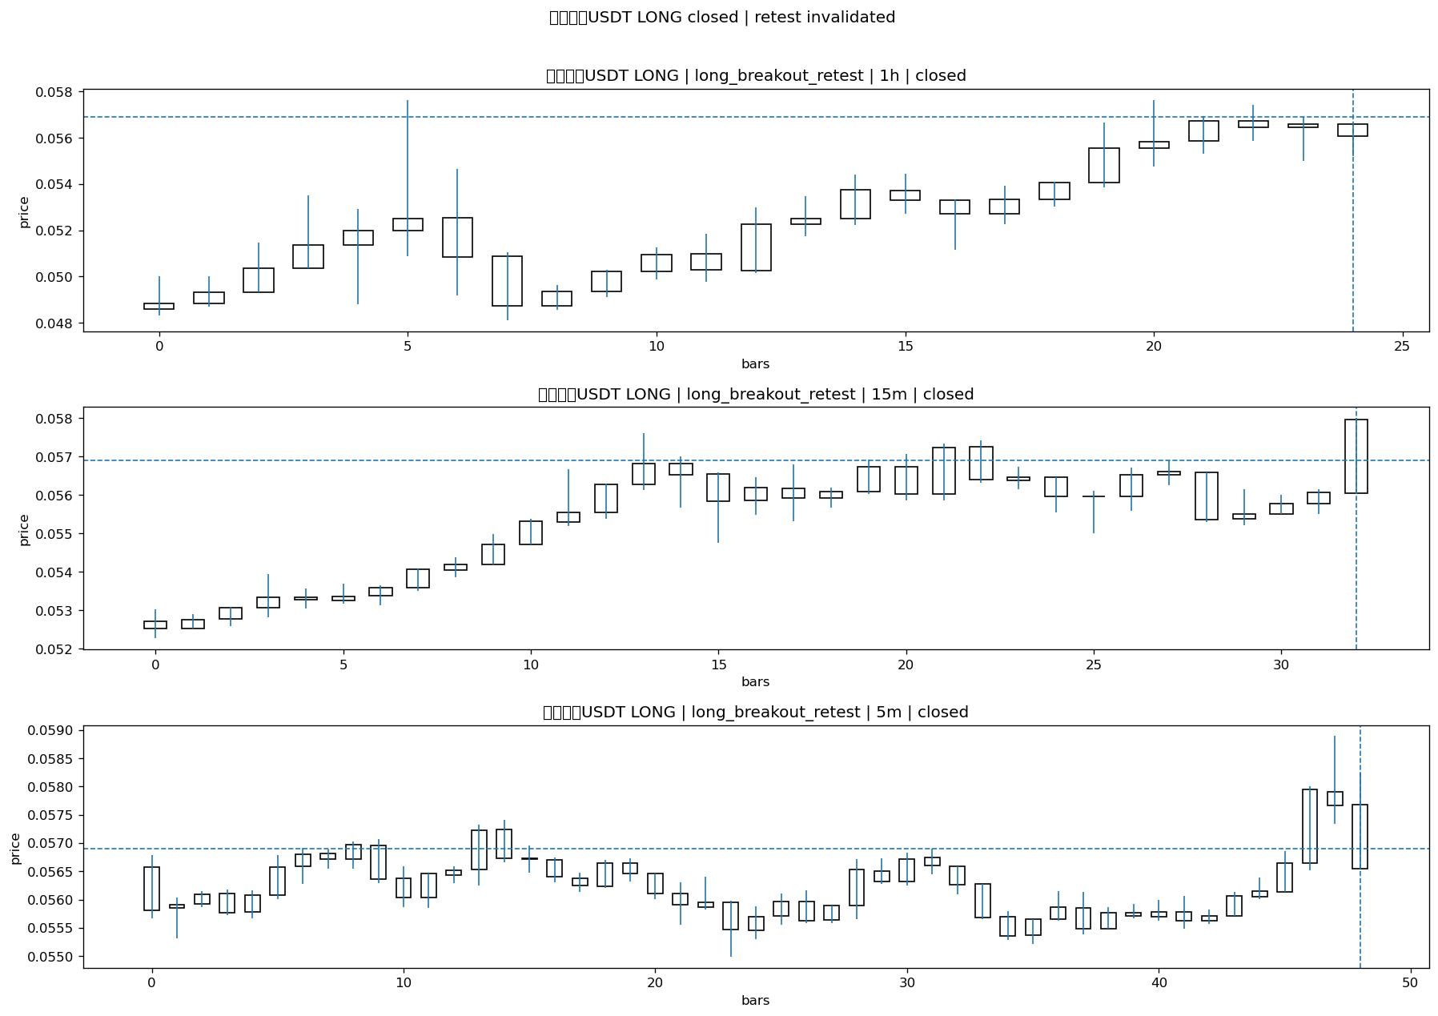
USDT_LONG_long_breakout_retest_closed_1775269574561.png

Post-Close Outcome
1h outcome | available=Y | favor=0.0000 | adverse=6.0281
2h outcome | available=Y | favor=0.0000 | adverse=6.0281
4h reference | favor=0.0000 | adverse=6.0281
Reclaim | 2h=Y | 4h=Y
Execution | entry_feasible=Y | window=10m | note=entry still reachable within 10m
Time-to-move | to_favor=4m | to_adverse=19m
Regret filter | regret_valid=N | reason=adverse_too_large
Conclusion | KILL_CORRECT | notes=entry_ref_from_breakout_level

Review placeholders
human_review_status=PENDING | verdict_code= | root_cause_code= | action_candidate_code=

Case 24: ONGUSDT-LONG-1775268900000
Summary | ONGUSDT | LONG | long_breakout_retest | status=INVALIDATED | close_reason=retest invalidated
Times | signal=2026-04-04 09:15:00 | created=2026-04-04 09:20:49 | confirmed= | sent= | close=2026-04-04 09:37:18 | fallback_due=2026-04-04 13:20:49
Semantics | is_confirmed=N | is_sent_signal=N | review_eligible=Y | semantic_consistency=Y
Review integrity | review_exclusion_reason= | semantic_issue=
Close anchoring | case_close_type=true_close | close_anchor_time=2026-04-04 09:37:18 | close_capture_basis=true_close
Regime / dispatch | regime_label=trend_continuation_friendly | fit=HIGH | dispatch=not_evaluated [not_evaluated]
Tradeability | entry_feasible=Y | slippage=0.0000 | regret_valid=N | outcome=KILL_CORRECT

Pre Pending
Stage status: capture_failed | Content type: none
Note: pre_fix_backfill_v2 — was missing_unexpected, snapshot was never taken (Sprint 3A.2 bug)

Pending Open
Stage status: capture_failed | Content type: none
Note: pre_fix_backfill_v2 — was missing_unexpected, snapshot was never taken (Sprint 3A.2 bug)

Entry Or Confirm
Stage status: not_applicable | Content type: none

Case Close
Stage status: captured | Content type: chart_snapshot
close_trigger_detail: retest invalidated
invalidation_detail: retest invalidated
Note: retest invalidated
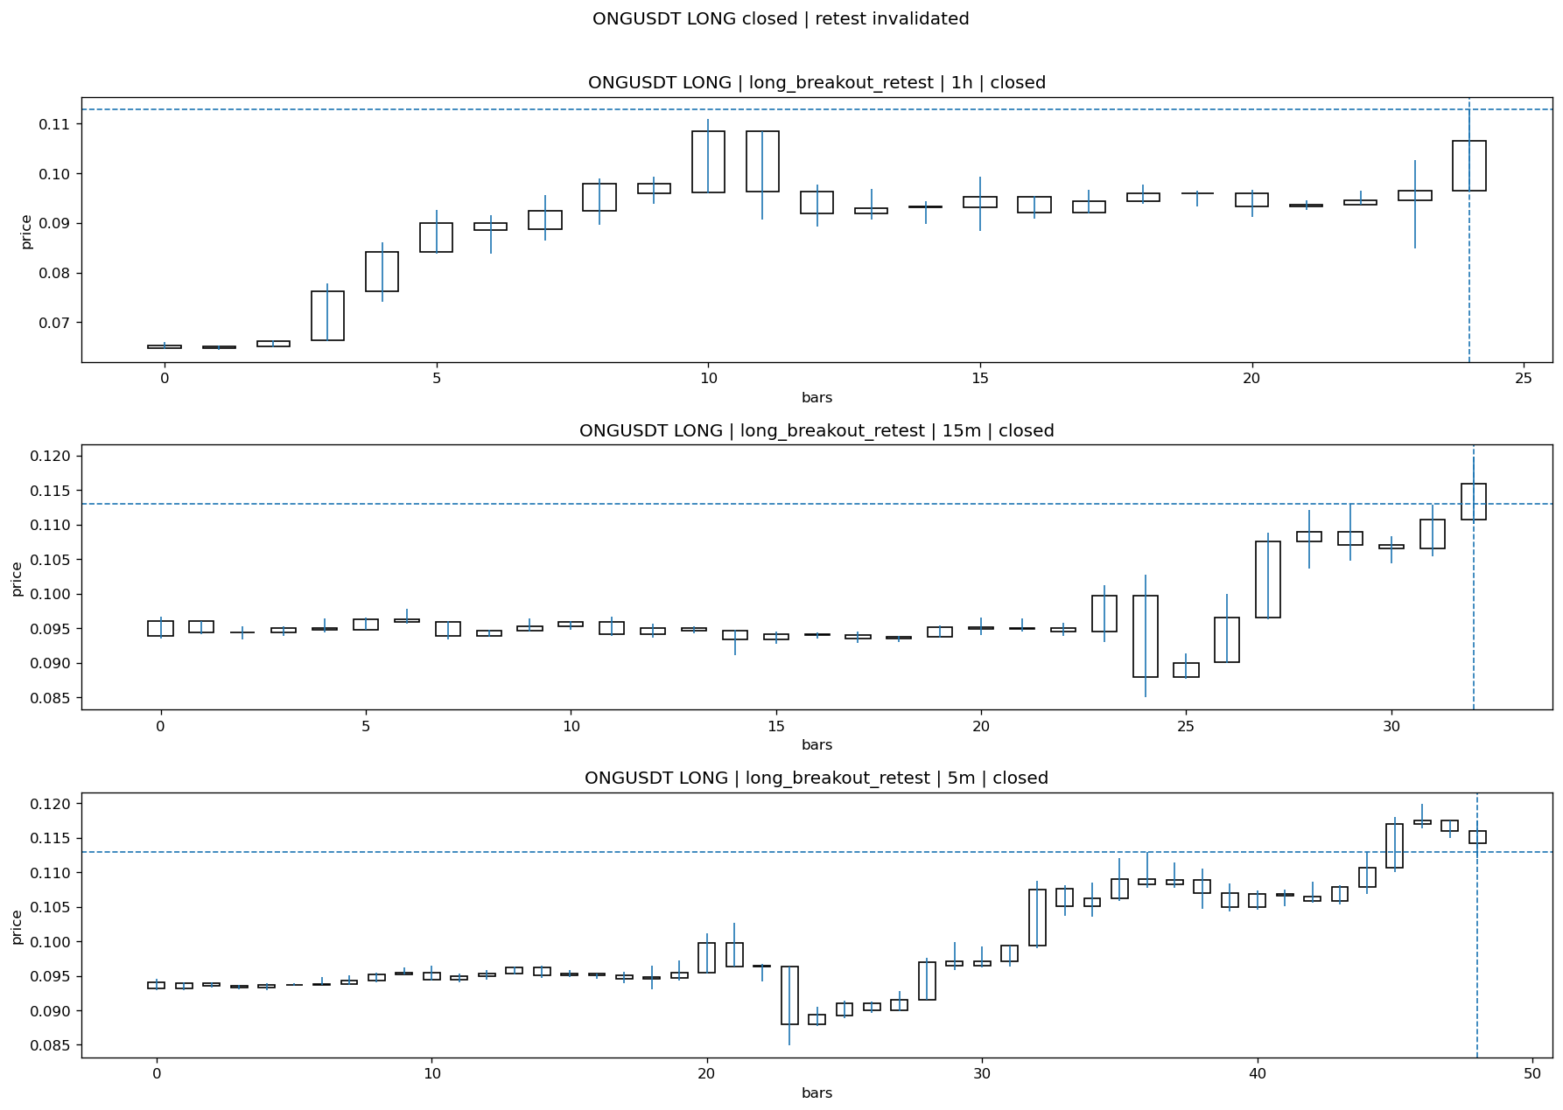
ONGUSDT_LONG_long_breakout_retest_closed_1775270238315.png

Post-Close Outcome
1h outcome | available=Y | favor=4.1704 | adverse=1.4610
2h outcome | available=Y | favor=4.1704 | adverse=5.1709
4h reference | favor=4.1704 | adverse=8.2168
Reclaim | 2h=Y | 4h=Y
Execution | entry_feasible=Y | window=10m | note=entry still reachable within 10m
Time-to-move | to_favor=23m | to_adverse=83m
Regret filter | regret_valid=N | reason=adverse_too_large
Conclusion | KILL_CORRECT | notes=entry_ref_from_breakout_level

Review placeholders
human_review_status=PENDING | verdict_code= | root_cause_code= | action_candidate_code=

Case 25: SIRENUSDT-LONG-1775268900000
Summary | SIRENUSDT | LONG | long_breakout_retest | status=INVALIDATED | close_reason=retest invalidated
Times | signal=2026-04-04 09:15:00 | created=2026-04-04 09:20:53 | confirmed= | sent= | close=2026-04-04 10:02:13 | fallback_due=2026-04-04 13:20:53
Semantics | is_confirmed=N | is_sent_signal=N | review_eligible=Y | semantic_consistency=Y
Review integrity | review_exclusion_reason= | semantic_issue=
Close anchoring | case_close_type=true_close | close_anchor_time=2026-04-04 10:02:13 | close_capture_basis=true_close
Regime / dispatch | regime_label=trend_continuation_friendly | fit=HIGH | dispatch=not_evaluated [not_evaluated]
Tradeability | entry_feasible=Y | slippage=0.0000 | regret_valid=Y | outcome=WAIT_TOO_SHORT_CANDIDATE

Pre Pending
Stage status: capture_failed | Content type: none
Note: pre_fix_backfill_v2 — was missing_unexpected, snapshot was never taken (Sprint 3A.2 bug)

Pending Open
Stage status: capture_failed | Content type: none
Note: pre_fix_backfill_v2 — was missing_unexpected, snapshot was never taken (Sprint 3A.2 bug)

Entry Or Confirm
Stage status: not_applicable | Content type: none

Case Close
Stage status: captured | Content type: chart_snapshot
close_trigger_detail: retest invalidated
invalidation_detail: retest invalidated
Note: retest invalidated
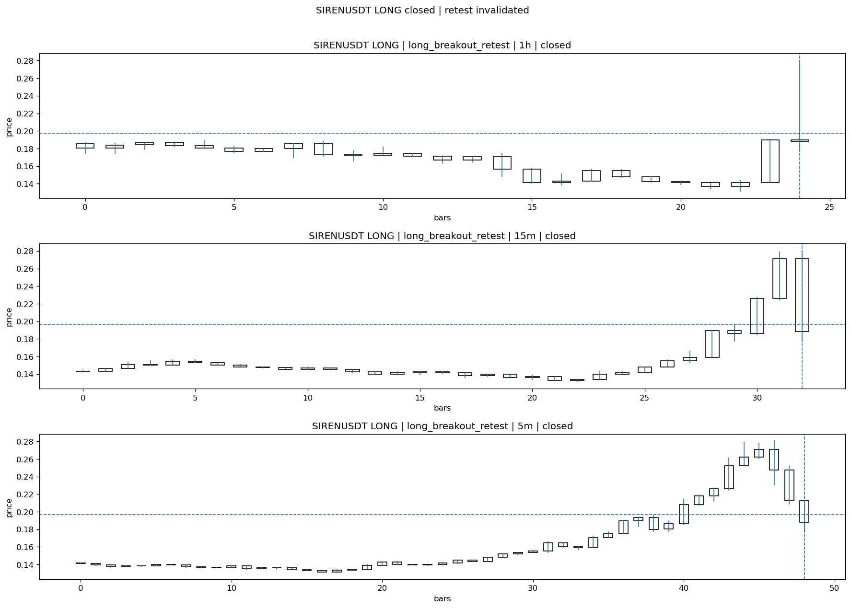
SIRENUSDT_LONG_long_breakout_retest_closed_1775271733332.png

Post-Close Outcome
1h outcome | available=Y | favor=36.3174 | adverse=13.9471
2h outcome | available=Y | favor=36.3174 | adverse=13.9471
4h reference | favor=36.3174 | adverse=13.9471
Reclaim | 2h=Y | 4h=Y
Execution | entry_feasible=Y | window=10m | note=entry still reachable within 10m
Time-to-move | to_favor=58m | to_adverse=3m
Regret filter | regret_valid=Y | reason=valid_missed_continuation
Conclusion | WAIT_TOO_SHORT_CANDIDATE | notes=entry_ref_from_breakout_level

Review placeholders
human_review_status=PENDING | verdict_code= | root_cause_code= | action_candidate_code=

Case 26: DUSDT-LONG-1775269200000
Summary | DUSDT | LONG | long_breakout_retest | status=INVALIDATED | close_reason=retest invalidated
Times | signal=2026-04-04 09:20:00 | created=2026-04-04 09:26:29 | confirmed= | sent= | close=2026-04-04 09:31:46 | fallback_due=2026-04-04 13:26:29
Semantics | is_confirmed=N | is_sent_signal=N | review_eligible=Y | semantic_consistency=Y
Review integrity | review_exclusion_reason= | semantic_issue=
Close anchoring | case_close_type=true_close | close_anchor_time=2026-04-04 09:31:46 | close_capture_basis=true_close
Regime / dispatch | regime_label=trend_continuation_friendly | fit=HIGH | dispatch=not_evaluated [not_evaluated]
Tradeability | entry_feasible=Y | slippage=0.0000 | regret_valid=N | outcome=KILL_CORRECT

Pre Pending
Stage status: capture_failed | Content type: none
Note: pre_fix_backfill_v2 — was missing_unexpected, snapshot was never taken (Sprint 3A.2 bug)

Pending Open
Stage status: capture_failed | Content type: none
Note: pre_fix_backfill_v2 — was missing_unexpected, snapshot was never taken (Sprint 3A.2 bug)

Entry Or Confirm
Stage status: not_applicable | Content type: none

Case Close
Stage status: captured | Content type: chart_snapshot
close_trigger_detail: retest invalidated
invalidation_detail: retest invalidated
Note: retest invalidated
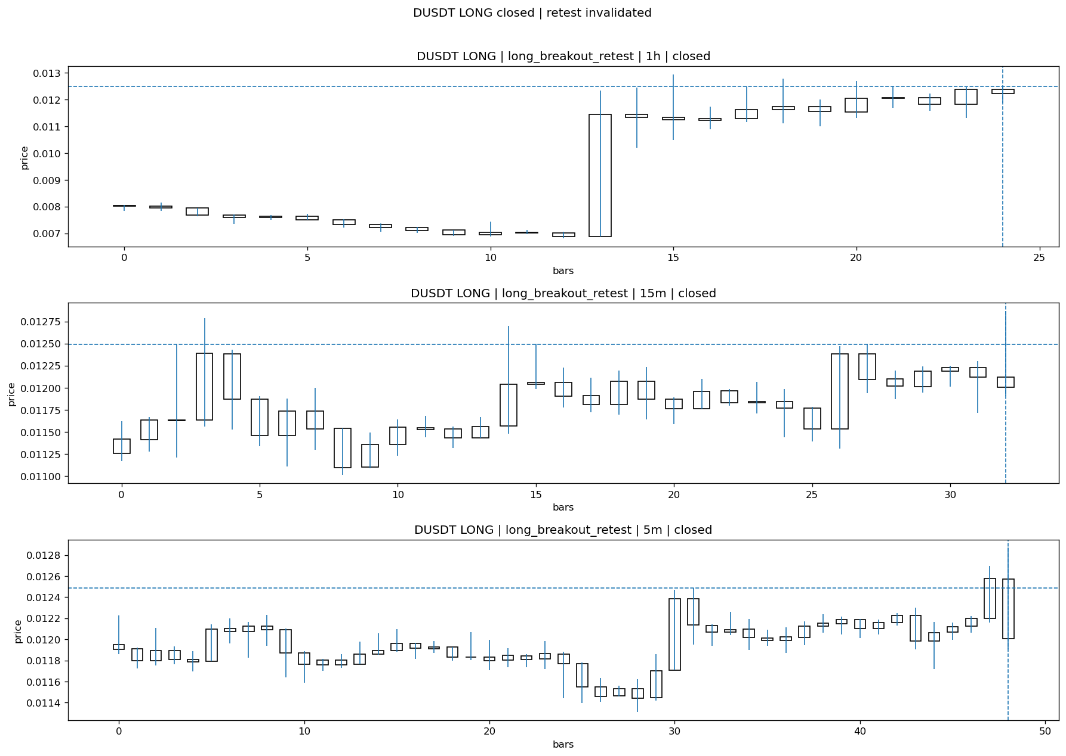
DUSDT_LONG_long_breakout_retest_closed_1775269906679.png

Post-Close Outcome
1h outcome | available=Y | favor=0.0000 | adverse=5.3407
2h outcome | available=Y | favor=1.6895 | adverse=5.3407
4h reference | favor=3.1628 | adverse=17.5274
Reclaim | 2h=Y | 4h=Y
Execution | entry_feasible=Y | window=10m | note=entry still reachable within 10m
Time-to-move | to_favor=103m | to_adverse=3m
Regret filter | regret_valid=N | reason=adverse_too_large
Conclusion | KILL_CORRECT | notes=entry_ref_from_breakout_level

Review placeholders
human_review_status=PENDING | verdict_code= | root_cause_code= | action_candidate_code=

Case 27: FIDAUSDT-LONG-1775269500000
Summary | FIDAUSDT | LONG | long_breakout_retest | status=INVALIDATED | close_reason=retest invalidated
Times | signal=2026-04-04 09:25:00 | created=2026-04-04 09:32:08 | confirmed= | sent= | close=2026-04-04 09:37:19 | fallback_due=2026-04-04 13:32:08
Semantics | is_confirmed=N | is_sent_signal=N | review_eligible=Y | semantic_consistency=Y
Review integrity | review_exclusion_reason= | semantic_issue=
Close anchoring | case_close_type=true_close | close_anchor_time=2026-04-04 09:37:19 | close_capture_basis=true_close
Regime / dispatch | regime_label=trend_continuation_friendly | fit=HIGH | dispatch=not_evaluated [not_evaluated]
Tradeability | entry_feasible=Y | slippage=0.0000 | regret_valid=N | outcome=KILL_CORRECT

Pre Pending
Stage status: capture_failed | Content type: none
Note: pre_fix_backfill_v2 — was missing_unexpected, snapshot was never taken (Sprint 3A.2 bug)

Pending Open
Stage status: capture_failed | Content type: none
Note: pre_fix_backfill_v2 — was missing_unexpected, snapshot was never taken (Sprint 3A.2 bug)

Entry Or Confirm
Stage status: not_applicable | Content type: none

Case Close
Stage status: captured | Content type: chart_snapshot
close_trigger_detail: retest invalidated
invalidation_detail: retest invalidated
Note: retest invalidated
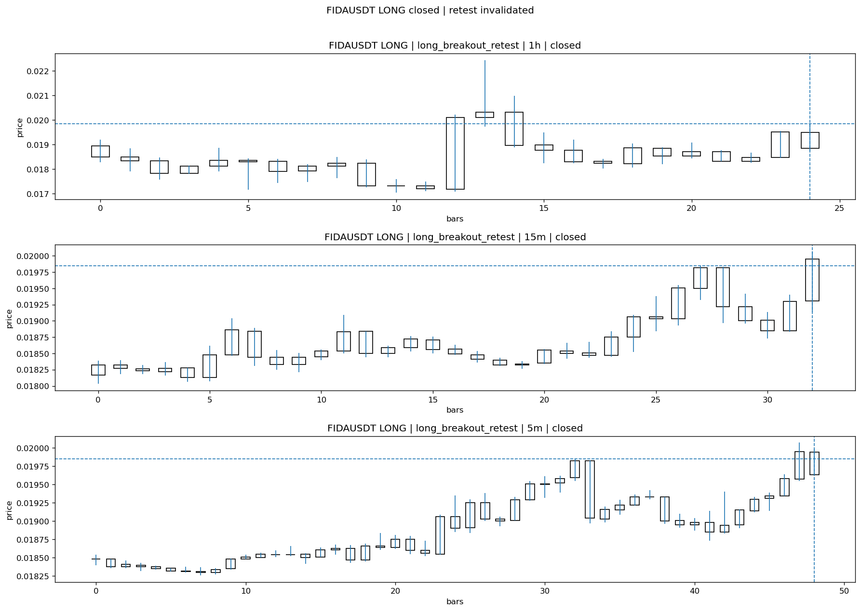
FIDAUSDT_LONG_long_breakout_retest_closed_1775270239425.png

Post-Close Outcome
1h outcome | available=Y | favor=2.4181 | adverse=2.7204
2h outcome | available=Y | favor=2.4181 | adverse=2.7204
4h reference | favor=11.9899 | adverse=2.7204
Reclaim | 2h=Y | 4h=Y
Execution | entry_feasible=Y | window=10m | note=entry still reachable within 10m
Time-to-move | to_favor=48m | to_adverse=18m
Regret filter | regret_valid=N | reason=adverse_too_large
Conclusion | KILL_CORRECT | notes=entry_ref_from_breakout_level

Review placeholders
human_review_status=PENDING | verdict_code= | root_cause_code= | action_candidate_code=

Case 28: CTSIUSDT-LONG-1775272800000
Summary | CTSIUSDT | LONG | long_breakout_retest | status=INVALIDATED | close_reason=retest invalidated
Times | signal=2026-04-04 10:20:00 | created=2026-04-04 10:26:09 | confirmed= | sent= | close=2026-04-04 10:31:30 | fallback_due=2026-04-04 14:26:09
Semantics | is_confirmed=N | is_sent_signal=N | review_eligible=Y | semantic_consistency=Y
Review integrity | review_exclusion_reason= | semantic_issue=
Close anchoring | case_close_type=true_close | close_anchor_time=2026-04-04 10:31:30 | close_capture_basis=true_close
Regime / dispatch | regime_label=trend_continuation_friendly | fit=HIGH | dispatch=not_evaluated [not_evaluated]
Tradeability | entry_feasible=Y | slippage=0.0000 | regret_valid=Y | outcome=WAIT_TOO_SHORT_CANDIDATE

Pre Pending
Stage status: capture_failed | Content type: none
Note: pre_fix_backfill_v2 — was missing_unexpected, snapshot was never taken (Sprint 3A.2 bug)

Pending Open
Stage status: capture_failed | Content type: none
Note: pre_fix_backfill_v2 — was missing_unexpected, snapshot was never taken (Sprint 3A.2 bug)

Entry Or Confirm
Stage status: not_applicable | Content type: none

Case Close
Stage status: captured | Content type: chart_snapshot
close_trigger_detail: retest invalidated
invalidation_detail: retest invalidated
Note: retest invalidated
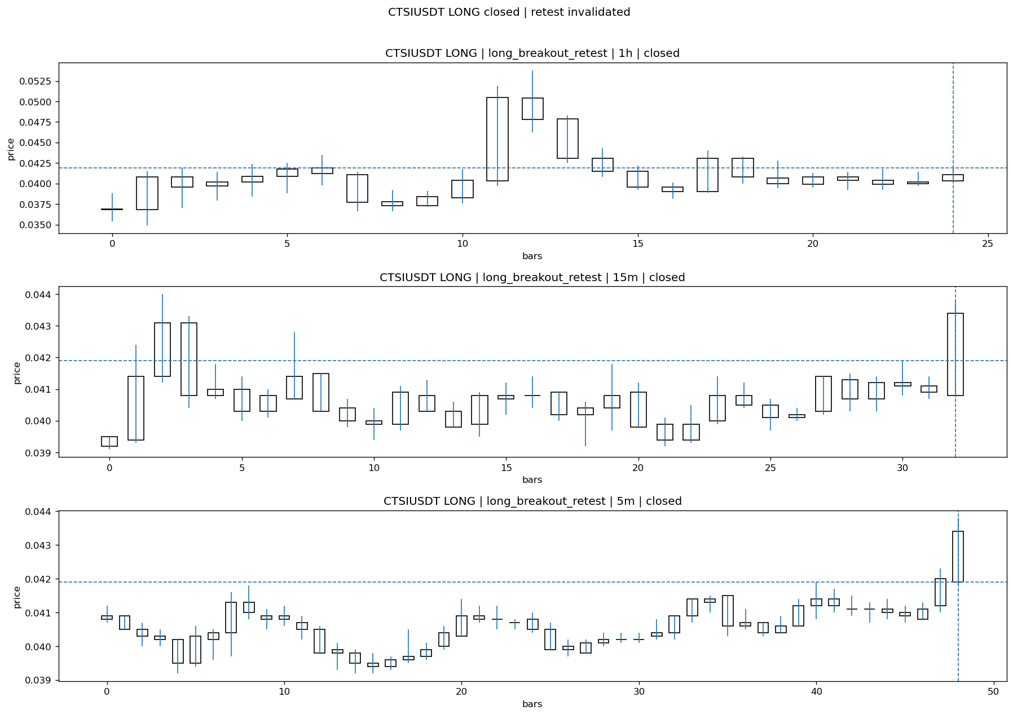
CTSIUSDT_LONG_long_breakout_retest_closed_1775273490921.png

Post-Close Outcome
1h outcome | available=Y | favor=4.0573 | adverse=2.1480
2h outcome | available=Y | favor=4.0573 | adverse=3.1026
4h reference | favor=4.0573 | adverse=3.8186
Reclaim | 2h=Y | 4h=Y
Execution | entry_feasible=Y | window=10m | note=entry still reachable within 10m
Time-to-move | to_favor=13m | to_adverse=118m
Regret filter | regret_valid=Y | reason=valid_missed_continuation
Conclusion | WAIT_TOO_SHORT_CANDIDATE | notes=entry_ref_from_breakout_level

Review placeholders
human_review_status=PENDING | verdict_code= | root_cause_code= | action_candidate_code=

Case 29: FIDAUSDT-LONG-1775272800000
Summary | FIDAUSDT | LONG | long_breakout_retest | status=INVALIDATED | close_reason=retest invalidated
Times | signal=2026-04-04 10:20:00 | created=2026-04-04 10:29:08 | confirmed= | sent= | close=2026-04-04 10:31:31 | fallback_due=2026-04-04 14:29:08
Semantics | is_confirmed=N | is_sent_signal=N | review_eligible=Y | semantic_consistency=Y
Review integrity | review_exclusion_reason= | semantic_issue=
Close anchoring | case_close_type=true_close | close_anchor_time=2026-04-04 10:31:31 | close_capture_basis=true_close
Regime / dispatch | regime_label=trend_continuation_friendly | fit=HIGH | dispatch=not_evaluated [not_evaluated]
Tradeability | entry_feasible=Y | slippage=0.0000 | regret_valid=N | outcome=KILL_CORRECT

Pre Pending
Stage status: capture_failed | Content type: none
Note: pre_fix_backfill_v2 — was missing_unexpected, snapshot was never taken (Sprint 3A.2 bug)

Pending Open
Stage status: capture_failed | Content type: none
Note: pre_fix_backfill_v2 — was missing_unexpected, snapshot was never taken (Sprint 3A.2 bug)

Entry Or Confirm
Stage status: not_applicable | Content type: none

Case Close
Stage status: captured | Content type: chart_snapshot
close_trigger_detail: retest invalidated
invalidation_detail: retest invalidated
Note: retest invalidated
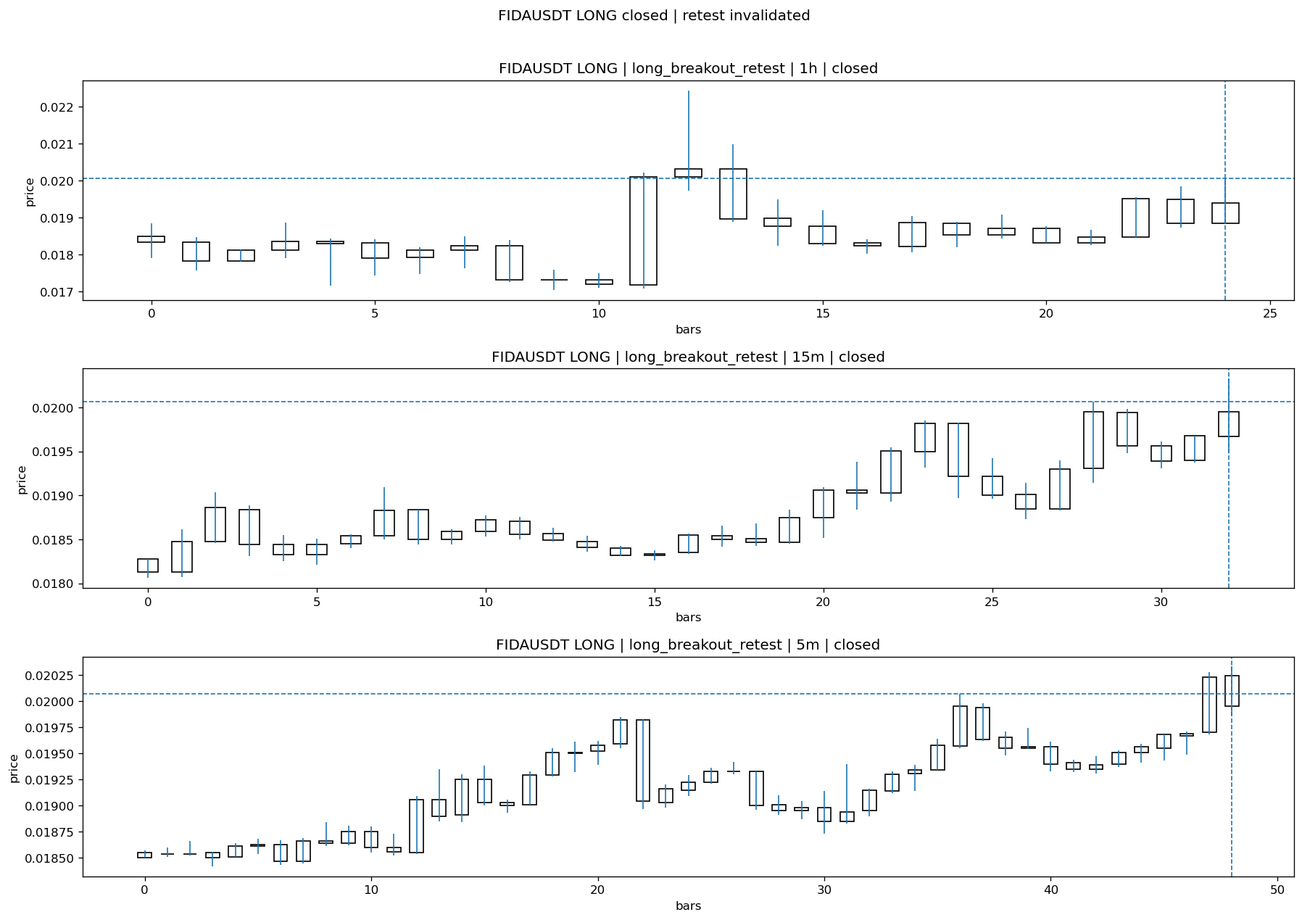
FIDAUSDT_LONG_long_breakout_retest_closed_1775273491970.png

Post-Close Outcome
1h outcome | available=Y | favor=0.1495 | adverse=3.0394
2h outcome | available=Y | favor=3.9860 | adverse=3.0394
4h reference | favor=10.7623 | adverse=3.0394
Reclaim | 2h=Y | 4h=Y
Execution | entry_feasible=Y | window=10m | note=entry still reachable within 10m
Time-to-move | to_favor=98m | to_adverse=18m
Regret filter | regret_valid=N | reason=no_meaningful_fast_move
Conclusion | KILL_CORRECT | notes=entry_ref_from_breakout_level

Review placeholders
human_review_status=PENDING | verdict_code= | root_cause_code= | action_candidate_code=

Case 30: POLYXUSDT-LONG-1775273100000
Summary | POLYXUSDT | LONG | long_breakout_retest | status=INVALIDATED | close_reason=acceptance_floor_lost 0.053720<0.054342
Times | signal=2026-04-04 10:25:00 | created=2026-04-04 10:30:29 | confirmed= | sent= | close=2026-04-04 10:35:16 | fallback_due=2026-04-04 14:30:29
Semantics | is_confirmed=N | is_sent_signal=N | review_eligible=Y | semantic_consistency=Y
Review integrity | review_exclusion_reason= | semantic_issue=
Close anchoring | case_close_type=true_close | close_anchor_time=2026-04-04 10:35:16 | close_capture_basis=true_close
Regime / dispatch | regime_label=trend_continuation_friendly | fit=HIGH | dispatch=not_evaluated [not_evaluated]
Tradeability | entry_feasible=Y | slippage=0.0000 | regret_valid=N | outcome=KILL_CORRECT

Pre Pending
Stage status: capture_failed | Content type: none
Note: pre_fix_backfill_v2 — was missing_unexpected, snapshot was never taken (Sprint 3A.2 bug)

Pending Open
Stage status: capture_failed | Content type: none
Note: pre_fix_backfill_v2 — was missing_unexpected, snapshot was never taken (Sprint 3A.2 bug)

Entry Or Confirm
Stage status: not_applicable | Content type: none

Case Close
Stage status: captured | Content type: chart_snapshot
close_trigger_detail: acceptance_floor_lost 0.053720<0.054342
invalidation_detail: acceptance_floor_lost 0.053720<0.054342
Note: acceptance_floor_lost 0.053720<0.054342
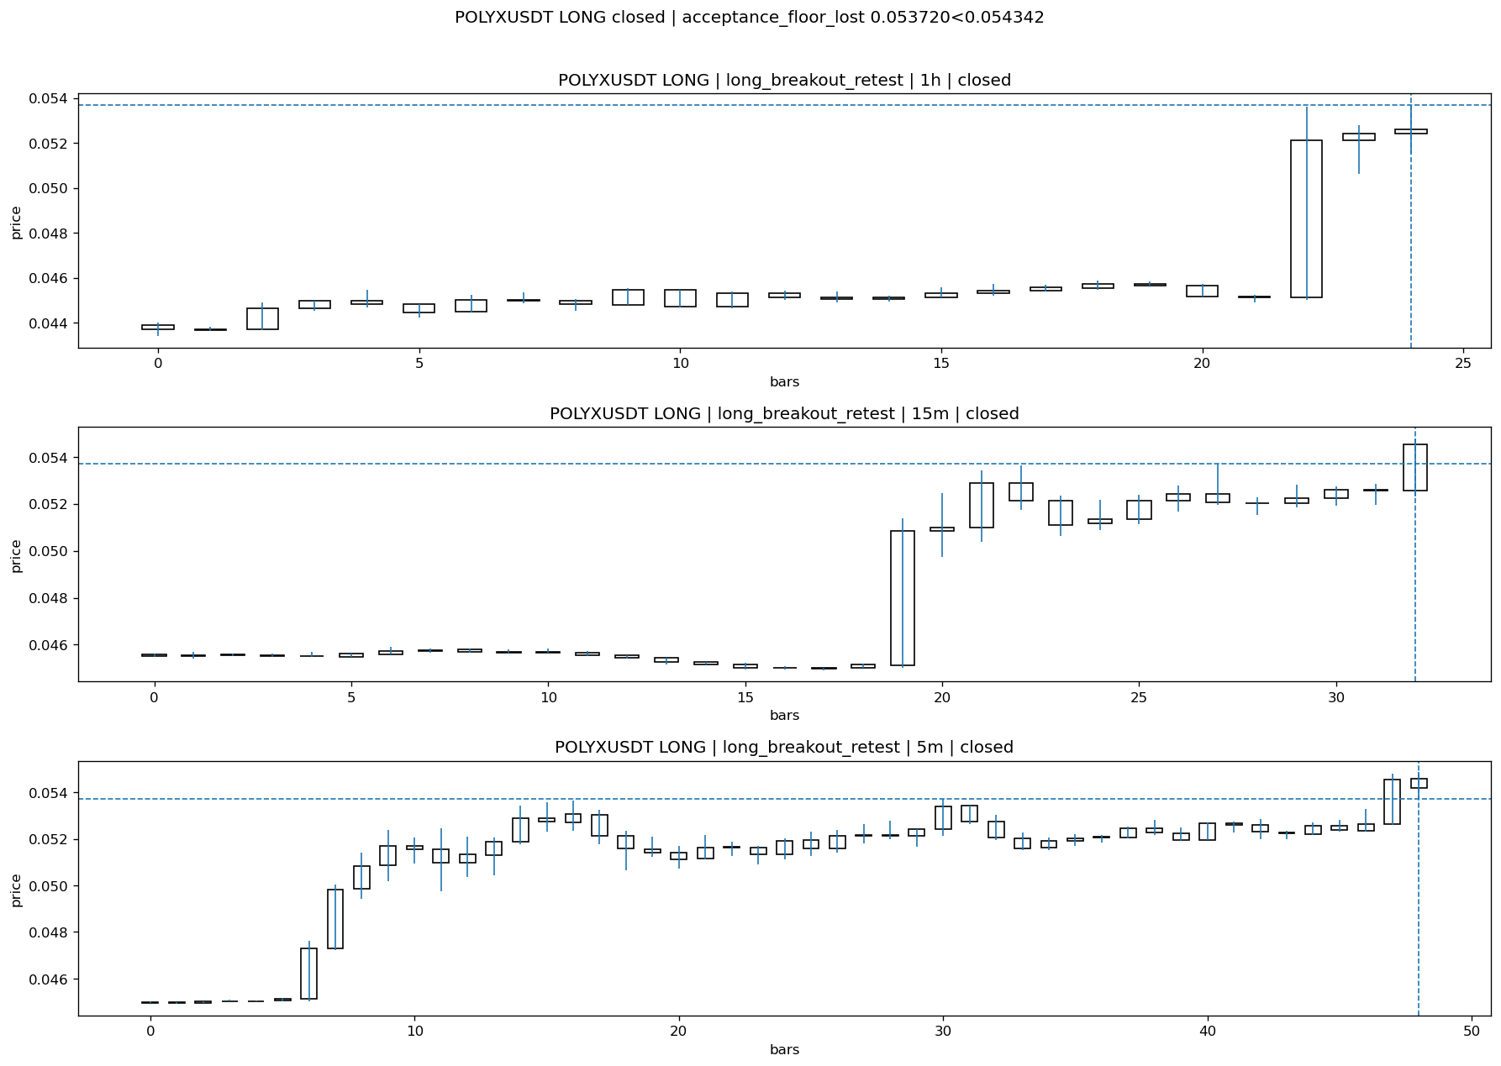
POLYXUSDT_LONG_long_breakout_retest_closed_1775273716924.png

Post-Close Outcome
1h outcome | available=Y | favor=3.8175 | adverse=0.8380
2h outcome | available=Y | favor=4.8603 | adverse=0.8380
4h reference | favor=4.8603 | adverse=2.3836
Reclaim | 2h=Y | 4h=Y
Execution | entry_feasible=Y | window=10m | note=entry still reachable within 10m
Time-to-move | to_favor=85m | to_adverse=25m
Regret filter | regret_valid=N | reason=no_meaningful_fast_move
Conclusion | KILL_CORRECT | notes=entry_ref_from_breakout_level

Review placeholders
human_review_status=PENDING | verdict_code= | root_cause_code= | action_candidate_code=

Case 31: CTSIUSDT-LONG-1775273100000
Summary | CTSIUSDT | LONG | long_breakout_retest | status=INVALIDATED | close_reason=retest invalidated
Times | signal=2026-04-04 10:25:00 | created=2026-04-04 10:31:38 | confirmed= | sent= | close=2026-04-04 10:40:47 | fallback_due=2026-04-04 14:31:38
Semantics | is_confirmed=N | is_sent_signal=N | review_eligible=Y | semantic_consistency=Y
Review integrity | review_exclusion_reason= | semantic_issue=
Close anchoring | case_close_type=true_close | close_anchor_time=2026-04-04 10:40:47 | close_capture_basis=true_close
Regime / dispatch | regime_label=trend_continuation_friendly | fit=HIGH | dispatch=not_evaluated [not_evaluated]
Tradeability | entry_feasible=Y | slippage=0.0000 | regret_valid=N | outcome=KILL_CORRECT

Pre Pending
Stage status: capture_failed | Content type: none
Note: pre_fix_backfill_v2 — was missing_unexpected, snapshot was never taken (Sprint 3A.2 bug)

Pending Open
Stage status: capture_failed | Content type: none
Note: pre_fix_backfill_v2 — was missing_unexpected, snapshot was never taken (Sprint 3A.2 bug)

Entry Or Confirm
Stage status: not_applicable | Content type: none

Case Close
Stage status: captured | Content type: chart_snapshot
close_trigger_detail: retest invalidated
invalidation_detail: retest invalidated
Note: retest invalidated
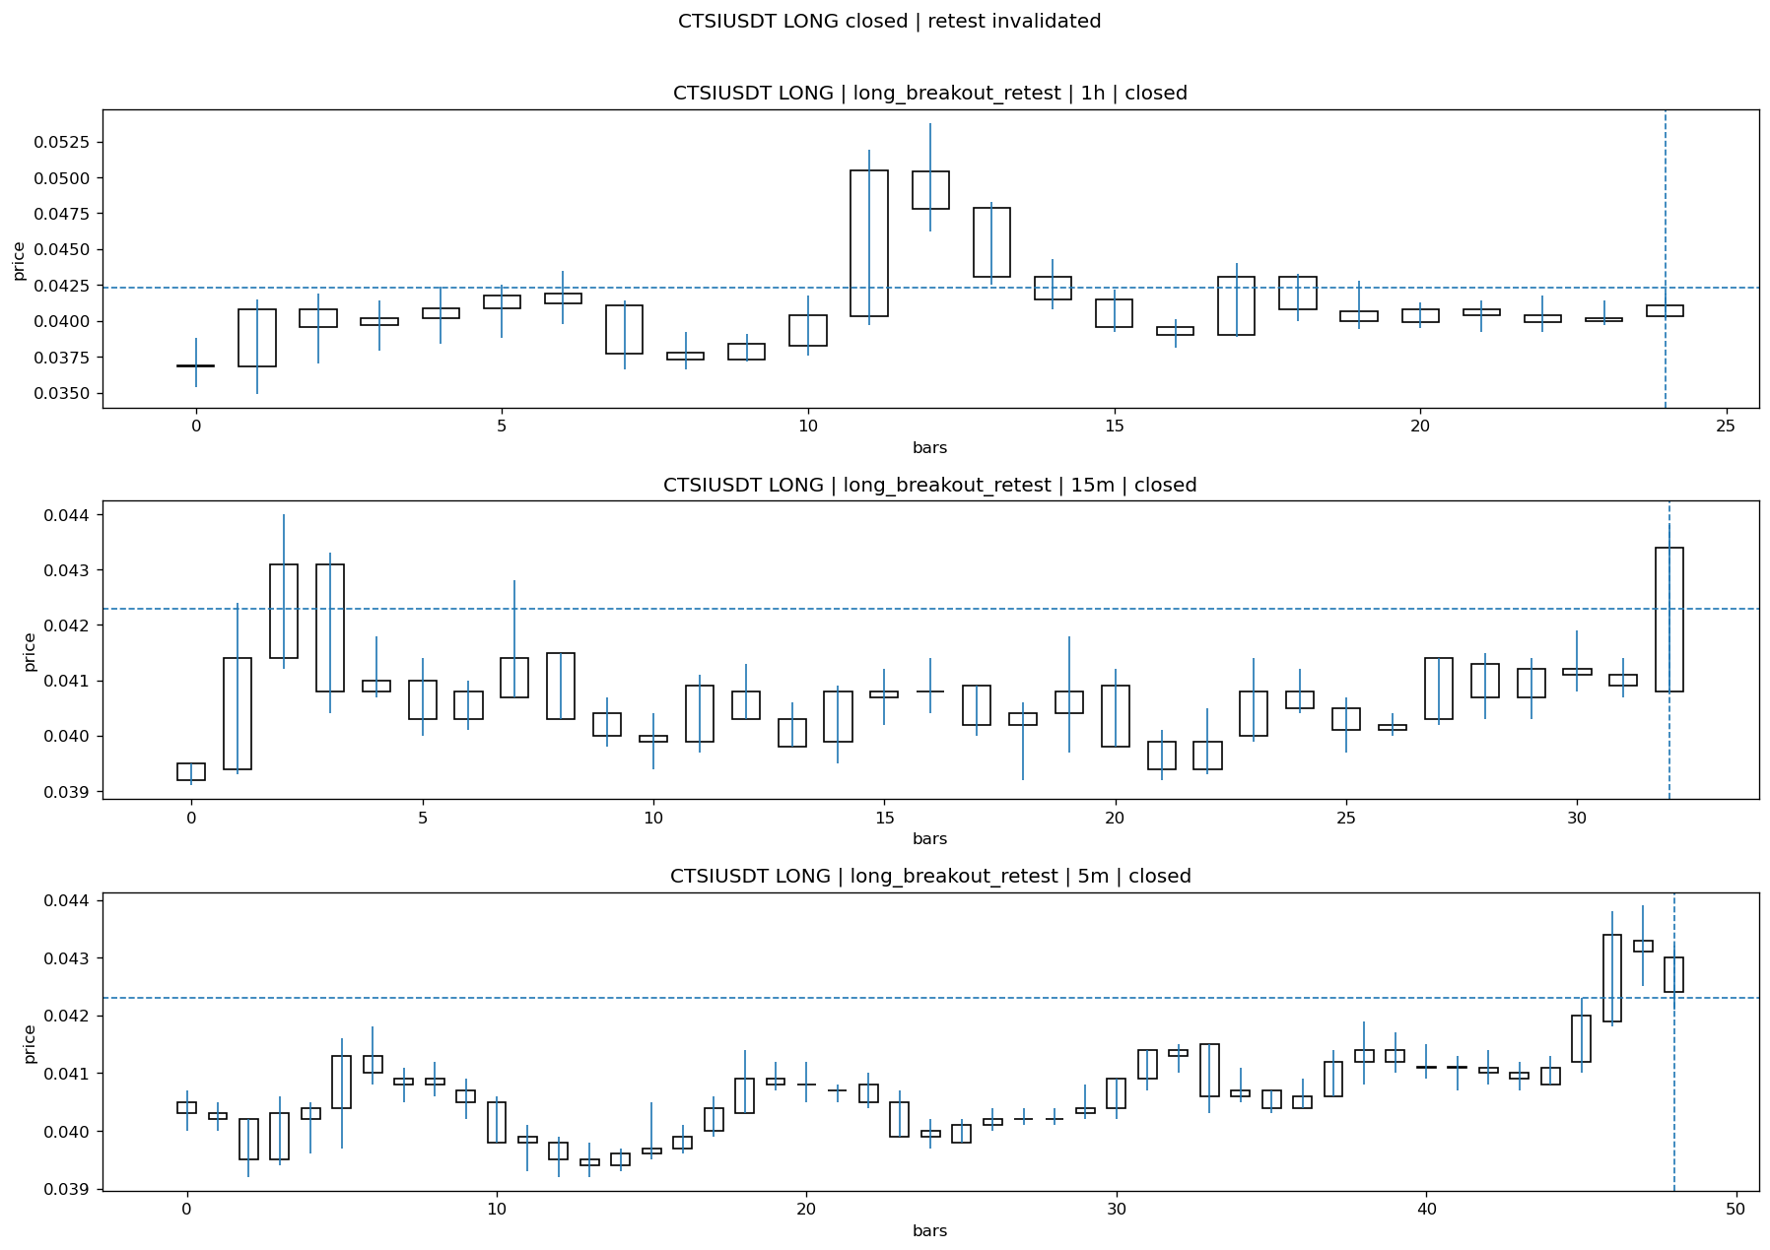
CTSIUSDT_LONG_long_breakout_retest_closed_1775274047783.png

Post-Close Outcome
1h outcome | available=Y | favor=3.0733 | adverse=3.0733
2h outcome | available=Y | favor=3.0733 | adverse=4.0189
4h reference | favor=3.0733 | adverse=4.7281
Reclaim | 2h=Y | 4h=Y
Execution | entry_feasible=Y | window=10m | note=entry still reachable within 10m
Time-to-move | to_favor=4m | to_adverse=109m
Regret filter | regret_valid=N | reason=adverse_too_large
Conclusion | KILL_CORRECT | notes=entry_ref_from_breakout_level

Review placeholders
human_review_status=PENDING | verdict_code= | root_cause_code= | action_candidate_code=

Case 32: STOUSDT-LONG-1775274600000
Summary | STOUSDT | LONG | long_breakout_retest | status=EXPIRED_WAIT | close_reason=retest wait expired
Times | signal=2026-04-04 10:50:00 | created=2026-04-04 10:57:28 | confirmed= | sent= | close=2026-04-04 11:36:08 | fallback_due=2026-04-04 14:57:28
Semantics | is_confirmed=N | is_sent_signal=N | review_eligible=Y | semantic_consistency=Y
Review integrity | review_exclusion_reason= | semantic_issue=
Close anchoring | case_close_type=true_close | close_anchor_time=2026-04-04 11:36:08 | close_capture_basis=true_close
Regime / dispatch | regime_label=trend_continuation_friendly | fit=HIGH | dispatch=not_evaluated [not_evaluated]
Tradeability | entry_feasible=Y | slippage=0.0000 | regret_valid=Y | outcome=WAIT_TOO_SHORT_CANDIDATE

Pre Pending
Stage status: capture_failed | Content type: none
Note: pre_fix_backfill_v2 — was missing_unexpected, snapshot was never taken (Sprint 3A.2 bug)

Pending Open
Stage status: capture_failed | Content type: none
Note: pre_fix_backfill_v2 — was missing_unexpected, snapshot was never taken (Sprint 3A.2 bug)

Entry Or Confirm
Stage status: not_applicable | Content type: none
confirm_fail_detail: retest wait expired

Case Close
Stage status: captured | Content type: chart_snapshot
close_trigger_detail: retest wait expired
Note: retest wait expired
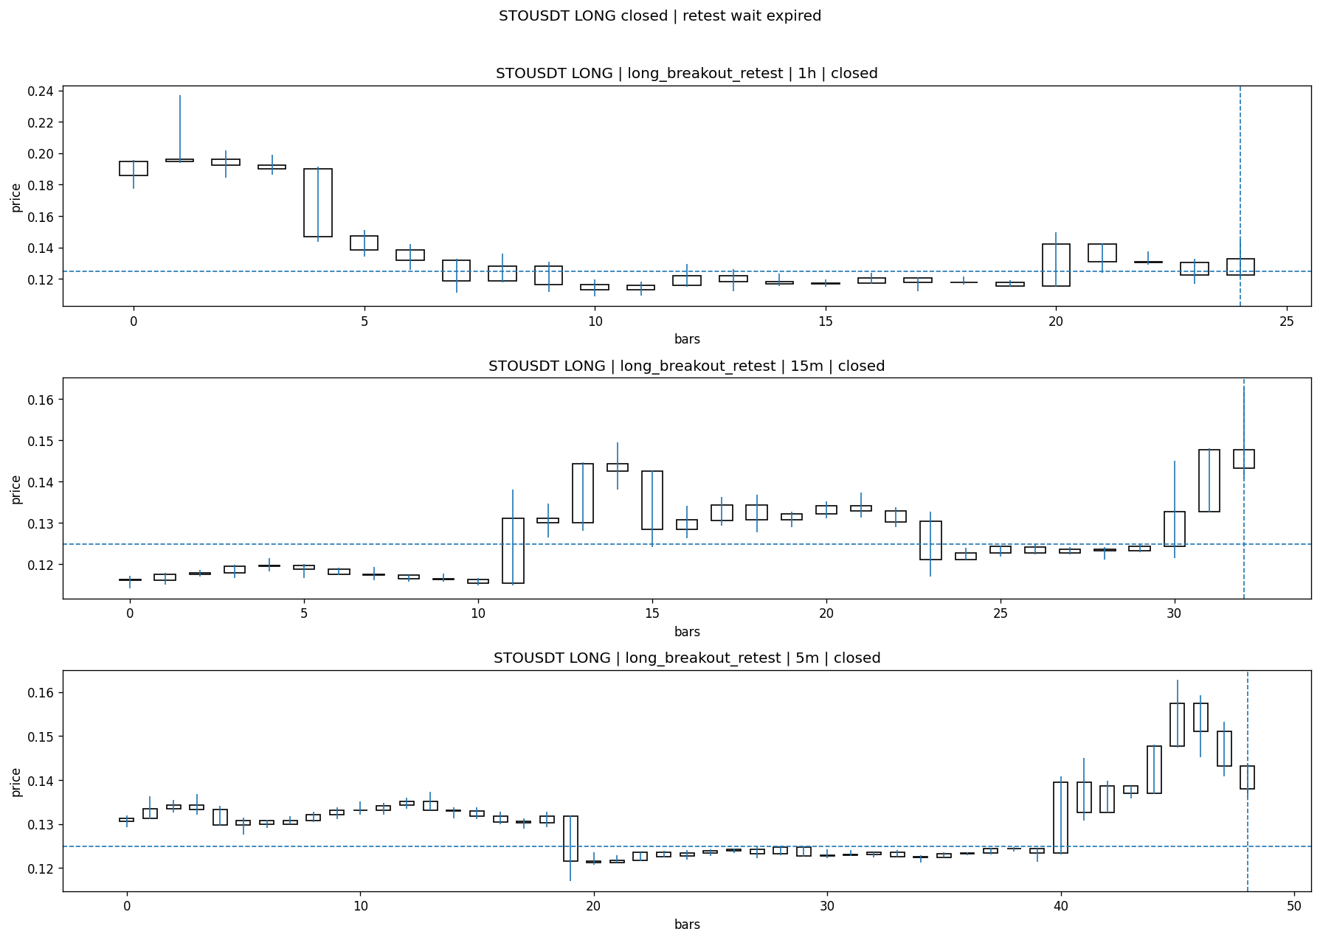
STOUSDT_LONG_long_breakout_retest_closed_1775277368556.png

Post-Close Outcome
1h outcome | available=Y | favor=28.0922 | adverse=0.0000
2h outcome | available=Y | favor=28.0922 | adverse=0.0000
4h reference | favor=28.0922 | adverse=0.0000
Reclaim | 2h=N | 4h=N
Execution | entry_feasible=Y | window=10m | note=entry still reachable within 10m
Time-to-move | to_favor=24m | to_adverse=74m
Regret filter | regret_valid=Y | reason=valid_missed_continuation
Conclusion | WAIT_TOO_SHORT_CANDIDATE | notes=entry_ref_from_breakout_level

Review placeholders
human_review_status=PENDING | verdict_code= | root_cause_code= | action_candidate_code=

Case 33: POLYXUSDT-LONG-1775275500000
Summary | POLYXUSDT | LONG | long_breakout_retest | status=INVALIDATED | close_reason=retest invalidated
Times | signal=2026-04-04 11:05:00 | created=2026-04-04 11:11:53 | confirmed= | sent= | close=2026-04-04 11:16:48 | fallback_due=2026-04-04 15:11:53
Semantics | is_confirmed=N | is_sent_signal=N | review_eligible=Y | semantic_consistency=Y
Review integrity | review_exclusion_reason= | semantic_issue=
Close anchoring | case_close_type=true_close | close_anchor_time=2026-04-04 11:16:48 | close_capture_basis=true_close
Regime / dispatch | regime_label=trend_continuation_friendly | fit=HIGH | dispatch=not_evaluated [not_evaluated]
Tradeability | entry_feasible=Y | slippage=0.0000 | regret_valid=N | outcome=KILL_CORRECT

Pre Pending
Stage status: capture_failed | Content type: none
Note: pre_fix_backfill_v2 — was missing_unexpected, snapshot was never taken (Sprint 3A.2 bug)

Pending Open
Stage status: capture_failed | Content type: none
Note: pre_fix_backfill_v2 — was missing_unexpected, snapshot was never taken (Sprint 3A.2 bug)

Entry Or Confirm
Stage status: not_applicable | Content type: none

Case Close
Stage status: captured | Content type: chart_snapshot
close_trigger_detail: retest invalidated
invalidation_detail: retest invalidated
Note: retest invalidated
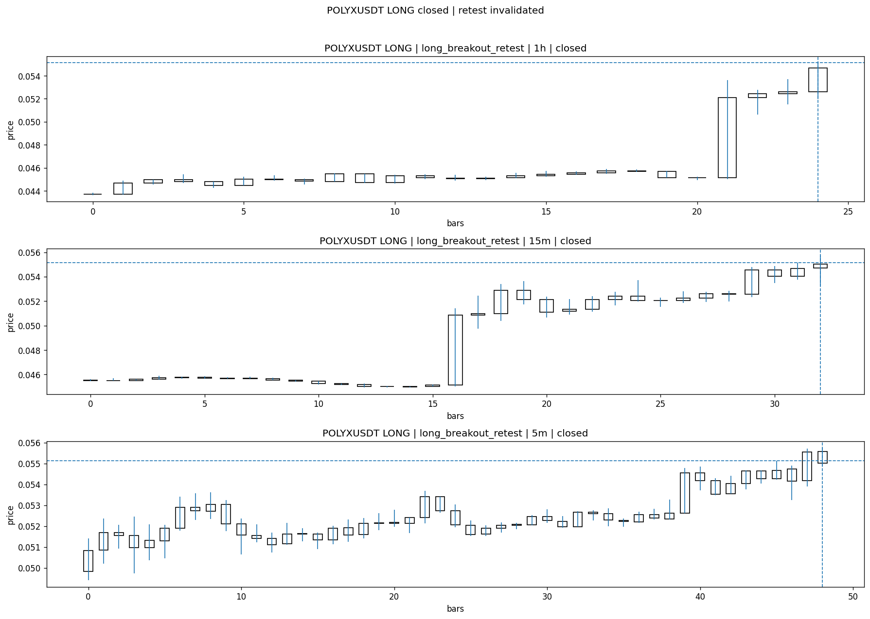
POLYXUSDT_LONG_long_breakout_retest_closed_1775276208042.png

Post-Close Outcome
1h outcome | available=Y | favor=2.1404 | adverse=2.4306
2h outcome | available=Y | favor=2.1404 | adverse=4.9157
4h reference | favor=2.1404 | adverse=4.9157
Reclaim | 2h=Y | 4h=Y
Execution | entry_feasible=Y | window=10m | note=entry still reachable within 10m
Time-to-move | to_favor=43m | to_adverse=93m
Regret filter | regret_valid=N | reason=adverse_too_large
Conclusion | KILL_CORRECT | notes=entry_ref_from_breakout_level

Review placeholders
human_review_status=PENDING | verdict_code= | root_cause_code= | action_candidate_code=

Case 34: HEMIUSDT-LONG-1775277600000
Summary | HEMIUSDT | LONG | long_breakout_retest | status=INVALIDATED | close_reason=retest invalidated
Times | signal=2026-04-04 11:40:00 | created=2026-04-04 11:45:05 | confirmed= | sent= | close=2026-04-04 11:50:03 | fallback_due=2026-04-04 15:45:05
Semantics | is_confirmed=N | is_sent_signal=N | review_eligible=Y | semantic_consistency=Y
Review integrity | review_exclusion_reason= | semantic_issue=
Close anchoring | case_close_type=true_close | close_anchor_time=2026-04-04 11:50:03 | close_capture_basis=true_close
Regime / dispatch | regime_label=trend_continuation_friendly | fit=HIGH | dispatch=not_evaluated [not_evaluated]
Tradeability | entry_feasible=Y | slippage=0.0000 | regret_valid=N | outcome=KILL_CORRECT

Pre Pending
Stage status: capture_failed | Content type: none
Note: pre_fix_backfill_v2 — was missing_unexpected, snapshot was never taken (Sprint 3A.2 bug)

Pending Open
Stage status: capture_failed | Content type: none
Note: pre_fix_backfill_v2 — was missing_unexpected, snapshot was never taken (Sprint 3A.2 bug)

Entry Or Confirm
Stage status: not_applicable | Content type: none

Case Close
Stage status: captured | Content type: chart_snapshot
close_trigger_detail: retest invalidated
invalidation_detail: retest invalidated
Note: retest invalidated
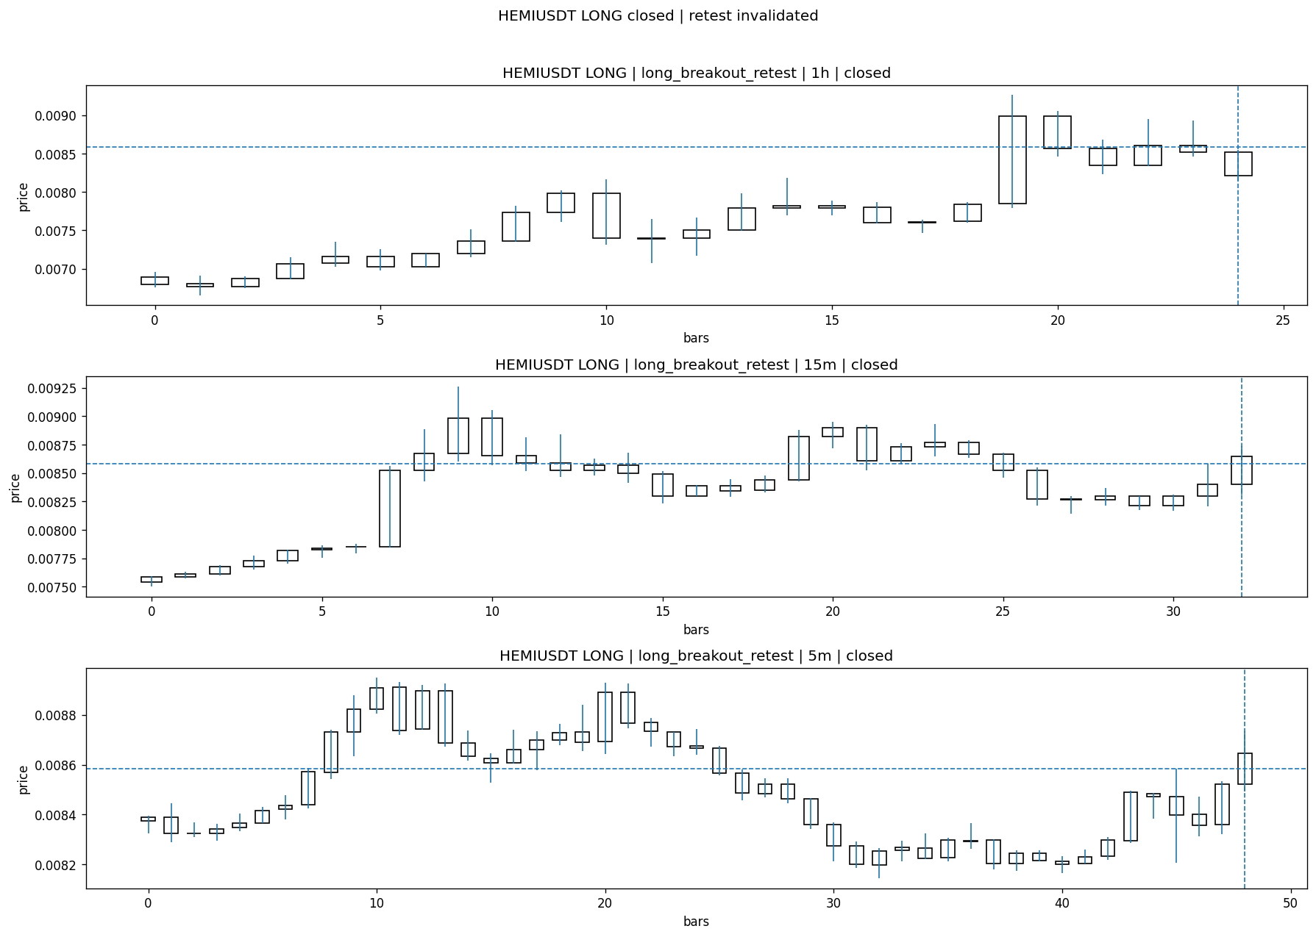
HEMIUSDT_LONG_long_breakout_retest_closed_1775278203200.png

Post-Close Outcome
1h outcome | available=Y | favor=1.4560 | adverse=9.1206
2h outcome | available=Y | favor=1.4560 | adverse=9.1206
4h reference | favor=1.4560 | adverse=9.1206
Reclaim | 2h=Y | 4h=Y
Execution | entry_feasible=Y | window=10m | note=entry still reachable within 10m
Time-to-move | to_favor=30m | to_adverse=60m
Regret filter | regret_valid=N | reason=adverse_too_large
Conclusion | KILL_CORRECT | notes=entry_ref_from_breakout_level

Review placeholders
human_review_status=PENDING | verdict_code= | root_cause_code= | action_candidate_code=

Case 35: FIDAUSDT-LONG-1775277600000
Summary | FIDAUSDT | LONG | long_breakout_retest | status=INVALIDATED | close_reason=retest invalidated
Times | signal=2026-04-04 11:40:00 | created=2026-04-04 11:47:37 | confirmed= | sent= | close=2026-04-04 11:50:04 | fallback_due=2026-04-04 15:47:37
Semantics | is_confirmed=N | is_sent_signal=N | review_eligible=Y | semantic_consistency=Y
Review integrity | review_exclusion_reason= | semantic_issue=
Close anchoring | case_close_type=true_close | close_anchor_time=2026-04-04 11:50:04 | close_capture_basis=true_close
Regime / dispatch | regime_label=trend_continuation_friendly | fit=HIGH | dispatch=not_evaluated [not_evaluated]
Tradeability | entry_feasible=Y | slippage=0.0000 | regret_valid=N | outcome=KILL_CORRECT

Pre Pending
Stage status: capture_failed | Content type: none
Note: pre_fix_backfill_v2 — was missing_unexpected, snapshot was never taken (Sprint 3A.2 bug)

Pending Open
Stage status: capture_failed | Content type: none
Note: pre_fix_backfill_v2 — was missing_unexpected, snapshot was never taken (Sprint 3A.2 bug)

Entry Or Confirm
Stage status: not_applicable | Content type: none

Case Close
Stage status: captured | Content type: chart_snapshot
close_trigger_detail: retest invalidated
invalidation_detail: retest invalidated
Note: retest invalidated
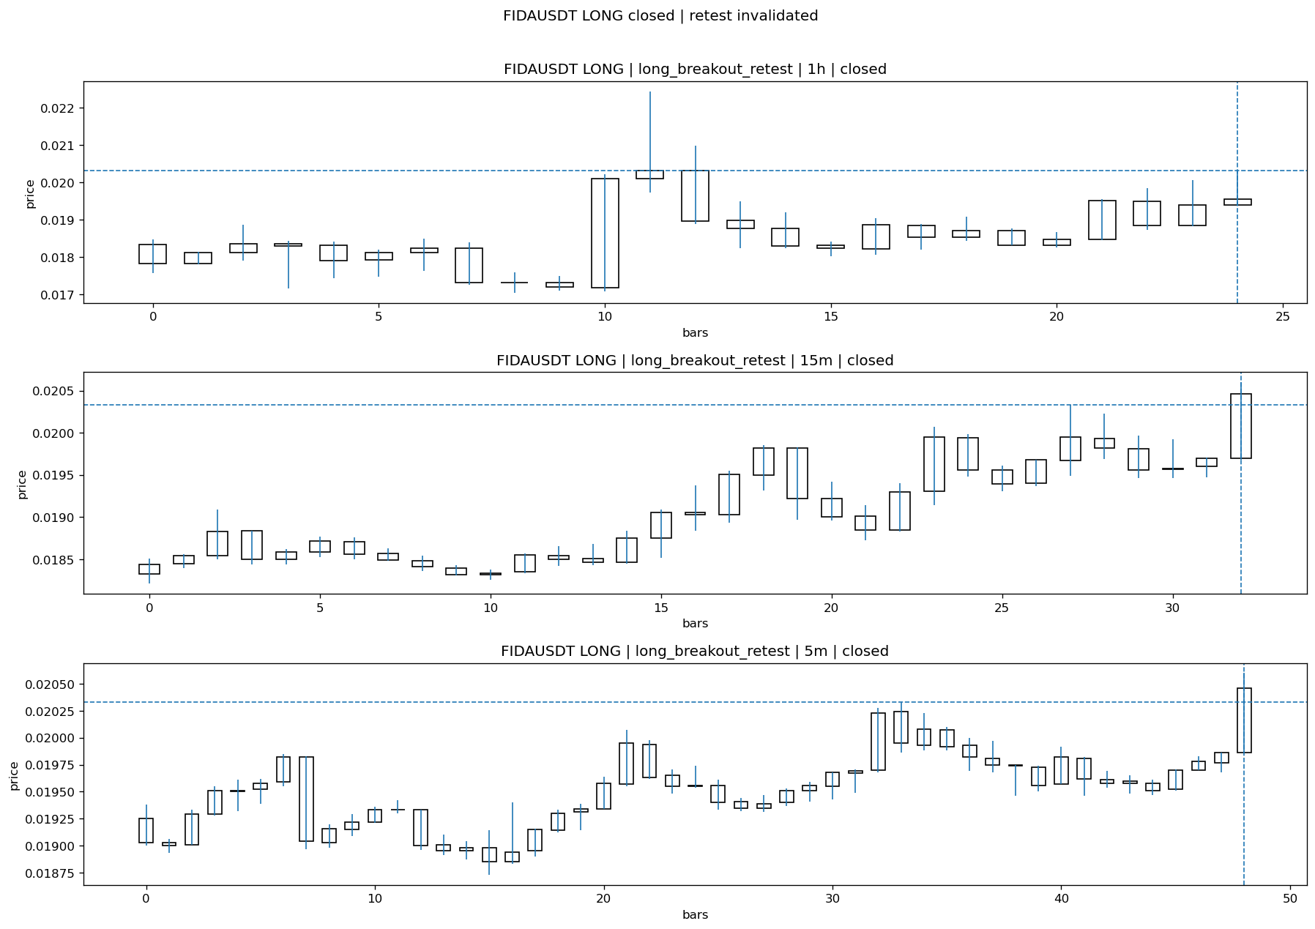
FIDAUSDT_LONG_long_breakout_retest_closed_1775278204794.png

Post-Close Outcome
1h outcome | available=Y | favor=2.6562 | adverse=2.9513
2h outcome | available=Y | favor=9.3458 | adverse=3.3940
4h reference | favor=9.3458 | adverse=3.3940
Reclaim | 2h=Y | 4h=Y
Execution | entry_feasible=Y | window=10m | note=entry still reachable within 10m
Time-to-move | to_favor=105m | to_adverse=65m
Regret filter | regret_valid=N | reason=no_meaningful_fast_move
Conclusion | KILL_CORRECT | notes=entry_ref_from_breakout_level

Review placeholders
human_review_status=PENDING | verdict_code= | root_cause_code= | action_candidate_code=

Case 36: PUFFERUSDT-LONG-1775277600000
Summary | PUFFERUSDT | LONG | long_breakout_retest | status=INVALIDATED | close_reason=acceptance_floor_lost 0.033620<0.033961
Times | signal=2026-04-04 11:40:00 | created=2026-04-04 11:47:41 | confirmed= | sent= | close=2026-04-04 11:50:04 | fallback_due=2026-04-04 15:47:41
Semantics | is_confirmed=N | is_sent_signal=N | review_eligible=Y | semantic_consistency=Y
Review integrity | review_exclusion_reason= | semantic_issue=
Close anchoring | case_close_type=true_close | close_anchor_time=2026-04-04 11:50:04 | close_capture_basis=true_close
Regime / dispatch | regime_label=trend_continuation_friendly | fit=HIGH | dispatch=not_evaluated [not_evaluated]
Tradeability | entry_feasible=Y | slippage=0.0000 | regret_valid=N | outcome=KILL_CORRECT

Pre Pending
Stage status: capture_failed | Content type: none
Note: pre_fix_backfill_v2 — was missing_unexpected, snapshot was never taken (Sprint 3A.2 bug)

Pending Open
Stage status: capture_failed | Content type: none
Note: pre_fix_backfill_v2 — was missing_unexpected, snapshot was never taken (Sprint 3A.2 bug)

Entry Or Confirm
Stage status: not_applicable | Content type: none

Case Close
Stage status: captured | Content type: chart_snapshot
close_trigger_detail: acceptance_floor_lost 0.033620<0.033961
invalidation_detail: acceptance_floor_lost 0.033620<0.033961
Note: acceptance_floor_lost 0.033620<0.033961
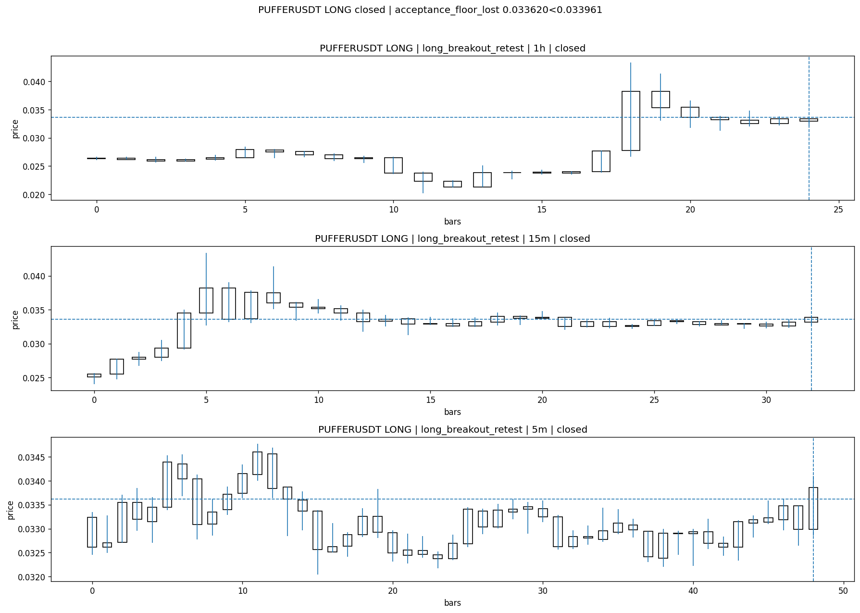
PUFFERUSDT_LONG_long_breakout_retest_closed_1775278204161.png

Post-Close Outcome
1h outcome | available=Y | favor=23.9143 | adverse=0.3569
2h outcome | available=Y | favor=33.3730 | adverse=0.3569
4h reference | favor=33.3730 | adverse=0.3569
Reclaim | 2h=Y | 4h=Y
Execution | entry_feasible=Y | window=10m | note=entry still reachable within 10m
Time-to-move | to_favor=115m | to_adverse=5m
Regret filter | regret_valid=N | reason=no_meaningful_fast_move
Conclusion | KILL_CORRECT | notes=entry_ref_from_breakout_level

Review placeholders
human_review_status=PENDING | verdict_code= | root_cause_code= | action_candidate_code=

Case 37: PUFFERUSDT-LONG-1775278500000
Summary | PUFFERUSDT | LONG | long_breakout_retest | status=INVALIDATED | close_reason=retest invalidated
Times | signal=2026-04-04 11:55:00 | created=2026-04-04 12:04:23 | confirmed= | sent= | close=2026-04-04 12:06:46 | fallback_due=2026-04-04 16:04:23
Semantics | is_confirmed=N | is_sent_signal=N | review_eligible=Y | semantic_consistency=Y
Review integrity | review_exclusion_reason= | semantic_issue=
Close anchoring | case_close_type=true_close | close_anchor_time=2026-04-04 12:06:46 | close_capture_basis=true_close
Regime / dispatch | regime_label=trend_continuation_friendly | fit=HIGH | dispatch=not_evaluated [not_evaluated]
Tradeability | entry_feasible=Y | slippage=0.0000 | regret_valid=N | outcome=KILL_CORRECT

Pre Pending
Stage status: capture_failed | Content type: none
Note: pre_fix_backfill_v2 — was missing_unexpected, snapshot was never taken (Sprint 3A.2 bug)

Pending Open
Stage status: capture_failed | Content type: none
Note: pre_fix_backfill_v2 — was missing_unexpected, snapshot was never taken (Sprint 3A.2 bug)

Entry Or Confirm
Stage status: not_applicable | Content type: none

Case Close
Stage status: captured | Content type: chart_snapshot
close_trigger_detail: retest invalidated
invalidation_detail: retest invalidated
Note: retest invalidated
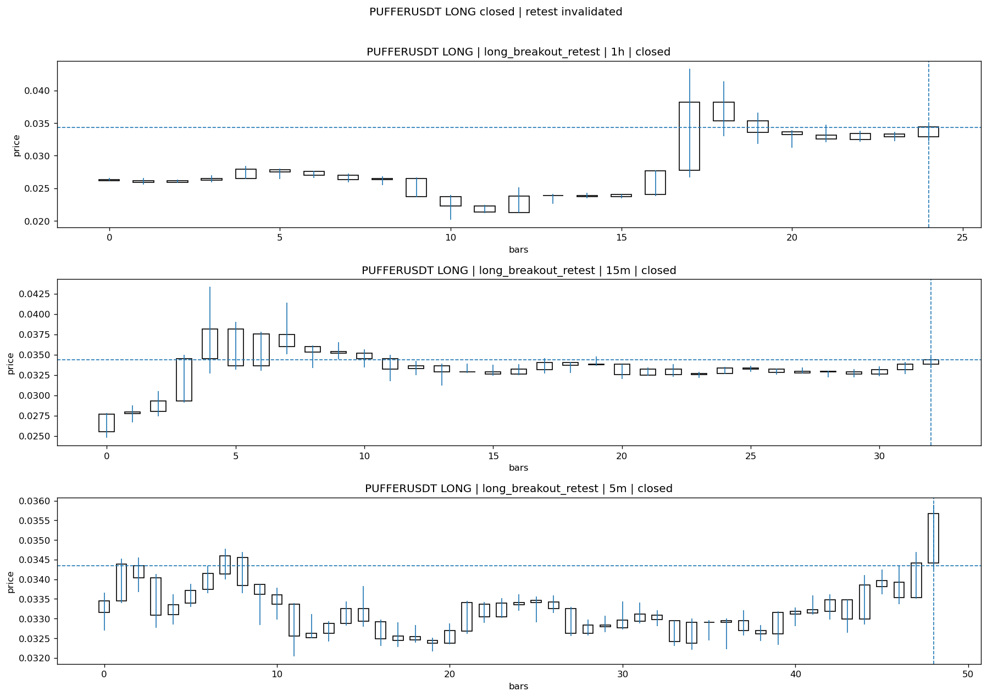
PUFFERUSDT_LONG_long_breakout_retest_closed_1775279206170.png

Post-Close Outcome
1h outcome | available=Y | favor=21.2809 | adverse=0.0000
2h outcome | available=Y | favor=30.5386 | adverse=0.0000
4h reference | favor=30.5386 | adverse=0.0000
Reclaim | 2h=N | 4h=N
Execution | entry_feasible=Y | window=10m | note=entry still reachable within 10m
Time-to-move | to_favor=98m | to_adverse=13m
Regret filter | regret_valid=N | reason=no_meaningful_fast_move
Conclusion | KILL_CORRECT | notes=entry_ref_from_breakout_level

Review placeholders
human_review_status=PENDING | verdict_code= | root_cause_code= | action_candidate_code=

Case 38: PUFFERUSDT-LONG-1775278500000
Summary | PUFFERUSDT | LONG | long_breakout_retest | status=INVALIDATED | close_reason=retest invalidated
Times | signal=2026-04-04 11:55:00 | created=2026-04-04 12:04:23 | confirmed= | sent= | close=2026-04-04 12:06:46 | fallback_due=2026-04-04 16:04:23
Semantics | is_confirmed=N | is_sent_signal=N | review_eligible=Y | semantic_consistency=Y
Review integrity | review_exclusion_reason= | semantic_issue=
Close anchoring | case_close_type=true_close | close_anchor_time=2026-04-04 12:06:46 | close_capture_basis=true_close
Regime / dispatch | regime_label=trend_continuation_friendly | fit=HIGH | dispatch=not_evaluated [not_evaluated]
Tradeability | entry_feasible=Y | slippage=0.0000 | regret_valid=N | outcome=KILL_CORRECT

Pre Pending
Stage status: capture_failed | Content type: none
Note: pre_fix_backfill_v2 — was missing_unexpected, snapshot was never taken (Sprint 3A.2 bug)

Pending Open
Stage status: capture_failed | Content type: none
Note: pre_fix_backfill_v2 — was missing_unexpected, snapshot was never taken (Sprint 3A.2 bug)

Entry Or Confirm
Stage status: not_applicable | Content type: none

Case Close
Stage status: captured | Content type: chart_snapshot
close_trigger_detail: retest invalidated
invalidation_detail: retest invalidated
Note: retest invalidated

PUFFERUSDT_LONG_long_breakout_retest_closed_1775279206170.png

Post-Close Outcome
1h outcome | available=Y | favor=21.2809 | adverse=0.0000
2h outcome | available=Y | favor=30.5386 | adverse=0.0000
4h reference | favor=30.5386 | adverse=0.0000
Reclaim | 2h=N | 4h=N
Execution | entry_feasible=Y | window=10m | note=entry still reachable within 10m
Time-to-move | to_favor=98m | to_adverse=13m
Regret filter | regret_valid=N | reason=no_meaningful_fast_move
Conclusion | KILL_CORRECT | notes=entry_ref_from_breakout_level

Review placeholders
human_review_status=PENDING | verdict_code= | root_cause_code= | action_candidate_code=

Case 39: PUFFERUSDT-LONG-1775278800000
Summary | PUFFERUSDT | LONG | long_breakout_retest | status=EXPIRED_WAIT | close_reason=retest wait expired
Times | signal=2026-04-04 12:00:00 | created=2026-04-04 12:07:08 | confirmed= | sent= | close=2026-04-04 12:45:18 | fallback_due=2026-04-04 16:07:08
Semantics | is_confirmed=N | is_sent_signal=N | review_eligible=N | semantic_consistency=Y
Review integrity | review_exclusion_reason=outcome_2h_unavailable | semantic_issue=
Close anchoring | case_close_type=true_close | close_anchor_time=2026-04-04 12:45:18 | close_capture_basis=true_close
Regime / dispatch | regime_label=trend_continuation_friendly | fit=HIGH | dispatch=not_evaluated [not_evaluated]
Tradeability | entry_feasible= | slippage= | regret_valid= | outcome=

Pre Pending
Stage status: capture_failed | Content type: none
Note: pre_fix_backfill_v2 — was missing_unexpected, snapshot was never taken (Sprint 3A.2 bug)

Pending Open
Stage status: capture_failed | Content type: none
Note: pre_fix_backfill_v2 — was missing_unexpected, snapshot was never taken (Sprint 3A.2 bug)

Entry Or Confirm
Stage status: not_applicable | Content type: none
confirm_fail_detail: retest wait expired

Case Close
Stage status: captured | Content type: chart_snapshot
close_trigger_detail: retest wait expired
Note: retest wait expired
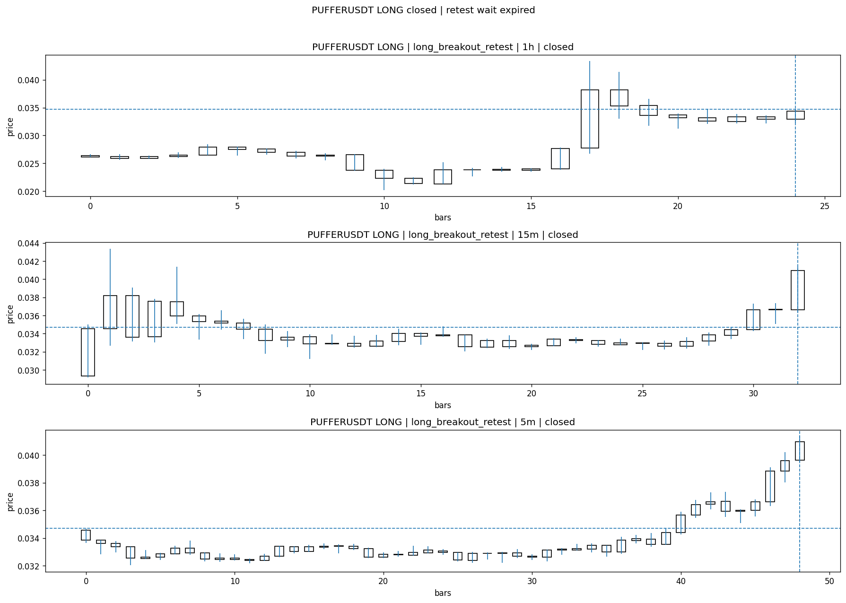
PUFFERUSDT_LONG_long_breakout_retest_closed_1775281518650.png

Post-Close Outcome
1h outcome | available=N | reason=not_enough_post_close_time
2h outcome | available=N | reason=not_enough_post_close_time
4h reference | not_available_yet
Reclaim | not_available_yet
Execution | entry_feasible=not_available_yet | window=not_available_yetm | note=not_available_yet
Time-to-move | not_available_yet
Regret filter | regret_valid=not_available_yet | reason=not_available_yet
Conclusion | not_available_yet | notes=not_enough_post_close_time

Review placeholders
human_review_status=PENDING | verdict_code= | root_cause_code= | action_candidate_code=

Case 40: PUFFERUSDT-LONG-1775281200000
Summary | PUFFERUSDT | LONG | long_breakout_retest | status=INVALIDATED | close_reason=retest invalidated
Times | signal=2026-04-04 12:40:00 | created=2026-04-04 12:45:38 | confirmed= | sent= | close=2026-04-04 12:50:48 | fallback_due=2026-04-04 16:45:38
Semantics | is_confirmed=N | is_sent_signal=N | review_eligible=N | semantic_consistency=Y
Review integrity | review_exclusion_reason=outcome_2h_unavailable | semantic_issue=
Close anchoring | case_close_type=true_close | close_anchor_time=2026-04-04 12:50:48 | close_capture_basis=true_close
Regime / dispatch | regime_label=unclear_mixed | fit=MEDIUM | dispatch=not_evaluated [not_evaluated]
Tradeability | entry_feasible= | slippage= | regret_valid= | outcome=

Pre Pending
Stage status: capture_failed | Content type: none
Note: pre_fix_backfill_v2 — was missing_unexpected, snapshot was never taken (Sprint 3A.2 bug)

Pending Open
Stage status: capture_failed | Content type: none
Note: pre_fix_backfill_v2 — was missing_unexpected, snapshot was never taken (Sprint 3A.2 bug)

Entry Or Confirm
Stage status: not_applicable | Content type: none

Case Close
Stage status: captured | Content type: chart_snapshot
close_trigger_detail: retest invalidated
invalidation_detail: retest invalidated
Note: retest invalidated
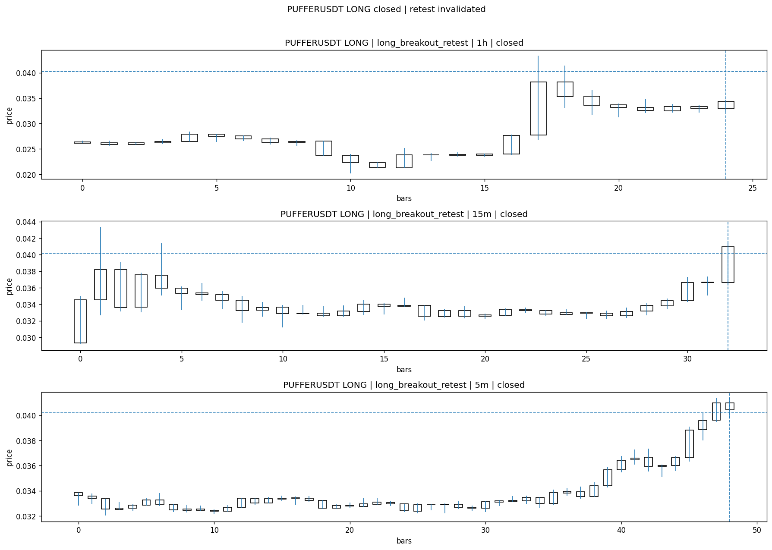
PUFFERUSDT_LONG_long_breakout_retest_closed_1775281848284.png

Post-Close Outcome
1h outcome | available=N | reason=not_enough_post_close_time
2h outcome | available=N | reason=not_enough_post_close_time
4h reference | not_available_yet
Reclaim | not_available_yet
Execution | entry_feasible=not_available_yet | window=not_available_yetm | note=not_available_yet
Time-to-move | not_available_yet
Regret filter | regret_valid=not_available_yet | reason=not_available_yet
Conclusion | not_available_yet | notes=not_enough_post_close_time

Review placeholders
human_review_status=PENDING | verdict_code= | root_cause_code= | action_candidate_code=

Case 41: NOMUSDT-LONG-1775283000000
Summary | NOMUSDT | LONG | long_breakout_retest | status=INVALIDATED | close_reason=retest invalidated
Times | signal=2026-04-04 13:10:00 | created=2026-04-04 13:18:40 | confirmed= | sent= | close=2026-04-04 13:26:45 | fallback_due=2026-04-04 17:18:40
Semantics | is_confirmed=N | is_sent_signal=N | review_eligible=N | semantic_consistency=Y
Review integrity | review_exclusion_reason=outcome_2h_unavailable | semantic_issue=
Close anchoring | case_close_type=true_close | close_anchor_time=2026-04-04 13:26:45 | close_capture_basis=true_close
Regime / dispatch | regime_label=trend_continuation_friendly | fit=HIGH | dispatch=not_evaluated [not_evaluated]
Tradeability | entry_feasible= | slippage= | regret_valid= | outcome=

Pre Pending
Stage status: capture_failed | Content type: none
Note: pre_fix_backfill_v2 — was missing_unexpected, snapshot was never taken (Sprint 3A.2 bug)

Pending Open
Stage status: capture_failed | Content type: none
Note: pre_fix_backfill_v2 — was missing_unexpected, snapshot was never taken (Sprint 3A.2 bug)

Entry Or Confirm
Stage status: not_applicable | Content type: none

Case Close
Stage status: captured | Content type: chart_snapshot
close_trigger_detail: retest invalidated
invalidation_detail: retest invalidated
Note: retest invalidated
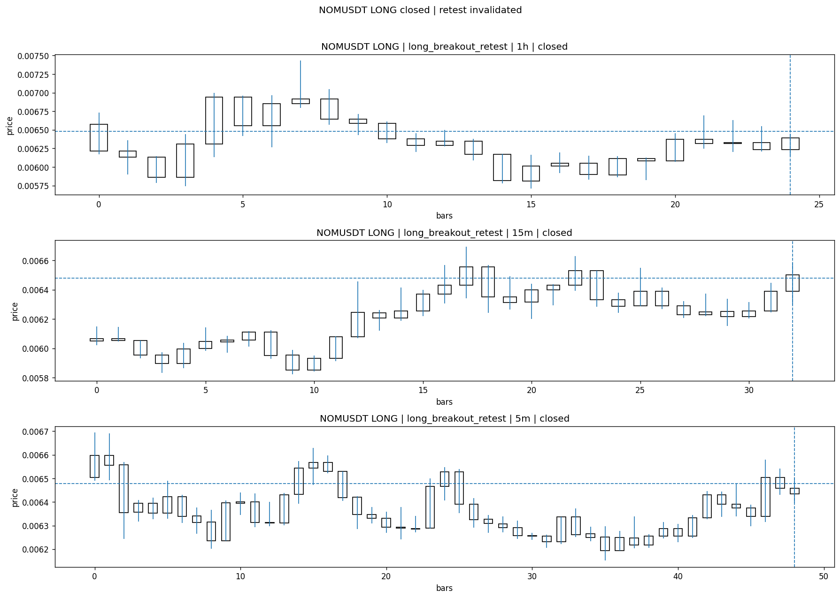
NOMUSDT_LONG_long_breakout_retest_closed_1775284005791.png

Post-Close Outcome
1h outcome | available=N | reason=not_enough_post_close_time
2h outcome | available=N | reason=not_enough_post_close_time
4h reference | not_available_yet
Reclaim | not_available_yet
Execution | entry_feasible=not_available_yet | window=not_available_yetm | note=not_available_yet
Time-to-move | not_available_yet
Regret filter | regret_valid=not_available_yet | reason=not_available_yet
Conclusion | not_available_yet | notes=not_enough_post_close_time

Review placeholders
human_review_status=PENDING | verdict_code= | root_cause_code= | action_candidate_code=

Case 42: PUFFERUSDT-LONG-1775283900000
Summary | PUFFERUSDT | LONG | long_breakout_retest | status=INVALIDATED | close_reason=retest invalidated
Times | signal=2026-04-04 13:25:00 | created=2026-04-04 13:32:37 | confirmed= | sent= | close=2026-04-04 13:35:06 | fallback_due=2026-04-04 17:32:37
Semantics | is_confirmed=N | is_sent_signal=N | review_eligible=N | semantic_consistency=Y
Review integrity | review_exclusion_reason=outcome_2h_unavailable | semantic_issue=
Close anchoring | case_close_type=true_close | close_anchor_time=2026-04-04 13:35:06 | close_capture_basis=true_close
Regime / dispatch | regime_label=unclear_mixed | fit=MEDIUM | dispatch=not_evaluated [not_evaluated]
Tradeability | entry_feasible= | slippage= | regret_valid= | outcome=

Pre Pending
Stage status: capture_failed | Content type: none
Note: pre_fix_backfill_v2 — was missing_unexpected, snapshot was never taken (Sprint 3A.2 bug)

Pending Open
Stage status: capture_failed | Content type: none
Note: pre_fix_backfill_v2 — was missing_unexpected, snapshot was never taken (Sprint 3A.2 bug)

Entry Or Confirm
Stage status: not_applicable | Content type: none

Case Close
Stage status: captured | Content type: chart_snapshot
close_trigger_detail: retest invalidated
invalidation_detail: retest invalidated
Note: retest invalidated
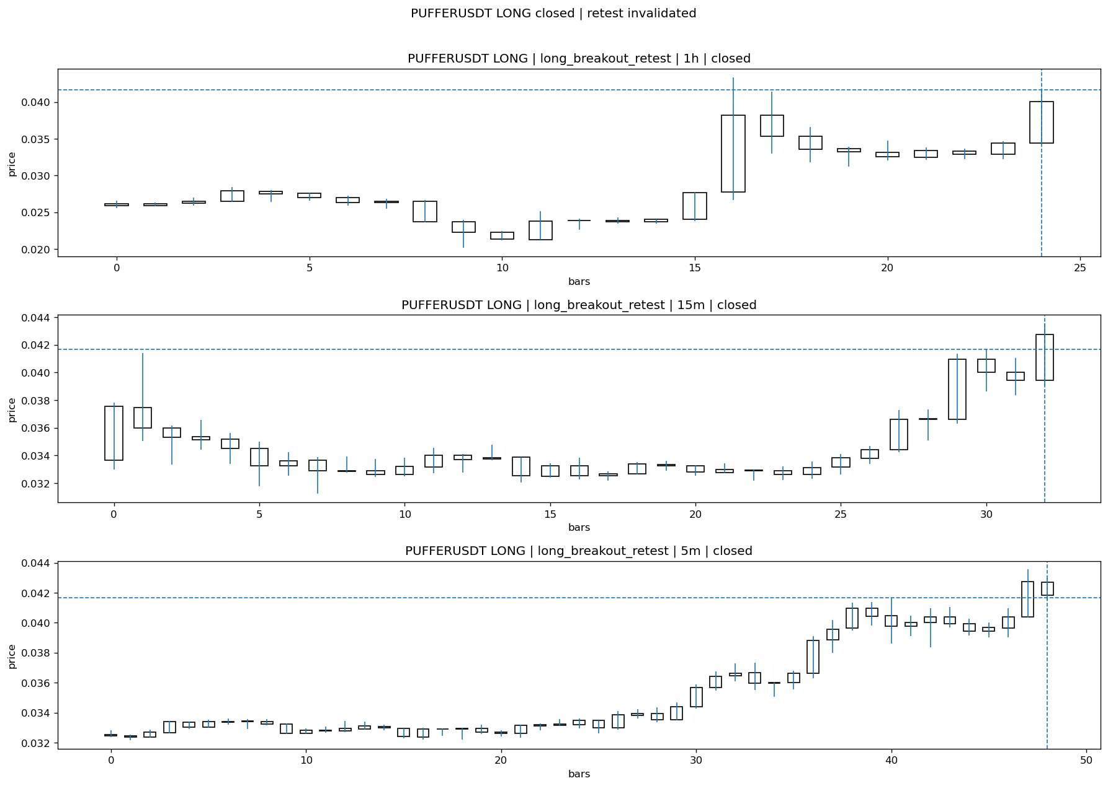
PUFFERUSDT_LONG_long_breakout_retest_closed_1775284506903.png

Post-Close Outcome
1h outcome | available=N | reason=not_enough_post_close_time
2h outcome | available=N | reason=not_enough_post_close_time
4h reference | not_available_yet
Reclaim | not_available_yet
Execution | entry_feasible=not_available_yet | window=not_available_yetm | note=not_available_yet
Time-to-move | not_available_yet
Regret filter | regret_valid=not_available_yet | reason=not_available_yet
Conclusion | not_available_yet | notes=not_enough_post_close_time

Review placeholders
human_review_status=PENDING | verdict_code= | root_cause_code= | action_candidate_code=

Case 43: FIDAUSDT-LONG-1775283900000
Summary | FIDAUSDT | LONG | long_breakout_retest | status=INVALIDATED | close_reason=retest invalidated
Times | signal=2026-04-04 13:25:00 | created=2026-04-04 13:32:41 | confirmed= | sent= | close=2026-04-04 13:51:39 | fallback_due=2026-04-04 17:32:41
Semantics | is_confirmed=N | is_sent_signal=N | review_eligible=N | semantic_consistency=Y
Review integrity | review_exclusion_reason=outcome_2h_unavailable | semantic_issue=
Close anchoring | case_close_type=true_close | close_anchor_time=2026-04-04 13:51:39 | close_capture_basis=true_close
Regime / dispatch | regime_label=unclear_mixed | fit=MEDIUM | dispatch=not_evaluated [not_evaluated]
Tradeability | entry_feasible= | slippage= | regret_valid= | outcome=

Pre Pending
Stage status: capture_failed | Content type: none
Note: pre_fix_backfill_v2 — was missing_unexpected, snapshot was never taken (Sprint 3A.2 bug)

Pending Open
Stage status: capture_failed | Content type: none
Note: pre_fix_backfill_v2 — was missing_unexpected, snapshot was never taken (Sprint 3A.2 bug)

Entry Or Confirm
Stage status: not_applicable | Content type: none

Case Close
Stage status: captured | Content type: chart_snapshot
close_trigger_detail: retest invalidated
invalidation_detail: retest invalidated
Note: retest invalidated
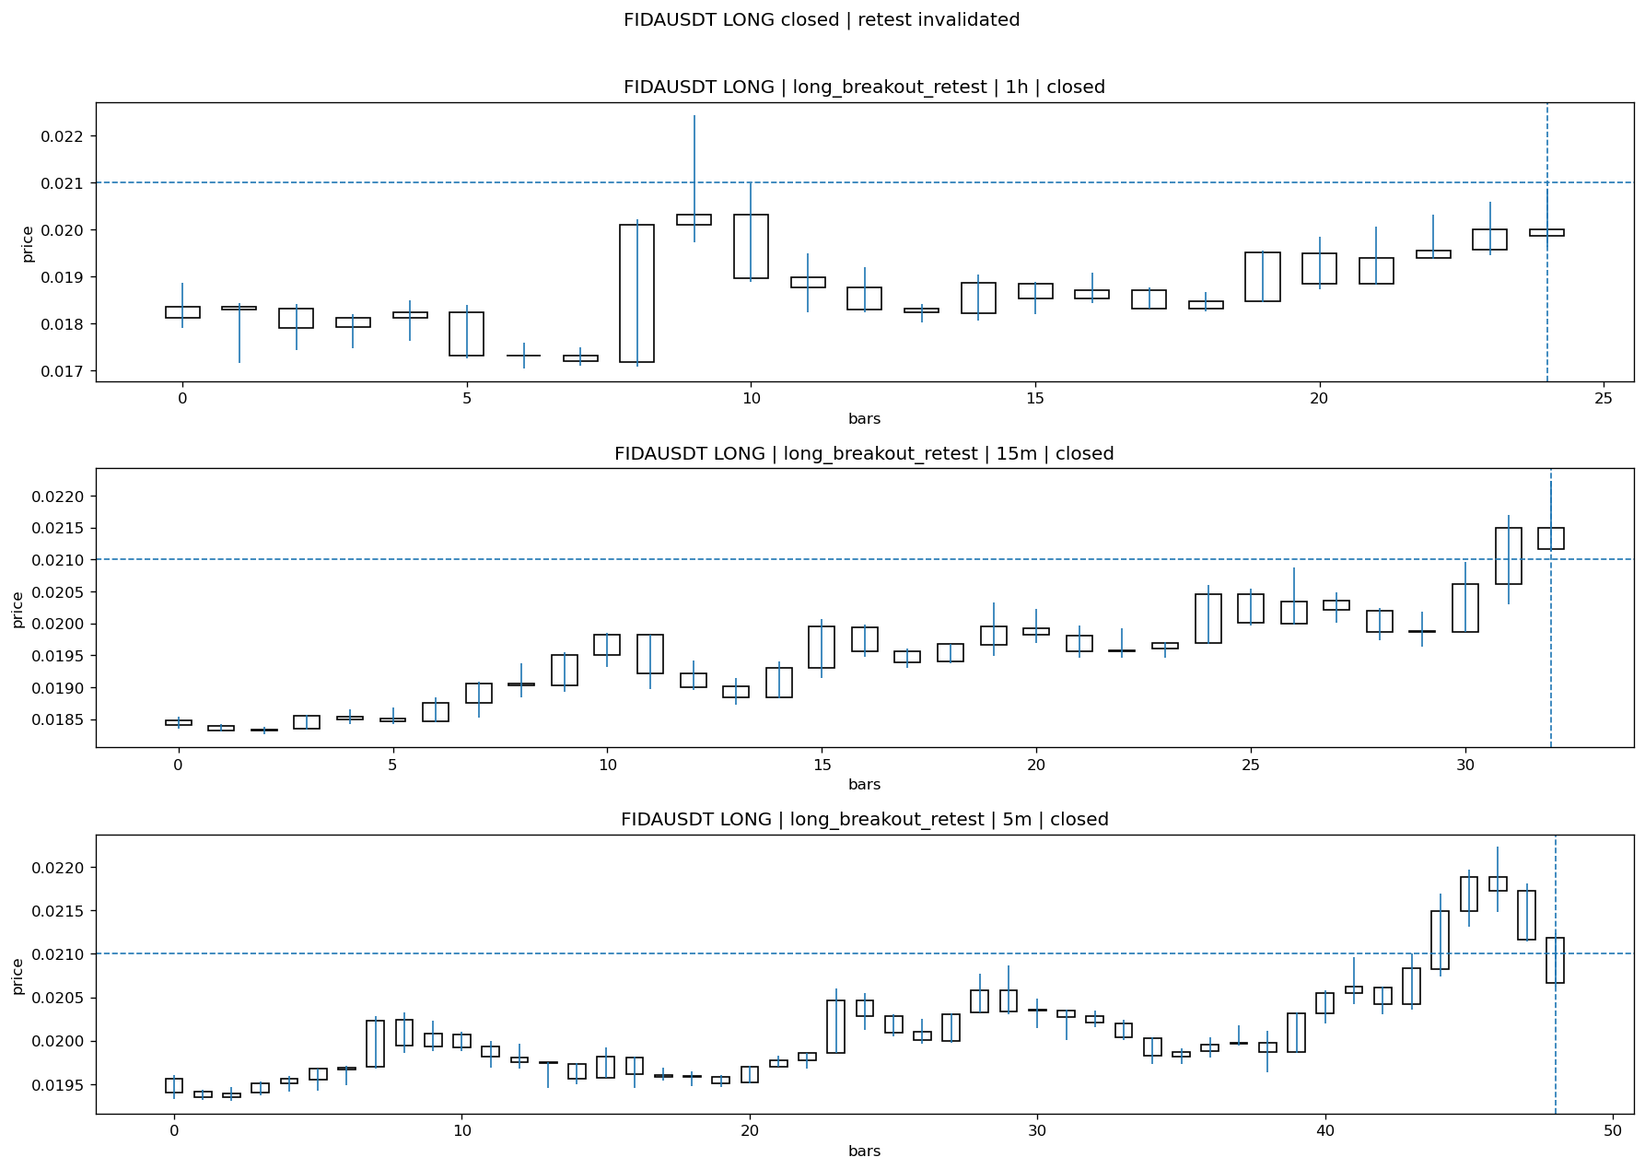
FIDAUSDT_LONG_long_breakout_retest_closed_1775285499769.png

Post-Close Outcome
1h outcome | available=N | reason=not_enough_post_close_time
2h outcome | available=N | reason=not_enough_post_close_time
4h reference | not_available_yet
Reclaim | not_available_yet
Execution | entry_feasible=not_available_yet | window=not_available_yetm | note=not_available_yet
Time-to-move | not_available_yet
Regret filter | regret_valid=not_available_yet | reason=not_available_yet
Conclusion | not_available_yet | notes=not_enough_post_close_time

Review placeholders
human_review_status=PENDING | verdict_code= | root_cause_code= | action_candidate_code=

Case 44: PUFFERUSDT-LONG-1775285100000
Summary | PUFFERUSDT | LONG | long_breakout_retest | status=INVALIDATED | close_reason=retest invalidated
Times | signal=2026-04-04 13:45:00 | created=2026-04-04 13:51:56 | confirmed= | sent= | close=2026-04-04 13:57:11 | fallback_due=2026-04-04 17:51:56
Semantics | is_confirmed=N | is_sent_signal=N | review_eligible=N | semantic_consistency=Y
Review integrity | review_exclusion_reason=outcome_2h_unavailable | semantic_issue=
Close anchoring | case_close_type=true_close | close_anchor_time=2026-04-04 13:57:11 | close_capture_basis=true_close
Regime / dispatch | regime_label=unclear_mixed | fit=MEDIUM | dispatch=not_evaluated [not_evaluated]
Tradeability | entry_feasible= | slippage= | regret_valid= | outcome=

Pre Pending
Stage status: capture_failed | Content type: none
Note: pre_fix_backfill_v2 — was missing_unexpected, snapshot was never taken (Sprint 3A.2 bug)

Pending Open
Stage status: capture_failed | Content type: none
Note: pre_fix_backfill_v2 — was missing_unexpected, snapshot was never taken (Sprint 3A.2 bug)

Entry Or Confirm
Stage status: not_applicable | Content type: none

Case Close
Stage status: captured | Content type: chart_snapshot
close_trigger_detail: retest invalidated
invalidation_detail: retest invalidated
Note: retest invalidated
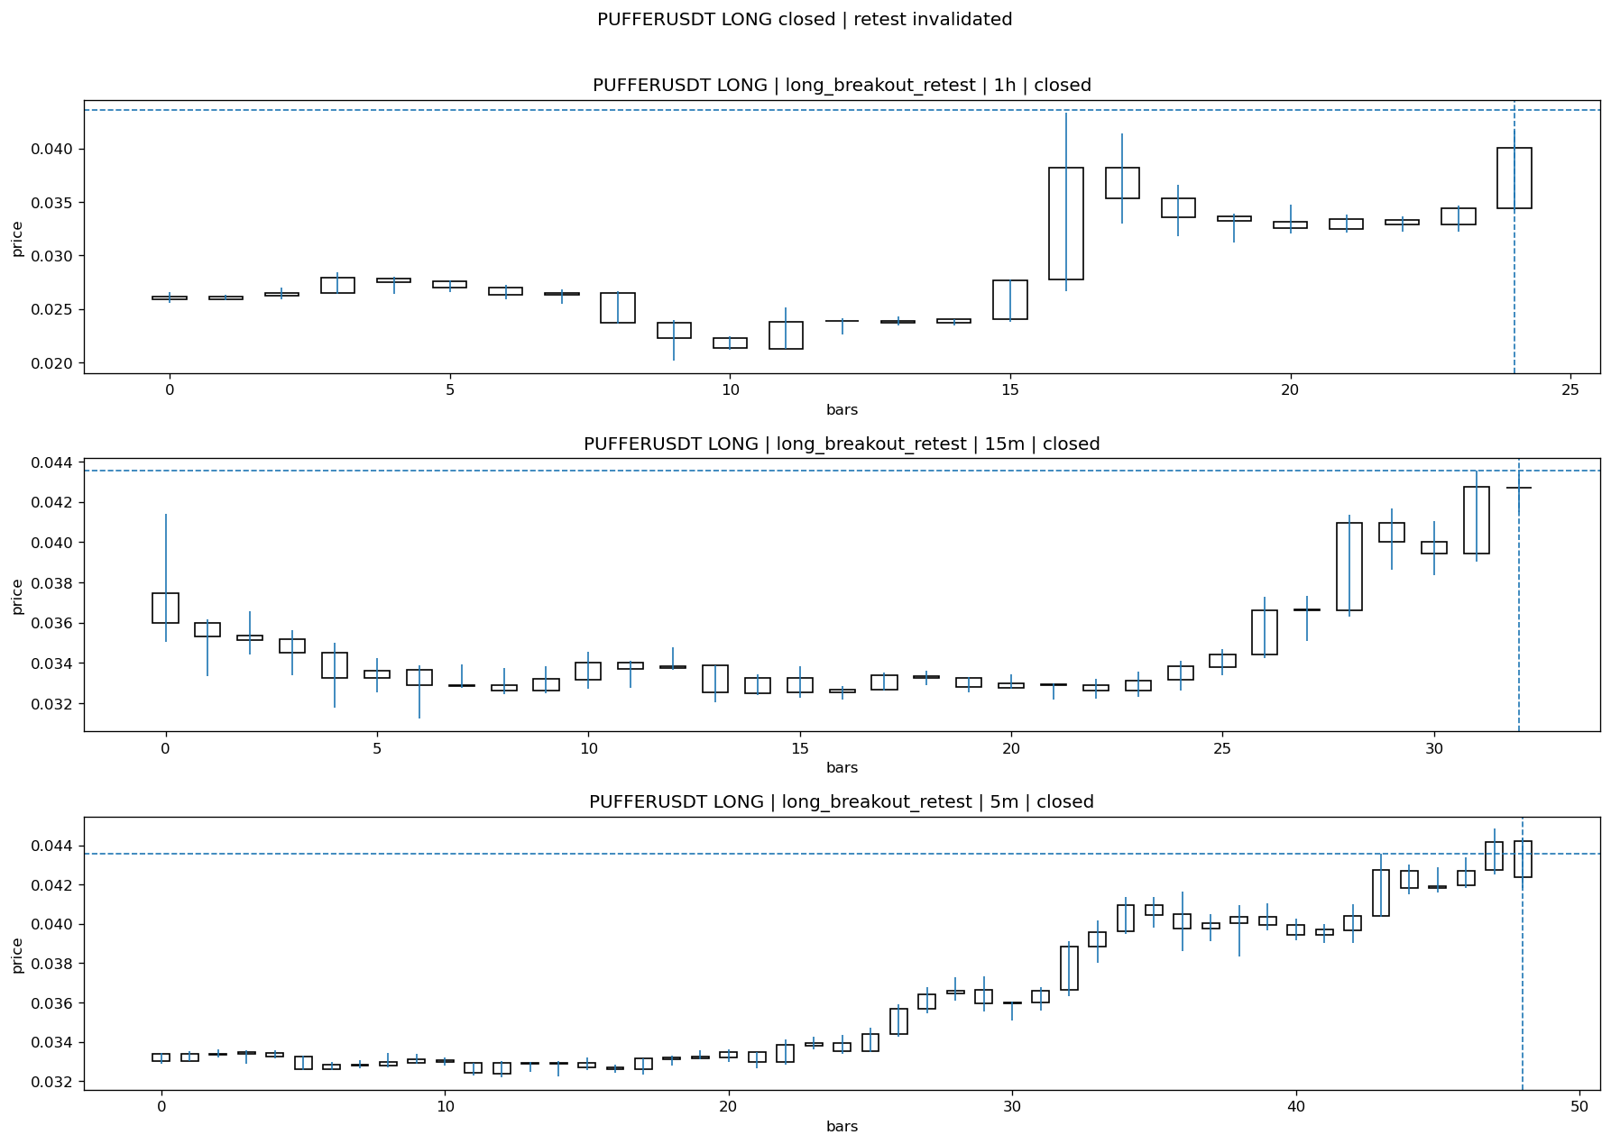
PUFFERUSDT_LONG_long_breakout_retest_closed_1775285831500.png

Post-Close Outcome
1h outcome | available=N | reason=not_enough_post_close_time
2h outcome | available=N | reason=not_enough_post_close_time
4h reference | not_available_yet
Reclaim | not_available_yet
Execution | entry_feasible=not_available_yet | window=not_available_yetm | note=not_available_yet
Time-to-move | not_available_yet
Regret filter | regret_valid=not_available_yet | reason=not_available_yet
Conclusion | not_available_yet | notes=not_enough_post_close_time

Review placeholders
human_review_status=PENDING | verdict_code= | root_cause_code= | action_candidate_code=

Case 45: SIRENUSDT-LONG-1775286000000
Summary | SIRENUSDT | LONG | long_breakout_retest | status=INVALIDATED | close_reason=retest invalidated
Times | signal=2026-04-04 14:00:00 | created=2026-04-04 14:05:34 | confirmed= | sent= | close=2026-04-04 14:10:59 | fallback_due=2026-04-04 18:05:34
Semantics | is_confirmed=N | is_sent_signal=N | review_eligible=N | semantic_consistency=Y
Review integrity | review_exclusion_reason=outcome_2h_unavailable | semantic_issue=
Close anchoring | case_close_type=true_close | close_anchor_time=2026-04-04 14:10:59 | close_capture_basis=true_close
Regime / dispatch | regime_label=trend_continuation_friendly | fit=HIGH | dispatch=not_evaluated [not_evaluated]
Tradeability | entry_feasible= | slippage= | regret_valid= | outcome=

Pre Pending
Stage status: capture_failed | Content type: none
Note: pre_fix_backfill_v2 — was missing_unexpected, snapshot was never taken (Sprint 3A.2 bug)

Pending Open
Stage status: capture_failed | Content type: none
Note: pre_fix_backfill_v2 — was missing_unexpected, snapshot was never taken (Sprint 3A.2 bug)

Entry Or Confirm
Stage status: not_applicable | Content type: none

Case Close
Stage status: captured | Content type: chart_snapshot
close_trigger_detail: retest invalidated
invalidation_detail: retest invalidated
Note: retest invalidated
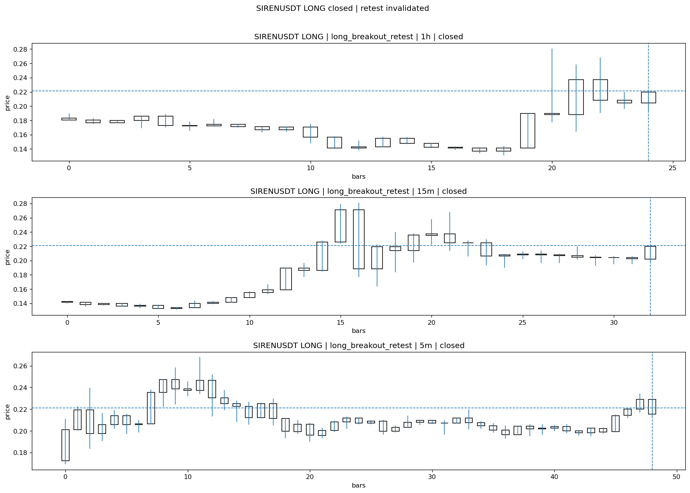
SIRENUSDT_LONG_long_breakout_retest_closed_1775286659174.png

Post-Close Outcome
1h outcome | available=N | reason=not_enough_post_close_time
2h outcome | available=N | reason=not_enough_post_close_time
4h reference | not_available_yet
Reclaim | not_available_yet
Execution | entry_feasible=not_available_yet | window=not_available_yetm | note=not_available_yet
Time-to-move | not_available_yet
Regret filter | regret_valid=not_available_yet | reason=not_available_yet
Conclusion | not_available_yet | notes=not_enough_post_close_time

Review placeholders
human_review_status=PENDING | verdict_code= | root_cause_code= | action_candidate_code=

Case 46: NOMUSDT-LONG-1775287800000
Summary | NOMUSDT | LONG | long_breakout_retest | status=PENDING | close_reason=
Times | signal=2026-04-04 14:30:00 | created=2026-04-04 14:38:52 | confirmed= | sent= | close=not_reached_yet | fallback_due=2026-04-04 18:38:52
Semantics | is_confirmed=N | is_sent_signal=N | review_eligible=Y | semantic_consistency=Y
Review integrity | review_exclusion_reason= | semantic_issue=
Close anchoring | case_close_type=not_due_yet | close_anchor_time= | close_capture_basis=
Regime / dispatch | regime_label=unclear_mixed | fit=MEDIUM | dispatch=not_evaluated [not_evaluated]
Tradeability | entry_feasible= | slippage= | regret_valid= | outcome=

Pre Pending
Stage status: missing_unexpected | Content type: none
Note: MISSING UNEXPECTED

Pending Open
Stage status: missing_unexpected | Content type: none
Note: MISSING UNEXPECTED

Entry Or Confirm
Stage status: not_applicable | Content type: none
Note: NOT APPLICABLE

Case Close
Stage status: not_reached_yet | Content type: none
Note: NOT REACHED YET

Post-Close Outcome
1h outcome | available=N | reason=not_available_yet
2h outcome | available=N | reason=not_available_yet
4h reference | not_available_yet
Reclaim | not_available_yet
Execution | entry_feasible=not_available_yet | window=not_available_yetm | note=not_available_yet
Time-to-move | not_available_yet
Regret filter | regret_valid=not_available_yet | reason=not_available_yet
Conclusion | not_available_yet | notes=not_available_yet

Review placeholders
human_review_status=PENDING | verdict_code= | root_cause_code= | action_candidate_code=

L. Decision Footer
→ Next action: Fix semantic health first — broken confirmed-path rows make strategy conclusions unreliable.

Semantic rules locked in this report:
• confirmed ≠ sent (always distinct)
• confirmed ≠ close (confirmed_ts ≠ closed_ts)
• entry_or_confirm keyed to confirm time only
• not_reached_yet is explicit — never substituted with fake timestamp
• no strategy / regime / dispatch / veto changes in this report
• semantically broken confirmed rows excluded from optimization counts

Daily Review Report V2 | 2026-04-04 | cases=46 | confirmed=5 | sent=0

