Daily Signal Review 2026-03-28
Lifecycle evidence + short-horizon outcome review pack
Metric | Value
Total cases | 55
Review eligible | 43
Excluded | 12
Semantic inconsistency | 11
missing_unexpected: pre_pending | 0
missing_unexpected: pending_open | 55
missing_unexpected: entry_or_confirm | 11
missing_unexpected: case_close | 44

Case Registry Preview
Case ID | Symbol | Side | Strategy | Status | Outcome
LYNUSDT-LONG-1774656600000 | LYNUSDT | LONG | long_breakout_retest | INVALIDATED | KILL_CORRECT
KATUSDT-LONG-1774656900000 | KATUSDT | LONG | long_breakout_retest | INVALIDATED | KILL_CORRECT
ANKRUSDT-SHORT-EXH-1774656900000 | ANKRUSDT | SHORT | short_exhaustion_retest | INVALIDATED | KILL_CORRECT
HYPEUSDT-SHORT-EXH-1774656900000 | HYPEUSDT | SHORT | short_exhaustion_retest | CONFIRMED | NO_MEANINGFUL_MOVE
SIRENUSDT-LONG-1774658100000 | SIRENUSDT | LONG | long_breakout_retest | INVALIDATED | KILL_CORRECT
BASUSDT-LONG-1774659300000 | BASUSDT | LONG | long_breakout_retest | INVALIDATED | KILL_CORRECT
DOTUSDT-SHORT-EXH-1774659600000 | DOTUSDT | SHORT | short_exhaustion_retest | CONFIRMED | NO_MEANINGFUL_MOVE
FILUSDT-SHORT-EXH-1774659600000 | FILUSDT | SHORT | short_exhaustion_retest | CONFIRMED | WAIT_TOO_SHORT_CANDIDATE
AAVEUSDT-SHORT-EXH-1774659600000 | AAVEUSDT | SHORT | short_exhaustion_retest | CONFIRMED | NO_MEANINGFUL_MOVE
PENGUUSDT-SHORT-EXH-1774659600000 | PENGUUSDT | SHORT | short_exhaustion_retest | CONFIRMED | NO_MEANINGFUL_MOVE
GALAUSDT-SHORT-EXH-1774659600000 | GALAUSDT | SHORT | short_exhaustion_retest | INVALIDATED | KILL_CORRECT
XLMUSDT-SHORT-EXH-1774659600000 | XLMUSDT | SHORT | short_exhaustion_retest | CONFIRMED | NO_MEANINGFUL_MOVE
ARBUSDT-SHORT-EXH-1774659600000 | ARBUSDT | SHORT | short_exhaustion_retest | EXPIRED_WAIT | NO_MEANINGFUL_MOVE
OPUSDT-SHORT-EXH-1774659600000 | OPUSDT | SHORT | short_exhaustion_retest | EXPIRED_WAIT | NO_MEANINGFUL_MOVE
ZROUSDT-SHORT-EXH-1774660500000 | ZROUSDT | SHORT | short_exhaustion_retest | CONFIRMED | NO_MEANINGFUL_MOVE
BASUSDT-LONG-1774661100000 | BASUSDT | LONG | long_breakout_retest | INVALIDATED | KILL_CORRECT
CFGUSDT-LONG-1774661400000 | CFGUSDT | LONG | long_breakout_retest | INVALIDATED | KILL_CORRECT
PIPPINUSDT-LONG-1774663200000 | PIPPINUSDT | LONG | long_breakout_retest | EXPIRED_WAIT | NO_MEANINGFUL_MOVE
SIRENUSDT-LONG-1774668600000 | SIRENUSDT | LONG | long_breakout_retest | INVALIDATED | KILL_CORRECT
SIRENUSDT-LONG-1774669800000 | SIRENUSDT | LONG | long_breakout_retest | INVALIDATED | KILL_CORRECT
AAVEUSDT-SHORT-EXH-1774669500000 | AAVEUSDT | SHORT | short_exhaustion_retest | CONFIRMED | NO_MEANINGFUL_MOVE
CFGUSDT-LONG-1774670100000 | CFGUSDT | LONG | long_breakout_retest | INVALIDATED | KILL_CORRECT
SIRENUSDT-LONG-1774670700000 | SIRENUSDT | LONG | long_breakout_retest | EXPIRED_WAIT | NO_MEANINGFUL_MOVE
FETUSDT-SHORT-EXH-1774670400000 | FETUSDT | SHORT | short_exhaustion_retest | EXPIRED_WAIT | NO_MEANINGFUL_MOVE
ONTUSDT-LONG-1774671000000 | ONTUSDT | LONG | long_breakout_retest | EXPIRED_WAIT | NO_MEANINGFUL_MOVE
1000SHIBUSDT-SHORT-EXH-1774670400000 | 1000SHIBUSDT | SHORT | short_exhaustion_retest | INVALIDATED | KILL_CORRECT
BRUSDT-LONG-1774671600000 | BRUSDT | LONG | long_breakout_retest | EXPIRED_WAIT | WAIT_TOO_SHORT_CANDIDATE
LYNUSDT-LONG-1774671900000 | LYNUSDT | LONG | long_breakout_retest | INVALIDATED | WAIT_TOO_SHORT_CANDIDATE
CFGUSDT-LONG-1774672800000 | CFGUSDT | LONG | long_breakout_retest | INVALIDATED | KILL_CORRECT
ONTUSDT-LONG-1774673700000 | ONTUSDT | LONG | long_breakout_retest | INVALIDATED | WAIT_TOO_SHORT_CANDIDATE
HUMAUSDT-LONG-1774674300000 | HUMAUSDT | LONG | long_breakout_retest | EXPIRED_WAIT | NO_MEANINGFUL_MOVE
ONTUSDT-LONG-1774674600000 | ONTUSDT | LONG | long_breakout_retest | INVALIDATED | WAIT_TOO_SHORT_CANDIDATE
ONTUSDT-LONG-1774676100000 | ONTUSDT | LONG | long_breakout_retest | EXPIRED_WAIT | NO_MEANINGFUL_MOVE
PIXELUSDT-SHORT-EXH-1774675800000 | PIXELUSDT | SHORT | short_exhaustion_retest | CONFIRMED | NO_MEANINGFUL_MOVE
SIRENUSDT-LONG-1774676400000 | SIRENUSDT | LONG | long_breakout_retest | INVALIDATED | KILL_CORRECT
QUSDT-LONG-1774676400000 | QUSDT | LONG | long_breakout_retest | INVALIDATED | WAIT_TOO_SHORT_CANDIDATE
RIVERUSDT-LONG-1774676700000 | RIVERUSDT | LONG | long_breakout_retest | INVALIDATED | KILL_CORRECT
QUSDT-LONG-1774676700000 | QUSDT | LONG | long_breakout_retest | INVALIDATED | KILL_CORRECT
BLUAIUSDT-SHORT-EXH-1774680300000 | BLUAIUSDT | SHORT | short_exhaustion_retest | EXPIRED_WAIT | NO_MEANINGFUL_MOVE
ONTUSDT-LONG-1774683000000 | ONTUSDT | LONG | long_breakout_retest | INVALIDATED | WAIT_TOO_SHORT_CANDIDATE
WLDUSDT-LONG-1774683600000 | WLDUSDT | LONG | long_breakout_retest | EXPIRED_WAIT | WAIT_TOO_SHORT_CANDIDATE
BASUSDT-LONG-1774684500000 | BASUSDT | LONG | long_breakout_retest | INVALIDATED | WAIT_TOO_SHORT_CANDIDATE
MUSDT-LONG-1774685100000 | MUSDT | LONG | long_breakout_retest | INVALIDATED | KILL_CORRECT
LYNUSDT-LONG-1774685400000 | LYNUSDT | LONG | long_breakout_retest | INVALIDATED | KILL_CORRECT
RIVERUSDT-LONG-1774685700000 | RIVERUSDT | LONG | long_breakout_retest | INVALIDATED | KILL_CORRECT
BASUSDT-LONG-1774686000000 | BASUSDT | LONG | long_breakout_retest | INVALIDATED | KILL_CORRECT
RIVERUSDT-LONG-1774686300000 | RIVERUSDT | LONG | long_breakout_retest | INVALIDATED | KILL_CORRECT
SIRENUSDT-LONG-1774687800000 | SIRENUSDT | LONG | long_breakout_retest | EXPIRED_WAIT | NO_MEANINGFUL_MOVE
WLDUSDT-LONG-1774689300000 | WLDUSDT | LONG | long_breakout_retest | INVALIDATED | KILL_CORRECT
KITEUSDT-SHORT-EXH-1774689300000 | KITEUSDT | SHORT | short_exhaustion_retest | CONFIRMED | NO_MEANINGFUL_MOVE
4USDT-LONG-1774690500000 | 4USDT | LONG | long_breakout_retest | EXPIRED_WAIT | NO_MEANINGFUL_MOVE
FILUSDT-SHORT-EXH-1774690200000 | FILUSDT | SHORT | short_exhaustion_retest | INVALIDATED | KILL_CORRECT
NEARUSDT-SHORT-EXH-1774690200000 | NEARUSDT | SHORT | short_exhaustion_retest | CONFIRMED | NO_MEANINGFUL_MOVE
TAUSDT-SHORT-EXH-1774691100000 | TAUSDT | SHORT | short_exhaustion_retest | EXPIRED_WAIT | NO_MEANINGFUL_MOVE
TAOUSDT-SHORT-EXH-1774692900000 | TAOUSDT | SHORT | short_exhaustion_retest | PENDING

Case 1: LYNUSDT-LONG-1774656600000
Summary | LYNUSDT | LONG | long_breakout_retest | status_final=INVALIDATED | close_reason=retest invalidated
Times | signal=2026-03-28 07:10:00 | created=2026-03-28 07:16:39 | confirmed= | sent= | close=2026-03-28 07:35:09 | fallback_due=2026-03-28 11:16:39
Semantics | is_confirmed=N | is_sent_signal=N | review_eligible=Y | semantic_consistency=Y
Review integrity | review_exclusion_reason= | semantic_issue=
Close anchoring | case_close_type=true_close | close_anchor_time=2026-03-28 07:35:09 | close_capture_basis=true_close
Tradeability / outcome | entry_feasible=Y | slippage=0.0000 | regret_valid=N | outcome=KILL_CORRECT

Pre Pending
Stage status: captured | Content type: chart_snapshot
Note: pre_pending context
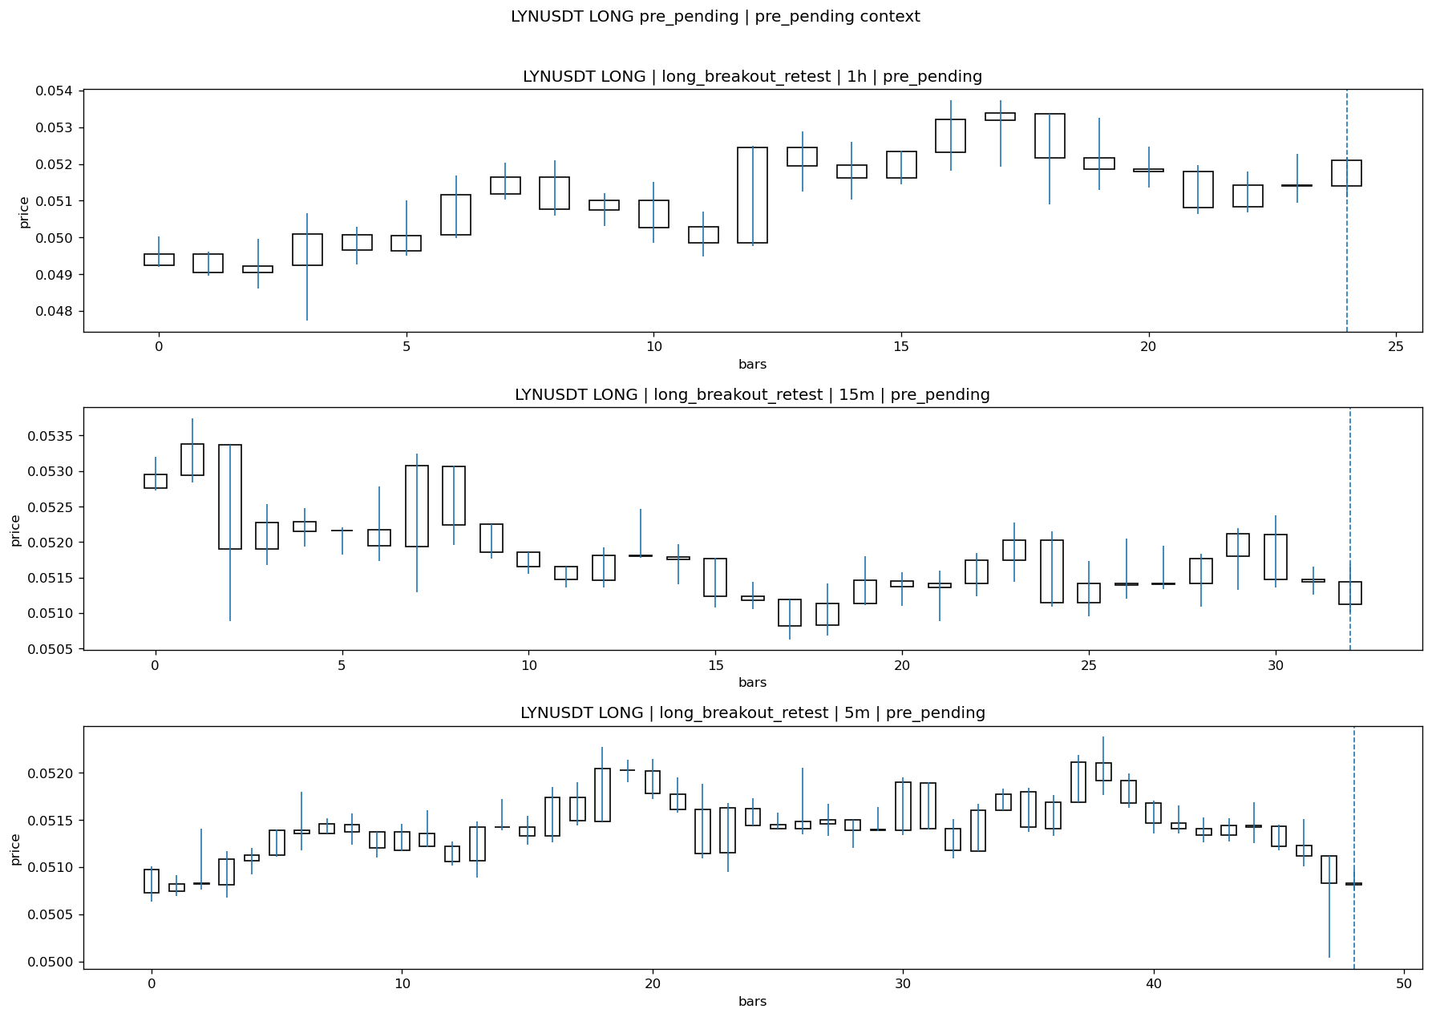
LYNUSDT_LONG_long_breakout_retest_pre_pending_1774656300000.png

Pending Open
Stage status: missing_unexpected | Content type: none
Note: MISSING UNEXPECTED

Entry Or Confirm
Stage status: not_applicable | Content type: none
Note: NOT APPLICABLE

Case Close
Stage status: missing_unexpected | Content type: none
Note: MISSING UNEXPECTED

Post-Close Outcome
1h outcome | available=Y | favor=0.0000 | adverse=13.4307 | summary=favor=0.00% adverse=13.43%
2h outcome | available=Y | favor=0.0000 | adverse=13.4307 | summary=favor=0.00% adverse=13.43%
4h reference | favor=0.0000 | adverse=13.4307
Reclaim | 2h=Y | 4h=Y
Execution reality | entry_feasible=Y | entry_window=10m | entry_note=entry still reachable within 10m
Time-to-move | time_to_max_favor=5m | time_to_max_adverse=40m
Regret filter | regret_valid=N | reason=adverse_too_large
Conclusion | KILL_CORRECT | notes=entry_ref_from_breakout_level

Review placeholders
human_review_status=PENDING | verdict_code= | root_cause_code= | action_candidate_code=

Case 2: KATUSDT-LONG-1774656900000
Summary | KATUSDT | LONG | long_breakout_retest | status_final=INVALIDATED | close_reason=retest invalidated
Times | signal=2026-03-28 07:15:00 | created=2026-03-28 07:21:55 | confirmed= | sent= | close=2026-03-28 07:27:00 | fallback_due=2026-03-28 11:21:55
Semantics | is_confirmed=N | is_sent_signal=N | review_eligible=Y | semantic_consistency=Y
Review integrity | review_exclusion_reason= | semantic_issue=
Close anchoring | case_close_type=true_close | close_anchor_time=2026-03-28 07:27:00 | close_capture_basis=true_close
Tradeability / outcome | entry_feasible=Y | slippage=0.0000 | regret_valid=N | outcome=KILL_CORRECT

Pre Pending
Stage status: captured | Content type: chart_snapshot
Note: pre_pending context
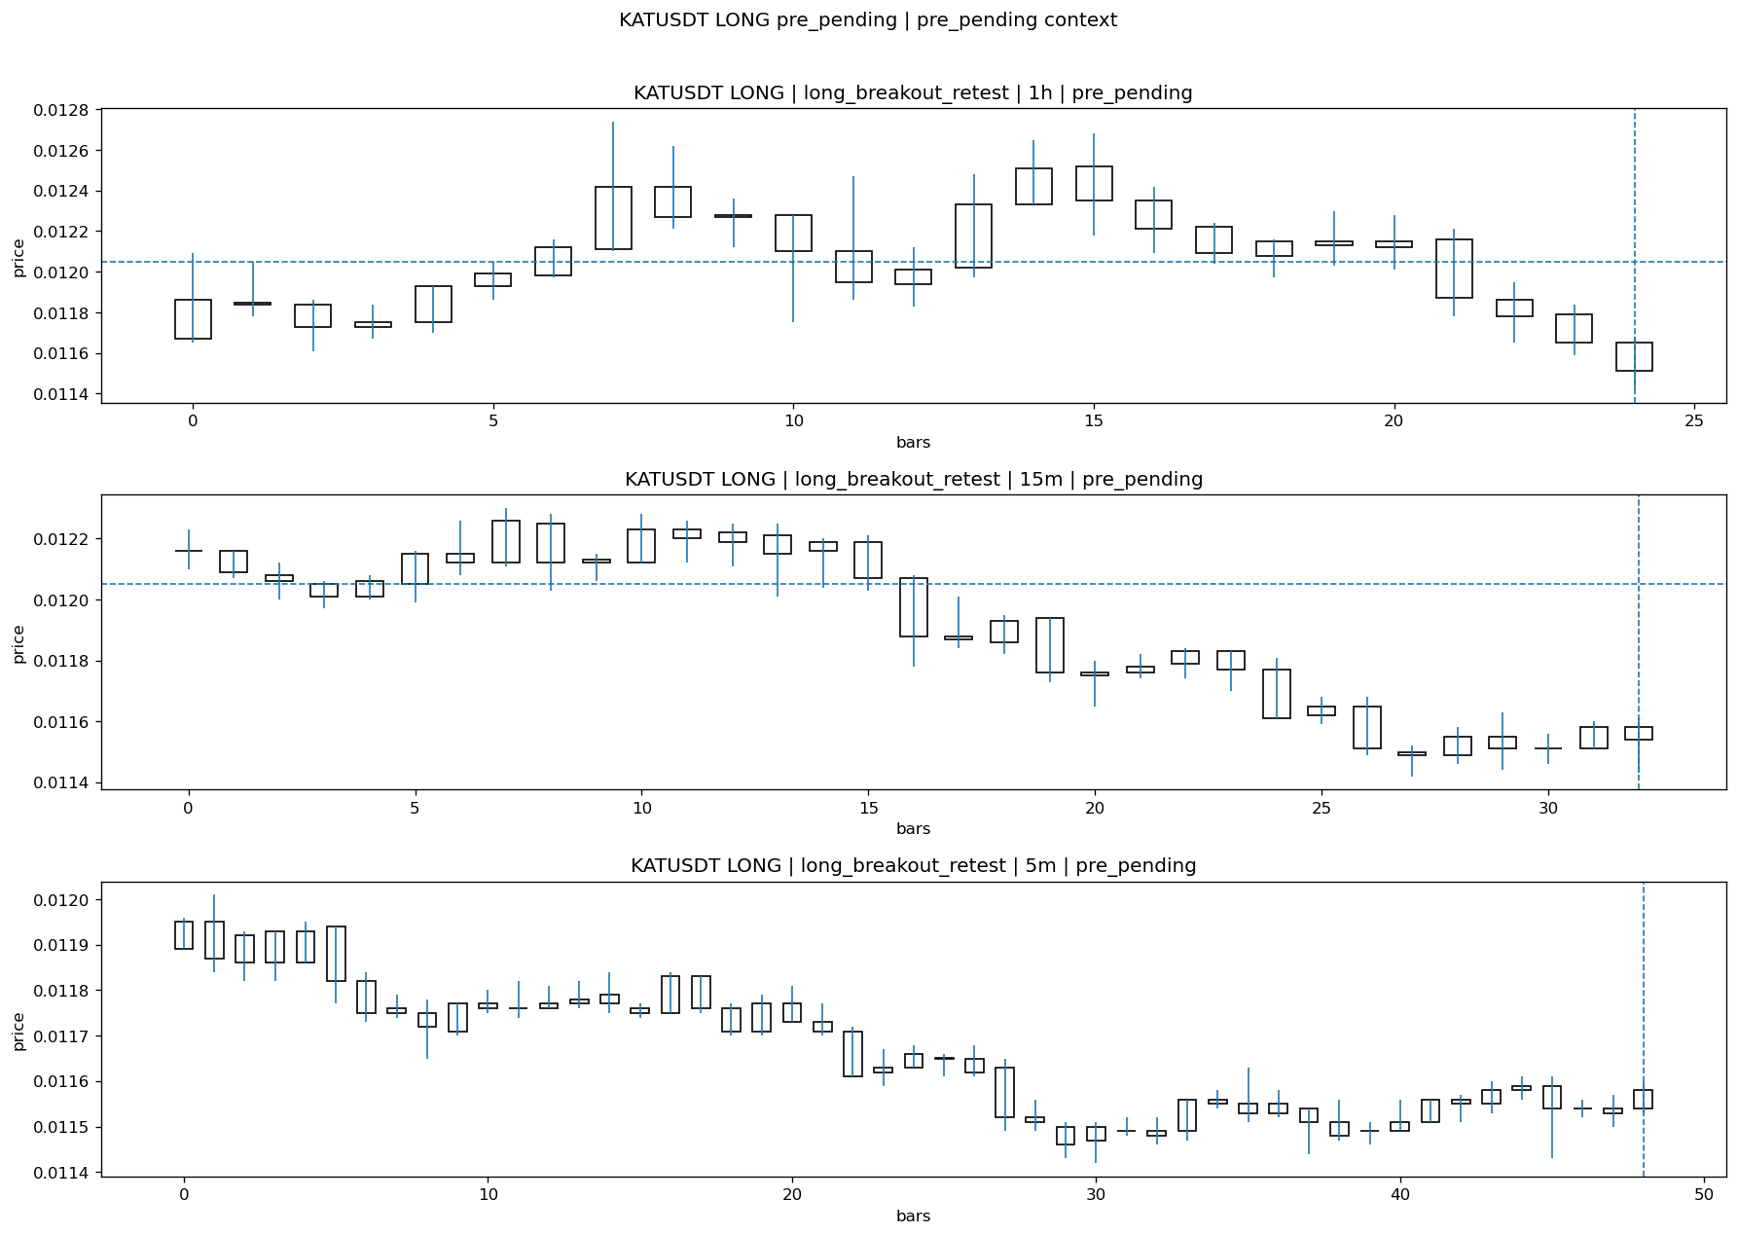
KATUSDT_LONG_long_breakout_retest_pre_pending_1774656600000.png

Pending Open
Stage status: missing_unexpected | Content type: none
Note: MISSING UNEXPECTED

Entry Or Confirm
Stage status: not_applicable | Content type: none
Note: NOT APPLICABLE

Case Close
Stage status: missing_unexpected | Content type: none
Note: MISSING UNEXPECTED

Post-Close Outcome
1h outcome | available=Y | favor=2.2407 | adverse=2.4066 | summary=favor=2.24% adverse=2.41%
2h outcome | available=Y | favor=2.2407 | adverse=6.4730 | summary=favor=2.24% adverse=6.47%
4h reference | favor=2.2407 | adverse=7.6349
Reclaim | 2h=Y | 4h=Y
Execution reality | entry_feasible=Y | entry_window=10m | entry_note=entry still reachable within 10m
Time-to-move | time_to_max_favor=18m | time_to_max_adverse=68m
Regret filter | regret_valid=N | reason=adverse_too_large
Conclusion | KILL_CORRECT | notes=entry_ref_from_breakout_level

Review placeholders
human_review_status=PENDING | verdict_code= | root_cause_code= | action_candidate_code=

Case 3: ANKRUSDT-SHORT-EXH-1774656900000
Summary | ANKRUSDT | SHORT | short_exhaustion_retest | status_final=INVALIDATED | close_reason=retest invalidated
Times | signal=2026-03-28 07:15:00 | created=2026-03-28 07:30:09 | confirmed= | sent= | close=2026-03-28 08:02:13 | fallback_due=2026-03-28 11:30:09
Semantics | is_confirmed=N | is_sent_signal=N | review_eligible=Y | semantic_consistency=Y
Review integrity | review_exclusion_reason= | semantic_issue=
Close anchoring | case_close_type=true_close | close_anchor_time=2026-03-28 08:02:13 | close_capture_basis=true_close
Tradeability / outcome | entry_feasible=Y | slippage=0.0000 | regret_valid=N | outcome=KILL_CORRECT

Pre Pending
Stage status: captured | Content type: chart_snapshot
Note: pre_pending context
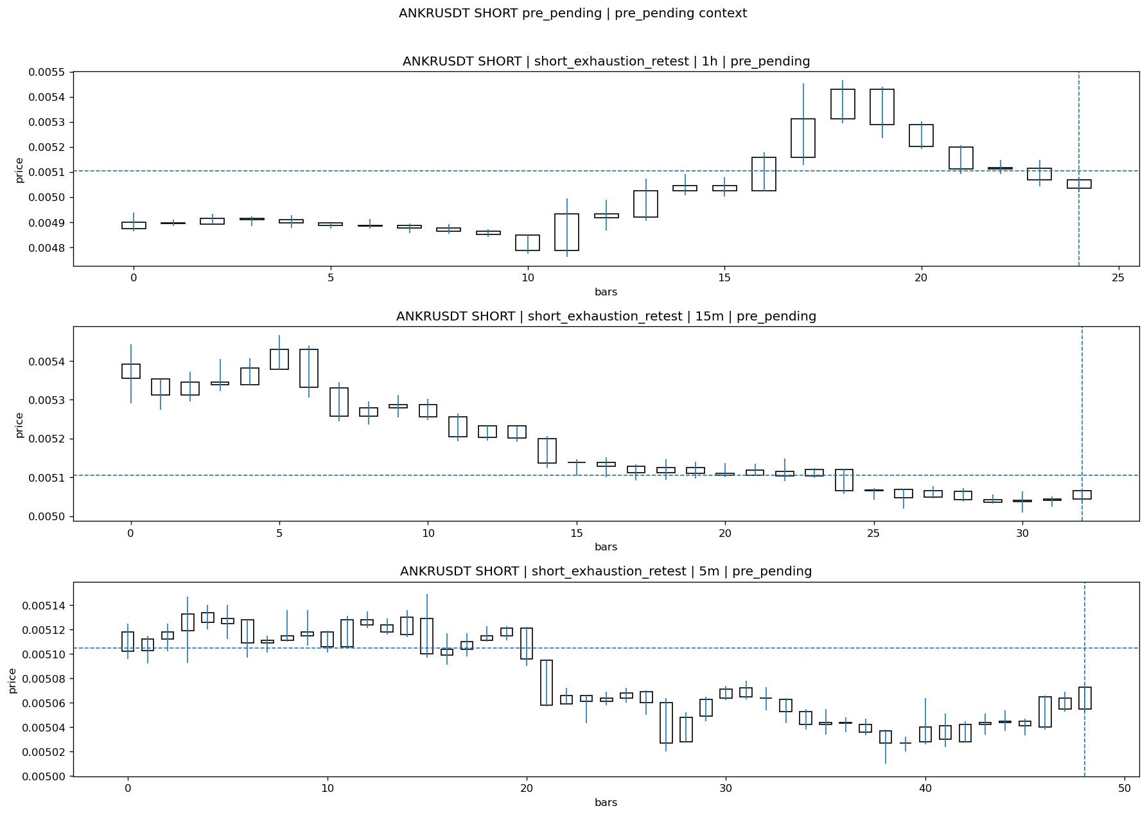
ANKRUSDT_SHORT_short_exhaustion_retest_pre_pending_1774656000000.png

Pending Open
Stage status: missing_unexpected | Content type: none
Note: MISSING UNEXPECTED

Entry Or Confirm
Stage status: not_applicable | Content type: none
Note: NOT APPLICABLE

Case Close
Stage status: missing_unexpected | Content type: none
Note: MISSING UNEXPECTED

Post-Close Outcome
1h outcome | available=Y | favor=2.1352 | adverse=4.3683 | summary=favor=2.14% adverse=4.37%
2h outcome | available=Y | favor=2.5269 | adverse=4.3683 | summary=favor=2.53% adverse=4.37%
4h reference | favor=3.2321 | adverse=4.3683
Reclaim | 2h=Y | 4h=Y
Execution reality | entry_feasible=Y | entry_window=10m | entry_note=entry still reachable within 10m
Time-to-move | time_to_max_favor=103m | time_to_max_adverse=13m
Regret filter | regret_valid=N | reason=adverse_too_large
Conclusion | KILL_CORRECT | notes=entry_ref_from_breakout_level

Review placeholders
human_review_status=PENDING | verdict_code= | root_cause_code= | action_candidate_code=

Case 4: HYPEUSDT-SHORT-EXH-1774656900000
Summary | HYPEUSDT | SHORT | short_exhaustion_retest | status_final=CONFIRMED | close_reason=signal confirmed
Times | signal=2026-03-28 07:15:00 | created=2026-03-28 07:32:33 | confirmed= | sent= | close=2026-03-28 08:02:14 | fallback_due=2026-03-28 11:32:33
Semantics | is_confirmed=N | is_sent_signal=N | review_eligible=N | semantic_consistency=N
Review integrity | review_exclusion_reason=confirmed_without_confirmed_ts | semantic_issue=confirmed_without_confirmed_ts
Close anchoring | case_close_type=not_due_yet | close_anchor_time= | close_capture_basis=not_due_yet
Tradeability / outcome | entry_feasible=Y | slippage=0.0000 | regret_valid=N | outcome=NO_MEANINGFUL_MOVE

Pre Pending
Stage status: captured | Content type: chart_snapshot
Note: pre_pending context
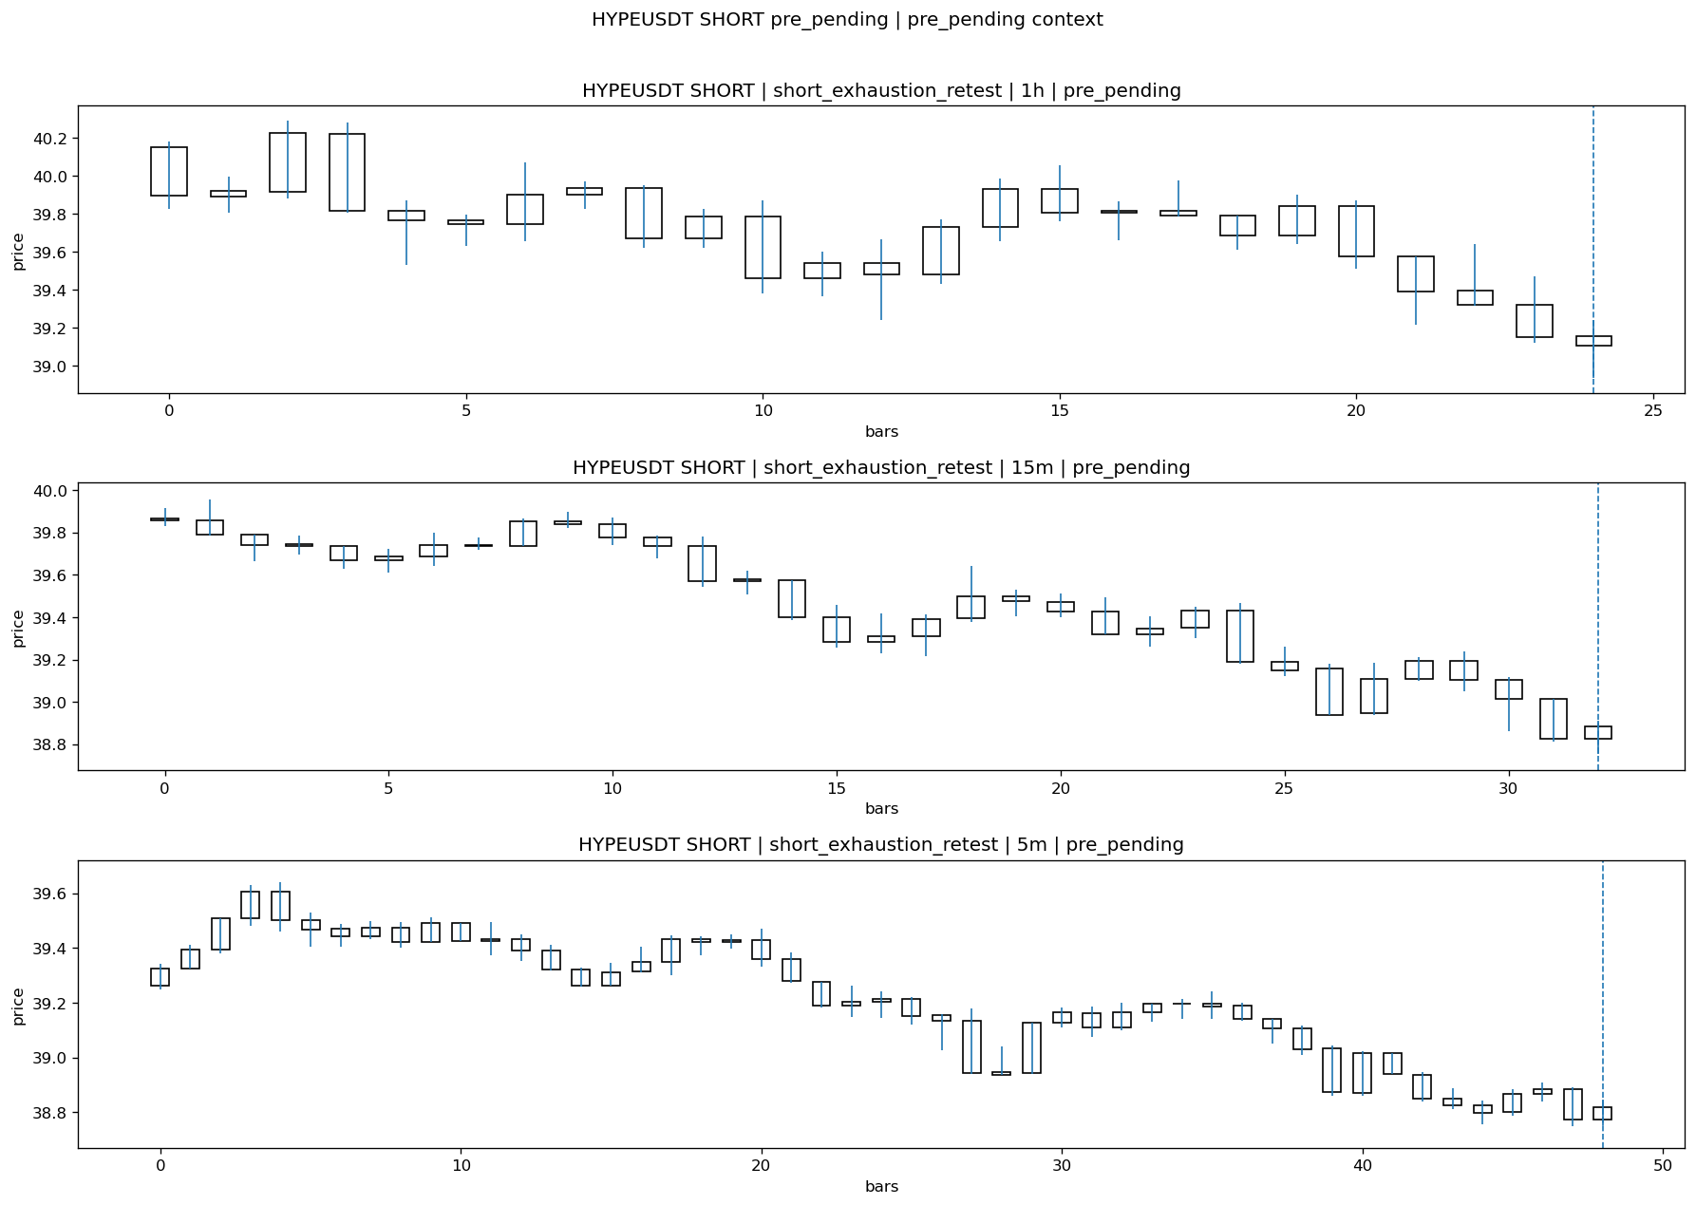
HYPEUSDT_SHORT_short_exhaustion_retest_pre_pending_1774656000000.png

Pending Open
Stage status: missing_unexpected | Content type: none
Note: MISSING UNEXPECTED

Entry Or Confirm
Stage status: missing_unexpected | Content type: none
Note: MISSING UNEXPECTED

Case Close
Stage status: not_reached_yet | Content type: none
Note: NOT REACHED YET

Post-Close Outcome
1h outcome | available=Y | favor=0.4636 | adverse=0.3510 | summary=favor=0.46% adverse=0.35%
2h outcome | available=Y | favor=0.4636 | adverse=0.7491 | summary=favor=0.46% adverse=0.75%
4h reference | favor=0.4636 | adverse=1.2258
Reclaim | 2h=Y | 4h=Y
Execution reality | entry_feasible=Y | entry_window=10m | entry_note=entry still reachable within 10m
Time-to-move | time_to_max_favor=33m | time_to_max_adverse=113m
Regret filter | regret_valid=N | reason=no_meaningful_fast_move
Conclusion | NO_MEANINGFUL_MOVE | notes=entry_ref_from_breakout_level

Review placeholders
human_review_status=PENDING | verdict_code= | root_cause_code= | action_candidate_code=

Case 5: SIRENUSDT-LONG-1774658100000
Summary | SIRENUSDT | LONG | long_breakout_retest | status_final=INVALIDATED | close_reason=retest invalidated
Times | signal=2026-03-28 07:35:00 | created=2026-03-28 07:40:35 | confirmed= | sent= | close=2026-03-28 08:10:26 | fallback_due=2026-03-28 11:40:35
Semantics | is_confirmed=N | is_sent_signal=N | review_eligible=Y | semantic_consistency=Y
Review integrity | review_exclusion_reason= | semantic_issue=
Close anchoring | case_close_type=true_close | close_anchor_time=2026-03-28 08:10:26 | close_capture_basis=true_close
Tradeability / outcome | entry_feasible=Y | slippage=0.0000 | regret_valid=N | outcome=KILL_CORRECT

Pre Pending
Stage status: captured | Content type: chart_snapshot
Note: pre_pending context
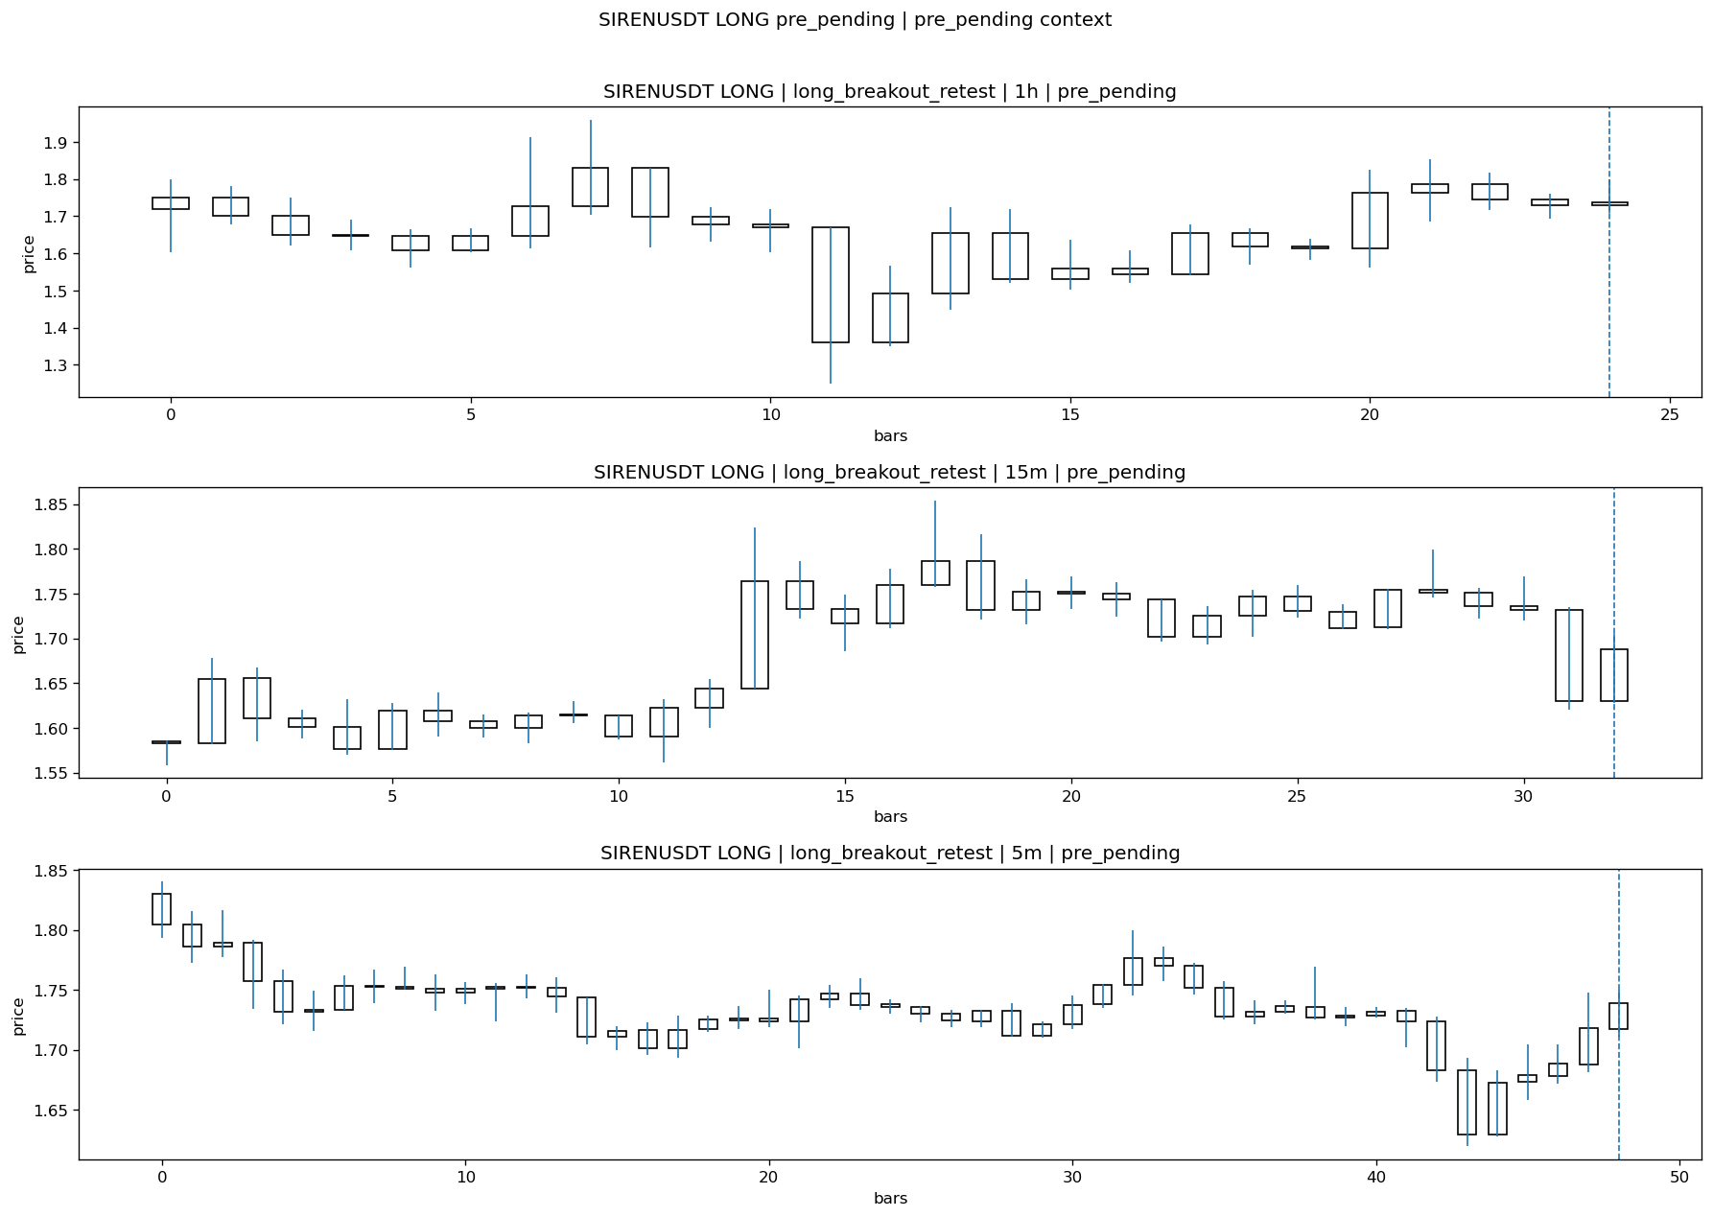
SIRENUSDT_LONG_long_breakout_retest_pre_pending_1774657800000.png

Pending Open
Stage status: missing_unexpected | Content type: none
Note: MISSING UNEXPECTED

Entry Or Confirm
Stage status: not_applicable | Content type: none
Note: NOT APPLICABLE

Case Close
Stage status: missing_unexpected | Content type: none
Note: MISSING UNEXPECTED

Post-Close Outcome
1h outcome | available=Y | favor=11.2041 | adverse=5.5108 | summary=favor=11.20% adverse=5.51%
2h outcome | available=Y | favor=13.7492 | adverse=5.5108 | summary=favor=13.75% adverse=5.51%
4h reference | favor=70.2228 | adverse=5.5108
Reclaim | 2h=Y | 4h=Y
Execution reality | entry_feasible=Y | entry_window=10m | entry_note=entry still reachable within 10m
Time-to-move | time_to_max_favor=95m | time_to_max_adverse=55m
Regret filter | regret_valid=N | reason=no_meaningful_fast_move
Conclusion | KILL_CORRECT | notes=entry_ref_from_breakout_level

Review placeholders
human_review_status=PENDING | verdict_code= | root_cause_code= | action_candidate_code=

Case 6: BASUSDT-LONG-1774659300000
Summary | BASUSDT | LONG | long_breakout_retest | status_final=INVALIDATED | close_reason=acceptance_floor_lost 0.008263<0.008390
Times | signal=2026-03-28 07:55:00 | created=2026-03-28 08:02:51 | confirmed= | sent= | close=2026-03-28 08:10:27 | fallback_due=2026-03-28 12:02:51
Semantics | is_confirmed=N | is_sent_signal=N | review_eligible=Y | semantic_consistency=Y
Review integrity | review_exclusion_reason= | semantic_issue=
Close anchoring | case_close_type=true_close | close_anchor_time=2026-03-28 08:10:27 | close_capture_basis=true_close
Tradeability / outcome | entry_feasible=Y | slippage=0.0000 | regret_valid=N | outcome=KILL_CORRECT

Pre Pending
Stage status: captured | Content type: chart_snapshot
Note: pre_pending context
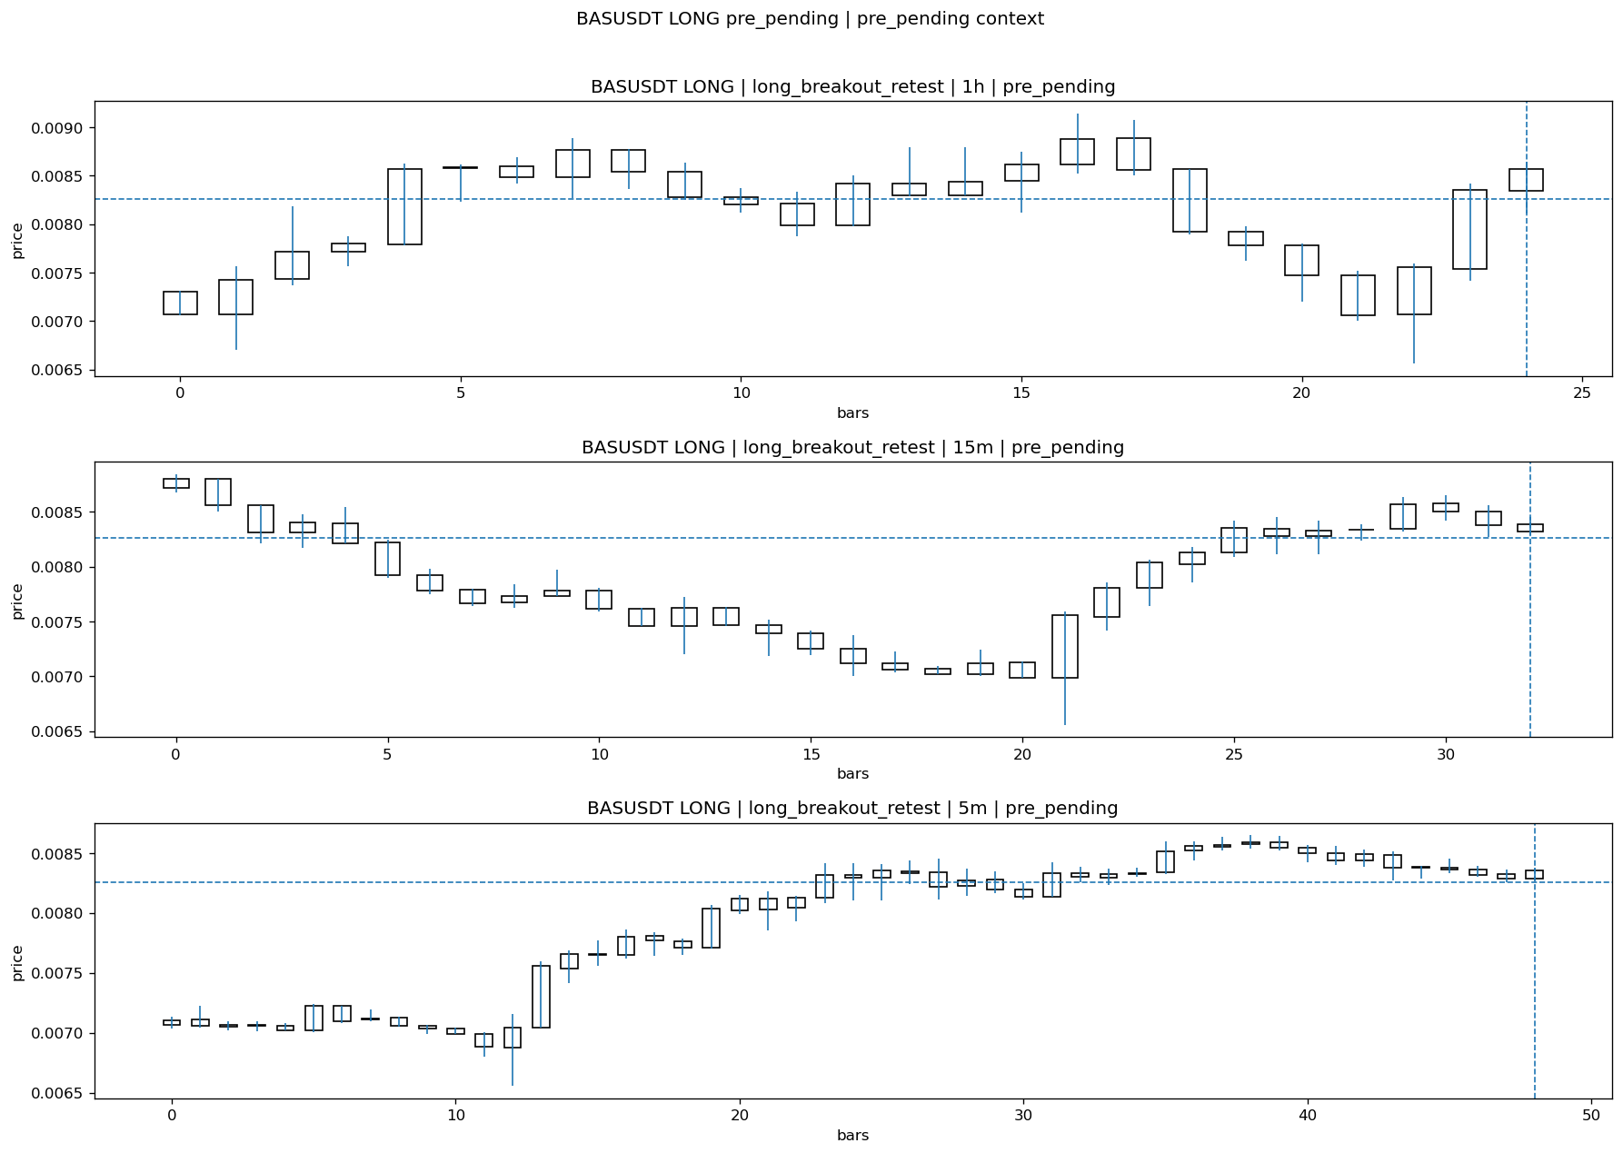
BASUSDT_LONG_long_breakout_retest_pre_pending_1774659000000.png

Pending Open
Stage status: missing_unexpected | Content type: none
Note: MISSING UNEXPECTED

Entry Or Confirm
Stage status: not_applicable | Content type: none
Note: NOT APPLICABLE

Case Close
Stage status: missing_unexpected | Content type: none
Note: MISSING UNEXPECTED

Post-Close Outcome
1h outcome | available=Y | favor=6.9976 | adverse=2.1308 | summary=favor=7.00% adverse=2.13%
2h outcome | available=Y | favor=7.2155 | adverse=7.7966 | summary=favor=7.22% adverse=7.80%
4h reference | favor=7.2155 | adverse=17.3971
Reclaim | 2h=Y | 4h=Y
Execution reality | entry_feasible=Y | entry_window=10m | entry_note=entry still reachable within 10m
Time-to-move | time_to_max_favor=65m | time_to_max_adverse=120m
Regret filter | regret_valid=N | reason=adverse_too_large
Conclusion | KILL_CORRECT | notes=entry_ref_from_breakout_level

Review placeholders
human_review_status=PENDING | verdict_code= | root_cause_code= | action_candidate_code=

Case 7: DOTUSDT-SHORT-EXH-1774659600000
Summary | DOTUSDT | SHORT | short_exhaustion_retest | status_final=CONFIRMED | close_reason=signal confirmed
Times | signal=2026-03-28 08:00:00 | created=2026-03-28 08:16:05 | confirmed= | sent= | close=2026-03-28 08:32:28 | fallback_due=2026-03-28 12:16:05
Semantics | is_confirmed=N | is_sent_signal=N | review_eligible=N | semantic_consistency=N
Review integrity | review_exclusion_reason=confirmed_without_confirmed_ts | semantic_issue=confirmed_without_confirmed_ts
Close anchoring | case_close_type=not_due_yet | close_anchor_time= | close_capture_basis=not_due_yet
Tradeability / outcome | entry_feasible=Y | slippage=0.0000 | regret_valid=N | outcome=NO_MEANINGFUL_MOVE

Pre Pending
Stage status: captured | Content type: chart_snapshot
Note: pre_pending context
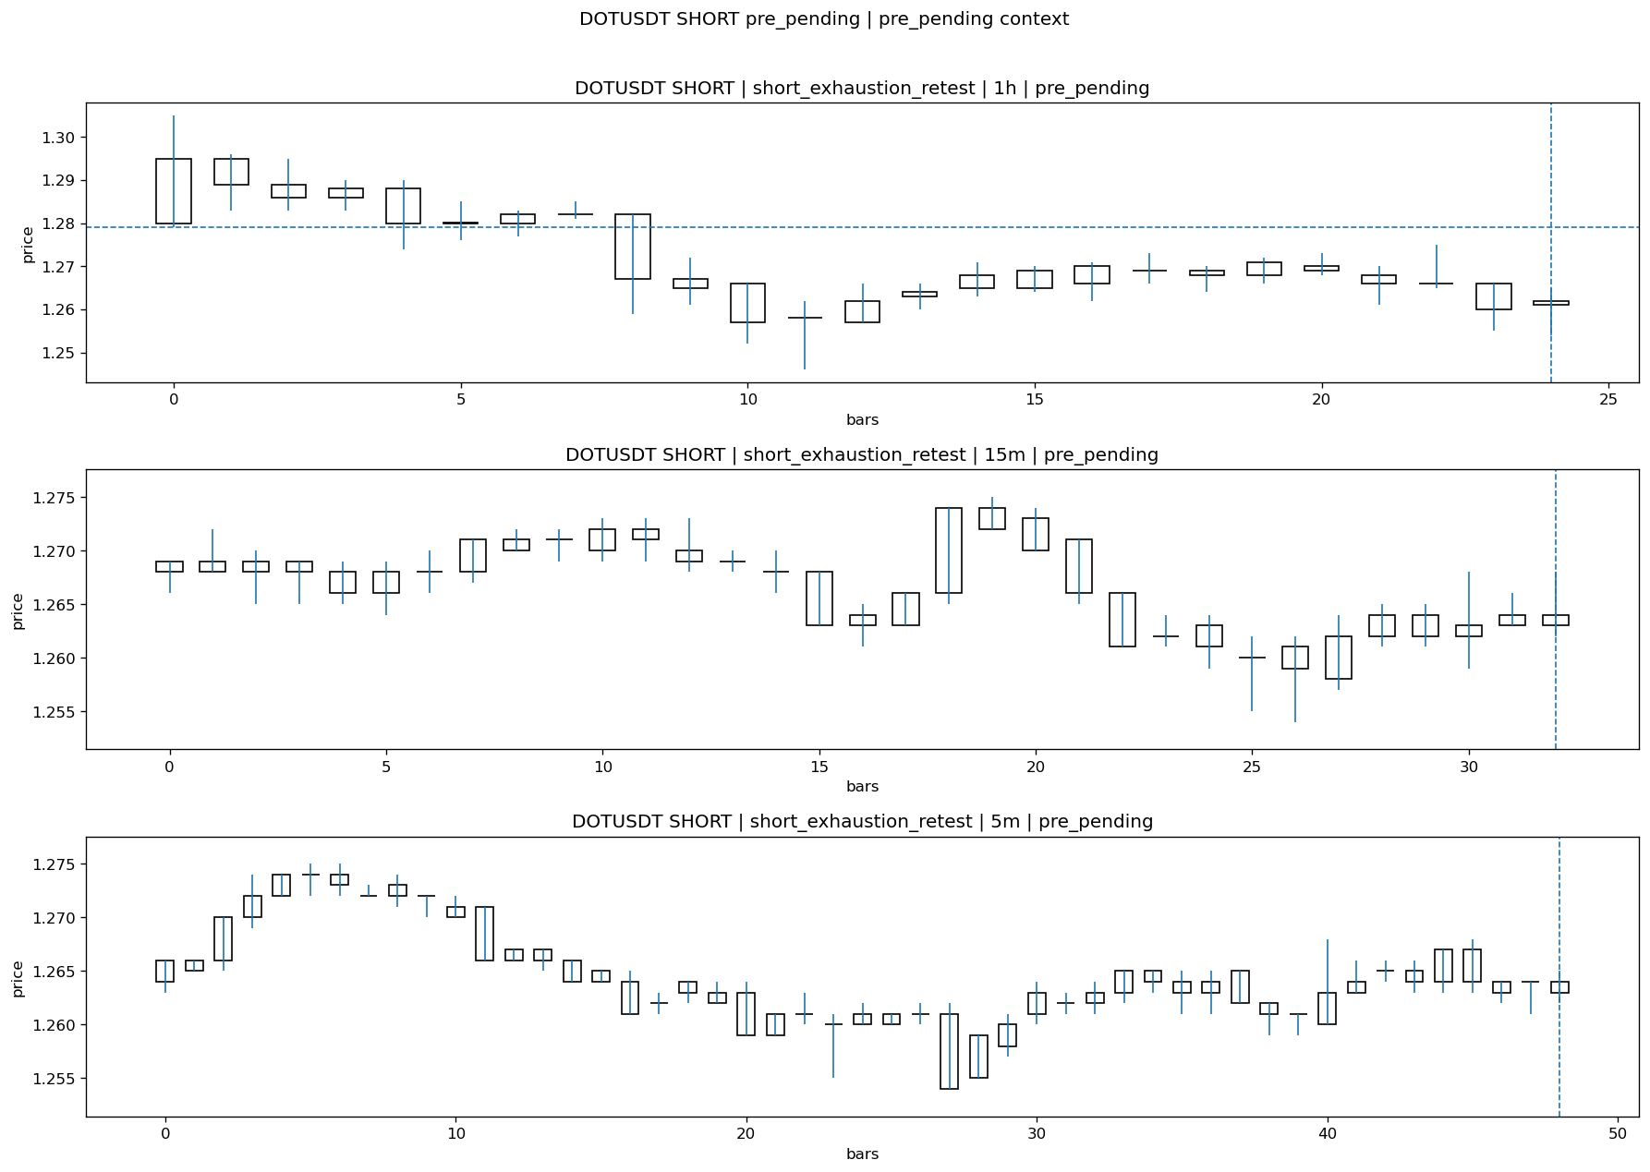
DOTUSDT_SHORT_short_exhaustion_retest_pre_pending_1774658700000.png

Pending Open
Stage status: missing_unexpected | Content type: none
Note: MISSING UNEXPECTED

Entry Or Confirm
Stage status: missing_unexpected | Content type: none
Note: MISSING UNEXPECTED

Case Close
Stage status: not_reached_yet | Content type: none
Note: NOT REACHED YET

Post-Close Outcome
1h outcome | available=Y | favor=0.7037 | adverse=0.4691 | summary=favor=0.70% adverse=0.47%
2h outcome | available=Y | favor=0.7037 | adverse=0.4691 | summary=favor=0.70% adverse=0.47%
4h reference | favor=0.7037 | adverse=0.7037
Reclaim | 2h=Y | 4h=Y
Execution reality | entry_feasible=Y | entry_window=10m | entry_note=entry still reachable within 10m
Time-to-move | time_to_max_favor=3m | time_to_max_adverse=33m
Regret filter | regret_valid=N | reason=no_meaningful_fast_move
Conclusion | NO_MEANINGFUL_MOVE | notes=entry_ref_from_breakout_level

Review placeholders
human_review_status=PENDING | verdict_code= | root_cause_code= | action_candidate_code=

Case 8: FILUSDT-SHORT-EXH-1774659600000
Summary | FILUSDT | SHORT | short_exhaustion_retest | status_final=CONFIRMED | close_reason=signal confirmed
Times | signal=2026-03-28 08:00:00 | created=2026-03-28 08:16:10 | confirmed= | sent= | close=2026-03-28 08:32:29 | fallback_due=2026-03-28 12:16:10
Semantics | is_confirmed=N | is_sent_signal=N | review_eligible=N | semantic_consistency=N
Review integrity | review_exclusion_reason=confirmed_without_confirmed_ts | semantic_issue=confirmed_without_confirmed_ts
Close anchoring | case_close_type=not_due_yet | close_anchor_time= | close_capture_basis=not_due_yet
Tradeability / outcome | entry_feasible=Y | slippage=0.0000 | regret_valid=Y | outcome=WAIT_TOO_SHORT_CANDIDATE

Pre Pending
Stage status: captured | Content type: chart_snapshot
Note: pre_pending context
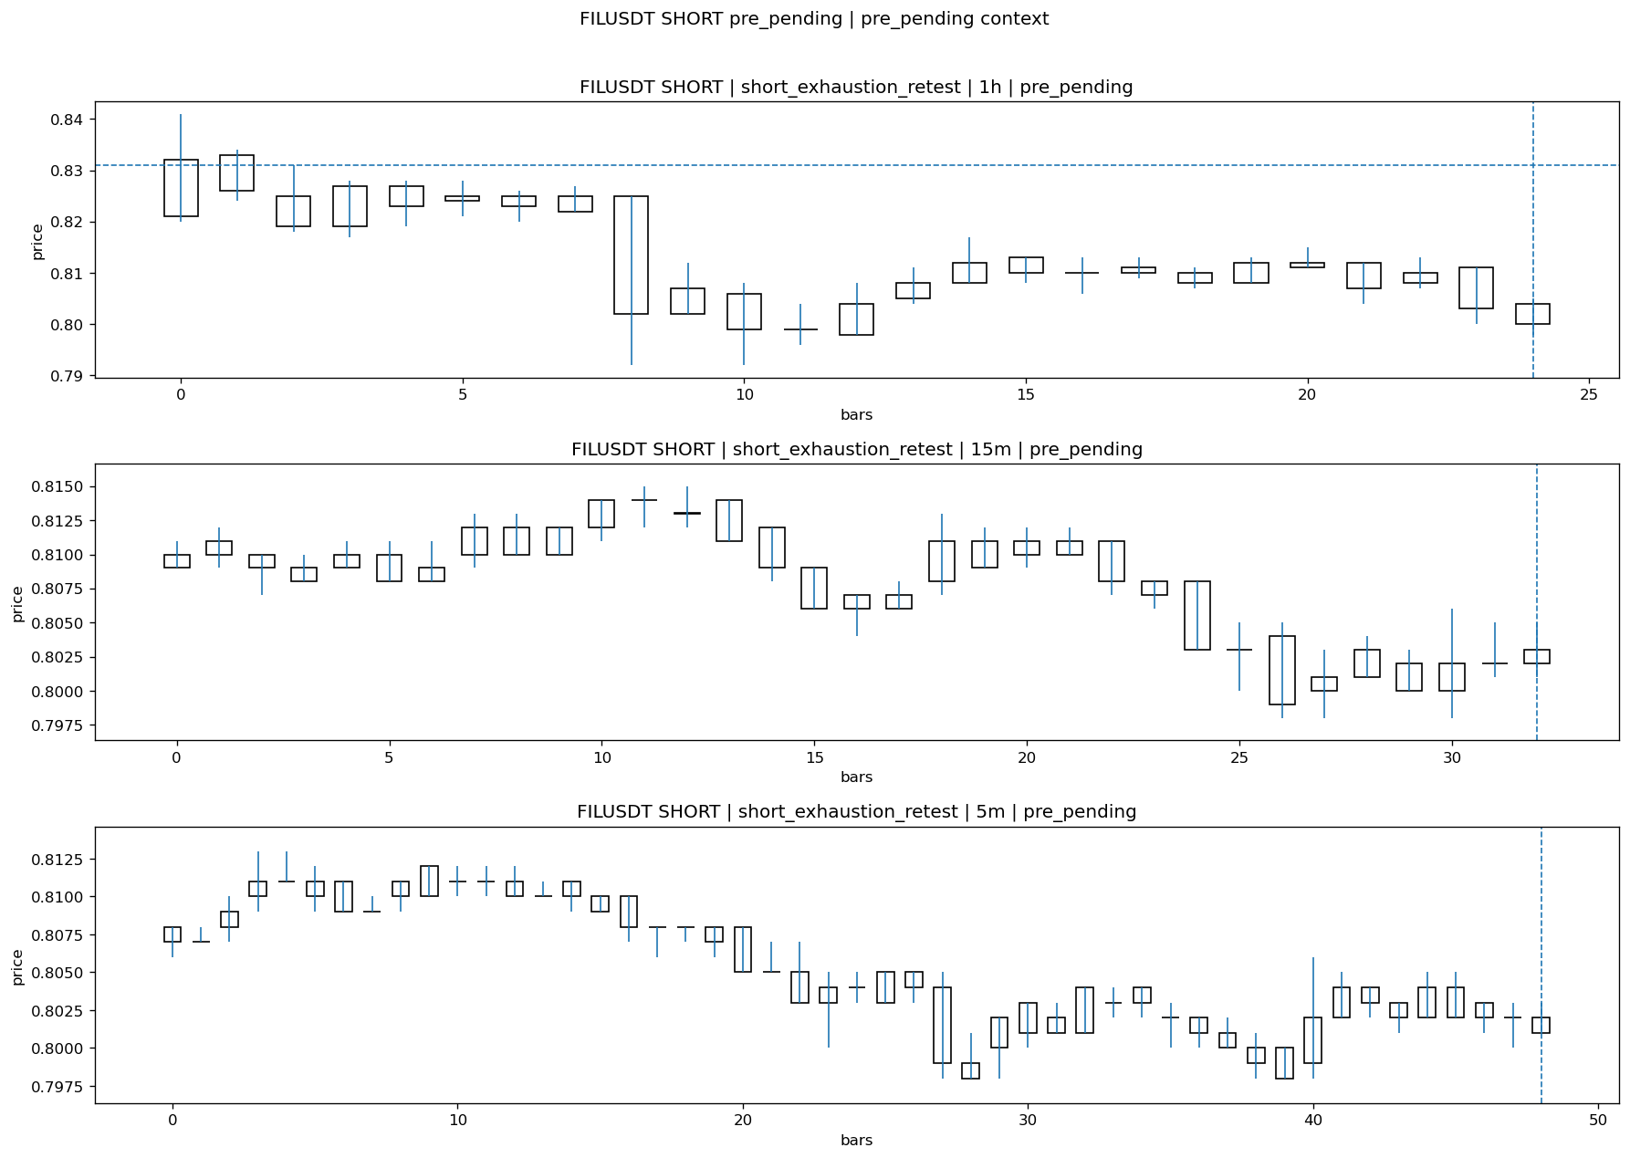
FILUSDT_SHORT_short_exhaustion_retest_pre_pending_1774658700000.png

Pending Open
Stage status: missing_unexpected | Content type: none
Note: MISSING UNEXPECTED

Entry Or Confirm
Stage status: missing_unexpected | Content type: none
Note: MISSING UNEXPECTED

Case Close
Stage status: not_reached_yet | Content type: none
Note: NOT REACHED YET

Post-Close Outcome
1h outcome | available=Y | favor=1.5644 | adverse=0.1203 | summary=favor=1.56% adverse=0.12%
2h outcome | available=Y | favor=1.5644 | adverse=0.1203 | summary=favor=1.56% adverse=0.12%
4h reference | favor=1.5644 | adverse=0.1203
Reclaim | 2h=Y | 4h=Y
Execution reality | entry_feasible=Y | entry_window=10m | entry_note=entry still reachable within 10m
Time-to-move | time_to_max_favor=3m | time_to_max_adverse=33m
Regret filter | regret_valid=Y | reason=valid_missed_continuation
Conclusion | WAIT_TOO_SHORT_CANDIDATE | notes=entry_ref_from_breakout_level

Review placeholders
human_review_status=PENDING | verdict_code= | root_cause_code= | action_candidate_code=

Case 9: AAVEUSDT-SHORT-EXH-1774659600000
Summary | AAVEUSDT | SHORT | short_exhaustion_retest | status_final=CONFIRMED | close_reason=signal confirmed
Times | signal=2026-03-28 08:00:00 | created=2026-03-28 08:16:15 | confirmed= | sent= | close=2026-03-28 08:32:31 | fallback_due=2026-03-28 12:16:15
Semantics | is_confirmed=N | is_sent_signal=N | review_eligible=N | semantic_consistency=N
Review integrity | review_exclusion_reason=confirmed_without_confirmed_ts | semantic_issue=confirmed_without_confirmed_ts
Close anchoring | case_close_type=not_due_yet | close_anchor_time= | close_capture_basis=not_due_yet
Tradeability / outcome | entry_feasible=Y | slippage=0.0000 | regret_valid=N | outcome=NO_MEANINGFUL_MOVE

Pre Pending
Stage status: captured | Content type: chart_snapshot
Note: pre_pending context
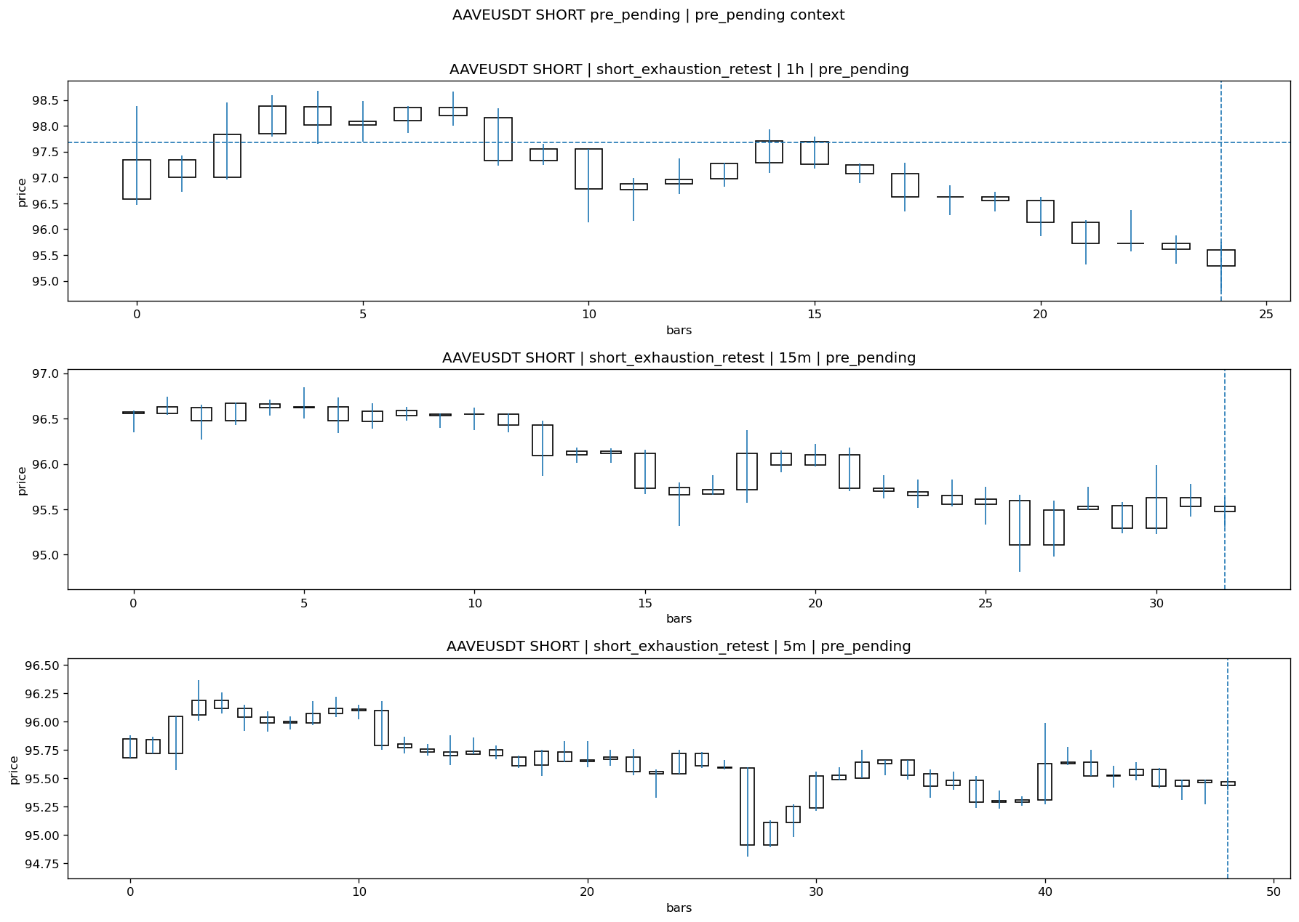
AAVEUSDT_SHORT_short_exhaustion_retest_pre_pending_1774658700000.png

Pending Open
Stage status: missing_unexpected | Content type: none
Note: MISSING UNEXPECTED

Entry Or Confirm
Stage status: missing_unexpected | Content type: none
Note: MISSING UNEXPECTED

Case Close
Stage status: not_reached_yet | Content type: none
Note: NOT REACHED YET

Post-Close Outcome
1h outcome | available=Y | favor=0.8600 | adverse=0.3583 | summary=favor=0.86% adverse=0.36%
2h outcome | available=Y | favor=0.8600 | adverse=0.3583 | summary=favor=0.86% adverse=0.36%
4h reference | favor=1.3923 | adverse=0.3583
Reclaim | 2h=Y | 4h=Y
Execution reality | entry_feasible=Y | entry_window=10m | entry_note=entry still reachable within 10m
Time-to-move | time_to_max_favor=2m | time_to_max_adverse=27m
Regret filter | regret_valid=N | reason=no_meaningful_fast_move
Conclusion | NO_MEANINGFUL_MOVE | notes=entry_ref_from_breakout_level

Review placeholders
human_review_status=PENDING | verdict_code= | root_cause_code= | action_candidate_code=

Case 10: PENGUUSDT-SHORT-EXH-1774659600000
Summary | PENGUUSDT | SHORT | short_exhaustion_retest | status_final=CONFIRMED | close_reason=signal confirmed
Times | signal=2026-03-28 08:00:00 | created=2026-03-28 08:16:28 | confirmed= | sent= | close=2026-03-28 08:32:32 | fallback_due=2026-03-28 12:16:28
Semantics | is_confirmed=N | is_sent_signal=N | review_eligible=N | semantic_consistency=N
Review integrity | review_exclusion_reason=confirmed_without_confirmed_ts | semantic_issue=confirmed_without_confirmed_ts
Close anchoring | case_close_type=not_due_yet | close_anchor_time= | close_capture_basis=not_due_yet
Tradeability / outcome | entry_feasible=Y | slippage=0.0000 | regret_valid=N | outcome=NO_MEANINGFUL_MOVE

Pre Pending
Stage status: captured | Content type: chart_snapshot
Note: pre_pending context
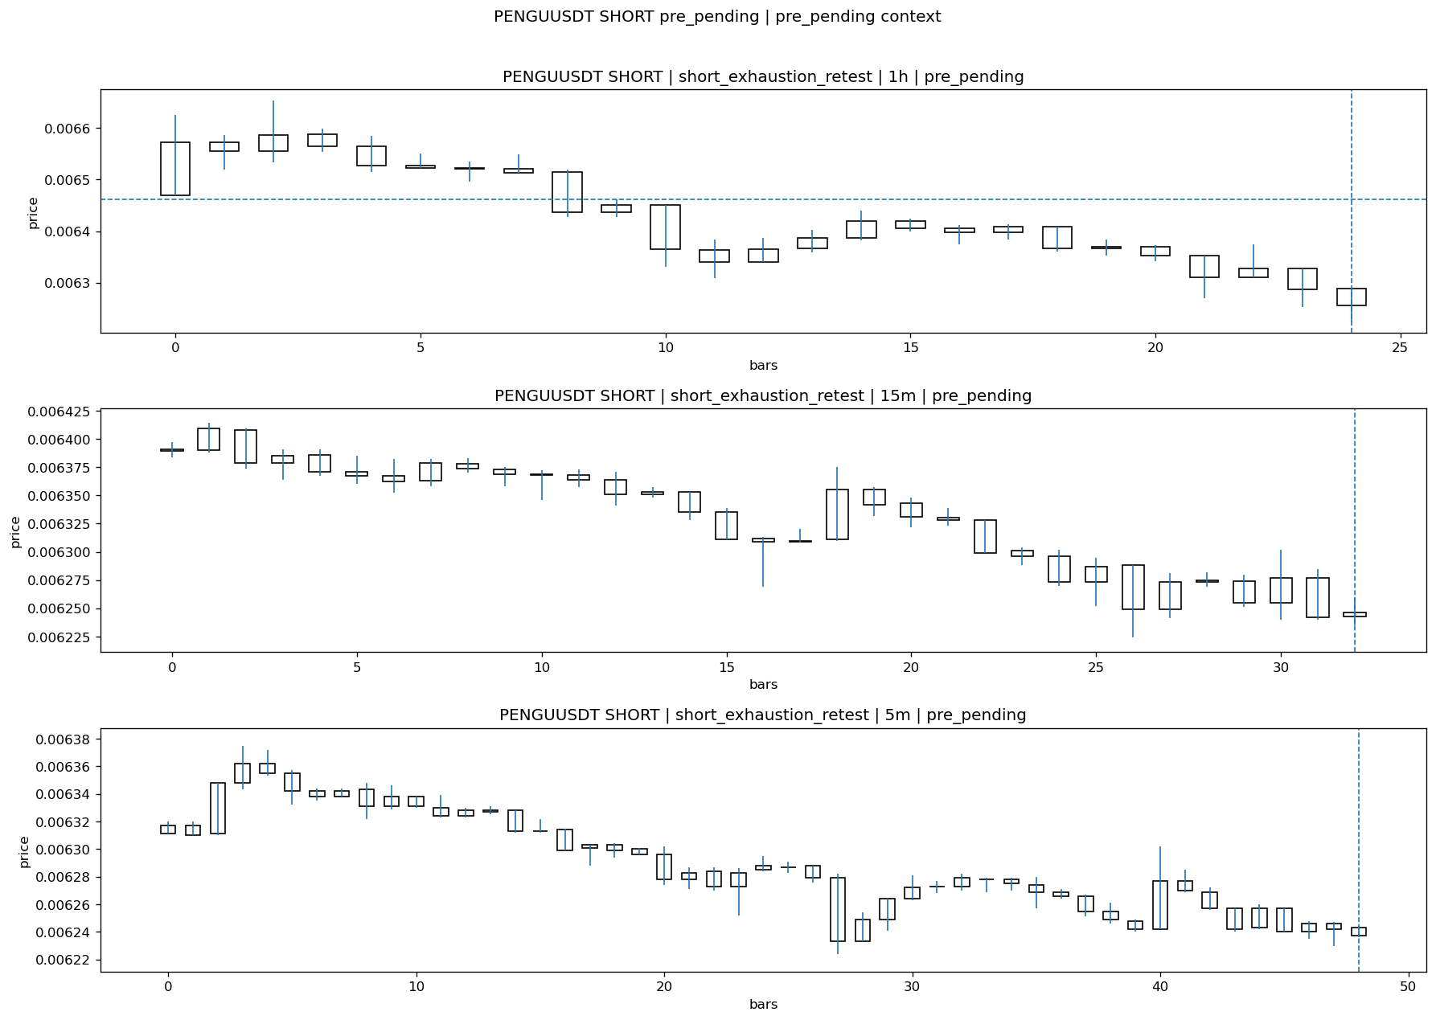
PENGUUSDT_SHORT_short_exhaustion_retest_pre_pending_1774658700000.png

Pending Open
Stage status: missing_unexpected | Content type: none
Note: MISSING UNEXPECTED

Entry Or Confirm
Stage status: missing_unexpected | Content type: none
Note: MISSING UNEXPECTED

Case Close
Stage status: not_reached_yet | Content type: none
Note: NOT REACHED YET

Post-Close Outcome
1h outcome | available=Y | favor=0.8666 | adverse=0.3405 | summary=favor=0.87% adverse=0.34%
2h outcome | available=Y | favor=0.8666 | adverse=0.3405 | summary=favor=0.87% adverse=0.34%
4h reference | favor=1.4392 | adverse=0.3405
Reclaim | 2h=Y | 4h=Y
Execution reality | entry_feasible=Y | entry_window=10m | entry_note=entry still reachable within 10m
Time-to-move | time_to_max_favor=2m | time_to_max_adverse=27m
Regret filter | regret_valid=N | reason=no_meaningful_fast_move
Conclusion | NO_MEANINGFUL_MOVE | notes=entry_ref_from_breakout_level

Review placeholders
human_review_status=PENDING | verdict_code= | root_cause_code= | action_candidate_code=

Case 11: GALAUSDT-SHORT-EXH-1774659600000
Summary | GALAUSDT | SHORT | short_exhaustion_retest | status_final=INVALIDATED | close_reason=retest invalidated
Times | signal=2026-03-28 08:00:00 | created=2026-03-28 08:16:31 | confirmed= | sent= | close=2026-03-28 08:32:33 | fallback_due=2026-03-28 12:16:31
Semantics | is_confirmed=N | is_sent_signal=N | review_eligible=Y | semantic_consistency=Y
Review integrity | review_exclusion_reason= | semantic_issue=
Close anchoring | case_close_type=true_close | close_anchor_time=2026-03-28 08:32:33 | close_capture_basis=true_close
Tradeability / outcome | entry_feasible=Y | slippage=0.0000 | regret_valid=N | outcome=KILL_CORRECT

Pre Pending
Stage status: captured | Content type: chart_snapshot
Note: pre_pending context
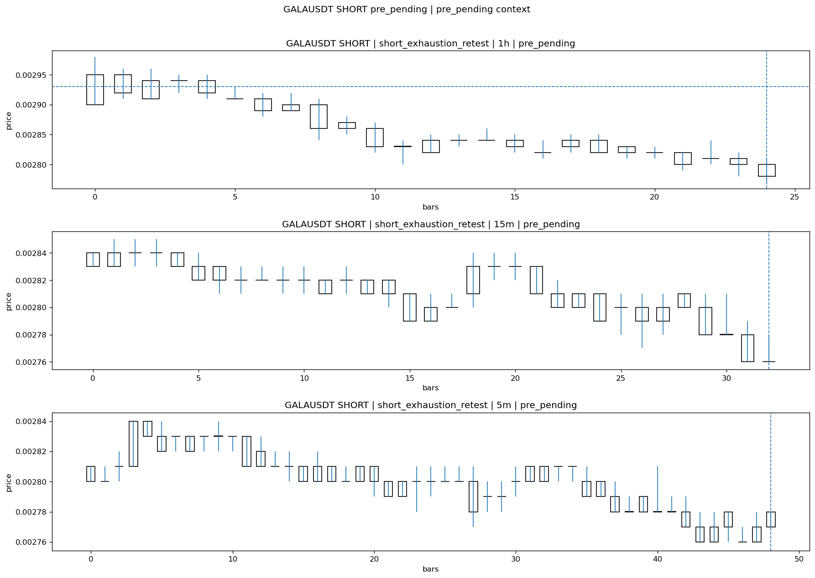
GALAUSDT_SHORT_short_exhaustion_retest_pre_pending_1774658700000.png

Pending Open
Stage status: missing_unexpected | Content type: none
Note: MISSING UNEXPECTED

Entry Or Confirm
Stage status: not_applicable | Content type: none
Note: NOT APPLICABLE

Case Close
Stage status: missing_unexpected | Content type: none
Note: MISSING UNEXPECTED

Post-Close Outcome
1h outcome | available=Y | favor=0.6826 | adverse=0.6826 | summary=favor=0.68% adverse=0.68%
2h outcome | available=Y | favor=1.0239 | adverse=0.6826 | summary=favor=1.02% adverse=0.68%
4h reference | favor=1.0239 | adverse=0.6826
Reclaim | 2h=Y | 4h=Y
Execution reality | entry_feasible=Y | entry_window=10m | entry_note=entry still reachable within 10m
Time-to-move | time_to_max_favor=87m | time_to_max_adverse=27m
Regret filter | regret_valid=N | reason=no_meaningful_fast_move
Conclusion | KILL_CORRECT | notes=entry_ref_from_breakout_level

Review placeholders
human_review_status=PENDING | verdict_code= | root_cause_code= | action_candidate_code=

Case 12: XLMUSDT-SHORT-EXH-1774659600000
Summary | XLMUSDT | SHORT | short_exhaustion_retest | status_final=CONFIRMED | close_reason=signal confirmed
Times | signal=2026-03-28 08:00:00 | created=2026-03-28 08:16:34 | confirmed= | sent= | close=2026-03-28 08:32:34 | fallback_due=2026-03-28 12:16:34
Semantics | is_confirmed=N | is_sent_signal=N | review_eligible=N | semantic_consistency=N
Review integrity | review_exclusion_reason=confirmed_without_confirmed_ts | semantic_issue=confirmed_without_confirmed_ts
Close anchoring | case_close_type=not_due_yet | close_anchor_time= | close_capture_basis=not_due_yet
Tradeability / outcome | entry_feasible=Y | slippage=0.0000 | regret_valid=N | outcome=NO_MEANINGFUL_MOVE

Pre Pending
Stage status: captured | Content type: chart_snapshot
Note: pre_pending context
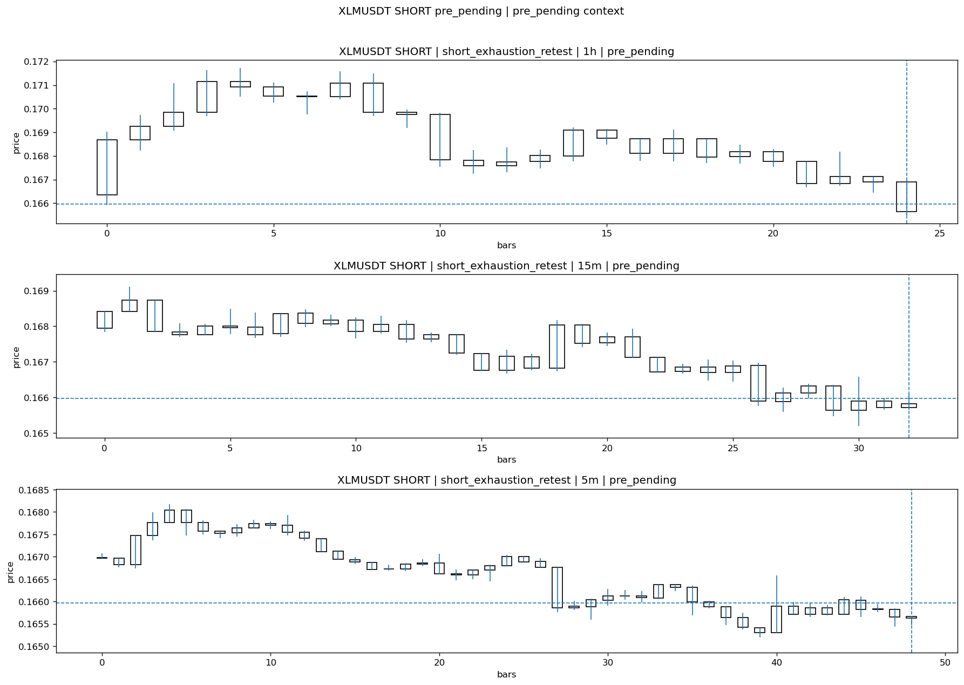
XLMUSDT_SHORT_short_exhaustion_retest_pre_pending_1774658700000.png

Pending Open
Stage status: missing_unexpected | Content type: none
Note: MISSING UNEXPECTED

Entry Or Confirm
Stage status: missing_unexpected | Content type: none
Note: MISSING UNEXPECTED

Case Close
Stage status: not_reached_yet | Content type: none
Note: NOT REACHED YET

Post-Close Outcome
1h outcome | available=Y | favor=0.5603 | adverse=0.2651 | summary=favor=0.56% adverse=0.27%
2h outcome | available=Y | favor=0.6025 | adverse=0.2651 | summary=favor=0.60% adverse=0.27%
4h reference | favor=1.0002 | adverse=0.2651
Reclaim | 2h=Y | 4h=Y
Execution reality | entry_feasible=Y | entry_window=10m | entry_note=entry still reachable within 10m
Time-to-move | time_to_max_favor=107m | time_to_max_adverse=32m
Regret filter | regret_valid=N | reason=no_meaningful_fast_move
Conclusion | NO_MEANINGFUL_MOVE | notes=entry_ref_from_breakout_level

Review placeholders
human_review_status=PENDING | verdict_code= | root_cause_code= | action_candidate_code=

Case 13: ARBUSDT-SHORT-EXH-1774659600000
Summary | ARBUSDT | SHORT | short_exhaustion_retest | status_final=EXPIRED_WAIT | close_reason=retest wait expired
Times | signal=2026-03-28 08:00:00 | created=2026-03-28 08:16:39 | confirmed= | sent= | close=2026-03-28 09:02:31 | fallback_due=2026-03-28 12:16:39
Semantics | is_confirmed=N | is_sent_signal=N | review_eligible=Y | semantic_consistency=Y
Review integrity | review_exclusion_reason= | semantic_issue=
Close anchoring | case_close_type=true_close | close_anchor_time=2026-03-28 09:02:31 | close_capture_basis=true_close
Tradeability / outcome | entry_feasible=Y | slippage=0.0000 | regret_valid=N | outcome=NO_MEANINGFUL_MOVE

Pre Pending
Stage status: captured | Content type: chart_snapshot
Note: pre_pending context
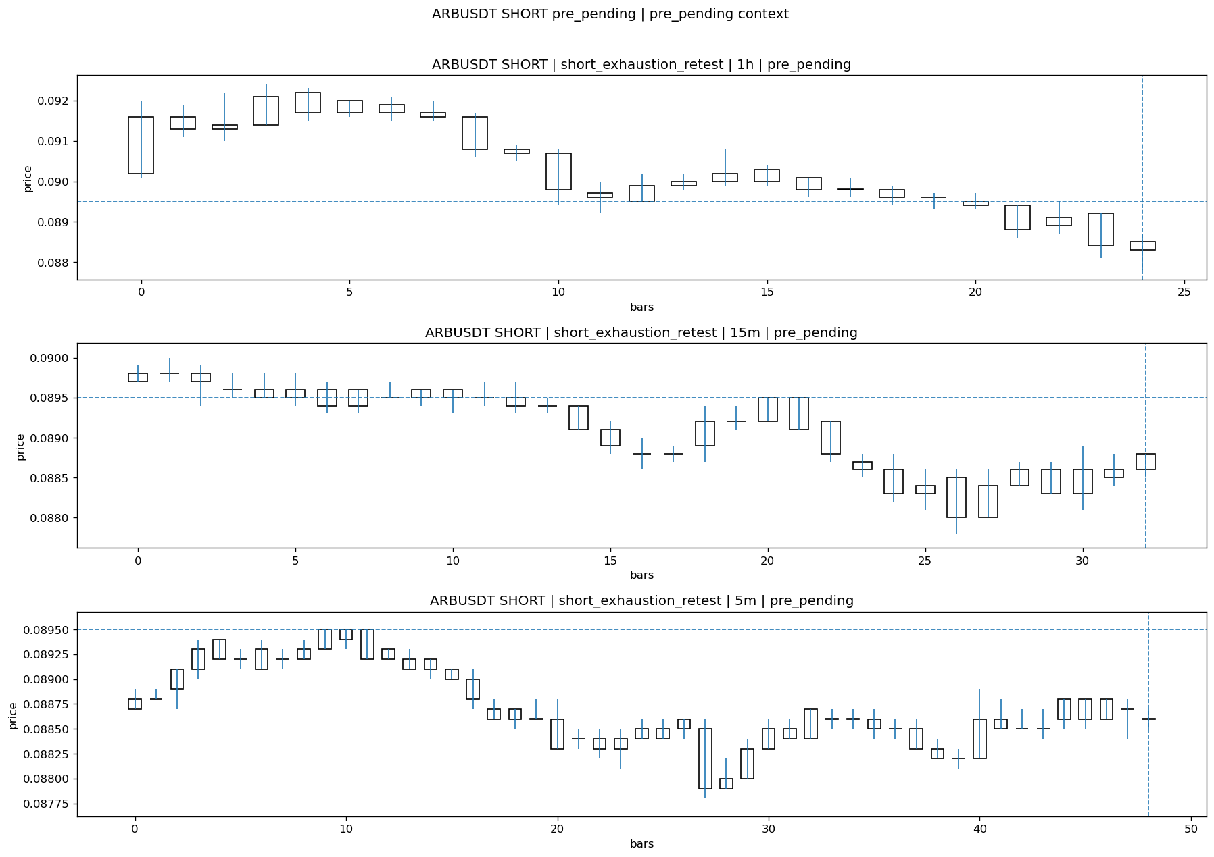
ARBUSDT_SHORT_short_exhaustion_retest_pre_pending_1774658700000.png

Pending Open
Stage status: missing_unexpected | Content type: none
Note: MISSING UNEXPECTED

Entry Or Confirm
Stage status: not_applicable | Content type: none
Note: NOT APPLICABLE

Case Close
Stage status: missing_unexpected | Content type: none
Note: MISSING UNEXPECTED

Post-Close Outcome
1h outcome | available=Y | favor=0.5587 | adverse=0.2235 | summary=favor=0.56% adverse=0.22%
2h outcome | available=Y | favor=0.5587 | adverse=0.2235 | summary=favor=0.56% adverse=0.22%
4h reference | favor=0.6704 | adverse=0.2235
Reclaim | 2h=Y | 4h=Y
Execution reality | entry_feasible=Y | entry_window=10m | entry_note=entry still reachable within 10m
Time-to-move | time_to_max_favor=27m | time_to_max_adverse=2m
Regret filter | regret_valid=N | reason=no_meaningful_fast_move
Conclusion | NO_MEANINGFUL_MOVE | notes=entry_ref_from_breakout_level

Review placeholders
human_review_status=PENDING | verdict_code= | root_cause_code= | action_candidate_code=

Case 14: OPUSDT-SHORT-EXH-1774659600000
Summary | OPUSDT | SHORT | short_exhaustion_retest | status_final=EXPIRED_WAIT | close_reason=retest wait expired
Times | signal=2026-03-28 08:00:00 | created=2026-03-28 08:16:44 | confirmed= | sent= | close=2026-03-28 09:02:32 | fallback_due=2026-03-28 12:16:44
Semantics | is_confirmed=N | is_sent_signal=N | review_eligible=Y | semantic_consistency=Y
Review integrity | review_exclusion_reason= | semantic_issue=
Close anchoring | case_close_type=true_close | close_anchor_time=2026-03-28 09:02:32 | close_capture_basis=true_close
Tradeability / outcome | entry_feasible=Y | slippage=0.0000 | regret_valid=N | outcome=NO_MEANINGFUL_MOVE

Pre Pending
Stage status: captured | Content type: chart_snapshot
Note: pre_pending context
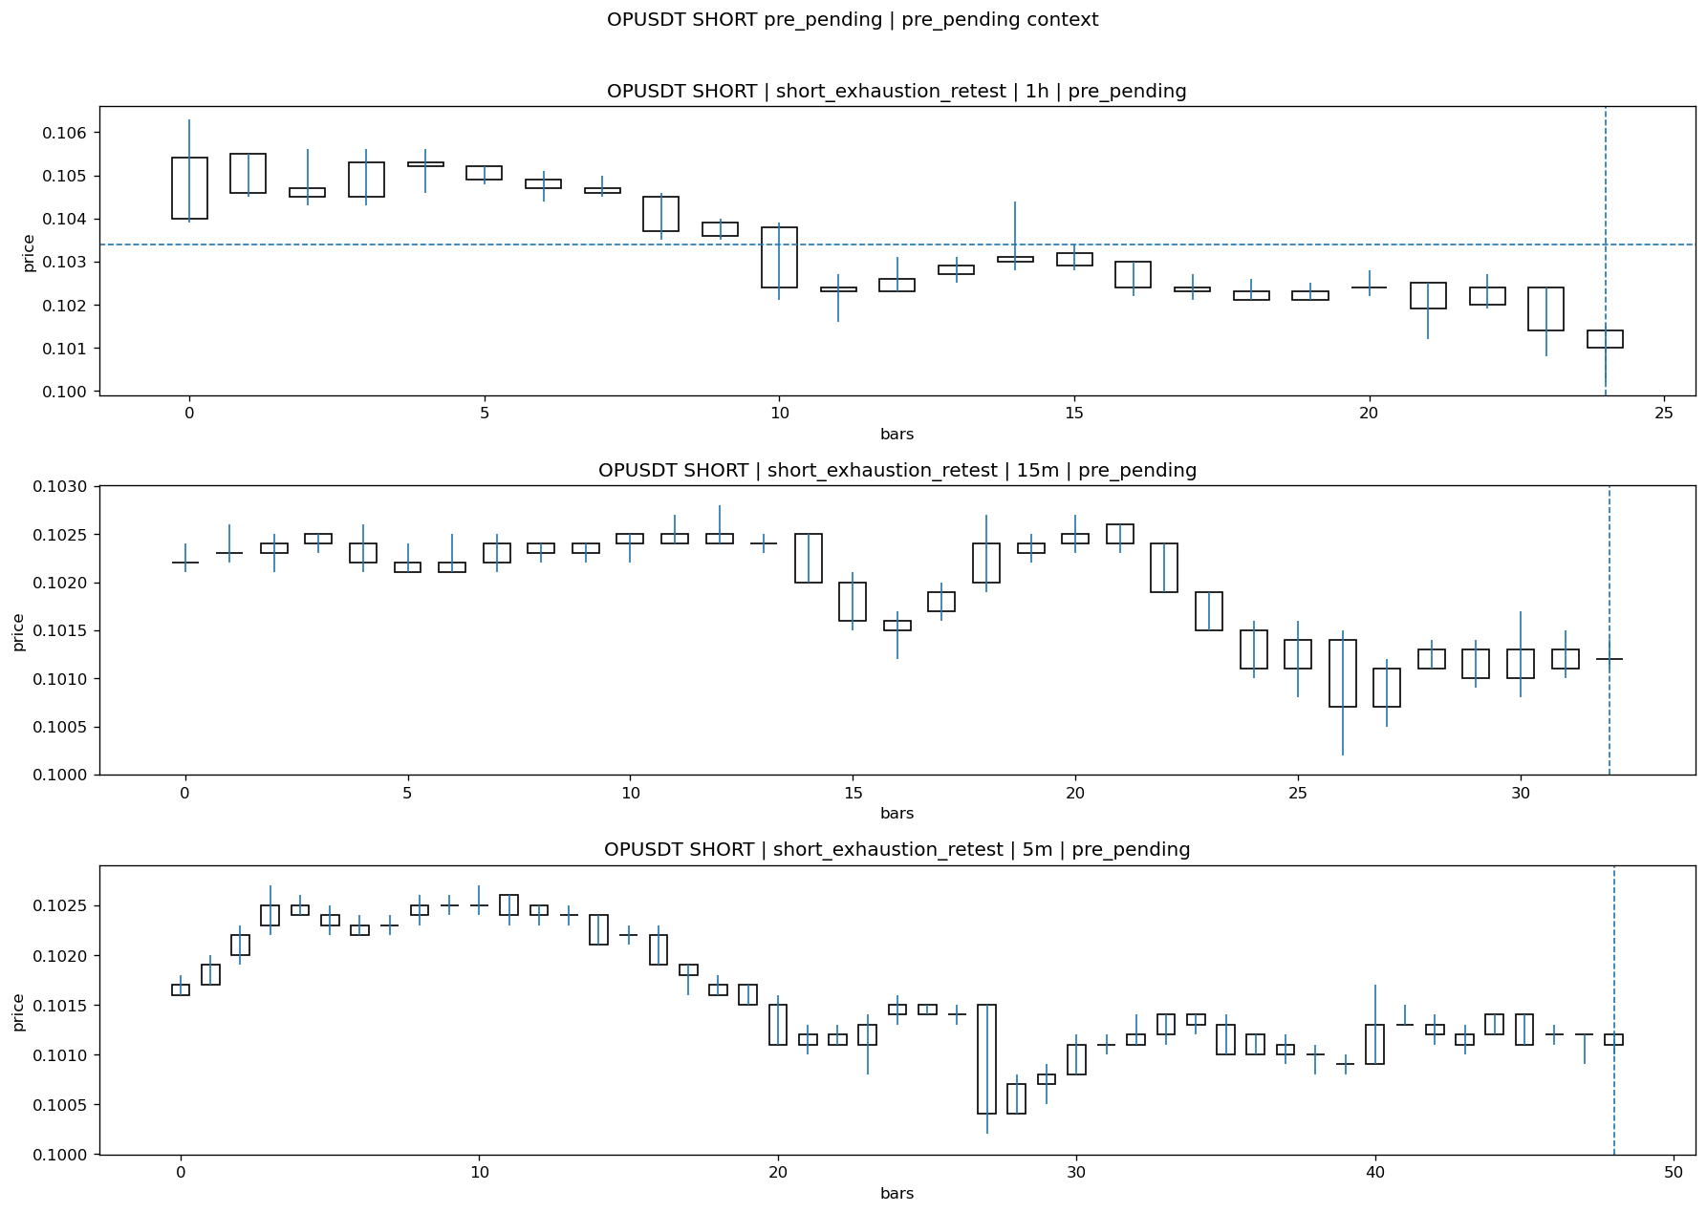
OPUSDT_SHORT_short_exhaustion_retest_pre_pending_1774658700000.png

Pending Open
Stage status: missing_unexpected | Content type: none
Note: MISSING UNEXPECTED

Entry Or Confirm
Stage status: not_applicable | Content type: none
Note: NOT APPLICABLE

Case Close
Stage status: missing_unexpected | Content type: none
Note: MISSING UNEXPECTED

Post-Close Outcome
1h outcome | available=Y | favor=0.8704 | adverse=0.0967 | summary=favor=0.87% adverse=0.10%
2h outcome | available=Y | favor=0.8704 | adverse=0.0967 | summary=favor=0.87% adverse=0.10%
4h reference | favor=0.8704 | adverse=0.0967
Reclaim | 2h=Y | 4h=Y
Execution reality | entry_feasible=Y | entry_window=10m | entry_note=entry still reachable within 10m
Time-to-move | time_to_max_favor=27m | time_to_max_adverse=2m
Regret filter | regret_valid=N | reason=no_meaningful_fast_move
Conclusion | NO_MEANINGFUL_MOVE | notes=entry_ref_from_breakout_level

Review placeholders
human_review_status=PENDING | verdict_code= | root_cause_code= | action_candidate_code=

Case 15: ZROUSDT-SHORT-EXH-1774660500000
Summary | ZROUSDT | SHORT | short_exhaustion_retest | status_final=CONFIRMED | close_reason=signal confirmed
Times | signal=2026-03-28 08:15:00 | created=2026-03-28 08:30:18 | confirmed= | sent= | close=2026-03-28 08:46:17 | fallback_due=2026-03-28 12:30:18
Semantics | is_confirmed=N | is_sent_signal=N | review_eligible=N | semantic_consistency=N
Review integrity | review_exclusion_reason=confirmed_without_confirmed_ts | semantic_issue=confirmed_without_confirmed_ts
Close anchoring | case_close_type=not_due_yet | close_anchor_time= | close_capture_basis=not_due_yet
Tradeability / outcome | entry_feasible=Y | slippage=0.0000 | regret_valid=N | outcome=NO_MEANINGFUL_MOVE

Pre Pending
Stage status: captured | Content type: chart_snapshot
Note: pre_pending context
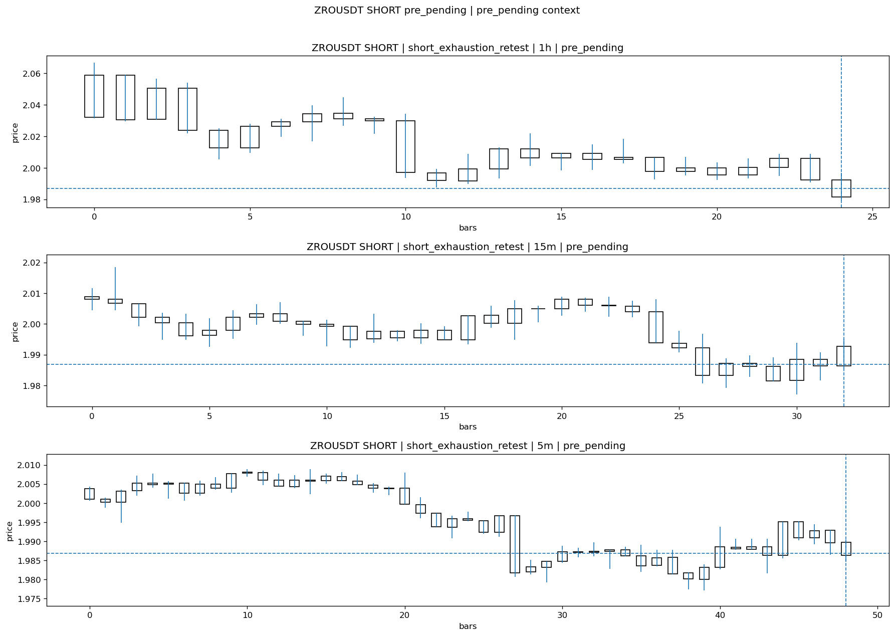
ZROUSDT_SHORT_short_exhaustion_retest_pre_pending_1774659600000.png

Pending Open
Stage status: missing_unexpected | Content type: none
Note: MISSING UNEXPECTED

Entry Or Confirm
Stage status: missing_unexpected | Content type: none
Note: MISSING UNEXPECTED

Case Close
Stage status: not_reached_yet | Content type: none
Note: NOT REACHED YET

Post-Close Outcome
1h outcome | available=Y | favor=0.2617 | adverse=1.2129 | summary=favor=0.26% adverse=1.21%
2h outcome | available=Y | favor=0.2617 | adverse=1.4193 | summary=favor=0.26% adverse=1.42%
4h reference | favor=0.2617 | adverse=3.2865
Reclaim | 2h=Y | 4h=Y
Execution reality | entry_feasible=Y | entry_window=10m | entry_note=entry still reachable within 10m
Time-to-move | time_to_max_favor=4m | time_to_max_adverse=119m
Regret filter | regret_valid=N | reason=adverse_too_large
Conclusion | NO_MEANINGFUL_MOVE | notes=entry_ref_from_breakout_level

Review placeholders
human_review_status=PENDING | verdict_code= | root_cause_code= | action_candidate_code=

Case 16: BASUSDT-LONG-1774661100000
Summary | BASUSDT | LONG | long_breakout_retest | status_final=INVALIDATED | close_reason=retest invalidated
Times | signal=2026-03-28 08:25:00 | created=2026-03-28 08:33:13 | confirmed= | sent= | close=2026-03-28 08:40:51 | fallback_due=2026-03-28 12:33:13
Semantics | is_confirmed=N | is_sent_signal=N | review_eligible=Y | semantic_consistency=Y
Review integrity | review_exclusion_reason= | semantic_issue=
Close anchoring | case_close_type=true_close | close_anchor_time=2026-03-28 08:40:51 | close_capture_basis=true_close
Tradeability / outcome | entry_feasible=Y | slippage=0.0000 | regret_valid=N | outcome=KILL_CORRECT

Pre Pending
Stage status: captured | Content type: chart_snapshot
Note: pre_pending context
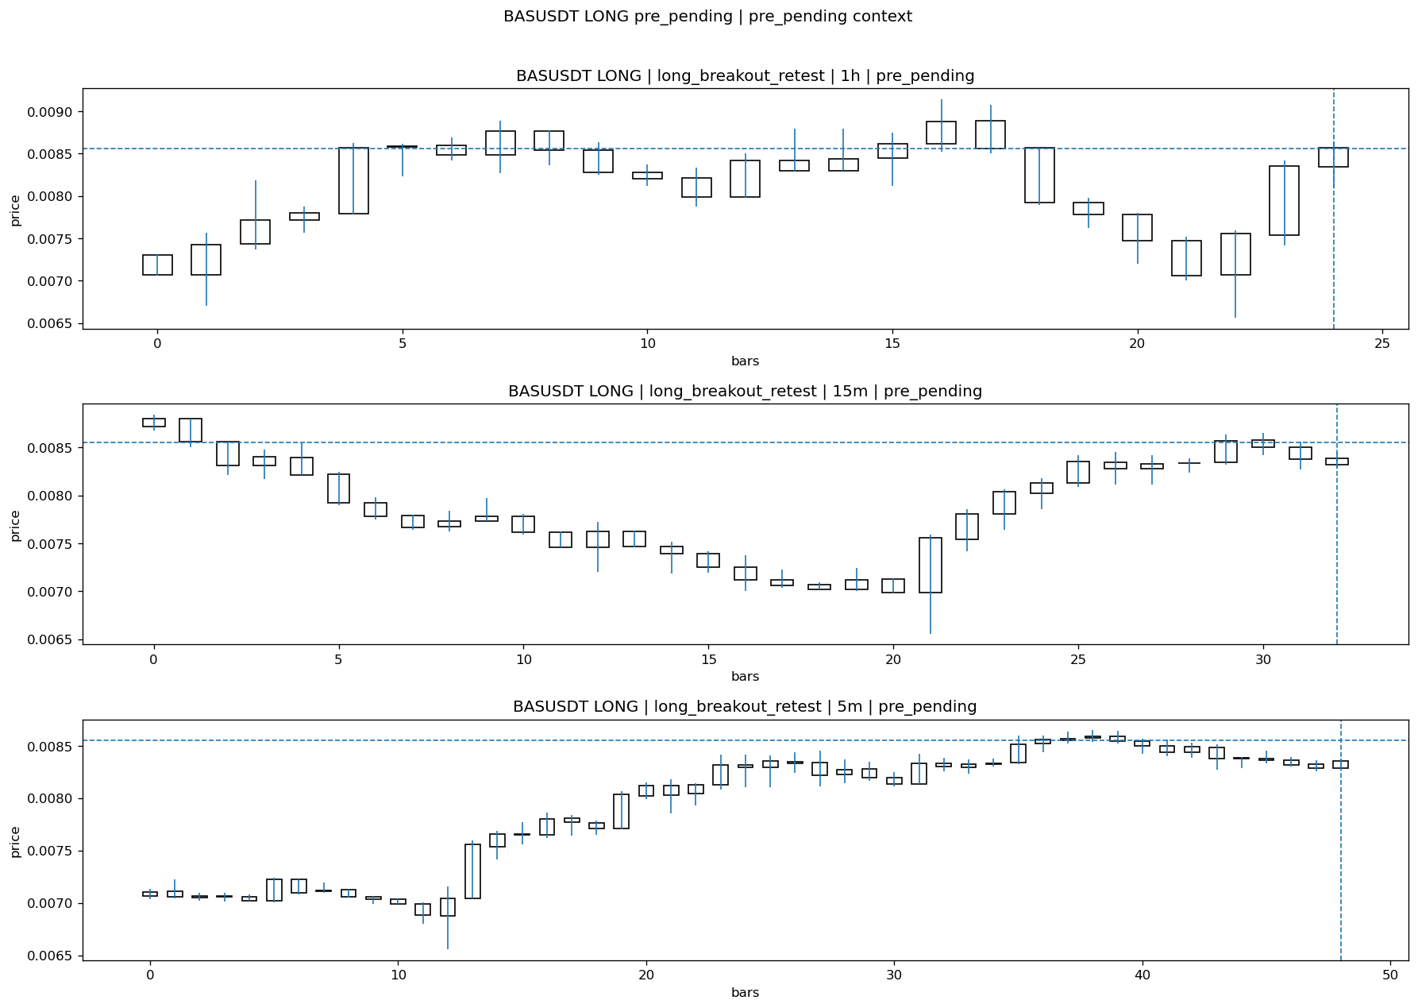
BASUSDT_LONG_long_breakout_retest_pre_pending_1774660800000.png

Pending Open
Stage status: missing_unexpected | Content type: none
Note: MISSING UNEXPECTED

Entry Or Confirm
Stage status: not_applicable | Content type: none
Note: NOT APPLICABLE

Case Close
Stage status: missing_unexpected | Content type: none
Note: MISSING UNEXPECTED

Post-Close Outcome
1h outcome | available=Y | favor=3.5184 | adverse=6.1017 | summary=favor=3.52% adverse=6.10%
2h outcome | available=Y | favor=3.5184 | adverse=12.6242 | summary=favor=3.52% adverse=12.62%
4h reference | favor=3.5184 | adverse=20.2455
Reclaim | 2h=Y | 4h=Y
Execution reality | entry_feasible=Y | entry_window=10m | entry_note=entry still reachable within 10m
Time-to-move | time_to_max_favor=34m | time_to_max_adverse=119m
Regret filter | regret_valid=N | reason=adverse_too_large
Conclusion | KILL_CORRECT | notes=entry_ref_from_breakout_level

Review placeholders
human_review_status=PENDING | verdict_code= | root_cause_code= | action_candidate_code=

Case 17: CFGUSDT-LONG-1774661400000
Summary | CFGUSDT | LONG | long_breakout_retest | status_final=INVALIDATED | close_reason=retest invalidated
Times | signal=2026-03-28 08:30:00 | created=2026-03-28 08:35:53 | confirmed= | sent= | close=2026-03-28 09:02:33 | fallback_due=2026-03-28 12:35:53
Semantics | is_confirmed=N | is_sent_signal=N | review_eligible=Y | semantic_consistency=Y
Review integrity | review_exclusion_reason= | semantic_issue=
Close anchoring | case_close_type=true_close | close_anchor_time=2026-03-28 09:02:33 | close_capture_basis=true_close
Tradeability / outcome | entry_feasible=Y | slippage=0.0000 | regret_valid=N | outcome=KILL_CORRECT

Pre Pending
Stage status: captured | Content type: chart_snapshot
Note: pre_pending context
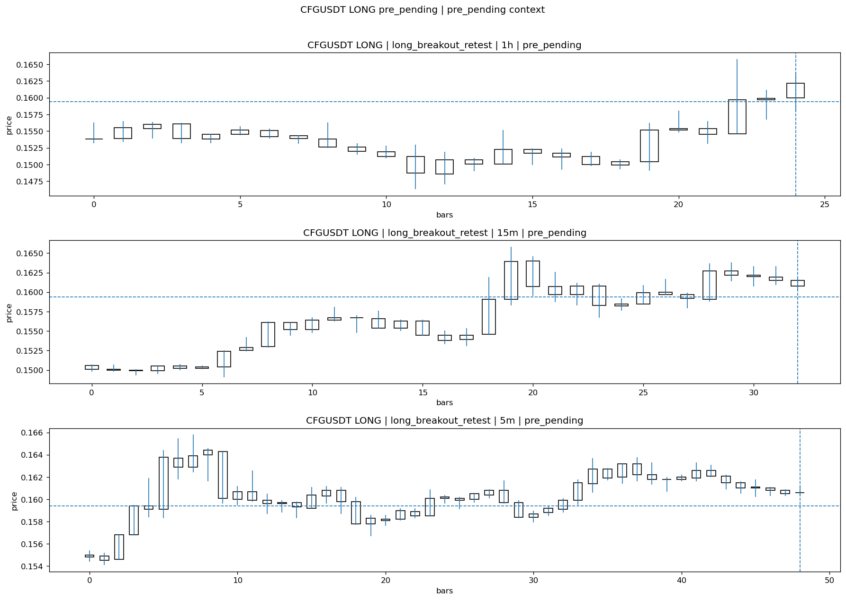
CFGUSDT_LONG_long_breakout_retest_pre_pending_1774661100000.png

Pending Open
Stage status: missing_unexpected | Content type: none
Note: MISSING UNEXPECTED

Entry Or Confirm
Stage status: not_applicable | Content type: none
Note: NOT APPLICABLE

Case Close
Stage status: missing_unexpected | Content type: none
Note: MISSING UNEXPECTED

Post-Close Outcome
1h outcome | available=Y | favor=2.1330 | adverse=1.6311 | summary=favor=2.13% adverse=1.63%
2h outcome | available=Y | favor=2.8231 | adverse=1.6311 | summary=favor=2.82% adverse=1.63%
4h reference | favor=4.8306 | adverse=2.5721
Reclaim | 2h=Y | 4h=Y
Execution reality | entry_feasible=Y | entry_window=10m | entry_note=entry still reachable within 10m
Time-to-move | time_to_max_favor=112m | time_to_max_adverse=2m
Regret filter | regret_valid=N | reason=no_meaningful_fast_move
Conclusion | KILL_CORRECT | notes=entry_ref_from_breakout_level

Review placeholders
human_review_status=PENDING | verdict_code= | root_cause_code= | action_candidate_code=

Case 18: PIPPINUSDT-LONG-1774663200000
Summary | PIPPINUSDT | LONG | long_breakout_retest | status_final=EXPIRED_WAIT | close_reason=retest wait expired
Times | signal=2026-03-28 09:00:00 | created=2026-03-28 09:05:23 | confirmed= | sent= | close=2026-03-28 09:45:57 | fallback_due=2026-03-28 13:05:23
Semantics | is_confirmed=N | is_sent_signal=N | review_eligible=Y | semantic_consistency=Y
Review integrity | review_exclusion_reason= | semantic_issue=
Close anchoring | case_close_type=true_close | close_anchor_time=2026-03-28 09:45:57 | close_capture_basis=true_close
Tradeability / outcome | entry_feasible=Y | slippage=0.0000 | regret_valid=N | outcome=NO_MEANINGFUL_MOVE

Pre Pending
Stage status: captured | Content type: chart_snapshot
Note: pre_pending context
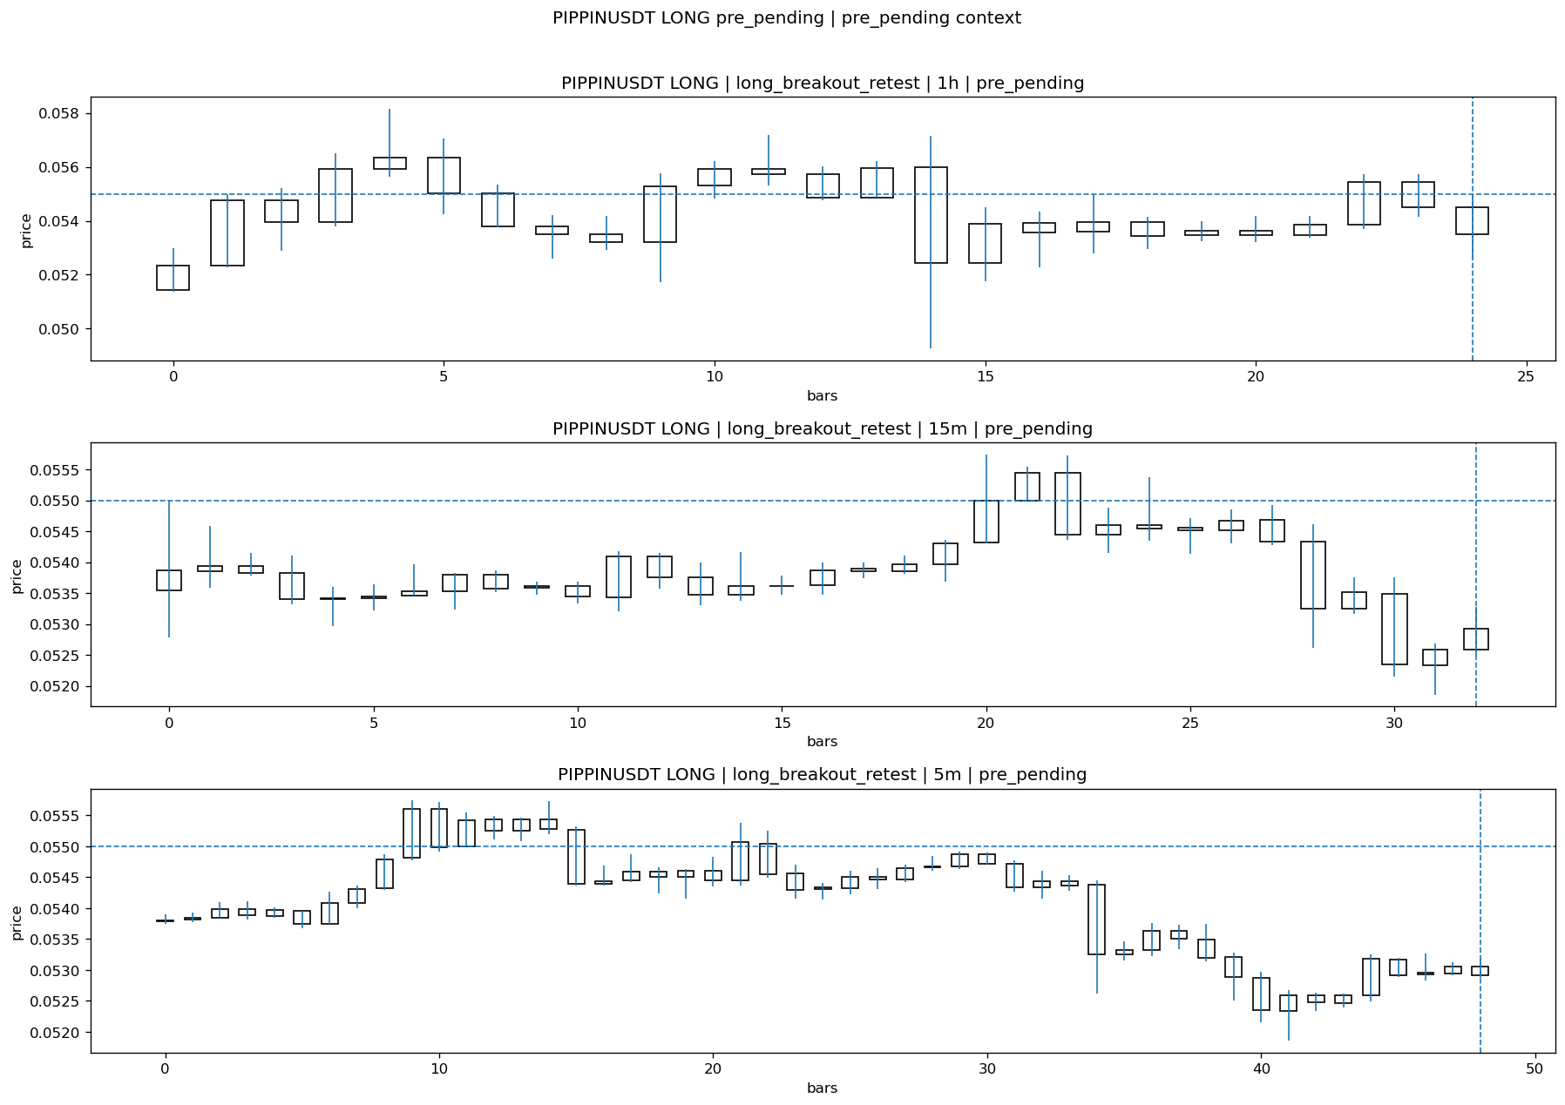
PIPPINUSDT_LONG_long_breakout_retest_pre_pending_1774662900000.png

Pending Open
Stage status: missing_unexpected | Content type: none
Note: MISSING UNEXPECTED

Entry Or Confirm
Stage status: not_applicable | Content type: none
Note: NOT APPLICABLE

Case Close
Stage status: missing_unexpected | Content type: none
Note: MISSING UNEXPECTED

Post-Close Outcome
1h outcome | available=Y | favor=6.7636 | adverse=0.0000 | summary=favor=6.76% adverse=0.00%
2h outcome | available=Y | favor=7.8727 | adverse=0.0000 | summary=favor=7.87% adverse=0.00%
4h reference | favor=7.8727 | adverse=2.7636
Reclaim | 2h=N | 4h=Y
Execution reality | entry_feasible=Y | entry_window=10m | entry_note=entry still reachable within 10m
Time-to-move | time_to_max_favor=104m | time_to_max_adverse=79m
Regret filter | regret_valid=N | reason=no_meaningful_fast_move
Conclusion | NO_MEANINGFUL_MOVE | notes=entry_ref_from_breakout_level

Review placeholders
human_review_status=PENDING | verdict_code= | root_cause_code= | action_candidate_code=

Case 19: SIRENUSDT-LONG-1774668600000
Summary | SIRENUSDT | LONG | long_breakout_retest | status_final=INVALIDATED | close_reason=retest invalidated
Times | signal=2026-03-28 10:30:00 | created=2026-03-28 10:37:36 | confirmed= | sent= | close=2026-03-28 10:51:06 | fallback_due=2026-03-28 14:37:36
Semantics | is_confirmed=N | is_sent_signal=N | review_eligible=Y | semantic_consistency=Y
Review integrity | review_exclusion_reason= | semantic_issue=
Close anchoring | case_close_type=true_close | close_anchor_time=2026-03-28 10:51:06 | close_capture_basis=true_close
Tradeability / outcome | entry_feasible=Y | slippage=0.0000 | regret_valid=N | outcome=KILL_CORRECT

Pre Pending
Stage status: captured | Content type: chart_snapshot
Note: pre_pending context

SIRENUSDT_LONG_long_breakout_retest_pre_pending_1774668300000.png

Pending Open
Stage status: missing_unexpected | Content type: none
Note: MISSING UNEXPECTED

Entry Or Confirm
Stage status: not_applicable | Content type: none
Note: NOT APPLICABLE

Case Close
Stage status: missing_unexpected | Content type: none
Note: MISSING UNEXPECTED

Post-Close Outcome
1h outcome | available=Y | favor=49.0974 | adverse=0.0000 | summary=favor=49.10% adverse=0.00%
2h outcome | available=Y | favor=61.7867 | adverse=0.0000 | summary=favor=61.79% adverse=0.00%
4h reference | favor=66.0832 | adverse=0.0000
Reclaim | 2h=N | 4h=N
Execution reality | entry_feasible=Y | entry_window=10m | entry_note=entry still reachable within 10m
Time-to-move | time_to_max_favor=114m | time_to_max_adverse=9m
Regret filter | regret_valid=N | reason=no_meaningful_fast_move
Conclusion | KILL_CORRECT | notes=entry_ref_from_breakout_level

Review placeholders
human_review_status=PENDING | verdict_code= | root_cause_code= | action_candidate_code=

Case 20: SIRENUSDT-LONG-1774669800000
Summary | SIRENUSDT | LONG | long_breakout_retest | status_final=INVALIDATED | close_reason=retest invalidated
Times | signal=2026-03-28 10:50:00 | created=2026-03-28 10:59:16 | confirmed= | sent= | close=2026-03-28 11:01:58 | fallback_due=2026-03-28 14:59:16
Semantics | is_confirmed=N | is_sent_signal=N | review_eligible=Y | semantic_consistency=Y
Review integrity | review_exclusion_reason= | semantic_issue=
Close anchoring | case_close_type=true_close | close_anchor_time=2026-03-28 11:01:58 | close_capture_basis=true_close
Tradeability / outcome | entry_feasible=Y | slippage=0.0000 | regret_valid=N | outcome=KILL_CORRECT

Pre Pending
Stage status: captured | Content type: chart_snapshot
Note: pre_pending context

SIRENUSDT_LONG_long_breakout_retest_pre_pending_1774669500000.png

Pending Open
Stage status: missing_unexpected | Content type: none
Note: MISSING UNEXPECTED

Entry Or Confirm
Stage status: not_applicable | Content type: none
Note: NOT APPLICABLE

Case Close
Stage status: missing_unexpected | Content type: none
Note: MISSING UNEXPECTED

Post-Close Outcome
1h outcome | available=Y | favor=37.8983 | adverse=0.4661 | summary=favor=37.90% adverse=0.47%
2h outcome | available=Y | favor=53.0435 | adverse=0.4661 | summary=favor=53.04% adverse=0.47%
4h reference | favor=53.0435 | adverse=0.4661
Reclaim | 2h=Y | 4h=Y
Execution reality | entry_feasible=Y | entry_window=10m | entry_note=entry still reachable within 10m
Time-to-move | time_to_max_favor=113m | time_to_max_adverse=3m
Regret filter | regret_valid=N | reason=no_meaningful_fast_move
Conclusion | KILL_CORRECT | notes=entry_ref_from_breakout_level

Review placeholders
human_review_status=PENDING | verdict_code= | root_cause_code= | action_candidate_code=

Case 21: AAVEUSDT-SHORT-EXH-1774669500000
Summary | AAVEUSDT | SHORT | short_exhaustion_retest | status_final=CONFIRMED | close_reason=signal confirmed
Times | signal=2026-03-28 10:45:00 | created=2026-03-28 11:02:18 | confirmed= | sent= | close=2026-03-28 11:15:42 | fallback_due=2026-03-28 15:02:18
Semantics | is_confirmed=N | is_sent_signal=N | review_eligible=N | semantic_consistency=N
Review integrity | review_exclusion_reason=confirmed_without_confirmed_ts | semantic_issue=confirmed_without_confirmed_ts
Close anchoring | case_close_type=not_due_yet | close_anchor_time= | close_capture_basis=not_due_yet
Tradeability / outcome | entry_feasible=Y | slippage=0.0000 | regret_valid=N | outcome=NO_MEANINGFUL_MOVE

Pre Pending
Stage status: captured | Content type: chart_snapshot
Note: pre_pending context
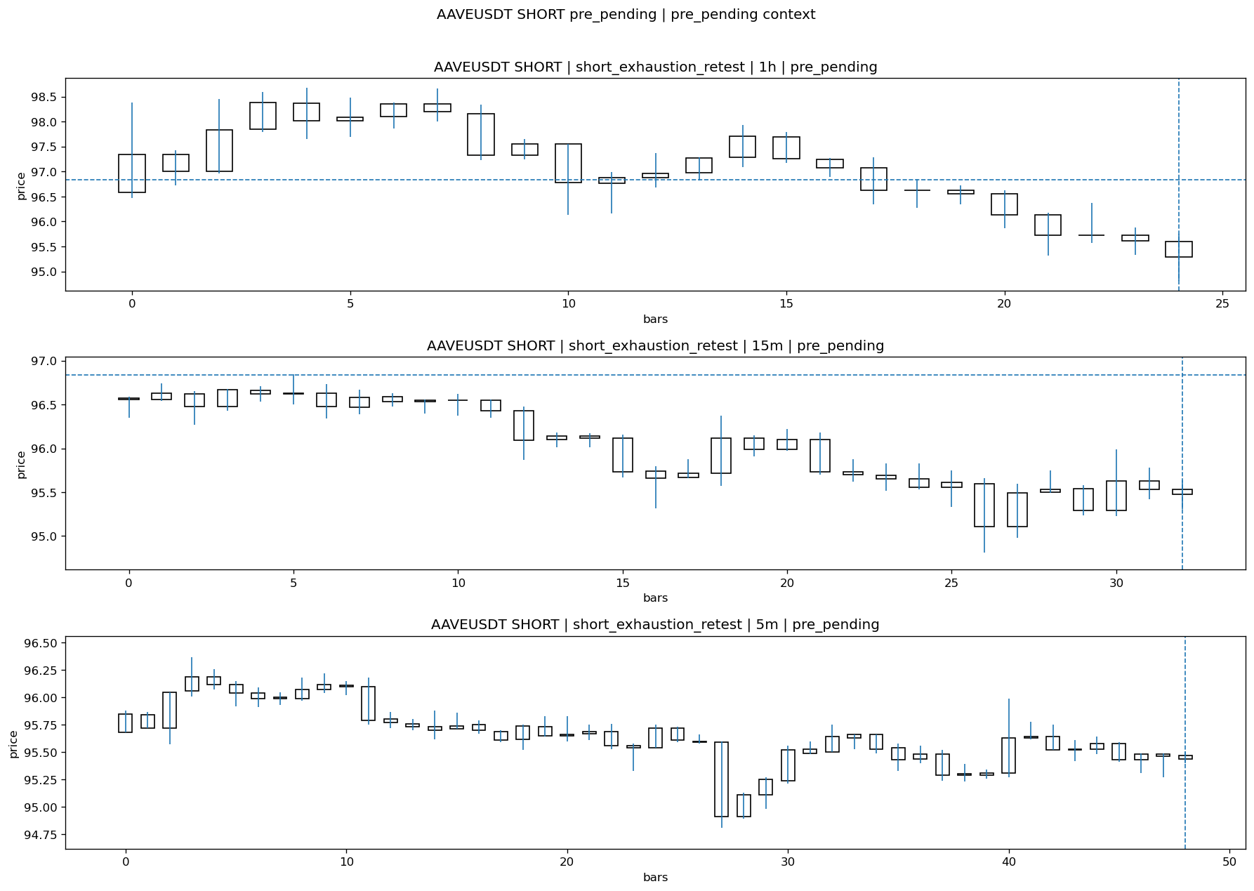
AAVEUSDT_SHORT_short_exhaustion_retest_pre_pending_1774668600000.png

Pending Open
Stage status: missing_unexpected | Content type: none
Note: MISSING UNEXPECTED

Entry Or Confirm
Stage status: missing_unexpected | Content type: none
Note: MISSING UNEXPECTED

Case Close
Stage status: not_reached_yet | Content type: none
Note: NOT REACHED YET

Post-Close Outcome
1h outcome | available=Y | favor=0.5060 | adverse=0.1033 | summary=favor=0.51% adverse=0.10%
2h outcome | available=Y | favor=0.5060 | adverse=0.6093 | summary=favor=0.51% adverse=0.61%
4h reference | favor=0.5060 | adverse=1.5593
Reclaim | 2h=Y | 4h=Y
Execution reality | entry_feasible=Y | entry_window=10m | entry_note=entry still reachable within 10m
Time-to-move | time_to_max_favor=14m | time_to_max_adverse=119m
Regret filter | regret_valid=N | reason=no_meaningful_fast_move
Conclusion | NO_MEANINGFUL_MOVE | notes=entry_ref_from_breakout_level

Review placeholders
human_review_status=PENDING | verdict_code= | root_cause_code= | action_candidate_code=

Case 22: CFGUSDT-LONG-1774670100000
Summary | CFGUSDT | LONG | long_breakout_retest | status_final=INVALIDATED | close_reason=retest invalidated
Times | signal=2026-03-28 10:55:00 | created=2026-03-28 11:02:25 | confirmed= | sent= | close=2026-03-28 11:07:30 | fallback_due=2026-03-28 15:02:25
Semantics | is_confirmed=N | is_sent_signal=N | review_eligible=Y | semantic_consistency=Y
Review integrity | review_exclusion_reason= | semantic_issue=
Close anchoring | case_close_type=true_close | close_anchor_time=2026-03-28 11:07:30 | close_capture_basis=true_close
Tradeability / outcome | entry_feasible=Y | slippage=0.0000 | regret_valid=N | outcome=KILL_CORRECT

Pre Pending
Stage status: captured | Content type: chart_snapshot
Note: pre_pending context
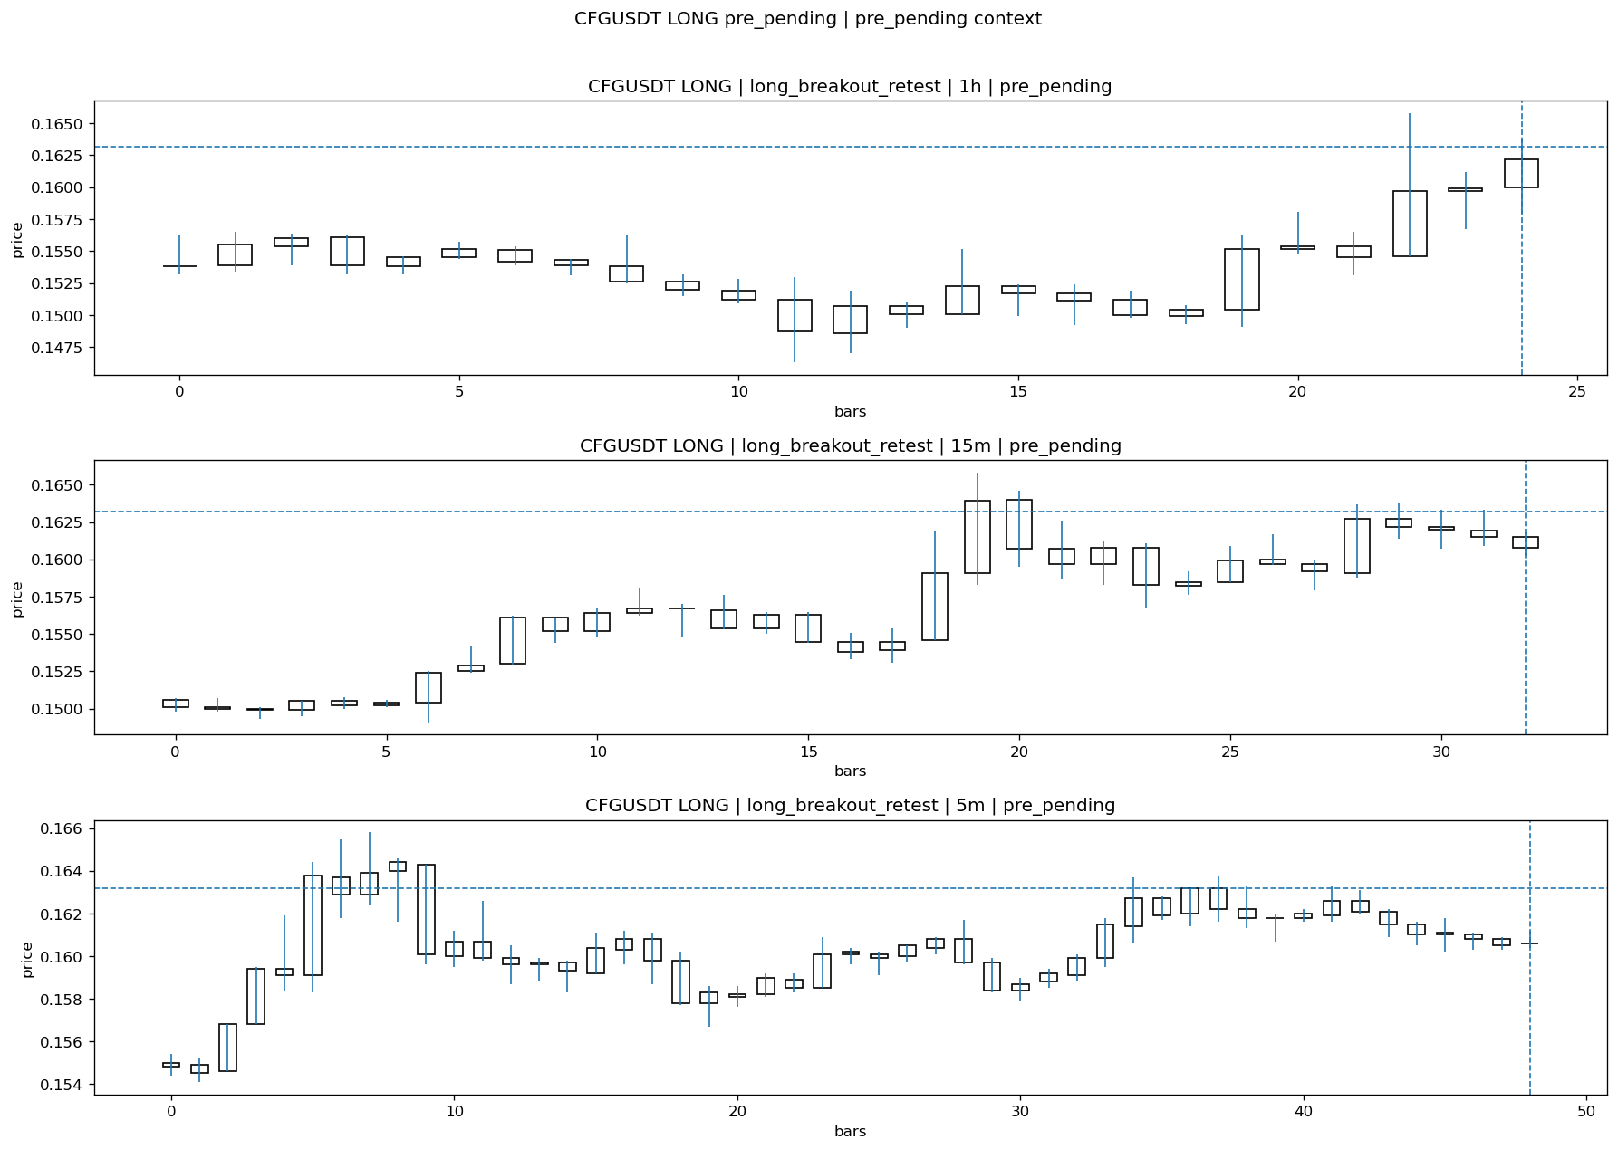
CFGUSDT_LONG_long_breakout_retest_pre_pending_1774669800000.png

Pending Open
Stage status: missing_unexpected | Content type: none
Note: MISSING UNEXPECTED

Entry Or Confirm
Stage status: not_applicable | Content type: none
Note: NOT APPLICABLE

Case Close
Stage status: missing_unexpected | Content type: none
Note: MISSING UNEXPECTED

Post-Close Outcome
1h outcome | available=Y | favor=2.3897 | adverse=2.8186 | summary=favor=2.39% adverse=2.82%
2h outcome | available=Y | favor=2.3897 | adverse=4.8407 | summary=favor=2.39% adverse=4.84%
4h reference | favor=2.3897 | adverse=5.7598
Reclaim | 2h=Y | 4h=Y
Execution reality | entry_feasible=Y | entry_window=10m | entry_note=entry still reachable within 10m
Time-to-move | time_to_max_favor=32m | time_to_max_adverse=97m
Regret filter | regret_valid=N | reason=adverse_too_large
Conclusion | KILL_CORRECT | notes=entry_ref_from_breakout_level

Review placeholders
human_review_status=PENDING | verdict_code= | root_cause_code= | action_candidate_code=

Case 23: SIRENUSDT-LONG-1774670700000
Summary | SIRENUSDT | LONG | long_breakout_retest | status_final=EXPIRED_WAIT | close_reason=retest wait expired
Times | signal=2026-03-28 11:05:00 | created=2026-03-28 11:10:16 | confirmed= | sent= | close=2026-03-28 11:52:50 | fallback_due=2026-03-28 15:10:16
Semantics | is_confirmed=N | is_sent_signal=N | review_eligible=Y | semantic_consistency=Y
Review integrity | review_exclusion_reason= | semantic_issue=
Close anchoring | case_close_type=true_close | close_anchor_time=2026-03-28 11:52:50 | close_capture_basis=true_close
Tradeability / outcome | entry_feasible=Y | slippage=0.0000 | regret_valid=N | outcome=NO_MEANINGFUL_MOVE

Pre Pending
Stage status: captured | Content type: chart_snapshot
Note: pre_pending context

SIRENUSDT_LONG_long_breakout_retest_pre_pending_1774670400000.png

Pending Open
Stage status: missing_unexpected | Content type: none
Note: MISSING UNEXPECTED

Entry Or Confirm
Stage status: not_applicable | Content type: none
Note: NOT APPLICABLE

Case Close
Stage status: missing_unexpected | Content type: none
Note: MISSING UNEXPECTED

Post-Close Outcome
1h outcome | available=Y | favor=44.3874 | adverse=0.0000 | summary=favor=44.39% adverse=0.00%
2h outcome | available=Y | favor=48.2218 | adverse=0.0000 | summary=favor=48.22% adverse=0.00%
4h reference | favor=68.4338 | adverse=0.0000
Reclaim | 2h=N | 4h=N
Execution reality | entry_feasible=Y | entry_window=10m | entry_note=entry still reachable within 10m
Time-to-move | time_to_max_favor=62m | time_to_max_adverse=22m
Regret filter | regret_valid=N | reason=no_meaningful_fast_move
Conclusion | NO_MEANINGFUL_MOVE | notes=entry_ref_from_breakout_level

Review placeholders
human_review_status=PENDING | verdict_code= | root_cause_code= | action_candidate_code=

Case 24: FETUSDT-SHORT-EXH-1774670400000
Summary | FETUSDT | SHORT | short_exhaustion_retest | status_final=EXPIRED_WAIT | close_reason=retest wait expired
Times | signal=2026-03-28 11:00:00 | created=2026-03-28 11:16:07 | confirmed= | sent= | close=2026-03-28 12:01:08 | fallback_due=2026-03-28 15:16:07
Semantics | is_confirmed=N | is_sent_signal=N | review_eligible=Y | semantic_consistency=Y
Review integrity | review_exclusion_reason= | semantic_issue=
Close anchoring | case_close_type=true_close | close_anchor_time=2026-03-28 12:01:08 | close_capture_basis=true_close
Tradeability / outcome | entry_feasible=Y | slippage=0.0000 | regret_valid=N | outcome=NO_MEANINGFUL_MOVE

Pre Pending
Stage status: captured | Content type: chart_snapshot
Note: pre_pending context
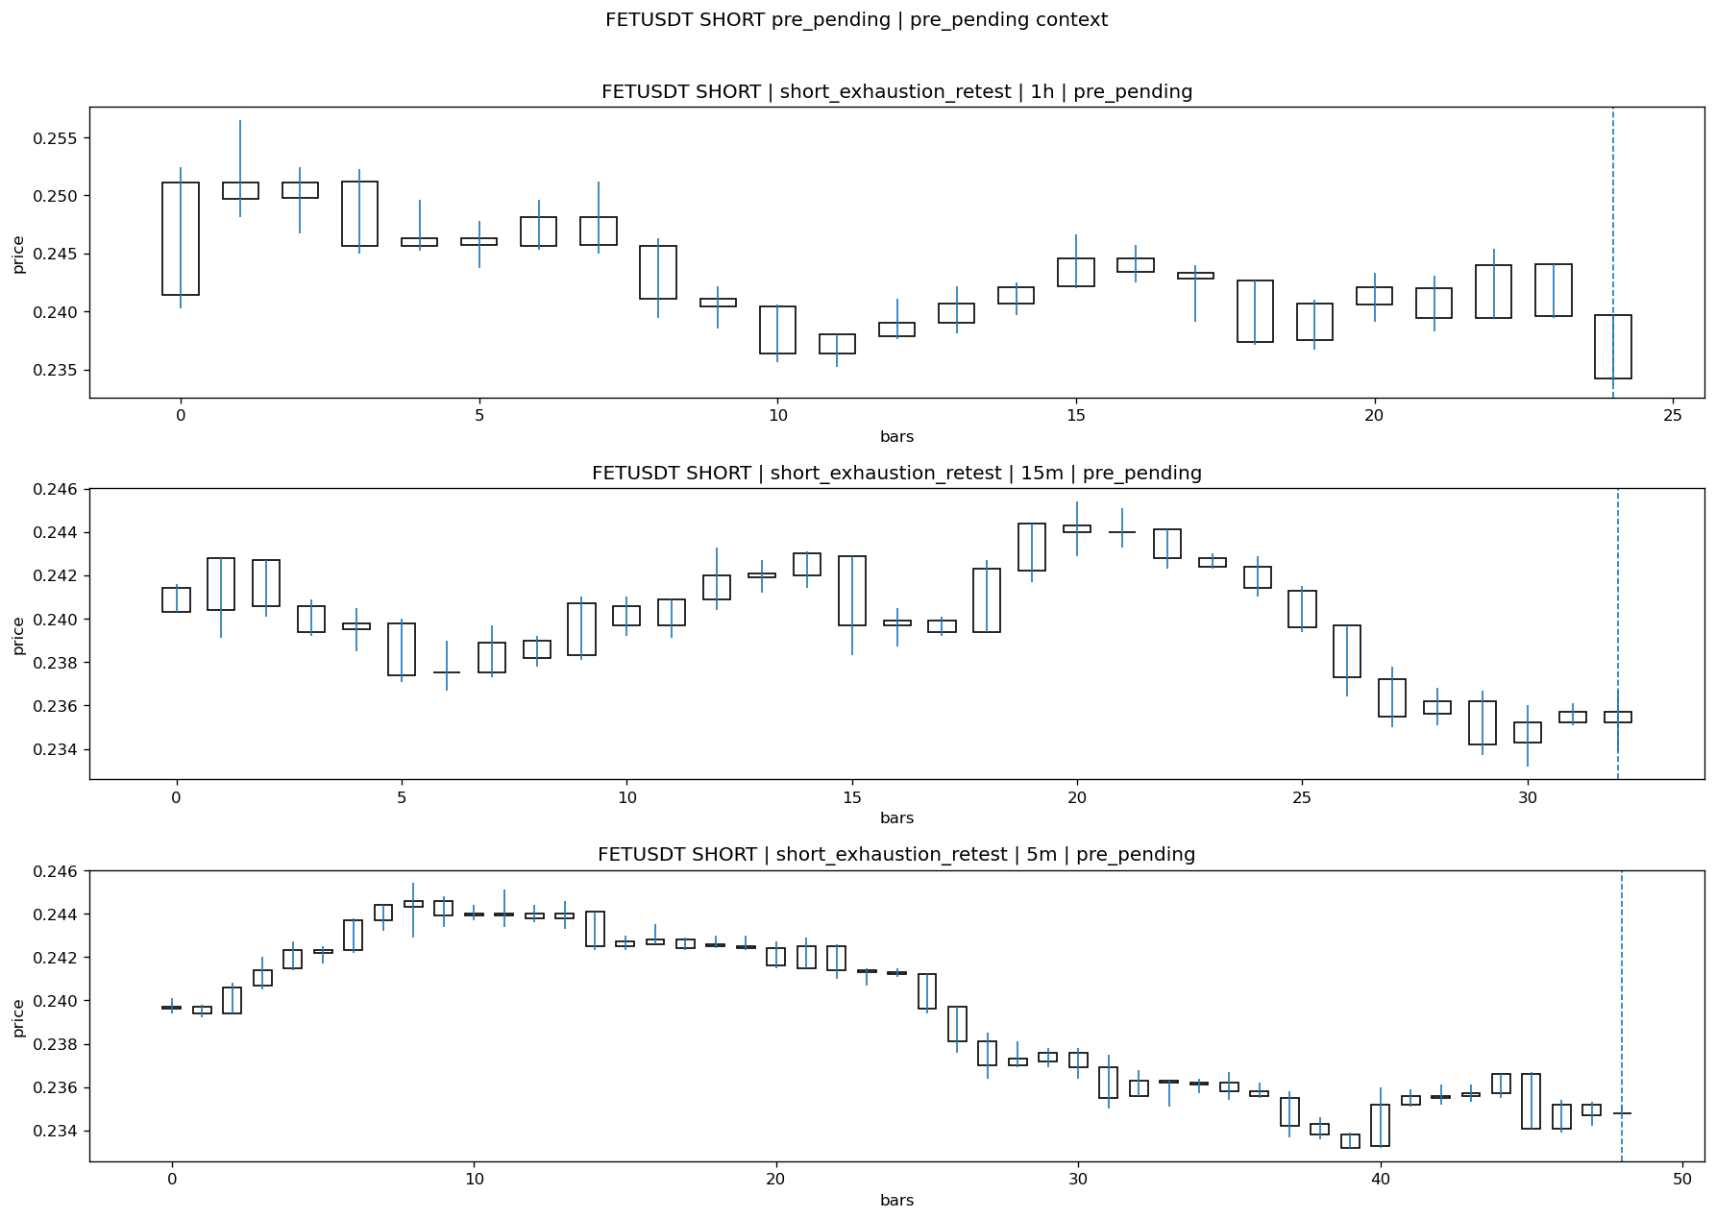
FETUSDT_SHORT_short_exhaustion_retest_pre_pending_1774669500000.png

Pending Open
Stage status: missing_unexpected | Content type: none
Note: MISSING UNEXPECTED

Entry Or Confirm
Stage status: not_applicable | Content type: none
Note: NOT APPLICABLE

Case Close
Stage status: missing_unexpected | Content type: none
Note: MISSING UNEXPECTED

Post-Close Outcome
1h outcome | available=Y | favor=0.2210 | adverse=0.7515 | summary=favor=0.22% adverse=0.75%
2h outcome | available=Y | favor=0.2210 | adverse=1.9010 | summary=favor=0.22% adverse=1.90%
4h reference | favor=0.2210 | adverse=4.1556
Reclaim | 2h=Y | 4h=Y
Execution reality | entry_feasible=Y | entry_window=10m | entry_note=entry still reachable within 10m
Time-to-move | time_to_max_favor=9m | time_to_max_adverse=74m
Regret filter | regret_valid=N | reason=adverse_too_large
Conclusion | NO_MEANINGFUL_MOVE | notes=entry_ref_from_breakout_level

Review placeholders
human_review_status=PENDING | verdict_code= | root_cause_code= | action_candidate_code=

Case 25: ONTUSDT-LONG-1774671000000
Summary | ONTUSDT | LONG | long_breakout_retest | status_final=EXPIRED_WAIT | close_reason=retest wait expired
Times | signal=2026-03-28 11:10:00 | created=2026-03-28 11:16:19 | confirmed= | sent= | close=2026-03-28 11:55:36 | fallback_due=2026-03-28 15:16:19
Semantics | is_confirmed=N | is_sent_signal=N | review_eligible=Y | semantic_consistency=Y
Review integrity | review_exclusion_reason= | semantic_issue=
Close anchoring | case_close_type=true_close | close_anchor_time=2026-03-28 11:55:36 | close_capture_basis=true_close
Tradeability / outcome | entry_feasible=Y | slippage=0.0000 | regret_valid=N | outcome=NO_MEANINGFUL_MOVE

Pre Pending
Stage status: captured | Content type: chart_snapshot
Note: pre_pending context
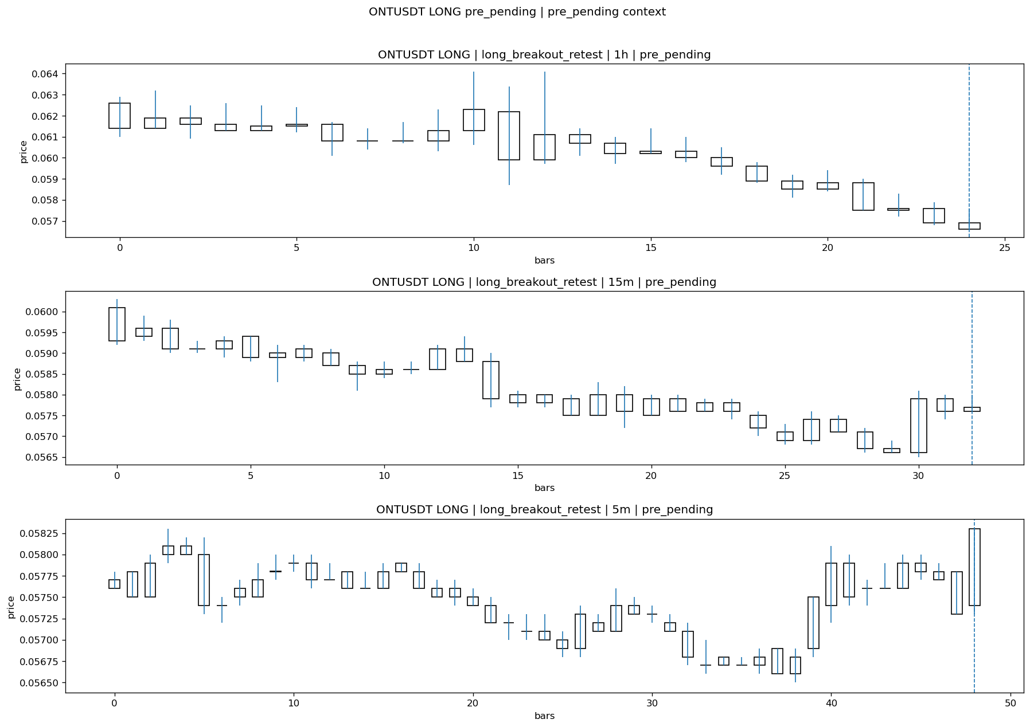
ONTUSDT_LONG_long_breakout_retest_pre_pending_1774670700000.png

Pending Open
Stage status: missing_unexpected | Content type: none
Note: MISSING UNEXPECTED

Entry Or Confirm
Stage status: not_applicable | Content type: none
Note: NOT APPLICABLE

Case Close
Stage status: missing_unexpected | Content type: none
Note: MISSING UNEXPECTED

Post-Close Outcome
1h outcome | available=Y | favor=23.5060 | adverse=0.0000 | summary=favor=23.51% adverse=0.00%
2h outcome | available=Y | favor=26.4940 | adverse=0.0000 | summary=favor=26.49% adverse=0.00%
4h reference | favor=32.6693 | adverse=0.0000
Reclaim | 2h=N | 4h=N
Execution reality | entry_feasible=Y | entry_window=10m | entry_note=entry still reachable within 10m
Time-to-move | time_to_max_favor=69m | time_to_max_adverse=4m
Regret filter | regret_valid=N | reason=no_meaningful_fast_move
Conclusion | NO_MEANINGFUL_MOVE | notes=entry_ref_from_breakout_level

Review placeholders
human_review_status=PENDING | verdict_code= | root_cause_code= | action_candidate_code=

Case 26: 1000SHIBUSDT-SHORT-EXH-1774670400000
Summary | 1000SHIBUSDT | SHORT | short_exhaustion_retest | status_final=INVALIDATED | close_reason=retest invalidated
Times | signal=2026-03-28 11:00:00 | created=2026-03-28 11:16:24 | confirmed= | sent= | close=2026-03-28 11:32:12 | fallback_due=2026-03-28 15:16:24
Semantics | is_confirmed=N | is_sent_signal=N | review_eligible=Y | semantic_consistency=Y
Review integrity | review_exclusion_reason= | semantic_issue=
Close anchoring | case_close_type=true_close | close_anchor_time=2026-03-28 11:32:12 | close_capture_basis=true_close
Tradeability / outcome | entry_feasible=Y | slippage=0.0000 | regret_valid=N | outcome=KILL_CORRECT

Pre Pending
Stage status: captured | Content type: chart_snapshot
Note: pre_pending context
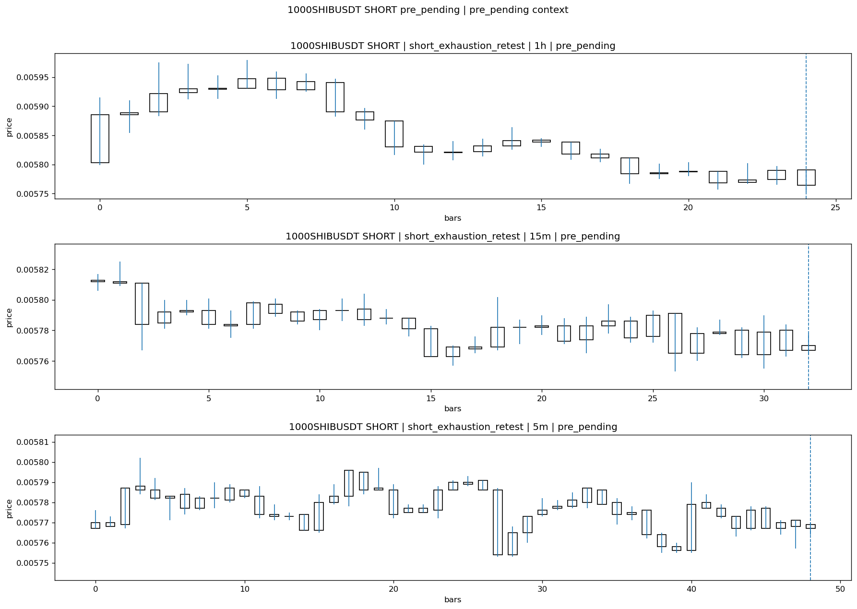
1000SHIBUSDT_SHORT_short_exhaustion_retest_pre_pending_1774669500000.png

Pending Open
Stage status: missing_unexpected | Content type: none
Note: MISSING UNEXPECTED

Entry Or Confirm
Stage status: not_applicable | Content type: none
Note: NOT APPLICABLE

Case Close
Stage status: missing_unexpected | Content type: none
Note: MISSING UNEXPECTED

Post-Close Outcome
1h outcome | available=Y | favor=0.1048 | adverse=0.3144 | summary=favor=0.10% adverse=0.31%
2h outcome | available=Y | favor=0.1048 | adverse=0.9780 | summary=favor=0.10% adverse=0.98%
4h reference | favor=0.1048 | adverse=1.8163
Reclaim | 2h=Y | 4h=Y
Execution reality | entry_feasible=Y | entry_window=10m | entry_note=entry still reachable within 10m
Time-to-move | time_to_max_favor=38m | time_to_max_adverse=103m
Regret filter | regret_valid=N | reason=no_meaningful_fast_move
Conclusion | KILL_CORRECT | notes=entry_ref_from_breakout_level

Review placeholders
human_review_status=PENDING | verdict_code= | root_cause_code= | action_candidate_code=

Case 27: BRUSDT-LONG-1774671600000
Summary | BRUSDT | LONG | long_breakout_retest | status_final=EXPIRED_WAIT | close_reason=retest wait expired
Times | signal=2026-03-28 11:20:00 | created=2026-03-28 11:27:00 | confirmed= | sent= | close=2026-03-28 12:06:38 | fallback_due=2026-03-28 15:27:00
Semantics | is_confirmed=N | is_sent_signal=N | review_eligible=Y | semantic_consistency=Y
Review integrity | review_exclusion_reason= | semantic_issue=
Close anchoring | case_close_type=true_close | close_anchor_time=2026-03-28 12:06:38 | close_capture_basis=true_close
Tradeability / outcome | entry_feasible=Y | slippage=0.0000 | regret_valid=Y | outcome=WAIT_TOO_SHORT_CANDIDATE

Pre Pending
Stage status: captured | Content type: chart_snapshot
Note: pre_pending context
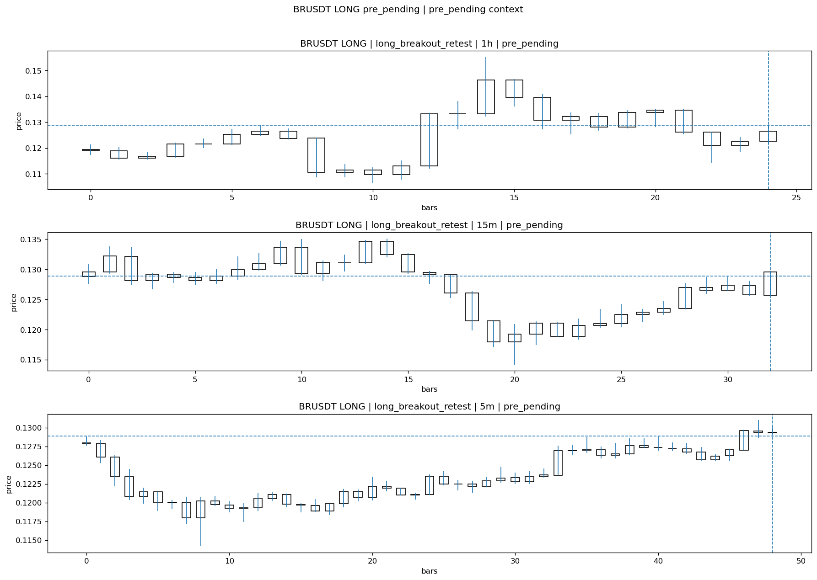
BRUSDT_LONG_long_breakout_retest_pre_pending_1774671300000.png

Pending Open
Stage status: missing_unexpected | Content type: none
Note: MISSING UNEXPECTED

Entry Or Confirm
Stage status: not_applicable | Content type: none
Note: NOT APPLICABLE

Case Close
Stage status: missing_unexpected | Content type: none
Note: MISSING UNEXPECTED

Post-Close Outcome
1h outcome | available=Y | favor=9.4218 | adverse=0.0000 | summary=favor=9.42% adverse=0.00%
2h outcome | available=Y | favor=9.4218 | adverse=6.4649 | summary=favor=9.42% adverse=6.46%
4h reference | favor=9.4218 | adverse=9.1347
Reclaim | 2h=Y | 4h=Y
Execution reality | entry_feasible=Y | entry_window=10m | entry_note=entry still reachable within 10m
Time-to-move | time_to_max_favor=8m | time_to_max_adverse=118m
Regret filter | regret_valid=Y | reason=valid_missed_continuation
Conclusion | WAIT_TOO_SHORT_CANDIDATE | notes=entry_ref_from_breakout_level

Review placeholders
human_review_status=PENDING | verdict_code= | root_cause_code= | action_candidate_code=

Case 28: LYNUSDT-LONG-1774671900000
Summary | LYNUSDT | LONG | long_breakout_retest | status_final=INVALIDATED | close_reason=retest invalidated
Times | signal=2026-03-28 11:25:00 | created=2026-03-28 11:32:43 | confirmed= | sent= | close=2026-03-28 11:41:54 | fallback_due=2026-03-28 15:32:43
Semantics | is_confirmed=N | is_sent_signal=N | review_eligible=Y | semantic_consistency=Y
Review integrity | review_exclusion_reason= | semantic_issue=
Close anchoring | case_close_type=true_close | close_anchor_time=2026-03-28 11:41:54 | close_capture_basis=true_close
Tradeability / outcome | entry_feasible=Y | slippage=0.0000 | regret_valid=Y | outcome=WAIT_TOO_SHORT_CANDIDATE

Pre Pending
Stage status: captured | Content type: chart_snapshot
Note: pre_pending context
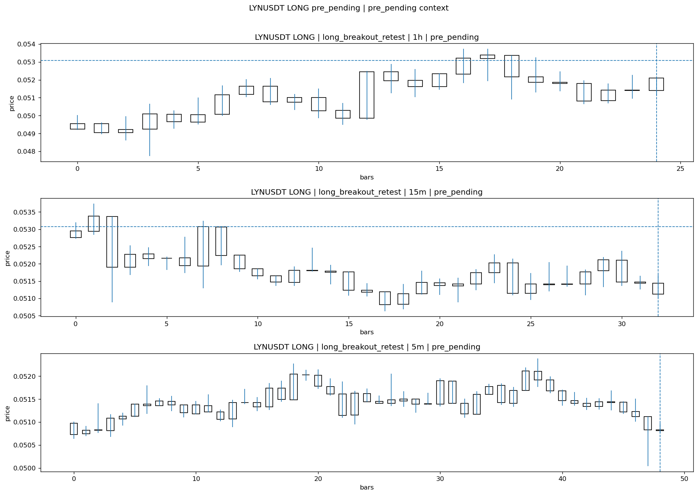
LYNUSDT_LONG_long_breakout_retest_pre_pending_1774671600000.png

Pending Open
Stage status: missing_unexpected | Content type: none
Note: MISSING UNEXPECTED

Entry Or Confirm
Stage status: not_applicable | Content type: none
Note: NOT APPLICABLE

Case Close
Stage status: missing_unexpected | Content type: none
Note: MISSING UNEXPECTED

Post-Close Outcome
1h outcome | available=Y | favor=3.4665 | adverse=1.8086 | summary=favor=3.47% adverse=1.81%
2h outcome | available=Y | favor=3.4665 | adverse=1.8086 | summary=favor=3.47% adverse=1.81%
4h reference | favor=7.8937 | adverse=1.8086
Reclaim | 2h=Y | 4h=Y
Execution reality | entry_feasible=Y | entry_window=10m | entry_note=entry still reachable within 10m
Time-to-move | time_to_max_favor=3m | time_to_max_adverse=58m
Regret filter | regret_valid=Y | reason=valid_missed_continuation
Conclusion | WAIT_TOO_SHORT_CANDIDATE | notes=entry_ref_from_breakout_level

Review placeholders
human_review_status=PENDING | verdict_code= | root_cause_code= | action_candidate_code=

Case 29: CFGUSDT-LONG-1774672800000
Summary | CFGUSDT | LONG | long_breakout_retest | status_final=INVALIDATED | close_reason=retest invalidated
Times | signal=2026-03-28 11:40:00 | created=2026-03-28 11:47:44 | confirmed= | sent= | close=2026-03-28 11:52:51 | fallback_due=2026-03-28 15:47:44
Semantics | is_confirmed=N | is_sent_signal=N | review_eligible=Y | semantic_consistency=Y
Review integrity | review_exclusion_reason= | semantic_issue=
Close anchoring | case_close_type=true_close | close_anchor_time=2026-03-28 11:52:51 | close_capture_basis=true_close
Tradeability / outcome | entry_feasible=Y | slippage=0.0000 | regret_valid=N | outcome=KILL_CORRECT

Pre Pending
Stage status: captured | Content type: chart_snapshot
Note: pre_pending context
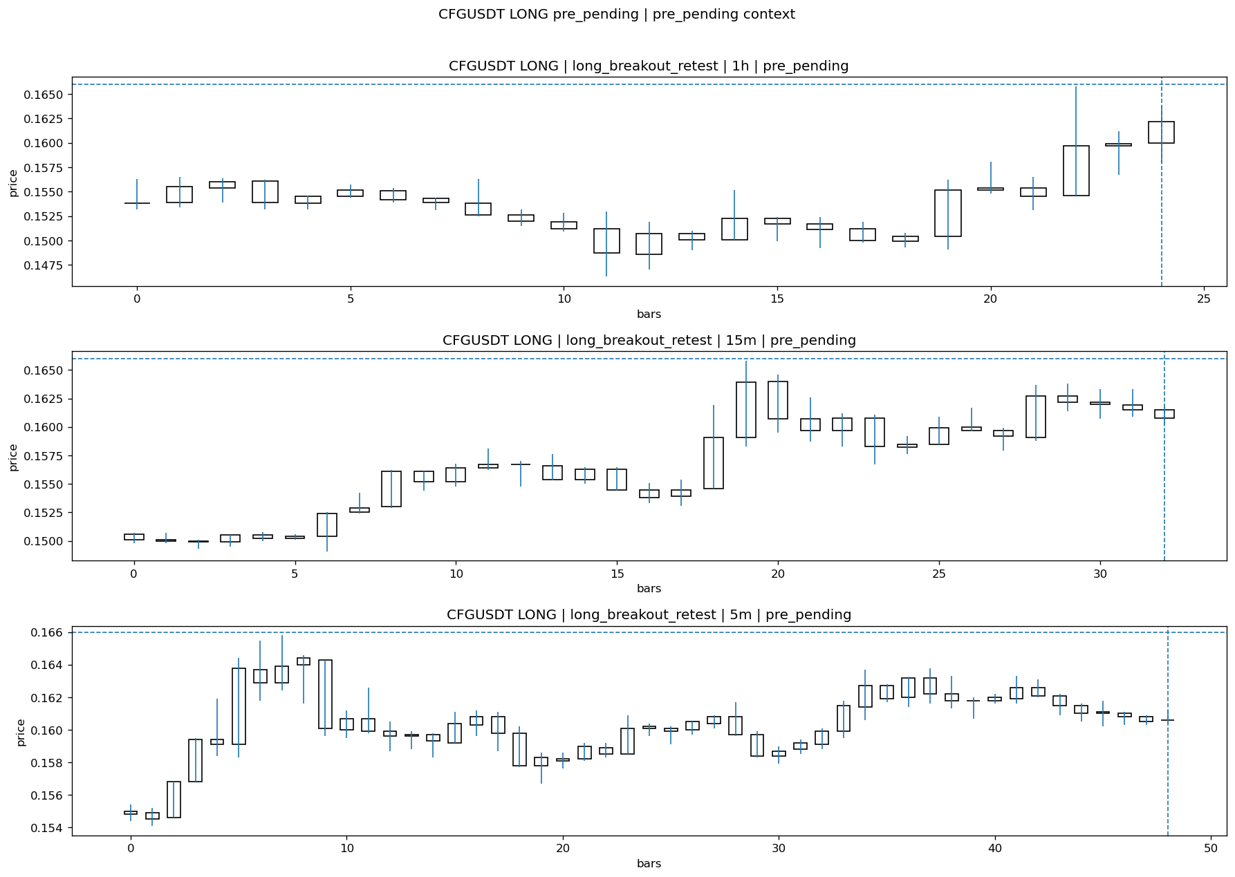
CFGUSDT_LONG_long_breakout_retest_pre_pending_1774672500000.png

Pending Open
Stage status: missing_unexpected | Content type: none
Note: MISSING UNEXPECTED

Entry Or Confirm
Stage status: not_applicable | Content type: none
Note: NOT APPLICABLE

Case Close
Stage status: missing_unexpected | Content type: none
Note: MISSING UNEXPECTED

Post-Close Outcome
1h outcome | available=Y | favor=0.3614 | adverse=6.4458 | summary=favor=0.36% adverse=6.45%
2h outcome | available=Y | favor=0.3614 | adverse=6.4458 | summary=favor=0.36% adverse=6.45%
4h reference | favor=0.3614 | adverse=7.9518
Reclaim | 2h=Y | 4h=Y
Execution reality | entry_feasible=Y | entry_window=10m | entry_note=entry still reachable within 10m
Time-to-move | time_to_max_favor=2m | time_to_max_adverse=52m
Regret filter | regret_valid=N | reason=adverse_too_large
Conclusion | KILL_CORRECT | notes=entry_ref_from_breakout_level

Review placeholders
human_review_status=PENDING | verdict_code= | root_cause_code= | action_candidate_code=

Case 30: ONTUSDT-LONG-1774673700000
Summary | ONTUSDT | LONG | long_breakout_retest | status_final=INVALIDATED | close_reason=retest invalidated
Times | signal=2026-03-28 11:55:00 | created=2026-03-28 12:04:20 | confirmed= | sent= | close=2026-03-28 12:06:39 | fallback_due=2026-03-28 16:04:20
Semantics | is_confirmed=N | is_sent_signal=N | review_eligible=Y | semantic_consistency=Y
Review integrity | review_exclusion_reason= | semantic_issue=
Close anchoring | case_close_type=true_close | close_anchor_time=2026-03-28 12:06:39 | close_capture_basis=true_close
Tradeability / outcome | entry_feasible=Y | slippage=0.0000 | regret_valid=Y | outcome=WAIT_TOO_SHORT_CANDIDATE

Pre Pending
Stage status: captured | Content type: chart_snapshot
Note: pre_pending context

ONTUSDT_LONG_long_breakout_retest_pre_pending_1774673400000.png

Pending Open
Stage status: missing_unexpected | Content type: none
Note: MISSING UNEXPECTED

Entry Or Confirm
Stage status: not_applicable | Content type: none
Note: NOT APPLICABLE

Case Close
Stage status: missing_unexpected | Content type: none
Note: MISSING UNEXPECTED

Post-Close Outcome
1h outcome | available=Y | favor=19.3609 | adverse=0.0000 | summary=favor=19.36% adverse=0.00%
2h outcome | available=Y | favor=19.3609 | adverse=0.0000 | summary=favor=19.36% adverse=0.00%
4h reference | favor=25.1880 | adverse=0.0000
Reclaim | 2h=N | 4h=N
Execution reality | entry_feasible=Y | entry_window=10m | entry_note=entry still reachable within 10m
Time-to-move | time_to_max_favor=58m | time_to_max_adverse=3m
Regret filter | regret_valid=Y | reason=valid_missed_continuation
Conclusion | WAIT_TOO_SHORT_CANDIDATE | notes=entry_ref_from_breakout_level

Review placeholders
human_review_status=PENDING | verdict_code= | root_cause_code= | action_candidate_code=

Case 31: HUMAUSDT-LONG-1774674300000
Summary | HUMAUSDT | LONG | long_breakout_retest | status_final=EXPIRED_WAIT | close_reason=retest wait expired
Times | signal=2026-03-28 12:05:00 | created=2026-03-28 12:12:40 | confirmed= | sent= | close=2026-03-28 12:50:37 | fallback_due=2026-03-28 16:12:40
Semantics | is_confirmed=N | is_sent_signal=N | review_eligible=Y | semantic_consistency=Y
Review integrity | review_exclusion_reason= | semantic_issue=
Close anchoring | case_close_type=true_close | close_anchor_time=2026-03-28 12:50:37 | close_capture_basis=true_close
Tradeability / outcome | entry_feasible=Y | slippage=0.0000 | regret_valid=N | outcome=NO_MEANINGFUL_MOVE

Pre Pending
Stage status: captured | Content type: chart_snapshot
Note: pre_pending context
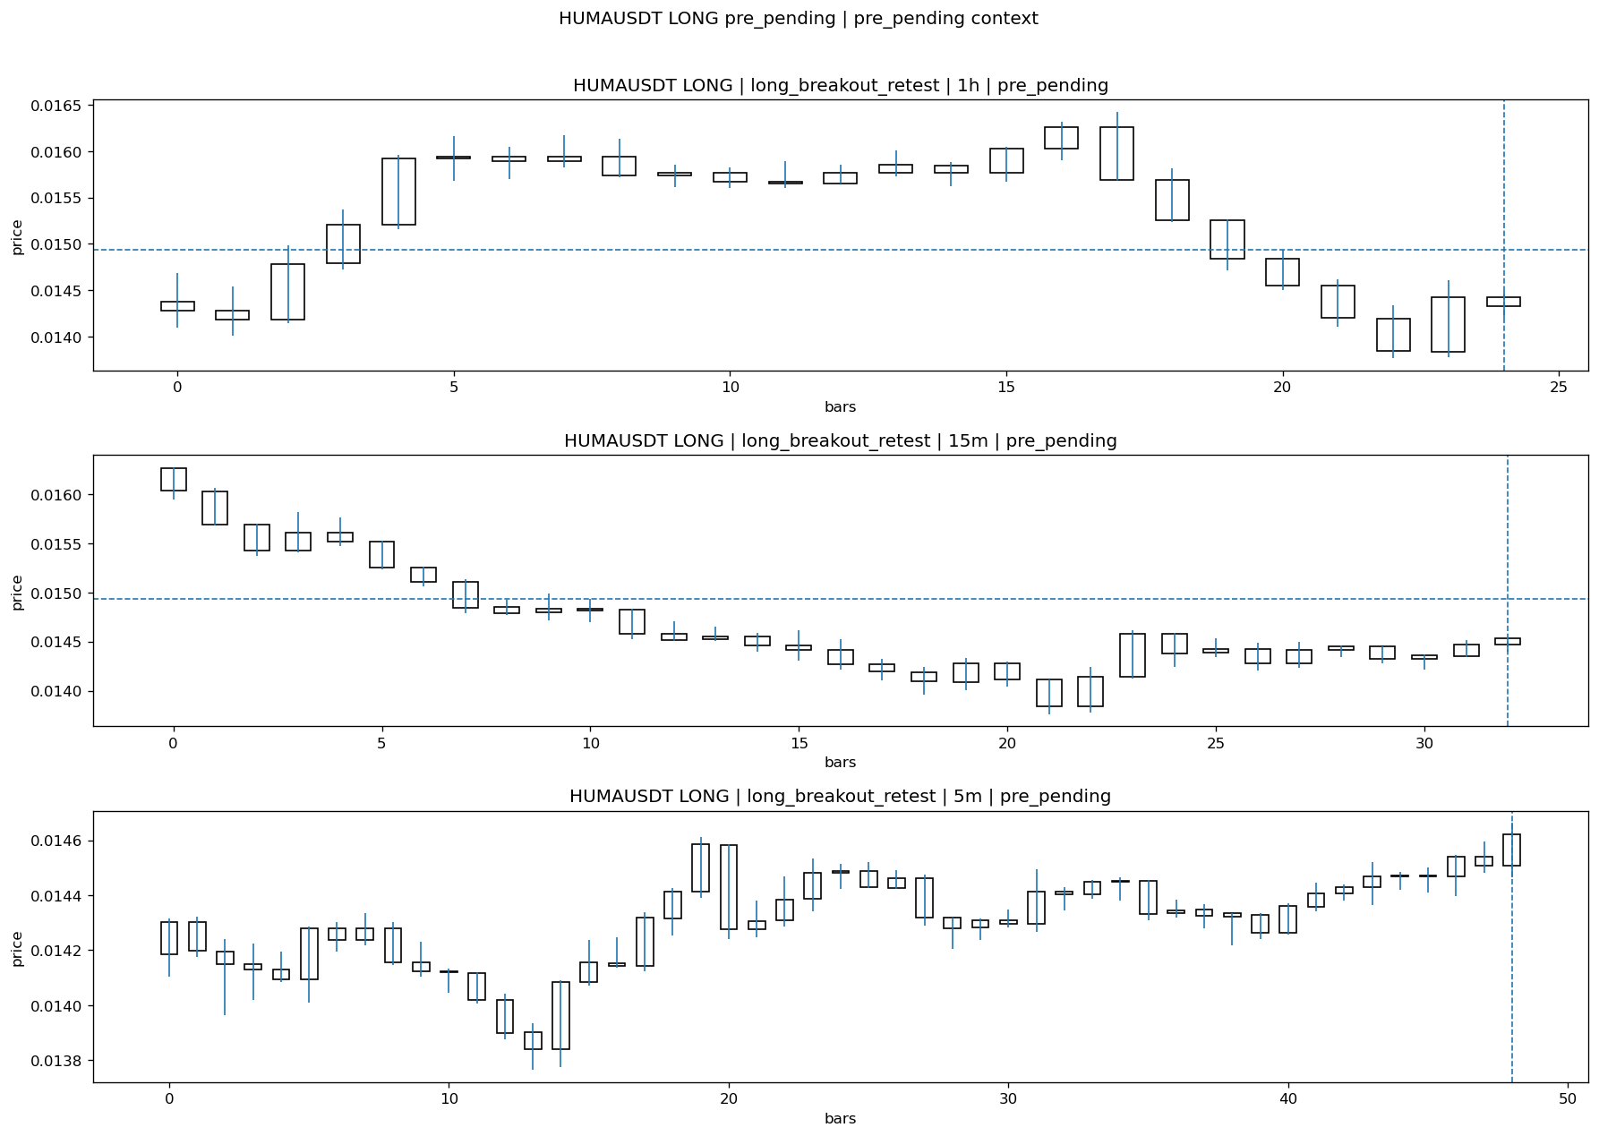
HUMAUSDT_LONG_long_breakout_retest_pre_pending_1774674000000.png

Pending Open
Stage status: missing_unexpected | Content type: none
Note: MISSING UNEXPECTED

Entry Or Confirm
Stage status: not_applicable | Content type: none
Note: NOT APPLICABLE

Case Close
Stage status: missing_unexpected | Content type: none
Note: MISSING UNEXPECTED

Post-Close Outcome
1h outcome | available=Y | favor=4.6474 | adverse=4.1586 | summary=favor=4.65% adverse=4.16%
2h outcome | available=Y | favor=4.6474 | adverse=4.1586 | summary=favor=4.65% adverse=4.16%
4h reference | favor=4.6474 | adverse=4.1586
Reclaim | 2h=Y | 4h=Y
Execution reality | entry_feasible=Y | entry_window=10m | entry_note=entry still reachable within 10m
Time-to-move | time_to_max_favor=4m | time_to_max_adverse=59m
Regret filter | regret_valid=N | reason=adverse_too_large
Conclusion | NO_MEANINGFUL_MOVE | notes=entry_ref_from_breakout_level

Review placeholders
human_review_status=PENDING | verdict_code= | root_cause_code= | action_candidate_code=

Case 32: ONTUSDT-LONG-1774674600000
Summary | ONTUSDT | LONG | long_breakout_retest | status_final=INVALIDATED | close_reason=retest invalidated
Times | signal=2026-03-28 12:10:00 | created=2026-03-28 12:15:21 | confirmed= | sent= | close=2026-03-28 12:20:25 | fallback_due=2026-03-28 16:15:21
Semantics | is_confirmed=N | is_sent_signal=N | review_eligible=Y | semantic_consistency=Y
Review integrity | review_exclusion_reason= | semantic_issue=
Close anchoring | case_close_type=true_close | close_anchor_time=2026-03-28 12:20:25 | close_capture_basis=true_close
Tradeability / outcome | entry_feasible=Y | slippage=0.0000 | regret_valid=Y | outcome=WAIT_TOO_SHORT_CANDIDATE

Pre Pending
Stage status: captured | Content type: chart_snapshot
Note: pre_pending context

ONTUSDT_LONG_long_breakout_retest_pre_pending_1774674300000.png

Pending Open
Stage status: missing_unexpected | Content type: none
Note: MISSING UNEXPECTED

Entry Or Confirm
Stage status: not_applicable | Content type: none
Note: NOT APPLICABLE

Case Close
Stage status: missing_unexpected | Content type: none
Note: MISSING UNEXPECTED

Post-Close Outcome
1h outcome | available=Y | favor=14.0036 | adverse=1.6158 | summary=favor=14.00% adverse=1.62%
2h outcome | available=Y | favor=14.0036 | adverse=1.6158 | summary=favor=14.00% adverse=1.62%
4h reference | favor=19.5691 | adverse=1.6158
Reclaim | 2h=Y | 4h=Y
Execution reality | entry_feasible=Y | entry_window=10m | entry_note=entry still reachable within 10m
Time-to-move | time_to_max_favor=45m | time_to_max_adverse=5m
Regret filter | regret_valid=Y | reason=valid_missed_continuation
Conclusion | WAIT_TOO_SHORT_CANDIDATE | notes=entry_ref_from_breakout_level

Review placeholders
human_review_status=PENDING | verdict_code= | root_cause_code= | action_candidate_code=

Case 33: ONTUSDT-LONG-1774676100000
Summary | ONTUSDT | LONG | long_breakout_retest | status_final=EXPIRED_WAIT | close_reason=retest wait expired
Times | signal=2026-03-28 12:35:00 | created=2026-03-28 12:42:37 | confirmed= | sent= | close=2026-03-28 13:21:34 | fallback_due=2026-03-28 16:42:37
Semantics | is_confirmed=N | is_sent_signal=N | review_eligible=Y | semantic_consistency=Y
Review integrity | review_exclusion_reason= | semantic_issue=
Close anchoring | case_close_type=true_close | close_anchor_time=2026-03-28 13:21:34 | close_capture_basis=true_close
Tradeability / outcome | entry_feasible=Y | slippage=0.0000 | regret_valid=N | outcome=NO_MEANINGFUL_MOVE

Pre Pending
Stage status: captured | Content type: chart_snapshot
Note: pre_pending context
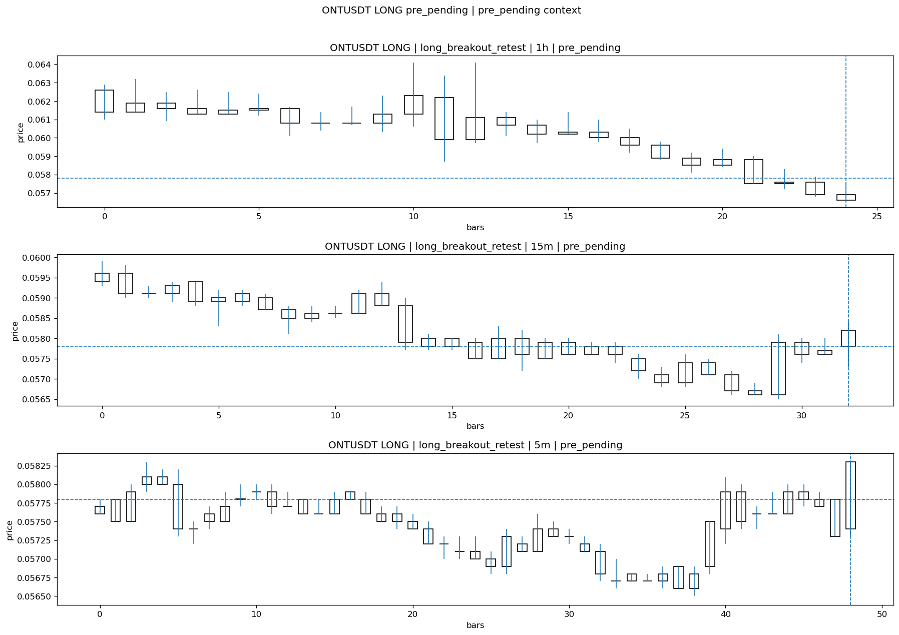
ONTUSDT_LONG_long_breakout_retest_pre_pending_1774675800000.png

Pending Open
Stage status: missing_unexpected | Content type: none
Note: MISSING UNEXPECTED

Entry Or Confirm
Stage status: not_applicable | Content type: none
Note: NOT APPLICABLE

Case Close
Stage status: missing_unexpected | Content type: none
Note: MISSING UNEXPECTED

Post-Close Outcome
1h outcome | available=Y | favor=9.5156 | adverse=0.0000 | summary=favor=9.52% adverse=0.00%
2h outcome | available=Y | favor=15.2249 | adverse=0.0000 | summary=favor=15.22% adverse=0.00%
4h reference | favor=15.2249 | adverse=0.0000
Reclaim | 2h=N | 4h=N
Execution reality | entry_feasible=Y | entry_window=10m | entry_note=entry still reachable within 10m
Time-to-move | time_to_max_favor=68m | time_to_max_adverse=3m
Regret filter | regret_valid=N | reason=no_meaningful_fast_move
Conclusion | NO_MEANINGFUL_MOVE | notes=entry_ref_from_breakout_level

Review placeholders
human_review_status=PENDING | verdict_code= | root_cause_code= | action_candidate_code=

Case 34: PIXELUSDT-SHORT-EXH-1774675800000
Summary | PIXELUSDT | SHORT | short_exhaustion_retest | status_final=CONFIRMED | close_reason=signal confirmed
Times | signal=2026-03-28 12:30:00 | created=2026-03-28 12:45:15 | confirmed= | sent= | close=2026-03-28 13:32:28 | fallback_due=2026-03-28 16:45:15
Semantics | is_confirmed=N | is_sent_signal=N | review_eligible=N | semantic_consistency=N
Review integrity | review_exclusion_reason=confirmed_without_confirmed_ts | semantic_issue=confirmed_without_confirmed_ts
Close anchoring | case_close_type=not_due_yet | close_anchor_time= | close_capture_basis=not_due_yet
Tradeability / outcome | entry_feasible=Y | slippage=0.0000 | regret_valid=N | outcome=NO_MEANINGFUL_MOVE

Pre Pending
Stage status: captured | Content type: chart_snapshot
Note: pre_pending context
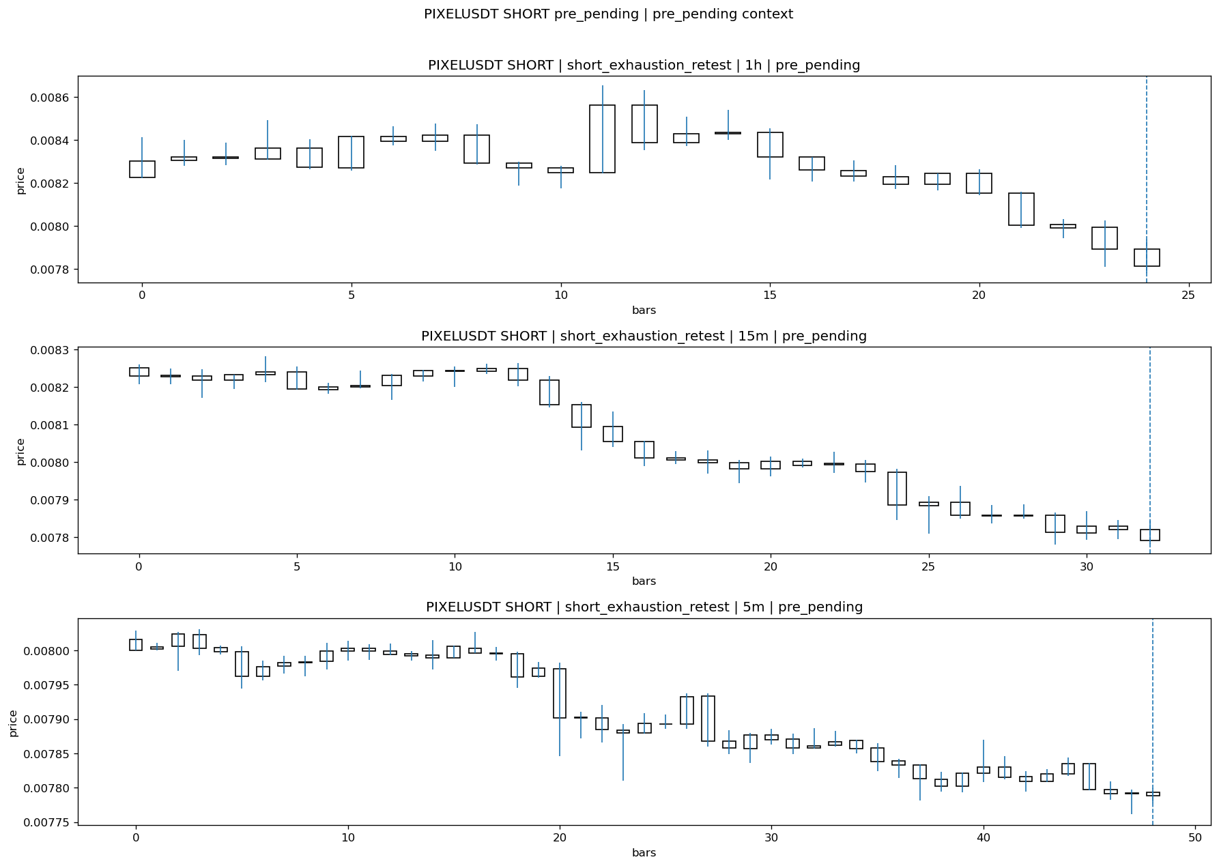
PIXELUSDT_SHORT_short_exhaustion_retest_pre_pending_1774674900000.png

Pending Open
Stage status: missing_unexpected | Content type: none
Note: MISSING UNEXPECTED

Entry Or Confirm
Stage status: missing_unexpected | Content type: none
Note: MISSING UNEXPECTED

Case Close
Stage status: not_reached_yet | Content type: none
Note: NOT REACHED YET

Post-Close Outcome
1h outcome | available=Y | favor=3.3692 | adverse=0.0000 | summary=favor=3.37% adverse=0.00%
2h outcome | available=Y | favor=3.3922 | adverse=0.0000 | summary=favor=3.39% adverse=0.00%
4h reference | favor=5.7529 | adverse=0.0000
Reclaim | 2h=N | 4h=N
Execution reality | entry_feasible=Y | entry_window=10m | entry_note=entry still reachable within 10m
Time-to-move | time_to_max_favor=98m | time_to_max_adverse=58m
Regret filter | regret_valid=N | reason=no_meaningful_fast_move
Conclusion | NO_MEANINGFUL_MOVE | notes=entry_ref_from_breakout_level

Review placeholders
human_review_status=PENDING | verdict_code= | root_cause_code= | action_candidate_code=

Case 35: SIRENUSDT-LONG-1774676400000
Summary | SIRENUSDT | LONG | long_breakout_retest | status_final=INVALIDATED | close_reason=retest invalidated
Times | signal=2026-03-28 12:40:00 | created=2026-03-28 12:47:51 | confirmed= | sent= | close=2026-03-28 13:07:07 | fallback_due=2026-03-28 16:47:51
Semantics | is_confirmed=N | is_sent_signal=N | review_eligible=Y | semantic_consistency=Y
Review integrity | review_exclusion_reason= | semantic_issue=
Close anchoring | case_close_type=true_close | close_anchor_time=2026-03-28 13:07:07 | close_capture_basis=true_close
Tradeability / outcome | entry_feasible=Y | slippage=0.0000 | regret_valid=N | outcome=KILL_CORRECT

Pre Pending
Stage status: captured | Content type: chart_snapshot
Note: pre_pending context
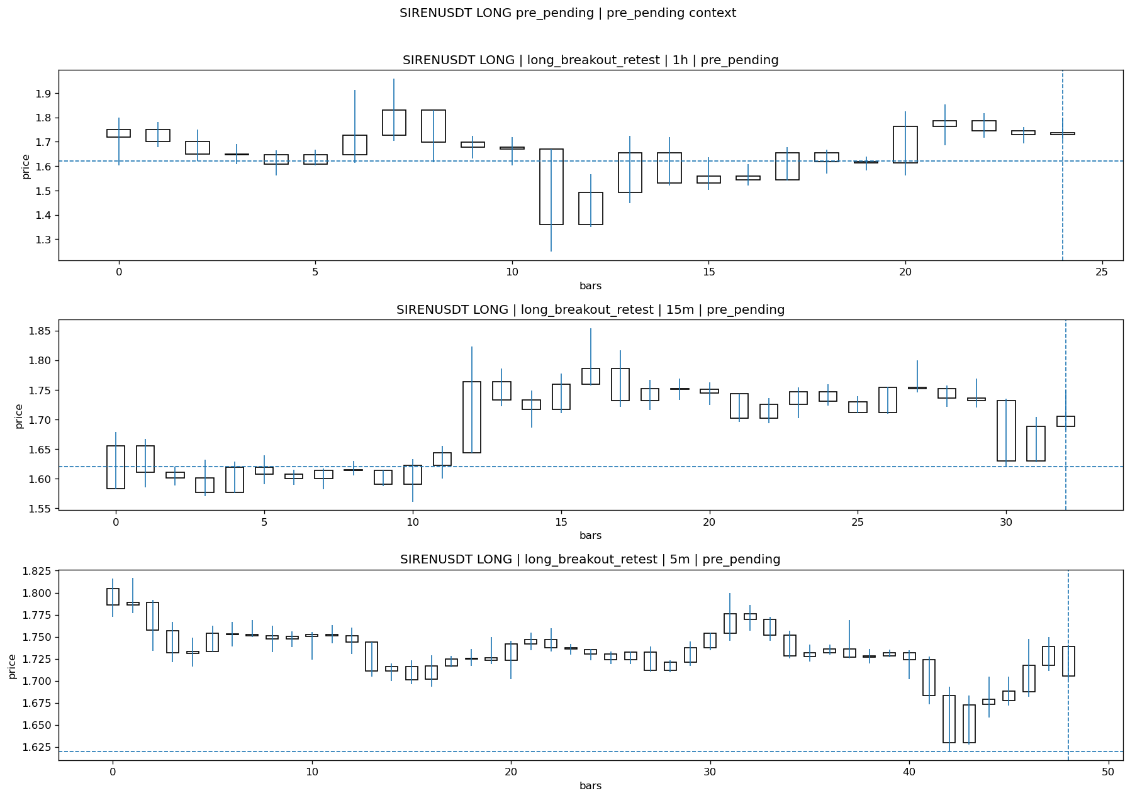
SIRENUSDT_LONG_long_breakout_retest_pre_pending_1774676100000.png

Pending Open
Stage status: missing_unexpected | Content type: none
Note: MISSING UNEXPECTED

Entry Or Confirm
Stage status: not_applicable | Content type: none
Note: NOT APPLICABLE

Case Close
Stage status: missing_unexpected | Content type: none
Note: MISSING UNEXPECTED

Post-Close Outcome
1h outcome | available=Y | favor=4.0207 | adverse=10.4249 | summary=favor=4.02% adverse=10.42%
2h outcome | available=Y | favor=4.8103 | adverse=10.4249 | summary=favor=4.81% adverse=10.42%
4h reference | favor=27.4226 | adverse=10.4249
Reclaim | 2h=Y | 4h=Y
Execution reality | entry_feasible=Y | entry_window=10m | entry_note=entry still reachable within 10m
Time-to-move | time_to_max_favor=113m | time_to_max_adverse=38m
Regret filter | regret_valid=N | reason=adverse_too_large
Conclusion | KILL_CORRECT | notes=entry_ref_from_breakout_level

Review placeholders
human_review_status=PENDING | verdict_code= | root_cause_code= | action_candidate_code=

Case 36: QUSDT-LONG-1774676400000
Summary | QUSDT | LONG | long_breakout_retest | status_final=INVALIDATED | close_reason=retest invalidated
Times | signal=2026-03-28 12:40:00 | created=2026-03-28 12:48:07 | confirmed= | sent= | close=2026-03-28 12:50:38 | fallback_due=2026-03-28 16:48:07
Semantics | is_confirmed=N | is_sent_signal=N | review_eligible=Y | semantic_consistency=Y
Review integrity | review_exclusion_reason= | semantic_issue=
Close anchoring | case_close_type=true_close | close_anchor_time=2026-03-28 12:50:38 | close_capture_basis=true_close
Tradeability / outcome | entry_feasible=Y | slippage=0.0000 | regret_valid=Y | outcome=WAIT_TOO_SHORT_CANDIDATE

Pre Pending
Stage status: captured | Content type: chart_snapshot
Note: pre_pending context
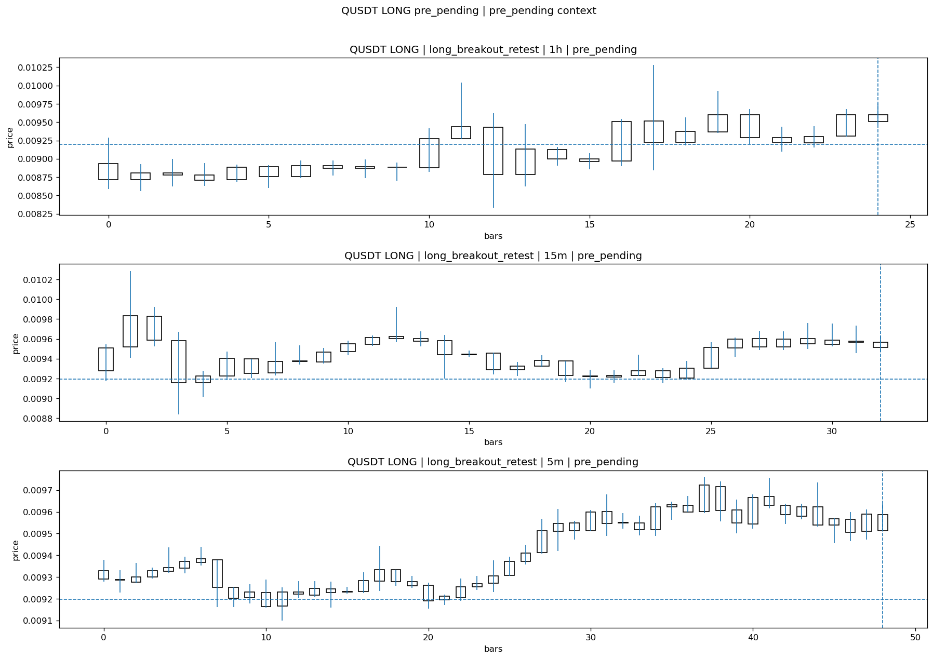
QUSDT_LONG_long_breakout_retest_pre_pending_1774676100000.png

Pending Open
Stage status: missing_unexpected | Content type: none
Note: MISSING UNEXPECTED

Entry Or Confirm
Stage status: not_applicable | Content type: none
Note: NOT APPLICABLE

Case Close
Stage status: missing_unexpected | Content type: none
Note: MISSING UNEXPECTED

Post-Close Outcome
1h outcome | available=Y | favor=5.6431 | adverse=0.7394 | summary=favor=5.64% adverse=0.74%
2h outcome | available=Y | favor=5.6431 | adverse=2.5769 | summary=favor=5.64% adverse=2.58%
4h reference | favor=5.6431 | adverse=9.1443
Reclaim | 2h=Y | 4h=Y
Execution reality | entry_feasible=Y | entry_window=10m | entry_note=entry still reachable within 10m
Time-to-move | time_to_max_favor=9m | time_to_max_adverse=119m
Regret filter | regret_valid=Y | reason=valid_missed_continuation
Conclusion | WAIT_TOO_SHORT_CANDIDATE | notes=entry_ref_from_breakout_level

Review placeholders
human_review_status=PENDING | verdict_code= | root_cause_code= | action_candidate_code=

Case 37: RIVERUSDT-LONG-1774676700000
Summary | RIVERUSDT | LONG | long_breakout_retest | status_final=INVALIDATED | close_reason=retest invalidated
Times | signal=2026-03-28 12:45:00 | created=2026-03-28 12:50:44 | confirmed= | sent= | close=2026-03-28 13:01:40 | fallback_due=2026-03-28 16:50:44
Semantics | is_confirmed=N | is_sent_signal=N | review_eligible=Y | semantic_consistency=Y
Review integrity | review_exclusion_reason= | semantic_issue=
Close anchoring | case_close_type=true_close | close_anchor_time=2026-03-28 13:01:40 | close_capture_basis=true_close
Tradeability / outcome | entry_feasible=Y | slippage=0.0000 | regret_valid=N | outcome=KILL_CORRECT

Pre Pending
Stage status: captured | Content type: chart_snapshot
Note: pre_pending context
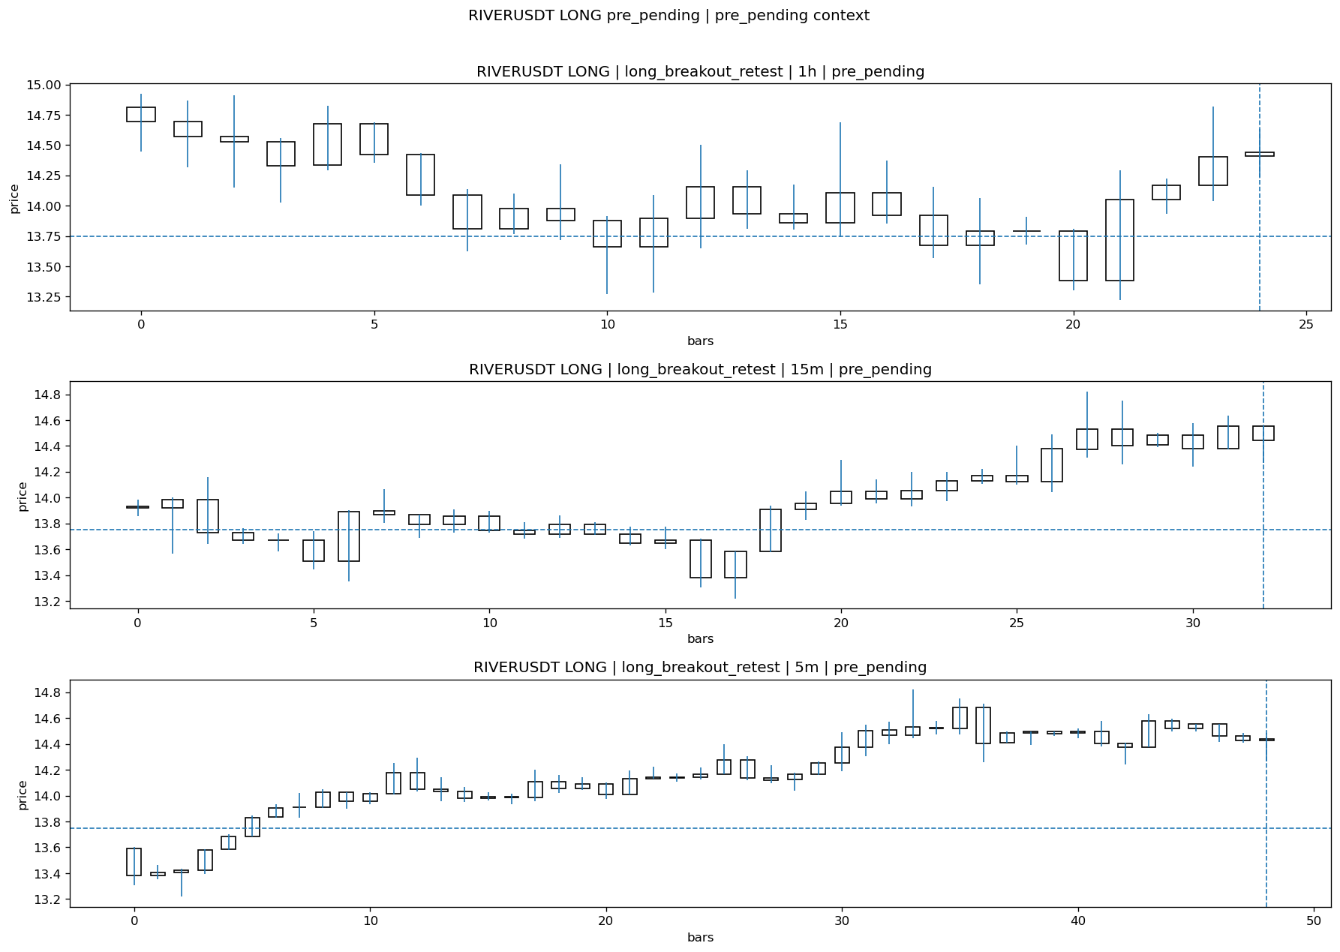
RIVERUSDT_LONG_long_breakout_retest_pre_pending_1774676400000.png

Pending Open
Stage status: missing_unexpected | Content type: none
Note: MISSING UNEXPECTED

Entry Or Confirm
Stage status: not_applicable | Content type: none
Note: NOT APPLICABLE

Case Close
Stage status: missing_unexpected | Content type: none
Note: MISSING UNEXPECTED

Post-Close Outcome
1h outcome | available=Y | favor=4.7273 | adverse=3.1273 | summary=favor=4.73% adverse=3.13%
2h outcome | available=Y | favor=8.8145 | adverse=3.1273 | summary=favor=8.81% adverse=3.13%
4h reference | favor=17.3818 | adverse=3.1273
Reclaim | 2h=Y | 4h=Y
Execution reality | entry_feasible=Y | entry_window=10m | entry_note=entry still reachable within 10m
Time-to-move | time_to_max_favor=73m | time_to_max_adverse=43m
Regret filter | regret_valid=N | reason=no_meaningful_fast_move
Conclusion | KILL_CORRECT | notes=entry_ref_from_breakout_level

Review placeholders
human_review_status=PENDING | verdict_code= | root_cause_code= | action_candidate_code=

Case 38: QUSDT-LONG-1774676700000
Summary | QUSDT | LONG | long_breakout_retest | status_final=INVALIDATED | close_reason=retest invalidated
Times | signal=2026-03-28 12:45:00 | created=2026-03-28 12:50:57 | confirmed= | sent= | close=2026-03-28 12:56:11 | fallback_due=2026-03-28 16:50:57
Semantics | is_confirmed=N | is_sent_signal=N | review_eligible=Y | semantic_consistency=Y
Review integrity | review_exclusion_reason= | semantic_issue=
Close anchoring | case_close_type=true_close | close_anchor_time=2026-03-28 12:56:11 | close_capture_basis=true_close
Tradeability / outcome | entry_feasible=Y | slippage=0.0000 | regret_valid=N | outcome=KILL_CORRECT

Pre Pending
Stage status: captured | Content type: chart_snapshot
Note: pre_pending context
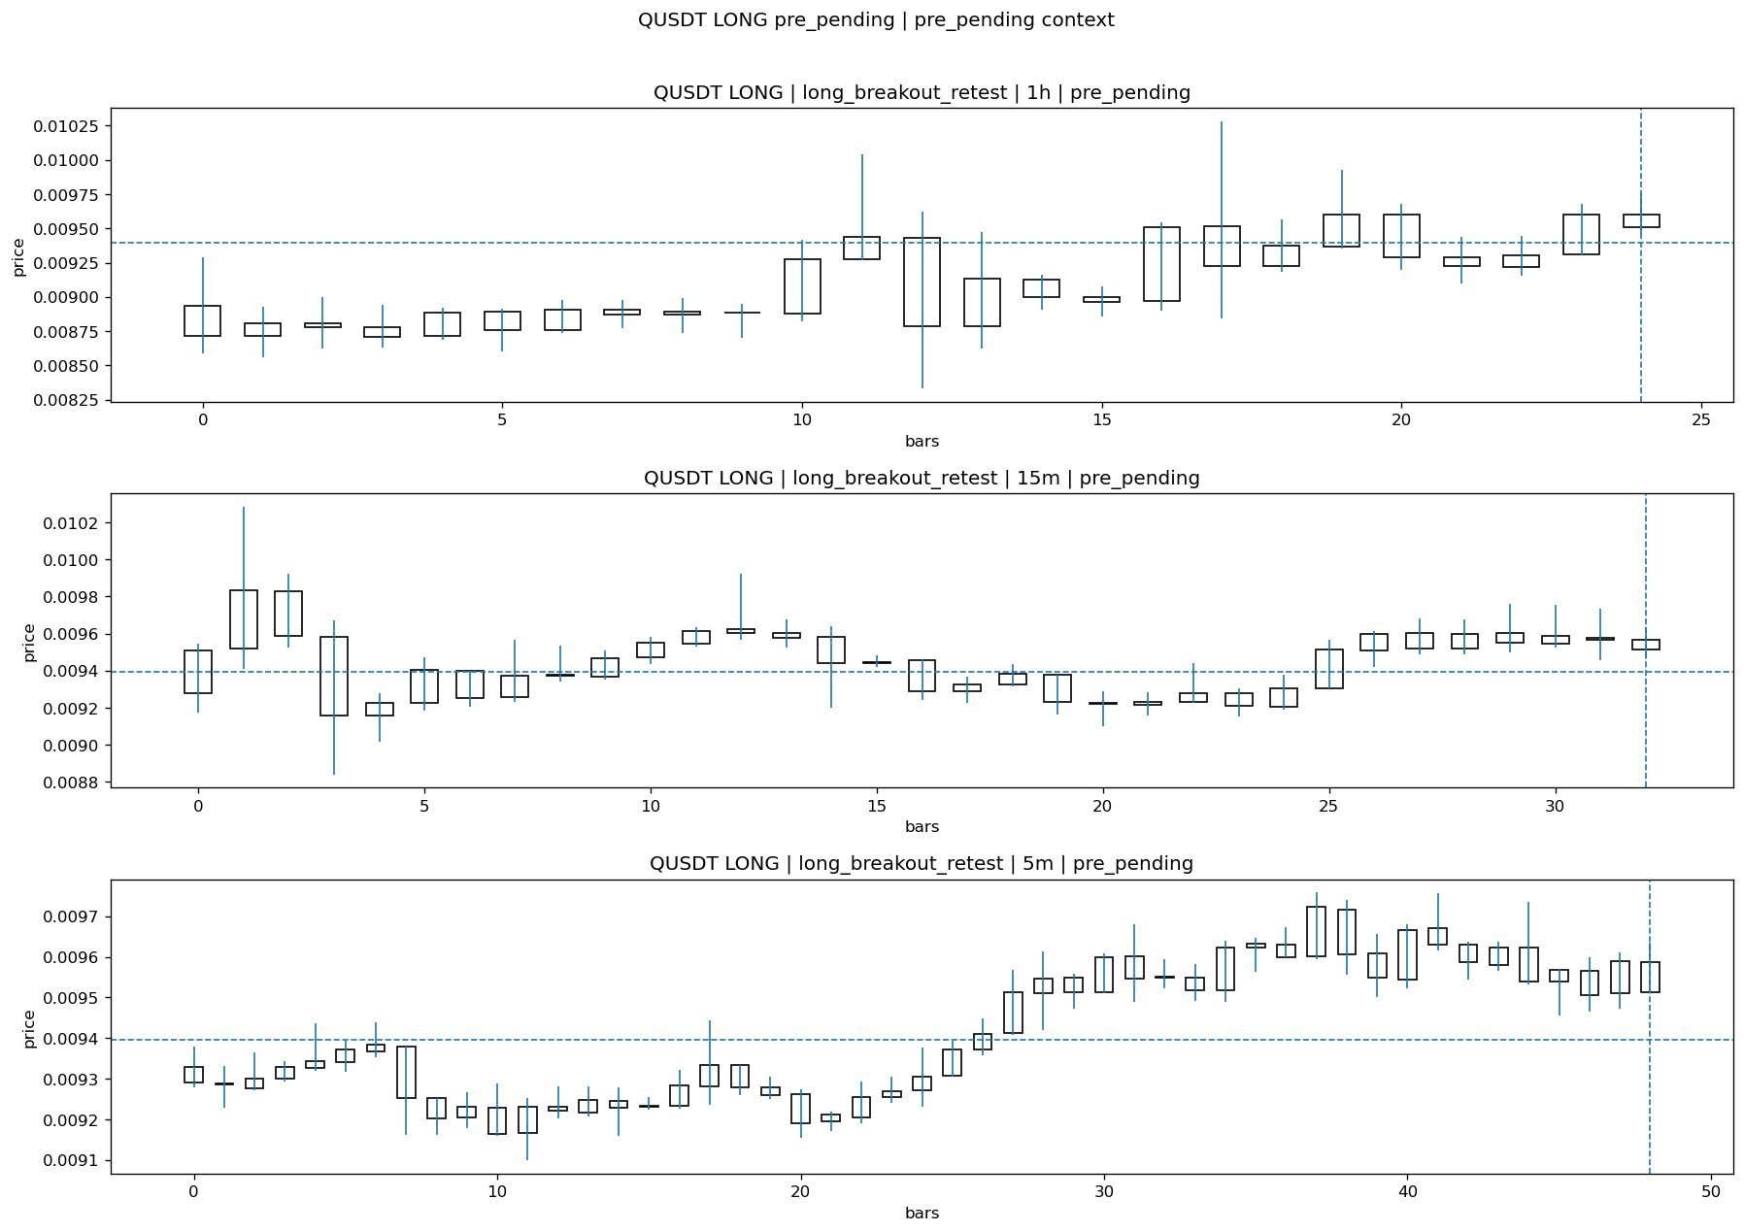
QUSDT_LONG_long_breakout_retest_pre_pending_1774676400000.png

Pending Open
Stage status: missing_unexpected | Content type: none
Note: MISSING UNEXPECTED

Entry Or Confirm
Stage status: not_applicable | Content type: none
Note: NOT APPLICABLE

Case Close
Stage status: missing_unexpected | Content type: none
Note: MISSING UNEXPECTED

Post-Close Outcome
1h outcome | available=Y | favor=3.4167 | adverse=2.8313 | summary=favor=3.42% adverse=2.83%
2h outcome | available=Y | favor=3.4167 | adverse=5.0452 | summary=favor=3.42% adverse=5.05%
4h reference | favor=3.4167 | adverse=11.0591
Reclaim | 2h=Y | 4h=Y
Execution reality | entry_feasible=Y | entry_window=10m | entry_note=entry still reachable within 10m
Time-to-move | time_to_max_favor=4m | time_to_max_adverse=119m
Regret filter | regret_valid=N | reason=adverse_too_large
Conclusion | KILL_CORRECT | notes=entry_ref_from_breakout_level

Review placeholders
human_review_status=PENDING | verdict_code= | root_cause_code= | action_candidate_code=

Case 39: BLUAIUSDT-SHORT-EXH-1774680300000
Summary | BLUAIUSDT | SHORT | short_exhaustion_retest | status_final=EXPIRED_WAIT | close_reason=retest wait expired
Times | signal=2026-03-28 13:45:00 | created=2026-03-28 14:02:43 | confirmed= | sent= | close=2026-03-28 14:46:00 | fallback_due=2026-03-28 18:02:43
Semantics | is_confirmed=N | is_sent_signal=N | review_eligible=Y | semantic_consistency=Y
Review integrity | review_exclusion_reason= | semantic_issue=
Close anchoring | case_close_type=true_close | close_anchor_time=2026-03-28 14:46:00 | close_capture_basis=true_close
Tradeability / outcome | entry_feasible=N | slippage= | regret_valid=N | outcome=NO_MEANINGFUL_MOVE

Pre Pending
Stage status: captured | Content type: chart_snapshot
Note: pre_pending context
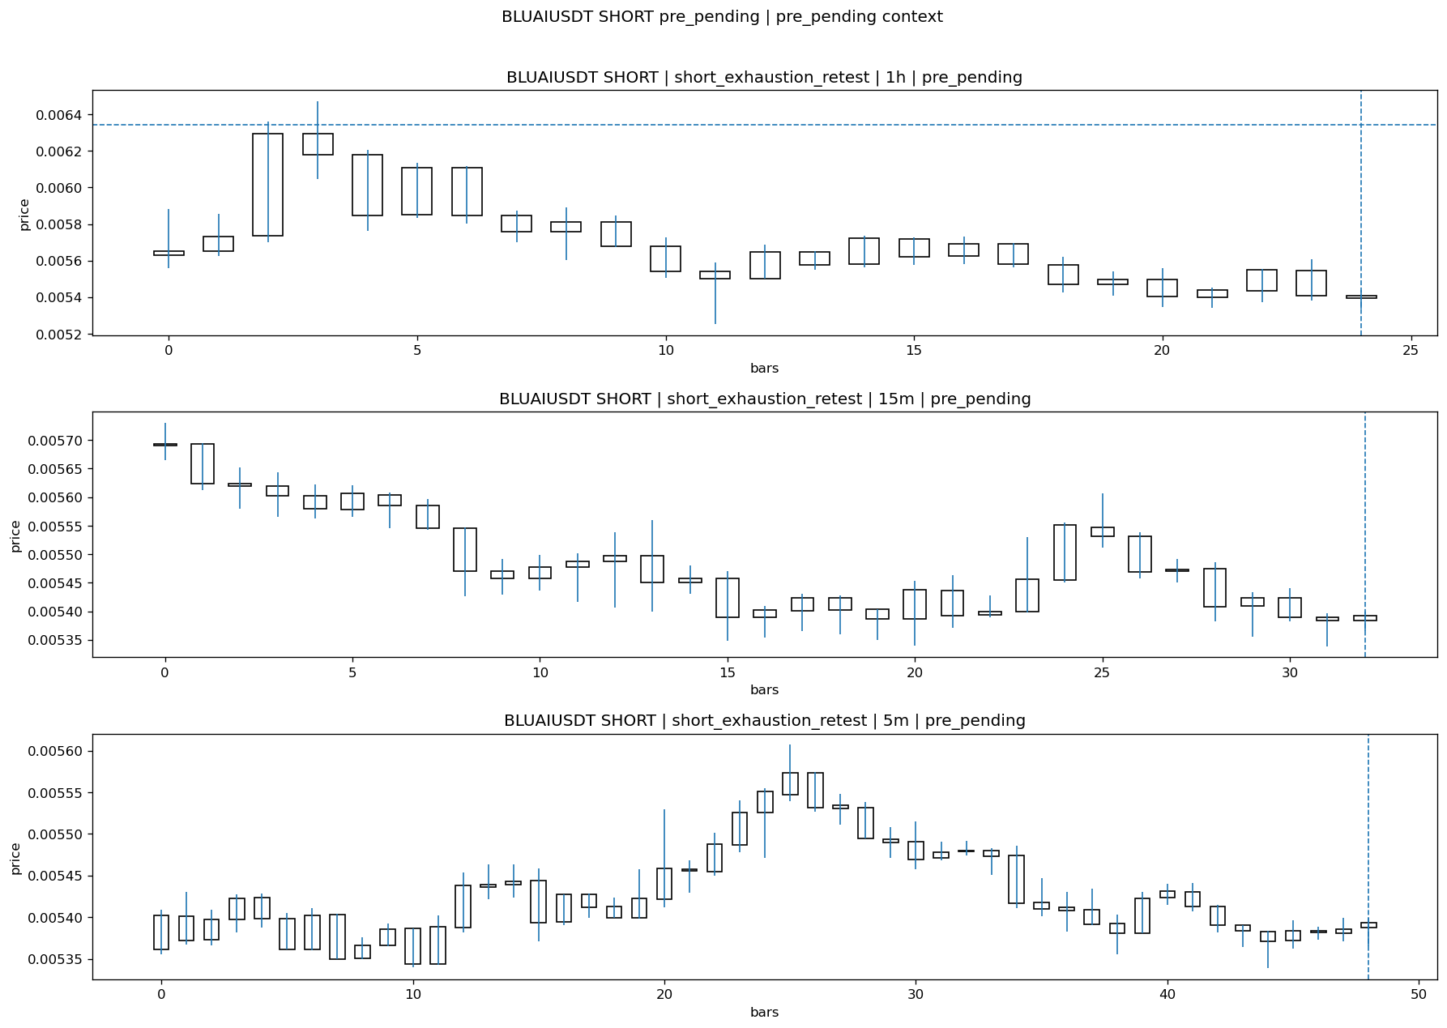
BLUAIUSDT_SHORT_short_exhaustion_retest_pre_pending_1774679400000.png

Pending Open
Stage status: missing_unexpected | Content type: none
Note: MISSING UNEXPECTED

Entry Or Confirm
Stage status: not_applicable | Content type: none
Note: NOT APPLICABLE

Case Close
Stage status: missing_unexpected | Content type: none
Note: MISSING UNEXPECTED

Post-Close Outcome
1h outcome | available=Y | favor=2.5851 | adverse=3.3890 | summary=favor=2.59% adverse=3.39%
2h outcome | available=Y | favor=3.0265 | adverse=6.0845 | summary=favor=3.03% adverse=6.08%
4h reference | favor=5.2175 | adverse=6.0845
Reclaim | 2h=Y | 4h=Y
Execution reality | entry_feasible=N | entry_window=10m | entry_note=entry not reached within 10m
Time-to-move | time_to_max_favor=99m | time_to_max_adverse=79m
Regret filter | regret_valid=N | reason=entry_not_feasible
Conclusion | NO_MEANINGFUL_MOVE | notes=entry_ref_from_breakout_level

Review placeholders
human_review_status=PENDING | verdict_code= | root_cause_code= | action_candidate_code=

Case 40: ONTUSDT-LONG-1774683000000
Summary | ONTUSDT | LONG | long_breakout_retest | status_final=INVALIDATED | close_reason=retest invalidated
Times | signal=2026-03-28 14:30:00 | created=2026-03-28 14:38:02 | confirmed= | sent= | close=2026-03-28 15:07:49 | fallback_due=2026-03-28 18:38:02
Semantics | is_confirmed=N | is_sent_signal=N | review_eligible=Y | semantic_consistency=Y
Review integrity | review_exclusion_reason= | semantic_issue=
Close anchoring | case_close_type=true_close | close_anchor_time=2026-03-28 15:07:49 | close_capture_basis=true_close
Tradeability / outcome | entry_feasible=Y | slippage=0.0000 | regret_valid=Y | outcome=WAIT_TOO_SHORT_CANDIDATE

Pre Pending
Stage status: captured | Content type: chart_snapshot
Note: pre_pending context
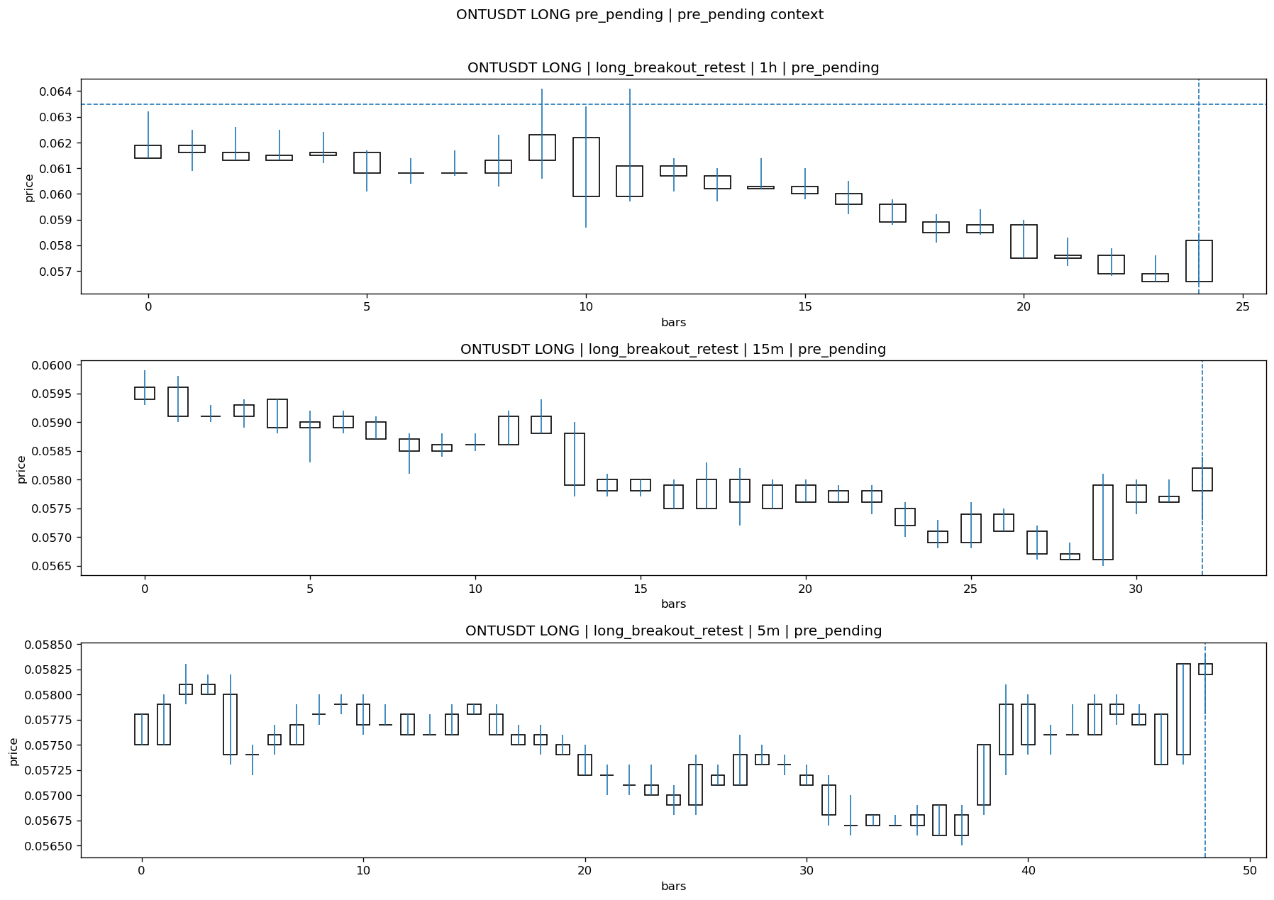
ONTUSDT_LONG_long_breakout_retest_pre_pending_1774682700000.png

Pending Open
Stage status: missing_unexpected | Content type: none
Note: MISSING UNEXPECTED

Entry Or Confirm
Stage status: not_applicable | Content type: none
Note: NOT APPLICABLE

Case Close
Stage status: missing_unexpected | Content type: none
Note: MISSING UNEXPECTED

Post-Close Outcome
1h outcome | available=Y | favor=2.8346 | adverse=0.1575 | summary=favor=2.83% adverse=0.16%
2h outcome | available=Y | favor=2.8346 | adverse=0.4724 | summary=favor=2.83% adverse=0.47%
4h reference | favor=6.9291 | adverse=1.1024
Reclaim | 2h=Y | 4h=Y
Execution reality | entry_feasible=Y | entry_window=10m | entry_note=entry still reachable within 10m
Time-to-move | time_to_max_favor=17m | time_to_max_adverse=77m
Regret filter | regret_valid=Y | reason=valid_missed_continuation
Conclusion | WAIT_TOO_SHORT_CANDIDATE | notes=entry_ref_from_breakout_level

Review placeholders
human_review_status=PENDING | verdict_code= | root_cause_code= | action_candidate_code=

Case 41: WLDUSDT-LONG-1774683600000
Summary | WLDUSDT | LONG | long_breakout_retest | status_final=EXPIRED_WAIT | close_reason=retest wait expired
Times | signal=2026-03-28 14:40:00 | created=2026-03-28 14:46:11 | confirmed= | sent= | close=2026-03-28 15:26:58 | fallback_due=2026-03-28 18:46:11
Semantics | is_confirmed=N | is_sent_signal=N | review_eligible=Y | semantic_consistency=Y
Review integrity | review_exclusion_reason= | semantic_issue=
Close anchoring | case_close_type=true_close | close_anchor_time=2026-03-28 15:26:58 | close_capture_basis=true_close
Tradeability / outcome | entry_feasible=Y | slippage=0.0000 | regret_valid=Y | outcome=WAIT_TOO_SHORT_CANDIDATE

Pre Pending
Stage status: captured | Content type: chart_snapshot
Note: pre_pending context
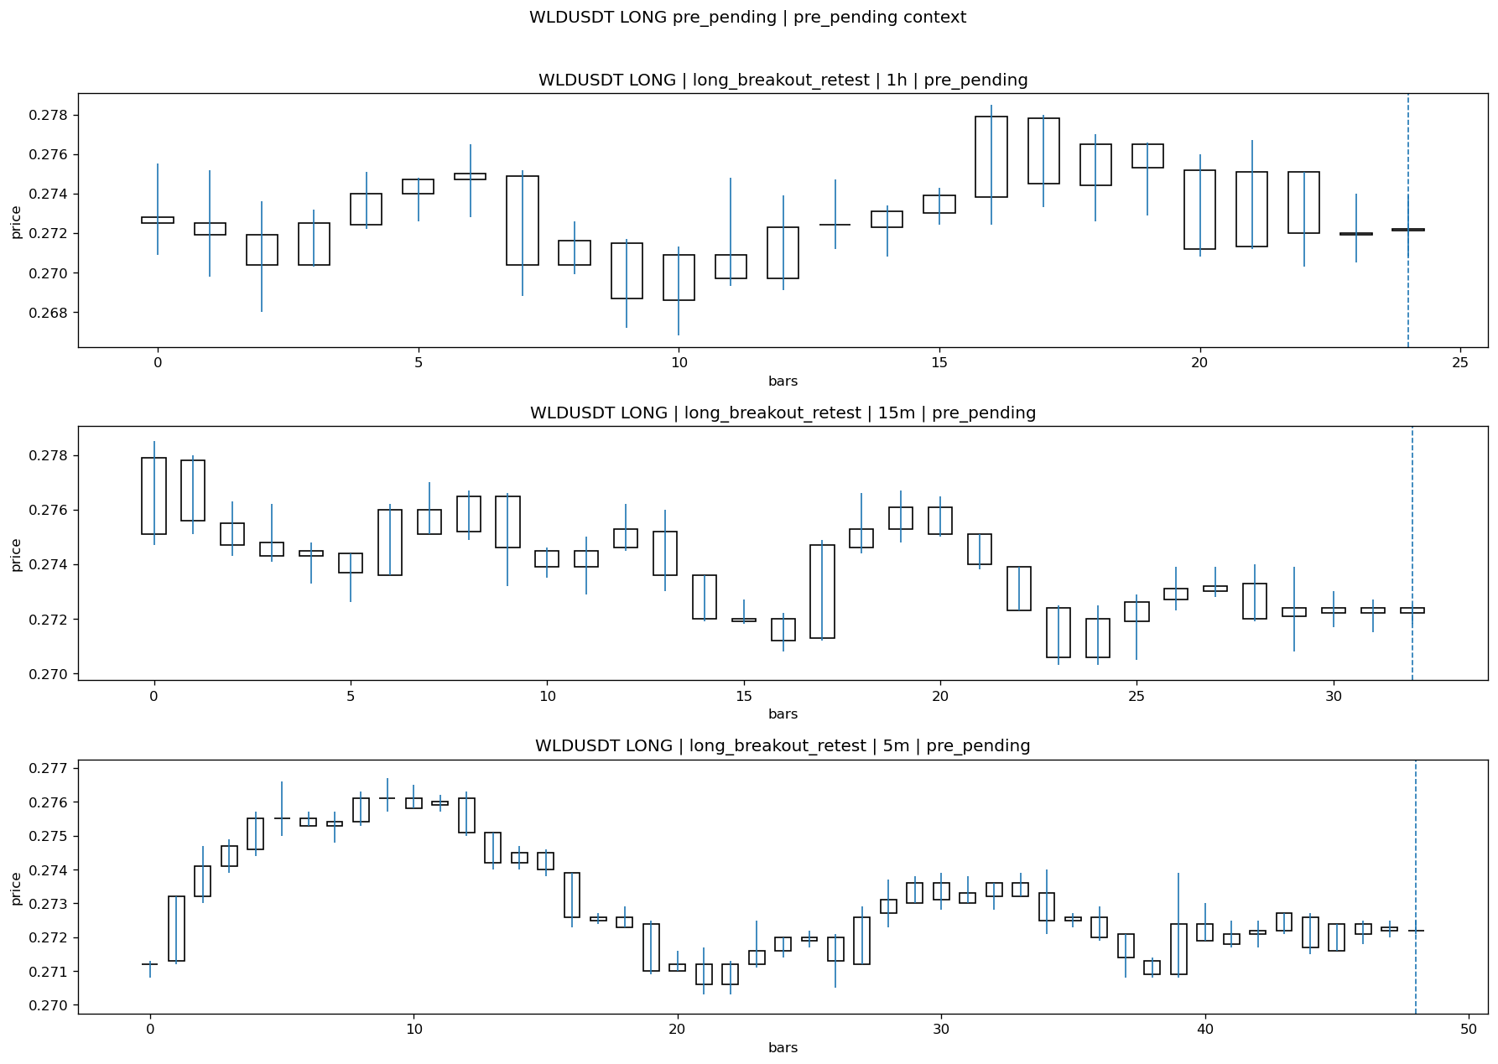
WLDUSDT_LONG_long_breakout_retest_pre_pending_1774683300000.png

Pending Open
Stage status: missing_unexpected | Content type: none
Note: MISSING UNEXPECTED

Entry Or Confirm
Stage status: not_applicable | Content type: none
Note: NOT APPLICABLE

Case Close
Stage status: missing_unexpected | Content type: none
Note: MISSING UNEXPECTED

Post-Close Outcome
1h outcome | available=Y | favor=5.2571 | adverse=0.0000 | summary=favor=5.26% adverse=0.00%
2h outcome | available=Y | favor=5.2571 | adverse=0.0000 | summary=favor=5.26% adverse=0.00%
4h reference | favor=5.2571 | adverse=0.0000
Reclaim | 2h=N | 4h=N
Execution reality | entry_feasible=Y | entry_window=10m | entry_note=entry still reachable within 10m
Time-to-move | time_to_max_favor=53m | time_to_max_adverse=83m
Regret filter | regret_valid=Y | reason=valid_missed_continuation
Conclusion | WAIT_TOO_SHORT_CANDIDATE | notes=entry_ref_from_breakout_level

Review placeholders
human_review_status=PENDING | verdict_code= | root_cause_code= | action_candidate_code=

Case 42: BASUSDT-LONG-1774684500000
Summary | BASUSDT | LONG | long_breakout_retest | status_final=INVALIDATED | close_reason=acceptance_floor_lost 0.008017<0.008174
Times | signal=2026-03-28 14:55:00 | created=2026-03-28 15:03:00 | confirmed= | sent= | close=2026-03-28 15:07:50 | fallback_due=2026-03-28 19:03:00
Semantics | is_confirmed=N | is_sent_signal=N | review_eligible=Y | semantic_consistency=Y
Review integrity | review_exclusion_reason= | semantic_issue=
Close anchoring | case_close_type=true_close | close_anchor_time=2026-03-28 15:07:50 | close_capture_basis=true_close
Tradeability / outcome | entry_feasible=Y | slippage=0.0000 | regret_valid=Y | outcome=WAIT_TOO_SHORT_CANDIDATE

Pre Pending
Stage status: captured | Content type: chart_snapshot
Note: pre_pending context
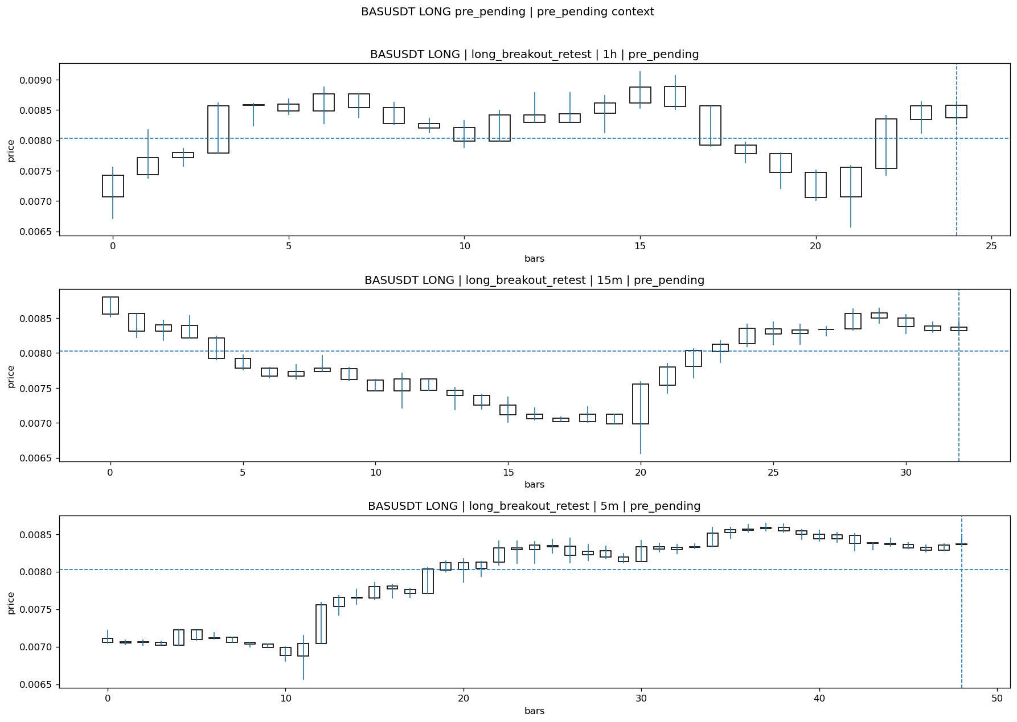
BASUSDT_LONG_long_breakout_retest_pre_pending_1774684200000.png

Pending Open
Stage status: missing_unexpected | Content type: none
Note: MISSING UNEXPECTED

Entry Or Confirm
Stage status: not_applicable | Content type: none
Note: NOT APPLICABLE

Case Close
Stage status: missing_unexpected | Content type: none
Note: MISSING UNEXPECTED

Post-Close Outcome
1h outcome | available=Y | favor=12.4019 | adverse=0.2988 | summary=favor=12.40% adverse=0.30%
2h outcome | available=Y | favor=12.4019 | adverse=2.4779 | summary=favor=12.40% adverse=2.48%
4h reference | favor=12.4019 | adverse=9.6003
Reclaim | 2h=Y | 4h=Y
Execution reality | entry_feasible=Y | entry_window=10m | entry_note=entry still reachable within 10m
Time-to-move | time_to_max_favor=37m | time_to_max_adverse=97m
Regret filter | regret_valid=Y | reason=valid_missed_continuation
Conclusion | WAIT_TOO_SHORT_CANDIDATE | notes=entry_ref_from_breakout_level

Review placeholders
human_review_status=PENDING | verdict_code= | root_cause_code= | action_candidate_code=

Case 43: MUSDT-LONG-1774685100000
Summary | MUSDT | LONG | long_breakout_retest | status_final=INVALIDATED | close_reason=retest invalidated
Times | signal=2026-03-28 15:05:00 | created=2026-03-28 15:11:08 | confirmed= | sent= | close=2026-03-28 15:32:29 | fallback_due=2026-03-28 19:11:08
Semantics | is_confirmed=N | is_sent_signal=N | review_eligible=Y | semantic_consistency=Y
Review integrity | review_exclusion_reason= | semantic_issue=
Close anchoring | case_close_type=true_close | close_anchor_time=2026-03-28 15:32:29 | close_capture_basis=true_close
Tradeability / outcome | entry_feasible=Y | slippage=0.0000 | regret_valid=N | outcome=KILL_CORRECT

Pre Pending
Stage status: captured | Content type: chart_snapshot
Note: pre_pending context
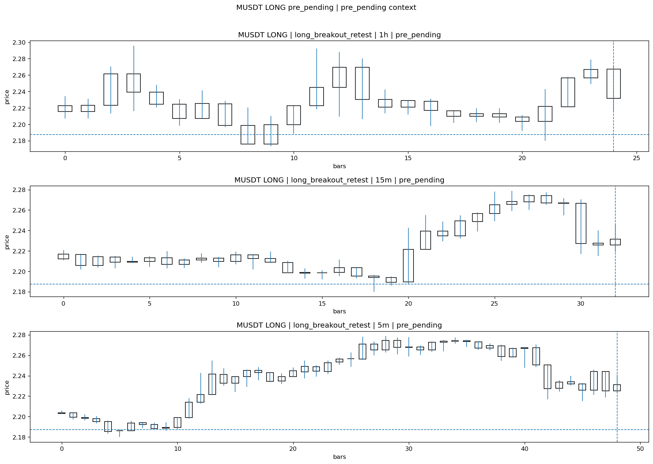
MUSDT_LONG_long_breakout_retest_pre_pending_1774684800000.png

Pending Open
Stage status: missing_unexpected | Content type: none
Note: MISSING UNEXPECTED

Entry Or Confirm
Stage status: not_applicable | Content type: none
Note: NOT APPLICABLE

Case Close
Stage status: missing_unexpected | Content type: none
Note: MISSING UNEXPECTED

Post-Close Outcome
1h outcome | available=Y | favor=1.3075 | adverse=0.1874 | summary=favor=1.31% adverse=0.19%
2h outcome | available=Y | favor=3.1819 | adverse=0.1874 | summary=favor=3.18% adverse=0.19%
4h reference | favor=4.2471 | adverse=1.6412
Reclaim | 2h=Y | 4h=Y
Execution reality | entry_feasible=Y | entry_window=10m | entry_note=entry still reachable within 10m
Time-to-move | time_to_max_favor=88m | time_to_max_adverse=43m
Regret filter | regret_valid=N | reason=no_meaningful_fast_move
Conclusion | KILL_CORRECT | notes=entry_ref_from_breakout_level

Review placeholders
human_review_status=PENDING | verdict_code= | root_cause_code= | action_candidate_code=

Case 44: LYNUSDT-LONG-1774685400000
Summary | LYNUSDT | LONG | long_breakout_retest | status_final=INVALIDATED | close_reason=retest invalidated
Times | signal=2026-03-28 15:10:00 | created=2026-03-28 15:16:32 | confirmed= | sent= | close=2026-03-28 15:21:29 | fallback_due=2026-03-28 19:16:32
Semantics | is_confirmed=N | is_sent_signal=N | review_eligible=Y | semantic_consistency=Y
Review integrity | review_exclusion_reason= | semantic_issue=
Close anchoring | case_close_type=true_close | close_anchor_time=2026-03-28 15:21:29 | close_capture_basis=true_close
Tradeability / outcome | entry_feasible=Y | slippage=0.0000 | regret_valid=N | outcome=KILL_CORRECT

Pre Pending
Stage status: captured | Content type: chart_snapshot
Note: pre_pending context
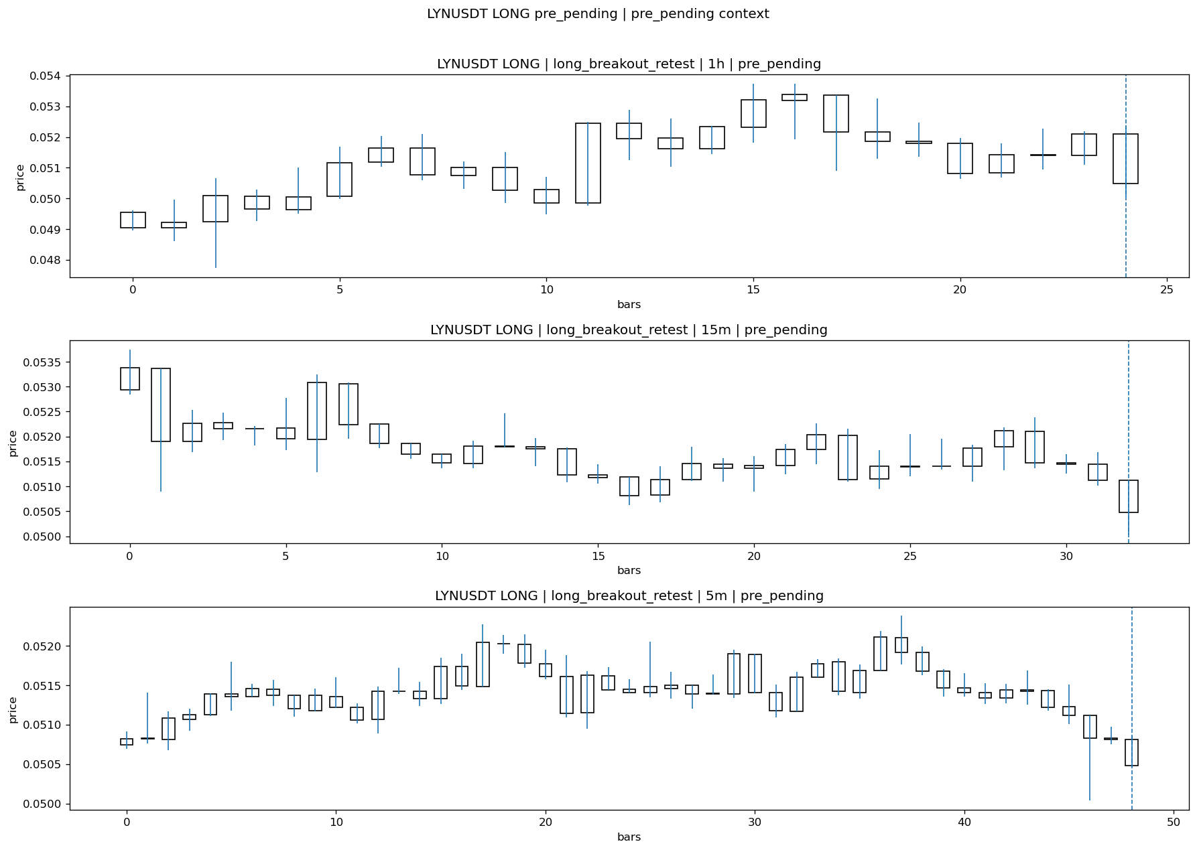
LYNUSDT_LONG_long_breakout_retest_pre_pending_1774685100000.png

Pending Open
Stage status: missing_unexpected | Content type: none
Note: MISSING UNEXPECTED

Entry Or Confirm
Stage status: not_applicable | Content type: none
Note: NOT APPLICABLE

Case Close
Stage status: missing_unexpected | Content type: none
Note: MISSING UNEXPECTED

Post-Close Outcome
1h outcome | available=Y | favor=4.3740 | adverse=3.3169 | summary=favor=4.37% adverse=3.32%
2h outcome | available=Y | favor=4.3740 | adverse=13.0855 | summary=favor=4.37% adverse=13.09%
4h reference | favor=4.3740 | adverse=13.0855
Reclaim | 2h=Y | 4h=Y
Execution reality | entry_feasible=Y | entry_window=10m | entry_note=entry still reachable within 10m
Time-to-move | time_to_max_favor=14m | time_to_max_adverse=64m
Regret filter | regret_valid=N | reason=adverse_too_large
Conclusion | KILL_CORRECT | notes=entry_ref_from_breakout_level

Review placeholders
human_review_status=PENDING | verdict_code= | root_cause_code= | action_candidate_code=

Case 45: RIVERUSDT-LONG-1774685700000
Summary | RIVERUSDT | LONG | long_breakout_retest | status_final=INVALIDATED | close_reason=retest invalidated
Times | signal=2026-03-28 15:15:00 | created=2026-03-28 15:24:18 | confirmed= | sent= | close=2026-03-28 15:26:59 | fallback_due=2026-03-28 19:24:18
Semantics | is_confirmed=N | is_sent_signal=N | review_eligible=Y | semantic_consistency=Y
Review integrity | review_exclusion_reason= | semantic_issue=
Close anchoring | case_close_type=true_close | close_anchor_time=2026-03-28 15:26:59 | close_capture_basis=true_close
Tradeability / outcome | entry_feasible=Y | slippage=0.0000 | regret_valid=N | outcome=KILL_CORRECT

Pre Pending
Stage status: captured | Content type: chart_snapshot
Note: pre_pending context
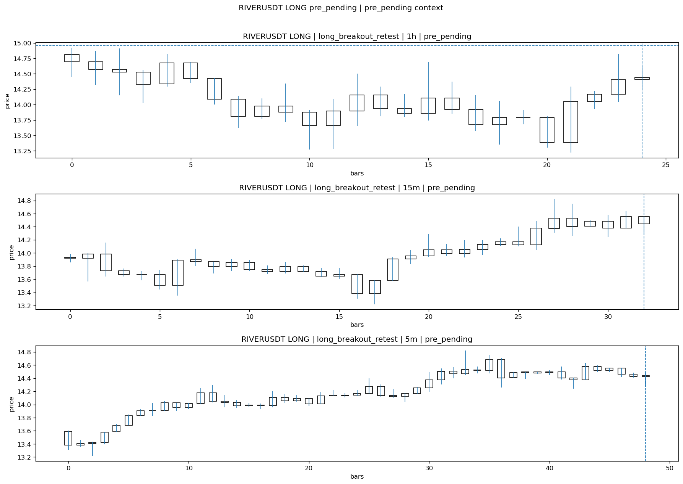
RIVERUSDT_LONG_long_breakout_retest_pre_pending_1774685400000.png

Pending Open
Stage status: missing_unexpected | Content type: none
Note: MISSING UNEXPECTED

Entry Or Confirm
Stage status: not_applicable | Content type: none
Note: NOT APPLICABLE

Case Close
Stage status: missing_unexpected | Content type: none
Note: MISSING UNEXPECTED

Post-Close Outcome
1h outcome | available=Y | favor=7.8733 | adverse=1.6910 | summary=favor=7.87% adverse=1.69%
2h outcome | available=Y | favor=7.8733 | adverse=8.2943 | summary=favor=7.87% adverse=8.29%
4h reference | favor=7.8733 | adverse=9.7046
Reclaim | 2h=Y | 4h=Y
Execution reality | entry_feasible=Y | entry_window=10m | entry_note=entry still reachable within 10m
Time-to-move | time_to_max_favor=8m | time_to_max_adverse=103m
Regret filter | regret_valid=N | reason=adverse_too_large
Conclusion | KILL_CORRECT | notes=entry_ref_from_breakout_level

Review placeholders
human_review_status=PENDING | verdict_code= | root_cause_code= | action_candidate_code=

Case 46: BASUSDT-LONG-1774686000000
Summary | BASUSDT | LONG | long_breakout_retest | status_final=INVALIDATED | close_reason=retest invalidated
Times | signal=2026-03-28 15:20:00 | created=2026-03-28 15:27:39 | confirmed= | sent= | close=2026-03-28 15:35:15 | fallback_due=2026-03-28 19:27:39
Semantics | is_confirmed=N | is_sent_signal=N | review_eligible=Y | semantic_consistency=Y
Review integrity | review_exclusion_reason= | semantic_issue=
Close anchoring | case_close_type=true_close | close_anchor_time=2026-03-28 15:35:15 | close_capture_basis=true_close
Tradeability / outcome | entry_feasible=Y | slippage=0.0000 | regret_valid=N | outcome=KILL_CORRECT

Pre Pending
Stage status: captured | Content type: chart_snapshot
Note: pre_pending context
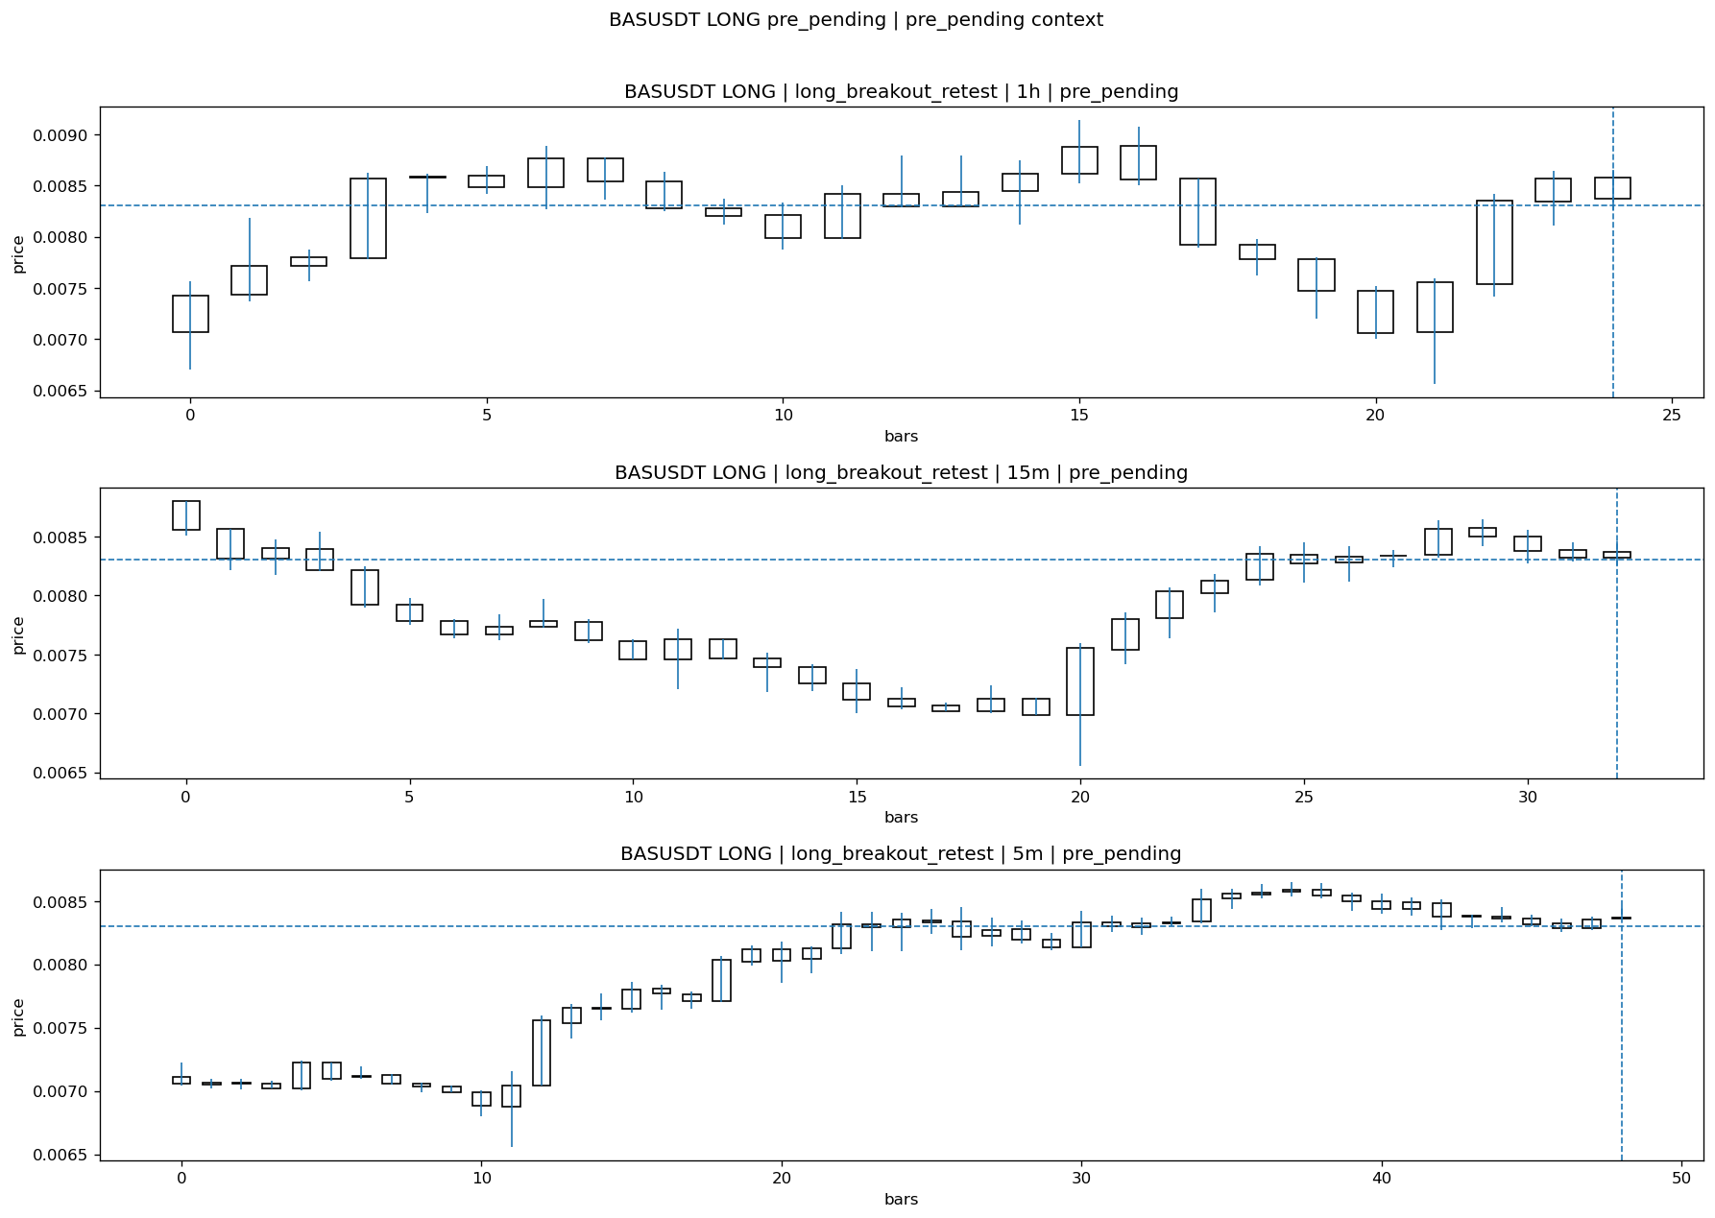
BASUSDT_LONG_long_breakout_retest_pre_pending_1774685700000.png

Pending Open
Stage status: missing_unexpected | Content type: none
Note: MISSING UNEXPECTED

Entry Or Confirm
Stage status: not_applicable | Content type: none
Note: NOT APPLICABLE

Case Close
Stage status: missing_unexpected | Content type: none
Note: MISSING UNEXPECTED

Post-Close Outcome
1h outcome | available=Y | favor=8.7328 | adverse=3.3245 | summary=favor=8.73% adverse=3.32%
2h outcome | available=Y | favor=8.7328 | adverse=7.6608 | summary=favor=8.73% adverse=7.66%
4h reference | favor=8.7328 | adverse=14.4062
Reclaim | 2h=Y | 4h=Y
Execution reality | entry_feasible=Y | entry_window=10m | entry_note=entry still reachable within 10m
Time-to-move | time_to_max_favor=10m | time_to_max_adverse=120m
Regret filter | regret_valid=N | reason=adverse_too_large
Conclusion | KILL_CORRECT | notes=entry_ref_from_breakout_level

Review placeholders
human_review_status=PENDING | verdict_code= | root_cause_code= | action_candidate_code=

Case 47: RIVERUSDT-LONG-1774686300000
Summary | RIVERUSDT | LONG | long_breakout_retest | status_final=INVALIDATED | close_reason=retest invalidated
Times | signal=2026-03-28 15:25:00 | created=2026-03-28 15:32:35 | confirmed= | sent= | close=2026-03-28 15:46:08 | fallback_due=2026-03-28 19:32:35
Semantics | is_confirmed=N | is_sent_signal=N | review_eligible=Y | semantic_consistency=Y
Review integrity | review_exclusion_reason= | semantic_issue=
Close anchoring | case_close_type=true_close | close_anchor_time=2026-03-28 15:46:08 | close_capture_basis=true_close
Tradeability / outcome | entry_feasible=Y | slippage=0.0000 | regret_valid=N | outcome=KILL_CORRECT

Pre Pending
Stage status: captured | Content type: chart_snapshot
Note: pre_pending context
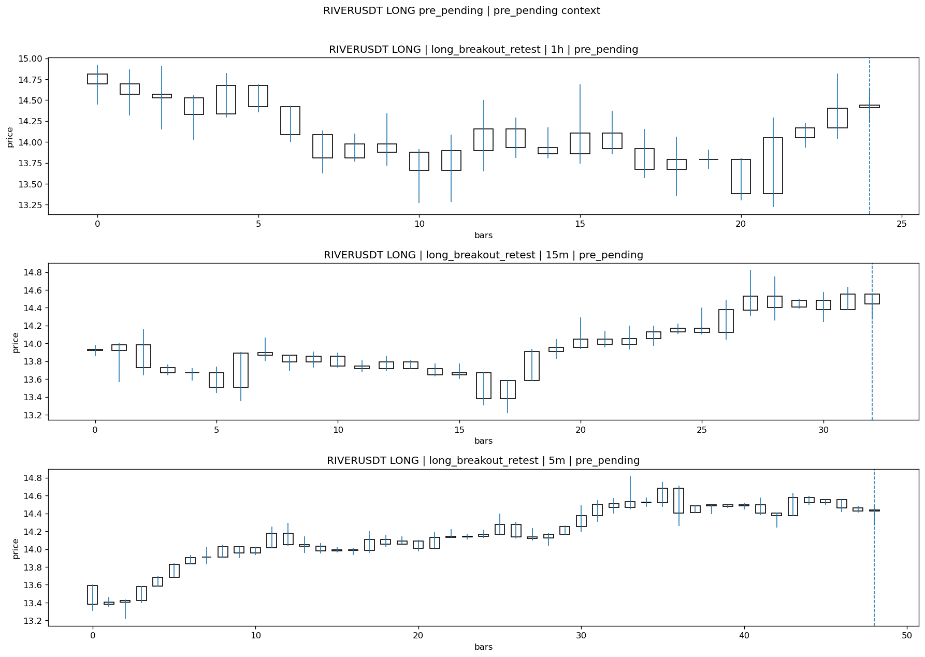
RIVERUSDT_LONG_long_breakout_retest_pre_pending_1774686000000.png

Pending Open
Stage status: missing_unexpected | Content type: none
Note: MISSING UNEXPECTED

Entry Or Confirm
Stage status: not_applicable | Content type: none
Note: NOT APPLICABLE

Case Close
Stage status: missing_unexpected | Content type: none
Note: MISSING UNEXPECTED

Post-Close Outcome
1h outcome | available=Y | favor=0.1316 | adverse=6.5724 | summary=favor=0.13% adverse=6.57%
2h outcome | available=Y | favor=0.1316 | adverse=10.8553 | summary=favor=0.13% adverse=10.86%
4h reference | favor=1.4145 | adverse=11.1184
Reclaim | 2h=Y | 4h=Y
Execution reality | entry_feasible=Y | entry_window=10m | entry_note=entry still reachable within 10m
Time-to-move | time_to_max_favor=19m | time_to_max_adverse=114m
Regret filter | regret_valid=N | reason=adverse_too_large
Conclusion | KILL_CORRECT | notes=entry_ref_from_breakout_level

Review placeholders
human_review_status=PENDING | verdict_code= | root_cause_code= | action_candidate_code=

Case 48: SIRENUSDT-LONG-1774687800000
Summary | SIRENUSDT | LONG | long_breakout_retest | status_final=EXPIRED_WAIT | close_reason=retest wait expired
Times | signal=2026-03-28 15:50:00 | created=2026-03-28 15:57:02 | confirmed= | sent= | close=2026-03-28 16:35:08 | fallback_due=2026-03-28 19:57:02
Semantics | is_confirmed=N | is_sent_signal=N | review_eligible=Y | semantic_consistency=Y
Review integrity | review_exclusion_reason= | semantic_issue=
Close anchoring | case_close_type=true_close | close_anchor_time=2026-03-28 16:35:08 | close_capture_basis=true_close
Tradeability / outcome | entry_feasible=Y | slippage=0.0000 | regret_valid=N | outcome=NO_MEANINGFUL_MOVE

Pre Pending
Stage status: captured | Content type: chart_snapshot
Note: pre_pending context
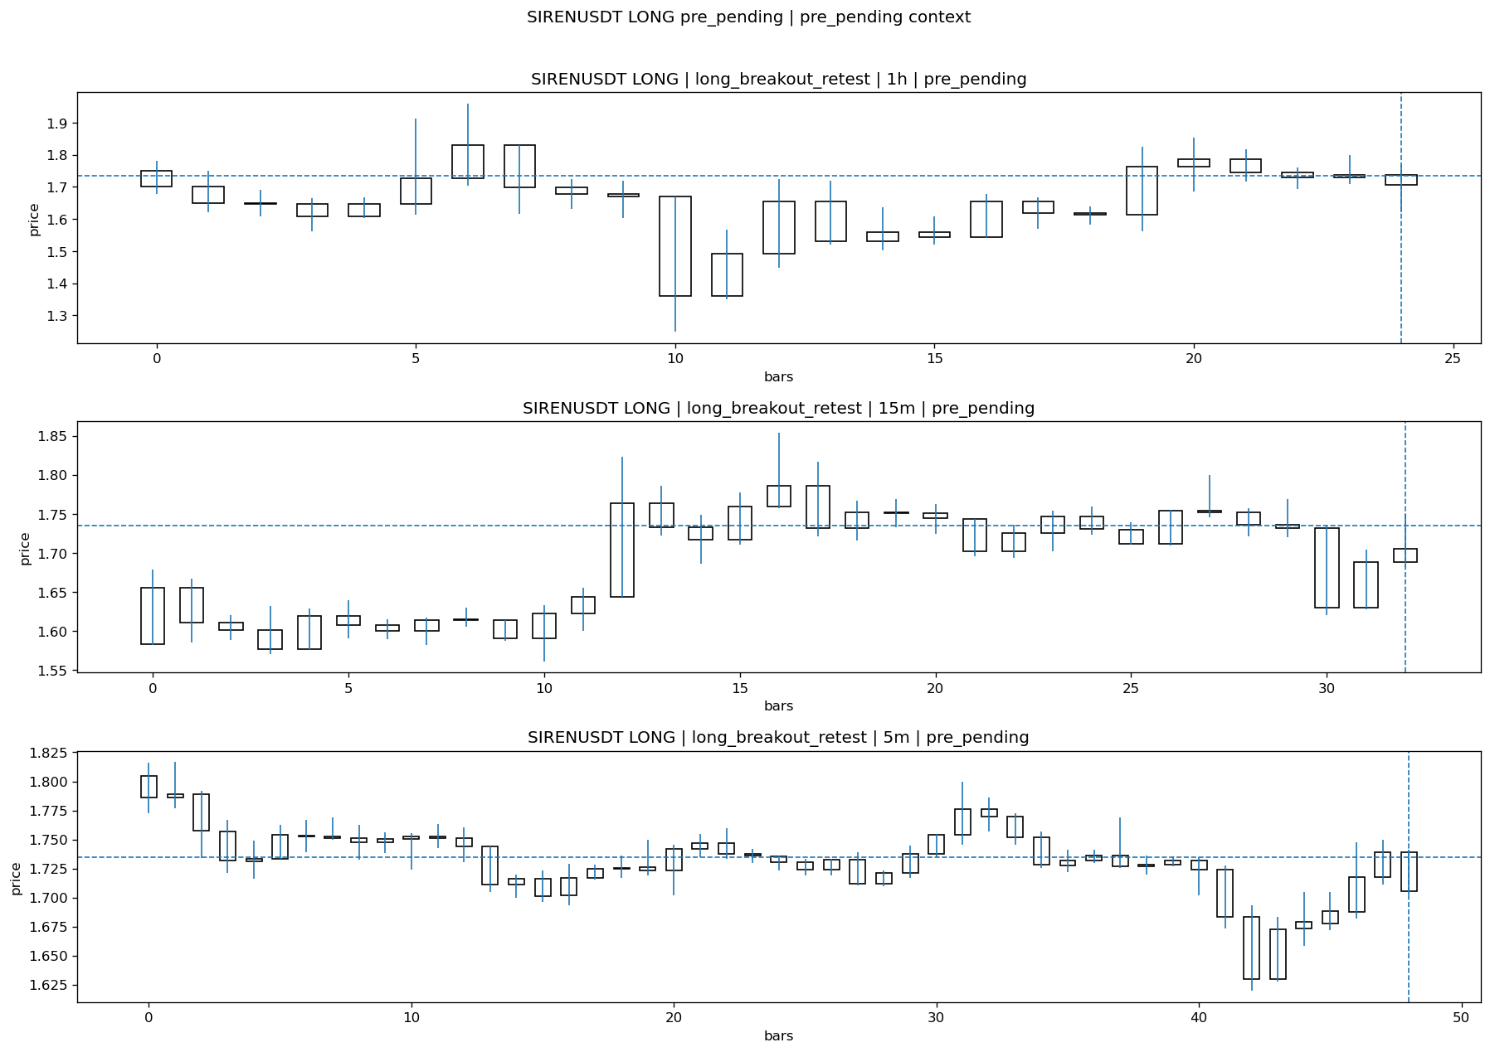
SIRENUSDT_LONG_long_breakout_retest_pre_pending_1774687500000.png

Pending Open
Stage status: missing_unexpected | Content type: none
Note: MISSING UNEXPECTED

Entry Or Confirm
Stage status: not_applicable | Content type: none
Note: NOT APPLICABLE

Case Close
Stage status: missing_unexpected | Content type: none
Note: MISSING UNEXPECTED

Post-Close Outcome
1h outcome | available=Y | favor=7.8271 | adverse=9.2450 | summary=favor=7.83% adverse=9.24%
2h outcome | available=Y | favor=7.8271 | adverse=11.0121 | summary=favor=7.83% adverse=11.01%
4h reference | favor=7.8271 | adverse=11.0121
Reclaim | 2h=Y | 4h=Y
Execution reality | entry_feasible=Y | entry_window=10m | entry_note=entry still reachable within 10m
Time-to-move | time_to_max_favor=35m | time_to_max_adverse=75m
Regret filter | regret_valid=N | reason=adverse_too_large
Conclusion | NO_MEANINGFUL_MOVE | notes=entry_ref_from_breakout_level

Review placeholders
human_review_status=PENDING | verdict_code= | root_cause_code= | action_candidate_code=

Case 49: WLDUSDT-LONG-1774689300000
Summary | WLDUSDT | LONG | long_breakout_retest | status_final=INVALIDATED | close_reason=retest invalidated
Times | signal=2026-03-28 16:15:00 | created=2026-03-28 16:24:21 | confirmed= | sent= | close=2026-03-28 16:32:26 | fallback_due=2026-03-28 20:24:21
Semantics | is_confirmed=N | is_sent_signal=N | review_eligible=Y | semantic_consistency=Y
Review integrity | review_exclusion_reason= | semantic_issue=
Close anchoring | case_close_type=true_close | close_anchor_time=2026-03-28 16:32:26 | close_capture_basis=true_close
Tradeability / outcome | entry_feasible=Y | slippage=0.0000 | regret_valid=N | outcome=KILL_CORRECT

Pre Pending
Stage status: captured | Content type: chart_snapshot
Note: pre_pending context
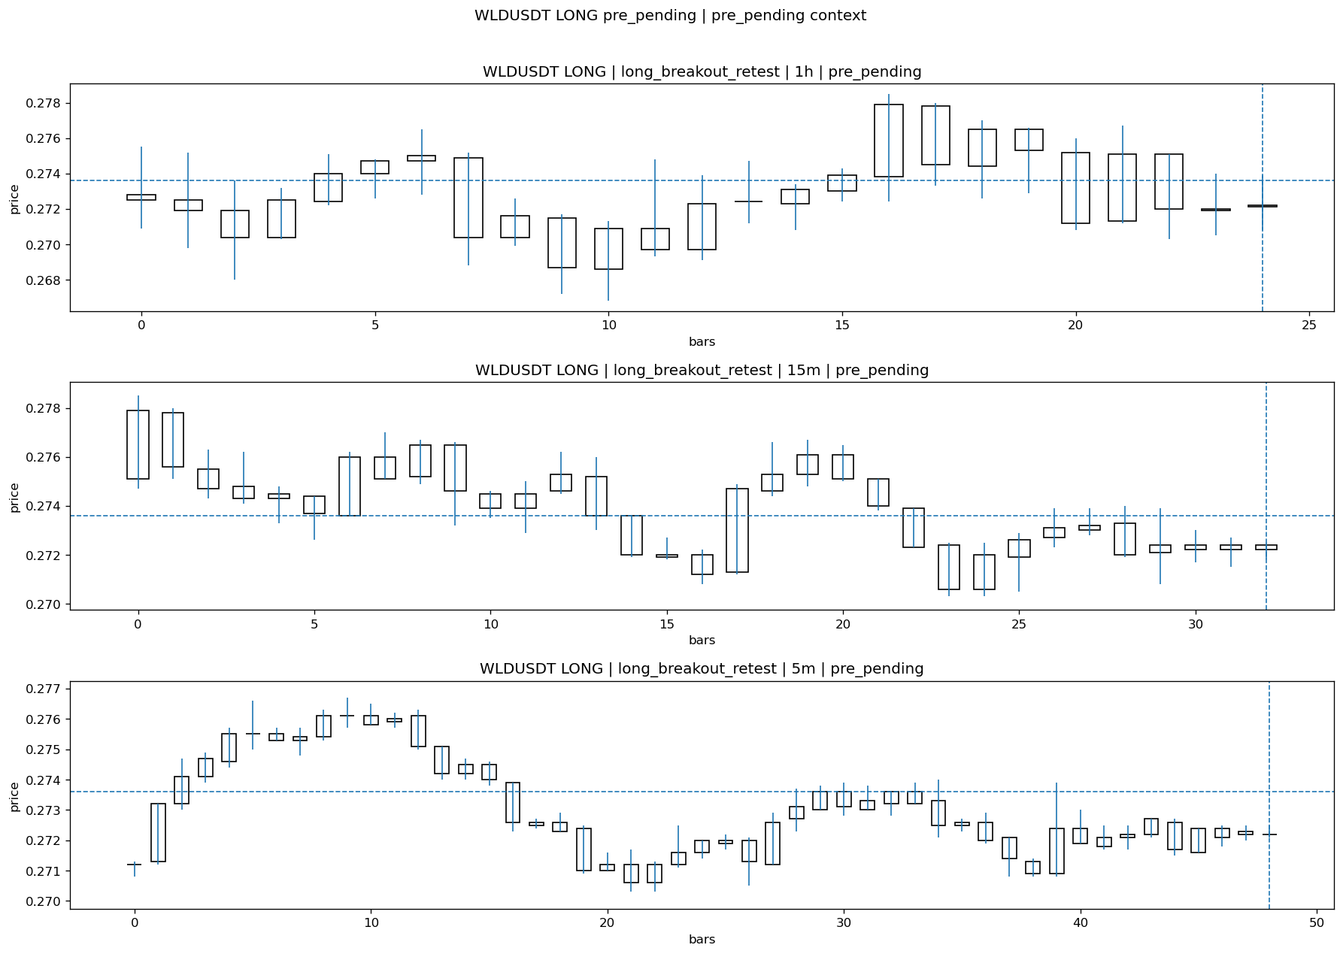
WLDUSDT_LONG_long_breakout_retest_pre_pending_1774689000000.png

Pending Open
Stage status: missing_unexpected | Content type: none
Note: MISSING UNEXPECTED

Entry Or Confirm
Stage status: not_applicable | Content type: none
Note: NOT APPLICABLE

Case Close
Stage status: missing_unexpected | Content type: none
Note: MISSING UNEXPECTED

Post-Close Outcome
1h outcome | available=Y | favor=0.0000 | adverse=3.2529 | summary=favor=0.00% adverse=3.25%
2h outcome | available=Y | favor=0.0000 | adverse=3.2529 | summary=favor=0.00% adverse=3.25%
4h reference | favor=0.0000 | adverse=3.2529
Reclaim | 2h=Y | 4h=Y
Execution reality | entry_feasible=Y | entry_window=10m | entry_note=entry still reachable within 10m
Time-to-move | time_to_max_favor=83m | time_to_max_adverse=18m
Regret filter | regret_valid=N | reason=adverse_too_large
Conclusion | KILL_CORRECT | notes=entry_ref_from_breakout_level

Review placeholders
human_review_status=PENDING | verdict_code= | root_cause_code= | action_candidate_code=

Case 50: KITEUSDT-SHORT-EXH-1774689300000
Summary | KITEUSDT | SHORT | short_exhaustion_retest | status_final=CONFIRMED | close_reason=signal confirmed
Times | signal=2026-03-28 16:15:00 | created=2026-03-28 16:30:03 | confirmed= | sent= | close=2026-03-28 16:46:02 | fallback_due=2026-03-28 20:30:03
Semantics | is_confirmed=N | is_sent_signal=N | review_eligible=N | semantic_consistency=N
Review integrity | review_exclusion_reason=confirmed_without_confirmed_ts | semantic_issue=confirmed_without_confirmed_ts
Close anchoring | case_close_type=not_due_yet | close_anchor_time= | close_capture_basis=not_due_yet
Tradeability / outcome | entry_feasible=N | slippage= | regret_valid=N | outcome=NO_MEANINGFUL_MOVE

Pre Pending
Stage status: captured | Content type: chart_snapshot
Note: pre_pending context
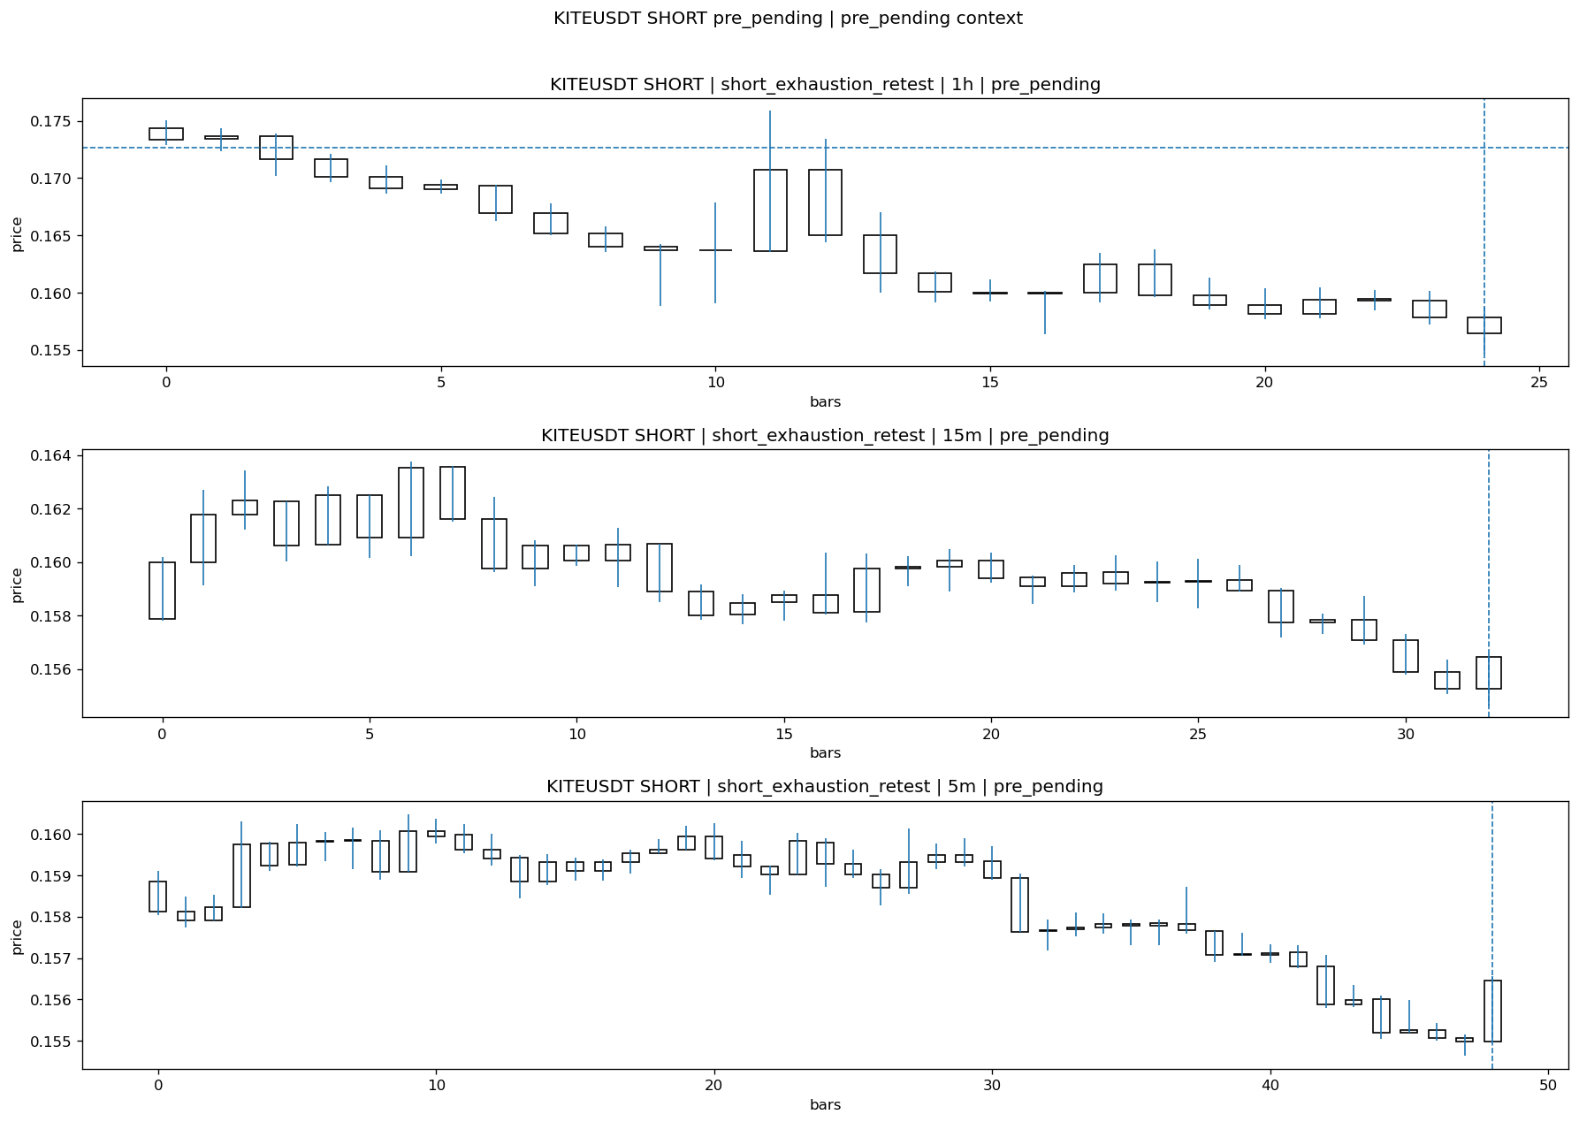
KITEUSDT_SHORT_short_exhaustion_retest_pre_pending_1774688400000.png

Pending Open
Stage status: missing_unexpected | Content type: none
Note: MISSING UNEXPECTED

Entry Or Confirm
Stage status: missing_unexpected | Content type: none
Note: MISSING UNEXPECTED

Case Close
Stage status: not_reached_yet | Content type: none
Note: NOT REACHED YET

Post-Close Outcome
1h outcome | available=Y | favor=1.9807 | adverse=0.0000 | summary=favor=1.98% adverse=0.00%
2h outcome | available=Y | favor=1.9807 | adverse=1.4594 | summary=favor=1.98% adverse=1.46%
4h reference | favor=1.9807 | adverse=2.3050
Reclaim | 2h=Y | 4h=Y
Execution reality | entry_feasible=N | entry_window=10m | entry_note=entry not reached within 10m
Time-to-move | time_to_max_favor=24m | time_to_max_adverse=89m
Regret filter | regret_valid=N | reason=entry_not_feasible
Conclusion | NO_MEANINGFUL_MOVE | notes=entry_ref_from_breakout_level

Review placeholders
human_review_status=PENDING | verdict_code= | root_cause_code= | action_candidate_code=

Case 51: 4USDT-LONG-1774690500000
Summary | 4USDT | LONG | long_breakout_retest | status_final=EXPIRED_WAIT | close_reason=retest wait expired
Times | signal=2026-03-28 16:35:00 | created=2026-03-28 16:43:51 | confirmed= | sent= | close=2026-03-28 17:21:33 | fallback_due=2026-03-28 20:43:51
Semantics | is_confirmed=N | is_sent_signal=N | review_eligible=Y | semantic_consistency=Y
Review integrity | review_exclusion_reason= | semantic_issue=
Close anchoring | case_close_type=true_close | close_anchor_time=2026-03-28 17:21:33 | close_capture_basis=true_close
Tradeability / outcome | entry_feasible=Y | slippage=0.0000 | regret_valid=N | outcome=NO_MEANINGFUL_MOVE

Pre Pending
Stage status: captured | Content type: chart_snapshot
Note: pre_pending context
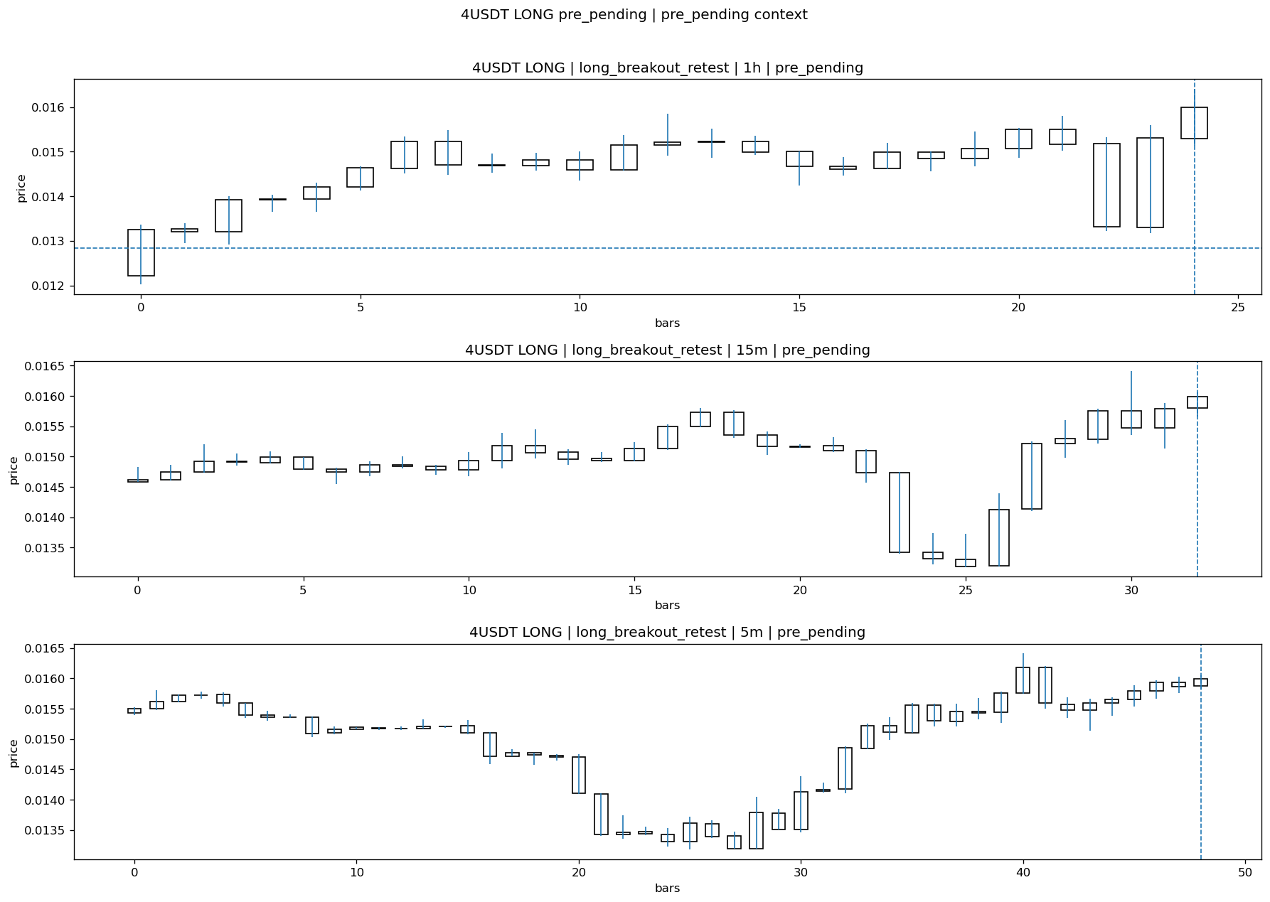
4USDT_LONG_long_breakout_retest_pre_pending_1774690200000.png

Pending Open
Stage status: missing_unexpected | Content type: none
Note: MISSING UNEXPECTED

Entry Or Confirm
Stage status: not_applicable | Content type: none
Note: NOT APPLICABLE

Case Close
Stage status: missing_unexpected | Content type: none
Note: MISSING UNEXPECTED

Post-Close Outcome
1h outcome | available=Y | favor=5.6573 | adverse=0.9974 | summary=favor=5.66% adverse=1.00%
2h outcome | available=Y | favor=7.7924 | adverse=0.9974 | summary=favor=7.79% adverse=1.00%
4h reference | favor=7.7924 | adverse=6.3274
Reclaim | 2h=Y | 4h=Y
Execution reality | entry_feasible=Y | entry_window=10m | entry_note=entry still reachable within 10m
Time-to-move | time_to_max_favor=113m | time_to_max_adverse=3m
Regret filter | regret_valid=N | reason=no_meaningful_fast_move
Conclusion | NO_MEANINGFUL_MOVE | notes=entry_ref_from_breakout_level

Review placeholders
human_review_status=PENDING | verdict_code= | root_cause_code= | action_candidate_code=

Case 52: FILUSDT-SHORT-EXH-1774690200000
Summary | FILUSDT | SHORT | short_exhaustion_retest | status_final=INVALIDATED | close_reason=retest invalidated
Times | signal=2026-03-28 16:30:00 | created=2026-03-28 16:46:21 | confirmed= | sent= | close=2026-03-28 17:16:05 | fallback_due=2026-03-28 20:46:21
Semantics | is_confirmed=N | is_sent_signal=N | review_eligible=Y | semantic_consistency=Y
Review integrity | review_exclusion_reason= | semantic_issue=
Close anchoring | case_close_type=true_close | close_anchor_time=2026-03-28 17:16:05 | close_capture_basis=true_close
Tradeability / outcome | entry_feasible=Y | slippage=0.0000 | regret_valid=N | outcome=KILL_CORRECT

Pre Pending
Stage status: captured | Content type: chart_snapshot
Note: pre_pending context
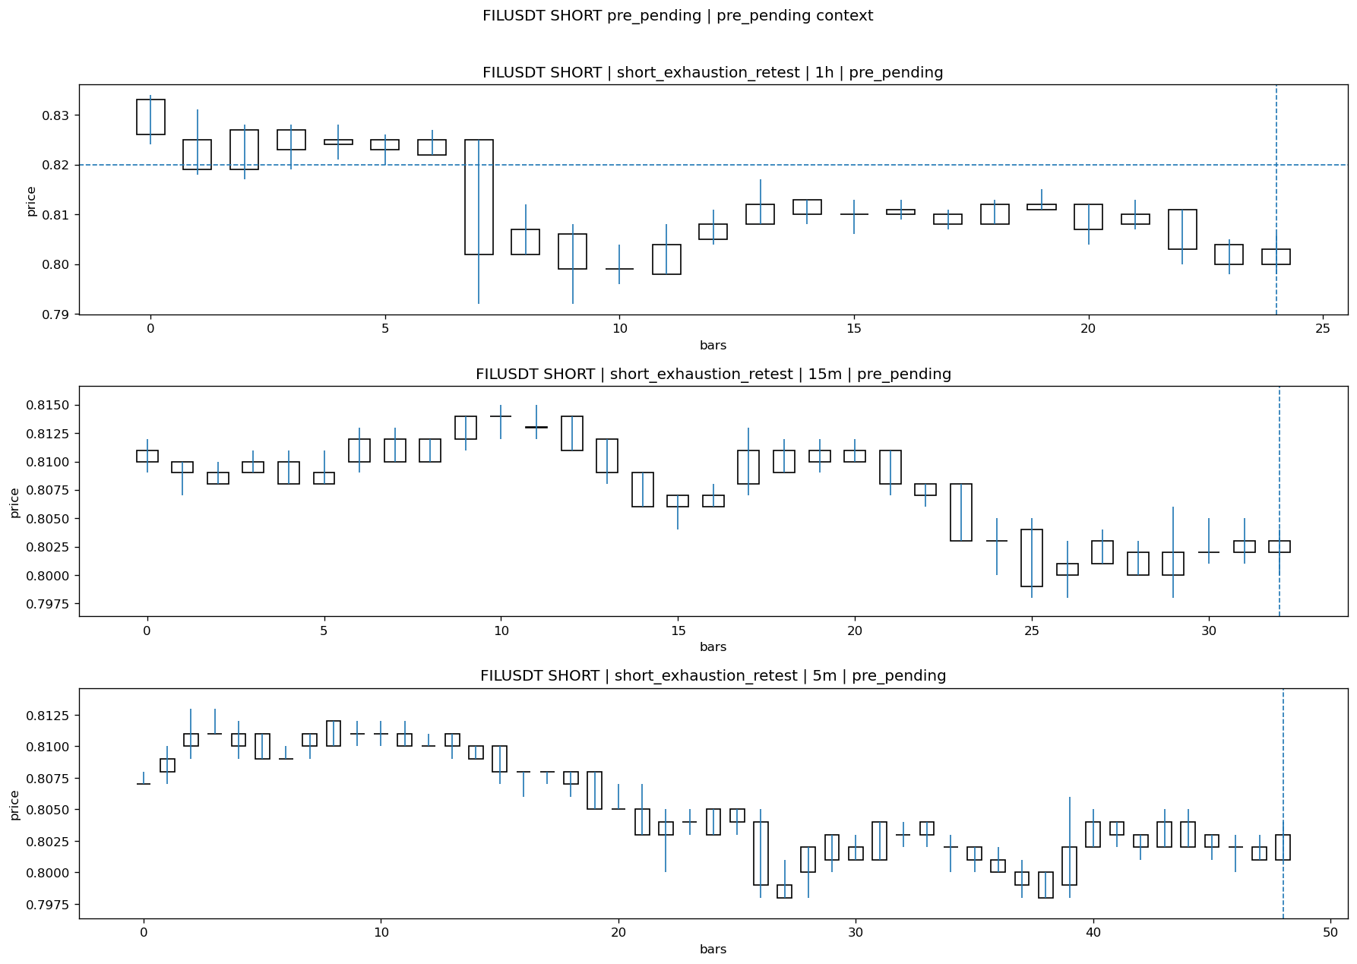
FILUSDT_SHORT_short_exhaustion_retest_pre_pending_1774689300000.png

Pending Open
Stage status: missing_unexpected | Content type: none
Note: MISSING UNEXPECTED

Entry Or Confirm
Stage status: not_applicable | Content type: none
Note: NOT APPLICABLE

Case Close
Stage status: missing_unexpected | Content type: none
Note: MISSING UNEXPECTED

Post-Close Outcome
1h outcome | available=Y | favor=0.3659 | adverse=0.2439 | summary=favor=0.37% adverse=0.24%
2h outcome | available=Y | favor=0.3659 | adverse=0.6098 | summary=favor=0.37% adverse=0.61%
4h reference | favor=0.3659 | adverse=2.5610
Reclaim | 2h=Y | 4h=Y
Execution reality | entry_feasible=Y | entry_window=10m | entry_note=entry still reachable within 10m
Time-to-move | time_to_max_favor=4m | time_to_max_adverse=89m
Regret filter | regret_valid=N | reason=no_meaningful_fast_move
Conclusion | KILL_CORRECT | notes=entry_ref_from_breakout_level

Review placeholders
human_review_status=PENDING | verdict_code= | root_cause_code= | action_candidate_code=

Case 53: NEARUSDT-SHORT-EXH-1774690200000
Summary | NEARUSDT | SHORT | short_exhaustion_retest | status_final=CONFIRMED | close_reason=signal confirmed
Times | signal=2026-03-28 16:30:00 | created=2026-03-28 16:46:25 | confirmed= | sent= | close=2026-03-28 17:16:06 | fallback_due=2026-03-28 20:46:25
Semantics | is_confirmed=N | is_sent_signal=N | review_eligible=N | semantic_consistency=N
Review integrity | review_exclusion_reason=confirmed_without_confirmed_ts | semantic_issue=confirmed_without_confirmed_ts
Close anchoring | case_close_type=not_due_yet | close_anchor_time= | close_capture_basis=not_due_yet
Tradeability / outcome | entry_feasible=Y | slippage=0.0000 | regret_valid=N | outcome=NO_MEANINGFUL_MOVE

Pre Pending
Stage status: captured | Content type: chart_snapshot
Note: pre_pending context
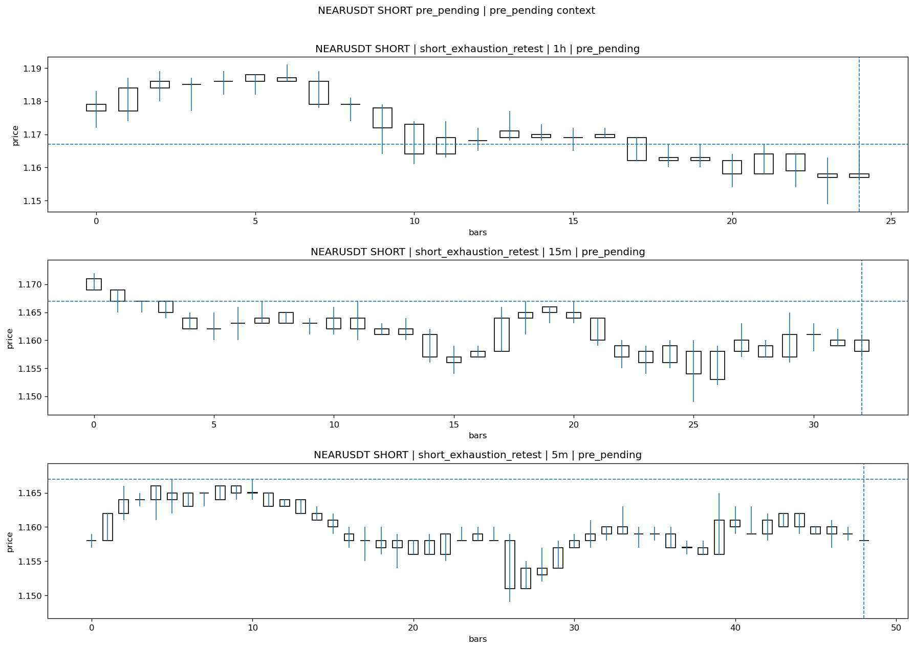
NEARUSDT_SHORT_short_exhaustion_retest_pre_pending_1774689300000.png

Pending Open
Stage status: missing_unexpected | Content type: none
Note: MISSING UNEXPECTED

Entry Or Confirm
Stage status: missing_unexpected | Content type: none
Note: MISSING UNEXPECTED

Case Close
Stage status: not_reached_yet | Content type: none
Note: NOT REACHED YET

Post-Close Outcome
1h outcome | available=Y | favor=0.5998 | adverse=0.0000 | summary=favor=0.60% adverse=0.00%
2h outcome | available=Y | favor=0.5998 | adverse=0.3428 | summary=favor=0.60% adverse=0.34%
4h reference | favor=0.5998 | adverse=1.6281
Reclaim | 2h=Y | 4h=Y
Execution reality | entry_feasible=Y | entry_window=10m | entry_note=entry still reachable within 10m
Time-to-move | time_to_max_favor=9m | time_to_max_adverse=74m
Regret filter | regret_valid=N | reason=no_meaningful_fast_move
Conclusion | NO_MEANINGFUL_MOVE | notes=entry_ref_from_breakout_level

Review placeholders
human_review_status=PENDING | verdict_code= | root_cause_code= | action_candidate_code=

Case 54: TAUSDT-SHORT-EXH-1774691100000
Summary | TAUSDT | SHORT | short_exhaustion_retest | status_final=EXPIRED_WAIT | close_reason=retest wait expired
Times | signal=2026-03-28 16:45:00 | created=2026-03-28 17:00:24 | confirmed= | sent= | close=2026-03-28 17:45:58 | fallback_due=2026-03-28 21:00:24
Semantics | is_confirmed=N | is_sent_signal=N | review_eligible=Y | semantic_consistency=Y
Review integrity | review_exclusion_reason= | semantic_issue=
Close anchoring | case_close_type=true_close | close_anchor_time=2026-03-28 17:45:58 | close_capture_basis=true_close
Tradeability / outcome | entry_feasible=N | slippage= | regret_valid=N | outcome=NO_MEANINGFUL_MOVE

Pre Pending
Stage status: captured | Content type: chart_snapshot
Note: pre_pending context
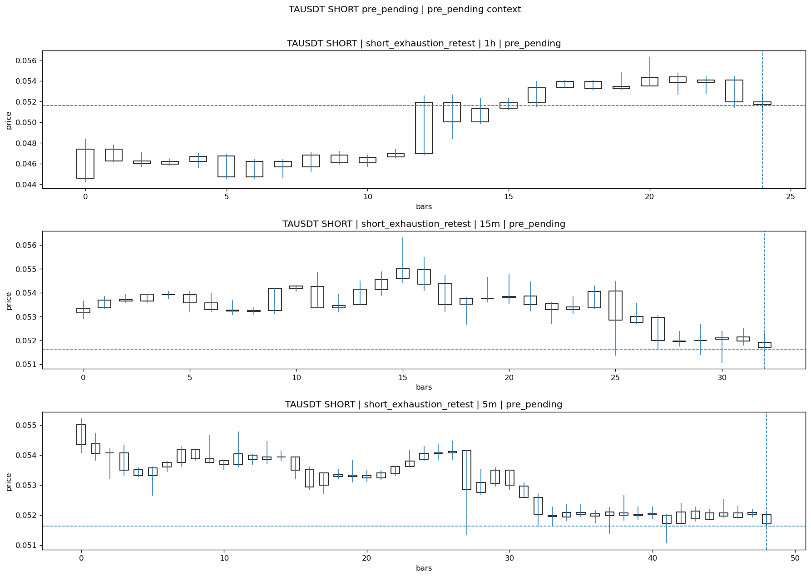
TAUSDT_SHORT_short_exhaustion_retest_pre_pending_1774690200000.png

Pending Open
Stage status: missing_unexpected | Content type: none
Note: MISSING UNEXPECTED

Entry Or Confirm
Stage status: not_applicable | Content type: none
Note: NOT APPLICABLE

Case Close
Stage status: missing_unexpected | Content type: none
Note: MISSING UNEXPECTED

Post-Close Outcome
1h outcome | available=Y | favor=11.8148 | adverse=0.0000 | summary=favor=11.81% adverse=0.00%
2h outcome | available=Y | favor=20.0659 | adverse=0.0000 | summary=favor=20.07% adverse=0.00%
4h reference | favor=20.0659 | adverse=0.0000
Reclaim | 2h=N | 4h=N
Execution reality | entry_feasible=N | entry_window=10m | entry_note=entry not reached within 10m
Time-to-move | time_to_max_favor=89m | time_to_max_adverse=4m
Regret filter | regret_valid=N | reason=entry_not_feasible
Conclusion | NO_MEANINGFUL_MOVE | notes=entry_ref_from_breakout_level

Review placeholders
human_review_status=PENDING | verdict_code= | root_cause_code= | action_candidate_code=

Case 55: TAOUSDT-SHORT-EXH-1774692900000
Summary | TAOUSDT | SHORT | short_exhaustion_retest | status_final=PENDING | close_reason=
Times | signal=2026-03-28 17:15:00 | created=2026-03-28 17:32:27 | confirmed= | sent= | close= | fallback_due=2026-03-28 21:32:27
Semantics | is_confirmed=N | is_sent_signal=N | review_eligible=N | semantic_consistency=Y
Review integrity | review_exclusion_reason=outcome_2h_unavailable | semantic_issue=
Close anchoring | case_close_type=fallback_4h_snapshot | close_anchor_time= | close_capture_basis=
Tradeability / outcome | entry_feasible= | slippage= | regret_valid= | outcome=

Pre Pending
Stage status: captured | Content type: chart_snapshot
Note: pre_pending context
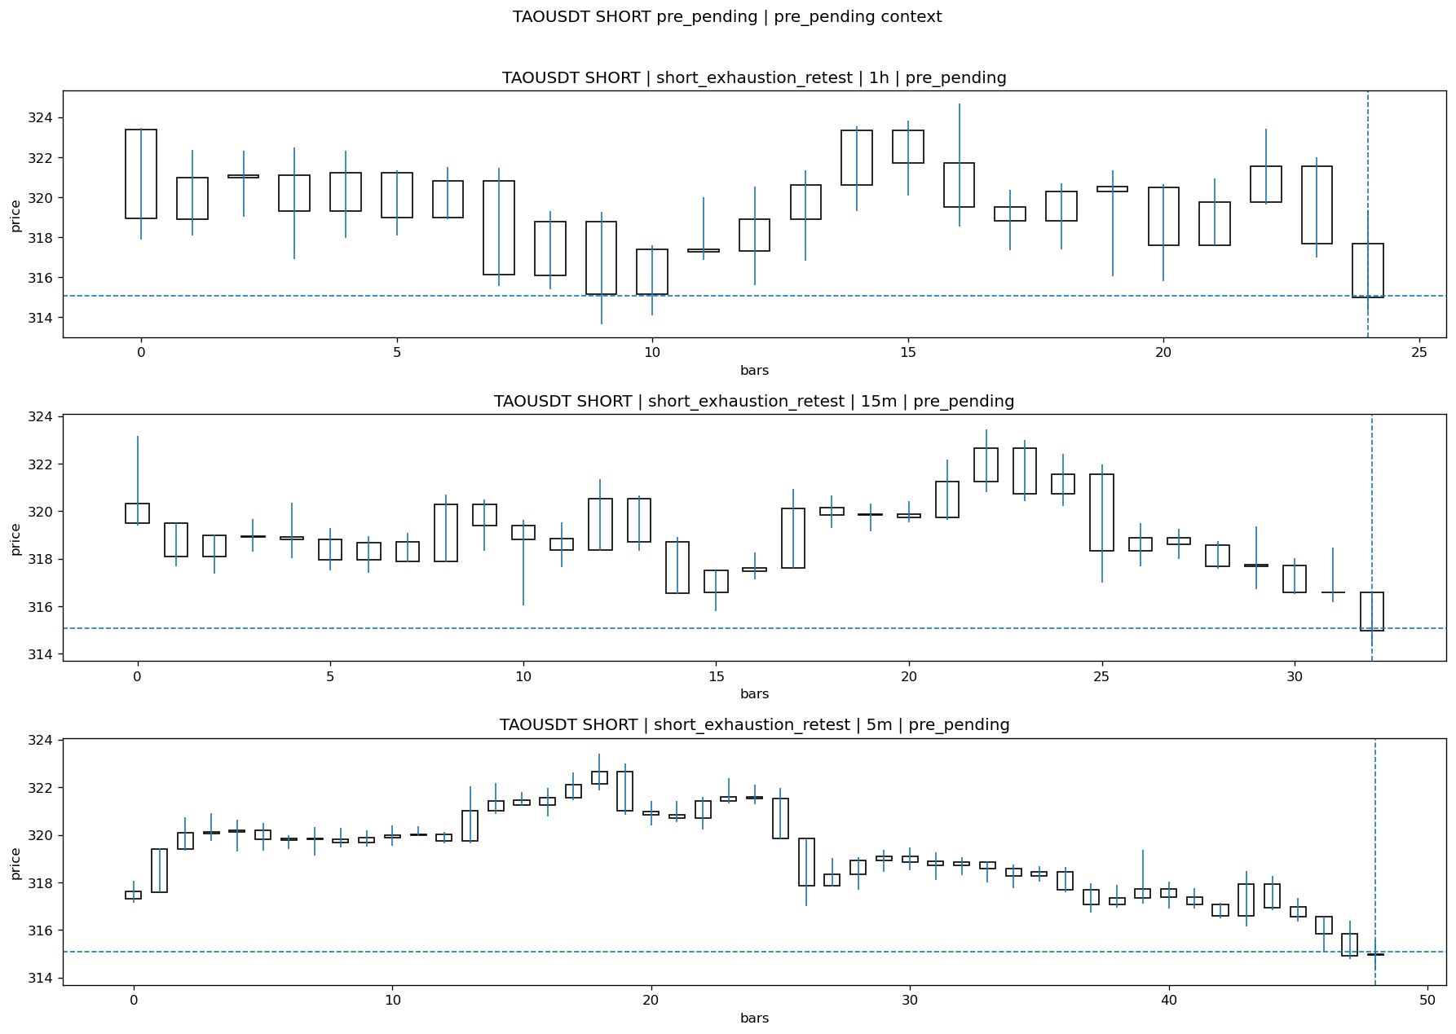
TAOUSDT_SHORT_short_exhaustion_retest_pre_pending_1774692000000.png

Pending Open
Stage status: missing_unexpected | Content type: none
Note: MISSING UNEXPECTED

Entry Or Confirm
Stage status: not_applicable | Content type: none
Note: NOT APPLICABLE

Case Close
Stage status: missing_unexpected | Content type: none
Note: MISSING UNEXPECTED

Post-Close Outcome
1h outcome | available=N | favor= | adverse= | summary=
2h outcome | available=N | favor= | adverse= | summary=
4h reference | favor= | adverse=
Reclaim | 2h= | 4h=
Execution reality | entry_feasible= | entry_window=m | entry_note=
Time-to-move | time_to_max_favor=m | time_to_max_adverse=m
Regret filter | regret_valid= | reason=
Conclusion | | notes=

Review placeholders
human_review_status=PENDING | verdict_code= | root_cause_code= | action_candidate_code=

