Daily Signal Review 2026-03-26
Total cases: 6
Slot-complete: 6 | Lifecycle-complete: 4 | Evidence full/partial/none: 3/2/1
Confirmed: 0 | Sent: 0 | Confirmed not sent: 0

Case Registry Preview
BEATUSDT-LONG-1774529700000 | BEATUSDT | LONG | long_breakout_retest | confirmed=N | sent=N | status=EXPIRED_WAIT | evidence=partial | lifecycle_complete=Y
TAOUSDT-LONG-1774530300000 | TAOUSDT | LONG | long_breakout_retest | confirmed=N | sent=N | status=INVALIDATED | evidence=partial | lifecycle_complete=Y
ROBOUSDT-LONG-1774531800000 | ROBOUSDT | LONG | long_breakout_retest | confirmed=N | sent=N | status=INVALIDATED | evidence=full | lifecycle_complete=Y
DUSKUSDT-SHORT-EXH-1774531800000 | DUSKUSDT | SHORT | short_exhaustion_retest | confirmed=N | sent=N | status=CONFIRMED | evidence=none | lifecycle_complete=N
TAOUSDT-LONG-1774533600000 | TAOUSDT | LONG | long_breakout_retest | confirmed=N | sent=N | status=INVALIDATED | evidence=full | lifecycle_complete=Y
ARIAUSDT-SHORT-EXH-1774533600000 | ARIAUSDT | SHORT | short_exhaustion_retest | confirmed=N | sent=N | status=PENDING | evidence=full | lifecycle_complete=N

Case 1: BEATUSDT-LONG-1774529700000
BEATUSDT | LONG | long_breakout_retest | status_final=EXPIRED_WAIT | close_reason=retest wait expired
signal=2026-03-26 19:55:00 | created=2026-03-26 20:00:07 | confirmed= | sent= | close= | fallback_due=2026-03-27 00:00:07
slot_bundle_complete=Y | evidence_ready_for_review=partial | lifecycle_complete=Y | case_close_type=true_close

Pre Pending
Stage status: missing_unexpected | Content type: none
MISSING UNEXPECTED

Pending Open
Stage status: missing_unexpected | Content type: none
MISSING UNEXPECTED

Entry Or Confirm
Stage status: not_applicable | Content type: none
NOT APPLICABLE

Case Close
Stage status: captured | Content type: chart_snapshot | Close type: true_close
Note: retest wait expired
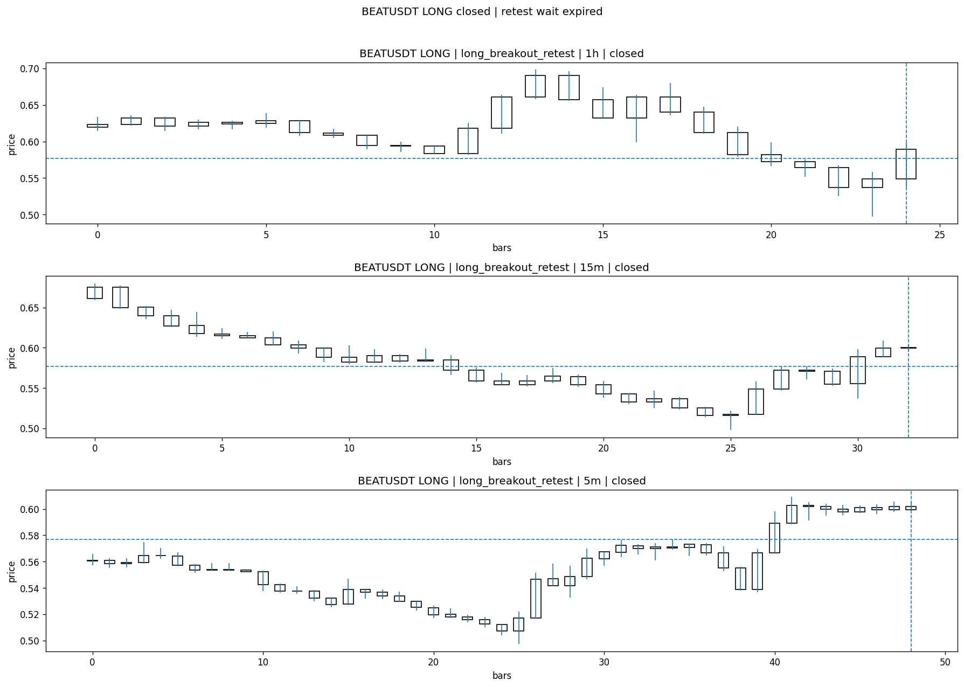
Review placeholders
human_review_status=PENDING | verdict_code= | root_cause_code= | action_candidate_code=

Case 2: TAOUSDT-LONG-1774530300000
TAOUSDT | LONG | long_breakout_retest | status_final=INVALIDATED | close_reason=acceptance_floor_lost 340.780000<343.310000
signal=2026-03-26 20:05:00 | created=2026-03-26 20:12:39 | confirmed= | sent= | close= | fallback_due=2026-03-27 00:12:39
slot_bundle_complete=Y | evidence_ready_for_review=partial | lifecycle_complete=Y | case_close_type=true_close

Pre Pending
Stage status: missing_unexpected | Content type: none
MISSING UNEXPECTED

Pending Open
Stage status: missing_unexpected | Content type: none
MISSING UNEXPECTED

Entry Or Confirm
Stage status: not_applicable | Content type: none
NOT APPLICABLE

Case Close
Stage status: captured | Content type: chart_snapshot | Close type: true_close
Note: acceptance_floor_lost 340.780000<343.310000
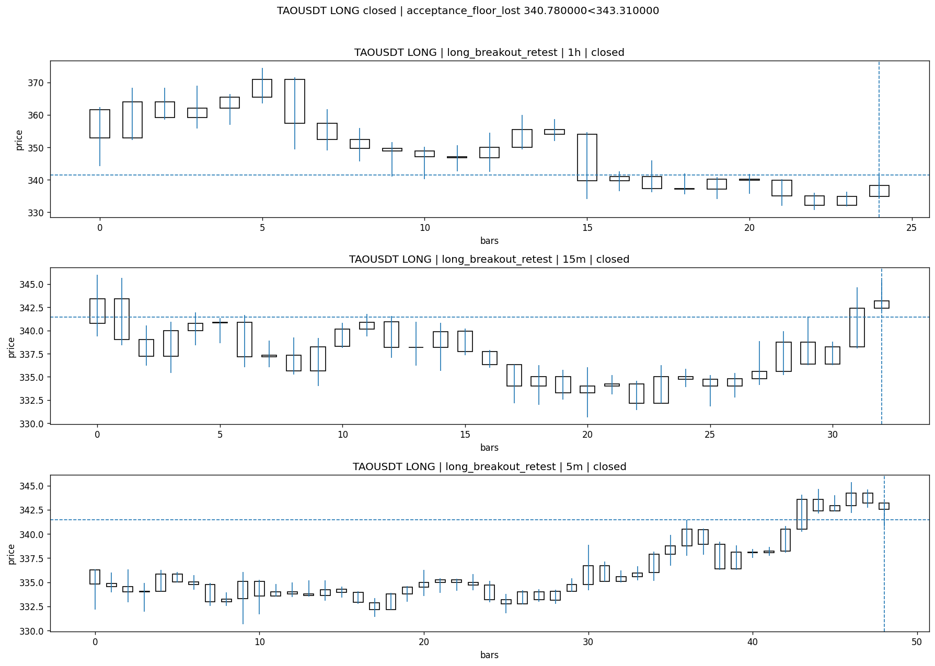
Review placeholders
human_review_status=PENDING | verdict_code= | root_cause_code= | action_candidate_code=

Case 3: ROBOUSDT-LONG-1774531800000
ROBOUSDT | LONG | long_breakout_retest | status_final=INVALIDATED | close_reason=retest invalidated
signal=2026-03-26 20:30:00 | created=2026-03-26 20:38:24 | confirmed= | sent= | close=2026-03-26 20:40:53 | fallback_due=2026-03-27 00:38:24
slot_bundle_complete=Y | evidence_ready_for_review=full | lifecycle_complete=Y | case_close_type=true_close

Pre Pending
Stage status: captured | Content type: chart_snapshot
Note: pre_pending context
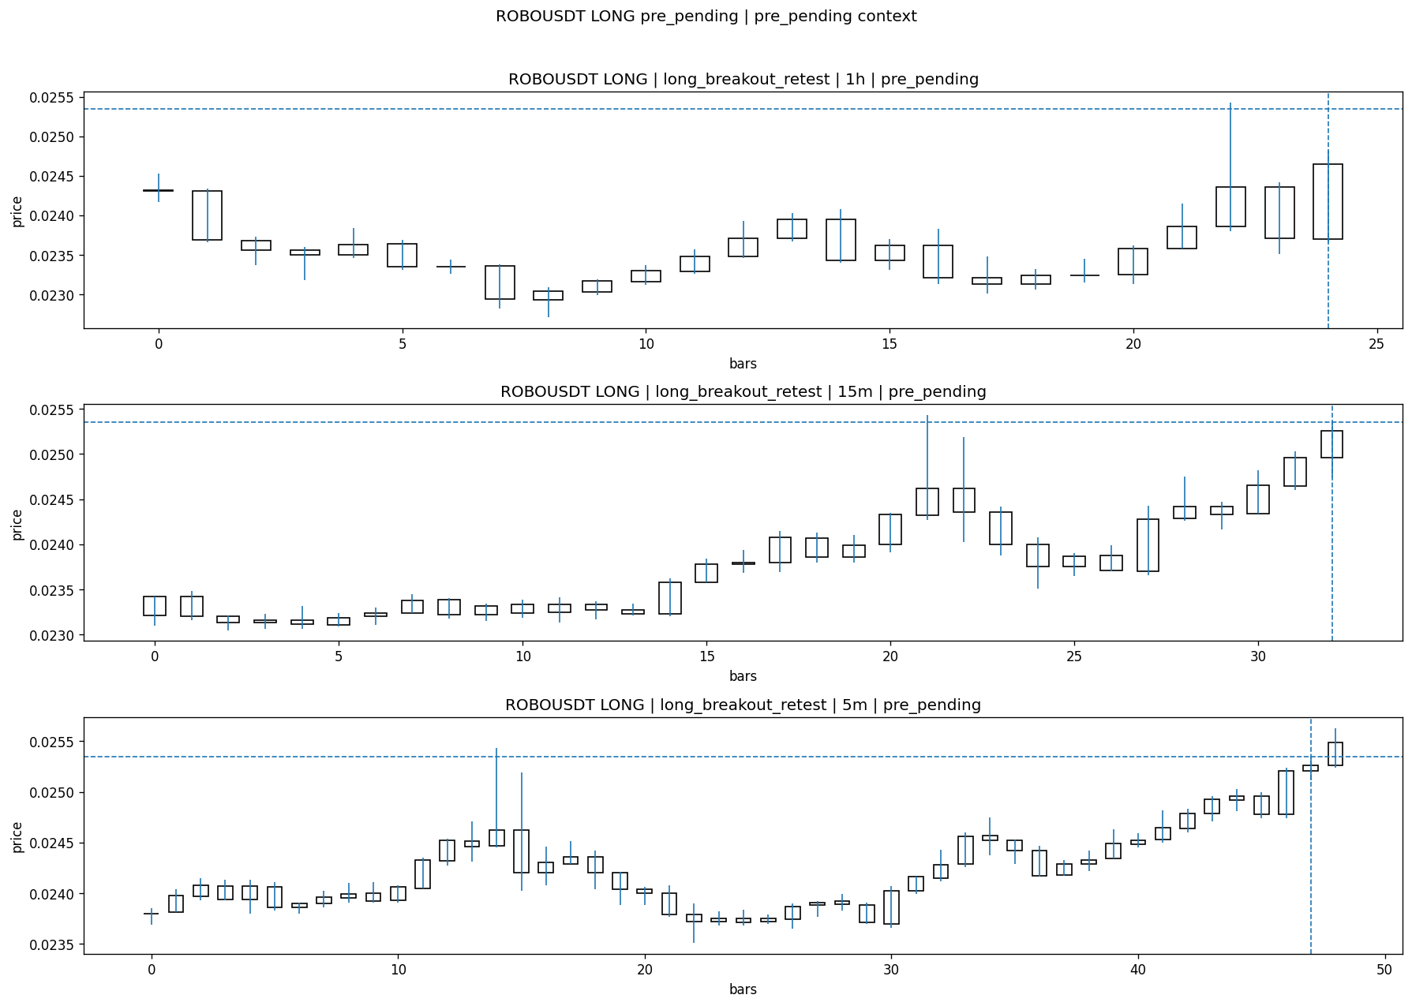

Pending Open
Stage status: captured | Content type: chart_snapshot
Note: OI jump 3.30% + breakout pending + 15m up + 1h up
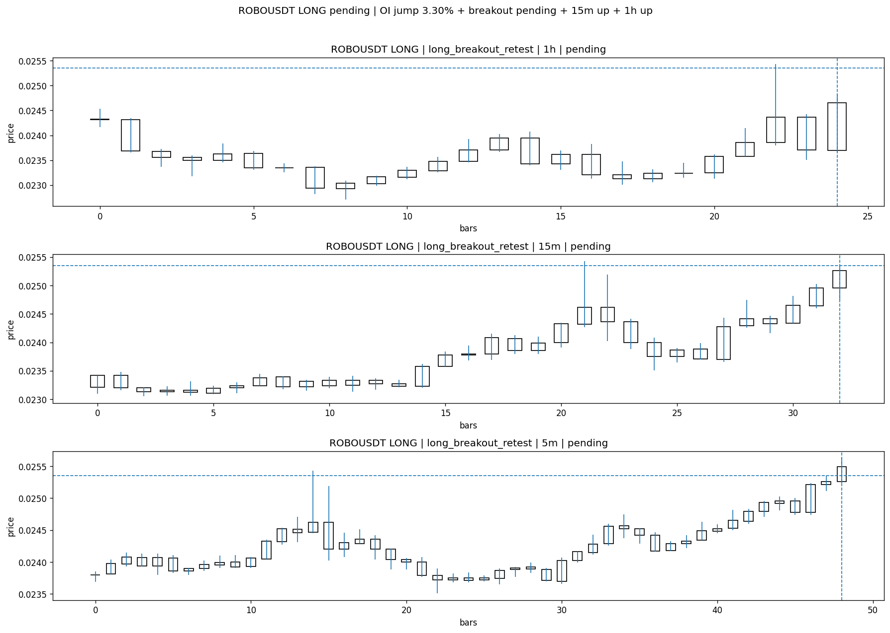

Entry Or Confirm
Stage status: not_applicable | Content type: none
NOT APPLICABLE

Case Close
Stage status: captured | Content type: chart_snapshot | Close type: true_close
Note: retest invalidated
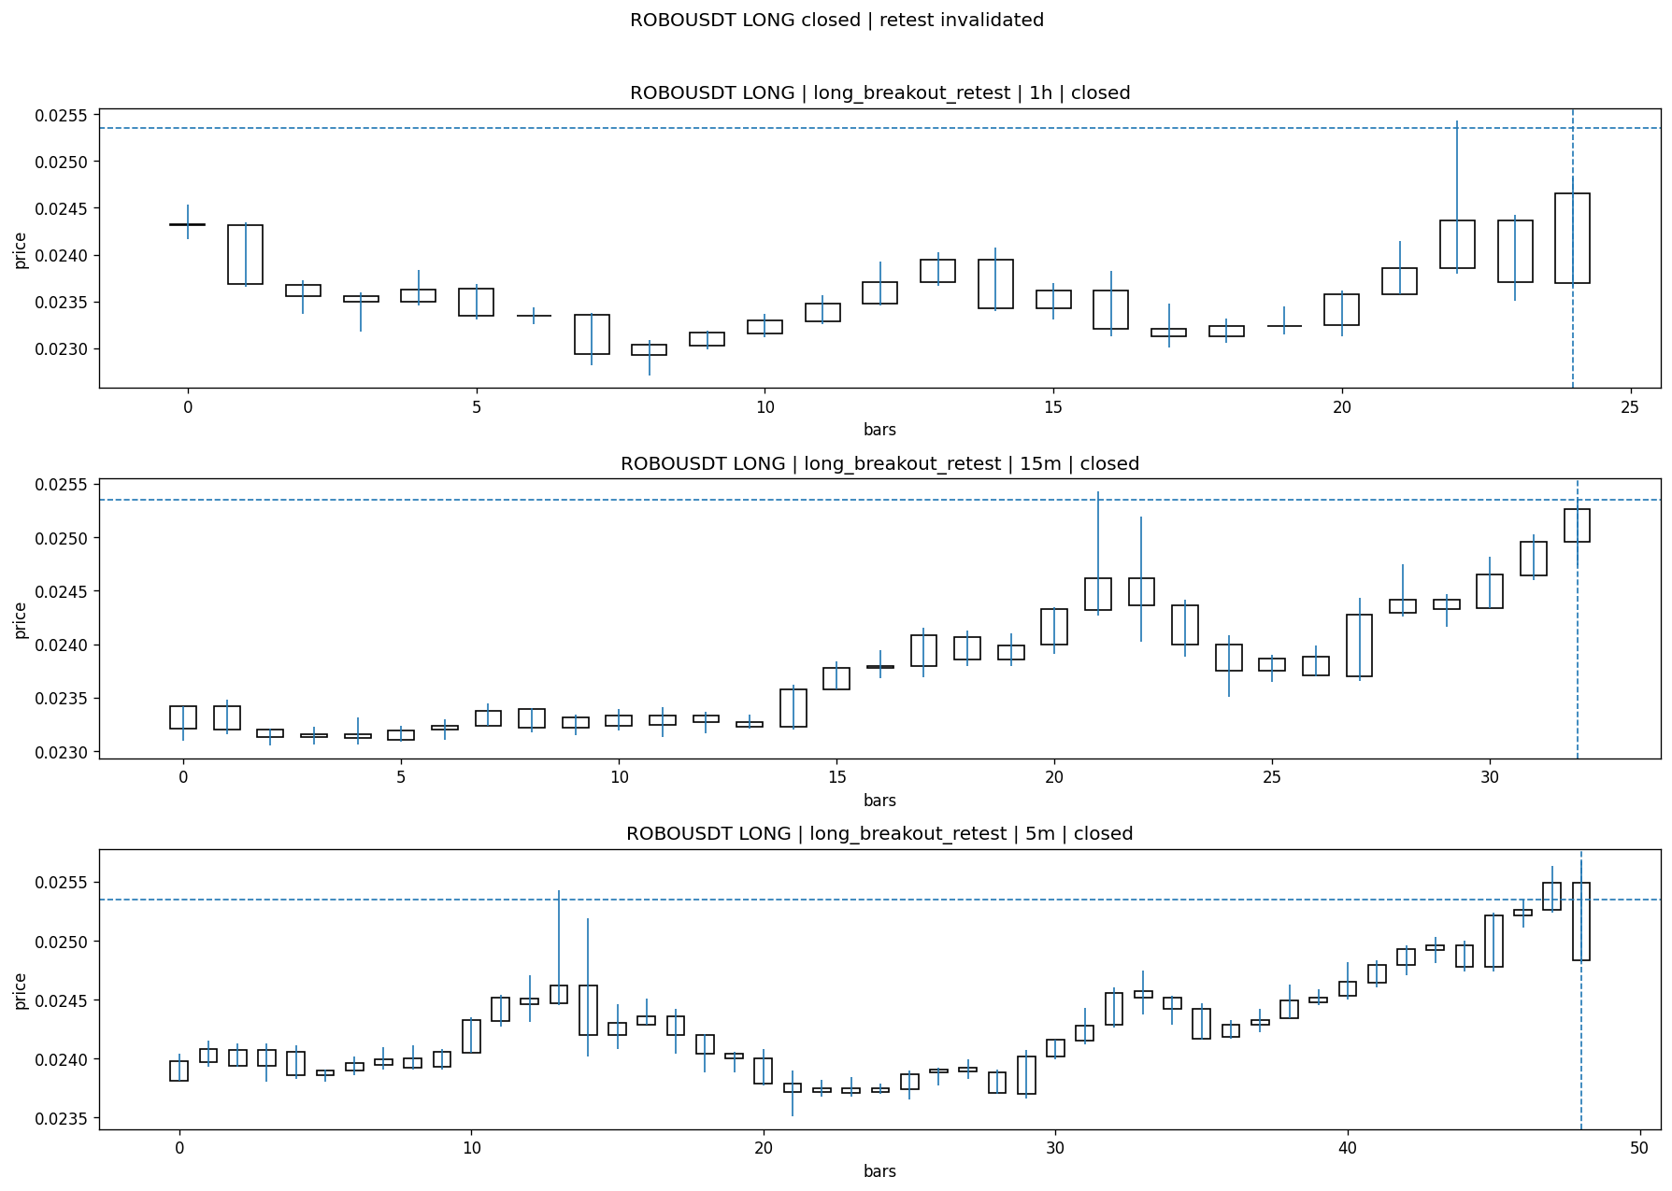
Review placeholders
human_review_status=PENDING | verdict_code= | root_cause_code= | action_candidate_code=

Case 4: DUSKUSDT-SHORT-EXH-1774531800000
DUSKUSDT | SHORT | short_exhaustion_retest | status_final=CONFIRMED | close_reason=signal confirmed
signal=2026-03-26 20:30:00 | created=2026-03-26 20:45:43 | confirmed= | sent= | close= | fallback_due=2026-03-27 00:45:43
slot_bundle_complete=Y | evidence_ready_for_review=none | lifecycle_complete=N | case_close_type=not_due_yet

Pre Pending
Stage status: missing_unexpected | Content type: none
MISSING UNEXPECTED

Pending Open
Stage status: missing_unexpected | Content type: none
MISSING UNEXPECTED

Entry Or Confirm
Stage status: captured | Content type: chart_snapshot
Note: signal confirmed
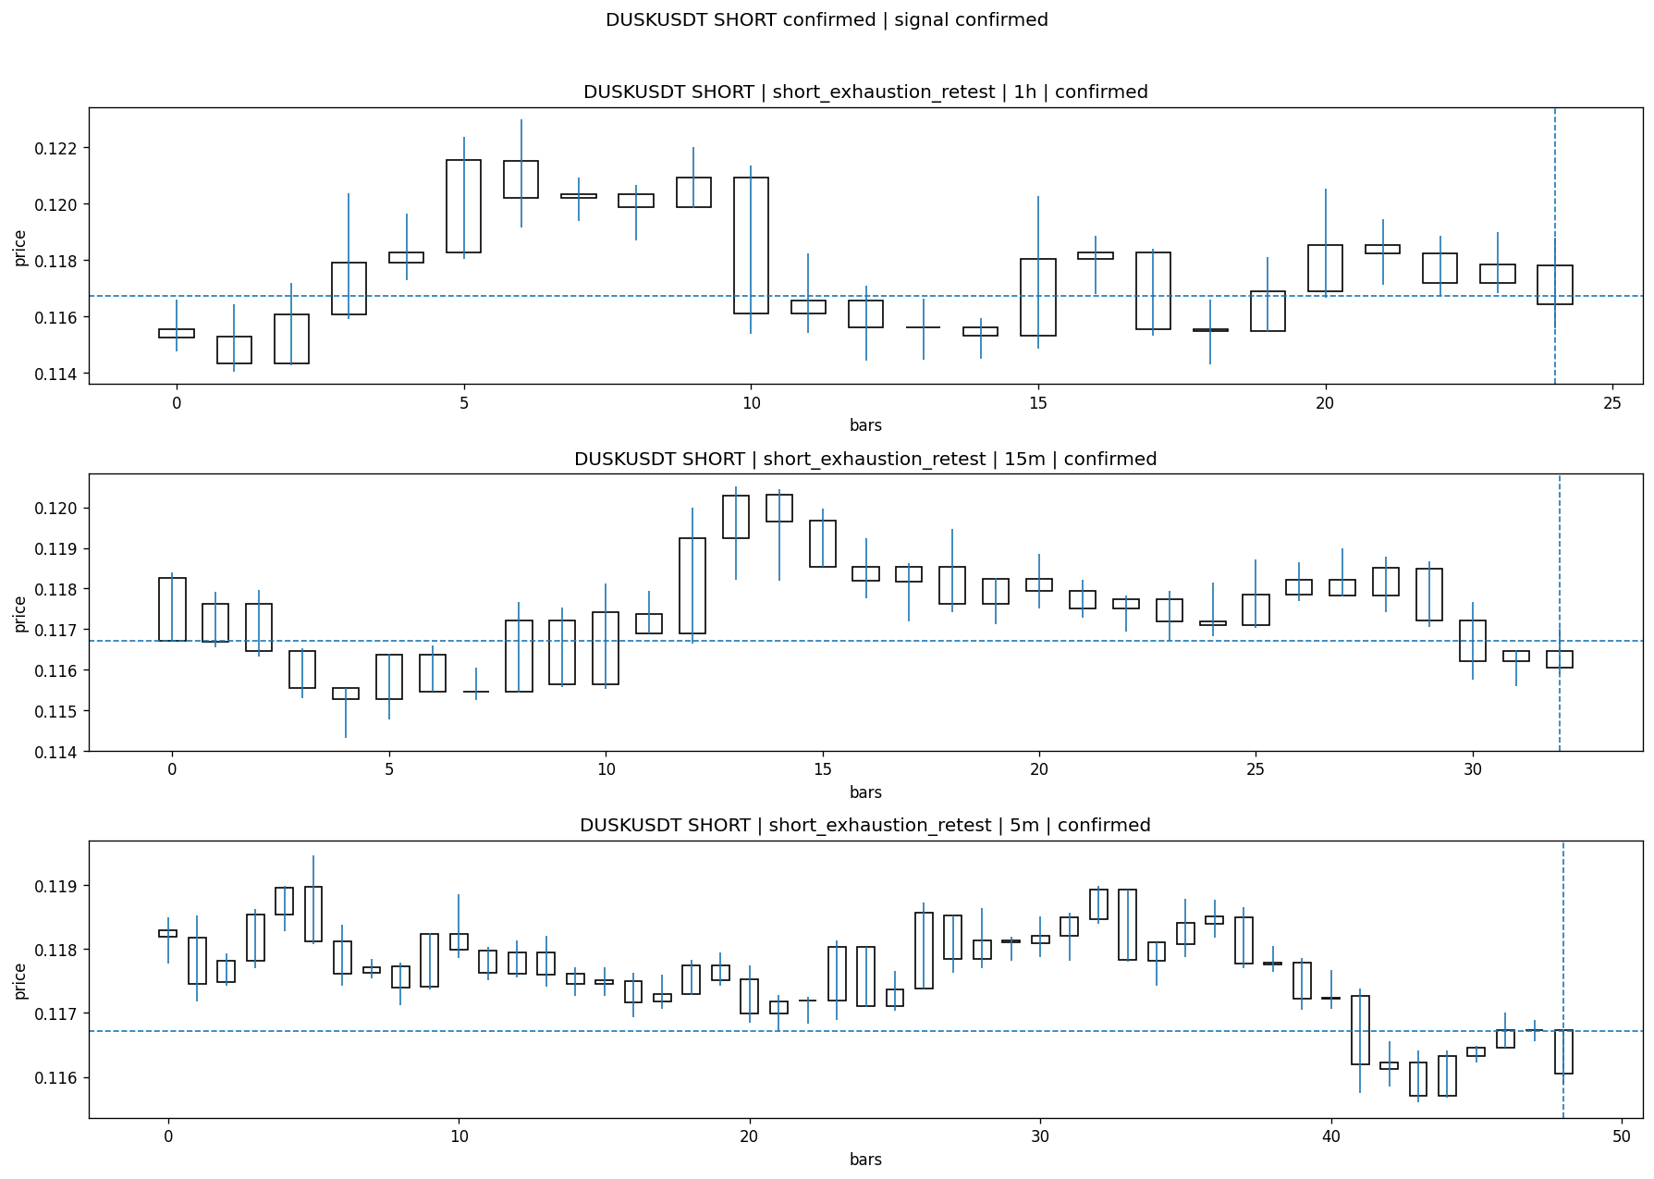

Case Close
Stage status: not_reached_yet | Content type: none | Close type: not_due_yet
NOT REACHED YET
Review placeholders
human_review_status=PENDING | verdict_code= | root_cause_code= | action_candidate_code=

Case 5: TAOUSDT-LONG-1774533600000
TAOUSDT | LONG | long_breakout_retest | status_final=INVALIDATED | close_reason=retest invalidated
signal=2026-03-26 21:00:00 | created=2026-03-26 21:06:05 | confirmed= | sent= | close=2026-03-26 21:17:09 | fallback_due=2026-03-27 01:06:05
slot_bundle_complete=Y | evidence_ready_for_review=full | lifecycle_complete=Y | case_close_type=true_close

Pre Pending
Stage status: captured | Content type: chart_snapshot
Note: pre_pending context
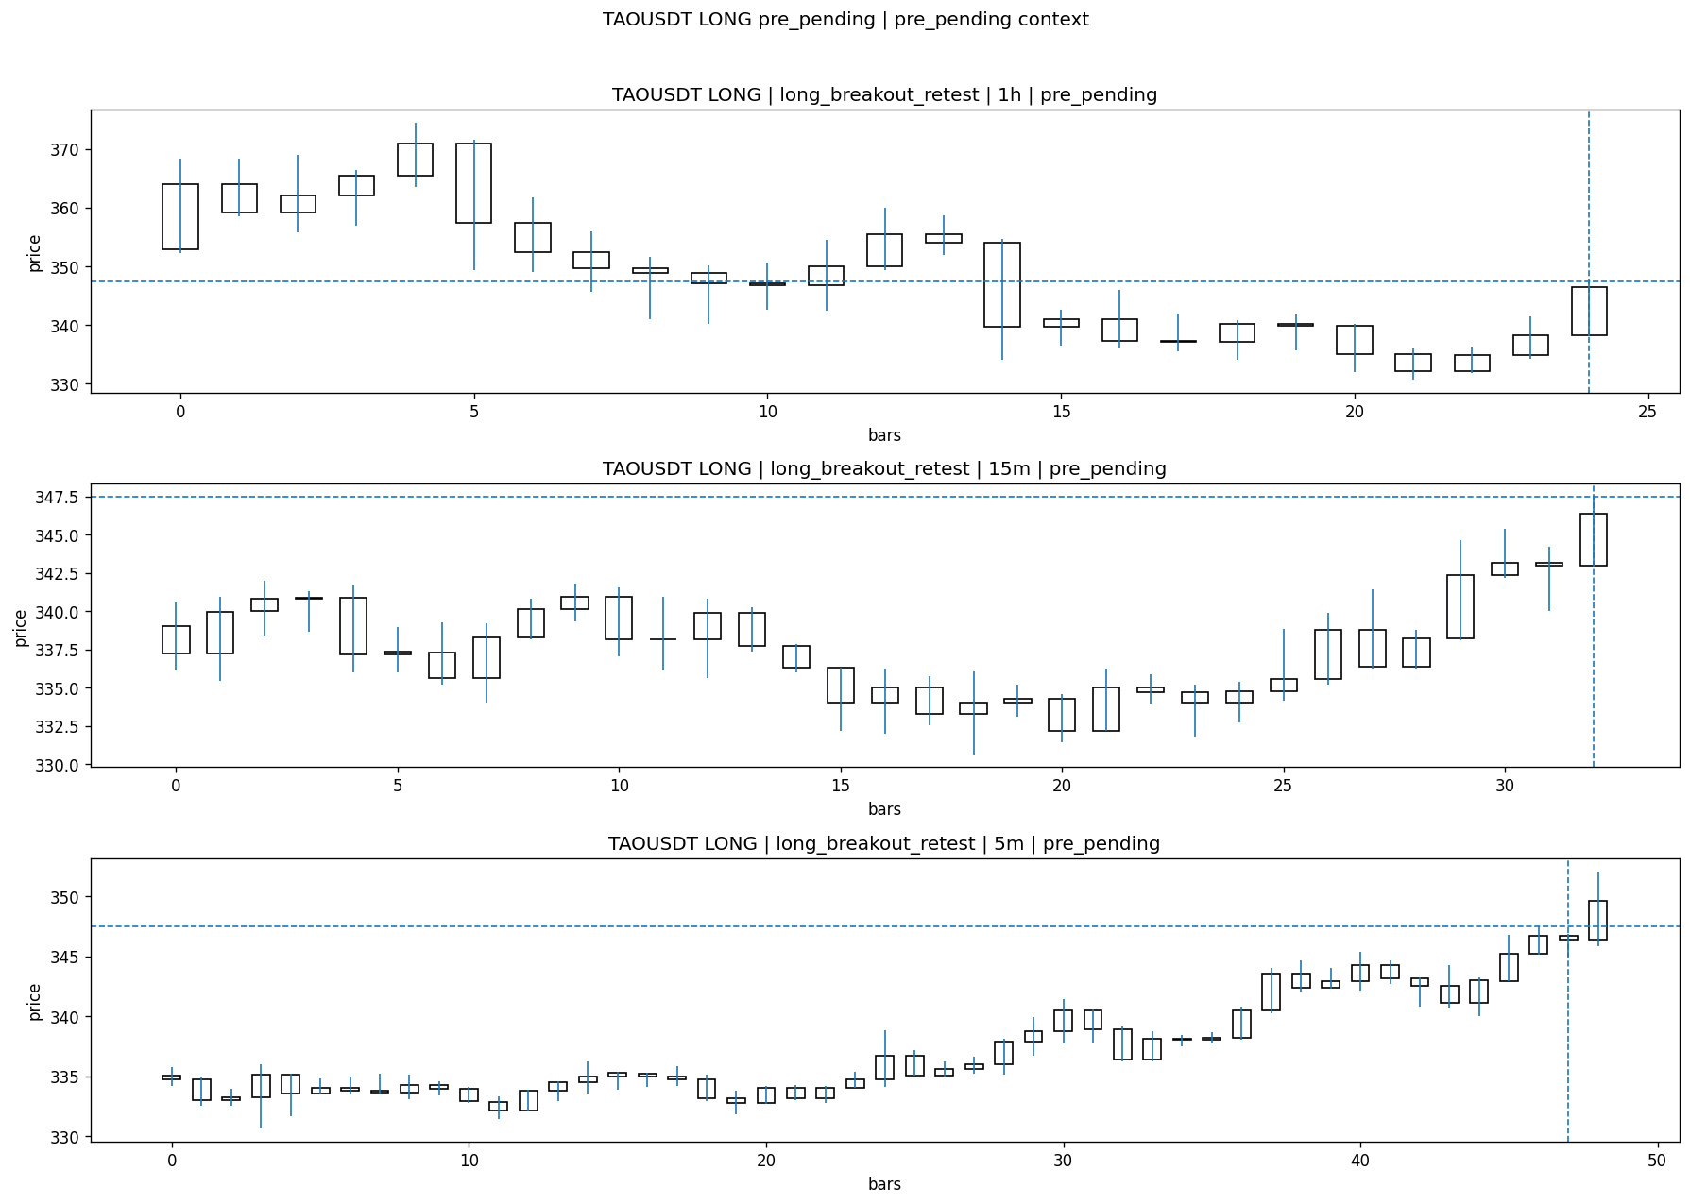

Pending Open
Stage status: captured | Content type: chart_snapshot
Note: OI jump 3.33% + breakout pending + 15m flat + 1h flat
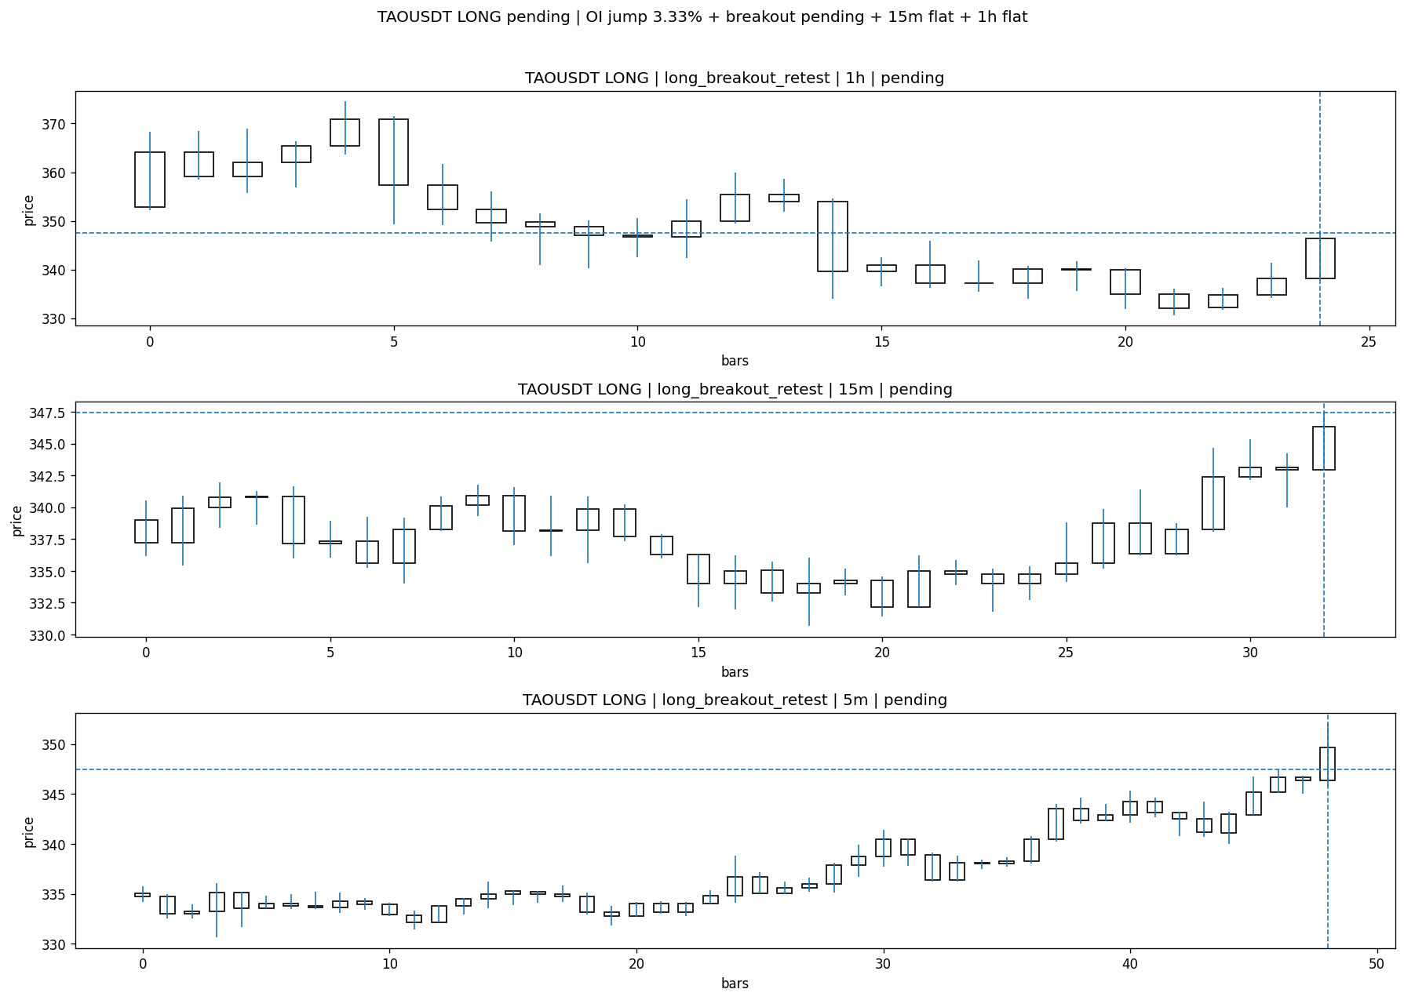

Entry Or Confirm
Stage status: not_applicable | Content type: none
NOT APPLICABLE

Case Close
Stage status: captured | Content type: chart_snapshot | Close type: true_close
Note: retest invalidated
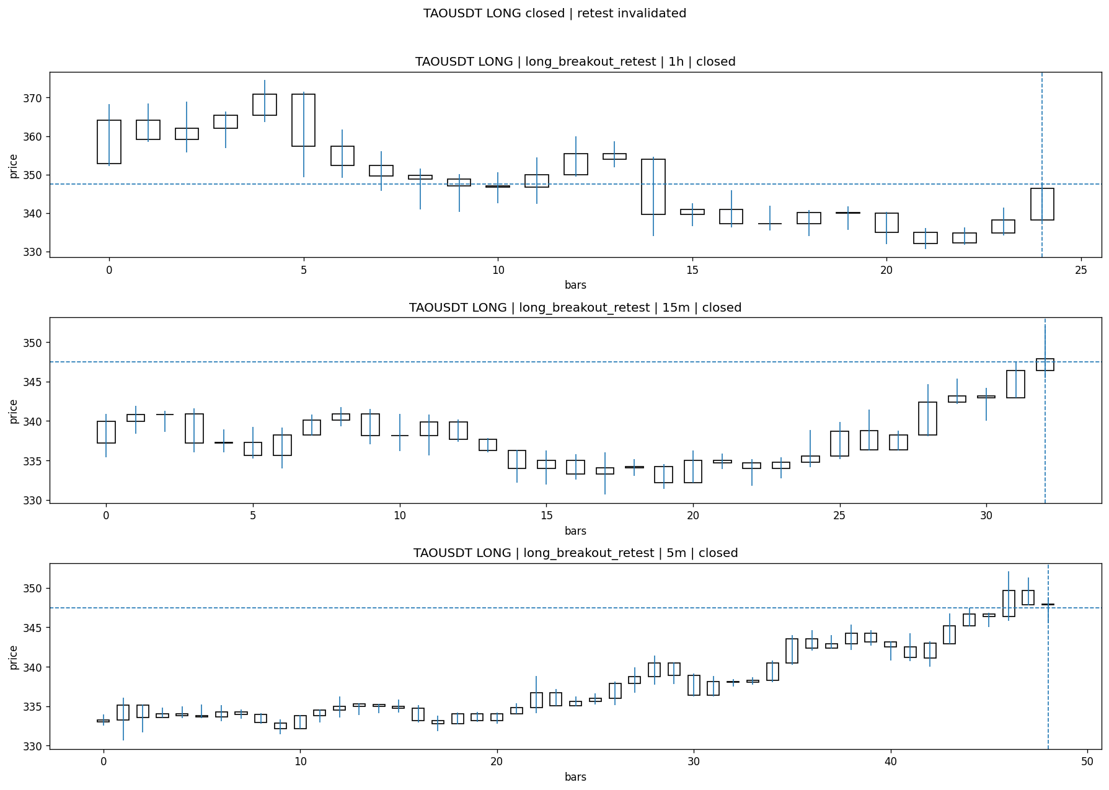
Review placeholders
human_review_status=PENDING | verdict_code= | root_cause_code= | action_candidate_code=

Case 6: ARIAUSDT-SHORT-EXH-1774533600000
ARIAUSDT | SHORT | short_exhaustion_retest | status_final=PENDING | close_reason=
signal=2026-03-26 21:00:00 | created=2026-03-26 21:20:35 | confirmed= | sent= | close= | fallback_due=2026-03-27 01:20:35
slot_bundle_complete=Y | evidence_ready_for_review=full | lifecycle_complete=N | case_close_type=not_due_yet

Pre Pending
Stage status: captured | Content type: chart_snapshot
Note: pre_pending context
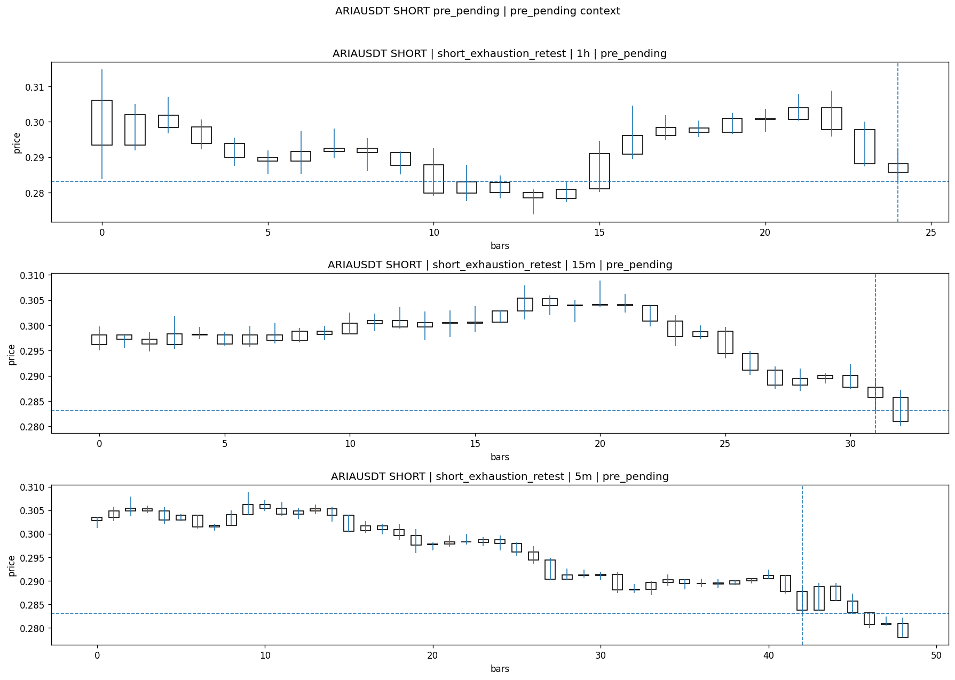

Pending Open
Stage status: captured | Content type: chart_snapshot
Note: 1h exhaustion 33/35 + 15m breakdown 27/30 -> retest fail pending
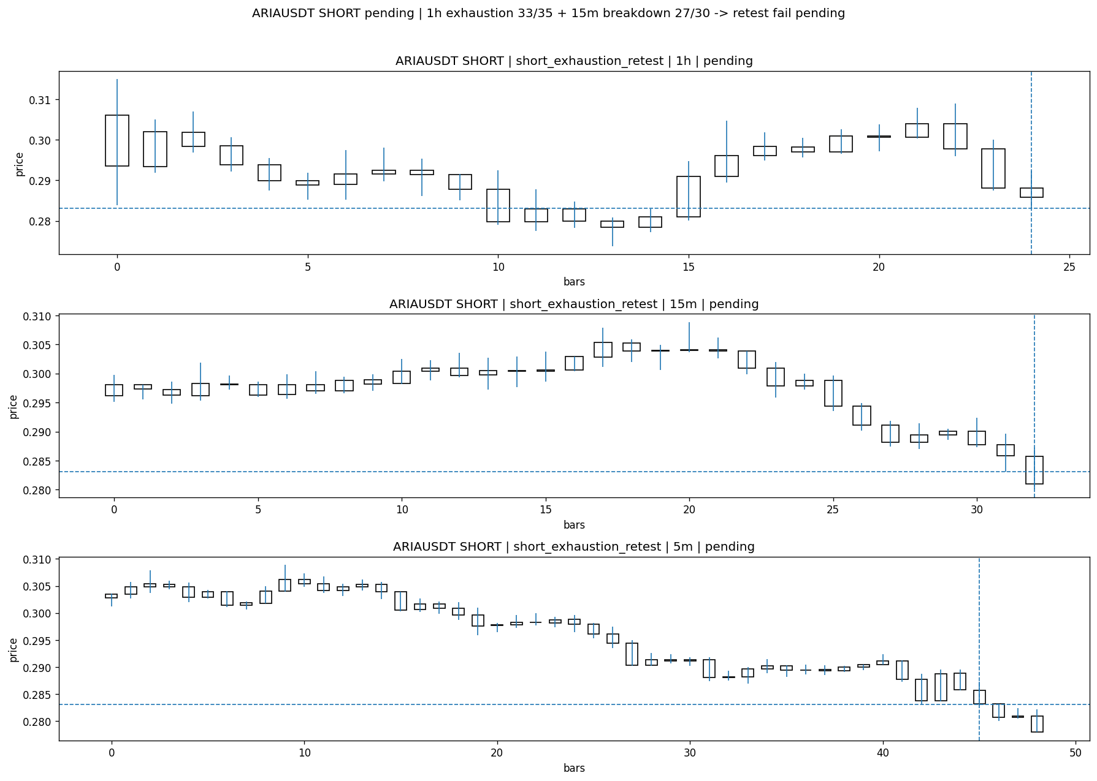

Entry Or Confirm
Stage status: not_reached_yet | Content type: none
NOT REACHED YET

Case Close
Stage status: not_reached_yet | Content type: none | Close type: not_due_yet
NOT REACHED YET
Review placeholders
human_review_status=PENDING | verdict_code= | root_cause_code= | action_candidate_code=

