AgentForge
System Diagrams & Data Flow Documentation
AgentForge 系统图与数据流文档

Version 1.0
April 2026
Confidential

Table of Contents / 目录

1. Introduction / 引言
2. System Architecture Diagram / 系统架构图
3. Data Flow Overview / 数据流概览
4. Agent Communication Sequence / 智能体通信序列
5. Provider Adapter Architecture / 提供者适配器架构
6. Database Entity-Relationship Diagram / 数据库实体关系图
7. iFlow Workflow Engine / 智能工作流引擎
8. Operating Modes / 运行模式
9. Diagram Legend & Conventions / 图例与约定
10. References / 参考文献

1. Introduction / 引言

1.1 Purpose / 目的
This document provides comprehensive visual documentation of AgentForge's system architecture, data flows, component interactions, and database design through diagrams and detailed descriptions. It serves as the definitive reference for understanding how the various subsystems of AgentForge interconnect and operate together.
本文档为AgentForge的系统架构、数据流、组件交互和数据库设计提供全面的可视化文档。它是理解AgentForge各子系统如何互连和协同工作的权威参考资料。

1.2 Scope / 范围
This document covers 7 diagram categories that span all major subsystems of AgentForge:
- System Architecture (7-layer design) / 系统架构（7层设计）
- Data Flow Overview / 数据流概览
- Agent Communication Sequence / 智能体通信序列
- Provider Adapter Architecture / 提供者适配器架构
- Database Entity-Relationship Diagram / 数据库实体关系图
- iFlow Workflow Engine / 智能工作流引擎
- Operating Modes / 运行模式

1.3 Audience / 读者
This document is intended for the following audiences:
- Software Developers implementing or extending AgentForge components
- System Architects designing integrations or modifications
- DevOps Engineers managing deployment and infrastructure
- QA Engineers validating system behavior and data flows
- Project Managers and Stakeholders reviewing system design

2. System Architecture Diagram / 系统架构图

2.1 Overview / 概述
AgentForge follows a 7-layer architecture pattern designed for separation of concerns, testability, and independent evolution of each layer. The diagram below illustrates the complete system architecture with all major components and their relationships.
AgentForge采用7层架构模式，旨在实现关注点分离、可测试性以及各层的独立演进。下图展示了包含所有主要组件及其关系的完整系统架构。

2.2 Architecture Diagram / 架构图
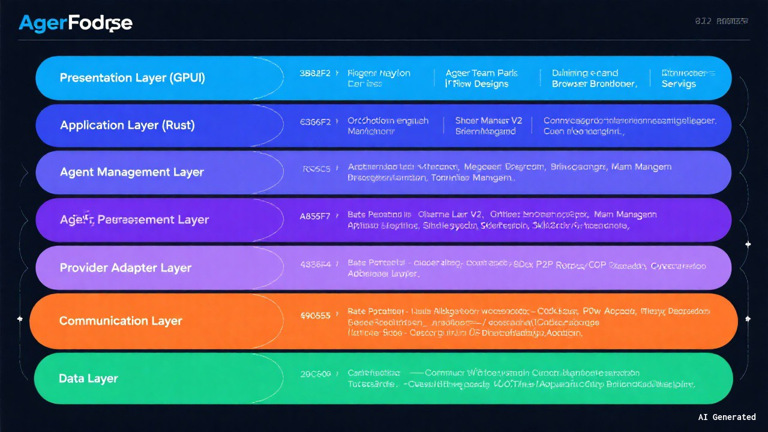
Figure 1: AgentForge System Architecture - 7-Layer Design / 图1：AgentForge系统架构 - 7层设计

2.3 Layer Descriptions / 层级说明
Layer 1 - Presentation Layer (GPUI) / 表示层（GPUI）
Rust-based desktop UI built on longbridge/gpui-component providing the user interface for all system interactions. This layer handles rendering, user input, and visual feedback. It communicates exclusively with the Application Layer through well-defined interfaces.
基于Rust的桌面UI，构建在longbridge/gpui-component之上，为所有系统交互提供用户界面。该层负责渲染、用户输入和视觉反馈，仅通过明确定义的接口与应用层通信。
Layer 2 - Application Layer (Rust) / 应用层（Rust）
Core business logic including the Orchestration Engine, SessionManagerV2, ConcurrencyGuard, BriefingManager, Document Generator, and Token Manager. This layer coordinates all high-level operations and serves as the central nervous system of AgentForge.
核心业务逻辑，包括编排引擎、SessionManagerV2、ConcurrencyGuard、BriefingManager、文档生成器和令牌管理器。该层协调所有高级操作，是AgentForge的中枢神经系统。
Layer 3 - Agent Management Layer / 智能体管理层
AgentManagerV2 handles the complete agent lifecycle (create, deploy, monitor, retire), identity system, skill registry, and memory management. This layer ensures agents are properly configured, capable of their assigned roles, and can learn from past interactions.
AgentManagerV2处理完整的智能体生命周期（创建、部署、监控、退役）、身份系统、技能注册和记忆管理。该层确保智能体正确配置、能够胜任分配的角色，并能从过去的交互中学习。
Layer 4 - Provider Adapter Layer / 提供者适配器层
BaseProviderAdapter interface with 6 concrete adapters (Claude, Codex, Gemini, iFlow, OpenCode, Custom) normalized through AdapterRegistry. This layer abstracts provider-specific details and provides a uniform interface for the Agent Management Layer.
BaseProviderAdapter接口及6个具体适配器（Claude、Codex、Gemini、iFlow、OpenCode、Custom）通过AdapterRegistry进行标准化。该层抽象了提供者特定的细节，为智能体管理层提供统一接口。
Layer 5 - Communication Layer / 通信层
AgentBridge (WebSocket) for real-time messaging, TeamBus (P2P routing) for team communication, and MCP Client for tool integration. This layer enables all inter-component and inter-agent communication through reliable, protocol-agnostic channels.
AgentBridge（WebSocket）用于实时消息传递，TeamBus（P2P路由）用于团队通信，MCP客户端用于工具集成。该层通过可靠的、与协议无关的通道实现所有组件间和智能体间的通信。
Layer 6 - Data Layer / 数据层
SQLite via rusqlite with Repository pattern, Obsidian vault integration, file system access, and FTS5 full-text search. This layer provides persistent storage, knowledge management, and efficient data retrieval capabilities.
通过rusqlite使用SQLite，采用Repository模式，集成Obsidian仓库、文件系统访问和FTS5全文搜索。该层提供持久化存储、知识管理和高效的数据检索能力。
Layer 7 - External Systems / 外部系统
Cloud AI provider APIs (Anthropic, OpenAI, Google), Obsidian application, and MCP tool servers. These are the external services that AgentForge integrates with to provide AI capabilities, knowledge management, and extended tool support.
云端AI提供者API（Anthropic、OpenAI、Google）、Obsidian应用和MCP工具服务器。这些是AgentForge集成的外部服务，用于提供AI能力、知识管理和扩展工具支持。

3. Data Flow Overview / 数据流概览

3.1 Overview / 概述
The data flow diagram illustrates how information moves through the AgentForge system, from user input to final output, covering all major data pathways including request processing, agent execution, inter-agent communication, persistence, knowledge management, tool integration, monitoring, and document generation.
数据流图展示了信息如何在AgentForge系统中流动，从用户输入到最终输出，涵盖所有主要数据路径，包括请求处理、智能体执行、智能体间通信、持久化、知识管理、工具集成、监控和文档生成。

3.2 Data Flow Diagram / 数据流图
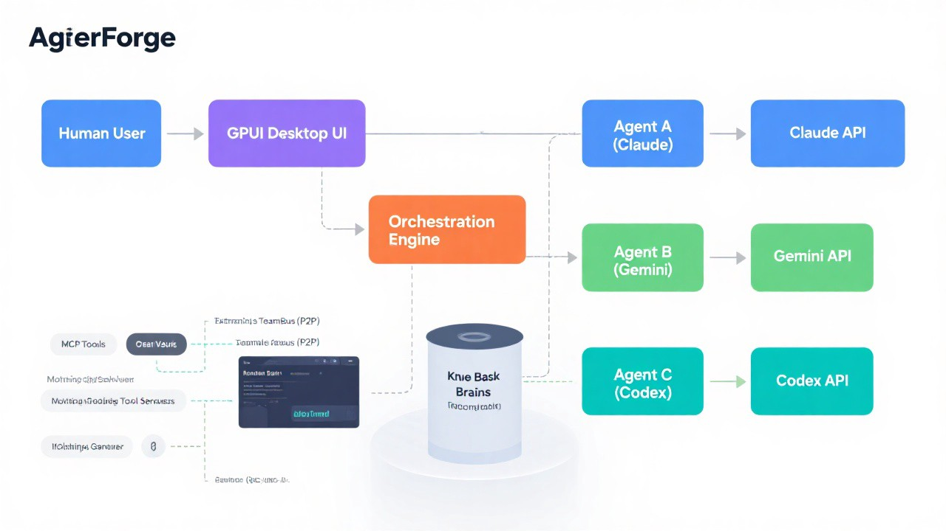
Figure 2: AgentForge Data Flow Overview / 图2：AgentForge数据流概览

3.3 Data Flow Descriptions / 数据流说明
User Request Flow / 用户请求流
The flow begins when a human user submits a task through the GPUI UI. The request is routed to the Orchestration Engine, which analyzes the task requirements and dispatches it to the appropriate agent(s). The engine may decompose complex tasks into multiple subtasks.
流程始于人类用户通过GPUI UI提交任务。请求被路由到编排引擎，引擎分析任务需求并将其分派给适当的智能体。引擎可能将复杂任务分解为多个子任务。
Agent Execution Flow / 智能体执行流
Each agent processes its assigned task by invoking the Provider Adapter layer, which translates the request into provider-specific API calls. The external AI provider processes the request and returns a response, which flows back through the adapter to the agent.
每个智能体通过调用提供者适配器层处理其分配的任务，适配器将请求转换为提供者特定的API调用。外部AI提供者处理请求并返回响应，响应通过适配器流回智能体。
Inter-Agent Communication / 智能体间通信
Agents communicate with each other through the TeamBus P2P routing system. This enables collaboration on shared tasks, knowledge sharing, and coordinated execution without requiring centralized mediation for every interaction.
智能体通过TeamBus P2P路由系统相互通信。这使得共享任务的协作、知识共享和协调执行成为可能，而无需为每次交互进行集中调解。
Data Persistence / 数据持久化
All agents write their results, state changes, and artifacts to SQLite through the Repository pattern. This ensures data consistency, enables recovery, and provides a queryable record of all system activities.
所有智能体通过Repository模式将其结果、状态变更和产物写入SQLite。这确保了数据一致性，支持恢复，并提供所有系统活动的可查询记录。
Knowledge Flow / 知识流
The Knowledge Base maintains a bidirectional synchronization with the Obsidian Vault. Agents can query the knowledge base for context and store new findings, while Obsidian provides human-readable access to the same knowledge corpus.
知识库与Obsidian仓库保持双向同步。智能体可以查询知识库获取上下文并存储新发现，而Obsidian为同一知识语料库提供人类可读的访问。
Tool Integration / 工具集成
MCP Tools enable agents to interact with external tool servers, extending their capabilities beyond core AI functions. This includes code execution, file operations, web access, and other specialized tools.
MCP工具使智能体能够与外部工具服务器交互，将其能力扩展到核心AI功能之外。这包括代码执行、文件操作、网络访问和其他专用工具。
Monitoring Flow / 监控流
All components emit metrics and events to the Monitoring Dashboard. This provides real-time visibility into system health, agent performance, task progress, and resource utilization.
所有组件向监控仪表板发送指标和事件。这提供了对系统健康状况、智能体性能、任务进度和资源利用率的实时可见性。
Document Output / 文档输出
The Document Generator reads aggregated data from the database and produces formatted output files (.doc, .md) that summarize task results, decisions, and deliverables.
文档生成器从数据库读取聚合数据，生成格式化的输出文件（.doc、.md），汇总任务结果、决策和交付物。

4. Agent Communication Sequence / 智能体通信序列

4.1 Overview / 概述
The agent communication sequence diagram illustrates the complete 18-step interaction flow when a human user submits a task that requires multi-agent collaboration. It shows how the Orchestration Engine coordinates agents, how agents communicate via TeamBus, and how results flow back to the user.
智能体通信序列图展示了当人类用户提交需要多智能体协作的任务时的完整18步交互流程。它展示了编排引擎如何协调智能体、智能体如何通过TeamBus通信，以及结果如何流回用户。

4.2 Sequence Diagram / 序列图
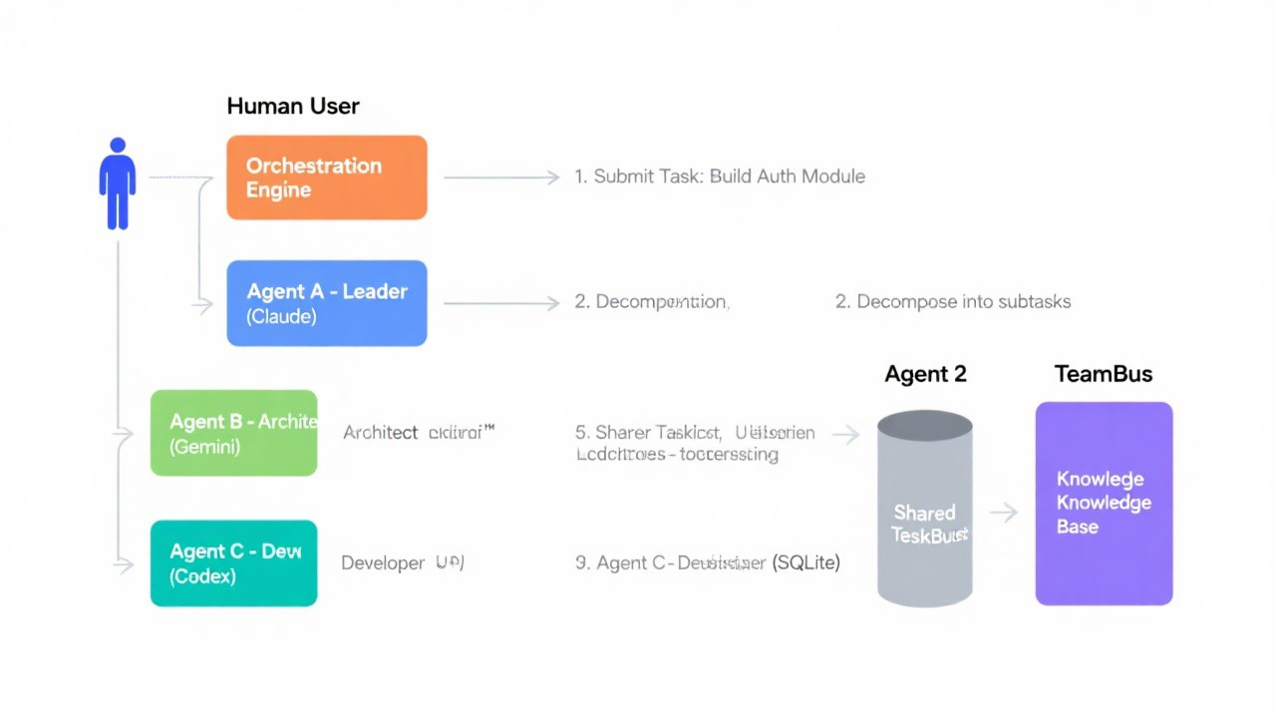
Figure 3: Agent Communication Sequence Diagram / 图3：智能体通信序列图

4.3 Step-by-Step Description / 逐步说明
Step 1
Human submits task to Orchestration Engine
人类向编排引擎提交任务
Step 2
Engine decomposes the task into subtasks based on complexity and requirements
引擎根据复杂度和需求将任务分解为子任务
Step 3
Tasks are created and stored in the SharedTaskList (SQLite)
任务被创建并存储在SharedTaskList（SQLite）中
Step 4
Engine assigns the "Lead Researcher" role to Agent A with a detailed briefing
引擎将"首席研究员"角色分配给智能体A，附带详细简报
Step 5
Engine assigns the "Schema Designer" role to Agent B with relevant context
引擎将"架构设计师"角色分配给智能体B，附带相关上下文
Step 6
Engine assigns the "Implementer" role to Agent C with implementation requirements
引擎将"实现者"角色分配给智能体C，附带实现需求
Step 7
All agents acknowledge their roles and initialize their contexts
所有智能体确认其角色并初始化上下文
Step 8
Agent A claims the first task from the SharedTaskList
智能体A从SharedTaskList认领第一个任务
Step 9
Agent A broadcasts its progress and initial findings via TeamBus
智能体A通过TeamBus广播其进展和初步发现
Step 10
Agent B sends a direct message to Agent A via TeamBus requesting schema collaboration
智能体B通过TeamBus向智能体A发送直接消息，请求架构协作
Step 11
Agent A responds with research findings relevant to the schema design
智能体A回复与架构设计相关的研究发现
Step 12
Agents B and A finalize the schema design through iterative TeamBus messages
智能体B和A通过迭代的TeamBus消息最终确定架构设计
Step 13
Agent B stores the finalized design in the Knowledge Base for future reference
智能体B将最终确定的设计存储在知识库中以供将来参考
Step 14
Agent C claims the implementation task from the SharedTaskList
智能体C从SharedTaskList认领实现任务
Step 15
Agent C queries the Knowledge Base to retrieve the schema design for implementation
智能体C查询知识库以检索架构设计用于实现
Step 16
Agent C broadcasts task completion via TeamBus to all team members
智能体C通过TeamBus向所有团队成员广播任务完成
Step 17
Agent A reports overall task completion and summary to the Orchestration Engine
智能体A向编排引擎报告整体任务完成和摘要
Step 18
Orchestration Engine returns the consolidated summary and results to the Human user
编排引擎将综合摘要和结果返回给人类用户

5. Provider Adapter Architecture / 提供者适配器架构

5.1 Overview / 概述
The Provider Adapter Architecture abstracts the differences between various AI providers, enabling AgentForge to work with multiple AI backends through a unified interface. This design supports provider-specific features while maintaining a consistent API for the rest of the system.
提供者适配器架构抽象了各种AI提供者之间的差异，使AgentForge能够通过统一接口与多个AI后端协同工作。这种设计在支持提供者特定功能的同时，为系统其余部分保持了一致的API。

5.2 Architecture Diagram / 架构图
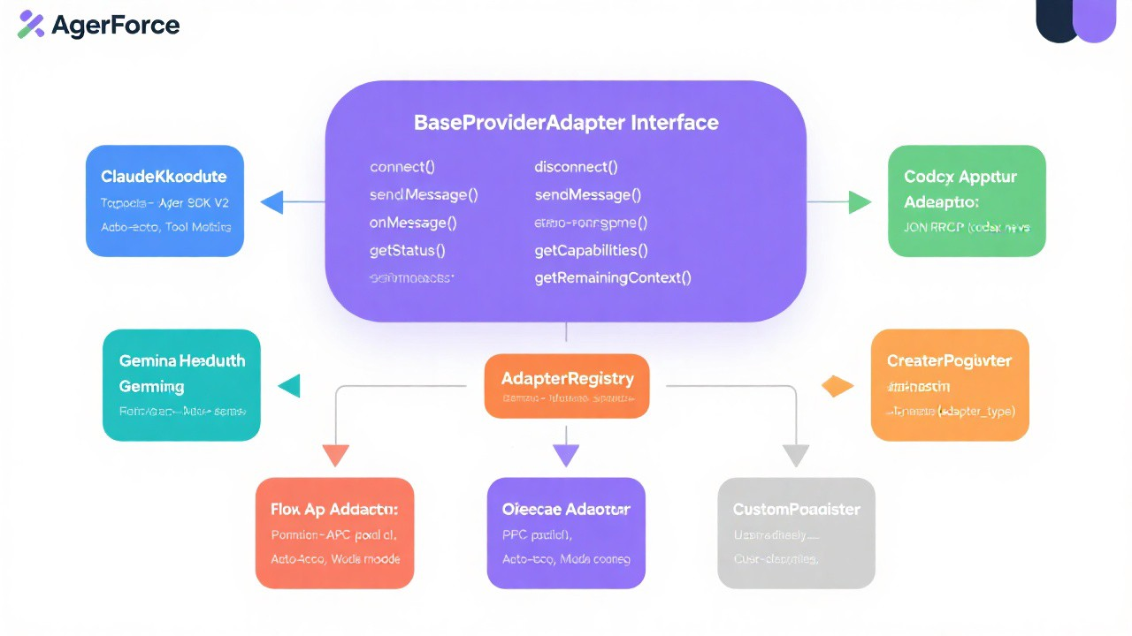
Figure 4: Provider Adapter Architecture / 图4：提供者适配器架构

5.3 Component Descriptions / 组件说明
BaseProviderAdapter Interface / 基础提供者适配器接口
The BaseProviderAdapter defines 7 core methods that all concrete adapters must implement:
- initialize() - Set up provider connection and authentication / 初始化提供者连接和认证
- send_message() - Send a message to the AI provider / 向AI提供者发送消息
- receive_response() - Receive and parse provider response / 接收和解析提供者响应
- stream_response() - Handle streaming responses for real-time output / 处理流式响应以实现实时输出
- validate_connection() - Verify provider connectivity / 验证提供者连接性
- get_capabilities() - Return provider feature set / 返回提供者功能集
- shutdown() - Clean up resources and close connections / 清理资源并关闭连接
Adapter Implementations / 适配器实现
Six concrete adapter implementations support different AI providers, each with provider-specific protocols and features:
- ClaudeAdapter - Anthropic Claude API (HTTP/REST, streaming, session resume)
- CodexAdapter - OpenAI Codex API (HTTP/REST, function calling, auto-accept)
- GeminiAdapter - Google Gemini API (gRPC, multimodal, long context)
- iFlowAdapter - iFlow Workflow Engine (custom protocol, DAG execution)
- OpenCodeAdapter - OpenCode provider (HTTP/REST, code generation)
- CustomAdapter - User-defined providers (configurable protocol)
AdapterRegistry / 适配器注册表
The AdapterRegistry implements the factory pattern, managing adapter instantiation and lifecycle. It provides adapter lookup by provider name and handles adapter registration at startup.
AdapterRegistry实现了工厂模式，管理适配器的实例化和生命周期。它通过提供者名称提供适配器查找，并在启动时处理适配器注册。
Event Normalization / 事件标准化
The toolMapping system normalizes events from different providers into a unified event format. This ensures that the Agent Management Layer receives consistent data regardless of which provider is being used.
toolMapping系统将来自不同提供者的事件标准化为统一的事件格式。这确保了智能体管理层无论使用哪个提供者都能接收到一致的数据。
Circuit Breaker Pattern / 断路器模式
A circuit breaker pattern is implemented for failover handling. When a provider becomes unresponsive or returns errors beyond a threshold, the circuit breaker opens and routes requests to alternative providers. This ensures system resilience and availability.
实现了断路器模式用于故障转移处理。当提供者变得无响应或返回超过阈值的错误时，断路器打开并将请求路由到备用提供者。这确保了系统的弹性和可用性。

6. Database Entity-Relationship Diagram / 数据库实体关系图

6.1 Overview / 概述
The database entity-relationship diagram illustrates the complete data model of AgentForge, showing all 14 tables organized into 7 functional domains, their attributes, and the relationships between them.
数据库实体关系图展示了AgentForge的完整数据模型，显示了组织在7个功能域中的所有14个表、它们的属性以及它们之间的关系。

6.2 ER Diagram / 实体关系图
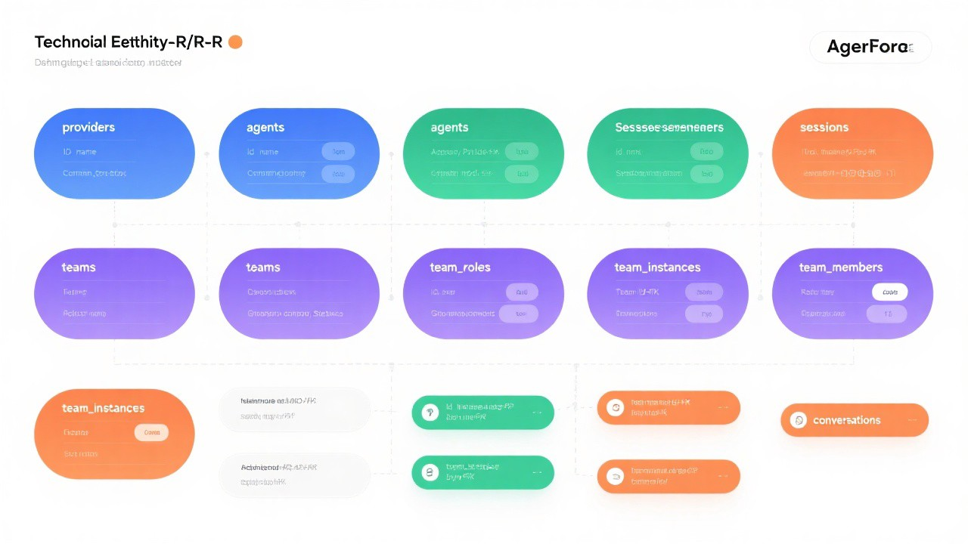
Figure 5: Database Entity-Relationship Diagram / 图5：数据库实体关系图

6.3 Table Domains / 表域
Domain 1: Provider Configuration / 提供者配置域
- providers - AI provider configurations (API keys, endpoints, settings)
- provider_stats - Provider usage statistics and performance metrics
Domain 2: Agent Management / 智能体管理域
- agents - Agent definitions, capabilities, and status
- agent_memories - Persistent agent memory and learning data
Domain 3: Team & Task Management / 团队与任务管理域
- teams - Team definitions and configurations
- team_instances - Active team execution instances
- team_members - Agent membership in teams
- team_tasks - Task assignments with self-referential parent/child subtask relationships
Domain 4: Session & Conversation / 会话与对话域
- sessions - User interaction sessions
- conversations - Individual conversation threads within sessions
Domain 5: Knowledge Management / 知识管理域
- knowledge_entries - Knowledge base entries with FTS5 full-text search
- knowledge_tags - Tag assignments for knowledge categorization
Domain 6: Audit & Compliance / 审计与合规域
- audit_log - Polymorphic audit trail referencing all entities
Domain 7: System Configuration / 系统配置域
- system_config - System-wide configuration key-value store

6.4 Key Relationships / 关键关系
- providers -> agents: One provider can support multiple agents (1:N)
- teams -> team_instances -> team_members -> team_tasks: Full team hierarchy chain
- sessions -> conversations: One session contains multiple conversations (1:N)
- team_tasks self-referential: parent_id enables hierarchical subtask decomposition
- audit_log polymorphic: entity_type + entity_id references any table in the system
- knowledge_entries FTS5: Virtual table enables fast full-text search across knowledge

7. iFlow Workflow Engine / 智能工作流引擎

7.1 Overview / 概述
The iFlow Workflow Engine provides a visual DAG (Directed Acyclic Graph) based workflow designer and execution environment. It enables users to define complex multi-step processes that combine agent tasks, human approvals, conditional branching, and data transformations into executable workflows.
iFlow工作流引擎提供基于可视化DAG（有向无环图）的工作流设计器和执行环境。它使用户能够将智能体任务、人工审批、条件分支和数据转换组合成可执行的工作流，定义复杂的多步骤流程。

7.2 Architecture Diagram / 架构图
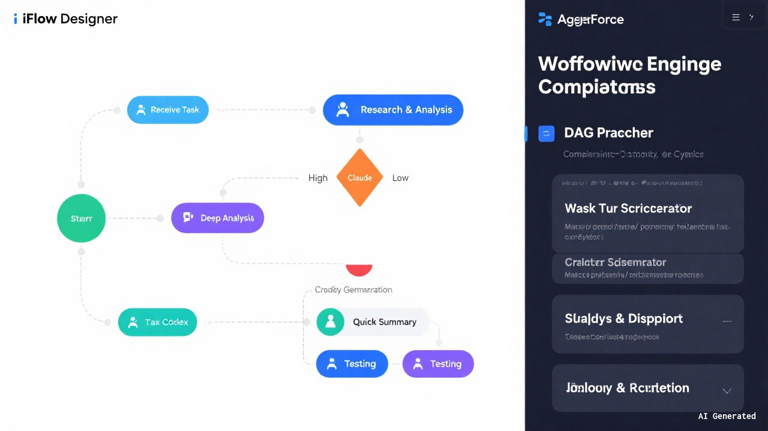
Figure 6: iFlow Workflow Engine Architecture / 图6：iFlow工作流引擎架构

7.3 Component Descriptions / 组件说明
Visual DAG Workflow Designer / 可视化DAG工作流设计器
The visual designer provides a drag-and-drop interface for creating workflows. Supported node types include:
- Start/End Nodes - Define workflow boundaries / 定义工作流边界
- Agent Task Nodes - Assign work to specific agents / 将工作分配给特定智能体
- Decision Nodes - Conditional branching based on data / 基于数据的条件分支
- Transform Nodes - Data transformation and mapping / 数据转换和映射
- Human Review Nodes - Manual approval gates / 人工审批关卡
- Parallel Nodes - Concurrent execution paths / 并发执行路径
Workflow Engine Components / 工作流引擎组件
- DAG Parser - Validates workflow structure and resolves dependencies / 验证工作流结构并解析依赖关系
- Task Scheduler - Determines execution order based on DAG topology / 基于DAG拓扑确定执行顺序
- Agent Dispatcher - Assigns tasks to agents based on capabilities and availability / 基于能力和可用性将任务分配给智能体
- State Manager - Tracks workflow and node execution state / 跟踪工作流和节点执行状态
- Data Router - Manages data flow between workflow nodes / 管理工作流节点间的数据流
- Error Handler - Implements error handling patterns / 实现错误处理模式
Execution Monitoring / 执行监控
Real-time progress tracking provides visibility into workflow execution. Each node displays its current status (pending, running, completed, failed, skipped) and the overall workflow progress is shown on the monitoring dashboard.
实时进度跟踪提供工作流执行的可视性。每个节点显示其当前状态（待处理、运行中、已完成、失败、已跳过），整体工作流进度显示在监控仪表板上。
Error Handling Patterns / 错误处理模式
- Retry - Automatic retry with exponential backoff for transient failures / 指数退避自动重试瞬态故障
- Fallback - Route to alternative agent or provider on persistent failure / 持续故障时路由到备用智能体或提供者
- Circuit Breaker - Stop attempting failed operations after threshold / 超过阈值后停止尝试失败的操作
- Manual Review - Escalate to human operator for complex error resolution / 升级到人工操作员处理复杂错误

8. Operating Modes / 运行模式

8.1 Overview / 概述
AgentForge supports three distinct operating modes that determine the level of human involvement in agent operations. Users can seamlessly switch between modes with full context preservation, allowing them to choose the right balance of autonomy and control for each task.
AgentForge支持三种不同的运行模式，决定人类在智能体操作中的参与程度。用户可以在模式间无缝切换，完全保留上下文，从而为每个任务选择适当的自主性和控制平衡。

8.2 Operating Modes Diagram / 运行模式图
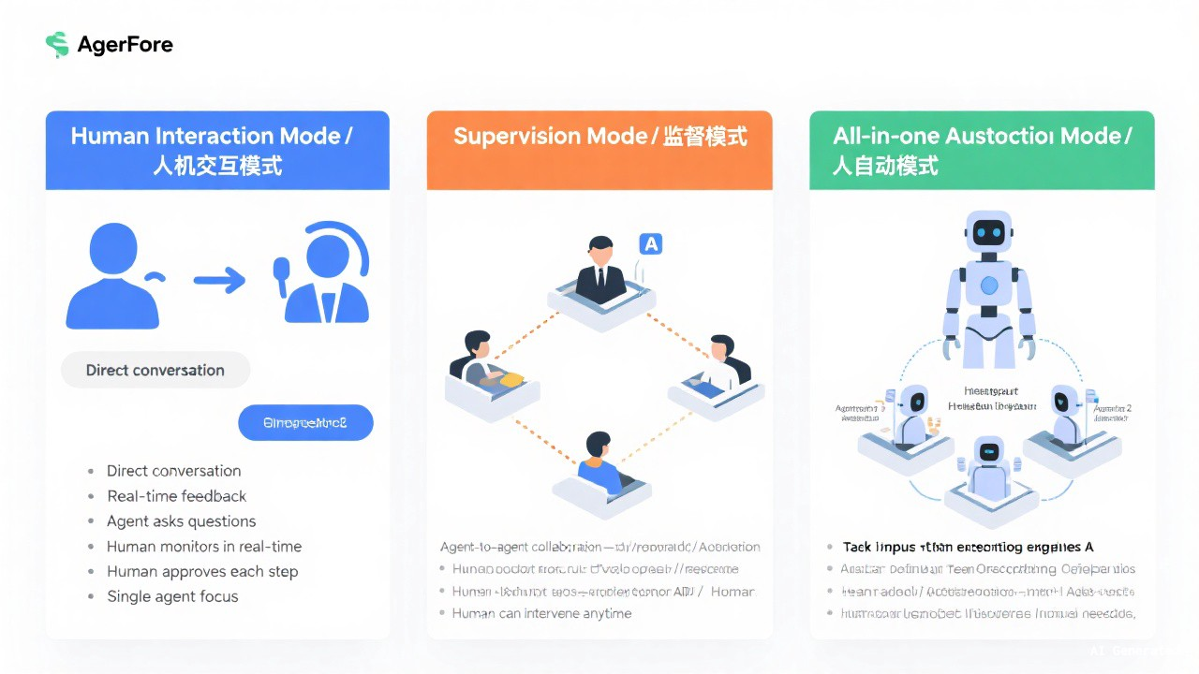
Figure 7: Three Operating Modes Comparison / 图7：三种运行模式对比

8.3 Mode Descriptions / 模式说明
Mode 1: Human Interaction Mode / 人机交互模式
In Human Interaction Mode, the user directly communicates with individual agents through a chat interface. Every agent action requires explicit human approval before execution. This mode provides maximum control and is ideal for exploratory work, learning, and sensitive operations.
在人机交互模式下，用户通过聊天界面直接与各个智能体通信。每个智能体操作都需要人类明确批准才能执行。此模式提供最大控制力，适合探索性工作、学习和敏感操作。
- Direct human-agent chat interface / 直接的人机聊天界面
- Real-time feedback on every action / 每个操作的实时反馈
- Explicit approval required for all agent actions / 所有智能体操作需要明确批准
- Full visibility into agent reasoning and decisions / 完全可见智能体推理和决策
Mode 2: Supervision Mode / 监督模式
In Supervision Mode, agents collaborate with each other autonomously while the human user monitors the process. The user can intervene at any point but is not required to approve every action. This mode is ideal for well-defined tasks where oversight is desired but micromanagement is not.
在监督模式下，智能体自主协作，人类用户监控过程。用户可以随时干预，但不需要批准每个操作。此模式适合需要监督但不需要微观管理的明确定义的任务。
- Agent-agent collaboration with human monitoring / 智能体间协作配合人类监控
- Periodic status updates and progress reports / 定期状态更新和进度报告
- User can intervene at any point / 用户可以随时干预
- Alerts for critical decisions or errors / 关键决策或错误的警报
Mode 3: All-in-one Autonomous Mode / 全自动模式
In All-in-one Autonomous Mode, the system operates completely independently from end to end. The user provides the initial task specification, and AgentForge handles all decomposition, agent coordination, execution, and result delivery without human intervention. This mode is ideal for repetitive tasks, batch processing, and trusted workflows.
在全自动模式下，系统从端到端完全独立运行。用户提供初始任务规范，AgentForge处理所有分解、智能体协调、执行和结果交付，无需人类干预。此模式适合重复性任务、批处理和可信工作流。
- Fully autonomous end-to-end execution / 完全自主的端到端执行
- No human intervention required / 无需人类干预
- Automated error recovery and fallback / 自动错误恢复和回退
- Batch task processing support / 批量任务处理支持
Mode Transition / 模式切换
Seamless mode switching is supported with full context preservation. When transitioning between modes, all agent states, conversation history, task progress, and knowledge base entries are preserved. Governance constraints are automatically adjusted based on the selected mode.
支持无缝模式切换，完全保留上下文。在模式之间切换时，所有智能体状态、对话历史、任务进度和知识库条目都被保留。治理约束根据所选模式自动调整。

9. Diagram Legend & Conventions / 图例与约定

9.1 Color Coding / 颜色编码
The following color scheme is used consistently across all diagrams:
- Blue / 蓝色 - UI and User-facing components / UI和面向用户的组件
- Orange / 橙色 - Orchestration and coordination components / 编排和协调组件
- Green / 绿色 - Agent components and execution / 智能体组件和执行
- Purple / 紫色 - Communication and messaging / 通信和消息传递
- Gray / 灰色 - External systems and infrastructure / 外部系统和基础设施

9.2 Shape Conventions / 形状约定
- Rectangle / 矩形 - System component or module / 系统组件或模块
- Diamond / 菱形 - Decision point or conditional logic / 决策点或条件逻辑
- Rounded Rectangle / 圆角矩形 - Start or End point / 起始或结束点
- Cylinder / 圆柱体 - Database or persistent storage / 数据库或持久化存储
- Parallelogram / 平行四边形 - Input or Output data / 输入或输出数据
- Circle / 圆形 - Connection point or junction / 连接点或汇合点

9.3 Arrow Types / 箭头类型
- Solid Arrow / 实线箭头 - Direct data flow / 直接数据流
- Dashed Arrow / 虚线箭头 - Communication or messaging channel / 通信或消息通道
- Dotted Arrow / 点线箭头 - Monitoring or metrics flow / 监控或指标流
- Thick Arrow / 粗箭头 - Primary or critical data path / 主要或关键数据路径

9.4 Line Styles / 线条样式
- Crow's Foot Notation / 鸦爪表示法 - Used in ER diagrams to show cardinality / 用于ER图中显示基数
- Sequence Numbers / 序列号 - Used in sequence diagrams to show message order / 用于序列图中显示消息顺序
- Layer Grouping / 层分组 - Dashed rectangles group related components / 虚线矩形分组相关组件

10. References / 参考文献

10.1 AgentForge Documentation / AgentForge文档
- AgentForge Business Requirements Document (BRD) / 业务需求文档
- AgentForge Product Requirements Document (PRD) / 产品需求文档
- AgentForge Software Requirements Specification (SRS) / 软件需求规格说明
- AgentForge Database Design Document / 数据库设计文档
- AgentForge Technical Specification / 技术规格说明
- AgentForge UI Design Document / UI设计文档

10.2 Technology References / 技术参考
- GPUI Component Documentation - longbridge/gpui-component
- SQLite Documentation - https://www.sqlite.org/docs.html
- rusqlite Crate Documentation - https://docs.rs/rusqlite
- MCP (Model Context Protocol) Specification
- Rust Programming Language Documentation - https://doc.rust-lang.org

10.3 Architecture References / 架构参考
- Clean Architecture - Robert C. Martin
- Designing Data-Intensive Applications - Martin Kleppmann
- Microservices Patterns - Chris Richardson
- Domain-Driven Design - Eric Evans

