

Music School
Management System

Java OOP Project Report
Conservatoire Virtuel Project
Course: JavaOOP - ING2_New
Authors: Tien Vuong VU / Quoc-Trung TUONG
1. Project description 3
1.1 Context and problem 3
1.2 Objectives and scope 3
2. Requirements and business rules 3
2.1 Functional requirements 3
2.2 Business rules 3
2.3 Requirement coverage 3
3. Architecture and design rationale 4
3.1 Packages and responsibilities 4
3.2 Interaction flow 4
3.3 Design decisions 5
4. UML design 5
4.1 Class diagram 5
4.2 Scheduling sequence diagram 5
4.3 Exam registration activity diagram 6
5. Object oriented design requirements 8
5.1 Abstract classes 8
5.2 Interfaces 8
5.3 Polymorphic collections and dynamic dispatch 8
5.4 Copy constructors 8
5.5 Encapsulation and defensive copies 8
5.6 Inheritance composition and type choices 8
6. Database design 9
6.1 ERD and table responsibilities 9
6.2 Constraints and data conventions 9
8. Testing scenario and results 10
8.1 Test environment and initial data 10
8.2 Manual test coverage 10
8.3 Detailed test records 10
8.4 Unit tests if implemented 25
8.5 Defects fixes and limitations 27
10. Project organization 27
10.1 Responsibilities and collaboration 27
10.2 Challenges and solutions 28
11. References 28

1. Project description

1.1 Context and problem
- Conservatoire Virtuel is a private music school that needs a central system for students, teachers, lessons, resources, exams and billing
- The application brings these records together and checks important scheduling and enrollment rules.

1.2 Objectives and scope
- The project is a Java OOP application with a console menu, a Swing GUI and MySQL persistence
- It supports internal school administration
- The submitted scope is a local application
- user authentication, online payments and a web API are not implemented.

2. Requirements and business rules

2.1 Functional requirements
- Manage student profiles and preferred instruments.
- Manage teacher specializations and availability.
- Maintain rooms and instruments.
- Offer finite and unlimited packages.
- Track enrollment and usage history.
- Schedule individual, group and single paid lessons.
- Manage rentals, exams and results.
- Record payments, outstanding balances and monthly summaries.

2.2 Business rules
- Use packages only within their enrollment validity dates and available allowance.
- Each lesson lasts 60 minutes.
- A group lesson reserves one hour for each participant.
- Cancelling less than 24 hours before the start consumes the hour.
- Earlier cancellation releases the hour.
- Prevent double booking of resources and people.
- Limit exam registration to the available capacity.
- Implementation choice: single paid lessons cost 4000 cents.
- Implementation choice: payment cannot exceed the outstanding balance.
- Implementation choice: cancelling a rental does not automatically refund its charge.

2.3 Requirement coverage
- The main requirement groups have corresponding model, controller, service and repository classes
- The table below identifies representative implementation locations
- Execution evidence and final verification status must be completed after manual testing.

Requirement | Implementation | Status
Enrollment, lessons and billing | - EnrollmentService  - SchedulingService  - RentalService  - BillingService | - Implemented  - manual verification pending
People, resources and exams | - StudentService  - TeacherService  - ResourceService  - ExamService | - Implemented  - manual verification pending

3. Architecture and design rationale

3.1 Packages and responsibilities
- Root package: org.app.
- model: domain objects.
- controller: request entry points.
- service: business rules.
- repository: SQL operations.
- database: JDBC, initialization and loading.
- view: console menus.
- gui: Swing interface.
Package | Responsibility | Main classes
model / controller / service | - Domain state  - request entry points  - business rules | - Activity, Enrollment  - SchedulingController  - SchedulingService
repository / database / view / gui | SQL, initialization, console menus and Swing presentation | - LessonRepository  - DbContext  - ConfigurationMenu  - MainFrame

3.2 Interaction flow
- For enrollment, the user enters student, package and validity details in the GUI.
- EnrollmentController calls EnrollmentService, which checks the references and builds an enrollment with a package snapshot.
- EnrollmentRepository and ChargeRepository save the enrollment and charge in one transaction.
- The GUI then refreshes the displayed records.

3.3 Design decisions
- Plain Java and JDBC keep the implementation suitable for an introductory OOP course
- Console and GUI reuse the same controllers and services, so business rules do not need to be duplicated in each interface.
- Repositories separate SQL from domain logic.
- Transactions keep related database writes consistent.

4. UML design

4.1 Class diagram
- Person generalizes Student and Teacher.
- Activity generalizes Lesson, Exam and Rental.
- CoursePackage generalizes FinitePackage and UnlimitedPackage.
- Enrollment owns a copied package snapshot, while lessons and exams contain participation or registration objects.
- The diagram should show these relationships and their multiplicities.
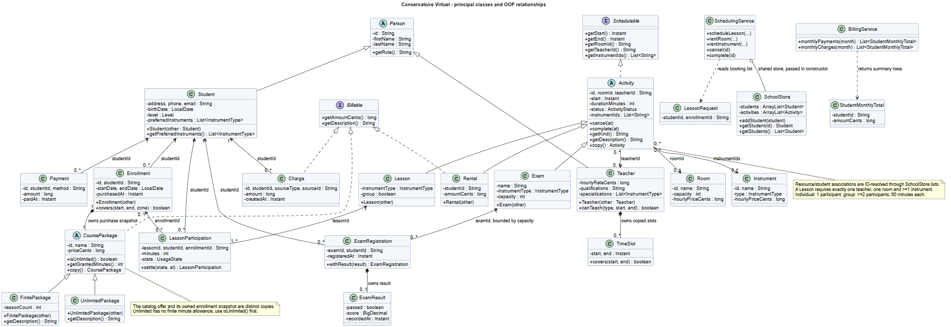
Figure 1. Overview of the principal classes, inheritance and object relationships.

4.2 Scheduling sequence diagram
- The user submits a lesson through SchedulingController
- SchedulingService loads teachers, rooms, instruments, students, enrollments and existing activities, validates the request and rejects conflicts
- It saves the activity, resources, participations and any single-lesson charges in a shared transaction, then returns the result.
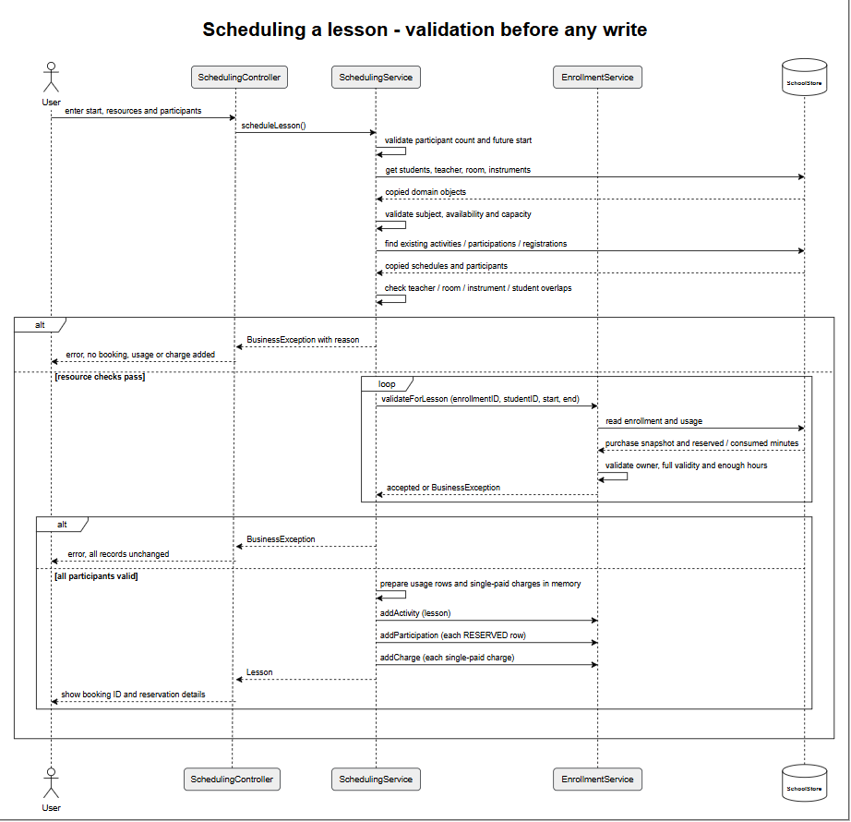
Figure 2. Lesson scheduling sequence showing validation, conflict rejection and creation of booking records.

4.3 Exam registration activity diagram
- The registration flow checks that the exam and student exist
- The exam must still accept registrations, have capacity and contain no duplicate registration
- The service checks the student's overlapping activities before saving the registration
- An invalid request returns an error.
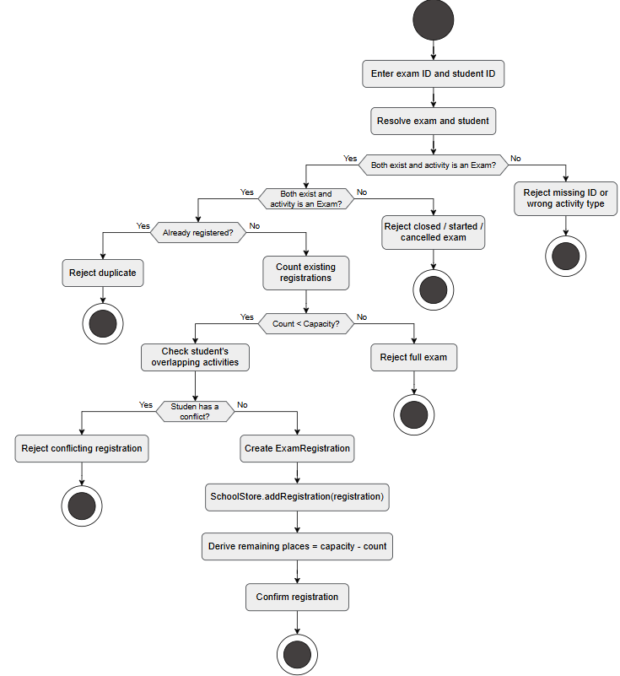
Figure 3. Exam registration activity flow with existence, duplicate, capacity and schedule-conflict checks.

5. Object oriented design requirements

5.1 Abstract classes
- The project includes three abstract classes
- Person shares identity and name between Student and Teacher
- Activity shares time, duration and lifecycle behavior between Lesson, Exam and Rental
- CoursePackage shares package identity, name and price between finite and unlimited packages.

5.2 Interfaces
- Schedulable defines getStart() and getEnd() for activities
- Billable defines getPriceCents() for packages and rentals
- These interfaces represent independent capabilities, while abstract classes hold shared implementation.

5.3 Polymorphic collections and dynamic dispatch
- DbLoader.loadActivities() returns a List<Activity> containing Lesson, Exam and Rental objects
- Calls such as activity.getKind() and activity.copy() execute the concrete subclass implementation at runtime
- FinitePackage and UnlimitedPackage also override package behavior.
Example: for (Activity activity : DbLoader.loadActivities()) System.out.println(activity.getKind());

5.4 Copy constructors
- Key classes such as Student, Teacher, Enrollment, Lesson, Exam and Rental provide copy constructors
- Teacher copies its availability slots
- Enrollment copies its package snapshot
- Exam copies registrations
- This supports duplication without sharing those mutable internal objects.
Example: Rental copied = new Rental(original); copied.cancel(beforeStart);

5.5 Encapsulation and defensive copies
- Domain fields are private and constructors validate values
- Activity changes state through cancel() and complete()
- Teacher returns copies of its specialization and availability lists, and Enrollment returns a package copy
- One remaining encapsulation limitation is Student.getPreferredInstruments(), which currently returns the internal list directly.

5.6 Inheritance composition and type choices
- Inheritance represents the shared nature of people, activities and packages
- Composition is used for an enrollment's package snapshot and an exam's registration objects
- Abstract types such as Activity allow common processing of different concrete activities, while concrete classes retain their own data and behavior.

6. Database design

6.1 ERD and table responsibilities
- The database contains 16 business tables.
- student and teacher: profiles.
- student_preference, teacher_specialization and teacher_availability: preferences, specializations and availability.
- room and instrument: resources.
- package_offer and enrollment: offers and purchased snapshots.
- activity: lessons, exams and rentals.
- activity_instrument: assigned instruments.
- lesson_participation: individual lesson participation and usage.
- exam_registration and exam_result: registrations and results.
- charge and payment: billing records.
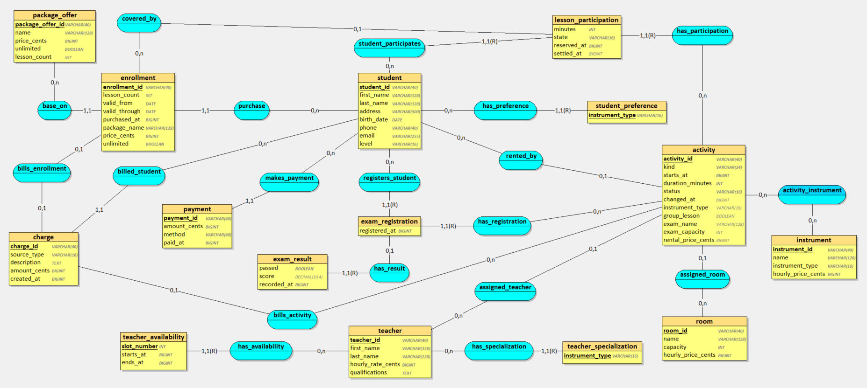

6.2 Constraints and data conventions
- Entity IDs: VARCHAR(40), using letters, digits, underscores or hyphens; no AUTO_INCREMENT.
- Charge and payment IDs can be generated by repository methods; several forms require an ID.
- Money: integer cents.
- Date-only values: DATE.
- Timestamps: BIGINT epoch seconds with Europe/Paris conversion.
- Foreign keys enforce references; composite keys prevent duplicate links.
- NULL enrollment_id: a single paid lesson.
- NULL exam score: no score, distinct from zero.

7. Testing scenario and results

7.1 Test environment and initial data
- The SQL seed includes students, teachers with specializations and availability, rooms, instruments, packages, enrollments, activities, exam registrations and results, charges and payments
- For repeatable manual tests, use separate QA records and future activity dates so existing records do not change the expected totals.

7.2 Manual test coverage
- Create, find and update operations.
- Enrollment with charge creation and rollback.
- Finite and unlimited learning time; package expiry.
- Lesson conflicts and teacher specialization/availability.
- Group consumption and early/late cancellation.
- Lesson completion.
- Rental pricing and lifecycle.
- Exam capacity and results.
- Payments and monthly summaries.
- Reject invalid inputs without partial writes.

7.3 Detailed test records
Test | Steps / sample data | Expected result | Actual result
MT01  Startup | - Configuration > 9: retry initialization on the existing seeded database. | - Initialization succeeds.  - Message: seed already processed; existing data retained. | 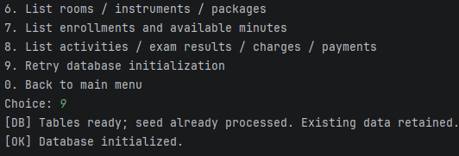
MT02  Students | - 29: read STU_001.  - 30: create STU_TEST_01, Mai Hoang Ng; DOB 2005-01-03; BEGINNER; PIANO.  - 31: update to ADVANCED; PIANO and GUITAR. Read again with 29.  - 30: retry STU_TEST_01 with level EXPERT. | - Student is created and updated; detail reloads as ADVANCED with GUITAR/PIANO.  - EXPERT is rejected: Unknown student level.  - The invalid-level attempt does not separately prove duplicate-ID validation. | 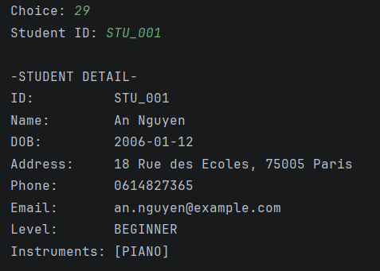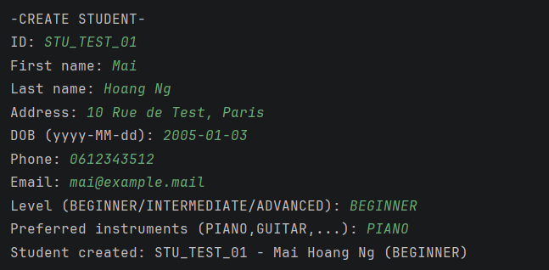  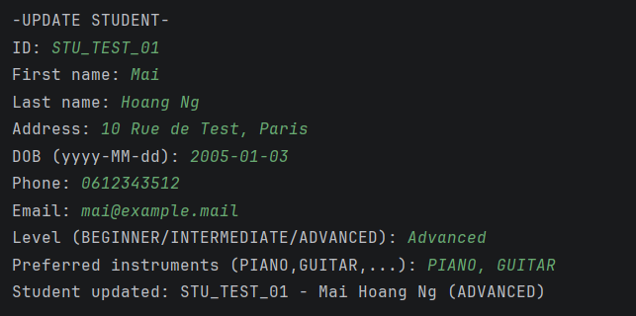  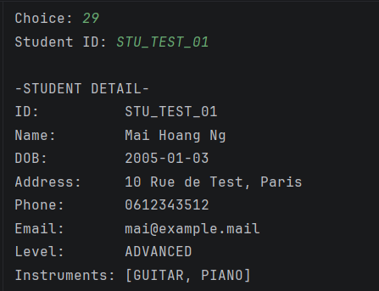  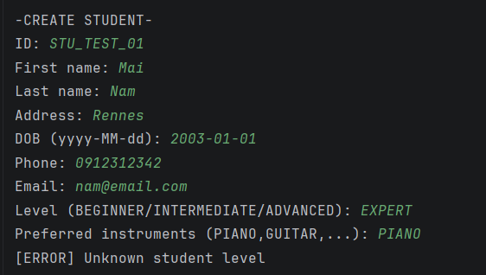
MT03  Teachers | - 33: read TCH_002 and TCH_007.  - 37: add TCH_007 availability on 2026-11-05, 08:00–18:00; read again.  - 37: try 18:00–08:00 on the same date. | - TCH_007 retains its 2026-11-09 slot and gains the 2026-11-05 slot.  - Reversed interval rejected: Availability end must follow start! | 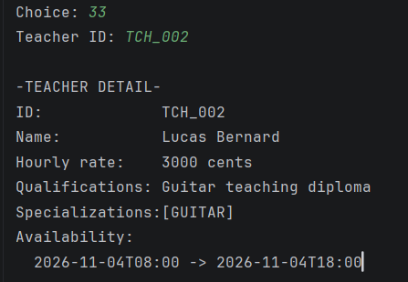  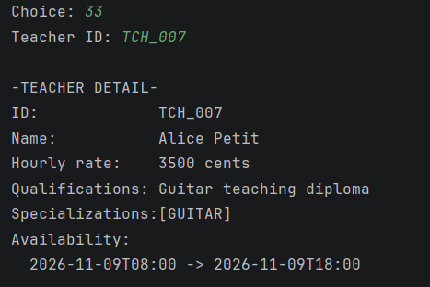  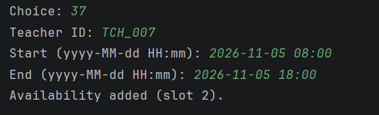  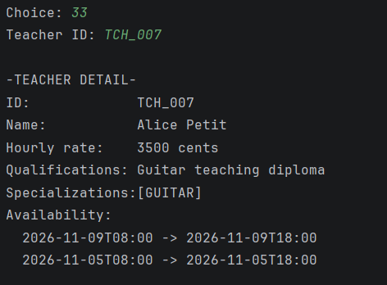  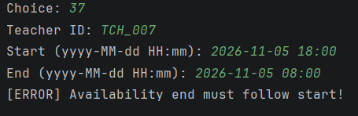
MT04  Enrollment | - 26: read STU_001 billing; starting balance 13600 cents.  - 12: STU_001 + PKG_INTRO_03; ENR_MT15_01 / CHG_MT15_01; valid 2026-11-01 to 2026-11-30.  - First try invalid end date 2026-11-31, then correct it.  - Read 13/26. Retry ENR_MT15_FAIL with existing CHG_001. | - Invalid date prompts for another date.  - Enrollment and one 12000-cent charge save; 180 minutes available.  - Charged: 22600 → 34600; balance: 13600 → 25600 cents; paid stays 9000.  - Existing charge ID is rejected; no success message. | 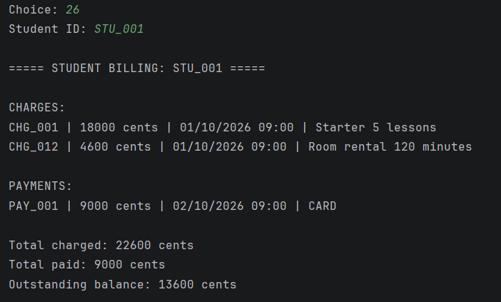  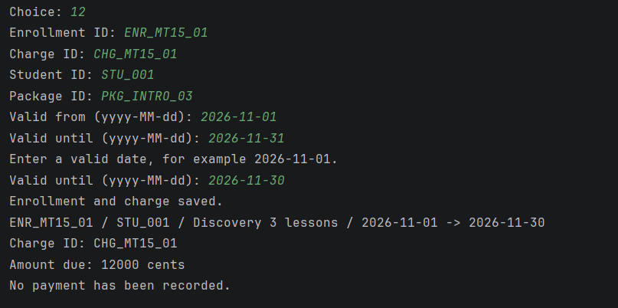  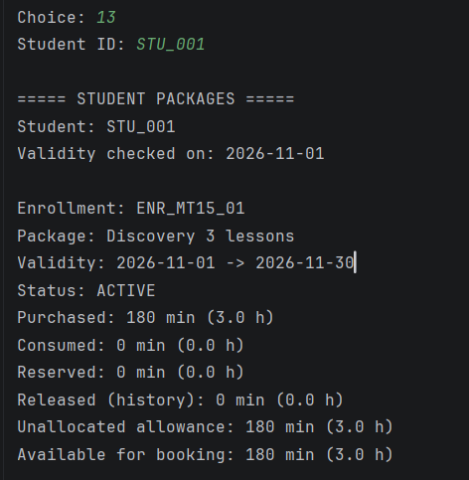  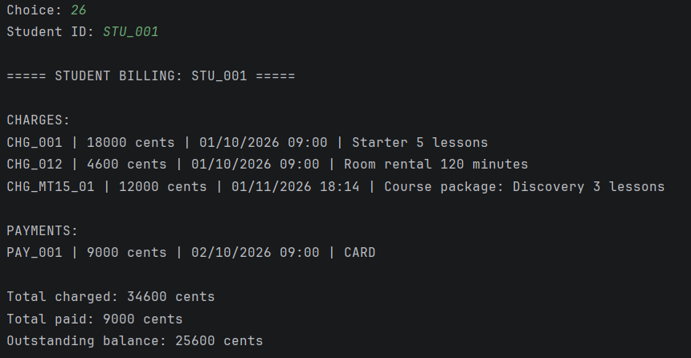  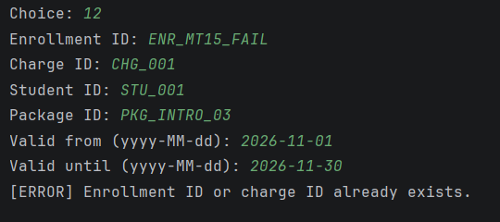
MT05  Package hours | - 13: read STU_004 / ENR_004, STU_008 / ENR_008 and STU_010 / ENR_010.  - 14: read STU_010 history.  - 15: LES_MT15_EXP, 2026-11-04 17:00; TCH_002 / RM_GT_02 / GUITAR / GT_02; STU_010 / ENR_010. | - ENR_004: 1200 available minutes at this stage.  - ENR_008: UNLIMITED; ENR_010: EXPIRED, 0 available.  - History shows LES_FL_01 as a single paid lesson.  - Expired-package booking rejected: whole lesson must be within validity dates. | 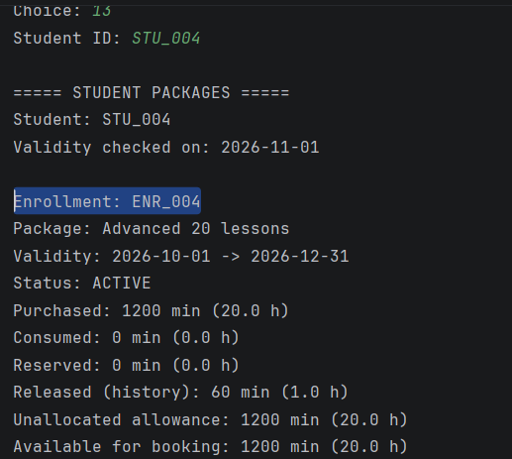  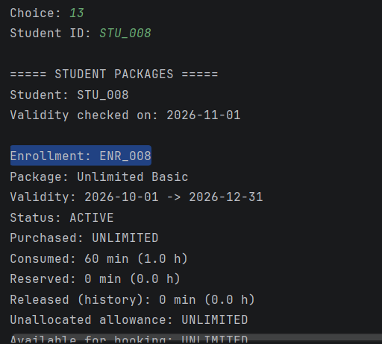  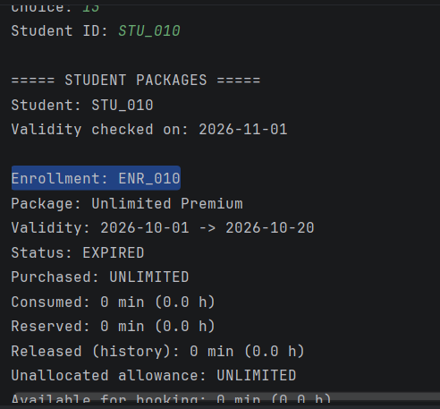  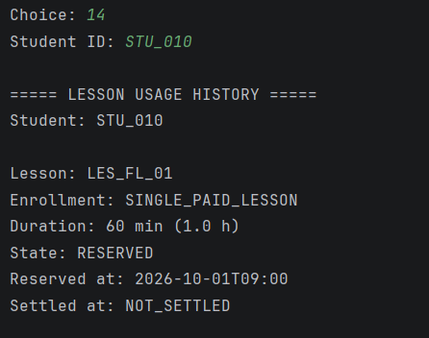  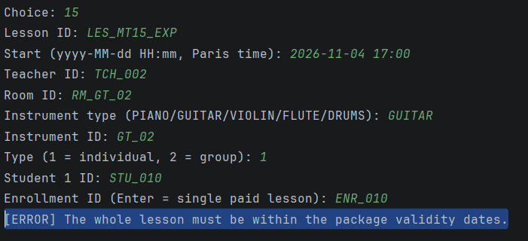
MT06  Scheduling | - 15: create LES_MT15_BAD on 2026-11-04 at 10:30 for 60 min.  - Use TCH_002 / RM_GT_01 / GUITAR / GT_01; individual STU_004 / ENR_004.  - Try LES_MT15_EARLY at 11:00 with the same resources.  - Read 13/14 for STU_004. | - 10:30 booking saves: LES_MT15_BAD, 10:30–11:30, RESERVED 60 min.  - 11:00 booking rejected: Room conflict with LES_MT15_BAD.  - ENR_004: 60 reserved, 1140 available minutes. | 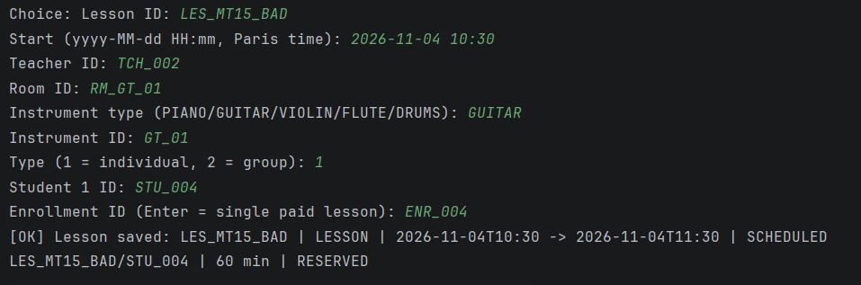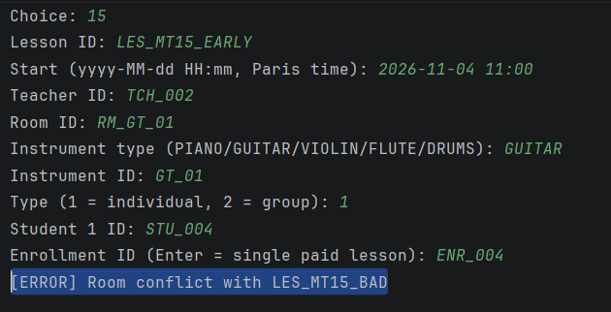  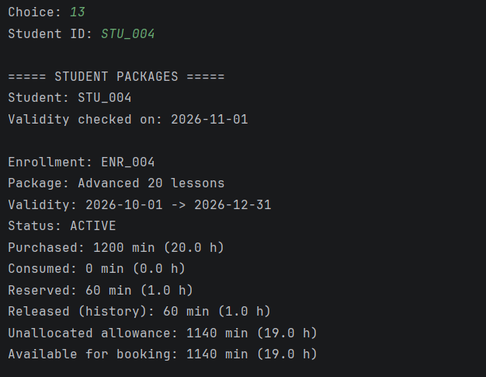  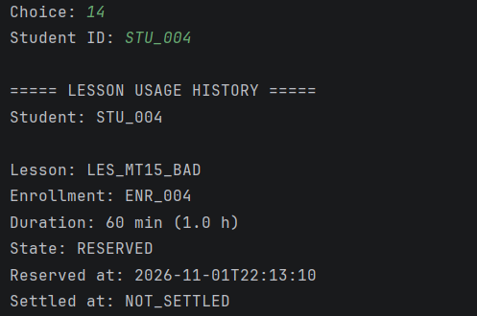
MT07  Group lesson | - 15: LES_MT15_GROUP, 2026-11-04 12:00; TCH_002 / RM_GT_01 / GUITAR / GT_01.  - Group of 2: STU_004 / ENR_004 and STU_005 / ENR_005. Read 13/14.  - 40: create RM_MT15_SMALL, capacity 1, hourly price 1000 cents.  - 15: try LES_MT15_CAP at 13:00 in that room with 2 students (the screenshot enters ENR_004 for both). | - Group booking saves; each student reserves 60 min.  - STU_004 / ENR_004: total reserved 120, available 1080 min at this stage.  - Small-room attempt rejected: Room capacity exceeded.  - This rejection tests capacity; it does not establish enrollment ownership validation. | 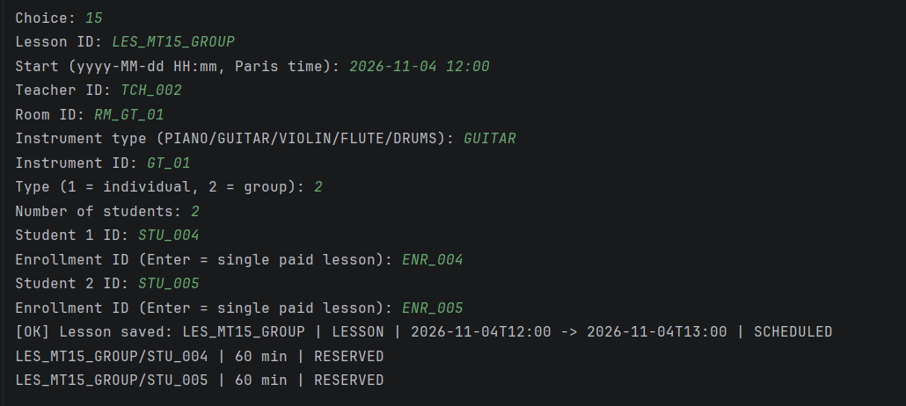  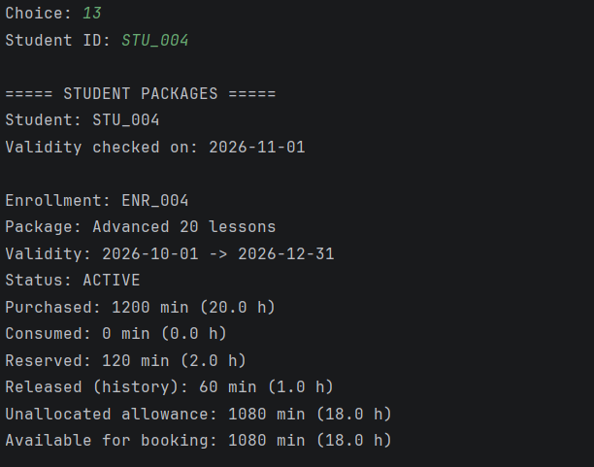  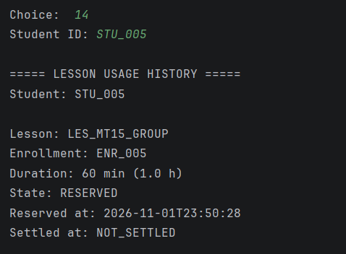  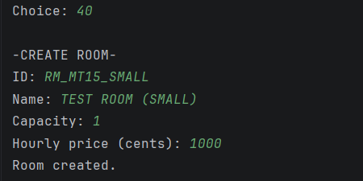  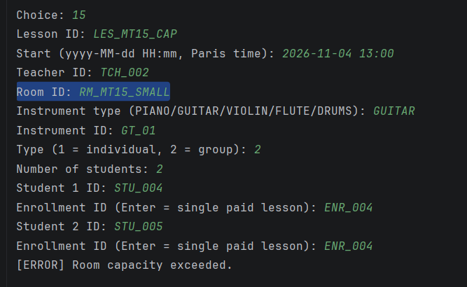
MT08  Early cancellation | - 13: read STU_004 / ENR_004: 1080 available, 120 reserved.  - 16: cancel LES_MT15_BAD before its 24-hour cutoff (2026-11-03 10:30).  - Read 13 again; retry cancellation. | - Lesson cancelled; participation RELEASED; 60 min returned.  - Available: 1080 → 1140; reserved: 120 → 60; released history: 60 → 120 min.  - Repeat rejected: Only scheduled lessons can be cancelled. | 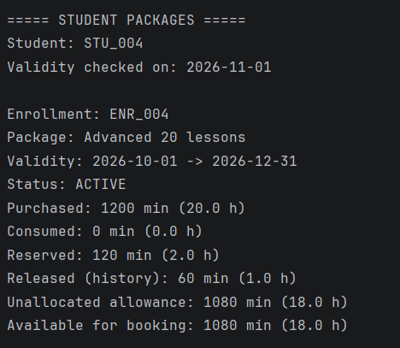  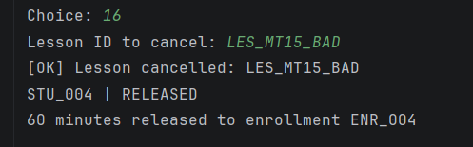  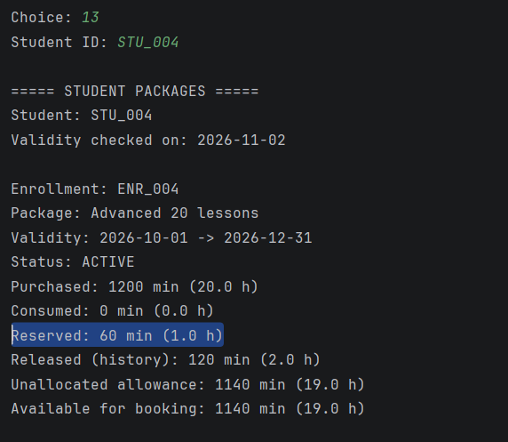  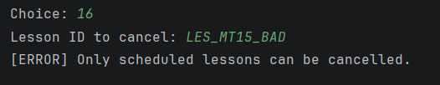
MT09  Late cancellation | - Use SQL-prepared LES_NOW_LATE, STU_006 / ENR_NOW_06, within 24 hours before Start.  - 13/14: read 120 available, 60 reserved, 0 consumed.  - 16: cancel LES_NOW_LATE; read 13/14 again. | - Lesson cancelled; participation CONSUMED.  - Available stays 120 min; reserved: 60 → 0; consumed: 0 → 60.  - No minutes returned. | 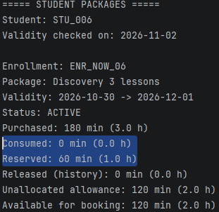  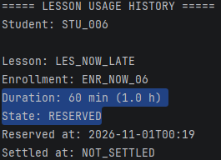  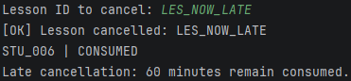  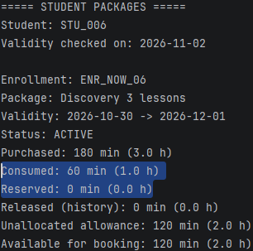  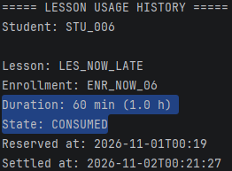
MT10  Lesson completion | - 17: try LES_NOW_FUTURE before End.  - 13: read ENR_NOW_04 / STU_004 and ENR_NOW_05 / STU_005: 1080 / 360 available min.  - 17: complete SQL-prepared LES_NOW_DONE after End.  - 14: read both histories; retry 17 for LES_NOW_DONE. | - Future lesson rejected: Lesson has not ended yet.  - LES_NOW_DONE completes; both students consume 60 min.  - Already-reserved time is not deducted again.  - Repeat rejected: Only scheduled lessons can be completed. | 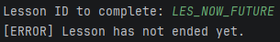  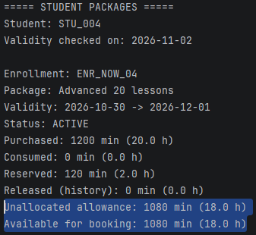  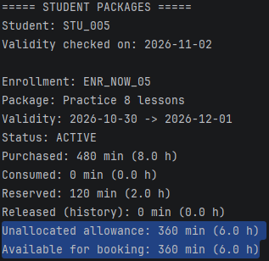  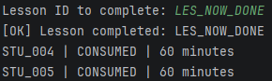  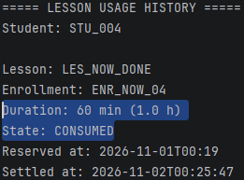  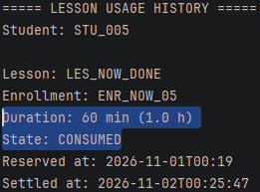  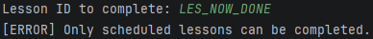
MT11  Rentals | - 26: STU_001 starting balance 26350 cents.  - 20: RENT_NOW_ROOM / RM_NOW_03; 2026-11-02 04:35–06:05, 90 min.  - 21: RENT_NOW_INS / GT_NOW_02; 2026-11-02 06:40–08:10, 90 min.  - 26: read billing. 23: cancel RENT_NOW_ROOM.  - 22: try future RENT_NOW_INS; complete SQL-prepared RENT_NOW_DONE, then retry. | - Charges: 2250 + 1050 cents; balance: 26350 → 29650.  - Room cancellation keeps billing unchanged; no automatic refund.  - Future rental completion rejected.  - RENT_NOW_DONE completes without changing billing; repeat rejected. | 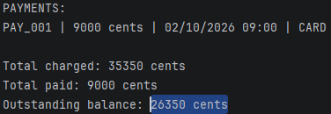  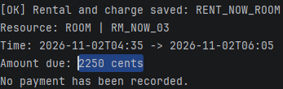  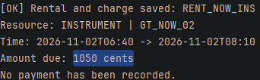  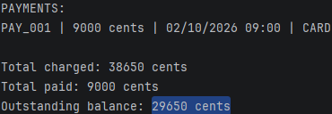  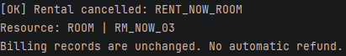  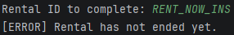  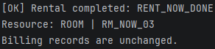  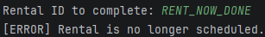
MT12  Payments | - 26: STU_001 baseline: charged 38650, paid 9000, balance 29650 cents.  - 27: read 2026-11: charges 116050; payments 0.  - 24: enter 0, then 3231312321; after re-prompts enter 5000, CARD.  - 26: read totals after payment. | - Invalid amounts prompt again; only valid payment saves.  - PAY_011 saves for 5000 cents, CARD.  - Charged stays 38650; paid becomes 14000; balance becomes 24650.  - Expected monthly payments increase by 5000; a post-payment monthly screenshot is not yet included. | 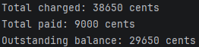  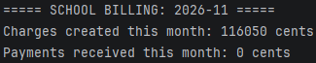  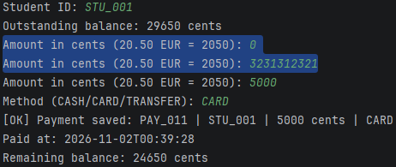  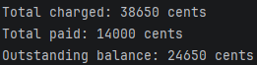
MT13  Exam registration | - 48: create EX_MT15_QUICK, name PIANO EXAM; PIANO / RM_ENSEMBLE_01 / PIA_01.  - Start 2026-11-02 08:00; duration 50 min; capacity 2.  - 47: read exam. 50: register STU_001 and STU_002 before Start.  - 51: list registrations. | - Exam created with the specified data; status SCHEDULED.  - Both registrations save.  - List contains exactly 2 students, each with no result. | 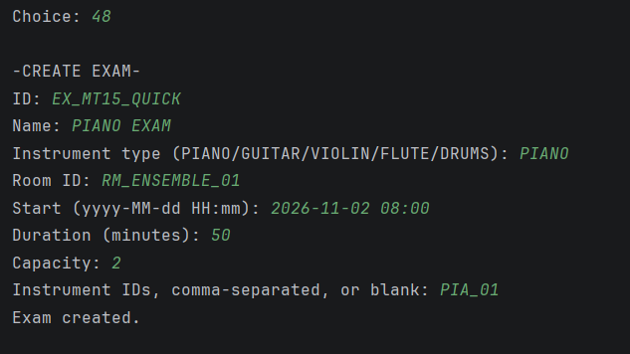  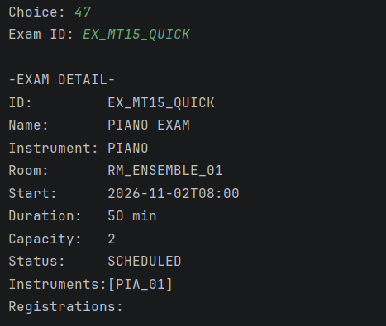  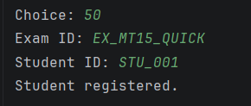  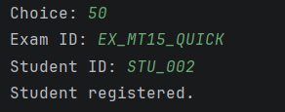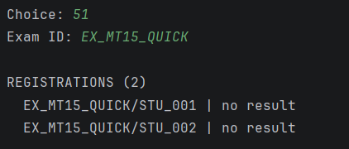
MT14  Exam limits | - 47: read EX_GT_01: 2026-11-10 14:00, capacity 1, STU_001 already registered.  - 50: try STU_002 in EX_GT_01.  - 50: retry STU_001 in EX_MT15_QUICK.  - 51: read EX_MT15_QUICK registrations. | - EX_GT_01 rejects the extra student: Exam is full!  - EX_MT15_QUICK rejects the duplicate: Already registered!  - EX_MT15_QUICK still lists 2 students with no result. | 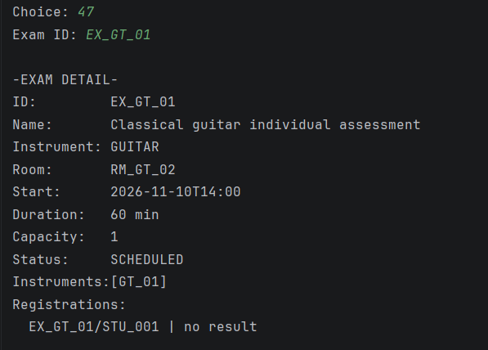  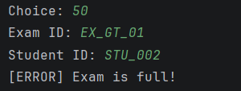  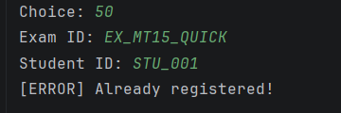  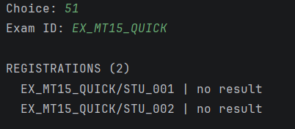
MT15  Exam results | - 52: try EX_MT15_QUICK before End (2026-11-02 08:50).  - 52: complete the separate EX_MT15_QUICK2 after End.  - 51: inspect EX_MT15_QUICK3: STU_001 and STU_002 are registered with no result.  - Pending: record FAIL/0 and PASS/blank; retry a result, then restart and reload. | - EX_MT15_QUICK: early completion rejected (Cannot complete activity!).  - EX_MT15_QUICK2: Exam completed.  - EX_MT15_QUICK3: 2 registrations, initially no result.  - Pending evidence: result entry, 0 versus NULL, duplicate-result rejection and persistence after restart. | 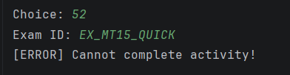  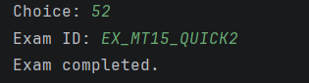  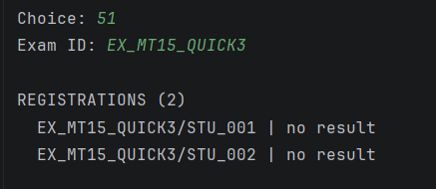  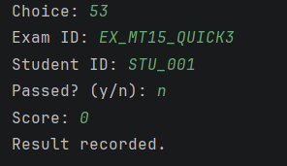  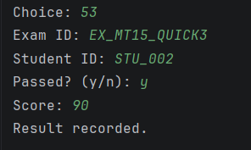  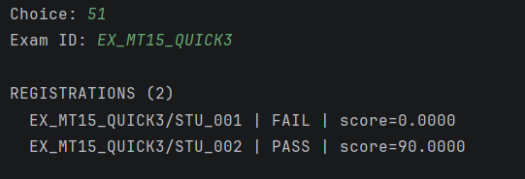  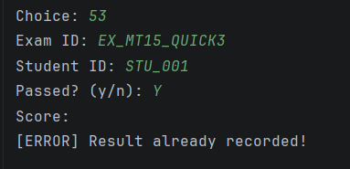

7.4 Unit tests if implemented
- Framework: JUnit Jupiter 5.11.4 with Maven Surefire 3.5.2; tests are stored in src/test/java.
- Isolation: all tests use in-memory objects and fixed dates. No GUI, MySQL connection, database initialization or seed data is required.
- EnrollmentTest - 9 tests: allowance, reservation, consumption without double deduction, release, expiry, validity boundaries, unlimited packages, per-participant group usage and negative prices.
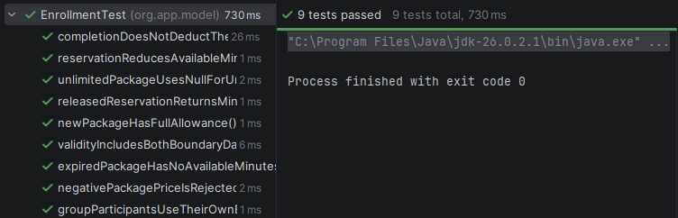
- ActivityTest - 7 tests: overlap, adjacent intervals, completion/cancellation boundaries, independent copies and polymorphic calls.
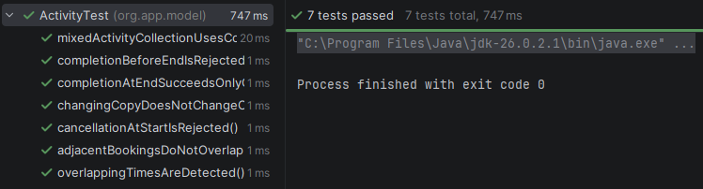
- ExamTest - 7 tests: valid, duplicate, full and closed registration; result lifecycle; zero versus missing scores; and unregistered candidates.
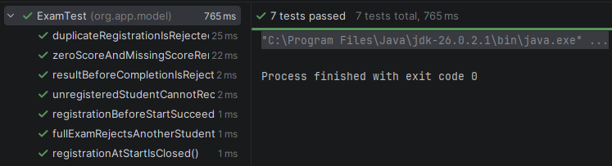
- SchedulingConflictTest - 8 tests: room, teacher, instrument and student conflicts; adjacent and cancelled bookings; conflicts with exams and instrument rentals. Only checkConflicts() is called, using supplied activity lists.
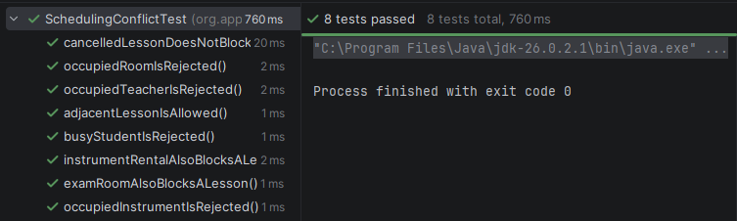

7.5 Defects fixes and limitations
- Student.getPreferredInstruments() exposes the internal preference list.
- No exam cancellation action.
- No automatic rental refund.
- GUI update forms require all values to be re-entered.
- Maximum-based charge/payment ID generation suits a simple local workflow but does not guarantee safe concurrent creation.

8. Project organization

8.1 Responsibilities and collaboration
- Task allocation: the four-day plan assigns 18 tasks to Vuong (V01-V18) and 14 to Trung (T01-T14), with a slightly larger technical scope for Vuong.
- Vuong - shared foundation: database initialization, schema/model conventions and Main integration (V01, V15).
- Vuong - learning services: finite/unlimited packages, enrollment with charges, available minutes and usage history (V02-V04).
- Vuong - activities: lesson scheduling, conflict prevention, cancellation, completion, schedules and rentals (V05-V11).
- Vuong - finance and delivery: payments, balances and summaries; module wiring, business-rule tests, UML/ERD, OOP demonstration and handover documentation (V12-V14, V16-V18).
- Trung - people and resources: student profiles/preferences, teacher profiles/specializations/availability, rooms and instruments (T01-T06).
- Trung - exams: creation, conflict checks, registration, completion and results (T07-T10).
- Trung - delivery: module wiring, invalid-input/persistence tests, demo data, the exam-registration activity diagram, report/slide compilation and defense rehearsal (T11-T14).
- Collaboration plan: agree on shared schema/model conventions, then develop separate repository → service → controller → menu modules using existing seed data.
- File ownership: Vuong coordinates Main/schema and LessonRepository/RentalRepository; Trung owns ExamRepository. Each member checks conflicts within their own service and limits SQL changes to the relevant activity kind.
- Integration checks: verify exam ↔ lesson/rental conflicts in both directions and reload data after restart. Do not close the shared Scanner or independently change the shared schema/model.
- Tracker snapshot: Completed labels report task progress; they do not replace execution evidence. Remaining integration, testing and documentation work is identified in the table below.
Member | Task allocation and status | Evidence
Vuong | - Completed: V01-V13 and V15.  - In progress: V14, V16-V18.  - Scope: foundation, packages, enrollment, scheduling, rentals, billing, integration and technical documentation. | Tracking - Conservatoire
Trung | - Completed: T01-T10.  - Needs attention: T11-T14.  - Scope: students, teachers, resources, exams, module delivery, tests, demo material, report and presentation. | Tracking - Conservatoire

8.2 Challenges and solutions
- Scheduling requires consistent checks across people, rooms and instruments
- Central service validation and shared activity data address this
- Related SQL inserts require transactions to prevent partial records
- Package snapshots preserve purchased terms, and shared controllers and services allow the console and GUI to use the same backend.

9. References
Conservatoire Virtuel - Music School Management System, assignment brief.
Java OOP course tutorials
Project Documents: Conservatoire Documents
Github: Conservatoire Project

