GitHub Username: Tienza

Repo Name: CMPT404-ARTIFICAL-INTELLIGENCE

Repo URL: <https://github.com/Tienza/CMPT404-ARTIFICAL-INTELLIGENCE.git>

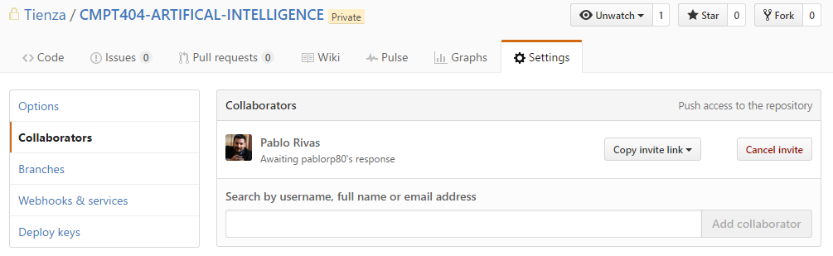

**Kaggle**

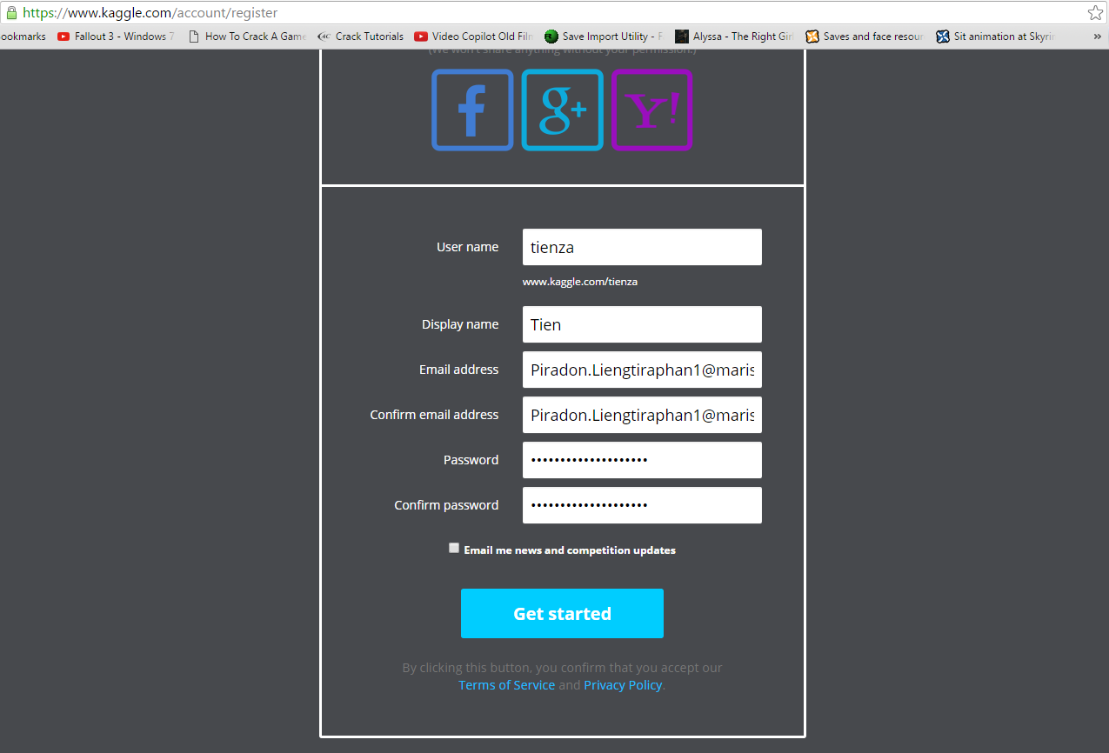

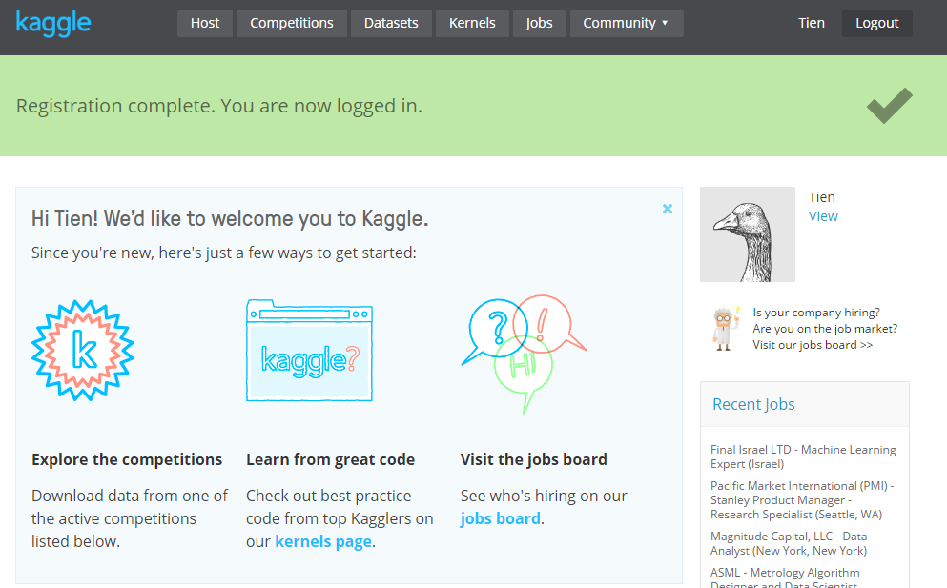

**Python**

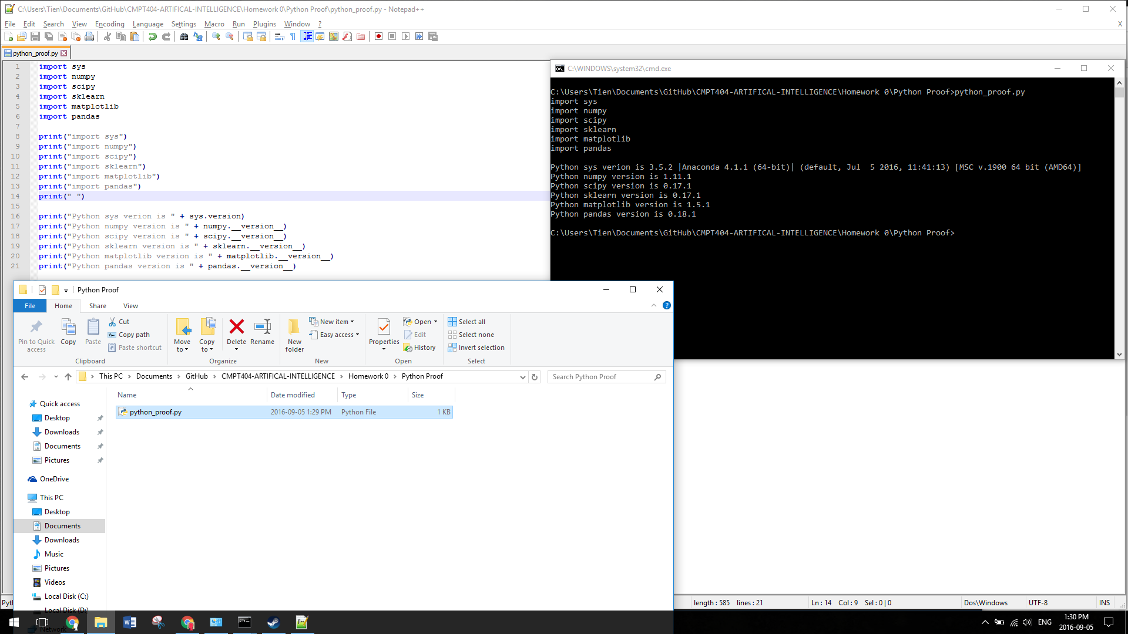

**Math**

Problems

$x=4$

$f'(x,y)=9x^{2}-2y^{2} \& f'(x,y)=4-4y$

3. A. No  
    B. Rank = 3  
    [-4,2,-6]  
    [-1,-4,3]  
    [14,9,3]  
     
    [-1,½,-3/2]  
    [-1,-4,3  
    [14,9,3]  
     
    [1,-½,3/2]  
    [0,-9/2,9/2]  
    [14,9,3]  
     
    [14,-7,21]  
    [0,-9/2,9/2]  
    [14,9,3]  
     
    [1,-½,3/2]  
    [0,-9/2,9/2]  
    [0,16,-18]  
     
    [-4,2,-6]  
    [0,-9/2,9/2]  
    [0,16,-18]  
     
    [-4,2,-6]  
    [0,1,-1]  
    [0,16,-18]  
     
    [-4,2-6]  
    [0,16,-16]  
    [0,16,-18]  
     
    [-4,2,-6]  
    [0,1,-1]  
    [0,0,-2]  
     
    [-4,2,-6]  
    [0,-9/2,9/2]  
    [0,0,-2]  
     
    [-4,2,-6]  
    [0,-9/2,9/2]  
    [0,0,-2]  
    C. (Graduate Students)
4. **Simple Gaussian: $f(x)=ae\frac{{(x-b)}^{2}}{{2x}^{2}}$**   
   **Multivariate Gaussian: $f(x,y)=A exp\left(-\left(\frac{{(x-x_{0})}^{2}}{2σ_{x}^{2}}+\frac{{(y-y_{0})}^{2}}{2σ_{y}^{2}}\right)\right)$**  
   **Bernoulli Distribution: P(n)=p^n(1-p)^(1-n)  
   Binomial Distribution:** Inline6.gifInline7.gifInline8.gif  
    Inline10.gifInline11.gif  
   **Exponential Distribution:** NumberedEquation1.gif
5. (Graduate Students)