API Documentation — NimbusVault v3
Version 3.2 — Updated February 18, 2026 — Platform Team

1. Introduction
The NimbusVault API lets you ingest documents, manage them in collections, and run semantic and hybrid searches over their content. The production base URL is https://api.nimbusvault.io/v3 and all responses are returned as UTF-8 encoded JSON.
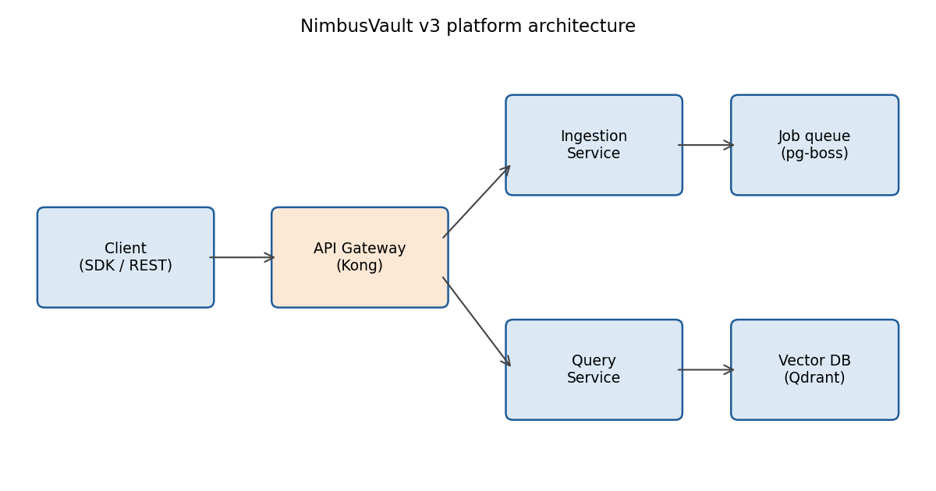
As the diagram shows, requests enter through a Kong-based API Gateway, which routes to the ingestion service (asynchronous processing via a pg-boss queue) or to the query service, which resolves searches against the Qdrant vector database.

2. Authentication
All requests must include the Authorization header with a Bearer token. API keys are generated from the admin panel and use two prefixes depending on the environment: nv_live_ for production and nv_test_ for the testing environment (sandbox). Sandbox keys operate on isolated data and incur no billing charges.
Keys can be scoped for read, write, or admin access. A compromised key must be rotated immediately from the panel; revocation takes effect in under 60 seconds.

3. Rate limits
Limits are enforced per API key and reported in the X-RateLimit-Limit, X-RateLimit-Remaining, and X-RateLimit-Reset headers. When exceeded, the API responds with HTTP status code 429.
Plan | Requests per minute | Daily ingestion (documents)
Starter | 60 | 1,000
Pro | 600 | 20,000
Enterprise | 3,000 | Unlimited (fair use)

4. Main endpoints
Method and path | Description | Required scope
POST /documents | Ingests a document (file or text) | write
GET /documents/{id} | Retrieves metadata and processing status | read
DELETE /documents/{id} | Deletes a document and its vectors | write
POST /collections | Creates a document collection | write
POST /search | Runs a semantic or hybrid search | read
POST /webhooks | Registers an endpoint for notifications | admin

4.1 Document ingestion
The POST /documents endpoint accepts files up to 150 MB in PDF, DOCX, PPTX, XLSX, HTML, Markdown, and plain text formats. Processing is asynchronous: the initial response returns the 'queued' status, and the document moves through the states queued, processing, ready, or failed. Status can be checked by polling or received via the document.ready webhook.

4.2 Search
The POST /search endpoint accepts the modes 'semantic', 'keyword', and 'hybrid' (mode parameter; the default value is hybrid). The top_k parameter controls the number of results: the default is 10 and the maximum allowed is 100. Embeddings are computed with the in-house nimbus-embed-2 model, with 1,024 dimensions, trained with a focus on Spanish and English.

5. Idempotency and pagination
Write operations accept the Idempotency-Key header (a client-generated UUID) to guarantee that network retries do not duplicate operations; idempotency keys are remembered for 24 hours. Listings are paginated by cursor using the limit (maximum 200) and starting_after parameters.

6. Error codes
HTTP code | Internal code | Meaning
400 | NV-1001 | Malformed request body
401 | NV-1003 | Missing or invalid API key
403 | NV-1010 | Key lacks the required scope
404 | NV-1020 | Resource not found
413 | NV-1035 | File exceeds 150 MB
422 | NV-1042 | Unsupported file format
429 | NV-1050 | Rate limit exceeded
500 | NV-1090 | Internal error; retry with backoff

7. Webhooks
The available events are document.ready, document.failed, collection.deleted, and usage.threshold. Each delivery includes an HMAC-SHA256 signature in the X-Nimbus-Signature header, computed with the webhook secret. Failed deliveries are retried up to 8 times with exponential backoff over a maximum of 24 hours.

8. Official SDKs
Official SDKs are maintained for TypeScript (npm: @nimbusvault/sdk), Python (pip: nimbusvault), and Go. The SDKs apply automatic retries on 429 and 5xx errors, with a default maximum of 3 retries. The API changelog is published at https://developers.nimbusvault.io/changelog and breaking changes are announced at least 90 days in advance.

