Onboarding Guide — Engineering Team
Version 2.5 — Updated March 10, 2026 — Maintained by Engineering Enablement

1. Welcome
This guide covers your first three months on the Engineering team at Nimbus Data Systems. Every new hire is assigned a technical buddy for the first 6 weeks, responsible for helping with setup, answering questions, and reviewing your first pull requests.
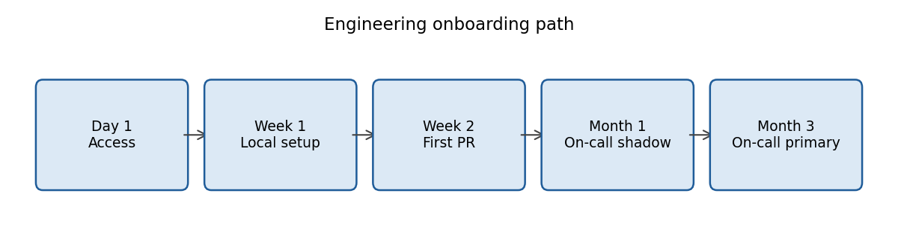

2. Day 1: access
On your first day you will receive a MacBook Pro M4 with 32 GB of RAM, already enrolled in the MDM. Access is managed via Okta and includes: Slack, Google Workspace, GitHub (nimbus-data organization), Linear, Notion, and Grafana. If you are missing any access by the end of day 1, escalate it in the #it-support channel.
- Corporate email follows the format firstname.lastname@nimbusdata.com.
- Your personal GitHub account is linked via SSO; no new accounts are created.
- Access to AWS and production environments is not granted on day 1: it is enabled upon completing the security training.

3. Tech stack
Layer | Technology
Backend | NestJS on Node.js 22 LTS, TypeScript 5
Relational database | PostgreSQL 16 (RDS)
Vector database | Qdrant
Cache and light queues | Redis 7
Background jobs | pg-boss
Infrastructure | AWS (EKS, S3, RDS), Terraform
Frontend | React 19 with Vite
Feature flags | LaunchDarkly

All code lives in the nimbus-core monorepo, managed with pnpm workspaces and Turborepo. The main branch is main and it is protected: changes land only through pull requests.

4. Local environment and workflow

4.1 Local setup
The goal for the first week is a working local environment. The ./scripts/bootstrap.sh script installs dependencies, starts the services with Docker Compose, and loads seed data. The pnpm dev command brings up the full platform at http://localhost:4200.

4.2 Branch and commit conventions
- Branches follow the format type/LIN-123-short-description, where LIN-123 is the Linear ticket.
- Commit messages follow Conventional Commits (feat:, fix:, chore:, docs:, refactor:).
- Every pull request requires 2 approvals plus sign-off from the CODEOWNERS of the affected area.
- The minimum test coverage enforced by the pipeline is 80% on changed lines.

4.3 Continuous integration and deployment
Continuous integration runs on GitHub Actions: lint, type-check, unit and integration tests. Deployments to staging are automatic when merging to main; production deployments are performed through ArgoCD with manual approval and are allowed Monday through Thursday until 16:00 ART. No production deployments happen on Fridays except hotfixes approved by the on-call lead.

5. Work rhythm
We work in 2-week sprints that start on Wednesdays. The daily standup is at 10:15 ART and lasts a maximum of 15 minutes. The retro takes place on the last Tuesday of the sprint. Sprint planning happens on the first Wednesday, facilitated by the team's tech lead.
Your first production pull request should be merged during week 2: your buddy will assign you a backlog ticket labeled good-first-issue.

6. On-call
On-call duty ramps up gradually: during your first month you participate as a shadow of the person on call, and starting in your third month you join the primary rotation. The rotation is weekly and the compensation per on-call week is USD 250, plus time off in lieu for overnight incidents.

7. Documentation and learning
- Technical documentation lives in Notion, in the Engineering space; architecture decisions are recorded as ADRs in the repository, under docs/adr/.
- Internal demos (Nimbus Fridays) take place on the last Friday of each month at 15:00 ART.
- Remember you have an annual learning budget of USD 800 (see Employee Handbook, section 3.2).

8. First-90-days checklist
Milestone | Expected timing
Local environment running | Week 1
First pull request merged | Week 2
Security training completed | Week 3
First on-call shift as shadow | Month 1
Presentation at Nimbus Fridays | Month 2
Joining the primary on-call rotation | Month 3

