Infrastructure and Incident Response Runbook
Code OPS-014 — Version 11 — Updated May 2, 2026 — Platform Team

1. Scope
This runbook defines how the NimbusVault platform operates in production and how incidents are handled. It is required reading for anyone participating in the on-call rotation.

2. Production topology
The primary region is AWS us-east-1; the disaster recovery (DR) region is sa-east-1 (São Paulo). Services run on Kubernetes (EKS 1.31) with horizontal autoscaling. The PostgreSQL database runs on RDS Multi-AZ with one read replica, and Qdrant runs on a 6-node cluster spread across 3 availability zones.
The availability target (SLA) committed to customers is 99.9% monthly. The platform's public status is communicated at status.nimbusvault.io.
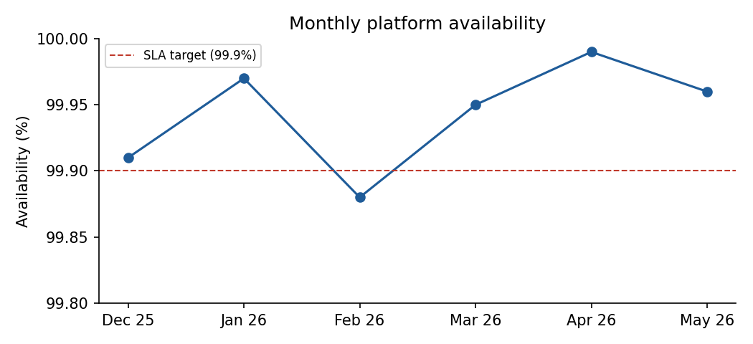

3. Severities and response times
Severity | Definition | First response | Customer communication
SEV1 | Platform down or data loss in progress | 15 minutes | Status page within 30 min
SEV2 | Core functionality degraded | 30 minutes | Status page within 60 min
SEV3 | Secondary functionality affected | 4 hours | Only if customers report it
SEV4 | Cosmetic or no-impact issue | 1 business day | Not required

Paging is managed with PagerDuty. A SEV1 incident escalates automatically to the Platform lead if not acknowledged within 10 minutes, and to the CTO if not acknowledged within 20 minutes.

3.1 Roles during an incident
- Incident Commander (IC): coordinates the response and makes decisions; does not debug.
- Technical operator: runs diagnostics and mitigations.
- Communicator: updates the status page and the #incidents channel at most every 30 minutes.

4. On-call
The on-call rotation is weekly and rotates on Mondays at 14:00 UTC. Each shift has a primary and a secondary; the secondary is paged if the primary does not acknowledge within 5 minutes. Shift swaps are agreed in the #on-call channel and recorded in PagerDuty.

5. Monitoring and alerts
Observability is based on Prometheus for metrics, Grafana for dashboards, and Loki for logs. The critical alerts that trigger immediate paging are:
Alert | Threshold | Initial action
Sustained node CPU | Above 85% for 10 minutes | Review HPA and consider manual scaling
API p99 latency | Above 1,200 ms for 5 minutes | Review the API Overview dashboard in Grafana
5xx errors | Above 2% of requests for 5 min | Review the latest deployment; consider rollback
Ingestion queue lag | Above 5,000 pending jobs | Scale up ingestion workers
PostgreSQL disk space | Below 15% free | Run WAL cleanup and expand the volume

6. Common procedures

6.1 Rolling back a deployment
Deployments are reverted from ArgoCD by selecting the previous revision (History and Rollback). A full rollback takes less than 4 minutes. After reverting, the incident must be tagged in Linear with rollback and announced in #deployments.

6.2 Database failover
If the primary RDS instance fails, the Multi-AZ failover is automatic and takes between 60 and 120 seconds. If the automatic failover does not complete within 5 minutes, the operator must initiate the manual failover documented in the RDS Failover page in Notion and notify the Platform lead.

6.3 Maintenance window
The scheduled maintenance window is Saturdays from 03:00 to 05:00 UTC. Any maintenance with impact must be announced on the status page at least 72 hours in advance.

7. Post-incidents
Every SEV1 or SEV2 incident requires a blameless post-mortem published within 5 business days of resolution, using the Notion template. The post-mortem must include a timeline, root cause, quantified impact, and corrective actions with owners and dates. Corrective actions are filed in Linear with the postmortem label and reviewed in the monthly reliability meeting.

8. Backup and recovery
PostgreSQL backups are continuous (point-in-time recovery) with an RPO of 1 hour and an RTO of 4 hours, as defined in Security Policy SEC-001. Qdrant snapshots are taken every 6 hours and replicated to the DR region. The disaster recovery drill (DR drill) is run twice a year, in May and November; the latest one, performed on May 9, 2026, completed full recovery in 3 hours and 12 minutes.

