Tierre Green

Assignment 2.2 – Hello JavaScript

January 17, 2021

**Exhibit A:**

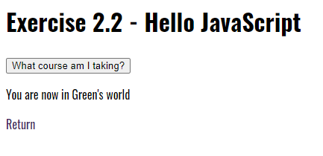

**Exhibit B:**

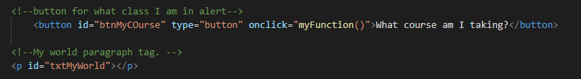

**Exhibit C:**

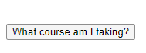

**Exhibit D:**

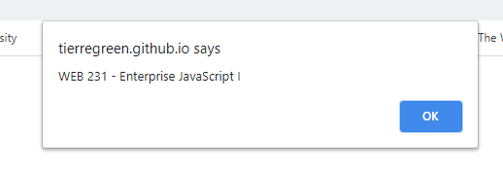

**Exhibit E:**

