
Radical Learning

TOWARDS EXPERIENTIAL, DISTRIBUTED

AND COLLABORATIVE ENVIRONMENTS OF LEARNING

AND CAPACITY-BUILDING

Vision Paper 1.0

OCTOBER 2018

1
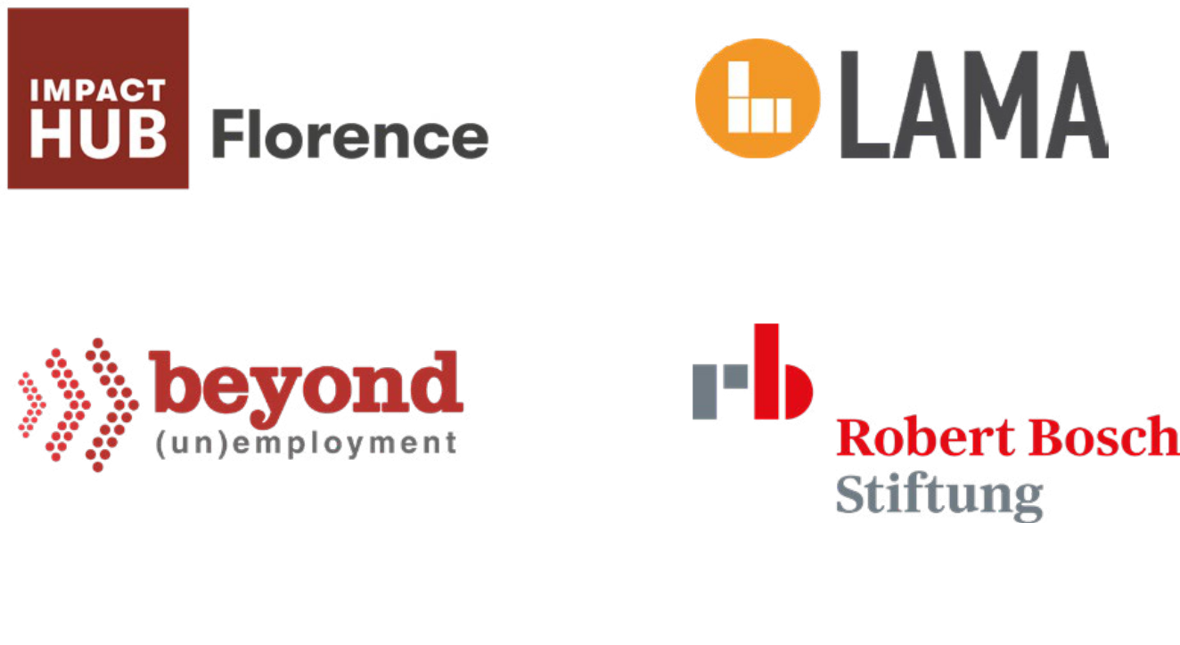

2

3

#1

- EXECUTIVE SUMMARY
pp. 12 - 17
#2

- BEYOND LEARNING IN SILOS

pp. 12 - 17
#3

- RADICAL LEARNING THEORY OF CHANGE
pp. 12 - 17
#4

- IMPACT HUB FLORENCE AS A LEARNING ENVIRONMENT

#An innovative competencies & skills framework

pp. 12 - 17

#Digital badges

pp. 12 - 17

#Archetypes as dimensions of profiling, monitoring and evaluation ex ante, in itinere, ex post

pp. 12 - 17

#Meta-competencies around an ideal membership journey

pp. 12 - 17

4

#Understanding touchpoints pp. 12 - 17

#Harnessing internal monitoring tools & systems to get meaningful data and information

pp. 12 - 17

#Driving multi-actor evaluation and endorsement

pp. 12 - 17

#Hosting as observation point

pp. 12 - 17

#Give back and tell

(learning) stories

pp. 12 - 17

#5

- RADICAL LEARNING BUILDING BLOCKS

#COMMUNITY | Situated learning

pp. 12 - 17

#ACADEMY | Contemporary learning

pp. 17 - 21

#CHALLENGES | Systemic learning

pp 21 - 40
#6

- CALL TO ACTION - Join Us!
pp. 17 - 21

#7

# REFERENCES
pp. 17 - 21

5

Radical Learning

- EXECUTIVE SUMMARY

# 1

6

This document contains a proposal for

a radical new environment of learning

and capacity-building rooted in social

innovation and oriented towards

shared social value.

Radical Learning is about imagining

how the education and training

systems of the 21st century could look

like, and how we can shape them into

platforms of individual and collective

empowerment for the common good.

It is about linking intentional and

unintentional learning, and connecting

formal, non-formal and informal

learning contexts in a way that helps

build continuity in meanings and

actions. It is about acknowledging the

human condition of plurality as the key

precondition for self-realization and

self-attainment. Most and foremost,

Radical Learning is about recognizing

life and living experiences as the most

powerful drivers of learning.

Radical Learning is a model, an

infrastructure and an approach at the

same time.

As a model, it provides a possible

architecture for organizing a

plethora of learning activities

within a unique framework, based

on dynamics of decentralization

and disintermediation. The latter

shall unleash peer collaboration and

horizontal governance, so as to drive

more flexible and modular teaching and

learning. This model may inspire Impact Hubs worldwide, but also stand as a possible reference for collaborative spaces and co-workings willing to transform themselves into explicit platforms of learning for their members and audiences. Besides, it may provide schools and universities with a space where to reconnect theory and practice meaningfully, particularly in relation to soft skills and citizenship skills. Furthermore, it may support enterprises and other organizations in the ideation of new solutions, thanks to the activation of an open and dynamic environment that embeds co-creation and open innovation as salient features of the learning journey.

As an infrastructure, it provides both soft and hard components to support the whole environment of learning, so as to allow newcomers - be they individuals, enterprises and other organizations - to join at any stage and contribute to add value and significance to the environment itself. They may do this by bringing in new knowledge, know-how and capacities, and/or by posing new questions and challenges for collective inquiry, exploration and co-creation.

As an approach, it suggests teaching and training methods that embed real-life settings and experience as testbeds for the development of new knowledge and skills. Besides, it builds on the concept of Communities

7
Radical Learning

of Practice (CoP) to harness collective intelligence and distributed collaboration towards goals of social change. Finally, it anchors to Art of Hosting practices to facilitate not only knowledge and experience sharing within the community of learners, but also to drive peer to peer processes of learnings’ recognition and validation.

Indeed, Radical Learning is deeply entrenched in Impact Hub Florence. As a community of 150+ professionals that daily share working spaces, interests and projects, Impact Hub Florence is a collector of a broad and varied set of knowledge, competencies and skills. The latter flow from member to member through peer mentoring and informal practices of exchange, following dynamics of self-organization and self-regulation. This is the value of collaboration as envisioned in the Impact Hub membership journey,

and the key ingredient that turns our community into an environment enabling personal and professional growth, social capital and attainment.

All in all, Radical Learning is an attempt to capture this value and make it explicit for both members and external audiences, redesigning our internal meanings, practices and tools, and shifting peer collaboration to a field of collective research and exploration oriented to learning.

#


Radical Learning builds on 5 years of experience in running Impact Hub Florence and sustaining its community over time. This provided us with the unique opportunity to observe how peer relationships may shape in a shared working environment, and how they may evolve in patterns

of collaboration. Likewise, this has been a privileged point of view to explore how Impact Hub Florence may help foster new knowledge, skills and pro-social attitudes within the community. Furthermore, years spent in researching, debating, training and hosting conversations around the collaborative economy, platform models, communities of practice and social innovation, have provided us with a more aware and robust approach to our own ideas and intuitions.

More precisely, Radical Learning has undergone around two years of ‘incubation’, mostly spent in research and user research, dozens of co-design workshops, informal conversations and open inquiry, as well as in thousands of readings of books and articles mostly found through serendipity and swapping. However, Radical Learning is an open-ended process, that

shall remain wakeful to suggestions, improvements, evolutions and indeed, critics.

#

8
# EXECUTIVE SUMMARY

This document has been elaborated

by Laura Martelloni, Glenda Galeotti,

Alessandra Zagli and Riccardo Luciani

- the core team leading RL from the initial stage of conceptualization and ideation.

Francesco Farina, teacher and primary

school dean for over 50 years, has

been our most precious critical friend,

pushing us continuously in questioning

around the words we use, and how the

latter take shape through the actions

we make.

The support of Chiara Nenci and

Margherita Violante Masini - Hosts

of Impact Hub Florence - was key to

gather insights and achieve better

understanding of how members

interact and contribute to create

shared value. Besides, many members

of the community have openly shared

their own membership journey, giving

us the chance to learn from their direct

experience, and make our starting

assumptions evolve over time.

Furthermore, we acknowledge

the contribution of the Beyond

Unemployment Programme1, that

provided an international space

for sharing ideas, experiences and

visions about skills development and

new forms of work, and for creating

communities of interest and practice

on these topics.

Indeed, Radical Learning takes its roots in the community-building and Art of Hosting practices that characterise the Impact Hub Network, and is inspired by its own vision of driving social change through collective intelligence, collaboration and open mind. In this respect, we are grateful to all the hubbers met during international gatherings, informal conversations and common projects developed over years.

A special thanks goes to Indy Johar and Imandeep Kaur, who have been tremendous sources of inspiration and learning, and who provided insights and ideas through their pioneering work in Birmingham Radical Childhood and Building Impact Movements initiatives2. RL has a lot in common with these initiatives, be it in terms of key motivations and vision.

Finally, we acknowledge the contributions of Enrico Parsi, Roberto Rubini, Beatrice Bettini, Giulio Bogani, Anna Maggi, Iacopo Braca, Tania Mattei, Daniele Bini, Alessandro Guarducci, Vincenzo Bonelli, Luisa Ortu, Paul Haywood and Adam Thorpe. Radical Learning would have remained a bunch of notes in a laptop without their ideas, passions and visions of other possible meanings and worlds.

Florence, October 2018

1 Beyond Unemployment is an international programme fund- |  | 2 See:
ed by Bosch Foundation, developed between 2017 and 2018 |  | https://birmingham.impacthub.net/mission/radical-childcare/
in five Impact Hubs (Florence, Birmingham, Yerevan, Zagreb, |  | systems-design-lab/
Moscow). The programme was aimed at creating local cohorts |  | https://provocations.darkmatterlabs.org/building-impact-
of experts and stakeholders around the topic of employment |  | movements-ff5df8006d0d
and unemployment, who have engaged in a one year initiative
of knowledge sharing and co-design of new solutions. See:
https://impacthub.net/thinking-beyond-unemployment/

9

Radical Learning

- SETTING THE SCENE | BEYOND LEARNING IN SILOS

# 2

10

The world is changing at an

unprecedented pace, and so are

education and training needs.

Under the pressure of a fourth

industrial revolution that promises

to reinvent everything - often by

disrupting the mainstream, we face

the need of shaping a completely

new body of knowledge and skills,

able to tackle the complexity and

interconnectedness of the 21st century

meaningfully and at levels never

experienced before.

Increasingly, we are aware that our old

brave (globalized) world is a small one,

and that the major problems of our

times - inequalities, poverty, social

exclusion, unemployment and

environmental deprivation - are the

effects of multiple, causal relationships

that occur simultaneously at micro,

meso and macro levels.

The force of interdependence is

quickly throwing down, one after

the other, traditional institutions

and models of social, economic and

political organization, making it evident

that no actor alone can drive change

and achieve impact at scale. Similarly,

no sectoral knowledge or vertical

competence alone is able to deal with

the innovation needs brought about

by the major transformations of the

revolution 4.0.

Quickly, systems and system thinking are becoming the leitmotif of this new era.

Robotics, automation, artificial intelligence, machine learning and big data bring with them the promise of potentiated humans and production systems with unedited intelligence. On the other hand, they also bring the threat, if not yet the case, of millions of jobs that will soon disappear.

Furthermore, the collaborative economy is expanding traditional models of consumption and production, impacting business models and business ecosystems. Platform models stand at the frontier of innovation; scaling up fast across sectors and industries, they are showing the extent to which many markets are becoming increasingly digital, while products and services are blending each other into hybrids.

The 2016 OECD report ‘New Forms of Work in the Digital Economy’ shows that the top 15 Internet companies are nowadays platform operators, and that their value by market capitalisation has multiplied 144 times over the last 20 years3. From a different perspective, McKinsey estimates that by 2030, the effects of automation and digital transformation will push a number between 75 and 375 million workers (3 to 14% of the global workforce) to switch occupational categories, with many occupations that will require higher educational attainments .

- OECD, New Forms of Work in the Digital Economy, 2016.

11
Radical Learning

Well beyond the mere digital literacy, this highlights how the digital fluency is what actually determines the difference between enterprises (and jobs) that grow and thrive on the one hand, and those that fight for survival on the other hand (Venier, 2017; Zamagni, 2018).

Unsurprisingly, the debate around the new forms of work and skills of the digital era is currently under the spotlight of political agendas across Europe and beyond. The pace of change in advanced economics is turning routine and low qualifications occupations into vulnerable ones, with phenomena of job polarisation and job displacement that open to the urgent need of policies and initiatives for upskilling and reskilling.

However, like any revolution, these transformations also bring with them new opportunities.

Non-standard forms of work characterized by temporal and spatial flexibility, increased autonomy and self-entrepreneurship may open windows for experimenting with new politics and practices of lifelong learning and individual development, provided that they are backed with adequate rights and protections against the risks of precariousness and exploitation often connected to on-demand and subordinated work. Similarly, the renewed centrality given to creativity, imagination and relational or soft skills - where machines are not (yet) able to compete with humans - let imagine not only the creation of new jobs at the crossroads between disciplines previously conceived and performed in silos; interestingly, they let also envision a new demand for social, relational and cultural services

and products as the consequence of time made free by automation (Zamagni, 2018). With a generation of Millennials who are looking at their lives as the way to make a difference in society , there are promising signs of a humus that may turn the ongoing technological revolution into a collective lab for social transformation and social progress.

In this complex and uncertain scenario, how do we prepare to the future? How do we equip ourselves in a way that is able to govern the current transformations, and channel them towards the future we want? What are the fixed points - values, beliefs, desires - in a context that forces us to change mental schemes and references continuously?

Since the industrial era, humans have been increasingly pushed towards specialization and learning in silos, following the idea that the division of labour would be the perfect scheme to recognize, and possibly valorize, differences and specificities in personal knowledge, abilities and attitudes.

This concept has somehow guided centuries of celebration of ‘technique’, hard sciences and vertical skills, and the occultation of the bond of humans with nature and natural ecosystems. If this has brought us to reach unprecedented levels of control over the world, it has also produced serious, often irreparable damages over its key resources.

Indeed, the fourth industrial revolution may be both a creative and destroying phenomenon. But while apparently shaping as an unprecedented technological force, it brings about a promising paradox.

12

By (re)celebrating human capacities

such as creativity, imagination, critical

thinking and emotional intelligence as

key drivers of innovation, the fourth

industrial revolution may contribute

to call back the centrality of the

individual. By acknowledging the

profound nature of interconnectedness

that links us to the others and to

the natural ecosystems in which we

live, it may help shape a new kind of

knowledge and capacities, able to

reconnect meanings, disciplines and

know-hows. By experimenting with

politics and practices of empowerment

in work, it can recall the key meaning

of work as the transformative action of

humans over the world (Zamagni, 2015;

Magatti, 2017), pushing us all towards

new and broader spaces for driving

sustainable change.

For this to happen however, we

need radical new environments of

imagination, capacity-building and

action.

Transformative collective actions do

not only need strong motivations.

Increasingly, they require the design

of unedited environments capable of

hosting a highly connected, interactive

and collaborative human network.

They require ideation, discovery and

creation processes able to navigate

across chaos and order, divergence

and convergence, shifting well beyond

control and linearity. They require new

frameworks for people to convene,
# BEYOND LEARNING IN SILOS

build mutual trust and, ultimately, engage in common projects. All in all, they require to move from a rhetoric based on outputs and outcomes, to value processes and narratives based on experience.

‘Real progress requires us to move beyond the silos of the Enlightenment, where we were encouraged to isolate social, economic and environmental factors that are in fact interdependent. It is clear that if we are to bring about meaningful change we will need to accelerate and invest in ecosystems. We will need to incubate and invest in building ecologies of learning and open innovation and intervention’ (Kaur and Johar, 2016).

This is the rationale for breaking down sectoral silos, and designing capacity-building and learning infrastructures built on distributed governance, open access, interdependence and synergies across systems, capacities and knowledge. This is also the rationale for pushing ourselves in challenging ex ante and pre-defined learning outcomes and outputs, and imagining how we design learning and capacity-building environments that are open-ended, evolutionary and transformative in means and scopes.

- McKinsey, Jobs Lost, Jobs Gained: Workforce Transition in a Time of Automation, 2017.

- See Deloitte, 2017; World Economic Forum, 2013.

13

Radical Learning

- RADICAL LEARNING THEORY OF CHANGE

# 3

14

Radical Learning is an open, platform-based environment of learning dedicated to turn the complexity, uncertainty and interconnectedness of the 21st century into opportunities for individual and collective discovery and capacity-building.

Radical Learning Theory of Change (ToC) builds on the following key principles:

#VALUE DRIVEN | Values not statements

We need to elevate the power of values as guiding principles of our individual and collective learning journeys, and as compasses in the uncertainty of present times. Indeed, values may change over time under the effects of social and economic transformations; yet, such variability does not exclude the existence of transcultural values that remain unvaried because of life being invariably a social existence. A value-driven learning environment shall allow the coexistence of plural identities, and leave the space for debate, conflict, negotiation, reformulation and expansion of values that the encounter between different identities may bring with it.

#RESILIENCE-ORIENTED | Navigating future through resilience

We shall create learning environments that orient and guide people towards their best future possibilities, allowing them to explore and realize such possibilities in a future that we can hardly predict nor imagine. We shall do so by acknowledging that any form of persistence is a sign of a dangerous inadequacy to a world that is changing fast, and by supporting mindsets that are much more open and resilient to the unpredictable. Resilience-oriented learning environments shall promote a combination of systemic, synthetic, creative, respectful and ethical thinking as driver of human development in the 21st century.

#SYSTEMS THINKING | Link not separate

We need a new epistemology able to overcome a ‘separate, divide and oppose’ way of thinking, and to shape mindsets that continuously create connections and links - be it across meanings, actions, people, social groups, cultures, actors and systems.

A way of thinking that reformulates the same idea of relationship and subject of the relationship, and that recognizes humans as parts - not lords - of the nature.

15
Radical Learning

#MULTIDISCIPLINARITY | Systemic not systematic

We need to overcome a type of knowledge fragmented in vertical and disciplinary silos, and approach problems and issues in their pre-disciplinary form. This shall open to multiple convergences and synergies across sciences and knowledge domains, and provide spaces for unedited emergencies that draw new frontiers of knowledge. Place-based challenges - being situated and contextualized - provide a yet untapped opportunity to experiment with the last mile of our local economy, unlocking creativity, talent and social capital that lie in communities and local places.

#CONNECTEDNESS IN DISCONTINUITY | Networks not silos

We need learning environments that are connected and continuous in meanings and actions, able to support meaningful transitions and orienteering to the future at the crossroads between formal, non-formal and informal learning contexts. Indeed, discontinuity, contradiction and paradox are salient features of life, and they are often key to personal development and growth. A connected learning environment shall help learners in overcoming the difficulties stemming from discontinuity, creating links between actors, contexts, practices and purports that in turn provide diversified and variegated educational events where to re-connect meanings and actions.

#OPENNESS AND INVITATIONAL | Collective not individual

We need learning environments that make the most of collective intelligence and peer collaboration, by acknowledging the richness and power inherent to diversity, and the potential of conflict as drivers of capabilities. This essentially means an environment of learning that embeds ‘the unforeseen’ brought by new actors, new problems and new proposals, and that accepts the uncertainty stemming from the ‘freedom of innovation’ left to the participants.

#EXPERIENTIAL AND REAL LIFE-BASED | Learning throughout life

We need to call back the key meaning of life as a learning journey, and drive new spaces and opportunities that use real life contexts as ground of individual and collective lifelong learning. This shall be reflected in a culture of teaching and learning that moves beyond pre-defined learning outputs and outcomes, and that shifts the focus on learning to learn thanks to the experience as a space of collective inquiry, research, experimentation and care.

16
# RADICAL LEARNING THEORY OF CHANGE

#OPEN-SOURCE | Openness not property

We need learning environments that are open and accessible in their tools, means and outputs, and that support open and free sharing of knowledge, skills and know-how. This shall allow others to freely reuse and build upon the learning outputs and outcomes produced within the environment, and support continuous flows of knowledge exchange and creation.

#PEER, DISINTERMEDIATED AND DISTRIBUTED | Ubiquitous not centralized

We need to unlock the potential of collaboration that may stem from disintermediated and ubiquitous models of learning, supporting people in sharing their knowledge and skills in a peer to peer way. Reciprocity and gift may be the levers for more personalized, flexible and modular teaching and learning that follow dynamics of self-regulation and self-organization in a community of learners.

#COMMUNITIES OF PRACTICE - Make not (only) think

We need learning environments that valorize the power of doing and making, unlocking human creativity, inventiveness and haptic intelligence around artefacts. Failure and error are salient features of any learning journey, and shall be embedded as key elements of reflection and evaluation. Communities of Practice are powerful means for fostering a culture of iterative and by design and by trials learning, and for encouraging the emergence of action-oriented learning as a hybrid of studio, field and online learning collectively shaped and pursued.

#PLURAL EVALUATION | Mediation between evaluations

We need learning assessment and validation approaches able to reflect and embed the plurality of the context in which we learn. Learning assessments shall go beyond vertical and stand-alone judgments, and be conceived as ongoing processes of mediation between the parties involved - learner, peers, educators, the wide stakeholders and surrounding environment. This shall transform assessment and recognition systems into opportunities for collective learning and awareness-raising, and for building mutual trust and commitment.

17

Radical Learning

- IMPACT HUB FLORENCE AS A LEARNING

AND CAPACITY-BUILDING ENVIRONMENT

# 4

18

- A physical space for co-working and co-creation specifically conceived and designed to prompt a working culture based on openness, sharing and collaboration;

Impact Hub Florence is a co-working

space and a lab dedicated to social

innovation.

As part of the Impact Hub Network6,

Impact Hub Florence operates as

a local node of a global community

of 16000+ members, distributed

across 100+ physical spaces in the 5

continents - and these numbers are

increasing constantly. This is a wide

and varied community of people with

different profiles and professional

experiences, but united by a shared

belief in driving sustainable change

through open collaboration and

collective commitment.

As a collaborative environment that attempts to take together both economics and society, Impact Hub Florence can be defined as an enabling ecosystem for social innovation, featured by open access, shared values and an overall positioning that, although operated locally, is often oriented to global challenges and performed with an international breath.

The Impact Hub model is characterized by three distinctive though integrated features:

- # A community of people from different walks of life and professional experiences, who often share a commitment in solving pressing social challenges through their work and active commitment;

- # A set of thematic contents that reflect the interests of the community itself, and that are channelled, from time to time, as events, awareness-raising activities and capacity-building programmes.

These components are transversally sided by the action of facilitation and animation developed by the Hosts - the key resources of the Impact Hub ecosystem. Hosts are the first and crucial enablers of the membership journey, and their work strongly contributes to shape the type of experience in Impact Hub. By running a sort of ‘serendipity engineering’ in the system, they help foster distributed and ubiquitous processes of peer collaboration, facilitating access to people, resources and information, driving new conversations and relationships, and supporting orientation and guidance.

- See: https://impacthub.net/

19
Radical Learning

Members interact and know each other. They may share knowledge, time, resources and projects. They may take care of specific aspects of the space
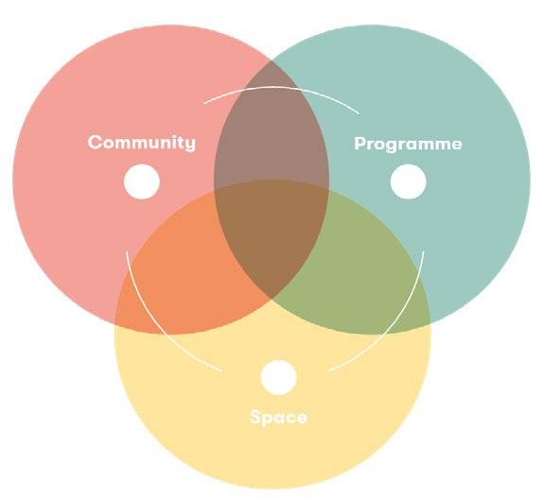

- the garden, furnitures, equipments. They may create ‘sub-communities’ of interest and practice around topics they are interested in. They may co-host the community, proposing new activities for the other members or supporting newcomers in exploring the environment. They may establish closer relations and friendship. There is not a by default journey, but rather a plethora of touchpoints that steer and shape the personal experience.

The foundational assumption of Radical Learning is that this plural relational and interaction system is where multiple and diverse learning processes actually occur, all characterized by being almost experiential, evolutive and not

predetermined as top-down learning objectives. Under this perspective, Impact Hub can be defined as an innovative learning environment: a physical, mental, cultural, organizational and emotional space that develops through multiple layers of relation and interaction - between members, members and artifacts, members and space, etc. -, and via different degrees of intentionality and awareness. People learn through and in relations, which in turn are place-based.

Yet there is more. Whatever the personal experience, the Impact Hub environment is directed towards building trust and social capital. As far as it supports the members in taking care of what they do for their own personal and professional growth, what they do for the others in the community, and what they do for the broader society through their projects and entrepreneurial initiatives, it may be a lab for a whole culture of care. It is all about steering peer collaboration towards care, where care becomes the assumption for any society doing good. So conceived, Impact Hub acquires an educational valence (De Santis, 1975) for both individuals and the community, turning relationships, experience and collaborative work in a shared environment into seedbeds for citizenship skills and soft skills oriented to transformative actions.

However, such ‘immaterial’ value of the membership often remains implicit, highly dependant on the individual journey within Impact Hub, as well

as on the level of self-awareness of the member. If so, how can we make this value tangible and meaningful for the members, in a way that it

20
# IMPACT HUB FLORENCE AS A LEARNING ENVIRONMENT

contributes to their own personal

and professional development?

How can we codify the learnings

gained through the membership

journey so that they contribute to

foster awareness and mutual trust?

Ultimately, how such awareness can

strengthen reinforcing learning loops

and drive both individuals and the

community towards empowered

transformative actions?

With these questions in mind, let’s start

discovering Radical Learning.

#

#An innovative

competencies & skills

framework

Knowledge, competencies & skills

frameworks are the ‘codes’ through

which we describe human capacities

and abilities in a way that they can

be commonly understood - and thus

portable - across different contexts.

Over decades, plenty of frameworks

have been built by different

organizations worldwide, and then

further advanced to keep up with

economic and societal transformations.

But while much has been developed

around competencies and skills

acquired in traditional settings,

relatively little has been done instead

on learning processes and outcomes within co-working and collaborative spaces.

Radical Learning is anchored to a specific competencies and skills framework developed through a combination of desk research, user research within Impact Hub Florence, and through design and prototyping activities realized in the OD&M project7. Our framework builds on the REBEL framework, the EntreComp

- Entrepreneurship Competence Framework (EC, 2016), and ESCO framework (EC, 2017)8, from which we took guidance to identify contexts and areas of learning, meta-competencies and specific competencies and skills that are relevant to Impact Hub Florence. Our framework actually reflects and steers the whole Radical Learning environment, and operates as a map of reference for any present and future activity and initiative developed by Impact Hub Florence.

The overall approach focuses on the development of Learning Capture and Portfolio Tools, proposed as digital resources for assessment, endorsement, recognition and eventual accreditation that offer transferability and adoption beyond Radical Learning9. At the core of the approach is a micro-credentialing system to support 360-degree assessment methods that, potentially, convert into transferable credit. These

- OD&M (Open Design & Manufacturing) is an international Knowledge Alliance dedicated to create communities of practices around the Open Design & Manufacturing paradigm, making the most of openness, sharing and collaboration to create new value chains of innovation oriented to the social good. Through this project, we are prototyping and testing an innovative learning framework based on the recognition of life-wide learning and the endorsement of flexible, non-formal and informal education, which builds on the REBEL framework

developed by Central Saint Martins University of the Arts London in collaboration with other partners across Europe. See: www.odmplatform.eu

- See: https://ec.europa.eu/jrc/en/publication/eur-scientific-and-technical-research-reports/entrecomp-entrepreneurship-competence-framework https://ec.europa.eu/esco/portal/home

- RL Platform is integrated with the Mozilla Open Badges international standard.

21
Radical Learning

tools can be used in the design of

assessments or curriculum outcomes,

and of teaching material. They can

be also used to profile a learner as a

way of establishing his/her existing

learning characteristics and strengths

and, therefore, profiling capacity

and requirements. As endorsement

tools, they can be applied by any

member of the community, or by

external partners, for the recognition

and reward of learning gains and

experience, contributing to 360 degree

assessments that offer robust evidence

of the quality of learning outcomes.

Importantly, this is not a rigid

framework: skills and competencies

can be combined and recombined

flexibly around meta-competencies

and achievements, and be freely

associated to specific activities and

learning events. Nonetheless, the

building blocks of Radical Learning

(see next chapter) are designed to

reflect a growing intensity, number and

variety of skills that can be acquired

throughout the environment, according

to an ideal journey that is directed

towards competencies and skills for

impactful social change.

22
# IMPACT HUB FLORENCE AS A LEARNING ENVIRONMENT

Radical Learning’s framework of competencies, skills and attitudes:

SPHERE

OF LIFE-WIDE

ATTITUDES

& BEHAVIORS

 | Engagement: open to cooperative and collaborative practices and
 | collective responsibility
 | Empathy: actively engaging and haring influence or difference with others
 | Motivation: willingness to accept responsibility and to initiate action
 | Commitment: reliable persistence or dedication to task or cause
 | Inclusivity: practicing values that produce access and opportunity for others
 | Openness: sensitivity and respect for unfamiliar experiences and
Values | situations
 | Sociability: convivial and supportive approach to team environment and
 | endeavour
 | Generosity: applying value to or embracing the goals of others
Social | Diplomacy: engaging sensitively with others through negotiation and tact
Social | Accountability: integrity achieved through acting responsibly and reliably
practices
 | Reciprocity: meaningful effort in support of others
 | Negotiation: effective habits of interaction in the process of decision making
 | Flexibility: acknowledging and integrating with other people and their
 | viewpoints
 | Problem-solving: proactive attitude towards the resolution of problems
 | Team-working: strategies and approaches for liaison and positive rapport
 | in pursuit of common goals
 | Responsibility: leading or supporting procedures to achieve shared goals
 | or outcomes
 | Endurance: persistence and resolution in response to task or collective
 | objectives
Cooperative | Ethics: compromise and adaptability in response to wider considerations
practice | and beliefs
 | Self-organisation: managing time, resources, and commitments to
 | enhance personal performance
 | Planning: predicting and preparing for future needs and responsibilities
 | Reflection: assessing and analysing prior experience to affect future
 | enhancement
 | Initiative: independent and pro- active engagement to achieve personal
 | challenge or goals
 | Creativity: making use of alternative or divergent notions and
 | perspectives
 | Criticality: employing impartial and objective logic to enhance
Engagement | understanding

23
 |  | Formal writing: understanding and using established formats for
 |  | professional purposes
 |  | Second language: effective communication through another or additional
 |  | language
 |  | Digital: using suitable media and technology for enquiry and
 |  | communication
 |  | Verbal: improvised or scripted speaking that disseminates intended
 |  | meanings
 |  | Non-verbal: interpreting or communicating through actions, active
 | Language | participation or gesture
SPHERE OF |  | Agility: engaging with and managing multiple and different content or ideas
SPHERE OF |  | Sensitivity: mindful and considerate of contextual detail or potential bias
INTERESTS,
INTERESTS, |  | Resilience: willingness to constructively engage with criticism and
CURIOSITY
CURIOSITY |  | alternatives
AND
AND |  | Inclusivity: actively engaging with other cultural experiences and
APPLICATION
APPLICATION | Intellectual | perspectives
 | Intellectual | Creativity: combine or respond to stimulus or content to produce ideas
 | openness
 |  | Organisation: coordinating and managing relevant information, resources
 |  | and materials
 |  | Reflection: thoughtful assessment or interpretation of collected
 |  | information or prior experience
 |  | Logic: application of reason to determine outcomes of particular value
 |  | Precision: accurate and appropriate use of material or content within
 |  | context
 | Intellectual | Insight: consideration beyond the obvious or the contemplation of
 | Analysis | alternatives
 |  | Questioning: challenging assumptions to further or develop
 |  | understanding
 |  | Pro-active: initiating research or testing to extend or deepen personal
 |  | understanding
 |  | Reliability: integrity and judgement reflecting on processes or outcomes
 | Intellectual | Procedural: producing sensitive and logical structures for gathering or
 | Enquiry | developing content
 |  | Self-awareness: objective engagement with processes of personal
 |  | reflection
 |  | Story telling: ability to create narrative or descriptive accounts of
 |  | experience
 | Contextual | Presentation: effective engagement and communication with an audience
 | Advocacy | or correspondent
 |  | Cultural Awareness: demonstrable interest in with broad or alternative
 |  | perspectives
 |  | Complexity: engagement with and management of multiple possibilities
 |  | and realities
 |  | Rationality: awareness of cause and effect, or evidence and argument
 |  | Comparative analysis: consideration of separate or aligned sources of
 | Contextual | precedent or information
 | Contextual | Subjectivity: reasoned application of emotional intelligence or personal
 | Interpreta-
 | tion | judgement

24

SPHERE OF EXPERIENCE

 | Observation: learning by example of others or earlier precedents
 | Investigation: pursuit of reason or personal discovery through structured
 | procedures
 | Study: developing awareness and understanding through a range of
 | appropriate sources
 | Collection: sourcing, collating and selecting of materials from varied sources
Research | Analysis: developing understanding through deconstructing and
practice | examining complex information
 | Intuition: self-aware, instinctual positive contribution to processes or ideas
 | Pro-activity: positive individual contribution and/or independent
 | initiative.
 | Idea generation: process of constructing and communicating thoughts,
 | gestures or form.
 | Disruption: engaging with alternative or counter perspectives in pursuit
 | of improvement.
Creative | Leadership: assuming responsibility in the service of an idea or activity
practice | that requires direction
 | Initiative: individual and proactive response to problems or opportunities
 | Decision making: interpretation and reasoned reaction to a situation or
 | problem.
 | Organisation: design and management of systems and processes
 | Ethical awareness: appreciation and negotiation of standard conventions
 | and beliefs
 | Experimentation: purposeful discovery through trial and error or
 | adaptation
 | Resilience: tenacity and determination in the face of specific challenge
 | Communication: delivering instruction or direction in relation to focus
 | and task
 | Enterprising: pro-active in planning and pursuing desired future
Effectuation | outcomes
 | Material handling: appropriate response to the properties or qualities of
 | the media
 | Procedural skills: structured and organised approach to creation or
 | production of content
Technical | Accuracy: precision or diligence in the execution of processes.
Technical | Efficiency: economic with time and energy appropriate to task.
practice
 | Safe practices: response to the appropriate management of risk
 | Data application: deploying categorized information with specific
 | purposes
 | Systems application: handling of procedures and processes of control
 | Complexity: negotiating and managing interrelated processes or
 | experiences
 | Problem-solving: considered or appropriate response to adversity,
 | producing change
 | Outlook: positive attitude and a constructive, open approach to
Management | outcomes and tasks

25

#Digital badges

In the digital era, traditional formats of skills, competencies and expertise description are turning quickly obsolete. As the market evolves, organizations and individuals are getting increasingly aware of the need of new tools and means able to better encompass the whole range of individual knowledge, skills and competencies, and to consider the plurality of contexts (formal, non-formal, informal) in which they can be acquired.

Radical Learning endorses the open-source Mozilla Open Badges, integrating it with the Nexudus platform10. Coherently with the Open Badges system, we use different types of badges to reflect the different learning events that can be experienced in Impact Hub, and to allow learners to develop dynamic digital portfolios. In particular:

● # Participation badges reflect
the participation to an event, or the engagement in a specific Community of Practice or Project Team;
● # Recognition badges actually

relate to skills and competencies acquired through active engagement in activities of different types11, but all characterized by being subjected to evaluation;

● # Achievement Badges applies to the completion of more structured activities that foresee the production of concrete outputs, and that entail a more complex (i.e. multi-dimensional) evaluation12.

Radical Learning

Indeed, all these different Badges can be used creatively, by combining them according to the specific activity. For example, a co-design jam can be described in terms of a participation badge, a set of badges that recognize specific skills developed through this activity, and via an achievement badge that contains data about the evidence produced.

While there are a number of predefined badges provided in our platform (corresponding to our framework), new badges can be added over time by the different actors who join RL, according to new learning activities and learning outcomes that might be integrated as adds-on in the learning environment.
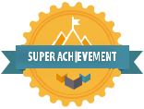
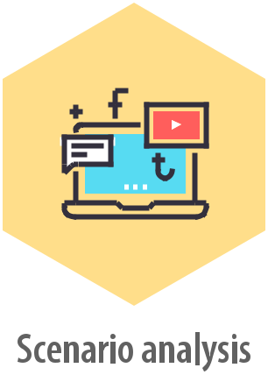

Fig.1-2: Examples of Badges used in Radical Learning

26

# IMPACT HUB FLORENCE AS A LEARNING ENVIRONMENT

#Archetypes as

dimensions of

profiling, monitoring

and evaluation ex

ante, in itinere, ex

post

People are different from each other,

in their own identities, stories, values,

motivations and desires. Yet, in our

experience, we have been observing

some recurring patterns in terms

of what actually drives people to

Impact Hub, and how they interact

with it. Some people may have a more

utility-driven approach, looking at

the environment mainly to maximize

their personal goals and aspirations;

others might be particularly content-

driven and proactive in proposing

new activities and establishing new

relations; others might be ‘super-social’

and show willingness in co-hosting

the community and taking care of the

space. Indeed, these ‘personalities’ can

take a variety of nuances and evolve

over time.

In Radical Learning, we use a gamified

system inspired by the Jungian

archetypes13, so to create tools of

onboarding, profiling, monitoring and

evaluation that explore individual

archetypes at the beginning, ongoing

and ex post. This system provides

a reference for playing creatively with our learning framework, and for considering changes in motivations, values, attitudes and beliefs alongside increased interaction and participation to the Impact Hub environment.

At this stage, we have identified three main archetypes, based on a growing intensity and purposeful interaction between the member and Impact Hub Florence14:

● # Utilizer: the member that uses the resources of the system to develop its own professional activity. This member may be oriented mainly to its personal goals and achievements, and be less interested in sharing openly his/her own expertise or contributing to the development of the community. Motivations of stability and independence may particularly characterize this member;

- # Collaborator: the member who activates his/her own resources and operates in collaboration with others to develop a common activity, project or product, as a result of a shared effort. This member proactively explores the system, and looks

at open collaboration as a way to achieve better results and kick off new initiatives and projects. Change-driven motivations might orient his/her action throughout the Impact Hub system;

- See: http://coworking.nexudus.com/en

- For example, these might be activities closely connected to the relational design of Impact Hub, such as sexy salads, business clinics, fuck up nights, etc.

- This may apply, for example, to co-creation journeys, jams, hackathons, among others.

- In 1919, Carl Jung used the term ‘archetypes’ to refer to ‘col-lectively-inherited unconscious ideas, patterns of thought, images, etc. that are universally present in individual psyches’. The 12 Jungian archetypes can be seen as sort of ‘emotional engines’ connected to four fundamental motivations of hu-mans: stability, independence, change and belonging.

27

● # Generator: the member who, thanks to collaboration and shared effort, is oriented towards the creation of shared social, economic and cultural value for the community and the broader society. This member is often driven by strong social-oriented beliefs and sense of belonging, and is keen to co-host the community and propose new activities for all.

#Meta-competencies around an ideal membership journey

Although there can be different membership experiences (and, by extension, different learning gains), Radical Learning promotes and supports learning journeys that incrementally intensify peer collaboration, active contribution and engagement in the system. For us, co-hosting the community is the highest point where we aim at bringing members, enabling them to express most of the skills outlined in the framework in a safe environment open to both failure and success. Therefore, we developed a matrix that combines archetypes with ‘contexts’ (or areas of learning events), and that identifies meta-competencies stemming from archetypes-contexts interaction.

Meta-competencies are identified based on a growing intensity of the

learning journey towards systems competencies and skills, where learning events increasingly embed tasks and actions of co-hosting with increased complexity and interconnectedness. In other terms, meta-competencies are organized alongside an ideal journey where learning activities incrementally push the development of new skills, competencies and attitudes, towards systems thinking and capacities.

Macro-competencies in RL are described as it follows:

- # Sensemaking: the process by which people give meaning to their experiences. It is often formally defined as ‘the ongoing retrospective development of plausible images that rationalize what people are doing’ (Weick, Sutcliffe, & Obstfeld, 2005). In RL, sensemaking is strictly connected to events and moments that entail

a deep change (a crisis, the start up of a new project or enterprise, an organizational or strategic change, etc.), and that bring questions like ‘what is going on here?’, ‘what should we do about it?’. In this context, sensemaking is the capacity to open to new paths and perspectives, paying continuous attention to the evolution of both the individual and collective identity.

- # Contextualizing: is the process by which a given phenomenon is inserted within a specific context, the latter determined by the set of values, beliefs, opinions and habits that lie behind the ‘how’ a given group of people apprehend a certain phenomenon and take decisions over it.

28
# IMPACT HUB FLORENCE AS A LEARNING ENVIRONMENT

- # Cooperating: cooperation is the process by which different parties (people, groups, organizations, communities, etc.) work on a common and shared purpose, going beyond collaboration over means. Cooperation also entails continuous negotiation and mediation between ‘diversities’, and

is closely associated to the need of genuine relations.

- # Organizing: the process of defining how community and space resources (relationships, knowledge, skills, information, etc.) are integrated and coordinated to accomplish objectives.

- # Extraprising: the process of inter-organizational action that facilitates multiple combination of ideas, people, places and resources to address challenges and drive innovation (Tracey & Stott, 2016). Extraprising is about moving across different contexts, teams, organizations and cultures so as to spread ideas and knowledge.

- # Innovating: the process by which new ideas and solutions are generated and introduced in a given context, creating new experiences and meanings.

Context | Utilizer | Collaborator | Generator
Exploring and under- |  |  |  | Contextual-
standing |  |  |  | izing
Participating and |  |  |  | Organizing
collaborating |  |  |  | Organizing
Self-awareness |  |  |  | Extraprising
and self-directing |  |  |  | Extraprising
 | Sense-making | Cooperating | Innovating | Co-hosting


The column ‘context’ helps orient the design of the learning environment, identifying and organizing specific learning events around macro-patterns of interaction (=activities) with the Hub system, on a growing level of intentionality and intensity. Throughout the rows and columns, activities can be organized according to

both archetypes and patterns, and be associated to different sets of skills and competencies.

29
Radical Learning

Fig. 3-4: Examples of Member journeys within Impact Hub Florence
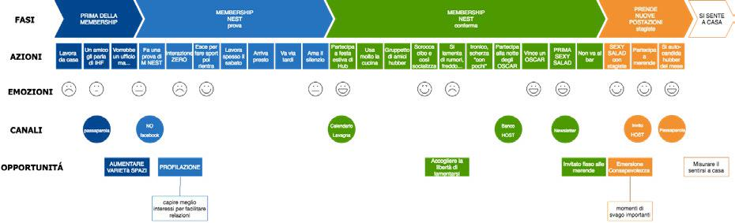
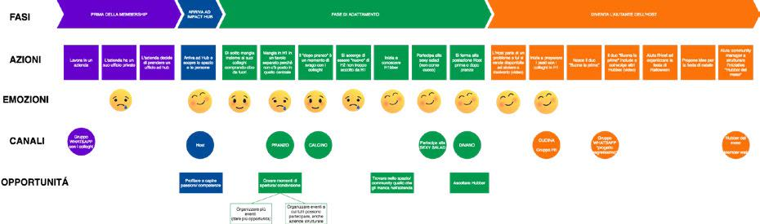

#Understanding

touchpoints

As a relational system, Impact Hub provides a plethora of touchpoints that orient the personal membership experience. Physical devices such as the onboarding and the memberwall, or activities like sexy-salads, business clinics and conviviums all help reconnect the individual with the surrounding environment. While some of them are proposed and managed directly by the Hosting team, most of touchpoints exactly happen because of free interactions and serendipity encoded in the relational design

of Impact Hub. As a consequence, they are distributed, ubiquitous and fluid, and therefore hard to be fully captured.

For Radical Learning, we developed a basic User Research; interestingly, this helped us understand how often a membership journey is not linear, but rather characterized by ‘tops and downs’ that can either confirm or disconfirm the perception and personal attitude towards the Impact Hub environment.

Indeed, discontinuity and disconfirmation are often important throughout the membership journey, as they help prompt autonomous responses by the members, and contribute to build shared social norms15. Mapping and systematizing touchpoints alongside

an ideal membership journey may help better capture the different learnings. In particular, mapping ‘disconfirming touchpoints’ may provide a special observation point for assessing and evaluating attitudes and behaviors in the sphere of problem-solving, initiative and sensitivity, among others.

30
# IMPACT HUB FLORENCE AS A LEARNING ENVIRONMENT

#Harnessing internal

monitoring tools

- systems to get meaningful data and information

Besides the annual Global Impact

survey16, every Impact Hub normally

adopts a number of tools for

monitoring members, activities and

spaces. The scope and sophistication

may change from Hub to Hub, but

we all collect a huge number of data

about the environment. Mapping

typology of data may provide useful

insights for building learning indicators.

Quantitative data such as time of

permanence in the space, space

bookings, printings, participation

to activities combined with more

qualitative data stemming from

interviews and surveys might be

embedded in the overall evaluation

system, and be observed over time

alongside with archetypes evolution.

Moreover, they can be used as sources

of storytelling and storysharing in the

community, as it happens through the

Impact Hub Oscar Night17.

#Driving multi-actor evaluation and endorsement

Throughout the membership journey, there are plenty of events and activities that entail an evaluation dimension, be it explicit or implicit. Interestingly, all these activities offer the opportunity to consider the plurality of Impact Hub as a context of learning, combining ‘institutional evaluation’ (i.e. evaluation by the Hosting team), with self-evaluation and community-based endorsement. This multi-dimensional evaluation shall be embedded and mirrored in the RL platform, where specific skills and competencies can be both released and endorsed by the different actors in the system.

- A widespread ‘motto’ across Impact Hubs is ‘see-act’. With-in our Art of Hosting practices, we actively support members in observing the space and responding actively to problems and uncomfortable situations that might happen, without ask-ing Hosts to solve them. Over years, this peculiar aspect has represented a recurrent field of exploration and lessons shar-ing between Impact Hubs.

- The Global Impact Survey is an annual questionnaire sub-

mitted to all the members of the global community. The survey attempts to evaluate and understand Impact Hub collective impact as a network and create valuable knowledge for the community.

- This is an annual activity that celebrates and awards Hub-bers across a number of predefined categories, that in turn build on concrete evidences measured through internal tools such as Nexudus, votations, questionnaires and interviews.

31
Radical Learning

#Hosting as

observation point

Hosts spend a lot of time with members, and for a plurality of purposes and activities. This puts them in a privileged position of observation, and provides them with a knowledge capital over the community and

the individual members that could be hardly achieved in other ways. Using hosting as an explicit practice of participant observation may help shape new practices for incentivizing awareness around learning processes and gains. Hosts can be powerful checkpoints for growing learning awareness, providing members with continuous feedbacks around their journeys. Furthermore, they may use coaching techniques, particularly team-based ones, and support members

in unleashing their yet untapped potential. Indeed, coaching is a complex field of action that requires specific knowledge and professional preparation; nonetheless, we may still explore some simple techniques around assertivity, active listening, spiral dialogue, among others.

#Give back and tell (learning) stories

Storytelling and storysharing are salient characteristics of all Impact Hubs. They support information flow and help build a common narrative around the community. Under a learning perspective, storytelling and storysharing may be considered as opportunities to give back to the community the insights gathered through monitoring and evaluation activities, incentivizing awareness-raising and acknowledgment of both collective and individual learning gains. We may use a wiki to create a dynamic learning story to which all members contribute, providing additional spaces for sharing and exchange.

32
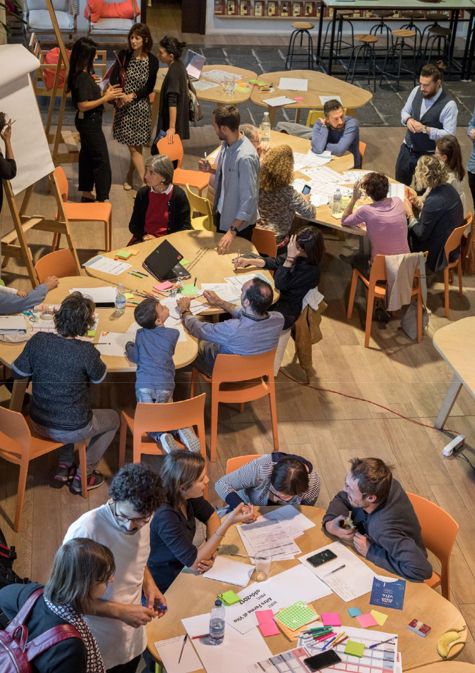
# IMPACT HUB FLORENCE AS A LEARNINGFigENVIRONMENT.5:ImpactHubFlorence

33
Radical Learning

- RADICAL LEARNING BUILDING BLOCKS

# 5

34

Radical Learning is a platform

based model of learning designed

around three interconnected -

although stand alone in their specific

objectives and means - building

blocks.

The three blocks are designed to capture not only the learning potential of Impact Hub as a complex ecosystem, but also to reflect a growing intensity of the learning process that a member may experience in the environment itself. On the other hand, the three blocks also stand as an internal framework of reference to guide and steer the strategic development of Impact Hub Florence, according to the overall objectives highlighted in the Theory of Change. This essentially means that any future activity, programme and initiative shall be embedded meaningfully and coherently within Radical Learning, adding value and significance to the different blocks and to the environment as a whole.

Each block puts emphasis on a

specific set of competencies and

skills, as well as on specific learning

approaches and methods, starting

from more soft and relational skills in

the first block (Community), passing

through more hard and technical

skills in the second block (Academy), and ending with what we call ‘systems knowledge and skills’ in the third block (Challenges).

From the point of view of the member, the Community block reflects the basic level of the membership - i.e. a basic, almost soft interaction with Impact Hub’s key resources and activities (sexy salads, business clinics, speed dating, parties, etc.), and is driven by situated or embedded learning processes. The Academy is the block dedicated to turn our community into a movement of ‘prosumers in learning’, providing members with both soft and hard components

to deliver meaningful teaching on vertical, in high-demand skills and competencies, while making the most of digital technologies to facilitate innovative learning recognition, certification and portfolio building. As typical in the sharing economy, members can be both teachers and learners, and therefore propose/ benefit from more modular, flexible and personalized teaching and learning. While the Academy builds on more traditional teaching and learning methods (frontal lessons, webinars, case studies, project work, etc.), its key positioning is strongly oriented to the labour market and to the innovation needs brought about by enterprises and organizations, who partner the different courses

35
Radical Learning
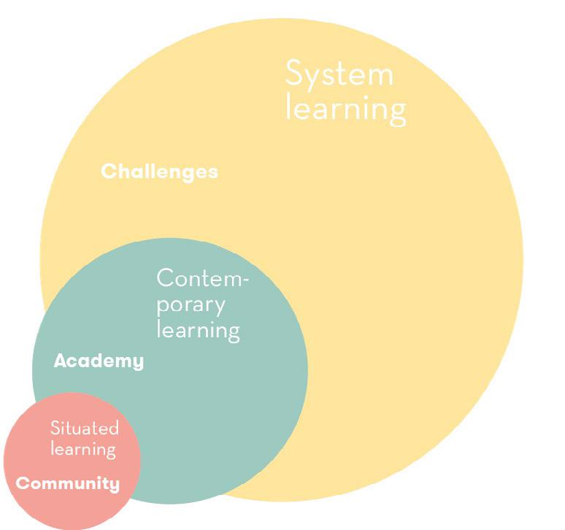

proposed also in light of recruitment. Finally, the Challenge block combines design thinking and systemic design approaches with the concept

of Communities of Practice (CoPs), so as to develop collective processes of open inquiry, research, experimentation and co-design of solutions around real problems and demands of innovation brought by either internal members and external organizations.

The three blocks are incremental and built one upon the other. There is an entry point in each block, meaning that they can be

experienced separately, or two, or all at once. Indeed, the redesign of Art of Hosting practices within Impact Hub Florence shall drive membership journeys that support transitions from one block to another, driving members in the acquisition of soft, hard and systems knowledge and skills. The RL competencies framework is the layer that encompasses all the three blocks, and where new skills and competencies (in particular, hard and systems skills) can be implanted dynamically by new partners who join the Academy and/or the Challenge.

36
# IMPACT HUB FLORENCE AS A LEARNING ENVIRONMENT

#COMMUNITY |

Situated learning

‘Community’ is the block

dedicated to the traditional

Hub membership. Working in

Impact Hub, interacting with

the community and the space,

participating to the activities or

contributing to the development

of the environment are all

opportunities of learning.

The key idea behind this block

is that these learnings can be

captured, measured, assessed

and given back to the members

as evidences of their personal

growth, particularly from the

point of view of their relational

and soft skills. Equally, they can

be evidences for the whole

community, particularly from the

point of view of the shared value

generated through collaboration.

It is about unlocking the information

which is not immediately visible, and

turning it into data and information

that are actionable for all the actors

involved or surrounding the system.

Throughout the membership

journey, members are profiled,

monitored and assessed against

archetypes and a number of

indicators and activities that are

either facilitated by the Hosts, or that happen freely in the environment. Each activity - sexy salads, sexy cakes, conviviums, etc. - entails an evaluation process which can be made by both hosts and participating members (=self-evaluation), and be endorsed

by the peers. In turn, this is ‘certified’ through specific badges. Furthermore, through gamification mechanisms, the RL platform provides the community with a system of digital tokens (=time) to activate peer exchanges, keep track of interactions and contributions (=tokens spent or gained), and incentivize awareness and acknowledgment of both collective and individual learning gains in the community, through open mutual learning recognition. All that contributes to enrich the individual profile of the member, and provides an overview of

the collaboration mood of the community.

Most and foremost, this is a digital driven system that gives back to members detailed information about their contribution to

the community, and turns such contribution into certified skills and competences that can be integrated within existing digital portfolios.

37

#ACADEMY | Contem-porary learning

The Academy is the block dedicated to give life to an open movement of ‘prosumers in teaching and learning’, making the most of collaborative economy’s principles and dynamics to unlock disintermediated and distributed learning processes that are more modular, flexible and personalized. We call it ‘contemporary learning’ as it shall focus on competencies and skills that are in high demand on the labour market, and involve experts and professionals able to bring concrete cases and projects that students can use as testbeds for learning by doing and by making processes.

The Academy shapes as an open and collaborative school where Impact Hub Florence operates as platform of connection and matchmaking for medium and short courses and workshops, providing a set of tools for management, quality assurance and digital-driven learnings’ recognition, certification and portfolio building.

Enterprises, associations and organizations can join the platform and operate as disciplinary hubs, involving and coordinating sub-communities of teachers in a specific thematic area. In

Radical Learning

this way, teachers become part of a broader Community of Practice committed to ‘learning to learn’, and to share lessons and experiences on the most effective strategies to cope with lifelong learning approaches and purposes.

Teachers and students meet each other during the courses, but they are also hosted in the broader Impact Hub ecosystem; therefore, they can benefit of the Community block and its own system for soft skills development and recognition. Enterprises propose new course or partner existing ones to assess students’ abilities and scout new talents, as well as to put their challenges at the core of the learning pathway.

Throughout the courses, the Radical Learning platform provides teachers with a digital infrastructure for managing subscriptions, apply quality measures and methodological guidelines, and play creatively with learnings recognition and certification. The RL platform is a tool that shall support a more dynamic, distributed and user-friendly way for certifying skills and competencies, providing learners with the opportunity to create innovative and creative portfolios grounded on measured evidences.

38
# IMPACT HUB FLORENCE AS A LEARNING ENVIRONMENT

#CHALLENGES |

Systemic learning

Challenges is the block dedicated

to systemic design and open

innovation. We use systemic

design and design thinking to

foster collective exploration and

co-creation of solutions around

real problems. Besides, we embed

the concept of Communities of

Practice as a method to boost

horizontal flows of knowledge

exchange within multi-disciplinary

teams of learners. Importantly, this

methodology shall help shift from

predefined learning objectives
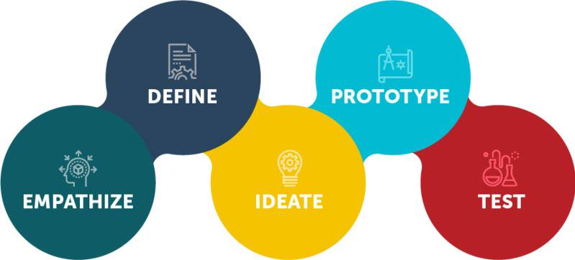

set at the beginning, to learning milestones that are disseminated throughout the journey. In other terms, learning milestones are checkpoints of individual and collective evaluation; they crystallize the journey around

a specific outcome or output (for example, a moodboard, a feasibility plan, a storyboard, etc.), which in turn serves as a guidance for the whole team to reflect around the learning process occurred until the release of that given output/outcome.

The challenge block is developed alongside the main phases of design-thinking:

Fig. 6: Main steps of design thinking

39

Throughout the different stages, a number of tools and methods are used, depending from time to time on the type of challenge, the team and the facilitators involved. Nonetheless, as a Community of Practice interested in experimenting continuously with new design tools and approaches, we make particular use of the Systemic Design Toolkit and methodology set therein18.

The specific outcomes and outputs associated to each stage may also depend on the specific challenge, the facilitators in charge and, in particular, on how the challenge itself evolves over time and takes shape. However, the overall learning architecture remains fixed, consisting of a) design macro-stages, and b) learning milestones = outputs/ outcomes = evaluation. Moreover, throughout the various stages, we always combine:

- # Open events - such as keynote speeches, talks, conferences - that mainly serve for inspiration and awareness-raising purposes;

- # Theoretical lessons that help learners acquire an in depth understanding of the different tools and approaches that can be used in a given stage;

- # Workshops on ‘vertical’ topics and meaningful adds-on (ex. Business model canvas, project

life cycle management, impact measurement, etc.);

● # Field work by the teams;

- # Peer review.

Challenges can be proposed by different actors and be of different types - business model, product, processes, organizational, etc.; nonetheless, the whole learning process shall embed social and environmental considerations throughout the journey. They are then launched both within the Impact Hub Florence community and externally through the RL platform, and can be joined by individuals. There are no particular requirements, although all prospective learners are assessed and eventually onboarded through the tools previously described (see Section 3).

The length of challenges may vary from 3 to 6 months; nonetheless, extended duration might be foreseen in specific cases. Throughout the challenges journey, the RL platform operates as a tool for learnings recognition and endorsement. Moreover, bilateral agreements with

local Universities, schools and vocational education institutions shall ensure the transferability and portability of learning gains within formal education contexts.

- See: https://www.systemicdesigntoolkit.org/

40
# IMPACT HUB FLORENCE AS A LEARNING ENVIRONMENT

Systems thinking Design thinking
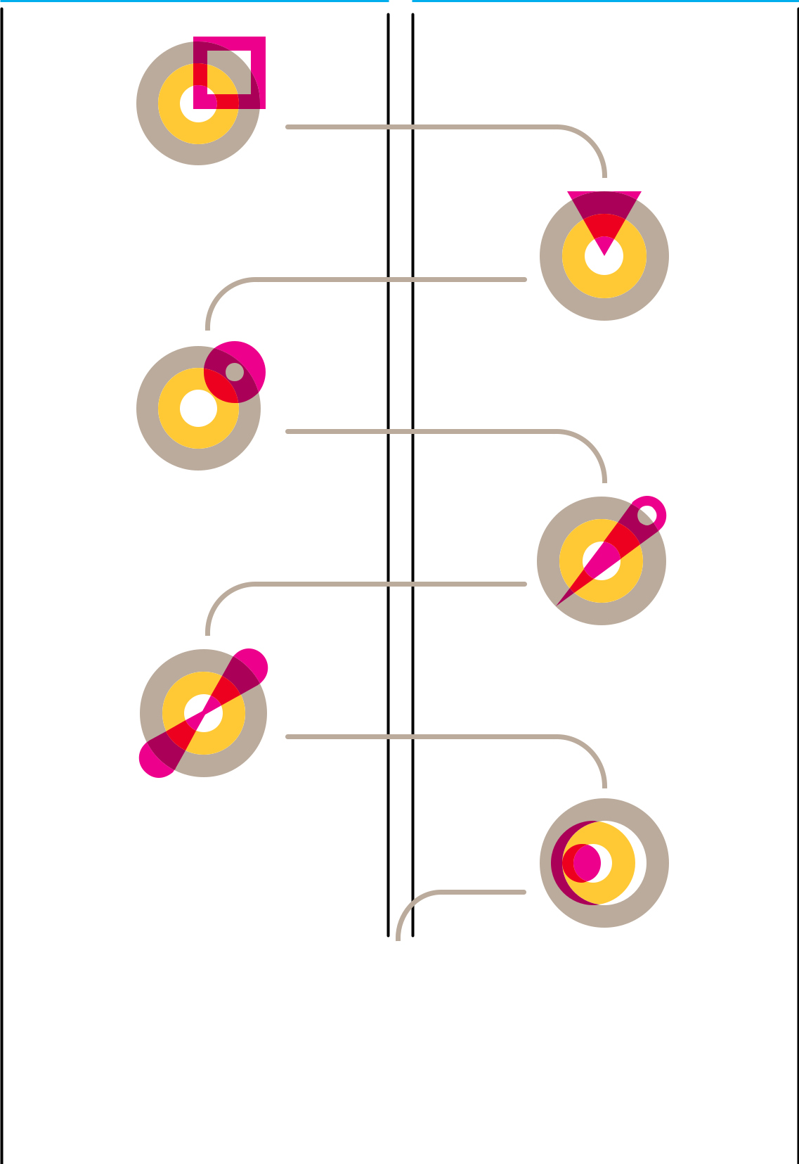

1. Framing the

system

2. Listening to

the system

- Understanding the system

4. Defining the

desired future

- Exploring the possibility space

6. Designing the


intervention model

- Fostering the transition

Fig.7: The main steps of the methodology provided in the Systemic Design Toolkit

41

Radical Learning

# CALL TO ACTION

# 6

42

Radical Learning is an open environment of learning. Whether you are an individual, an educational institution, a business or an organization of any type, we invite you to join at any stage and contribute to increase value and significance to the initiative. You can contribute to one or more of the following ways - and if you have new ideas about how to be involved, we are happy to hear!

#If you are a student or an active lifelong learner

- Keep you informed about the initiatives of Radical Learning and meet us at Impact Hub Florence

- Visit the website of the RL Academy and build your personal learning pathway by selecting one or more courses available

- Share your learning story in our blog

#If you are a teacher or an educator

#

#

Share your teaching story in our blog

Involve your learning community in the Challenge block by proposing a working topic or a concrete real challenge

#If you are a professional with skills and competencies in high demand on the labour market

#

#

Join the ‘Teachers Team’ of the Academy and propose a new course

Keep you updated about the initiatives of Radical Learning and meet us at Impact Hub Florence to understand how we can support you in the acquisition of soft skills

#If you are an enterprise or an organization active in the third sector

- Keep an active role by proposing your challenges as grounds of collective exploration and co-creation in the Challenge or Academy blocks

- Tell us which competencies and knowledge you are looking for and explore how we can support you in scouting talents

- Involve your team in a co-created, project-based learning journey or involve it in a course of the Academy.

#Moreover…

Radical Learning is backed by a fluid and open team. If you like the initiative and want to contribute to move it further through new ideas, improvements and specific contributions, you are welcome!

43
Radical Learning

# REFERENCES

# 7

44

Affinati, E. (2016). L’uomo del futuro. Sulle strade di Don Lorenzo Milani, Mondadori.

Arendt, H. (1958). The Human Condition, University of Chicago Press.

Augé M. (2000), Il senso degli altri. Attualità dell’antropologia, Bollati Boringhieri. Bacigalupo, M., Kampylis, P., Punie, Y., Van den Brande, G. (2016). EntreComp: The Entrepreneurship Competence Framework. Luxembourg: Publication Office of the European Union.
Barabasi, A.L. (2002). Linked: The New Science of Networks, Perseus Books Group. Bateson, G. (1972). Steps to an Ecology of Mind: Collected Essays in Anthropology, Psychiatry, Evolution, and Epistemology, University of Chicago Press.

Bateson, G. (1979). Mind and Nature: A Necessary Unity (Advances in Systems Theory, Complexity, and the Human Sciences), Hampton Press. Bauman, Z. (2000). La solitudine del cittadino globale, Feltrinelli.
Bauman, Z. (2001). La società individualizzata. Come cambia la nostra esperienza, Il Mulino.
Bauman Z. (2005), Intervista sull’identità, Laterza.

Bauman, Z. (2008). Individualmente insieme, Diabasis.

Capra, F. (1975). The Tao of Physics: An Exploration of the Parallels Between Modern Physics and Eastern Mysticism.
Capra, F. (2001), La Rete della Vita. Perché l’altruismo è alla base dell’evoluzione, Rizzoli. Ceccatelli Gurrieri G. (2003), Mediare culture. Nuove professioni fra comunicazione e intervento, Carocci.
Dark Matter Laboratories, (2017). Building impact movements. Place-based systems change for children and young people in North Camden. Deloitte, (2017). Millennial Survey 2017, Social impact, Innovation.
European Commission, (2017), European Skills/Competences, Qualifications and Occupations.
Hannerz U. (2001), La diversità culturale, Il Mulino.

Impact Hub, (2017). Beyond Unemployment. Convening & Collaborating with and for cities, Robert Bosch Stiftung.
Impact Hub Birmingham, (2016). Radical Childcare, A proposal to accelerate place based system change.
Johar, I. (2018), Societal Innovation & Our Future Cities. The case for a Social Contract for innovation.
Johar, I. (2017), 10 Provocations for the next 10 years of Social Innovation.

45
# REFERENCES

OD&M Project, (2017), Universities, Enterprises and Maker Communities in Open Design & Manufacturing across Europe: an exploratory study.
OECD, (2016). New Forms of Work in the Digital Economy, OECD Digital Economy Papers, No. 260, OECD Publishing, Paris.
Magatti, M. (2017). Cambio di paradigma. Uscire dalla crisi pensando al futuro. Feltrinelli. Manzini, E. (2015). Design, When Everybody Designs. An introduction to Design for Social Innovation, MIT Press.
Manzini, E. (2018). Politiche del quotidiano. Progetti di vita che cambiano il mondo, Edizioni di Comunità.
McKinsey, (2017). Jobs Lost, Jobs Gained: Workforce Transitions in a Time of Automation.
Morin, E. (2000). La testa ben fatta. Riforma dell’insegnamento e riforma del pensiero, Raffaello Cortina Editore.
Morin, E. (2001). I sette saperi necessari all’educazione del futuro, Raffaello Cortina Editore.
Morin, E. (2016). 7 lezioni sul Pensiero Globale, Raffaello Cortina Editore.

Raworth, K. (2017). L’economia della ciambella, Edizioni Ambiente.

Scharmer, O. (2013), Leading from the Emerging Future: From Ego-System to Eco-

System Economies, San Francisco: Berrett-Koehler.

Sclavi M. (2003), Arte di ascoltare e mondi possibili. Come si esce dalle cornici di cui siamo parte, Mondadori.
Sen, A. (2002). Globalizzazione e Libertà, Mondadori.

Sen, A. (2003). Etica ed Economia, Laterza.

Venier, F. (2017). La forza lavoro digitale e il futuro dell’organizzazione, Sviluppo e Organizzazione.
Weick, K., Sutcliffe, K. & Obstfeld, D. (2005). Organizing and the Process of Sensemaking, Organization Science.
Zamagni, S. (2016). Libertà del lavoro e giustizia del lavoro. Quaderni di Economia del Lavoro.
Zamagni, S. (2018). Questioni etiche nell’economia globale. In A. Fabris, Etiche applicate.

Una guida, Carocci Editore.

Zamagni, S. (2018). L’impatto economico e la sfida etica delle tecnologie convergenti, I Quaderni dell’Economia Civile.

46

47


Mail us at
radical.learning.florence@impacthub.net

Phone:
+39 055 576962

Keep you informed on Radical Learning initiatives:

eepurl.com/Np4nD

Explore the Academy programme:
florence.impacthub.net/radical-learning/

Propose a course:
florence.impacthub.net/radical-learning/

48

