What I learned
Library microservices: a reflection on the hard parts
Ties Vreeswijk, Fontys ICT, semester project
November 2026, iteration 2

This document has two parts. Part 1 is my reflection on what I learned while building the project, focusing on the parts that were actually hard. Part 2 contains the questions my teachers asked me after the first iteration. I didn't know all the answers at that point, so I looked into them and worked them out in my own project. Part 2 has the answers I found.
Contents
- Part 1: What I learned
  - 1. There is no transaction across two databases
  - 2. Retrying is only safe when the operation is idempotent
  - 3. A slow service is worse than a dead one
  - 4. Deciding what counts as a failure is a design decision
  - 5. Circuit breaker settings are a trade-off, not a fact
  - 6. Partial answers are better than no answer, but you have to choose
  - 7. Database per Service makes simple things awkward
  - 8. Following one action through several services
  - 9. Testing failure is its own skill
- Part 2: Questions from my teachers, and my answers
  - What exactly did you do with the circuit breaker, and how does it work?
  - Does the circuit breaker restart containers?
  - Can Docker act on what the circuit breaker detects?
  - What is the use of a circuit breaker in bigger projects?
  - How do you keep to the Database per Service pattern?
  - How can you show the demo live?

Part 1: What I learned
Building endpoints and routing turned out to be the easy part. The interesting lessons all came from the same place: once every service has its own database and the services talk over a network, things can fail halfway, and you have to decide what "correct" means when they do.
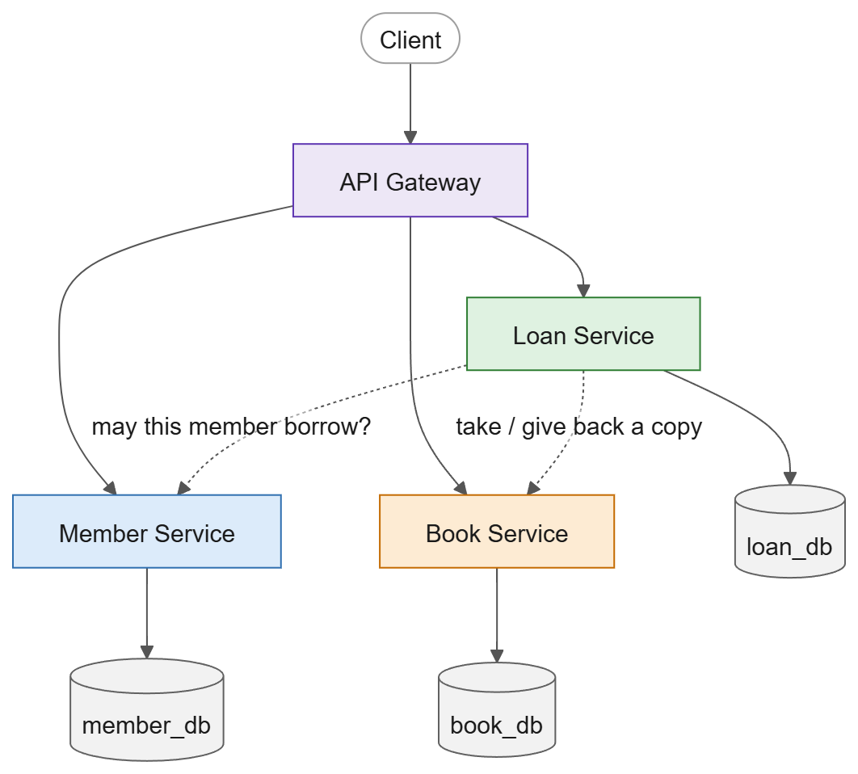
Figure 1. The system. Every service owns its own database; the services only talk to each other over HTTP.

1. There is no transaction across two databases
This was the biggest shift in how I think.
In a monolith, "delete a member and anonymize their loans" would be one database transaction: either everything happens or nothing does. In my system the member lives in member_db and the loans in loan_db, owned by two different services. No transaction covers both. I knew that in theory (it's the price of Database per Service), but I only really felt it when I had to build something that changes data in both places.
The answer was a saga: split the work into local steps, each one a normal transaction in one database, and decide up front what happens when a step fails (Figure 2).
# | Step | Service | Type
1 | Member becomes PendingDeletion | Member | compensatable
2 | Any active loans? | Loan | pivot
3 | Anonymize loan history | Loan | retryable
4 | Anonymize member, status Deleted | Member | retryable

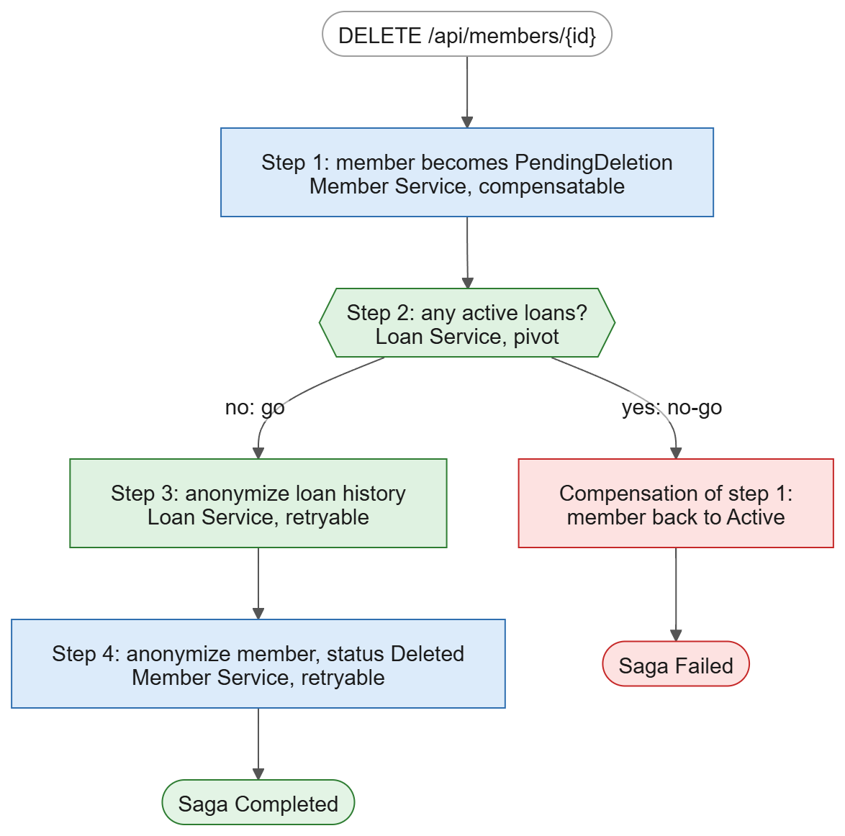
Figure 2. The "delete member" saga. Before the pivot the saga can still undo its work; after the pivot it only goes forward.
What I learned from building it:
- Compensation is not a rollback. Step 1 is already saved in member_db when step 2 says "no". There is nothing to roll back. So the saga does a new action that undoes the effect: it sets the member back to Active. A compensation is just another step that goes forward.
- The pivot decides everything. The steps before the pivot can be undone, the steps after it can't, so the saga must make sure they eventually succeed. That's why my saga gives up and compensates when the Loan Service stays unreachable before the pivot (after 10 attempts), but retries forever after it. I didn't understand why the pivot mattered until I had to write that rule.
- Step 1 is really a lock. At first step 1 seemed pointless: why mark the member before checking their loans? But without it, the member could borrow a book between the check in step 2 and the anonymizing in step 3, and the check would be wrong by the time it mattered. PendingDeletion makes the Loan Service refuse new loans, so the answer of step 2 stays true (Figure 3). This is called a semantic lock: a lock that lives in the data, not in the database.
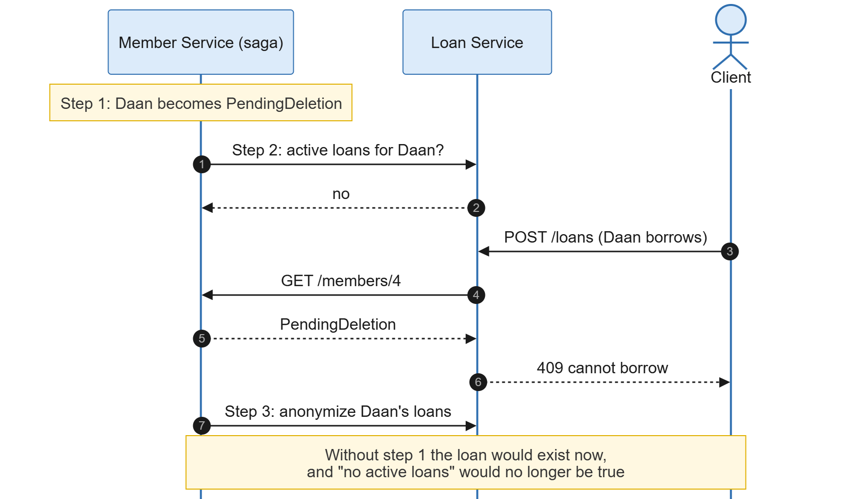
Figure 3. Step 1 works as a lock: while the member is PendingDeletion, the Loan Service refuses new loans.
- Eventual consistency is a real state, not a bug. While the saga runs, the data is "inconsistent": the member is PendingDeletion and the loans still point to them. That's allowed, as long as the system always ends up consistent. The client gets 202 Accepted and can ask for the status, instead of waiting for a result that may take a minute.
- The saga's state has to be saved. If the state only lived in memory, a crash halfway would leave a member stuck in PendingDeletion forever. So the saga is a table in member_db, saved after every step, and a background worker picks up anything that's unfinished (Figure 4). That's what made demo scenario 6 work: I stopped the Loan Service, deleted a member, and when the Loan Service came back the saga finished by itself.
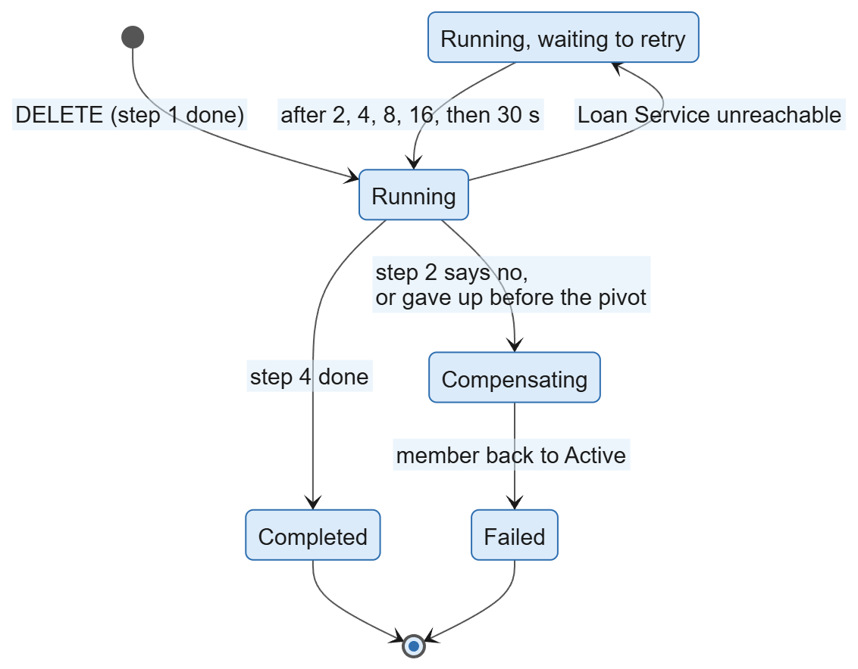
Figure 4. The states a saga goes through. The state is saved in member_db after every step.
- Orchestration over HTTP was enough. I always thought a saga needed a message broker, which is why it was out of scope at first. An orchestrated saga (one service runs the steps and remembers where it is) works fine over plain HTTP. A choreographed saga (services react to each other's events) is the one that really needs a broker.
I also learned where the saga does not go. Borrowing a book also touches two services (the Book Service takes a copy, the Loan Service saves the loan), and if saving the loan fails, the Loan Service gives the copy back. But if that "give back" call also fails, the copy stays taken. I accepted that on purpose. Not every multi-step flow needs a full saga, as long as I can explain where the gap is.

2. Retrying is only safe when the operation is idempotent
Retries sound like a free win: if a call fails, just try again. They're not free.
When a call times out, the gateway only knows that it didn't get an answer, not that the call failed. The Loan Service might have created the loan and then been too slow to reply. If the gateway retried POST /loans, the member could end up borrowing the same book twice (Figure 5). So my gateway only retries GET.
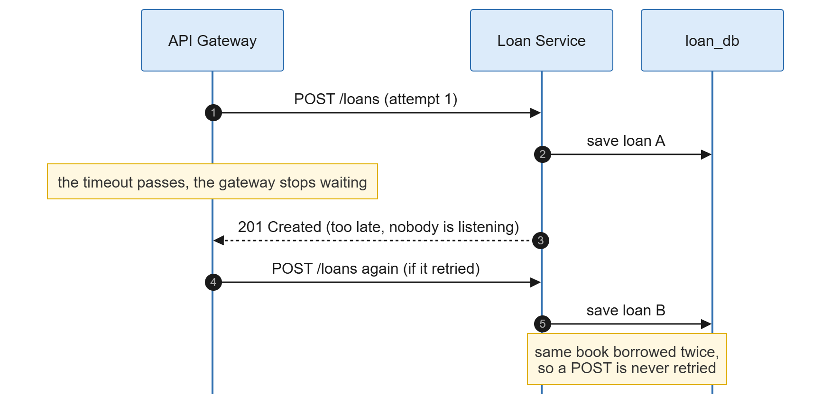
Figure 5. A timeout does not mean the call failed. Retrying a POST can do the same work twice.
The saga does retry a POST (/loans/anonymize), and that's only safe because I made it idempotent: it sets MemberId to null on all loans of that member, so the second call finds nothing to change and gives the same result. The rule I took away: before retrying something, ask what happens if the first attempt actually worked.

3. A slow service is worse than a dead one
A stopped container fails fast: the connection is refused (or, as I found out, the DNS lookup times out). A service that is running but slow is worse, because every caller waits for it, and the callers' callers wait for them. My health checks didn't help here at all: with fault injection on, the Book Service answered /health instantly and Docker reported it as healthy, while every real request took 3 seconds. "Running" is not the same as "working", and "healthy" is not the same as "fast".
The tools against it, and what each one actually does:
- Timeout: puts a limit on how long one call may wait. Without it, HttpClient waits 100 seconds.
- Retry: hides short hiccups. Against a slow service it makes things worse: three attempts of 2 seconds is 6 seconds of waiting.
- Circuit breaker: notices that a service keeps failing and stops calling it for a while, so callers get an answer in milliseconds instead of waiting for the timeout.
This is what I measured in demo scenario 3, with the Book Service made 3 seconds slow:
Request | Time | What happened
1st | 6.5 s | three attempts, each cut off by the 2 second timeout
2nd | 2.2 s | the circuit opened during this request
3rd | 0.003 s | the circuit is open, the gateway answers 503 at once

The order matters too (Figure 6). In my pipeline the retry is on the outside, then the circuit breaker, then the timeout on the inside. That way every retry attempt goes through the breaker and counts as a failure there, and the timeout is per attempt instead of for all attempts together.
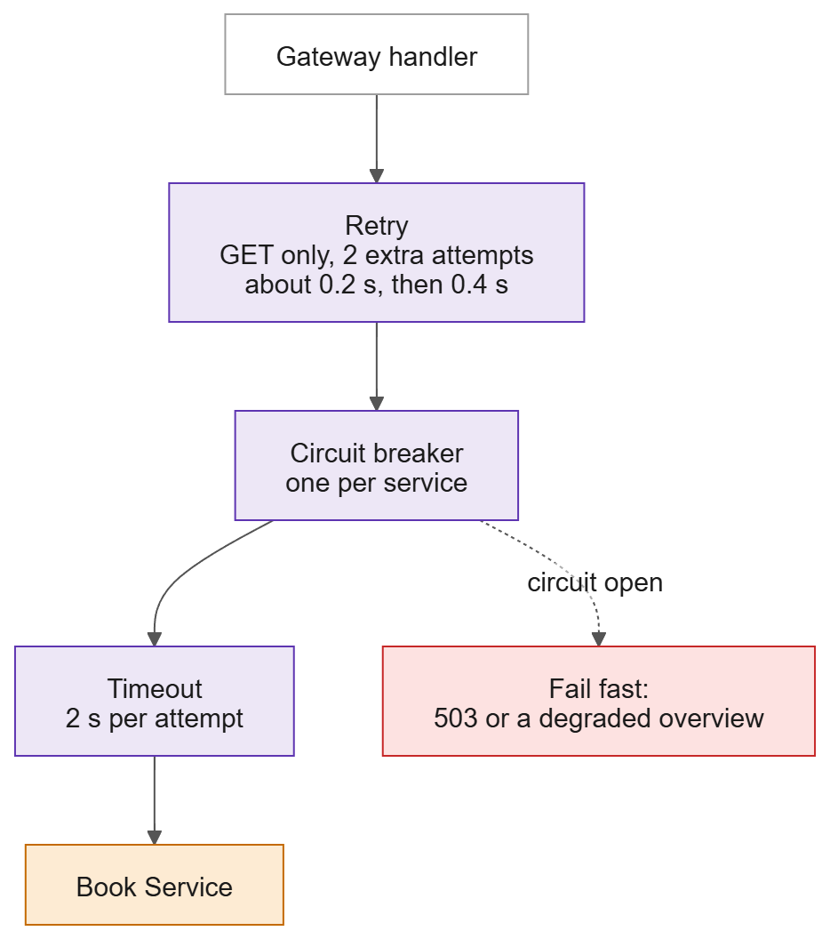
Figure 6. The resilience pipeline for each service in the gateway, from the outside in.

4. Deciding what counts as a failure is a design decision
I first thought "anything that isn't a 200 is a failure". That's wrong, and it took me a while to see why.
- 4xx answers are the client's fault, not the service's. A 404 says the service works fine.
- A 503 can be someone else's failure. The Loan Service answers 503 when the Book Service is down (Figure 7). If the gateway counted that 503 for the Loan Service's circuit, a broken Book Service would also cut off the perfectly healthy Loan Service. So my breaker counts no connection, timeouts and 500/502/504, but not 503.
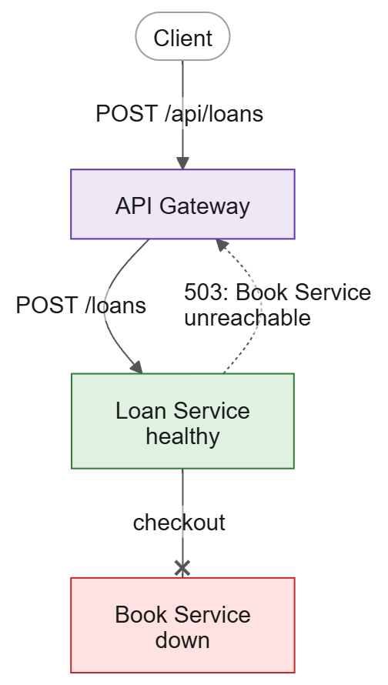
Figure 7. The Loan Service is healthy, but answers 503 because the Book Service is down. Counting that 503 would open the wrong circuit.
- Timeouts have to fit inside each other. The Loan Service waits up to 5 seconds for each of two other services. A 2 second gateway timeout would cut off normal POST /loans requests, so the Loan Service gets 12 seconds (Figure 8). A caller's timeout has to be longer than the work it waits for.
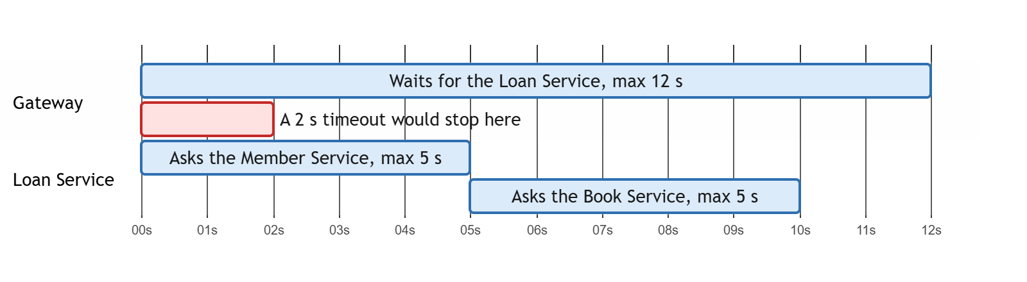
Figure 8. For POST /loans the Loan Service can wait up to 10 seconds on other services, so the gateway's timeout for the Loan Service is 12 seconds.

5. Circuit breaker settings are a trade-off, not a fact
I set the thresholds very low for the demo (open after 50% failures out of only 4 calls, see Figure 9), so you can see it trip right away. Testing the demo taught me what that costs:
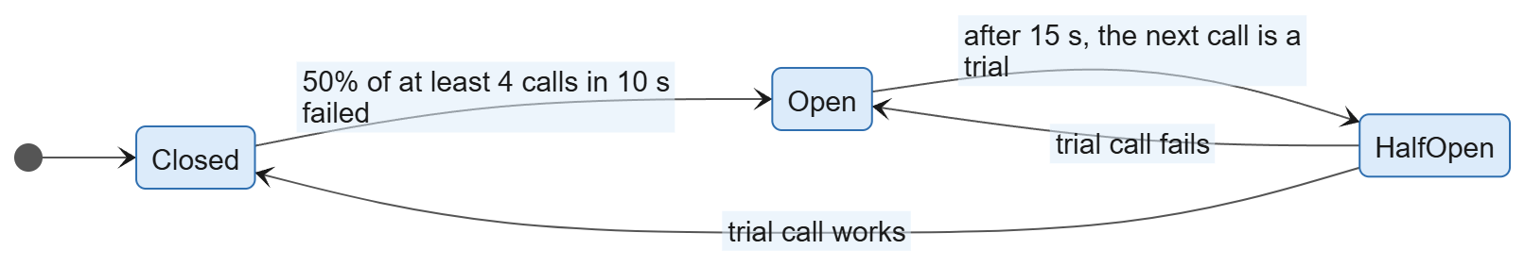
Figure 9. The three states of the circuit breaker with my demo settings.
- With 30% of the Book Service's requests failing at random, the retries saved the first few requests, but then the circuit opened anyway. Two unlucky failures close together are already 50% of 4 calls. A sensitive breaker protects quickly, but it also gives up on a service that mostly works.
- Older calls still count. The breaker looks at the last 10 seconds, so successful calls from the previous demo step influenced when it opened. The same steps don't always give the same timing.
- Half-open is lazy. I expected the circuit to switch to Half-open by itself after 15 seconds. In Polly it only switches when the next call comes in, and that call is the trial. My diagnostics endpoint kept saying Open until I sent a request.
Each service gets its own circuit. That's what keeps the failure contained: when the Book Service is down, the Member and Loan Service are still called normally.

6. Partial answers are better than no answer, but you have to choose
The member overview combines three services. When one is down, I had to decide per service whether the overview can do without it:
Service down | What the overview does | Why
Member Service | 503 | without the member there is nothing to show
Loan Service | the member with "loans": null | the member alone is still useful
Book Service | the loans without titles, "degraded": ["book-service"] | the loans are still useful without titles

That's not a technical decision, it's a product decision: what is still useful to the user? The technical part is just making sure the client can see that the answer is incomplete.

7. Database per Service makes simple things awkward
Some things that are trivial with one database became surprisingly fiddly:
- Seed data across services. A demo loan lives in loan_db, but the number of available copies lives in book_db. No service may touch another's database, so each one seeds its own part and I had to keep the numbers in step by hand (Figure 10). There's no foreign key to warn me when they don't match. The ids only line up because each table starts empty and the rows go in in the same order.
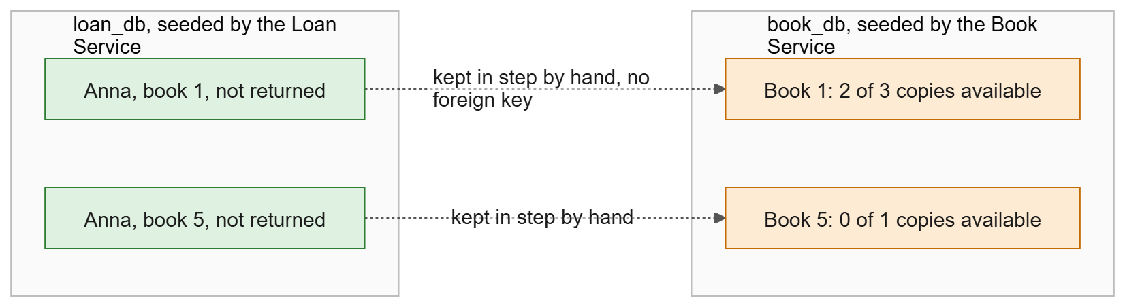
Figure 10. Two services seed their own databases, and the numbers only match because I keep them in step by hand.
- Anonymizing instead of deleting. I don't really delete the member, because the loan history is still useful (how often was a book borrowed?). But "clear the card number" broke the unique index on card numbers, so the field had to become nullable. And the loans keep their history with MemberId = null.
- Migrations aren't always right. EF Core generated defaultValue: "" for the new Status column, which isn't a valid status, so every existing member would have broken. I had to fix the migration by hand. Generated code still needs reading.

8. Following one action through several services
When one deletion runs through two services, the logs of each service on their own make no sense. I learned to pass a correlation id along: the gateway gives every request an X-Correlation-Id, and the saga sends its own id to the Loan Service (Figure 11). Then one search on the saga id shows one deletion from start to finish:
docker compose logs member-service loan-service | grep <saga id>
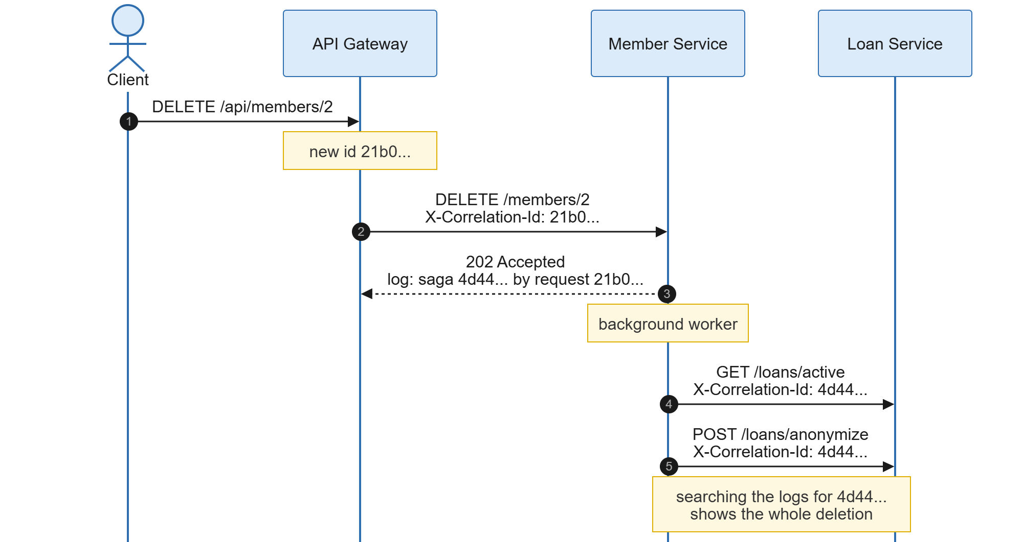
Figure 11. The correlation id travels with the request, and the saga uses its own id for its calls to the Loan Service.
The flip side: the framework logs so much by default (every request, every SQL query, every Polly attempt) that the important lines disappear. Turning log levels down through environment variables (Externalized Configuration again) was what made the logs usable in a demo.

9. Testing failure is its own skill
- Stopping a container is not enough to test failure. It only shows "dead". To show "slow" and "flaky" I added fault injection to the Book Service: a delay or a percentage of 500s, turned on with an environment variable.
- Test on fresh data, in isolation. The demo has to work right after docker compose up on an empty database. To check that without wiping my own database, I ran everything in a separate Compose project (docker compose -p ...) with its own volume.
- Write down what really happens, not what should happen. Running the demo script for real showed two places where my description was wrong (the circuit opened one request earlier than I wrote, and the flaky scenario tripped the breaker). I fixed the text, not the system, because what really happened was the more interesting lesson.

What I would still improve
- The correlation id only goes through forwarded requests and the saga. The overview's own calls and the Loan Service's calls to the other services don't carry it yet.
- The saga worker assumes there's only one Member Service. With two instances, both workers could pick up the same saga. That would need a lock in the database (SELECT ... FOR UPDATE SKIP LOCKED).
- If the saga ever had to publish events instead of calling HTTP endpoints, saving the state and sending the event would again be two things that can fail separately. That's the problem the Transactional Outbox pattern solves, and now I understand why it exists.
- There are no automated tests. Everything above was checked by hand with the demo script.

The short version
Splitting a system into services doesn't remove complexity, it moves it. Inside one service, the database protects you. Between services, you have to decide for yourself what happens when a call fails, times out, is retried or arrives twice. The patterns (saga, circuit breaker, idempotency, correlation ids) are mostly names for the decisions you have to make anyway.

Part 2: Questions from my teachers, and my answers
After the first iteration my teachers asked me the questions below. I didn't know all the answers at that point, so I looked into them and worked them out with my own project as the example. These are the answers I found.

What exactly did you do with the circuit breaker, and how does it work?
What it is for. When a service is down or slow, every request to it waits for a timeout. With many requests, everything piles up, and one broken service makes the whole system slow. The circuit breaker notices that a service keeps failing and stops calling it for a while, so callers get an answer straight away (a 503, or a partial overview) instead of waiting.
How it works. It has three states (Figure 9):
- Closed (normal): calls go through and the breaker counts how many fail.
- Open: in the last 10 seconds there were at least 4 calls and at least 50% of them failed. For 15 seconds the gateway doesn't call that service at all and fails immediately.
- Half-open: after the 15 seconds the next call is let through as a trial. If it works, the circuit closes again; if it fails, it opens for another 15 seconds.
What I built. Every service has its own HttpClient in the gateway with a Polly pipeline of three layers (Figure 6): a retry (GET only, 2 extra attempts), the circuit breaker (one per service) and a timeout per attempt (2 seconds, 12 for the Loan Service). Around it I added:
- A clear definition of failure: no connection, a timeout, or a 500/502/504. A 503 and 4xx answers don't count (see Part 1, section 4).
- Configuration: all thresholds come from environment variables (CIRCUIT_*), so I can change them without rebuilding. That's Externalized Configuration.
- Logging of every state change, for example Circuit for book-service: Closed/HalfOpen -> OPEN for 15s, and of every retry and timeout.
- A diagnostics endpoint, GET /api/diagnostics/circuits, that shows the state per service. It only exists in the demo setup.
- Clear 503s that say which service is down and what its circuit is doing: "error": "book-service unavailable", "circuit": "Open".
- A fallback in the member overview: without the Book Service it still answers, with "degraded": ["book-service"].
- Fault injection in the Book Service, so I can show a slow or flaky service without stopping the container.

Does the circuit breaker restart containers?
No. This was a misunderstanding I had myself. The circuit breaker never touches the broken service; it only changes how the caller behaves.
The best comparison I found is the fuse box at home. When a device shorts, the fuse trips and that group goes dark, so the rest of the house keeps working. The fuse doesn't repair the device. Someone has to fix it, and then the power comes back.
So the circuit breaker is detection plus a reaction, but the reaction is "stop calling", not "fix it":
- Detection: it counts failed calls and notices when a service keeps failing.
- Reaction: it stops calling that service for a while, so callers aren't kept waiting.
- Recovery check: after 15 seconds it tries one call to see if the service is back. If it is, everything goes back to normal by itself; nobody has to tell the gateway.
Repairing and restarting is the job of other parts (Figure 12):
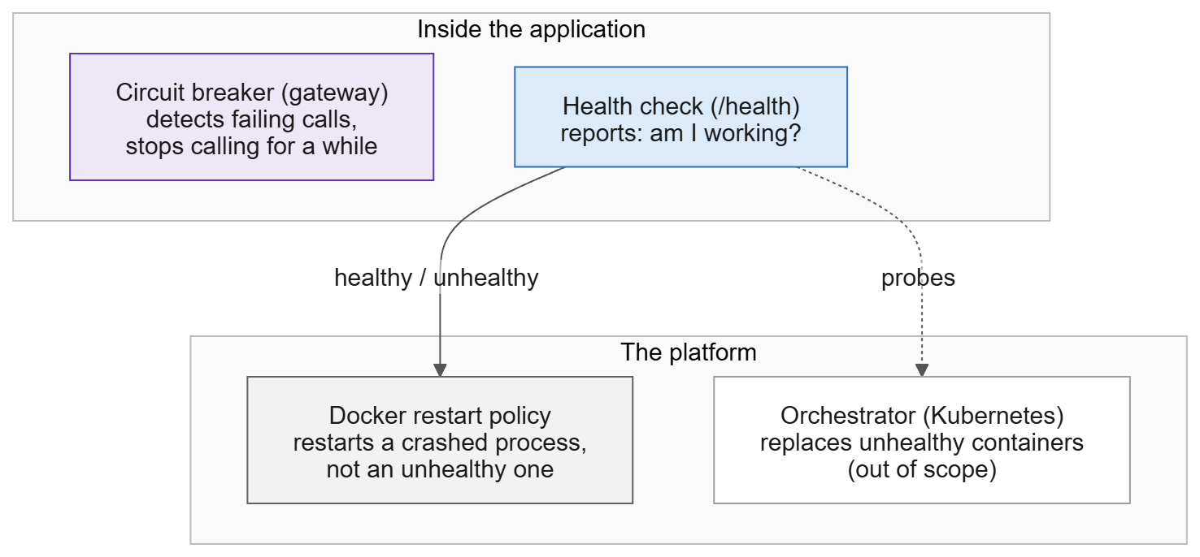
Figure 12. Who does what: the circuit breaker protects callers, the health check reports, the platform restarts.
- The health check (/health) is also detection, but from the other side: it asks the service itself "are you OK?". The circuit breaker looks at real traffic instead. They complement each other: in demo scenario 3 the Book Service was healthy while every real request took 3 seconds. The health check missed it, the circuit breaker caught it.
- The Docker restart policy (restart: unless-stopped on the VM) restarts a container when its process crashes. It does not restart a container that is only unhealthy. Locally there is no restart policy, so a crashed service stays down until I start it.
- An orchestrator like Kubernetes replaces containers that stay unhealthy. That's the real self-healing, but it's out of scope for this project.
In short: the circuit breaker detects and protects, the health check reports, and the platform restarts. The system recovers by itself once the service is back, but the circuit breaker isn't what repairs the service.

Can Docker act on what the circuit breaker detects?
Technically yes, but it isn't how it's normally done, and I wouldn't build it. The breaker's state lives in the gateway's memory, which Docker can't see. To act on it, the gateway would have to control Docker itself (through the Docker socket). That is a bad idea because:
- It's dangerous. Access to the Docker socket is effectively root access to the machine. The public entry point of the system would be able to start and stop anything.
- The gateway often doesn't know the real cause. If the Loan Service fails because the Book Service is down, restarting the Loan Service doesn't help. A timeout can also be the network instead of the service.
- It mixes responsibilities. The gateway routes and protects; managing infrastructure isn't its job. With several gateways, they could even fight over restarts.
- It can make things worse. A service that is slow because it's overloaded gets restarted, comes back, gets overloaded again, and so on.
What is done instead: the service reports through its own health check, and the platform acts on that. Kubernetes has two kinds of checks for this: a readiness probe ("send me no traffic for now", which is the circuit breaker idea at platform level) and a liveness probe ("I'm stuck, restart me"). The circuit breaker's state changes are used for monitoring and alerts, so a person or the platform gets told that a circuit keeps opening.
For my project I kept it as separation of concerns: the breaker protects callers, the health check reports, the platform restarts.

What is the use of a circuit breaker in bigger projects?
In my small project the circuit breaker mostly makes answers faster and clearer. In a big system it's one of the things that stops one problem from taking everything down.
The main problem: cascading failures. In a big system one request goes through many services. Say a webshop's review service becomes slow. Every product page waits for reviews, the product service's threads fill up with waiting requests, it can't serve other requests any more, and the services that call it start waiting too. A few minutes later the whole shop is down because of one non-essential service. With a circuit breaker, the product service stops waiting for reviews and shows the page without them (Figure 13).
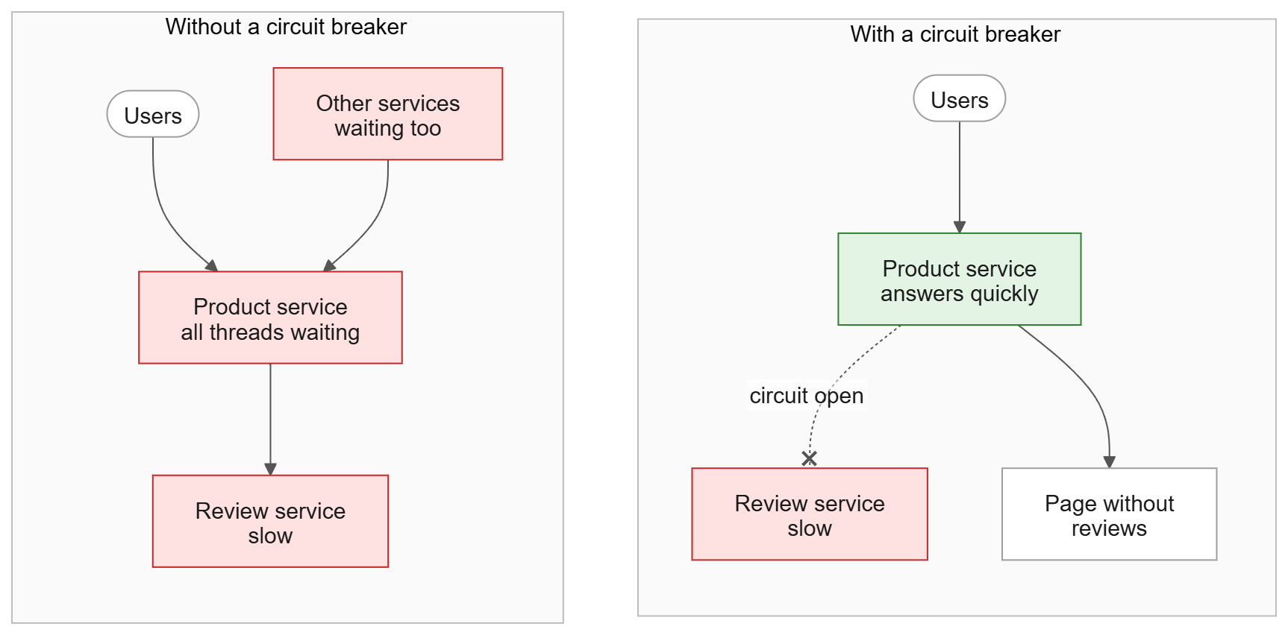
Figure 13. Without a breaker, one slow service fills up the threads of everything that calls it. With a breaker, the damage stays at the slow service.
What it gives you at scale:
- Fail fast instead of waiting: a page without reviews in 200 ms is better than an error after 30 seconds, and waiting costs a lot of resources at thousands of requests per second.
- Graceful degradation: the system gets a bit worse instead of broken. Recommendations down: show popular products. Payment provider down: "try again shortly" instead of a hanging checkout. My degraded overview is the same idea on a small scale.
- Room to recover: a service in trouble usually gets more traffic because everyone retries (a retry storm). The breaker stops that traffic for a while, and the half-open trial tests carefully whether the service is back.
- Containment between teams: every service usually belongs to a different team. Team A doesn't go down because team B had a bad deploy, which makes independent deploys safe in practice.
- A clear signal: a circuit that opens is measurable. Big systems put circuit states on dashboards and alert on them, often before the owning team notices the problem.
How it looks in big systems:
- It's often not in the code but in a service mesh (Istio, Linkerd, Envoy): a small proxy next to every service handles timeouts, retries and circuit breaking for all traffic, with the same rules for every team.
- Circuits are often per instance or per endpoint, not only per service: with 20 instances, one broken instance shouldn't make you drop all 20.
- It's combined with timeouts, retry budgets, bulkheads (separate thread pools per dependency) and rate limiting.
The downsides are the same ones I ran into: tuning is hard (too sensitive and it trips on normal hiccups), some calls have no sensible fallback (a bank transfer can't "do without the bank"), and a fallback that works too well can hide a broken service, which is why monitoring matters.
In one sentence: a circuit breaker turns "one slow service brings everything down" into "one feature is temporarily missing".

How do you keep to the Database per Service pattern?
The rule is: each service owns its own data, and other services can only reach it through that service's API. My project keeps to that at four levels.

1. Infrastructure: separate databases and users
There is one Postgres container, but the init script (db/init/01-create-databases.sh) creates three databases (book_db, member_db, loan_db) and three users, each the owner of one database. REVOKE ALL ... FROM PUBLIC makes sure only the owner can connect. Each service only gets its own connection string through an environment variable, so it doesn't even have the credentials for the other databases. It isn't just an agreement: if the Loan Service tried to read member_db, Postgres would refuse (Figure 14).
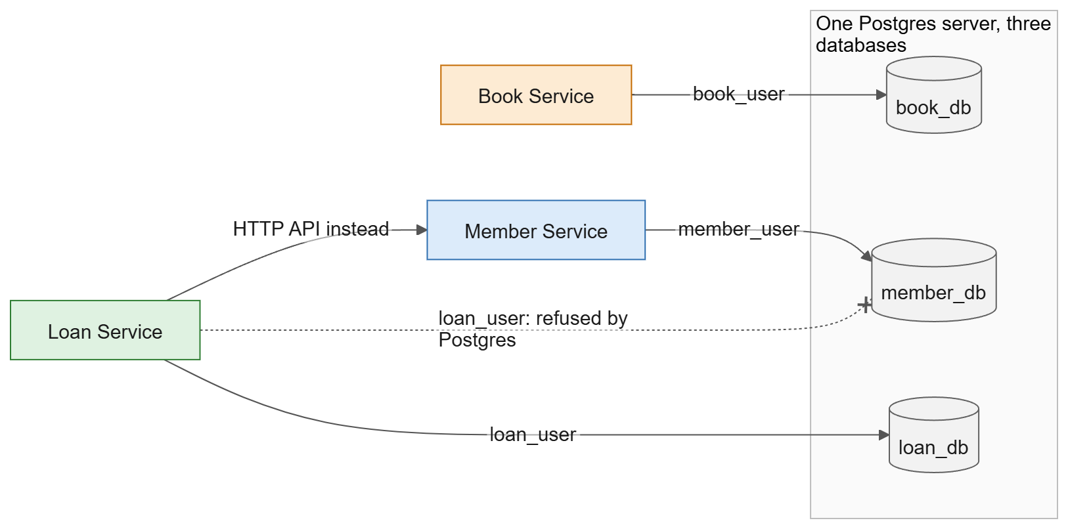
Figure 14. Each service connects with its own database user. The Loan Service cannot connect to member_db and has to use the Member Service's API instead.

2. Code: nothing shared between services
Each service has its own model, its own DbContext and its own EF Core migrations. There is no shared library: when the Loan Service needs member data, it defines its own small record with only the fields it needs. That duplication is deliberate: if the Member Service adds a field, nobody else breaks.

3. Data model: only ids, no foreign keys
A loan stores MemberId and BookId, but there are no foreign keys (the other tables are in other databases) and no copies of names or titles, because those would go stale.

4. Communication: only over HTTP
When a service needs another service's data, it asks that service. The Loan Service asks the Member Service whether a member may borrow, and asks the Book Service to take a copy instead of changing the copy count itself. The overview is combined in the gateway (API Composition), and deleting a member goes through the Loan Service's API in a saga.

What the pattern costs
Most of the complex work in my project comes from this pattern:
With one database | What I had to do instead
A JOIN for the overview | API Composition in the gateway
One transaction for "delete member + anonymize loans" | A saga with compensation and retries
A foreign key that guarantees a member exists | The Loan Service asks the Member Service when someone borrows
Seed data in one script | Each service seeds its own part, kept in step by hand
Lowering the copy count in the same transaction as saving the loan | A separate HTTP call, and giving the copy back if saving fails

In return, each service can change its schema, deploy, and even switch to a different kind of database without asking anyone else.

Where my setup is weaker
microservices.io names three variants, from light to strict: private tables per service, a schema per service, and a database server per service. Mine sits between the last two: separate databases with separate users on one shared Postgres server. That's a common choice, but it has downsides: if Postgres goes down, all three services suffer, and the superuser can still reach everything. Separating further is easy (one Postgres container per service; only the connection strings change), but I chose one server to keep the project simple.

How can you show the demo live?
The best way is on my own laptop, which is what my demo script (docs/DEMO.md) is written for. Docker Desktop runs the whole system, and I share my screen or use the projector:
- One side of the screen shows the logs (docker compose logs -f api-gateway member-service loan-service), the other side the requests in Rider (docs/demo.http). The audience sends a request and sees the retries, the circuit going Open, Half-open and Closed, or the saga steps in the logs right after.
- A second terminal is used for stopping and starting services and turning fault injection on and off.
- I control everything, and once the images are built I don't depend on Wi-Fi or the VPN.
The deployed version on the Fontys EduCloud VM can also be reached during a presentation, but it's less handy for this: the diagnostics endpoint and fault injection are off in production, stopping services means logging in to the VM, and its data isn't the fresh demo data. It's good for showing that the deployment works; for the patterns I use my laptop.
To make it go smoothly I start from fresh data ten minutes before (docker compose down -v, then docker compose up -d --build), rehearse the waiting moments (the 15 second break and up to 30 seconds for the saga), make the font big, and keep a screen recording of a successful run as a backup. If time is short, I show scenarios 1, 2, 4 and 6: the gateway, the circuit breaker and the saga, with scenario 6 as the highlight.

