JATKOKEHITYSOHJE
UUDEN KONFIGUROITAVAN ASIAN LISÄÄMINEN

Uuden datakonfiguraation lisääminen Metkaan
Tässä esimerkissä käymme läpi, kuinka Metkaan lisätään uusi konfiguroitava ja revisioitava asia (REVISIONABLE). Käytämme tässä esimerkissä SERIES-tyyppisen REVISIONABLEN kopiota, joka on vain nimetty uudelleen muotoon PERUNOIDEN_KASVATUS.
Toimenpide vaatii vähintäänkin välttävän ymmärryksen SQL-tietokannoista, JSON-merkintätavasta sekä jQuerystä (v 3.2.1). Mikäli uuden konfiguroitavan asian parissa tahdotaan toteuttaa toiminnallisuuksia, joihin Metka ei nykyisellään kykene, tulee kehittäjän osata myös Javaa (v 1.8).
Uuden konfiguroitavan asian lisääminen Metkaan alkaa ajamalla tietokantaan INSERT-komento, jolla lisäämme CONFIGURATION-tauluun uuden rivin:
sql> INSERT INTO "public"."configuration" ("configuration_id", "data", "type", "version") VALUES (9, '{"key":{"type":"PERUNOIDEN_KASVATUS","version":1},"references":{},"selectionLists":{},"fields":{"seriesabbr":{"key":"seriesabbr","type":"STRING","translatable":false,"immutable":true,"subfield":false,"editable":true,"writable":true,"indexed":true,"indexName":null,"generalSearch":false,"exact":true},"seriesdesc":{"key":"seriesdesc","type":"RICHTEXT","translatable":true,"immutable":false,"subfield":false,"editable":true,"writable":true,"indexed":true,"indexName":null,"generalSearch":true,"exact":false},"seriesnotes":{"key":"seriesnotes","type":"STRING","translatable":false,"immutable":false,"subfield":false,"editable":true,"writable":true,"indexed":true,"indexName":null,"generalSearch":false,"exact":false}},"restrictions":[{"type":"APPROVE","targets":[{"type":"FIELD","content":"seriesabbr","targets":[],"checks":[{"condition":{"type":"NOT_EMPTY","target":{"type":null,"content":null,"targets":[],"checks":[]}},"restrictors":[]},{"condition":{"type":"UNIQUE","target":{"type":null,"content":null,"targets":[],"checks":[]}},"restrictors":[]}]},{"type":"FIELD","content":"seriesname","targets":[],"checks":[{"condition":{"type":"NOT_EMPTY","target":{"type":null,"content":null,"targets":[],"checks":[]}},"restrictors":[]}]},{"type":"FIELD","content":"seriesdesc","targets":[],"checks":[{"condition":{"type":"NOT_EMPTY","target":{"type":null,"content":null,"targets":[],"checks":[]}},"restrictors":[]}]}]},{"type":"REMOVE_LOGICAL","targets":[{"type":"QUERY","content":"STUDY series.value:{id}","targets":[],"checks":[{"condition":{"type":"IS_EMPTY","target":{"type":null,"content":null,"targets":[],"checks":[]}},"restrictors":[]}]},{"type":"QUERY","content":"PUBLICATION series.value:{id}","targets":[],"checks":[{"condition":{"type":"IS_EMPTY","target":{"type":null,"content":null,"targets":[],"checks":[]}},"restrictors":[]}]}]}],"cascade":[],"namedTargets":{},"displayId":null}', 'PERUNOIDEN_KASVATUS', 1)

Tässä on hyvä tietää, että “configuration_id”:n arvon on oltava uniikki - muuten rivin lisääminen tietokantatauluun ei onnistu. Myös “type” -sarakkeen arvon on syytä olla tässä vaiheessa uniikki, sillä muutoin Metka luulee lisäämäämme riviä jonkin muun REVISIONABLEN datakonfiguraatioksi, ja konfiguraatiolle annetusta versionumeroinnista riippuen rivin lisääminen saattaa onnistua, mikäli vastaavaa versiota kyseisen REVISIONABLEN konfiguraatiosta ei löydy kannasta. Lopputulos ei kuitenkaan tässäkään tapauksessa ole toivomamme.
Vaihtoehtoinen tapa lisätä konfiguraatio metkaan, on kirjoittaa se JSON-tiedostona metka/src/main/resources/configuration/ -hakemistoon, jolloin metka tallentaa konfiguraation tietokantaan käynnistyessään.

Enumeraation lisääminen uudelle datakonfiguraatiolle
Lisättyämme datakonfiguraation tietokantaan, meidän täytyy lisätä sille myös enumeraatio.
Avaa tiedosto: fi.uta.fsd.metka.enums.ConfigurationType.java
Lisäykset tehdään tiedostoon seuraavasti. Kirjoita uuden enumeraation nimi tiedoston alkuun:
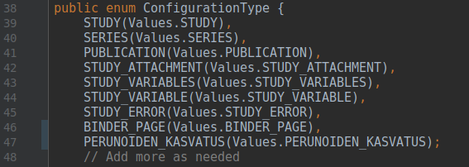
Lisää myös sitä vastaava merkkijonoarvo tiedoston loppuun:
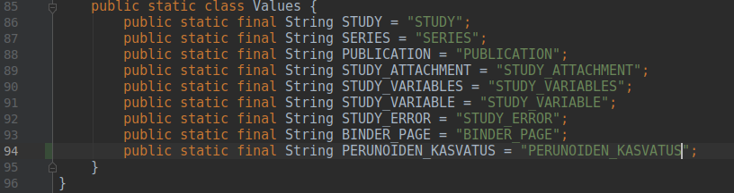

GUI-konfiguraation lisääminen uudelle revisionablelle
GUI-konfiguraation lisääminen metkaan tapahtuu samoin, kuin datakonfiguraationkin lisääminen. Käytämme tässäkin esimerkissä PUBLICATION-tyyppisen REVISIONABLEN GUI-konfiguraation kopiota. Toimenpiteeseen vaikuttavat samat seikat, kuin datakonfiguraationkin lisäämiseen: gui_configuration_id:n sekä version arvojen tulee olla taulussa uniikkeja.
sql> INSERT INTO public.gui_configuration (gui_configuration_id, data, type, version) VALUES (25, '{"key":{"type":"PERUNOIDEN_KASVATUS","version":1},"content":[{"id":null,"type":"COLUMN","permissions":[],"&title":null,"hidden":false,"readOnly":null,"columns":3,"rows":[{"id":null,"type":"ROW","permissions":[],"&title":null,"hidden":false,"readOnly":null,"cells":[{"id":null,"type":"CELL","permissions":[],"&title":{"default":"Julkaisuvuosi"},"hidden":false,"readOnly":null,"required":true,"contentType":"FIELD","important":false,"horizontal":false,"field":{"key":"publicationyear","displayType":null,"multiline":false,"multichoice":false,"columnFields":[],"disableRemoval":false,"dialogTitle":null,"rowsPerPage":null,"showSaveInfo":false,"displayHeader":true,"showReferenceValue":false,"showReferenceType":false,"showReferenceSaveInfo":false,"showReferenceApproveInfo":[],"showReferenceState":false,"showRowAmount":false,"allowDownload":false},"subfieldConfiguration":{},"colspan":1},{"id":null,"type":"CELL","permissions":[],"&title":{"default":"Voiko julkaista"},"hidden":false,"readOnly":null,"required":true,"contentType":"FIELD","important":false,"horizontal":false,"field":{"key":"publicationpublic","displayType":null,"multiline":false,"multichoice":false,"columnFields":[],"disableRemoval":false,"dialogTitle":null,"rowsPerPage":null,"showSaveInfo":false,"displayHeader":true,"showReferenceValue":false,"showReferenceType":false,"showReferenceSaveInfo":false,"showReferenceApproveInfo":[],"showReferenceState":false,"showRowAmount":false,"allowDownload":false},"subfieldConfiguration":{},"colspan":1},{"id":null,"type":"CELL","permissions":[],"&title":{"default":"Julkaisu id-nro"},"hidden":false,"readOnly":null,"required":true,"contentType":"FIELD","important":false,"horizontal":false,"field":{"key":"publicationid","displayType":null,"multiline":false,"multichoice":false,"columnFields":[],"disableRemoval":false,"dialogTitle":null,"rowsPerPage":null,"showSaveInfo":false,"displayHeader":true,"showReferenceValue":false,"showReferenceType":false,"showReferenceSaveInfo":false,"showReferenceApproveInfo":[],"showReferenceState":false,"showRowAmount":false,"allowDownload":false},"subfieldConfiguration":{},"colspan":1}]},{"id":null,"type":"ROW","permissions":[],"&title":null,"hidden":false,"readOnly":null,"cells":[{"id":null,"type":"CELL","permissions":[],"&title":{"default":"1. Tallennuspvm"},"hidden":false,"readOnly":null,"required":true,"contentType":"FIELD","important":false,"horizontal":false,"field":{"key":"publicationfirstsaved","displayType":null,"multiline":false,"multichoice":false,"columnFields":[],"disableRemoval":false,"dialogTitle":null,"rowsPerPage":null,"showSaveInfo":false,"displayHeader":true,"showReferenceValue":false,"showReferenceType":false,"showReferenceSaveInfo":false,"showReferenceApproveInfo":[],"showReferenceState":false,"showRowAmount":false,"allowDownload":false},"subfieldConfiguration":{},"colspan":1},{"id":null,"type":"CELL","permissions":[],"&title":{"default":"Julkaisun ilmoitustapa"},"hidden":false,"readOnly":null,"required":true,"contentType":"FIELD","important":false,"horizontal":false,"field":{"key":"publicationannouncement","displayType":null,"multiline":false,"multichoice":false,"columnFields":[],"disableRemoval":false,"dialogTitle":null,"rowsPerPage":null,"showSaveInfo":false,"displayHeader":true,"showReferenceValue":false,"showReferenceType":false,"showReferenceSaveInfo":false,"showReferenceApproveInfo":[],"showReferenceState":false,"showRowAmount":false,"allowDownload":false},"subfieldConfiguration":{},"colspan":1},{"id":null,"type":"CELL","permissions":[],"&title":{"default":"Julkaisun kieli"},"hidden":false,"readOnly":null,"required":true,"contentType":"FIELD","important":false,"horizontal":false,"field":{"key":"publicationlanguage","displayType":null,"multiline":false,"multichoice":false,"columnFields":[],"disableRemoval":false,"dialogTitle":null,"rowsPerPage":null,"showSaveInfo":false,"displayHeader":true,"showReferenceValue":false,"showReferenceType":false,"showReferenceSaveInfo":false,"showReferenceApproveInfo":[],"showReferenceState":false,"showRowAmount":false,"allowDownload":false},"subfieldConfiguration":{},"colspan":1}]},{"id":null,"type":"ROW","permissions":[],"&title":null,"hidden":false,"readOnly":null,"cells":[{"id":null,"type":"CELL","permissions":[],"&title":{"default":"Viimeisin muutospvm"},"hidden":false,"readOnly":null,"required":false,"contentType":"FIELD","important":false,"horizontal":false,"field":{"key":"savedAt","displayType":"CUSTOM_JS","multiline":false,"multichoice":false,"columnFields":[],"disableRemoval":false,"dialogTitle":null,"rowsPerPage":null,"showSaveInfo":false,"displayHeader":true,"showReferenceValue":false,"showReferenceType":false,"showReferenceSaveInfo":false,"showReferenceApproveInfo":[],"showReferenceState":false,"showRowAmount":false,"allowDownload":false},"subfieldConfiguration":{},"colspan":1},{"id":null,"type":"CELL","permissions":[],"&title":{"default":"Käsittelijä"},"hidden":false,"readOnly":null,"required":false,"contentType":"FIELD","important":false,"horizontal":false,"field":{"key":"savedBy","displayType":"CUSTOM_JS","multiline":false,"multichoice":false,"columnFields":[],"disableRemoval":false,"dialogTitle":null,"rowsPerPage":null,"showSaveInfo":false,"displayHeader":true,"showReferenceValue":false,"showReferenceType":false,"showReferenceSaveInfo":false,"showReferenceApproveInfo":[],"showReferenceState":false,"showRowAmount":false,"allowDownload":false},"subfieldConfiguration":{},"colspan":1},{"id":null,"type":"EMPTYCELL","permissions":[],"colspan":1}]}]},{"id":null,"type":"COLUMN","permissions":[],"&title":null,"hidden":false,"readOnly":null,"columns":1,"rows":[{"id":null,"type":"ROW","permissions":[],"&title":null,"hidden":false,"readOnly":null,"cells":[{"id":null,"type":"CELL","permissions":[],"&title":{"default":"Julkaisun otsikko"},"hidden":false,"readOnly":null,"required":true,"contentType":"FIELD","important":false,"horizontal":false,"field":{"key":"publicationtitle","displayType":null,"multiline":true,"multichoice":false,"columnFields":[],"disableRemoval":false,"dialogTitle":null,"rowsPerPage":null,"showSaveInfo":false,"displayHeader":true,"showReferenceValue":false,"showReferenceType":false,"showReferenceSaveInfo":false,"showReferenceApproveInfo":[],"showReferenceState":false,"showRowAmount":false,"allowDownload":false},"subfieldConfiguration":{},"colspan":1}]},{"id":null,"type":"ROW","permissions":[],"&title":null,"hidden":false,"readOnly":null,"cells":[{"id":null,"type":"CELL","permissions":[],"&title":{"default":"relPubl-tiedot"},"hidden":false,"readOnly":null,"required":true,"contentType":"FIELD","important":false,"horizontal":false,"field":{"key":"publicationrelpubl","displayType":null,"multiline":true,"multichoice":false,"columnFields":[],"disableRemoval":false,"dialogTitle":null,"rowsPerPage":null,"showSaveInfo":false,"displayHeader":true,"showReferenceValue":false,"showReferenceType":false,"showReferenceSaveInfo":false,"showReferenceApproveInfo":[],"showReferenceState":false,"showRowAmount":false,"allowDownload":false},"subfieldConfiguration":{},"colspan":1}]},{"id":null,"type":"ROW","permissions":[],"&title":null,"hidden":false,"readOnly":null,"cells":[{"id":null,"type":"CELL","permissions":[],"&title":{"default":"Julkaisun huomautukset"},"hidden":false,"readOnly":null,"required":false,"contentType":"FIELD","important":false,"horizontal":false,"field":{"key":"publicationnotes","displayType":null,"multiline":true,"multichoice":false,"columnFields":[],"disableRemoval":false,"dialogTitle":null,"rowsPerPage":null,"showSaveInfo":false,"displayHeader":true,"showReferenceValue":false,"showReferenceType":false,"showReferenceSaveInfo":false,"showReferenceApproveInfo":[],"showReferenceState":false,"showRowAmount":false,"allowDownload":false},"subfieldConfiguration":{},"colspan":1}]},{"id":null,"type":"ROW","permissions":[],"&title":null,"hidden":false,"readOnly":null,"cells":[{"id":null,"type":"CELL","permissions":[],"&title":{"default":"Liittyvät henkilöt"},"hidden":false,"readOnly":null,"required":false,"contentType":"FIELD","important":false,"horizontal":false,"field":{"key":"publicationauthors","displayType":null,"multiline":false,"multichoice":false,"columnFields":["firstname","lastname"],"disableRemoval":false,"dialogTitle":{"key":"publicationauthors","&VIEW":{"default":"Liittyvät henkilöt"},"&ADD":{"default":"Lisää henkilö"},"&MODIFY":{"default":"Muokkaa henkilöä"}},"rowsPerPage":null,"showSaveInfo":false,"displayHeader":true,"showReferenceValue":false,"showReferenceType":false,"showReferenceSaveInfo":false,"showReferenceApproveInfo":[],"showReferenceState":false,"showRowAmount":false,"allowDownload":false},"subfieldConfiguration":{},"colspan":1}]},{"id":null,"type":"ROW","permissions":[],"&title":null,"hidden":false,"readOnly":null,"cells":[{"id":null,"type":"CELL","permissions":[],"&title":{"default":"Pysyvät tunnisteet"},"hidden":false,"readOnly":null,"required":false,"contentType":"FIELD","important":false,"horizontal":false,"field":{"key":"publicationpids","displayType":null,"multiline":false,"multichoice":false,"columnFields":["pid","pidtype"],"disableRemoval":false,"dialogTitle":{"key":"publicationpids","&VIEW":{"default":"Pysyvät tunnisteet"},"&ADD":{"default":"Lisää tunniste"},"&MODIFY":{"default":"Muokkaa tunnistetta"}},"rowsPerPage":null,"showSaveInfo":false,"displayHeader":true,"showReferenceValue":false,"showReferenceType":false,"showReferenceSaveInfo":false,"showReferenceApproveInfo":[],"showReferenceState":false,"showRowAmount":false,"allowDownload":false},"subfieldConfiguration":{},"colspan":1}]},{"id":null,"type":"ROW","permissions":[],"&title":null,"hidden":false,"readOnly":null,"cells":[{"id":null,"type":"CELL","permissions":[],"&title":{"default":"Liittyvät aineistot"},"hidden":false,"readOnly":null,"required":false,"contentType":"FIELD","important":false,"horizontal":false,"field":{"key":"studies","displayType":null,"
multiline":false,"multichoice":false,"columnFields":["studyid","studytitle"],"disableRemoval":false,"dialogTitle":{"key":"studies","&ADD":{"default":"Lisää aineisto"}},"rowsPerPage":null,"showSaveInfo":false,"displayHeader":true,"showReferenceValue":false,"showReferenceType":false,"showReferenceSaveInfo":false,"showReferenceApproveInfo":[],"showReferenceState":false,"showRowAmount":false,"allowDownload":false},"subfieldConfiguration":{},"colspan":1}]},{"id":null,"type":"ROW","permissions":[],"&title":null,"hidden":false,"readOnly":null,"cells":[{"id":null,"type":"CELL","permissions":[],"&title":{"default":"Liittyvät sarjat"},"hidden":false,"readOnly":null,"required":false,"contentType":"FIELD","important":false,"horizontal":false,"field":{"key":"series","displayType":null,"multiline":false,"multichoice":false,"columnFields":["seriesabbr","seriesname"],"disableRemoval":false,"dialogTitle":{"key":"series","&ADD":{"default":"Lisää sarja"}},"rowsPerPage":null,"showSaveInfo":false,"displayHeader":true,"showReferenceValue":false,"showReferenceType":false,"showReferenceSaveInfo":false,"showReferenceApproveInfo":[],"showReferenceState":false,"showRowAmount":false,"allowDownload":false},"subfieldConfiguration":{},"colspan":1}]}]}],"buttons":[{"type":"SAVE","customHandler":null,"&title":{"default":"Tallenna"},"isHandledByUser":null,"isHandler":true,"hasHandler":null,"permissions":["canEditRevision"],"states":["DRAFT"]},{"type":"APPROVE","customHandler":null,"&title":{"default":"Hyväksy"},"isHandledByUser":null,"isHandler":true,"hasHandler":null,"permissions":["canApproveRevision"],"states":["DRAFT"]},{"type":"EDIT","customHandler":null,"&title":{"default":"Tee luonnos"},"isHandledByUser":null,"isHandler":null,"hasHandler":null,"permissions":["canEditRevision"],"states":["APPROVED"]},{"type":"REMOVE","customHandler":null,"&title":{"default":"Poista"},"isHandledByUser":null,"isHandler":true,"hasHandler":null,"permissions":["canRemoveRevision"],"states":["DRAFT","APPROVED"]},{"type":"RESTORE","customHandler":null,"&title":{"default":"Palauta"},"isHandledByUser":null,"isHandler":null,"hasHandler":null,"permissions":["canRestoreRevision"],"states":["REMOVED"]},{"type":"BEGIN_EDIT","customHandler":null,"&title":{"default":"Aloita muokkaus"},"isHandledByUser":null,"isHandler":null,"hasHandler":false,"permissions":["canEditRevision"],"states":["DRAFT"]},{"type":"CLAIM","customHandler":null,"&title":{"default":"Ota haltuun"},"isHandledByUser":null,"isHandler":false,"hasHandler":true,"permissions":["canForceClaimRevision","canEditRevision"],"states":["DRAFT"]},{"type":"RELEASE","customHandler":null,"&title":{"default":"Lopeta muokkaus"},"isHandledByUser":null,"isHandler":true,"hasHandler":null,"permissions":["canEditRevision"],"states":["DRAFT"]},{"type":"RELEASE","customHandler":null,"&title":{"default":"Vapauta luonnos"},"isHandledByUser":null,"isHandler":false,"hasHandler":true,"permissions":["canForceReleaseRevision"],"states":["DRAFT"]},{"type":"HISTORY","customHandler":null,"&title":{"default":"Revisiohistoria"},"isHandledByUser":null,"isHandler":null,"hasHandler":null,"permissions":["canViewRevision"],"states":[]}],"fieldTitles":{"firstname":{"key":"firstname","&title":{"default":"Etunimi"}},"lastname":{"key":"lastname","&title":{"default":"Sukunimi"}},"pid":{"key":"pid","&title":{"default":"Pysyvä tunniste"}},"pidtype":{"key":"pidtype","&title":{"default":"Tunnistetyyppi"}},"series":{"key":"series","&title":{"default":"Sarja"}},"seriesabbr":{"key":"seriesabbr","&title":{"default":"Sarjan lyhenne"}},"seriesname":{"key":"seriesname","&title":{"default":"Sarjan nimi"}},"studyid":{"key":"studyid","&title":{"default":"Aineiston numero"}},"studytitle":{"key":"studytitle","&title":{"default":"Aineiston nimi"}},"publicationyear":{"key":"publicationyear","&title":{"default":"Julkaisuvuosi"}},"publicationpublic":{"key":"publicationpublic","&title":{"default":"Voiko julkaista"}},"publicationid":{"key":"publicationid","&title":{"default":"Julkaisu id-nro"}},"publicationfirstsaved":{"key":"publicationfirstsaved","&title":{"default":"1. Tallennuspvm"}},"publicationannouncement":{"key":"publicationannouncement","&title":{"default":"Julkaisun ilmoitustapa"}},"publicationlanguage":{"key":"publicationlanguage","&title":{"default":"Julkaisun kieli"}},"publicationtitle":{"key":"publicationtitle","&title":{"default":"Julkaisun otsikko"}},"publicationrelpubl":{"key":"publicationrelpubl","&title":{"default":"relPubl-tiedot"}},"publicationnotes":{"key":"publicationnotes","&title":{"default":"Julkaisun huomautukset"}},"publicationauthors":{"key":"publicationauthors","&title":{"default":"Liittyvät henkilöt"}},"publicationpids":{"key":"publicationpids","&title":{"default":"Pysyvät tunnisteet"}},"studies":{"key":"studies","&title":{"default":"Liittyvät aineistot"}}},"dialogTitles":{},"subfieldConfiguration":{}}', 'PERUNOIDEN_KASVATUS', 1);
Myös GUI-konfiguraatio voidaan lisätä metkaan tallentamalla konfiguraatio JSON-tiedostona metka/src/main/resources/gui/ -hakemistoon, jolloin metka tallentaa sen kantaan käynnistyessään. Sekä GUI- että datakonfiguraatiot ovat kumpikin nyt kätevästi muokattavissa Metkan JSON-editorilla, mutta juuri muuta käyttöä niillä ei tässä vaiheessa vielä ole.

Uuden sivun lisääminen Metkaan
Jotta pääsemme tekemään uuden konfiguraation kanssa muutakin, kuin muokkaamaan sitä datakonfiguraatioeditorilla, täytyy meidän lisätä sille myös tarvittavat käyttöliittymätiedostot. Ensimmäiseksi lisäämme uuden sivun PERUNOIDEN_KASVATUS -tyyppisille REVISIONABLEILLE. Tällä sivulla voimme hakea ja luoda kyseisen tyyppisiä REVISIONABLEJA.
Luo uusi tiedosto: metka/src/main/webapp/resources/js/modules/pages/perunoiden_kasvatus.js
Tässä voi katsoa mallia Metkaan jo luoduista sivuista, riippuen toki siitä, minkälaista konfiguroitavaa asiaa olemme lisäämässä. Koska tässä tapausesimerkissä lisättävä konfiguraatio on käytännössä kopio SERIES-tyyppisen REVISIONABLEN (sarja) konfiguraatiosta, voimme käyttää pages -hakemistosta löytyvää series.js -tiedostoa pohjana, ja kopioida sen sisällön tiedostoon, jonka juuri loimme.
Mikäli haluamme käyttää sivulla hakua, hakuun täytyy lisätä arvo uudelle konfiguraation avaimelle:
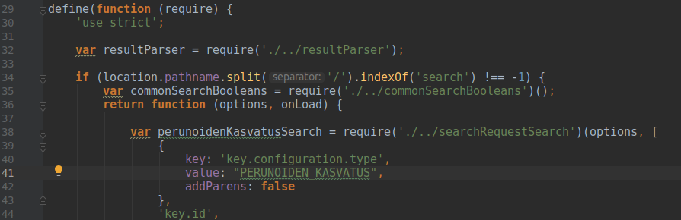
Myös sivun hakutuloksissa tulee viitata äsken luotuun hakumuuttujaan.

Uuden päävalikkolinkin lisääminen Metkaan
Avaa tiedosto: metka/src/main/webapp/resources/js/modules/topmenu.js
Lisäämme päävalikkoon uuden linkin, jota painamalla pääsemme äsken luomallemme sivulle:
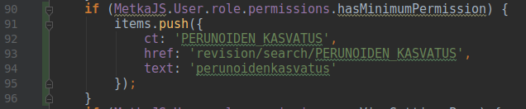
Valikkolinkkiä varten tulee määritellä ct (configuration type), href (polku, johon linkki johtaa), sekä käännöksen avain tekstille, joka valikkolinkissä halutaan näyttää.
Seuraavaksi lisäämme käännöksen tiedostoon: metka/src/main/webapp/resources/js/uiLocalication.js
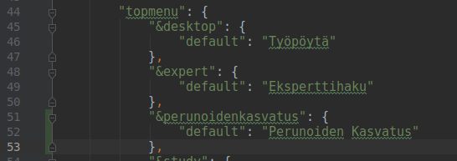
Tuloksen pitäisi näyttää tältä:
Linkki ei vielä tässä vaiheessa kuitenkaan toimi halutusti, sillä sille antamamme reititys ei vielä johda mihinkään.

Uuden sivun lisääminen Metkan sivukonfiguraatioon
Avaa tiedosto: metka/src/main/webapp/resources/js/modules/pageConfig.js
Lisää luomasi sivu metkan sivukonfiguraatioon, jotta valikkolinkille annettu reitti toimisi oikein:
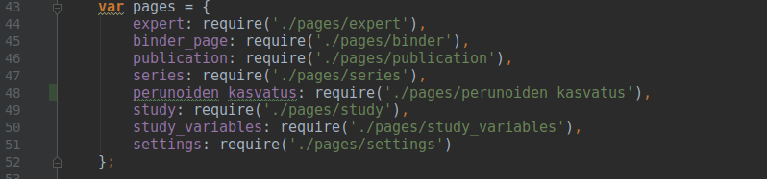
Kun lähdekoodiin on tehty tarvittavat muutokset, Metka tulee kääntää uudestaan komennolla mvn clean package -P<profiilin-nimi>.

