 | www.DBTechNet.org  DBTech VET |  |  | 

SQL Transactions

Authors
Martti Laiho, Haaga-Helia UAS
Fritz Laux, Reutlingen University
Mika Wendelius, Business Databases Oy

Disclaimers
This project has been funded with support from the European Commission. This publication [communication] reflects the views only of the authors, and the Commission cannot be held responsible for any use which may be made of the information contained therein. Trademarks of products mentioned are trademarks of the product vendors.
Objectives
Reliable data access is based on well-designed SQL transactions. A programmer who does not understand the required transaction technology can easily violate the data integrity in a database contents and block or slow down the production performance. The purpose of this tutorial is to present the basics of transaction programming using the mainstream DBMS products including the typical problems and transaction tuning possibilities.
Prerequisites
Readers should have hands-on skills on use of basic SQL of some DBMS product
Contents

I Client/Server and SQL Transactions 2
Introduction to SQL Transactions 4
Diagnosing the SQL errors 6
DBMS services and the internals of transaction processing 8
II Concurrent Clients in Multi-User Environment 10
Concurrency Problems – Possible Risks of Reliability 10
Lost Update Problem 11
Dirty Read Problem 12
Non-repeatable Read Problem 12
Phantom Problem 13
The ACID Principle of Ideal Transaction 14
Isolation Levels 14
Concurrency Control mechanisms 17
Locking Scheme Concurrency Control (LSCC) 17
Multi-Versioning Concurrency Control (MVCC) 19
Optimistic Concurrency Control (OCC) 20
III Some Best Practices for Transaction Planning 21
References and Links 22
Appendix 1 Experimenting with SQL Server Transactions 23
Appendix 2 Transactions in Java Programming 31
Appendix 3 Transactions and Database Recovery 36

I Client/Server and SQL Transactions

Almost all information systems use services of some database management system (DBMS) for storing and retrieving data. The current DBMS products are technically sophisticated, securing data integrity in databases and providing fast access to data even to multiple concurrent users. They provide reliable services to applications for managing persistency of data, but only if applications use these reliable services properly. This is done by building the data access parts of the application logic using database transactions. Transactions are recoverable units of data access work in terms of accessing the database, and also units of recovery for the whole database in case of system crashes, as presented in Appendix 3. They also provide basis for concurrency management in multi-user environment. In this tutorial we will focus on data access using SQL transactions by interactive SQL language, but keeping in mind that the programmatic data access of applications will use slightly different paradigm of which we present an example in Appendix 2.
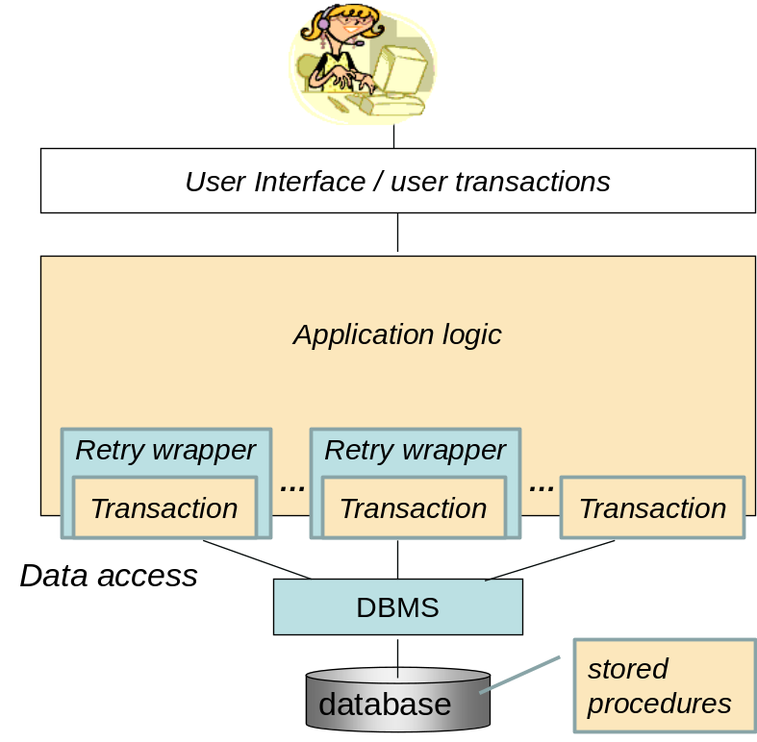

Fig 1. Positioning SQL transactions

Figure 1 presents a simplified view of the application architecture, positioning the database transactions on a different software layer than the user interface layer. From end user’s point of view the application serves use cases implemented as user transactions. “Under the cover” a single user transaction may use multiple SQL transactions, first some read-only transactions which retrieve data from the database, and finally a transaction which updates the contents in the database. With retry wrapper of a SQL transaction we mean programmed retries in case the transaction fails.

From point of view of the database server (marked by DBMS in Fig 1) the application logic layer uses database services in client/server mode by passing SQL commands as parameters of functions/methods via data access interfaces such as ODBC, JDBC, ADO.NET, LINQ, etc. depending on the programming language used, such as C++, C#, Java, PHP, etc. So, whatever data access interface we use, on “low level” we always use the SQL language of the database server for accessing the relational data in the database, and for reliable data access we need to understand the use of the SQL transactions.

Part of the application logic can also be written as procedures using the SQL dialect and stored in the database, but on this basic level course module we will not yet cover the challenging topics of stored procedures.

To properly understand SQL transactions, we need to agree of some basic concepts concerning a dialogue with a database server (see Figures 2 and 3 below):

For accessing the database, an application instance needs to start a database connection building the context of a SQL session, which we in the following will simply call as client, and the database server we will call as server. We will focus on SQL transactions in the context of an SQL session, omitting topics of nested transactions and distributed transactions, so an SQL transaction cannot continue after its SQL session has ended, even if the application instance starts a new connection to the same server.

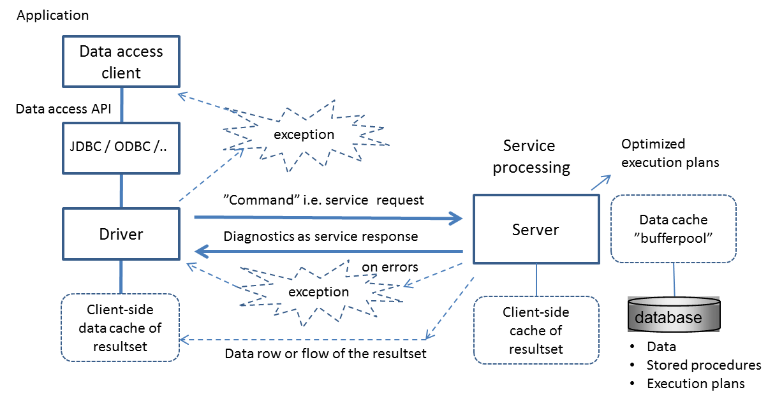
Figure 2. SQL command processing explained

An SQL command is a request that is sent by the client to the server (as a parameter). It can be built of one or more SQL statements (and a SQL statement can be built of other SQL statements, as we know). The service for the entered SQL command in the server is atomic in the sense that the whole SQL command has to succeed; otherwise the whole execution of the command will be cancelled (rolled back). As response to the SQL command the server sends diagnostic message of the success or failure of the command. We need to remember that an SQL command, say an UPDATE or DELETE, which does not find any matching rows, succeeds even if it from application’s point of view has failed, so we may need to check from the diagnostics how many rows have been found for the operation.

In case of SELECT command the generated non-empty resultset will be made available to the client for fetching it row-by-row, or in some data stream format which the data access interface will capture for the client.

Depending on the DBMS product, an SQL command can be a compound statement enclosed as a block in a BEGIN END pair, and according to the ISO SQL standard and implementation in DB2 the whole block can be declared as ATOMIC block, as follows

BEGIN ATOMIC
<SQL statement>;
<SQL statement>;
. . .
END

Depending on the DBMS product, a call for a stored procedure containing multiple SQL statements is an atomic operation. So, you need to know how your DBMS product behaves.

Introduction to SQL Transactions

When the application logic needs execution of a sequence of multiple SQL commands to be atomic, we need to enclose these commands into an SQL transaction which we can end either with COMMIT accepting all changes the transaction has made in the database or with ROLLBACK cancelling all changes made by the transaction. The advantage of ROLLBACK command is that when the application logic enclosed in a transaction fails, we do not need to call for reverse operations command-by-command, but the work can be cancelled either by decision in the application logic, or in some problematic case by the server .

According to ISO SQL standard and DB2 implementation any SQL command will start a transaction, if a transaction has not yet started. This method of starting a transaction is called as implicit start of transaction.

Some DBMS products, for example SQL Server and MySQL, operate by default in AUTOCOMMIT mode, which means that every SQL command will be considered as an automatically committed transaction which cannot be rolled back. Then, if we want to use real transactional logic, we need to start a transaction by some explicit start command, such as BEGIN WORK, BEGIN TRANSACTION, or START TRANSACTION, depending on the DBMS product.

Note: Apart from the autocommit mode, some DBMS products, such as Oracle, will implicitly commit transaction on any DDL command (CREATE, ALTER or DROP of some database object, such as TABLE, INDEX, VIEW, etc).

Note: Also some utility programs, such as CLP of DB2, and data access interfaces, such as ODBC and JDBC, will operate by default in AUTOCOMMIT mode!
For example in JDBC API every transaction need to be started by the following method call of the connection object
<connection>.setAutoCommit(false);

Instead of a simple sequence of SQL commands, some SQL transaction may require for a complex program logic, in which case the transaction logic will make choices on the basis of information it finds from the database. In spite of such complexities, the SQL transaction can be regarded as an indivisible "logical unit of work" (LUW), which either succeeds or is canceled in full.

As a building block of reliable applications, a transaction can also be regarded as “unit of recovery”, since in case of any system failures the uncommitted transactions will be automatically rolled back when the server is restarted.

A transaction can also be regarded as “unit of concurrency” since in case of concurrency conflicts (for example “deadlock” problem which we will cover later) either the server may ROLLBACK some of the conflicting transaction or request for ROLLBACK by the application.
A transaction which works perfectly well when tested in a single-user environment, may fail in multi-user environment due to some competition in accessing the same data (due to concurrency conflict). Depending on transaction logic it might succeed if the client will give it some retry possibilities by applying some “retry wrapper” programming pattern, marked in Figure 1 and demonstrated in the BankTransfer java program example at http://www.dbtechnet.org/VET/EN/BankTransfer.txt (with accompanying scripts for Windows at BankTransferScript.txt). This introduces the requirement that a transaction shall not have any side-effects to be applicable for retries, in other words, it can write only into the database - and especially it may not interact with the end-user (although our BankTransfer demo in Appendix 2 interacts with the user for testing purposes). However, if the transaction would unintentionally overwrite some data recently written by some competing transaction, as described in our RVV Paper (see “References and Links”), we should not apply the “retry wrapper” programming pattern on it, but proceed presenting the problem to the end-user.

Concurrent transactions accessing the same data may block others, as we will see in Part II. Therefore transactions should be planned as short as possible, just to do the necessary work. Since any dialog with the end-user in SQL transaction logic could lead to even catastrophic waiting times in production environment, it is necessary that no SQL transactions will give control to user interface level before the transaction has ended.

Example 1
Let’s consider following table of bank accounts
CREATE TABLE Accounts (
acctId INTEGER NOT NULL PRIMARY KEY,
balance DECIMAL(11,2) CHECK (balance >= 0.00)
);

A typical textbook example of SQL transactions is the following simplified bank transfer, which moves a certain amount (for example 100 euros) from one account to another

BEGIN TRANSACTION;
UPDATE Accounts SET balance = balance - 100 WHERE acctId = 101;
UPDATE Accounts SET balance = balance + 100 WHERE acctId = 202;
COMMIT WORK;

If the system fails or network connection from the client to the server breaks down after the first UPDATE command, the transaction protocol guarantees that no money will be lost from account 101, since finally the transaction would be rolled back.
However, this transaction is far from reliable:
- In case there are no such accounts, the UPDATE commands would “succeed” in terms of SQL. Therefore we should check from the available SQL diagnostics how many rows have been updated by every UPDATE command.
- In case the first UPDATE would fail due to balance going negative and violating the CHECK constraint, depending on the DBMS product the second UPDATE could succeed, which would be erroneous state in the database.

From this simple example we can see that the application developers need to know how the DBMS product will behave, and how the SQL diagnostics can be accessed in the data access interface API to be used. But there are much more to be learned and tuned.

Diagnosing the SQL errors

The early ISO SQL-89 standard defined the integer typed indicator SQLCODE in which the value 0 stands for success, value 100 stands for “NOT FOUND”, and all other codes are product specific and explained in product manuals. The number of rows processed successfully will be reported in SQL diagnostic area, which can be accessed in embedded SQL as a structure called SQLDA. In ISO SQL-92 standard the SQLCODE was replaced by SQLSTATE, a string of 5 characters, of which the first 2 characters make the class code of SQL errors and warnings, and the last 3 characters define subclass codes for these. String “00000” stands for successful execution. Hundreds of other values have been standardized, for example for SQL constraint violations, but many extra values depend on the DBMS product.

ISO SQL standard language does not define how these indicators should be accessed in interactive SQL language, so these are mainly available in data access APIs, such as embedded SQL, SQL Call Level Interface (CLI), ODBC and JDBC. However, some SQL implementations, which include procedural features, make these available in special registers or functions of the language.

In BEGIN-END blocks of PL/SQL language of Oracle the handling of errors, so called exception handling, is written at the end of the block after the EXCEPTION directive as follows

BEGIN
<processing>
EXCEPTION
WHEN <exception name> THEN
<exception handling>;
...
WHEN OTHERS THEN
err_code := sqlcode;
err_text := sqlerrm;
<exception handling>;
END;

In Transact-SQL (also called as T-SQL) of SQL Server some diagnostic indicators are available in @@-variables such as @@ERROR for native errorcode, or @@ROWCOUNT for number of rows just processed. Since version 2005 Transact-SQL includes also try-catch control structure, adopted from modern programming languages, as follows

BEGIN TRY
<T-SQL statement(s)>
END TRY
BEGIN CATCH
<exception handling based on
ERROR_NUMBER(),
ERROR_SEVERITY(),
ERROR_STATE(),
ERROR_PROCEDURE(),
ERROR_LINE(),
ERROR_MESSAGE()> ;
END CATCH;
GO

where ERROR_NUMBER() presents the native SQLCODE and ERROR_STATE() the SQLSTATE string.

In the native SQL language of DB2 the ISO SQL diagnostic indicators SQLCODE and SQLSTATE are available only in embedded SQL and the procedural extension for stored procedures, like in the following

<SQL statement>
IF (SQLSTATE <> '00000') THEN
<error handling>
END IF;

In JDBC API of Java language the SQL errors will raise SQLexceptions, which need to be catched by the application logic in Java using try-catch control structures, as follows

... throws SQLexception {
..
try {
...
<JDBC statement(s)>
}
catch (SQLexception ex) {
<exception handling>
}

where the try block may contain one or more JDBC statements with possible application logic. Possible SQLWarnings need to be checked separately by the application logic after each JDBC statement (stmt object below) which might generate some SQL warning, as follows
SQLWarning stmtWarn = stmt.getWarnings();
<processing the warning>

Number of rows processed successfully will be reported by the execute methods in JDBC.

In C# language of .NET architecture the try-catch control structure for exception handling is about the same as in Java.

DBMS services and the internals of transaction processing

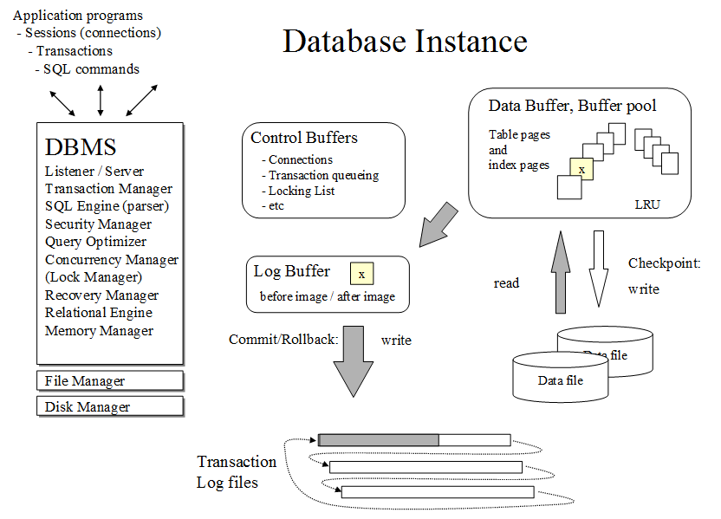
Figure 3. Overview of a Database Server
Figure 3 presents a “big picture” of the internals of transaction processing in a database server, and the slide series "Basics of SQL Transactions” available at http://www.dbtechnet.org/VET/EN/BasicsOfSqlTransactions.pdf explains in more detail architectures of some mainstream DBMS products, how a database server manages files of a database including the transaction logs (with snapshots from SQL Server transaction log), how it uses the bufferpool (data cache) in memory to keep disk I/O in minimum for performance tuning, how it serves SQL transactions, how reliable are COMMIT operations, and how ROLLBACK operations are implemented. In Appendix 3 we describe how DBMS can recover the database up to the latest committed transaction in case of power failures and soft crashes of the server. In case of hardware failures the database can be recovered using the backup of the database and the saved transaction log history since the database backup.

Exercises:
Don’t believe all what you read! For developing reliable applications, you need to know the services of your DBMS product. The DBMS products differ even on basics of SQL transaction services. In Appendix 1 we present tests on explicit and implicit SQL transactions, COMMIT and ROLLBACK, and transaction logic using SQL Server, but you should try them yourself to verify the behavior of SQL Server in parts A1.1-A1.2. For your experiments you can download SQL Server Express for free from Microsoft’s web site.

Also competing DBMS vendors have made special free editions of their products, and we have installed them in our free Debian Linux based Database Laboratory DebianDB, which you can download as an OVA file for importing it to VMware or VirtualBox virtual machines from http://www.dbtechnet.org/download/DebianDBVM05.zip (3.9 MB). The ZIP file contains also installing and management documents of DebianDB, but an additional “Quick Start” document on using the included DBMS products is available at http://www.dbtechnet.org/VET/EN/QuickStartToDebianDB.pdf.
The ZIP file at http://www.dbtechnet.org/VET/EN/SQL_Transactions.zip
contains scripts for testing COMMIT and ROLLBACK operations in various DBMS products, most of which are available in our Virtual Database Laboratory DebianDB.

II Concurrent Clients in Multi-User Environment

An application program working correctly in single-user environment, may accidently not work reliably when running concurrently with other clients (instances of the same or other application programs) in multi-user environment presented in Figure 4.

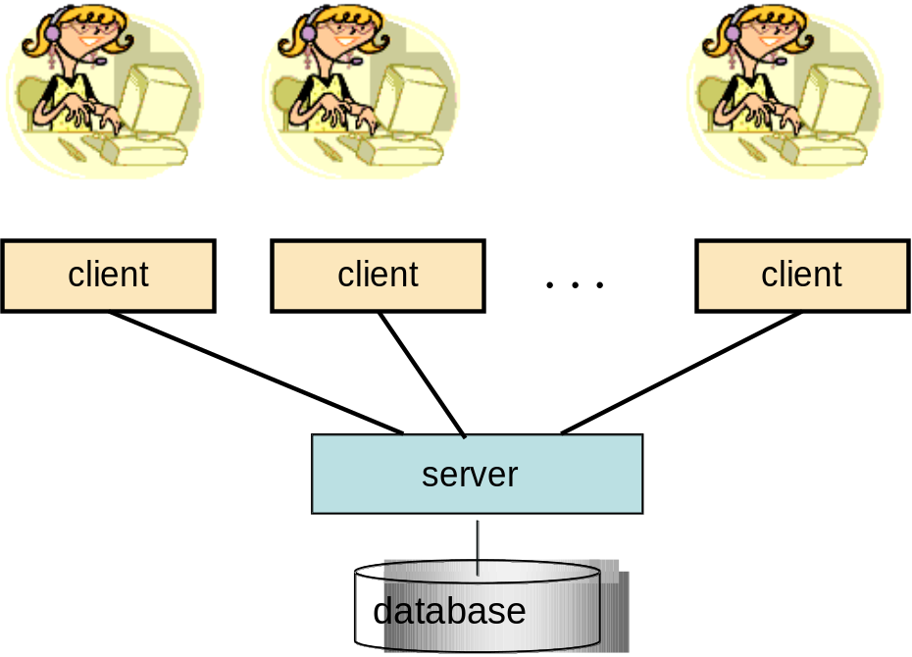

Figure 4. Multiple clients accessing the same database
(in multi-user environment)

Concurrency Problems – Possible Risks of Reliability

Without proper concurrency control services in the database product, or in lack of knowledge on how to use the services properly, the content in the database or results to our queries might become corrupted i.e. unreliable.

In the following we cover the typical concurrency problems (anomalies):
- lost update problem,
- dirty read problem i.e. reading of uncommitted data of some concurrent transaction,
- non-repeatable read problem, i.e. repeated read may not return all same rows,
- phantom read problem, i.e. during the transaction some qualifying rows may not be seen by the transaction
and then we will present how these problems can be solved.

Lost Update Problem

C. J. Date has presented the following example where two users on different teller machines (bank automata) are taking money from the same bank account, the balance of which is originally 1000 euros

Figure 5. Lost Update problem

Without concurrency control, result of 800 euros of the write operation of transaction A in step 5 will be lost in step 6, since transaction B will write blindly the new balance of 500 euros it has calculated. If this would happen before the end of transaction A, then the phenomena is called as “Lost Update”. However, every modern DBMS product has implemented some kind of concurrency control mechanism, which protects write operations against getting overwritten by concurrent transactions before the end of transaction.

If the scenario above is implemented as SELECT .. UPDATE sequences and protected by locking scheme, then instead of Lost Update, the scenario will proceed to DEADLOCK (explained later), in which case for example transaction B would be rolled back by DBMS and transaction A could proceed.

If the scenario above is implemented using single sensitive updates like

UPDATE Accounts SET balance = balance – 200
WHERE acctID = 100;

and protected by locking scheme, then the scenario would work without problems.

Dirty Read Problem

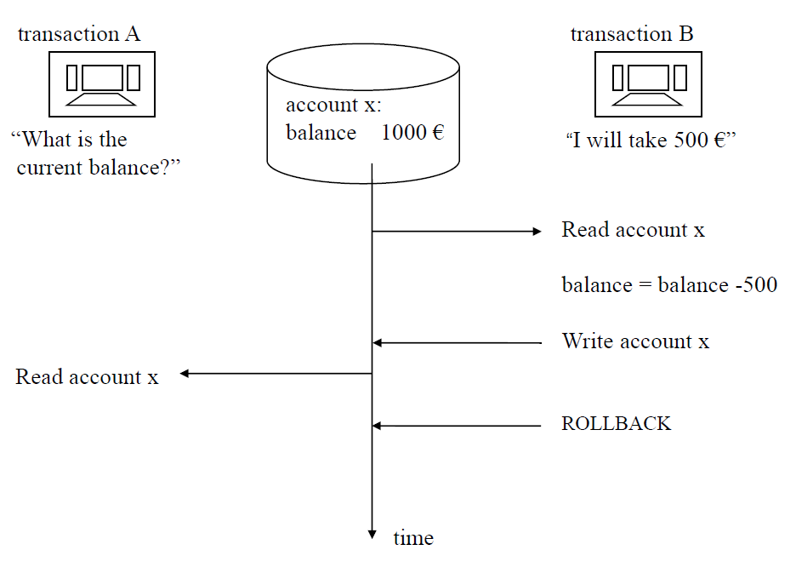

Figure 6 A Dirty Read example

Dirty Read anomaly means that the transaction accepts the risk of reading also unreliable data which may change or the updates into that data may get rolled back. This kind of transaction should not make any updates into the database, since this would lead into corrupted data contents.

Non-repeatable Read Problem

Non-repeatable Read anomaly means that resultsets of queries in the transaction are not stable, so that if the queries need to be repeated, some of the previously retrieved rows may not be available any more as they were originally. This does not exclude the possibility that also some new rows would appear into resultsets of the repeated queries.

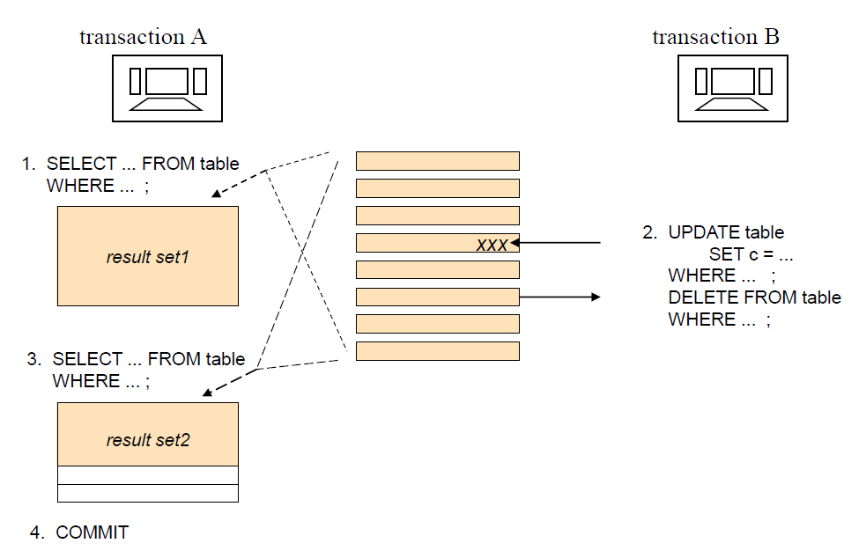

Figure 7. Nonrepeatable Read phenomen in transaction A

Phantom Problem

Phantom anomaly means that the resultsets of queries in the transaction may include new rows if some queries will be repeated. These may include newly inserted rows or updated rows where the column values have changed to fulfill the search conditions in the queries.

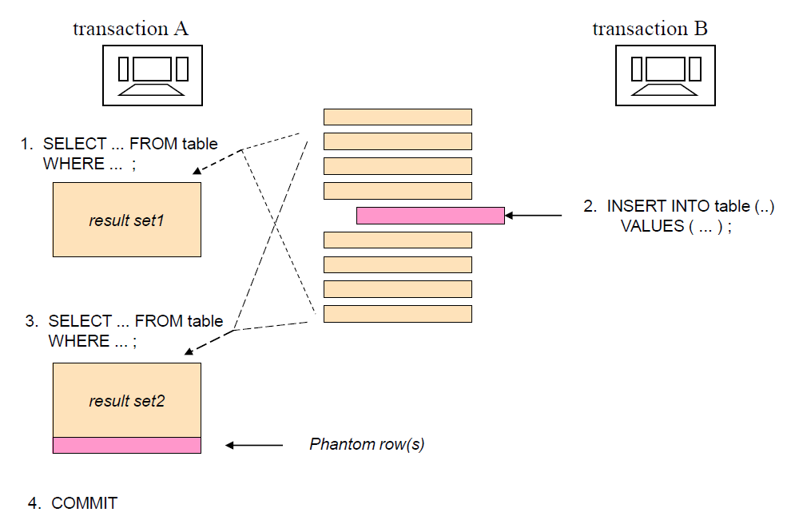

Figure 8. Example of a Phantom phenomen

The ACID Principle of Ideal Transaction

The ACID principle, presented by Theo Härder and Andreas Reuter in 1983 at ACM Computing Surveys, defines the ideal of reliable SQL transactions in multi-client environment. The ACID acronym comes from initials of the following four transaction properties:

Atomic A transaction need to be an atomic ("All or nothing") series of operations which either succeeds and will be committed or all its operations will be rolled back from the database.
Consistent The series of operations will transfer contents of the database from a consistent state to another consistent state. So, latest at commit time operations of the transaction have not violated any database constraints.
Most DBMS products apply the constraints immediately to every operation. Our more restrictive interpretation of consistency requires that the application logic in the transaction has to be relevant and properly tested (well-formed transaction).
Isolated The original definition by Härder and Reuter ”Events within a transaction must be hidden from other transactions running concurrently” will not be fully satisfied by most DBMS products, which we have explained in our “Concurrency Paper”, but need to considered also by the application developers. The current DBMS products use various concurrency control technologies for protecting concurrent transactions from side effects of others and application developers need to know how to use these services properly.
Durable The committed results in the database will survive on disks in spite of possible system failures.

The ACID principle requires that a transaction, which does not fulfill these properties, shall not be committed. So, either the application or the database server has to rollback such transactions.

Isolation Levels

The Isolated property in ACID principle is challenging. Depending on the concurrency control mechanisms, it can lead to concurrency conflicts and too long waiting times, slowing down the production use of the database.

ISO SQL standard does not define how the concurrency control should be implemented, but based on certain concurrency anomalies, bad behaving phenomena, it defines isolation levels, which need to solve these anomalies as defined in Table 1. Some of the isolation levels are less restrictive, and some are more restrictive giving better isolation, but perhaps at cost of performance slowdown.

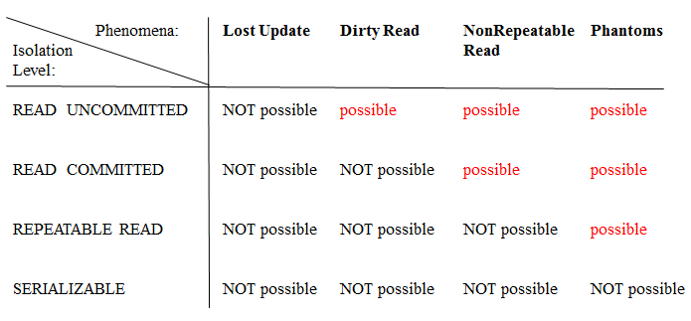

Table 1. ISO SQL isolation levels solving concurrency anomalies

The isolation services of the ISO SQL standard are explained in table 2 below

ISO SQL Isolation level | DB2  isol.  level | Isolation service explained
Read Uncommitted | UR | allows “dirty” reading of uncommitted data of concurrent transactions.
Read Committed | CS | does not allow reading of uncommitted data of concurrent transactions. Oracle and DB2 (9.7 and later) will read the latest committed version of the data, while some products will wait until the data gets committed first.
Repeatable Read | RS | allows reading of only committed data, and it is possible to repeat the reading without any UPDATE or DELETE changes made by concurrent transactions in the set of accessed rows
Serializable | RR | allows reading of only committed data, and it is possible to repeat the reading without any INSERT, UPDATE, or DELETE changes made by concurrent transactions in the set of accessed tables,

Table 2. Isolation Levels of ISO SQL (and DB2) explained

Note1 Note the difference between isolation level names in ISO SQL and DB2. DB2 originally defined 2 isolation levels: CS for Cursor Stability, and RR for Repeatable Read. The names have not been changed, even if ISO SQL later defined the current 4 isolation levels and gave different semantics for Repeatable Read.

Note2 In addition to ISO SQL isolation levels, bothin Oracle and SQL Server there has been implemented isolation level called Snapshot in which the transaction sees only snapshot of the committed data as it was in the beginning of the transaction, but no changes made by concurrent transactions. However, Oracle calls this as Serializable.

We will later discuss which isolation levels, and how they are supported in the DBMS products which we are studying. Depending on the DBMS product, the isolation levels can be defined as database level default, as SQL session level default, in the beginning of the transaction, or in some products even on command level (hint). As the best practice and according to ISO SQL, we recommend that isolation level should be configured at the beginning of every transaction and according to the actual isolation need of that transaction. According to ISO SQL standard, Oracle and SQL Server the isolation level will be set by the following command syntax

SET TRANSACTION ISOLATION LEVEL <isolation level>

but for example DB2 uses following syntax

SET CURRENT ISOLATION = <isolation level>

In spite of different syntaxes and isolation level names used by the DBMS products, ODBC and JDBC API know only the isolation level names of the ISO SQL, and for example in JDBC the isolation level is set as parameter of connection object’s method setTransactionIsolation as follows

<connection>.setTransactionIsolation(Connection.<transaction isolation>);

where <transaction isolation> is defined using reserved words corresponding isolation level, for example TRANSACTION_SERIALIZABLE for Serializable isolation.

Concurrency Control mechanisms

Modern DBMS products are mainly using the following Concurrency Control (CC) mechanisms for isolation
- Multi-granular locking scheme (called MGL or generally as LSCC)
- Multi-versioning concurrency control (called MVCC)
- Optimistic concurrency control (OCC).
In original OCC all changes made by the transaction are kept apart from the database, and synchronized into database only at COMMIT phase. This used for example in the Pyrrho DBMS of University of the West of Scotland (see www.pyrrhodb.com).

Locking Scheme Concurrency Control (LSCC)

Table 2 defines the basic locking scheme which the lock manager part of the database server uses automatically to protect integrity of data in read and write operations. Since only one write operation at a time is possible for a row, lock manager tries to get an exclusive i.e. X-lock protection on rows for write operations, such as INSERT, UPDATE, or DELETE. X-lock will be granted for write operations only when no other transaction has any locks on the same resource(s), and when granted the lock will be kept up to the end of the transaction, as shown in Table 2. Lock manager protects integrity of read operations, such as SELECT, by shared i.e. S-locks, which can be granted to multiple concurrent reading clients, since they don’t disturb each other, but depending on the isolation level of the transaction. Read Uncommitted isolation level does not require S-lock protection for reading, but in case of other isolation levels S-lock needed for reading, and will be granted if no other transaction has an X-lock on the row(s).
When a transaction needs following lock for a row | when another transaction already has got the following lock for the same row |  | when no other transaction has any lock on the same row
When a transaction needs following lock for a row | S-lock | X-lock | when no other transaction has any lock on the same row
S-lock .. | lock granted | wait for release | lock granted
X-lock .. | wait for release | wait for release | lock granted

Table 2 Compatibility of S-locks and X-locks
In case of Read Committed isolation the S-lock on the row will be released right after the read operation, whereas in Repeatable Read and Serializable isolation levels the S-locks will be kept up to the end of the transaction of the transaction. COMMIT or ROLLBACK operation will release all locks.

Note In some DBMS products the SQL dialect includes explicit LOCK commands, but locks are always released implicitly at end of transaction and S-lock earlier in case of Read Committed isolation. No explicit UNLOCK commands are available in SQL dialects.

Real locking schemes of DBMS products are more complicated, using lock on different granules, such as row, page, table, index range, schema, etc, and in addition to S-locks and X-locks some other locking modes. For row-level locks the lock managers generate first corresponding intent lock requests on larger granule levels, which make it possible to control compatibility of lock on different granules as described in Figure 9.

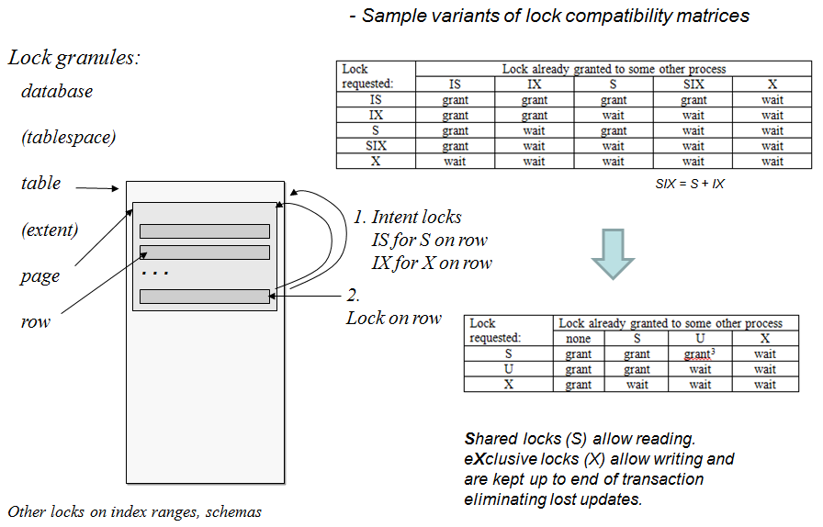

Figure 9. Compatibility control of locks on different granule levels

The locking protocol will sort out the Lost Update Problem, but if the competing transactions are using isolation level which keeps the S-locks up to end of the transactions, then the locking will lead to another problem as shown in Figure 10. Both transactions will be waiting for each other in a “never ending waiting cycle” called Deadlock. In early database products this was a crucial problem, but modern DBMS products include a sleeping thread called Deadlock Detector which usually wakes up every 2 seconds (sleeping time can be configured) to look for the deadlocks, and after finding one, will select one of the waiting transactions as the deadlock victim and does an automatic rollback to the victim.

Figure 10. Lost update problem solved by LSCC but leading to deadlock

The application client of the victim will get deadlock exception message, and should retry the transaction after a random, but short waiting time. See the “retry wrapper” part in the Java code for the BankTransfer example in Appendix 2.

Note It is important to remember that no DBMS can automatically restart the aborted victim in case of a deadlock, but it is responsibility of the application code, or the application server in which the data access client component has been installed. It is also important to understand that deadlock is not an error, and aborting the victim transaction is a service provided by the server, so that application clients can carry on the production in case those concurrent transactions just cannot both proceed.

Multi-Versioning Concurrency Control (MVCC)

In MVCC technique the server maintains a history chain in timestamp order of the updated versions of all data rows, so that for any updated row a committed version at the start time of any concurrent transaction can be found. This concurrency control technique eliminates the waiting times in reading and provides just 2 isolation levels: any transaction with Read Committed isolation level will get the latest committed versions from the history chains, and transaction with Snapshot isolation will get the latest committed versions of the rows at the start time of the particular transaction.

Figure 11 presents MVCC implementation in Oracle, which calls its Snapshot isolation as Serializable, which eliminates seeing the phantom rows, whereas Serializable in LSCC prevents phantoms rows from the database. In Oracle’s MVCC the first transaction to write (that is to insert, update or delete) a certain row will get kind of lock on the row and will win the competition of writing, and the concurrent writers are put to waiting queue. This means that deadlocks are possible, but instead of automatic aborting of the deadlock victim, Oracle finds immediately the row lock which would lead to deadlock, and raises exception to the client application and waits the client to sort out the deadlock by an explicit ROLLBACK command.

Figure 11. Multi-versioning (MVCC) based on history chains of committed rows

Concurrency control technique in Oracle can be called as hybrid CC, since in addition to MVCC Oracle provides explicit table locking commands, and also explicit locking of rows by command
"SELECT ... FOR UPDATE"

In Oracle a transaction can also be declared as Read Only transaction.

Also Microsoft has noticed the benefits of MVCC and since SQL Server version 2005 it has been possible to configure SQL Server to use row versioning by the following setting of database properties

Optimistic Concurrency Control (OCC)

Pyrrho DBMS is the only DBMS in our Database Lab to use a true optimistic concurrency control: in it all write operations into the database are recorded privately apart from concurrent transactions, are available only to the transaction itself, and finally written to database as part of the COMMIT operation.

The only isolation level available in Pyrrho DBMS is SERIALIZABLE.

* * *

III Some Best Practices for Transaction Planning

A user transaction typically needs multiple dialogues with the database. Some of these dialogues will only collect data from the database supporting the user transaction, and as a final step of user transaction some “save” button will trigger an SQL transaction which will update the database.

SQL transactions themselves build dialogue between the client application and the database server, but should not contain any dialogue with the end user, as this would slowdown the processing. Since SQL transactions may get rolled back, during the transaction they should not affect anything else but the database. The SQL transaction should be as short as possible, to minimize the concurrency competition, especially in case LSCC based systems.

Every SQL transaction should have a well-defined task, starting and ending in the same application component. In this tutorial we will not cover the topic of using SQL transactions in stored procedures, since the stored procedure languages and implementations are different in different DBMS products.

DBMS products differ from each other in terms of concurrency control services and transaction managing behavior, so it is important for reliability and performance that application developer knows the behavior of the DBMS to be used.

If multiple tables will be accessed in a series of commands, some textbooks advice to access the tables always in the same predefined order. This may not always be possible, and it does not guarantee protection against deadlock, which may even be result of accessing rows in different order in the same table.

Technical context of an SQL transaction is a single database connection. If transaction fails due to concurrency conflict, it should in many cases have a retry wrapper in the application code with some limit of 10 retries. However, if the transaction is dependent of database content retrieved in some previous SQL transaction of the same user transaction, and some concurrent transactions have changed that content in the database and the current transaction therefore fails to update the content, then this transaction should not have retry wrapper, but the control should be returned to the user for possible restart of the whole user transaction. We will cover this in our ”RVV Paper”.

A challenging limitation of cursor programming, which is used to manipulate the resultset of an SQL query by record-at-a-time oriented programming languages, is that the operational context of a server-side cursor is an SQL transaction.. According to ISO SQL standard and implementations in most DBMS products open cursors will be automatically closed at the end of transaction. We don’t cover cursor programming in this short tutorial, but it is good to be aware of this limitation.

SQL transactions in a user transaction don’t need to use the same database connection. Opening a new physical database connection is relatively slow process, which may take even seconds. This can be solved by connection pooling mechanism in an application server so that client processes using the same database connection string can open logical database connection by getting a readily opened physical connection instance from the pool, and by closing the logical connection, the physical connection will stay open and be returned to the pool for recycling the connections. So the same client on next connection opening may get a separate physical connection, and from point of view of the server it is considered as a different client! This means that the SQL transaction has to be closed before closing the connection.

A new database connection need to be opened for retries of the SQL transaction in case the connection was lost due to some network problems.

In case an application client needs multiple database connections open at the same time, perhaps to different databases, it is however important not to have separate SQL transactions running at same time, since without special service of distributed transactions, it is possible that some of the transactions will fail even if some transaction will succeed. In this tutorial we will not cover the topic of distributed transactions.

References and Links

The OVA file of our virtual Database Laboratory “DebianDB” can be downloaded from
http://www.dbtechnet.org/download/ DebianDBVM05.zip

and “Quick Start Guide” for accessing the DBMS products installed in the Lab can be downloaded from
http://www.dbtechnet.org/download/ QuickStartGuideToDebianDBv05.pdf

For more information on concurrency control technologies of DB2, Oracle and SQL Server see our “Concurrency Paper” at

http://www.dbtechnet.org/papers/SQL_ConcurrencyTechnologies.pdf

For more information on SQL transactions as part of a user transaction, and applying of row version verification (RVV aka “optimistic locking”) in various data access technologies see our “RVV Paper” at

http://www.dbtechnet.org/papers/RVV_Paper.pdf

Appendix 1 Experimenting with SQL Server Transactions

We are now inviting you to a “mystery tour” in the world of SQL transactionsusing your favorite DBMS product, to experiment and verify yourself what has been presented in this tutorial. The DBMS products behave slightly differently on transaction services, which may surprise you - and your customers - if you are not aware of these differences when developing applications. If you have time to look at more than one product, you will get a broader vision on transaction services provided by the DBMS products on the market.

The scripts tailored for the DBMS products available in our database laboratory DebianDB can be found at
http://www.dbtechnet.org/download/VET/EN/ SQL_Transactions_Appendix1.zip

Since SQL Server Express is not available in DebianDB, but is freely available from the Web site of Microsoft to download and install on your Windows workstations, we present here a way of experimenting with it.

In the following experiments we use SQL Server Management Studio (SSMS) program. First we will create a new database “TestDB” by following command using defaults for all parameters

CREATE DATABASE TestDB;

A1.1 Experimenting with single explicit transactions

Note As default SQL Server uses AUTOCOMMIT mode in which we cannot rollback anything.

Let’s start experimenting with single transactions:

-- Autocommit mode
CREATE TABLE T (id INT NOT NULL PRIMARY KEY, s VARCHAR(30));
INSERT INTO T (id, s) VALUES (1, 'first');
ROLLBACK; -- what happens?
SELECT * FROM T;

BEGIN TRANSACTION; -- an explicit transaction begins
INSERT INTO T (id, s) VALUES (2, 'second');
SELECT * FROM T;
ROLLBACK;
SELECT * FROM T;

BEGIN TRANSACTION;
CREATE TABLE T2 (id INT); -- testing use of a DDL command in a transaction!
INSERT INTO T2 (id) VALUES (1);
SELECT * FROM T2;
ROLLBACK;
GO -- GO marks the end of a batch SQL commands to be sent to the server
SELECT * FROM T2; -- What has happened to T2 ?

Does an error lead to automatic rollback in SQL server?

BEGIN TRANSACTION;
SELECT 1/0 AS dummy; -- division by zero should fail
SELECT @@ERROR AS 'sqlcode'
UPDATE T SET s = 'foo' WHERE id = 9999; -- updating an non-existing row
SELECT @@ROWCOUNT AS 'Updated'
DELETE FROM T WHERE id = 7777; -- deleting an non-existing row
SELECT @@ROWCOUNT AS 'Deleted'
INSERT INTO T (id, s) VALUES (2, 'testing insert after errors');
INSERT INTO T (id, s) VALUES (3, 'how about inserting too long string value?');
INSERT INTO T (id, s) VALUES (2, 'Hi, I am a duplicate');
SELECT * FROM T;
COMMIT;
GO
BEGIN TRANSACTION;
SELECT * FROM T;
DELETE FROM T WHERE id > 1;
COMMIT;

BEGIN TRANSACTION;
SET XACT_ABORT ON; -- In this mode an error generates automatic rollback
SELECT 1/0 AS dummy; -- division by zero
INSERT INTO T (id, s) VALUES (4, 'how about this insert?');
COMMIT;
GO
SET XACT_ABORT OFF; -- In this mode an error does not generate automatic rollback
SELECT * FROM T;
SELECT @@TRANCOUNT AS 'do we have an transaction?'
-- What happened to the transaction?

BEGIN TRANSACTION;
INSERT INTO T (id, s) VALUES (9, 'Let’s see what happens if ..');
SELECT * FROM T;

On exiting now the Management Studio, we will get following message
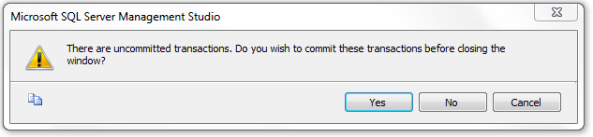
and for purposes of our experiment we select ”No”.

On restarting Management Studio and connecting to our TestDB we can study what happened to our latest uncommitted transaction just by listing the contents of table T

SELECT * FROM T;

-----------------------------------------------------------
A1.2 Experimenting with Implicit Transactions and Transaction Logic

As default SQL Server sessions operate in AUTOCOMMIT mode, and using explicit transactions we can build transactions of multiple SQL commands. However, the whole server instance can be configured to use implicit transactions. Also a single SQL session can be configured to use implicit transactions using the following SQL Server’s command
SET IMPLICIT_TRANSACTIONS ON;
which will be in force until end of session, and it can be turned off by the following command:
SET IMPLICIT_TRANSACTIONS OFF;

-----------------------------------------------------------
-- Experiment 1: COMMIT and ROLLBACK
--
-- in session of client A:
SET IMPLICIT_TRANSACTIONS ON;
--
CREATE TABLE Accounts (
acctID INTEGER NOT NULL PRIMARY KEY,
balance INTEGER NOT NULL
CONSTRAINT uncredible_account CHECK (balance >= 0)
);
COMMIT;
INSERT INTO Accounts (acctID,balance) VALUES (101,1000);
INSERT INTO Accounts (acctID,balance) VALUES (202,2000);
SELECT * FROM Accounts;
COMMIT;

-- let’s try the bank transfer
UPDATE Accounts SET balance = balance - 100 WHERE acctID = 101;
UPDATE Accounts SET balance = balance + 100 WHERE acctID = 202;
SELECT * FROM Accounts;
COMMIT;
-----------------------------------------------------------
-- Experiment 2: Transaction logic
--
-- restoring the original contents
DELETE FROM Accounts;
INSERT INTO Accounts (acctID,balance) VALUES (101,1000);
INSERT INTO Accounts (acctID,balance) VALUES (202,2000);
COMMIT;

UPDATE Accounts SET balance = balance - 2000 WHERE acctID = 101;
UPDATE Accounts SET balance = balance + 2000 WHERE acctID = 202;
COMMIT;
SELECT * FROM Accounts;
-- How did it go ?

-- Experiment 2b Transaction logic
--
-- restoring the original contents
DELETE FROM Accounts;
INSERT INTO Accounts (acctID,balance) VALUES (101,1000);
INSERT INTO Accounts (acctID,balance) VALUES (202,2000);
COMMIT WORK;

-- Experiment with IF structure of Transact-SQL
SELECT * FROM Accounts;
UPDATE Accounts SET balance = balance - 2000 WHERE acctID = 101;
IF @@error <> 0
ROLLBACK
ELSE BEGIN
UPDATE Accounts SET balance = balance + 2000 WHERE acctID = 202;
COMMIT;
END;
SELECT * FROM Accounts;
COMMIT;

-- Try this if the sum to be transferred would be 1000 euros

A1.3 Experimenting with Concurrent Transactions

For concurrency experiments we will open two parallel SQL query windows having SQL sessions “client A” and “client B” accessing the same database TestDB. For both sessions we select result to be listed in text mode by following menu selections
Query -> Results To -> Results to Text
and set both sessions to use implicit transactions
SET IMPLICIT_TRANSACTIONS ON;

For making best visual use of the Management Studio, we can organize the parallel SQLQuery windows appear vertically side-by-side by pressing the alternate mouse button on the title of either SQLQuery window and selecting from the pop-up window the alternative ”New Vertical Tab Group” (see figure 1-1),

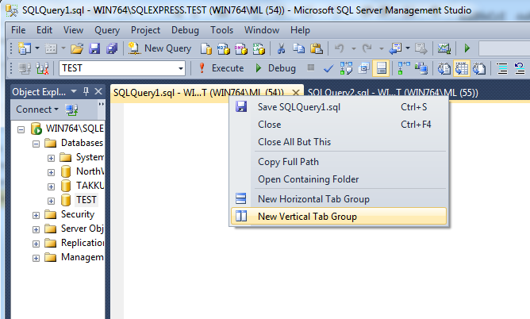

Figure 1-1. Opening 2 SQLQuery windows side-by-side

-- To start with fresh contents we enter following commands on a session
DELETE FROM Accounts;
INSERT INTO Accounts (acctID,balance) VALUES (101,1000);
INSERT INTO Accounts (acctID,balance) VALUES (202,2000);
COMMIT;

-- Experiment 3 "Lost update problem"
--

Lost Update problem raises if some INSERTed or UPDATEd row would be updated or deleted by some concurrent transaction before the first transaction ends. This might be possible in file-based NoSQL solutions, but modern DBMS products will prevent this. However, after the first transaction commits, any competing transaction can overwrite the rows of the committed transaction.

In the following we simulate the Lost Update scenario using READ COMMITTED isolation, which does not keep the S-locks. First the client applications read the balance values releasing the S-locks

-- client A starts
SET IMPLICIT_TRANSACTIONS ON;
SET TRANSACTION ISOLATION LEVEL READ COMMITTED;
SELECT acctID, balance FROM Accounts WHERE acctID = 101;

-- client B starts
SET IMPLICIT_TRANSACTIONS ON;
SET TRANSACTION ISOLATION LEVEL READ COMMITTED;
SELECT acctID, balance FROM Accounts WHERE acctID = 101;

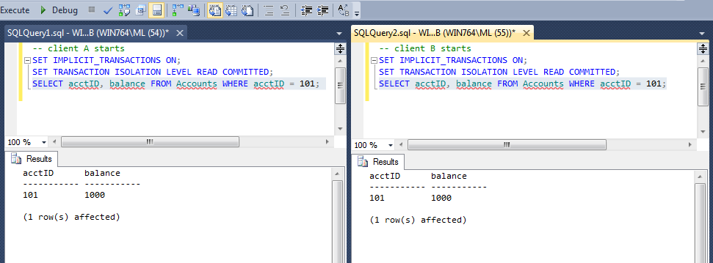

Figure 1-3. Competing SQL sessions in their windows

-- client A continues
UPDATE Accounts SET balance = 1000 - 200 WHERE acctID = 101;

-- client B continues
UPDATE Accounts SET balance = 1000 - 500 WHERE acctID = 101;

-- client A continues
SELECT acctID, balance FROM Accounts WHERE acctID = 101;
COMMIT;

-- client B continues
SELECT acctID, balance FROM Accounts WHERE acctID = 101;
COMMIT;

Note: In this experiment we did not have the real ”Lost Update Problem”, but after A commits its transaction B can proceed and overwrites the update made by A. We call this reliability problem as “Blind Overwriting” or “Dirty Write”. This can solved if the UPDATE commands use sensitive updates.

-----------------------------------------------------------
-- Experiment 4 "Lost Update Problem" fixed by locks
-- (competition on a single resource)
--
-- First restoring the original contents by client A
SET IMPLICIT_TRANSACTIONS ON;
DELETE FROM Accounts;
INSERT INTO Accounts (acctID,balance) VALUES (101,1000);
INSERT INTO Accounts (acctID,balance) VALUES (202,2000);
COMMIT WORK;

-- client A starts
SET IMPLICIT_TRANSACTIONS ON;
SET TRANSACTION ISOLATION LEVEL REPEATABLE READ;
SELECT acctID, balance FROM Accounts WHERE acctID = 101;

-- client B starts
SET IMPLICIT_TRANSACTIONS ON;
SET TRANSACTION ISOLATION LEVEL REPEATABLE READ;
SELECT acctID, balance FROM Accounts WHERE acctID = 101;

-- client A continues
UPDATE Accounts SET balance = balance - 200 WHERE acctID = 101;

-- client B continues
UPDATE Accounts SET balance = balance - 500 WHERE acctID = 101;

-- the client which survived will commit
SELECT acctID, balance FROM Accounts WHERE acctID = 101;
COMMIT;

-----------------------------------------------------------
-- Experiment 5
---
-- Competition on two resources in different order
-- First restoring the original contents by client A
SET IMPLICIT_TRANSACTIONS ON;
DELETE FROM Accounts;
INSERT INTO Accounts (acctID,balance) VALUES (101,1000);
INSERT INTO Accounts (acctID,balance) VALUES (202,2000);
COMMIT WORK;

-- client A starts
UPDATE Accounts SET balance = balance - 100
WHERE acctID = 101;

-- Client B starts
SET IMPLICIT_TRANSACTIONS ON;
UPDATE Accounts SET balance = balance - 200
WHERE acctID = 202;

-- Client A continues
UPDATE Accounts SET balance = balance + 100
WHERE acctID = 202;
COMMIT WORK;

-- Client B continues
UPDATE Accounts SET balance = balance + 200
WHERE acctID = 101;
-- So, what happend ?

--**********************************************************
In the following we will experiment concurrency anomalies i.e. data reliability risks
known by ISO SQL standard
- can we identify those?
- how can we fix the experiments?

--**********************************************************

-- Experiment 6 Dirty Read ?

-- First restoring the original contents by client A
SET IMPLICIT_TRANSACTIONS ON;
DELETE FROM Accounts;
INSERT INTO Accounts (acctID,balance) VALUES (101,1000);
INSERT INTO Accounts (acctID,balance) VALUES (202,2000);
COMMIT WORK;

-- client A starts
SET IMPLICIT_TRANSACTIONS ON;
UPDATE Accounts SET balance = balance - 100 WHERE acctID = 101;
UPDATE Accounts SET balance = balance + 100 WHERE acctID = 202;

-- Client B starts
SET IMPLICIT_TRANSACTIONS ON;
SET TRANSACTION ISOLATION LEVEL READ UNCOMMITTED;

SELECT * FROM Accounts;
COMMIT WORK;

-- Client A continues
ROLLBACK;
SELECT * FROM Accounts;
COMMIT;

-----------------------------------------------------------
-- Experiment 7 Unrepeatable Read ?

-- First restoring the original contents by client A
SET IMPLICIT_TRANSACTIONS ON;
DELETE FROM Accounts;
INSERT INTO Accounts (acctID,balance) VALUES (101,1000);
INSERT INTO Accounts (acctID,balance) VALUES (202,2000);
COMMIT WORK;

-- client A starts
SET IMPLICIT_TRANSACTIONS ON;
SET TRANSACTION ISOLATION LEVEL READ COMMITTED;
SELECT 'Accounts having balance > 500 euros:';
SELECT * FROM Accounts WHERE balance > 500;

-- Client B starts
SET IMPLICIT_TRANSACTIONS ON;
UPDATE Accounts SET balance = balance - 500 WHERE acctID = 101;
UPDATE Accounts SET balance = balance + 500 WHERE acctID = 202;
COMMIT WORK;

-- Client A continues
SELECT 'Let’s see the results:'
SELECT * FROM Accounts WHERE balance > 500;
COMMIT;

-----------------------------------------------------------
-- Experiment 8 Phantom ?

-- First restoring the original contents by client A
SET IMPLICIT_TRANSACTIONS ON;
DELETE FROM Accounts;
INSERT INTO Accounts (acctID,balance) VALUES (101,1000);
INSERT INTO Accounts (acctID,balance) VALUES (202,2000);
COMMIT WORK;

-- client A starts
SET TRANSACTION ISOLATION LEVEL READ COMMITTED;
SELECT 'Accounts having balance > 1000 euros:';
SELECT * FROM Accounts WHERE balance > 1000;

-- Client B starts
SET IMPLICIT_TRANSACTIONS ON;
INSERT INTO Accounts (acctID,balance) VALUES (303,3000);
COMMIT;

-- Client A continues
SELECT 'Let’s see the results:'
SELECT * FROM Accounts WHERE balance > 1000;

COMMIT;

-----------------------------------------------------------
-- Experiment 9 Phantom ?

-- First restoring the original contents by client A
SET IMPLICIT_TRANSACTIONS ON;
DELETE FROM Accounts;
INSERT INTO Accounts (acctID,balance) VALUES (101,1000);
INSERT INTO Accounts (acctID,balance) VALUES (202,2000);
COMMIT WORK;

-- client A starts
SET TRANSACTION ISOLATION LEVEL READ COMMITTED;
SELECT 'Accounts having balance > 1000 euros:';
SELECT * FROM Accounts WHERE balance > 1000;

-- Client B starts
SET IMPLICIT_TRANSACTIONS ON;
UPDATE Accounts SET balance = balance + 2000 WHERE acctID = 101;
COMMIT;

-- Client A continues
SELECT 'Let’s see the results:'
SELECT * FROM Accounts WHERE balance > 1000;

COMMIT;

Appendix 2 Transactions in Java Programming

We can experiment with SQL transactions as available in the SQL dialect and the services of the DBMS product to be used just using interactive SQL in SQL client tools, so called SQL Editors. However, for applications the data access is programmed using some data access API. To give a short example of writing SQL transactions using some API, we present the Bank Transfer example implemented in a Java program using JDBC as the data access API. We assume that the reader of this appendix is already familiar with Java programming and the JDBC API, and Figure 2-1 serves only as a visual overview helping to memorize the major objects, methods, and their interaction.
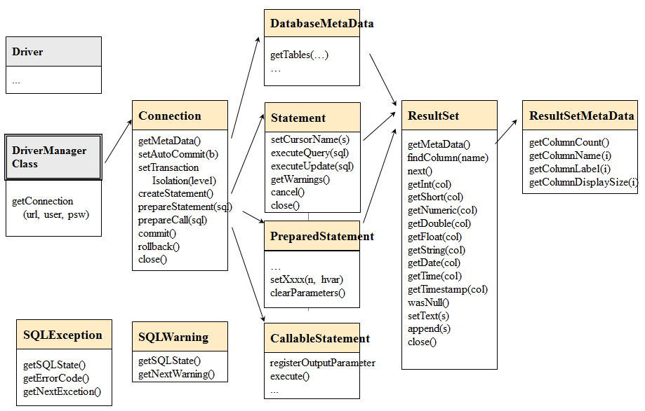

Figure 2-1 A Simplified overview of JDBC API

Example Java code: BankTransfer

The program BankTransfer transfers an amount of 100 euros from one bank account (fromAccount) to another bank account (toAccount). The driver name, URL of the database, username, user’s password, fromAccount and toAccount parameters are read from command line parameters of the program.

For test arrangement user should start two Command Windows on Windows platforms (or Terminal windows on Linux platforms) and run the program concurrently in both windows so that fromAcct of first is the toAcct of the other and vice versa, see the scripts below.

After updating the fromAcct the program waits for ENTER key to continue so that test runs get synchronized and we can test the concurrency conflict. The source program demonstrates also the ReTryer data access pattern.
/* DBTechNet Concurrency Lab 15.5.2008 Martti Laiho

BankTransfer.java

Save the java program as BankTransfer.java and compile as follows

javac BankTransfer.java

See BankTransferScript.txt for the test scripts applied to SQL Server, Oracle and DB2

Updates:
2.0 2008-05-26 ML preventing rollback by application after SQL Server deadlock
2.1 2012-09-24 ML restructured for presenting the Retry Wrapper block
2.2 2012-11-04 ML exception on non-existing accounts
************************************************************/
import java.io.*;
import java.sql.*;
public class BankTransfer {
public static String moreRetries = "N";

public static void main (String args[]) throws Exception
{
System.out.println("BankTransfer version 2.2");

if (args.length != 6) {
System.out.println("Usage:" +
"BankTransfer %driver% %URL% %user% %password% %fromAcct% %toAcct%");
System.exit(-1);
}
java.sql.Connection conn = null;
// String moreRetries = "N";
boolean sqlServer = false;
int counter = 0;
String URL = args[1];
String user = args[2];
String password = args[3];
String errMsg = "";
int amount = 100;
int fromAcct = Integer.parseInt(args[4]);
int toAcct = Integer.parseInt(args[5]);

// SQL Server's explicit transactions will require special treatment
if (URL.substring(5,14).equals("sqlserver")) {
sqlServer = true;
}
// register the JDBC driver and open connection
try {
Class.forName(args[0]);
conn = java.sql.DriverManager.getConnection(URL,user,password);
}
catch (Exception e) {
System.out.println("** Connection failure: " + e.getMessage());
System.exit(-1);
}
do { // Retry wrapper block of TransaferTransaction -------------
if (counter++ > 0) {
System.out.println("retry #" + counter);
if (sqlServer) {
conn.close();
System.out.println("Connection closed");
conn = java.sql.DriverManager.getConnection(URL,user,password);
conn.setAutoCommit(true);
}
}
TransferTransaction (conn,
fromAcct, toAcct, amount,
sqlServer, errMsg //,moreRetries
);
System.out.println("moreRetries="+moreRetries);
if (moreRetries.equals("Y")) {
long pause = (long) (Math.random () * 1000); // max 1 sec.
System.out.println("Waiting for "+pause+ " mseconds"); // just for testing
Thread.sleep(pause);
}
} while (moreRetries.equals("Y") && counter < 10); // max 10 retries
// end of the Retry wrapper block -------------------------------
conn.close();
System.out.println("\n End of Program. ");
}

static void TransferTransaction (Connection conn,
int fromAcct, int toAcct, int amount,
boolean sqlServer,
String errMsg //, String moreRetries
)
throws Exception {
String SQLState = "*****";
try {
conn.setAutoCommit(false); // transaction begins
conn.setTransactionIsolation(
Connection.TRANSACTION_SERIALIZABLE);
errMsg = "";
moreRetries = "N";

// a parameterized SQL command
PreparedStatement pstmt1 = conn.prepareStatement(
"UPDATE Accounts SET balance = balance + ? WHERE acctID = ?");
// setting the parameter values
pstmt1.setInt(1, -amount); // how much money to withdraw
pstmt1.setInt(2, fromAcct); // from which account
int count1 = pstmt1.executeUpdate();
if (count1 != 1) throw new Exception ("Account "+fromAcct + " is missing!");

// --- interactive pause for concurrency testing -----
// In the following we arrange the transaction to wait
// until the user presses ENTER key so that another client
// can proceed with a conflicting transaction.
// This is just for concurrency testing, so don't apply this
// user interaction in real applications!!!
System.out.print("\nPress ENTER to continue ...");
BufferedReader reader = new BufferedReader(
new InputStreamReader(System.in));
String s = reader.readLine();
// --- end of waiting --------------------------------------

pstmt1.setInt(1, amount); // how much money to add
pstmt1.setInt(2, toAcct); // to which account
int count2 = pstmt1.executeUpdate();
if (count2 != 1) throw new Exception ("Account "+toAcct + " is missing!");
System.out.print("committing ..");
conn.commit(); // end of transaction
pstmt1.close();
}
catch (SQLException ex) {
try {
errMsg = "\nSQLException:";
while (ex != null) {
SQLState = ex.getSQLState();
// is it a concurrency conflict?
if ((SQLState.equals("40001") // Solid, DB2, SQL Server,...
|| SQLState.equals("61000") // Oracle ORA-00060: deadlock detected
|| SQLState.equals("72000"))) // Oracle ORA-08177: can't serialize access
moreRetries = "Y";
errMsg = errMsg + "SQLState: "+ SQLState;
errMsg = errMsg + ", Message: "+ ex.getMessage();
errMsg = errMsg + ", Vendor: "+ ex.getErrorCode() + "\n";
ex = ex.getNextException();
}
// SQL Server does not allow rollback after deadlock !
if (sqlServer == false) {
conn.rollback(); // explicit rollback needed for Oracle
// and the extra rollback does not harm DB2
}
// println for testing purposes
System.out.println("** Database error: " + errMsg);
}
catch (Exception e) { // In case of possible problems in SQLException handling
System.out.println("SQLException handling error: " + e);
conn.rollback(); // Current transaction is rolled back
; // This is reserved for potential exception handling
}
} // SQLException
catch (Exception e) {
System.out.println("Some java error: " + e);
conn.rollback(); // Current transaction is rolled back also in this case
; // This is reserved for potential other exception handling
} // other exceptions
}
}
Listing 2-1 The BankTransfer Java code using JDBC

The scripts in Listing 2-2 can be used for testing the program in Windows workstation at two parallel Command Prompt Windows. The scripts assume that DBMS product is SQL Server Express, the database is called “TestDB”, and the JDBC driver is stored in the subdirectory “jdbc-drivers” of the current directory of the program.

rem script for the first window:
set CLASSPATH=.;jdbc-drivers\sqljdbc4.jar
set driver="com.microsoft.sqlserver.jdbc.SQLServerDriver"
set URL="jdbc:sqlserver://localhost;instanceName=SQLEXPRESS;databaseName=TestDB"
set user="user1"
set password="sql"
set fromAcct=101
set toAcct=202
java BankTransfer %driver% %URL% %user% %password% %fromAcct% %toAcct%

rem script for the second window:
set CLASSPATH=.;jdbc-drivers\sqljdbc4.jar
set driver="com.microsoft.sqlserver.jdbc.SQLServerDriver"
set URL="jdbc:sqlserver://localhost;instanceName=SQLEXPRESS;databaseName=TestDB"
set user="user1"
set password="sql"
set fromAcct=202
set toAcct=101
java BankTransfer %driver% %URL% %user% %password% %fromAcct% %toAcct%

Listing 2-2 Scripts for experimenting with BankTransfer on Windows

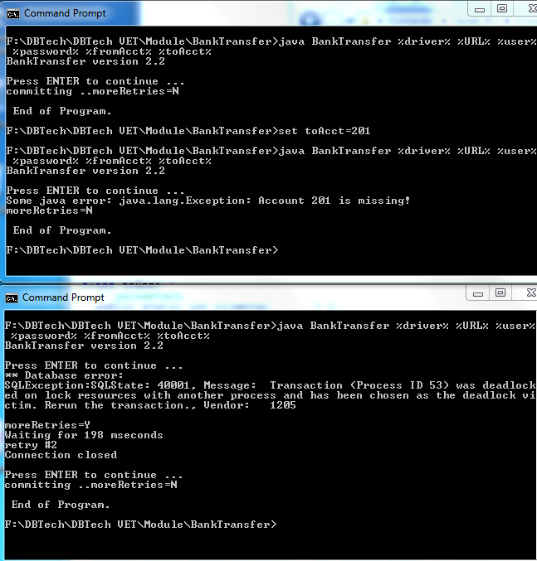

Figure 2-1 Sample tests of BankTransfer on Windows

Scripts for other DBMS products and Linux platform can be easily modified from these.

Appendix 3 Transactions and Database Recovery

(see http://www.dbtechnet.org/VET/FI/RdbmsRecovery.ppt )

When an SQL transaction starts the database server will give it a unique transaction id number, and for every action in the transaction it will write log records into the transaction log file. For every processed row the log record contains the transaction id and original contents of the row as ”before image” and contents of the row after the operation as “after image”. In case of INSERT command the before image is empty, and in case of DELETE command the after image part is empty. Also for COMMIT and ROLLBACK operations the corresponding log records will be written into the log, and as part of this all log records of the transaction will be written into the transaction log file on disk. Control from COMMIT operation will return to the client only after the commit record has been written to the disk.

From time to time the database server will make a CHECKPOINT operation in which serving the clients will stop, all transaction log records from the log cache will be written to the transaction log file and all updated data pages (marked by a “dirty bit”) in data cache (bufferpool) will be written on their original places in the data files of the database, and clearing the “dirty bits” of those pages in data cache. In transaction log a group of checkpoint records will be written including a list of transaction id numbers of the currently running transactions. Finally service of clients continues.

Note In a managed shutdown of the server there should not be any active SQL sessions as last transaction log operation the server writes an empty checkpoint record indicating a clean shutdown.

Figure 3-1 presents a history in transaction log before the database instance fails down or the whole server computer stops, for example due some power failure. All files on disk are readable, but the contents in bufferpool has been lost. The situation is called as Soft Crash.

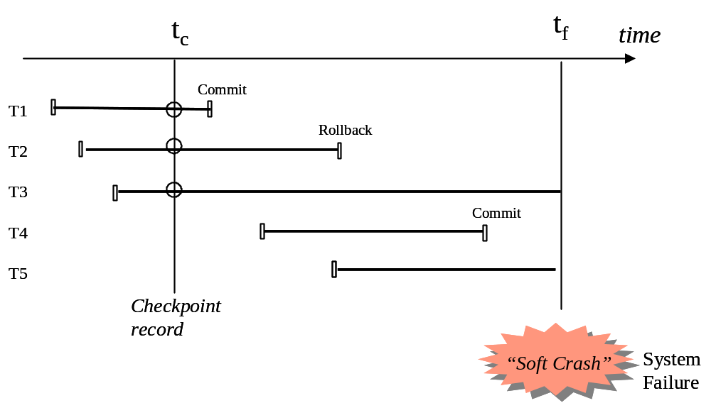

Figure 3-1. A history in transaction log before a soft crash

When the server will be restarted, it will first find the last checkpoint record in the transaction log. If the checkpoint record is empty, it indicates a managed shutdown, and the server is ready to serve the incoming clients. Otherwise, the server starts a rollback recovery procedure as follows:

First all transaction numbers listed in the checkpoint record will be copied to so called UNDO list of transactions to be rolled back, and the REDO list of id numbers of transaction to be redone into the database is set empty. The server scans then the transaction log from checkpoint to the end of the log enlisting all new transaction ids to the UNDO list, but moving ids of committed transactions from UNDO list to REDO list. After that the server proceeds backwards in the log writing to database the before images of all rows of transactions listed in the UNDO list, and then proceeds forward from the checkpoint record writing the after images of all rows of transactions listed in the REDO list. After that the database has been recovered into the level of last committed transaction before the soft crash, and the server can start serving the clients. See Fig. 3-2

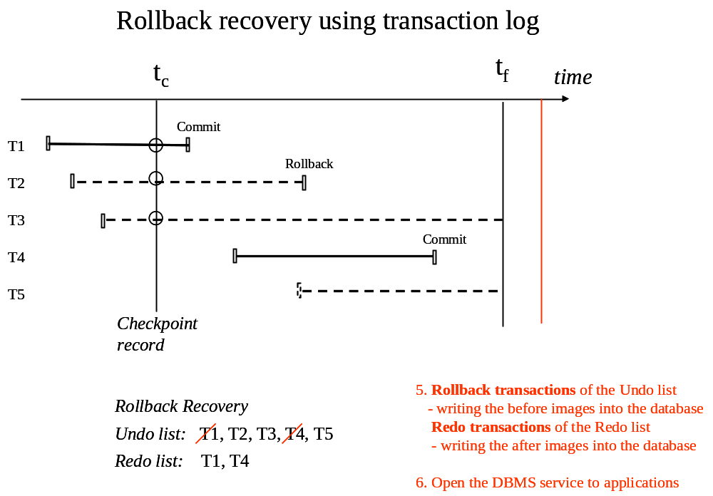
Figure 3-2. Rollback recovery of the database

Note Apart from the simplified recovery procedure described above, most modern DBMS products use ARIES protocol in which between checkpoints, when there is no load in database, a “lazy writer” thread synchronizes the dirty pages from the data cache back to data files. The synchronized pages marked by LSN marks of ARIES can then be omitted in the rollback recovery, and this will make the rollback recovery faster.

in literature some authors call locking scheme as ”pessimistic concurrency control” (PCC) and multi-versioning as ”optimistic concurrency control” although the real OCC has different concurrency semantics.

