Laboratory Automation for ELISA Instruments

Project name: laboratory automation for ELISA Instruments

Client: Pfizer

Date: May 16th, 2024

__________________________________________________________________

Contents

References 2

Introduction: 3

General information about the project 4

1. Situation sketch and problem definition of the project 4

2. Project assignment 4

3. Risk analysis 4

4. Organisation of the project 4

4.1 Explanation of the project/management model that will be applied 4

Overview 9

# Introduction

## Document Instruction

This document is a brief instruction for compiling a project of **Laboratory Automation for ELISA Instruments (LAFEI)**. That is a general, and the first project plan which is developed before the initiation phase of LAFEI and serves as an approval document for the entire project. The phases of LAFEI is decomposed into plan, design, modelling/coding, testing, operation, and delivery, etc. Regarding of each phase, a detailed project plan would be prepared and shall be approved. After each phase, this document must be revised. And then, a detailed plan shall be developed for the next phase. Evaluation of this document also takes place after each phase.

## Terminology

|  |  |
| --- | --- |
| Abbreviation | Notes |
| LAFEI | Laboratory Automation for ELISA Instruments |
| ELISA | Enzyme-Linked Immuno-Sorbed Assay |
| API | Application Programming Interface |
| APP | web APPlication |
| STEM | Science, Technology, Engineering and Math education |
| UI | User Interface |
|  |  |

# General information

## Situation and problem definition

### Description

In Pfizer, ELISA for detecting antigen-antibody binding is one of essential bench work. In lab, automated ELISA systems are widely used. Regarding of a typical ELISA, the automation could be handle liquid (add/remove samples or reagent), dispense reagent, wash plate, reaction incubation, etc. An assay would generate various data including array results, protocol, meta data (namely operator, room), reagent information, sample information, etc. Some high-throughput system may run > 100 96-plates in one work day (8-hour shift).

However, there are still number of manual steps and limited points meant that the automation of ELISA is limited. Here, some limit points are showed as the following:

* Compatibility among ELISA instruments including communications, and data format.
* Assay data real-time collection.
* Distribution of assay results among various groups
* Retrieval of input data, namely sample information, required for ELISA.
* Data backup, audit, integration, etc.

LAFEI aims at improving laboratory automation:

* Allow the ELISA team to focus on assay itself, and release them from routine work.
* Related downstream teams could easily get updated assay results.
* Team managers could monitor operations from the top.
* Depress errors during data transmission or communication among different teams.
* Improve high-throughput ability of entire ELISA systems.

### Stakeholders

#### Clients

departments of Pfizer which operate ELISA instruments

departments of Pfizer which consume data from ELISA instruments

#### instruments inventory

producer of ELISA instruments

## Project Assignment

### Principals

LAFEI follows STEM(Science, Technology, Engineering and Math education) focus. LAFEI meets the requirements raised from science. Any techniques applied in LAFEI would be practical with Pfizer current platforms. LAFEI shall be delivered and used by other Pfizer teams.

### Delivery

* Pipeline or workflow for data collection and synchronization.
* Pipeline or workflow for data retrieval and integration.
* Database that accommodates all ELISA results and all other meta data.
* Web interface for data access
* Graphic user interface for user access
* Analytic pipelines and reporting dashboard for ELISA analysis.
* Education: workflow instructions for scientist, engineering and managers.

### boundaries of the project

* LAFEI could not be used for operations of ELISA instruments. All ELISA bench work including parameters configurations are done by lab scientists rather than LAFEI.
* LAFEI is relying on ELISA instruments including interface and data format, which are determined by instruments produces.
* LAFEI can only process raw data which is readable and accessible.
* LAFEI is under regulated by rules in Pfizer or FDA or other laws.
* LAFEI is not designed for clinical practice.

## Risk analysis

Here, some risks are described as the following:

* ELISA instruments produces don’t open their interface of communication for third-party access.
* ELISA instruments produces don’t open their raw data format.
* ELISA instruments have n’t communication functions.
* There are conflicts among department involved in LAFEI.

## Organization of the project

### Phases

This section provides a description of the phases, activities in each phase and the associated control factors of the project.

* Plan. Plan project plan, phase plan, scope of instruments etc.
* Design. Design systems, pipeline, workflow, database, web applications.
* Modelling. Coding work on pipeline, database, web application.
* Testing. Local testing, system testing, workflow testing.
* Implementation. Work with collaborators and operate LAFEI for some months.
* Delivery. Delivery LAFEI

### Team

* Scientists.
* Hardware engineers or administrators.
* Managers.

# General Design

## Introduction

This session describe the design of LAFEI including high-level requirements, pipeline or workflow design, database, web application, and UI etc.

Showed as Figure 1, LAFEI is composed of scientists, ELISA instruments, web application and pipelines or workflows, etc. The major role of LAFEI is automatically data collection, integration, synchronization, backup, and presentation. ELISA instruments provide data, which is collected by LAFEI. Any operations of ELISA would trigger LAFEI operation. Any data operations are done by pipelines or workflows. The web application is composed of database, analytical tools, and UI etc. The app consume data collected by LAFEI.

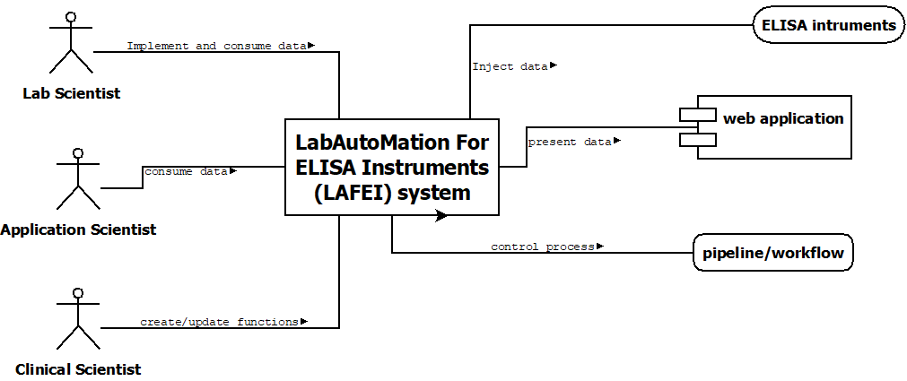

Figure 1. Contextual of LAFEI.

Showed as in Figure 2, the collecting server would communicate with the hardware through interface or shared drive, and collect all data. Certain pipeline would process and integrate data into database server. The app is running at webserver which could be accessed by scientists.

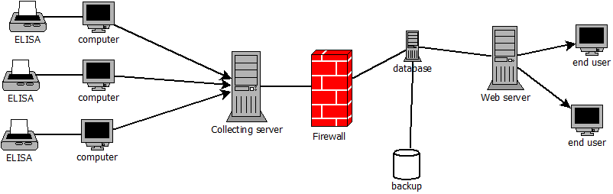

Figure 2. Architecture design of FALEI.

## Requirements

The section only define high-level requirements for the system LAFEI.

#### ELISA communication

* LAFEI shall access ELISA instruments through interface.
* LAFEI shall retrieve ELISA results from control computer.
* LAFEI shall update data processing with ELISA is operating.
* Scope of Data shall be ELISA results, sample information, operation data, or other meta data.
* LAFEI shall synchronize collect data to collecting server.

#### Database

* Data shall be automatically organized into key-value type.
* Database shall be updated automatically with ELISA instruments are operating.
* Database shall be designed in SQL schema.

#### Web application

## Pipeline design

## Database design

### Web application design