**Bioinformatics Automation:**

**Design and Development of Nextflow Pipelines, and its Deployment and Maintenance in AWS Cloud**

**Tiezheng Yuan**

**2020-2024**

+

Contents

Chapter 1. heading1 3

1.1. heading2 3

1.1.1. heading3 3

Chapter 2. heading1 3

2.1. heading2 3

2.1.1. heading3 3

2.2. heading2 3

# Introduction

## Goals and Objects

### Background

Nextflow (https://www.nextflow.io/) is workflow.

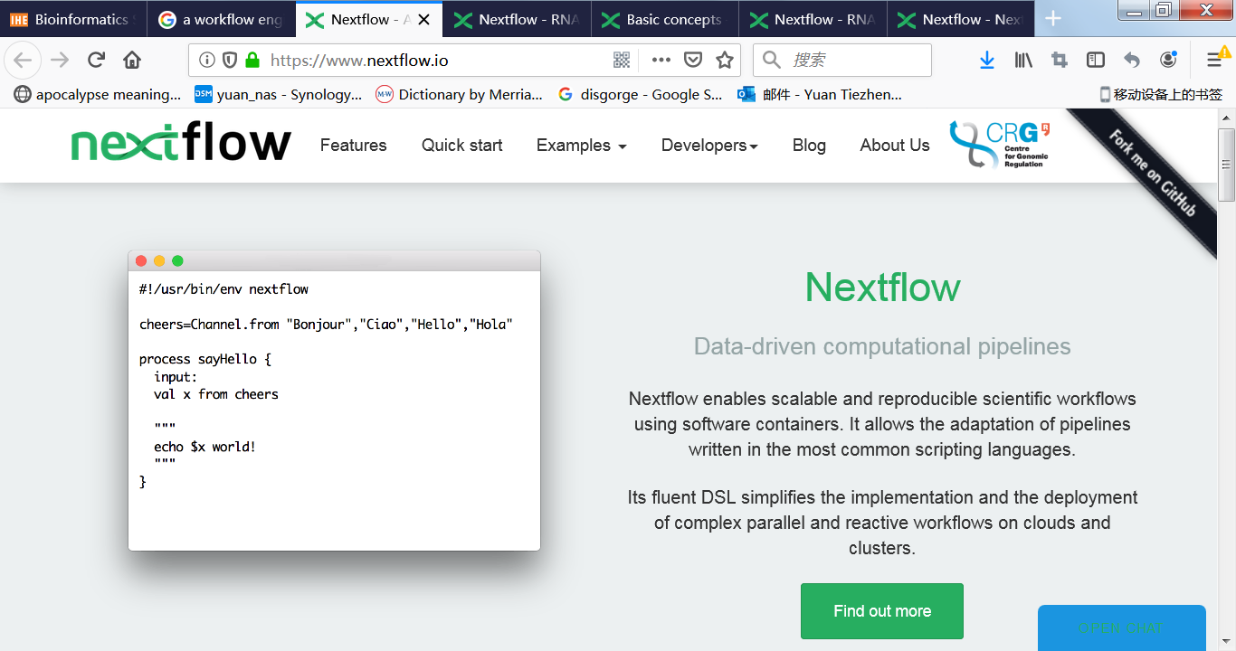

Figure 1 Workflow known as nextflow designed for bioinformatics pipelines.

#### heading4

##### heading5

## Terminology

### Abbreviation

|  |  |
| --- | --- |
| NF | nextflow |
| APP | Web application |
| CLI | Command line interface |
|  |  |
|  |  |
|  |  |
|  |  |
|  |  |

### References

# Nextflow Engineering

## Design

### Besic design

#### heading4

## Scripting

## Development and Deployment

### Installation

### Local testing

### Dev Testing

### Execution

## Optimization and Tune-up

# Bioinformatics Pipelines

## Introduction

## Bulk mRNA-Seq

## Single-cell RNA-Seq

## ATAC RNA-Seq

## CRISPER-Seq

# AWS

## Architecture of AWS

## Deployment nexflow

## Maintenance in AWS