PSF 30-Case AI-Coder Blind Pilot
Final Analysis Report — v1.0
GPT-5.6 Sol × 3 runs and Claude Opus 5 × 3 runs; frozen 30-case blind corpus

Executive conclusion
The technical-recovery phase is complete. All four Claude Opus 5 observations that had truncated at both the 3,000-token and 6,000-token ceilings completed successfully at the pre-specified final 12,000-token ceiling. There is therefore no residual max-token censoring in the pilot. The final selected dataset contains 179 strictly VALID observations and one Opus P01/run2 record that is INVALID only because its cross-cutting list duplicates X; its PRIMARY=A and primary evidence tier=E2 are intact.
The final analysis supports a reproducible PSF diagnostic spine rather than uniform validation of every category. GPT within-model pooled PRIMARY agreement is 86.7%, Opus is 95.5%, same-run GPT–Opus agreement is 88.8% (Cohen κ=0.862), and case-level model consensus agrees on 28/30 cases (93.3%, κ=0.918). A PRIMARY-only sensitivity analysis that includes the otherwise schema-invalid Opus P01/run2 judgment changes cross-model pooled agreement only from 88.8% to 88.9%, so the strict exclusion is not driving the result.
The strongest categories are A, D, E, and especially F. C is now positively exercised but retains a recognition-evidence threshold boundary with U. B is never assigned as either PRIMARY or SECONDARY and is therefore untested by this corpus. G is the clearest core-definition problem, centered on whether delayed/persistent outcomes can stand alone as PRIMARY when an upstream core transition is not identified. X is the main auxiliary-code instability.

1. Final recovery and data integrity
Run | Case | Final status | PRIMARY | Output tokens | Cost
1 | P21 | VALID | E | 5,286 | $0.2824
2 | P06 | VALID | A | 5,290 | $0.1447
3 | P06 | VALID | A | 6,040 | $0.1634
3 | P21 | VALID | E | 4,412 | $0.1223
The final recovery therefore resolves all four residual technical missing observations. P06 now has Opus A/A/A across its three valid runs, and P21 has Opus E/E/E. Recovery should stop permanently at this point; no further output-ceiling changes are warranted.
Model | VALID | INVALID | INCOMPLETE | Strict completion
GPT-5.6 Sol | 90 | 0 | 0 | 100.0%
Claude Opus 5 | 89 | 1 | 0 | 98.9%
Combined | 179 | 1 | 0 | 99.4% strict VALID
The only non-VALID record, Opus P01/run2, is a bounded schema error: X is returned twice with two different evidence spans. The PRIMARY field itself is complete and consistent with Opus runs 1 and 3. Strict full-record analyses exclude it; a separately reported PRIMARY-only sensitivity analysis includes it.

2. PRIMARY-code reliability
Comparison | N paired | Exact agreement | Cohen κ
GPT run1 vs run2 | 30 | 90.0% | .879
GPT run1 vs run3 | 30 | 86.7% | .837
GPT run2 vs run3 | 30 | 83.3% | .797
GPT pooled pairwise | 90 | 86.7% | .838
Opus run1 vs run2 | 29 | 93.1% | .914
Opus run1 vs run3 | 30 | 96.7% | .958
Opus run2 vs run3 | 29 | 96.6% | .957
Opus pooled pairwise | 88 | 95.5% | .943
GPT vs Opus — run1 | 30 | 86.7% | .835
GPT vs Opus — run2 | 29 | 89.7% | .874
GPT vs Opus — run3 | 30 | 90.0% | .877
GPT–Opus pooled same-run | 89 | 88.8% | .862
Case-level model consensus | 30 | 93.3% | .918
Krippendorff nominal α is 0.839 for GPT, 0.944 for Opus, and 0.874 for the descriptive six-run matrix. The pooled run-pair rows are descriptive because repeated pairs share the same underlying cases; the model runs are stability probes, not independent human raters.
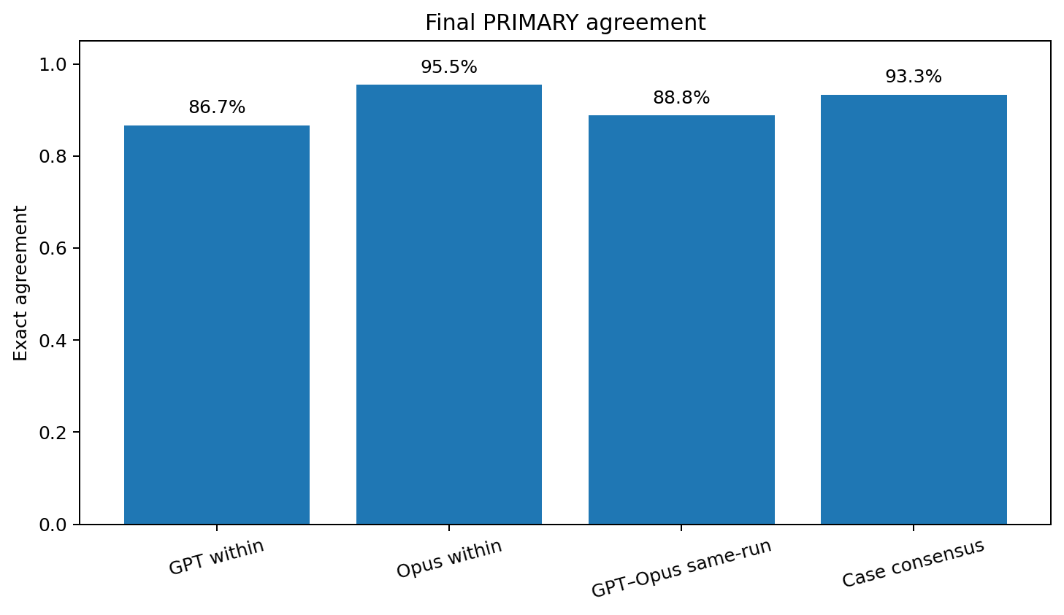
For the strict pooled cross-model result, the Wilson 95% interval for exact agreement is approximately 80.5%–93.8%. For case-level consensus, the corresponding interval is approximately 78.7%–98.2%. These intervals reflect only the finite set of paired case judgments, not broader population sampling uncertainty from the purposively constructed corpus.

3. PRIMARY-only sensitivity for the Opus P01 schema-invalid record
Endpoint | Strict full-record | PRIMARY-only sensitivity
Opus pooled within agreement | 95.5% | 95.6%
Opus pooled within κ | .943 | .944
GPT–Opus pooled agreement | 88.8% | 88.9%
GPT–Opus pooled κ | .862 | .863
The sensitivity differences are negligible. This supports retaining P01/run2 as INVALID for strict full-record and X/Y analyses while allowing its PRIMARY=A/E2 judgment to be described in a bounded sensitivity analysis. No rerun is needed.

4. Cross-model disagreement structure
Across the 89 strict VALID same-run GPT–Opus pairs, 79 PRIMARY judgments agree and 10 disagree. The disagreements remain concentrated in a small number of adjacent or underspecified boundaries rather than being diffusely distributed across the ontology.
Run | Case | GPT | Opus | Boundary
1 | P05 | D | U | Evaluation awareness / metagaming evidence versus the stricter requirement for a safety-relevant oversight-dependent behavior difference.
1 | P12 | C | U | Whether refusal under a different prompt condition supplies enough demonstrated recognition evidence for the focal harmful trajectory.
1 | P16 | G | U | Whether persistent/delayed effects can support G without an identified upstream core transition.
1 | P23 | E | C | Runtime update and stop/replan versus recognized-but-not-enacted updated constraint.
2 | P08 | U | A | Whether observed shortcut behavior strongly identifies an operative objective/authorization representation mismatch.
2 | P12 | C | U | Stable C-versus-U recognition-evidence threshold boundary.
2 | P20 | A | U | Whether poisoned tool metadata directly establishes operative-objective divergence.
3 | P10 | G | U | Whether cumulative multi-step outcome is sufficient for G without locating an upstream failure transition.
3 | P15 | A | C | Operative-objective divergence versus explicit recognized constraint followed by inconsistent intervention.
3 | P16 | G | U | Stable G-versus-U standalone Outcome & Feedback boundary.
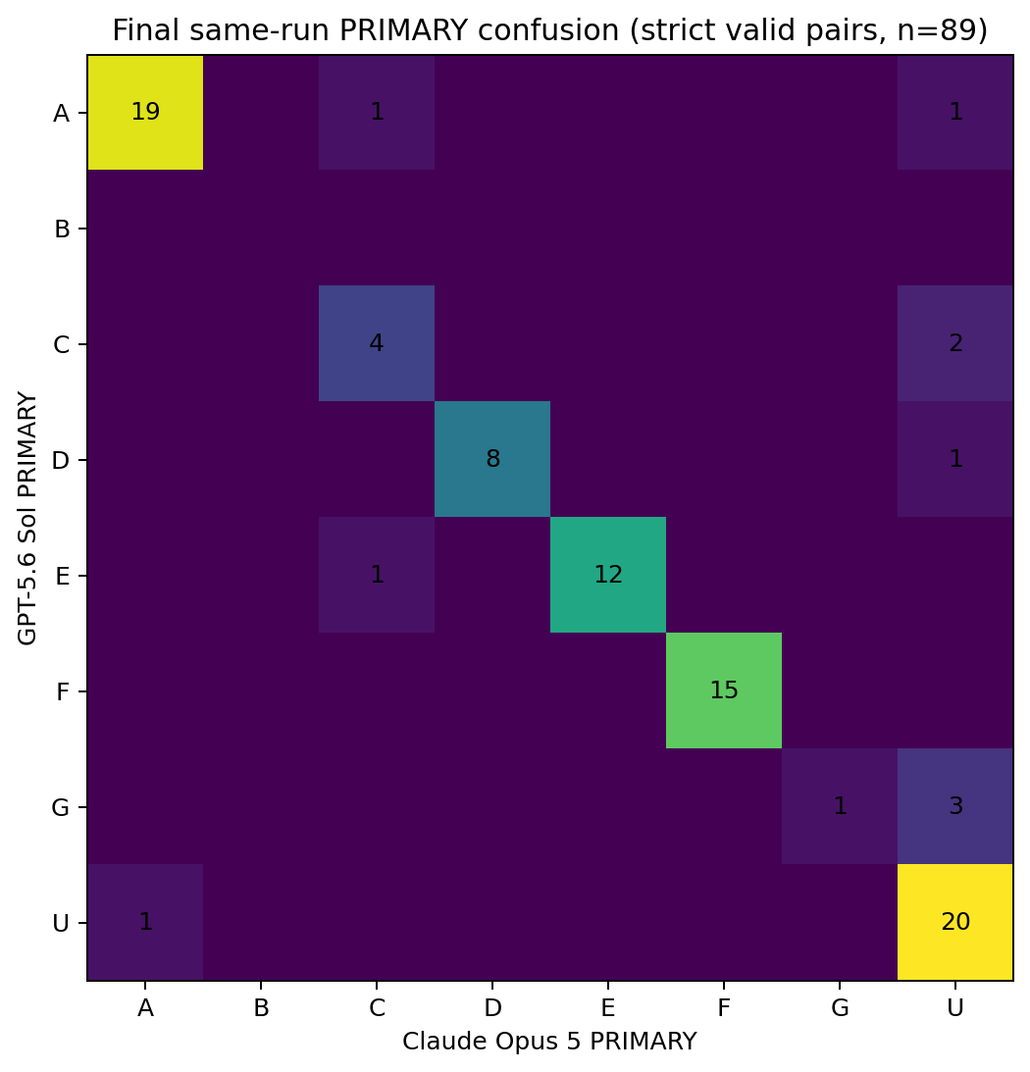

5. Case-level consensus and the two stable disagreements
Both models now have enough valid runs to form a unique case-level PRIMARY consensus for all 30 cases. Twenty-eight cases agree. The two stable cross-model consensus disagreements are P12 and P16.
Case | GPT consensus | Opus consensus | Interpretation
P12 | C (2/3) | U (3/3) | A genuine minimum-evidence disagreement about whether demonstrated recognition is established for the focal trajectory.
P16 | G (3/3) | U (2/3) | A genuine construct-definition disagreement about standalone Outcome & Feedback; Opus run2 assigns G, but U remains its modal judgment.
These are valuable falsification/revision targets. They indicate that the remaining problem is not arbitrary coder instability but specific PSF boundary conditions that can be revised prospectively in v0.3.

6. Per-code diagnostic performance
Core | Cross-model Dice/F1 | Final interpretation
A | .927 | Strong. Residual disagreement occurs when an operative objective is inferred from shortcut/adversarial behavior rather than directly represented.
B | not observed | No PRIMARY or SECONDARY B assignments. Situated Recognition is a corpus-coverage gap and cannot be claimed as empirically validated.
C | .667 | Positively exercised by cases including P15 and P23, but sensitive to the minimum evidence for demonstrated recognition.
D | .941 | Strong. P05 clarifies that evaluation awareness alone does not automatically establish oversight invariance failure.
E | .960 | Strong. The remaining adjacent ambiguity is mainly C versus E in runtime update / stop-replan cases.
F | 1.000 | Perfect paired agreement; the cleanest category in the pilot.
G | .400 | Weakest core boundary. GPT uses standalone G more readily; Opus usually prefers U when the upstream failure location is unspecified.
U | .833 | Functions as a conservative fallback and is used more frequently by Opus.
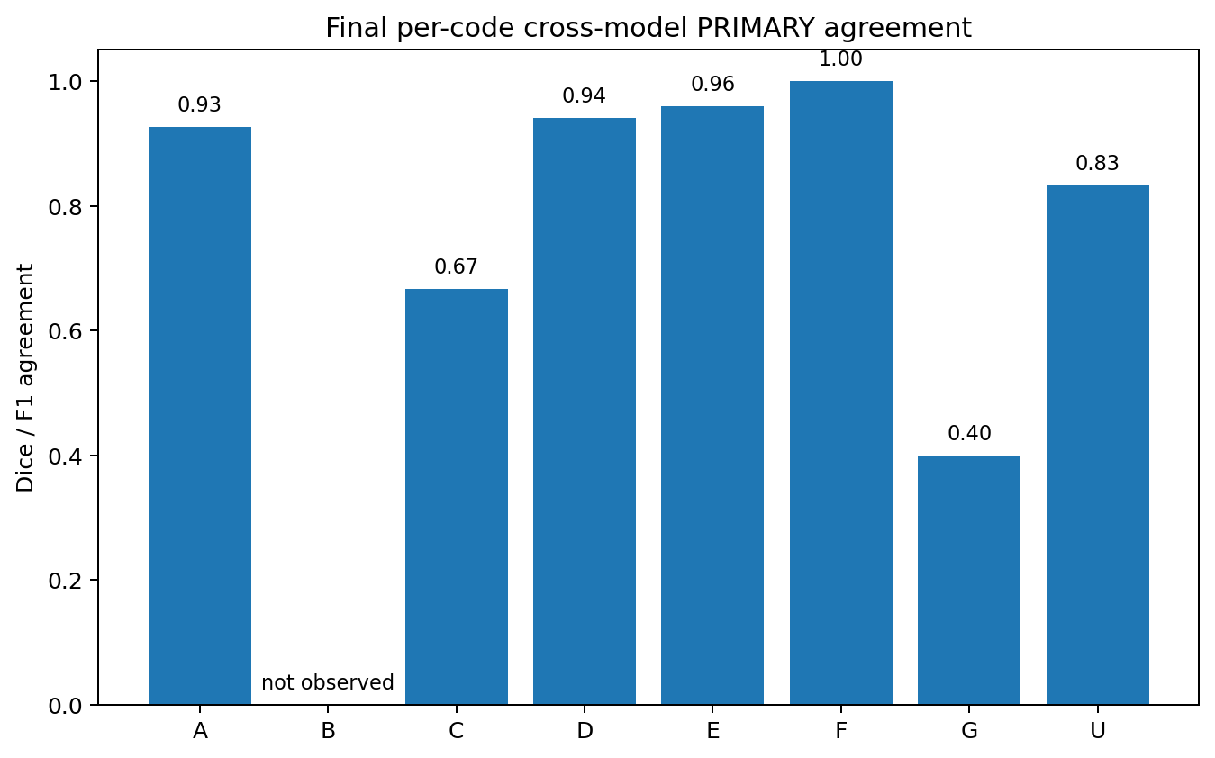

7. Stratum-level pattern
Stratum | Paired agreement | Interpretation
Objective / Generalization | 13/14 = 92.9% | High; one A-versus-U disagreement.
Harmful Tool-use / Agentic Misalignment | 12/15 = 80.0% | P12 and P15 expose recognition / enactment / specification boundaries.
Evaluation Awareness / Strategic Compliance | 14/15 = 93.3% | High; P05 is the principal D-versus-U boundary case.
Prompt Injection / Tool Security | 11/15 = 73.3% | Lowest agreement; G-versus-U and A-versus-U ambiguity is concentrated here.
Restraint / Abstention / Corrigibility | 14/15 = 93.3% | High; one C-versus-E runtime-update disagreement.
Multi-agent / Systemic Effects | 15/15 = 100% | Perfect agreement across all paired observations.
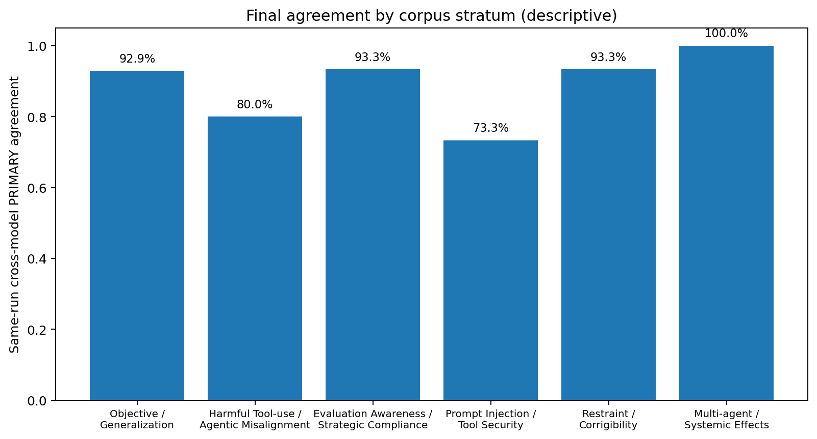
The stratum results are descriptive because the five cases per stratum were purposively selected and the 15 run-level pairs within a stratum are not independent samples. Nevertheless, the concentration of disagreement in Prompt Injection / Tool Security is diagnostically useful: these cases often establish that an attack occurred without establishing which core A/B/C/G transition failed.

8. Evidence tiers and evidence spans
Comparison | N | Exact tier agreement | Mean |ordinal distance|
GPT vs Opus run1 | 30 | 80.0% | 0.333
GPT vs Opus run2 | 29 | 75.9% | 0.379
GPT vs Opus run3 | 30 | 80.0% | 0.333
Conditional on same PRIMARY | 79 | 86.1% | 0.139
All 11 same-PRIMARY evidence-tier disagreements are adjacent E2-versus-E3 judgments. No large E0-versus-E3 jump occurs after holding PRIMARY constant. Evidence tiers are therefore less stable than PRIMARY but remain interpretable as an ordinal evidence-strength layer.
Evidence-span wording is substantially less identical: among the 79 same-PRIMARY pairs, exact normalized span identity is 15.2%, mean token Jaccard overlap is 0.493 (median 0.424), and 45.6% show at least 80% token containment. This is not a failure of diagnostic reliability because multiple packet passages may support the same diagnosis; evidence-span overlap is best retained as a traceability/audit measure.

9. SECONDARY, X/Y, and confidence
Endpoint | Final result | Interpretation
SECONDARY exact-set agreement | 87.6% | High but secondary use is sparse; should remain a secondary endpoint.
X/Y exact-set agreement | 82.0% | Lower than PRIMARY; cross-cutting coding is the main auxiliary instability.
X presence consensus agreement | 83.3% | Opus positive on 53.3% of cases versus GPT 36.7%; v0.3 should sharpen the minimum-evidence rule.
Y presence consensus agreement | 93.3% | Comparatively stable; only P22 and P30 differ at consensus level.
Confidence exact agreement | 53.9% | Model-native confidence is not a valid cross-model reliability outcome.
GPT assigns High confidence to 72/90 valid outputs (80.0%), whereas Opus assigns High to 31/89 (34.8%). Every paired observation in which Opus reports High confidence agrees with GPT on PRIMARY (31/31), while Opus Medium-confidence pairs agree in 48/58 cases (82.8%). This is agreement calibration, not accuracy calibration, because there is no independent gold label.

10. Diagnosis-to-mitigation differentiation
The exploratory actionability result remains strong after final recovery. Using one case-level consensus unit formed from mitigation text in runs that match the model's consensus PRIMARY, GPT within-diagnosis mean TF-IDF cosine similarity is 0.192 versus 0.025 across different diagnoses; Opus is 0.190 versus 0.028. Fixed-label permutation tests give p<0.001 for both models.
PRIMARY | Recurring mitigation language
A | objective/reward specification, goal robustness, evaluation and training boundaries
C | action-time constraint checking, state updates, policy gates and enactment checks
D | evaluation realism, rotating/hidden evaluations, deployment monitoring
E | stop/defer, staged authorization, interruption compliance, reversible defaults
F | mechanism design, welfare/externality-aware objectives, multi-agent monitoring
G | persistent-memory provenance, validation, rollback and delayed-outcome monitoring
U | instruction hierarchy, provenance/tool controls, or further evidence collection rather than a core-specific fix
This supports diagnostic actionability but is not an independent causal validation: diagnosis and mitigation are generated in the same response. A confirmatory study should test whether PSF diagnoses improve blinded intervention selection relative to an external baseline taxonomy.

11. Cost and reproducibility audit
Component | GPT | Opus | Combined
Original experiment | $3.196 | $5.925 | $9.121
First 6k recovery | $0.684 | $1.930 | $2.613
Final 12k recovery | — | $0.713 | $0.713
Total recorded | $3.880 | $8.568 | $12.447
All original, 6k-recovery, and 12k-final-recovery files are preserved separately. Final analysis selects the earliest technically usable result according to the pre-specified recovery rule. The one failed GPT P05 HTTP 429 event in the first recovery is not a model judgment and is not included in analysis; a later successful recovery supplies that observation.

12. Paper-ready claims and explicit limitations
The pilot is now methodologically mature enough to freeze for an arXiv v1 framed as framework + operationalization + blind pilot evaluation. The central empirical claim should be limited to initial reproducibility and diagnostic/actionability evidence.
- Supported: several PSF process distinctions are reproducibly identifiable across two independently instantiated frontier-model coder systems.
- Supported: A, D, E, and F show strong cross-model reproducibility; F is perfect in the present paired sample.
- Partial support: C is positively exercised but remains sensitive to what counts as demonstrated recognition in the focal trajectory.
- Untested: B is never assigned and requires deliberately sampled positive recognition-failure cases.
- Revision target: G needs a prospective v0.3 rule for whether Outcome & Feedback may stand alone as PRIMARY.
- Revision target: X needs a stricter distinction between a concrete failed/bypassed control and an inferred inadequate control boundary.
- Limitation: LLM–LLM agreement is not human expert validity, and the 30-case purposive corpus does not estimate real-world risk prevalence.
- Limitation: mitigation differentiation is descriptive and code-conditioned, not causal evidence that PSF improves intervention choice.

13. Recommended manuscript framing
A defensible summary sentence is: “PSF v0.2 exhibits a reproducible diagnostic spine across two frontier-model coder systems, with disagreement concentrated in identifiable construct boundaries rather than distributed across the ontology. The pilot provides initial evidence of operationalizability and diagnosis-specific mitigation differentiation, while revealing under-sampled Situated Recognition and unresolved Outcome & Feedback and External Control criteria.”
Do not revise PSF v0.2 after seeing these results. The pilot should remain a frozen evaluation of v0.2. Any clarification of B, G, or X should be labeled PSF v0.3 and evaluated prospectively in a larger confirmatory corpus with human expert coders and an external taxonomy baseline.

Appendix A. Statistical interpretation
- Exact agreement is calculated only on technically usable paired observations under the strict analysis.
- Cohen κ is reported for nominal pairwise agreement. Pooled run-pair κ is descriptive because pairs share underlying cases.
- Krippendorff α is nominal and allows missing/invalid records; the six-run value is descriptive because repeated runs from the same model are not independent raters.
- Case-level consensus is the unique modal PRIMARY among at least two valid runs for each model.
- Per-code Dice/F1 is calculated from paired same-run PRIMARY assignments and should be interpreted with caution for rare categories.
- Stratum-specific results are descriptive; cases were purposively stratified and are not a probability sample.

