Colab Introduction & Benefit

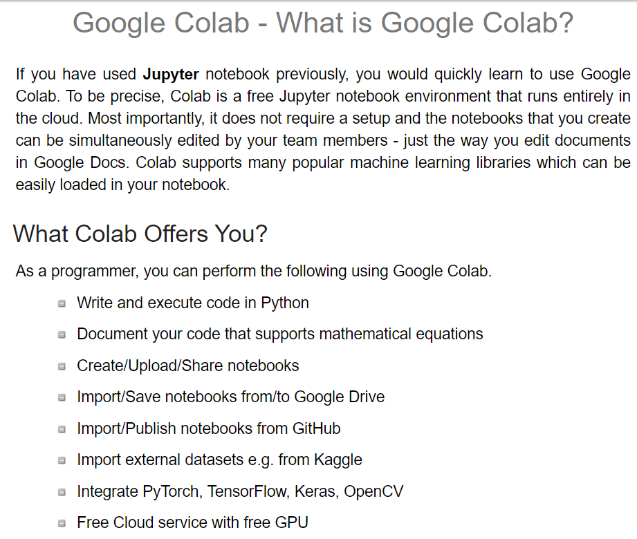

Creating and Renaming Notebook

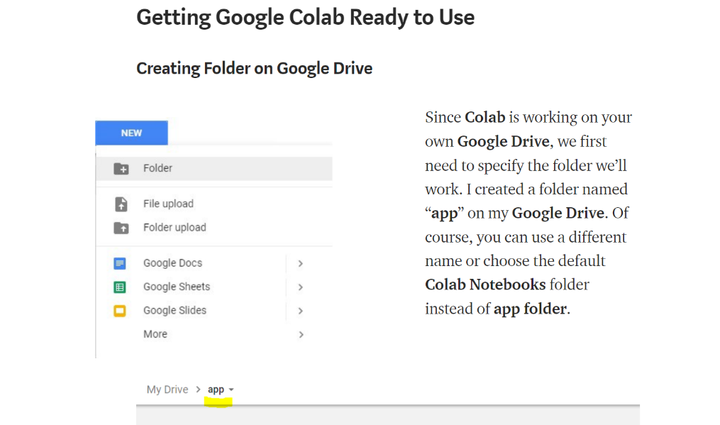

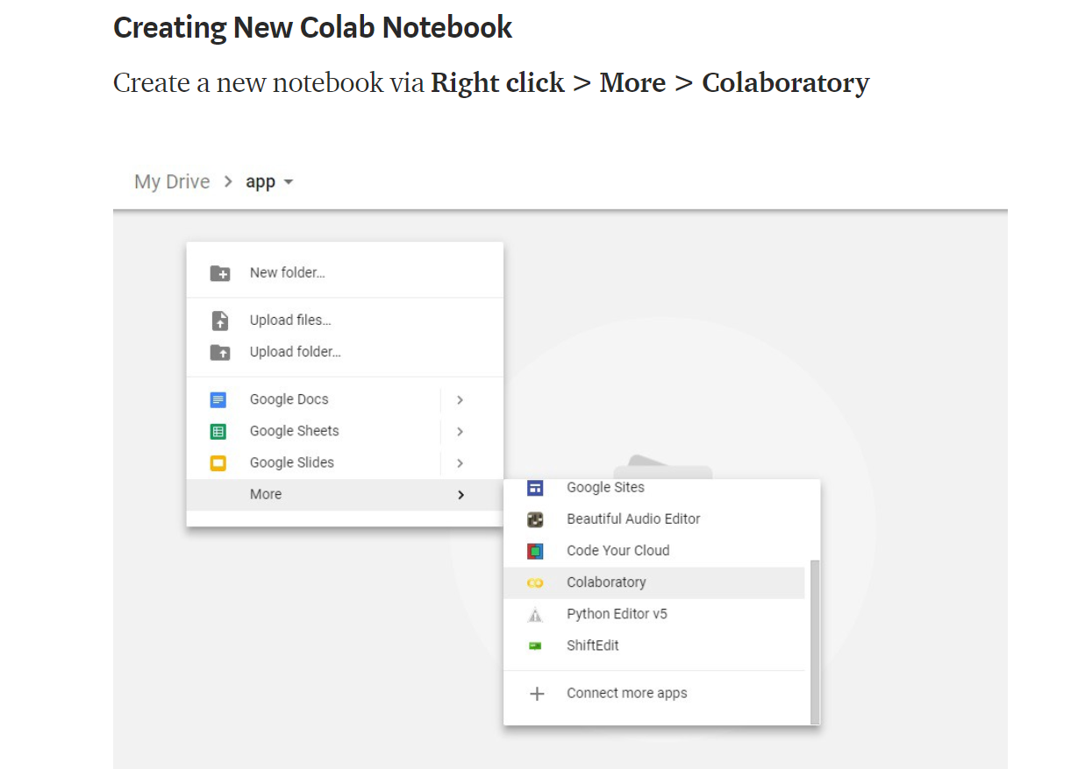

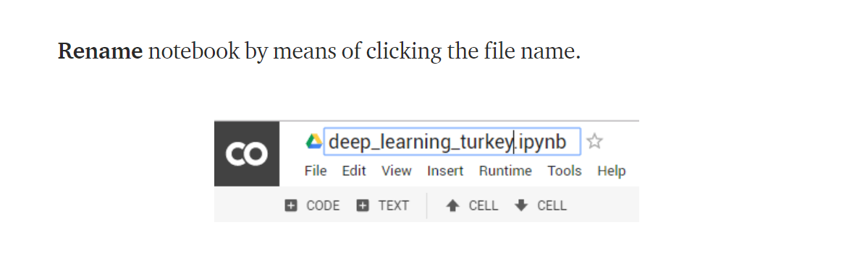

Setting UP GPU

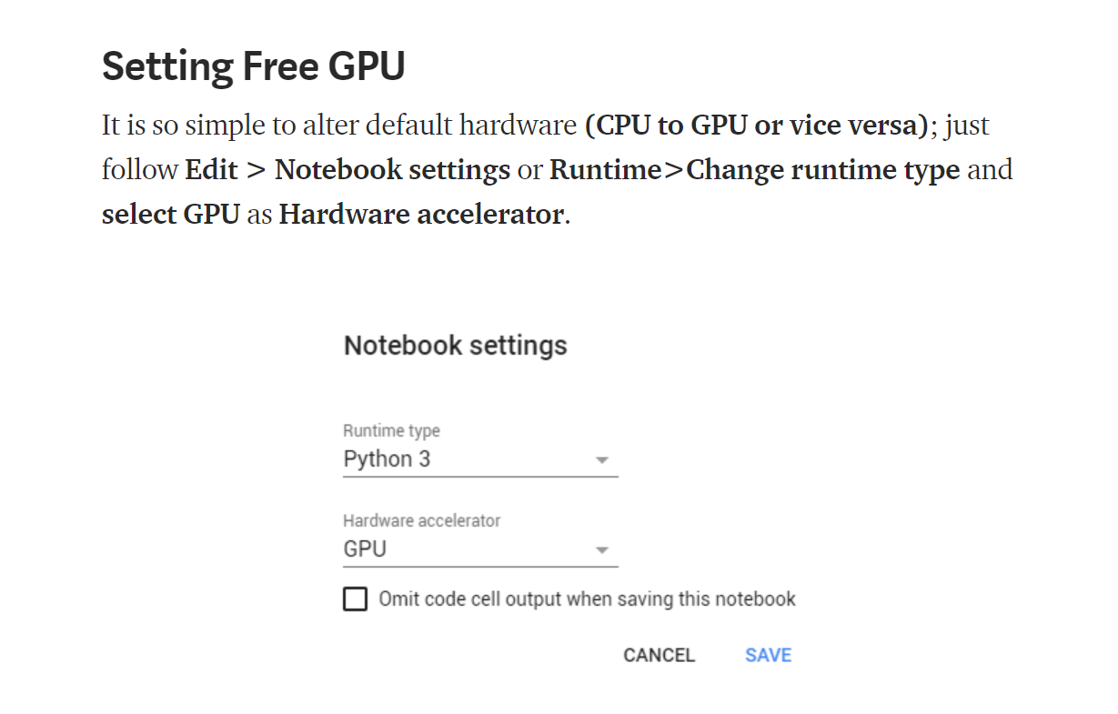

Checking if notebook is running on GPU backend

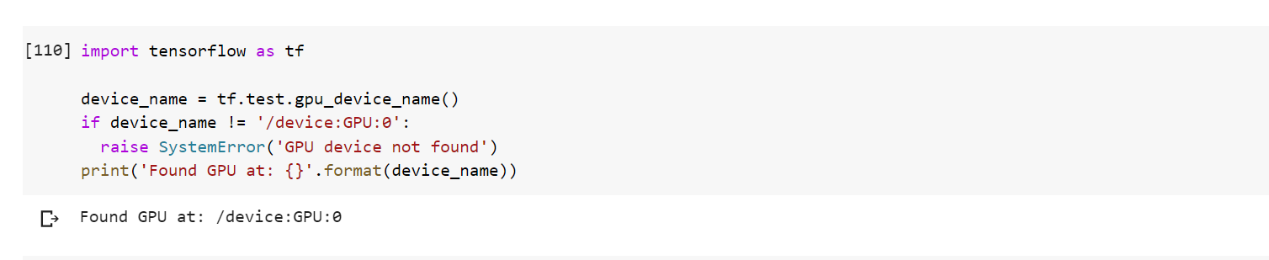

Running cells

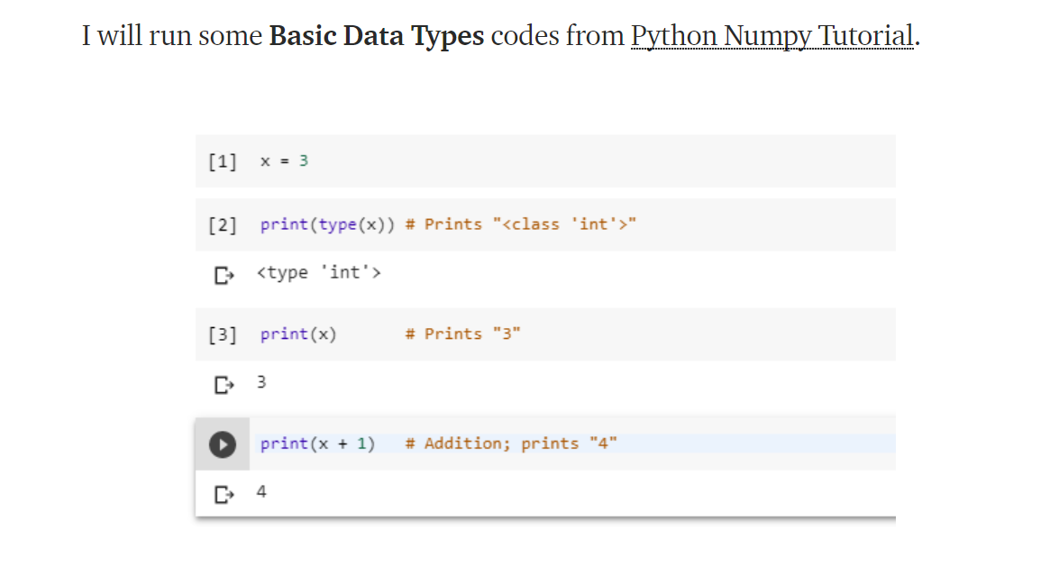

Mount Google Drive to Colab

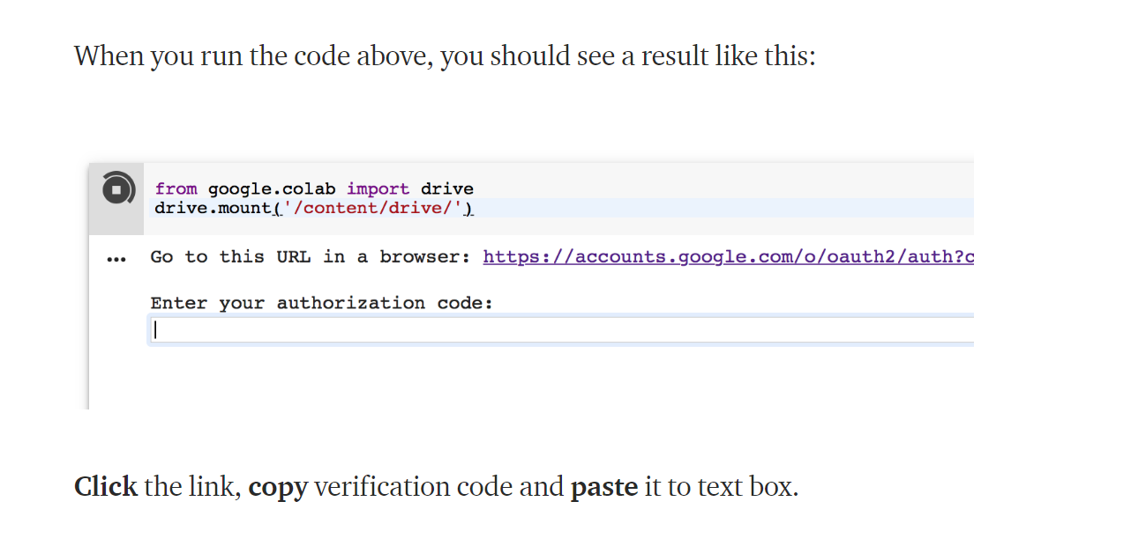

Colab Directory

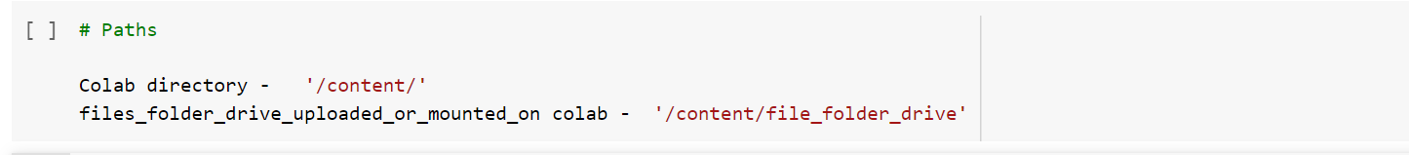

Colab Shell Commands



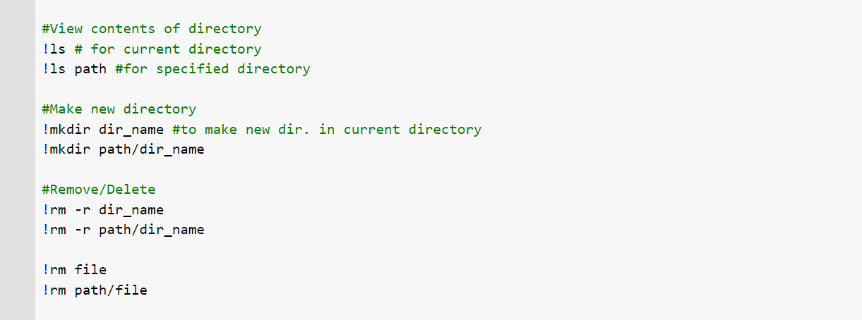

Download and Unzip Zip files

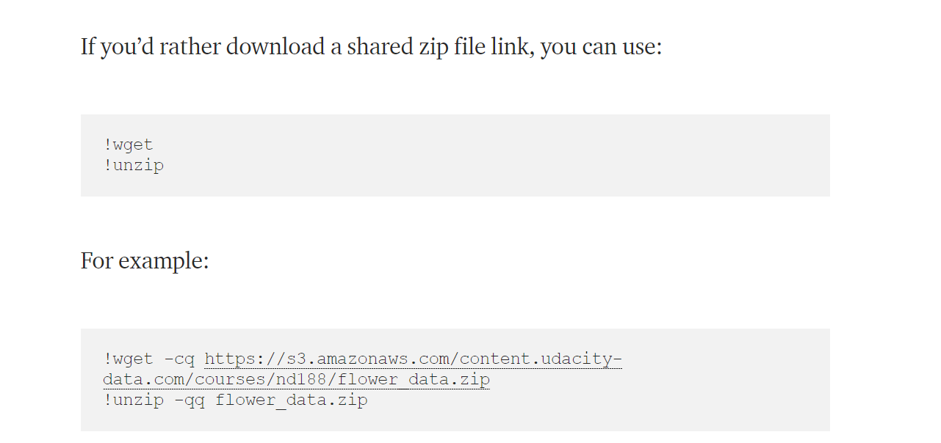

Sharing Notebook

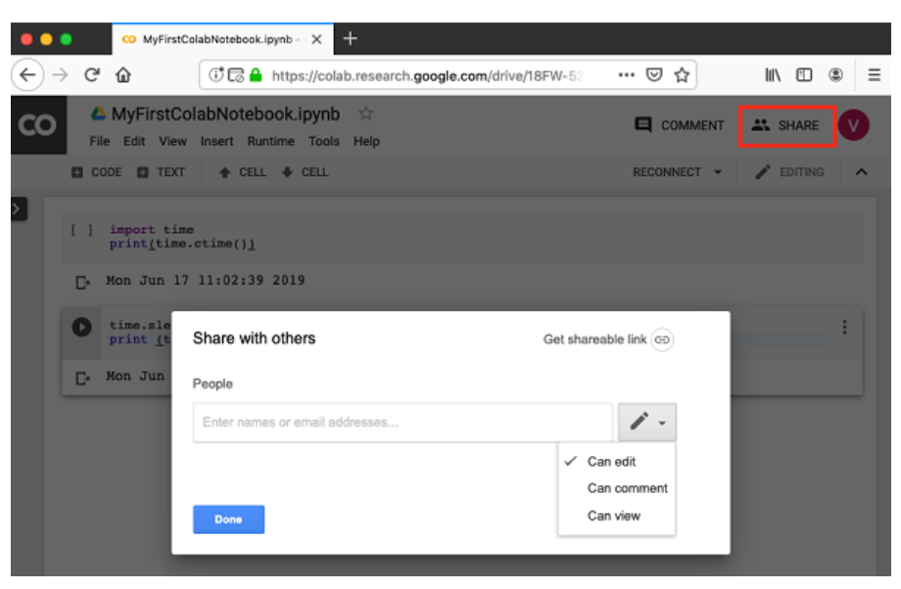

Saving to Google Drive/Git Hub

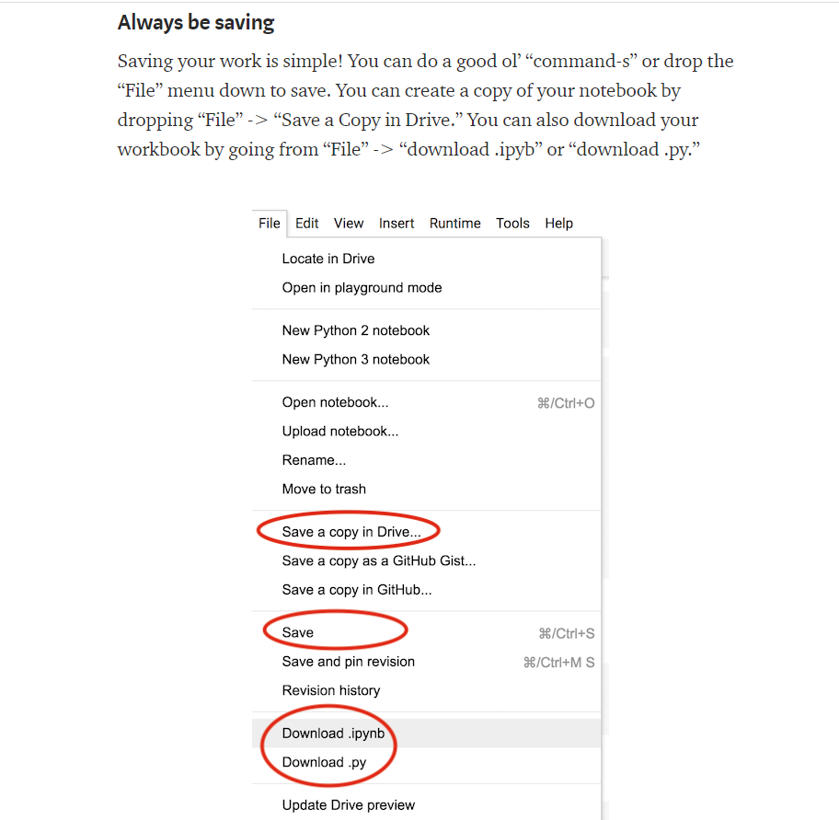

Clone & Run Git Hub Repo

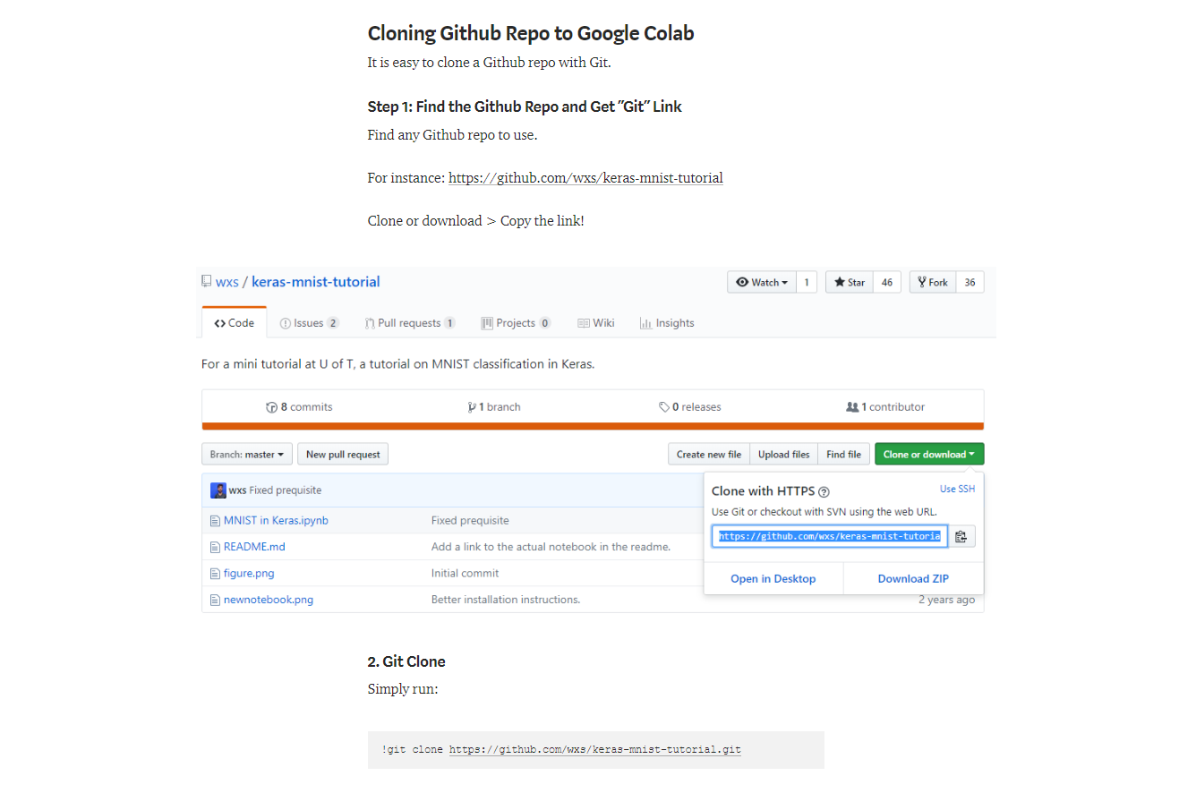

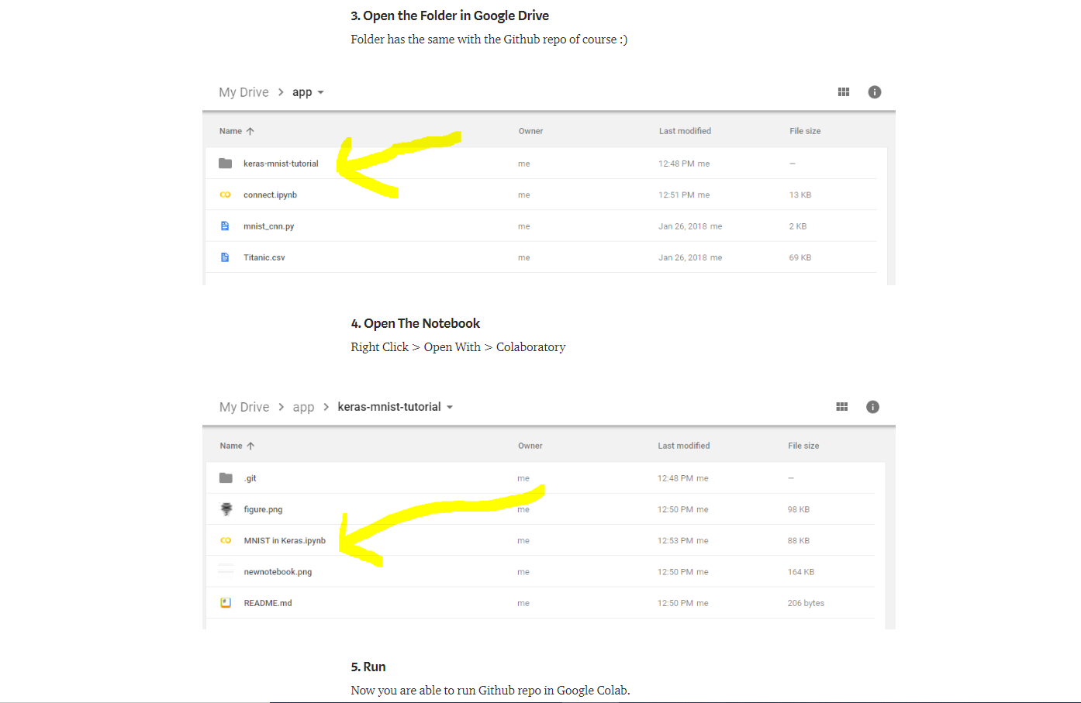

Use Kaggle Datasets In Colab

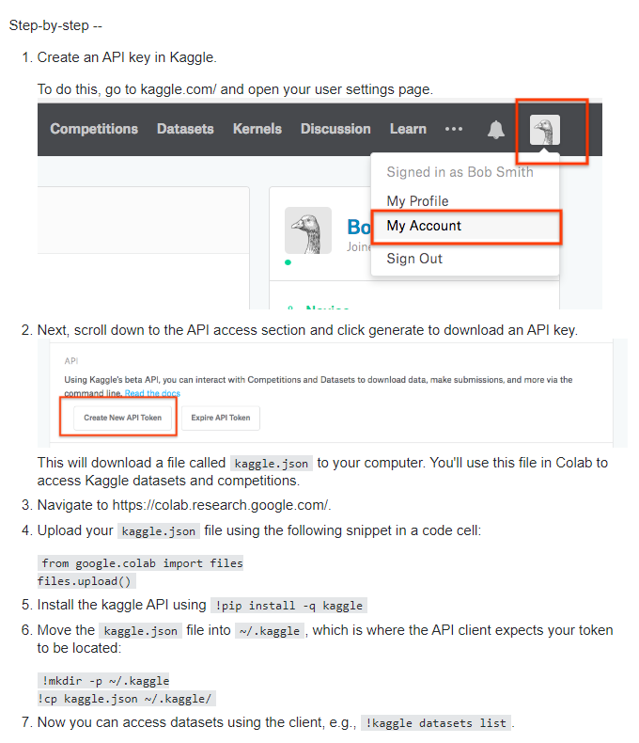

References

<https://www.tutorialspoint.com/google_colab/google_colab_quick_guide.htm>

<https://towardsdatascience.com/getting-started-with-google-colab-f2fff97f594c>

<https://colab.research.google.com/drive/1l09j_Yv3H016EqHyrJUe_0mNah1M80qf#scrollTo=5xlf41nj04Cc>

<https://medium.com/deep-learning-turkey/google-colab-free-gpu-tutorial-e113627b9f5d>

<https://stackoverflow.com/questions/49310470/using-kaggle-datasets-in-google-colab>