Clavyra
AI · AUTOMATION · CONSULTING
Brand Guidelines

Version 1.0 · Clavyra AI · 2026

ABOUT CLAVYRA AI
Clavyra AI is a global AI automation and consulting agency built to help businesses make more money and save time — using the power of artificial intelligence.

We serve business owners and teams worldwide who are ready to stop losing hours to manual work, missed customer inquiries, and inefficient processes. Our job is simple: find where your business leaks time and money, then fix it with AI.

Our core promise:
"We make your business more money and give you your time back — using AI."

BRAND IDENTITY
Mission | To give every business — regardless of size or location — access to intelligent automation that drives real, measurable results.

Vision | To be the most trusted AI automation partner for growth-focused businesses around the world.

Values | - Results first — we measure success by your ROI  - Clarity over jargon — plain language, real outcomes  - Trust through transparency — no surprises, no black boxes  - Global standards, personal service

LOGO
The Clavyra AI wordmark is the primary brand asset. The name is split into two visual parts: "Clav" in the primary text color and "yra" in Emerald — signifying clarity leading to growth.

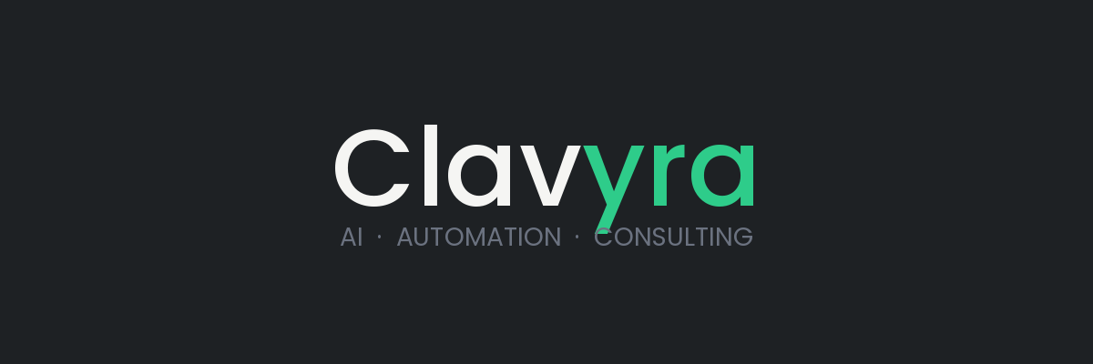

Primary version: dark background (Obsidian) with Chalk wordmark and Emerald accent.

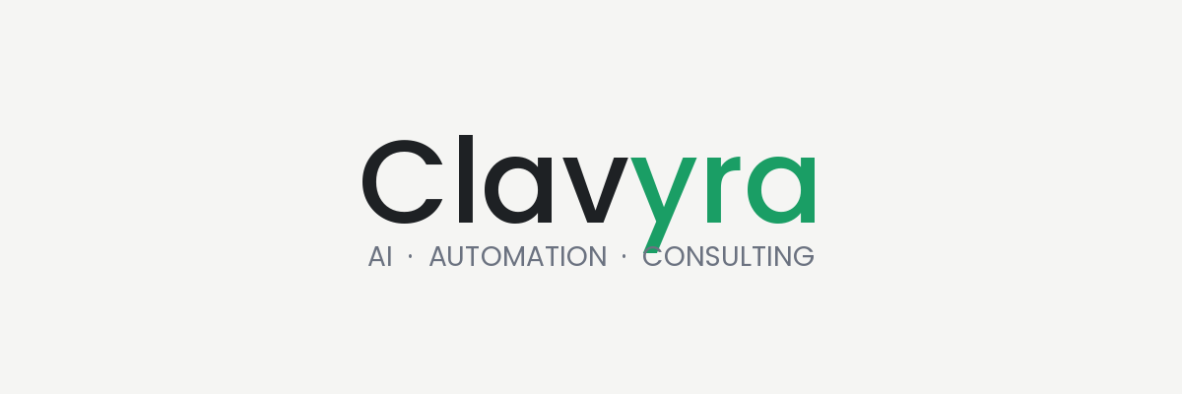

Light version: Chalk background with Obsidian wordmark and Forest accent.

Logo Usage Rules

DO | DON'T
✓ Use on dark or light backgrounds only | ✗ Place on busy or patterned backgrounds
✓ Keep "yra" always in Emerald/Forest | ✗ Change the accent color to anything else
✓ Maintain clear space equal to letter height | ✗ Stretch, compress, or rotate the wordmark
✓ Use full name "Clavyra AI" in documents | ✗ Use all caps (CLAVYRA) or all lowercase

COLOR PALETTE
The Clavyra AI palette is built around Obsidian and Emerald — authority and growth. These two colors anchor every design decision.

Obsidian  #1E2124  Primary background | Emerald  #2ECC8A  Accent — dark backgrounds | Forest  #1A9E65  Accent — light backgrounds
Charcoal  #3A3F44  Secondary background | Chalk  #F5F5F3  Light background / text on dark | Slate  #6B7280  Muted text / dividers

Approved Color Combinations

Dark Primary  Obsidian + Emerald + Chalk | Light Primary  Chalk + Forest + Obsidian | Accent Block  Forest + White text

TYPOGRAPHY
All brand typography uses Arial — a universally available, clean, and professional typeface. Hierarchy is established through size and weight only.

Style | Example | Specs
Display | Intelligent automation. | 28pt · Bold
Heading 1 | We build AI systems that work. | 20pt · Bold
Heading 2 | Our services | 16pt · Bold
Body | We help your business run smarter, faster, and more profitably. | 12pt · Regular
Caption | AI Chatbots · Automation · Consulting | 10pt · Regular
Label | BOOK A FREE CONSULTATION | 9pt · Bold · Caps

BRAND VOICE & MESSAGING
Clavyra AI speaks to business owners and decision-makers — not developers. Every message must answer one question: "Will this make me money or save me time?"

Voice Principles

Confident  Direct and clear. No buzzwords. We say what we do and we deliver it. Clients trust certainty. | Trusted  Calm authority. We speak to global clients as strategic peers — not as prospects to pitch. | Innovative  Forward-looking. We frame AI as a practical growth lever — not hype or future talk.

Client-First Language

✗ Tech talk (avoid) | ✓ Client language (use)
We deploy AI agents | We handle your customer inquiries 24/7 so you don't have to
Workflow automation solutions | We cut your team's manual work in half
AI consulting services | We find where you're losing money and fix it with AI
Custom chatbot development | Your business keeps running while you sleep
NLP-powered systems | Your customers get instant answers, every time
Machine learning integration | Your business gets smarter the longer we work together

Service Messaging

Service | Headline | Supporting message
AI Chatbots | Never miss a customer again | Your business answers inquiries 24/7 — even when you're asleep
Automation | Stop paying people to do what software can do | We eliminate repetitive work so your team focuses on growth
AI Agents | A team that works 24/7 without salaries | Intelligent agents that handle complex tasks end-to-end
Consulting | We find the leaks in your business and plug them | A clear AI roadmap with real ROI — not theory

BRAND ASSETS SUMMARY
Primary font | Arial (Bold & Regular)
Primary background | Obsidian #1E2124
Primary accent (dark) | Emerald #2ECC8A
Primary accent (light) | Forest #1A9E65
Light background | Chalk #F5F5F3
Secondary background | Charcoal #3A3F44
Muted text | Slate #6B7280
Logo style | Wordmark — "Clav" + "yra" in accent color
Tagline | AI · Automation · Consulting
Core promise | "We make your business more money and give you your time back."
Target client | Business owners & decision-makers, global market
Brand voice | Confident, Trusted, Innovative

Clavyra AI Brand Guidelines
For questions about brand usage, contact the Clavyra AI team.

