***Story Board / Wireframe – CSS &HTML Website***

***Index Page***

***Personality Page***

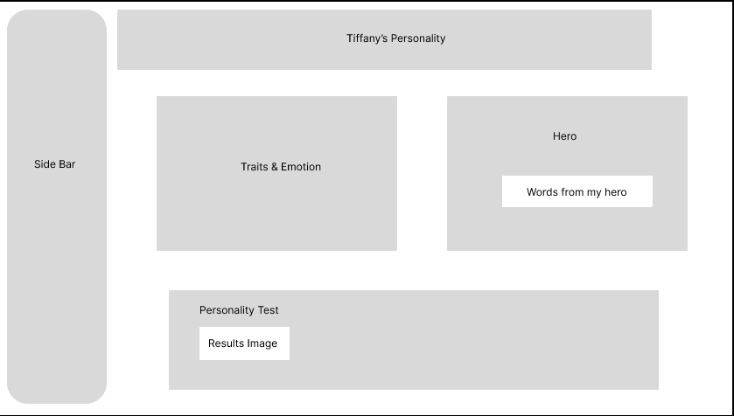

***Professional Page***

***Personal Development Page***

***Storyboard Page***

***Reference Page***

