****Innovation and Extra Functionality****

****G00425067 – TiffanyNgikChee Yong****

Feature1: Custom Styling (CSS Design Enhancements) 1

Feature2: Create Functionality 3

# Feature1: Custom Styling (CSS Design Enhancements)

To enhance the user interface and improve user experience, I added custom CSS to style the application. This includes:

* Custom layout and colour schemes for better visual aesthetics.

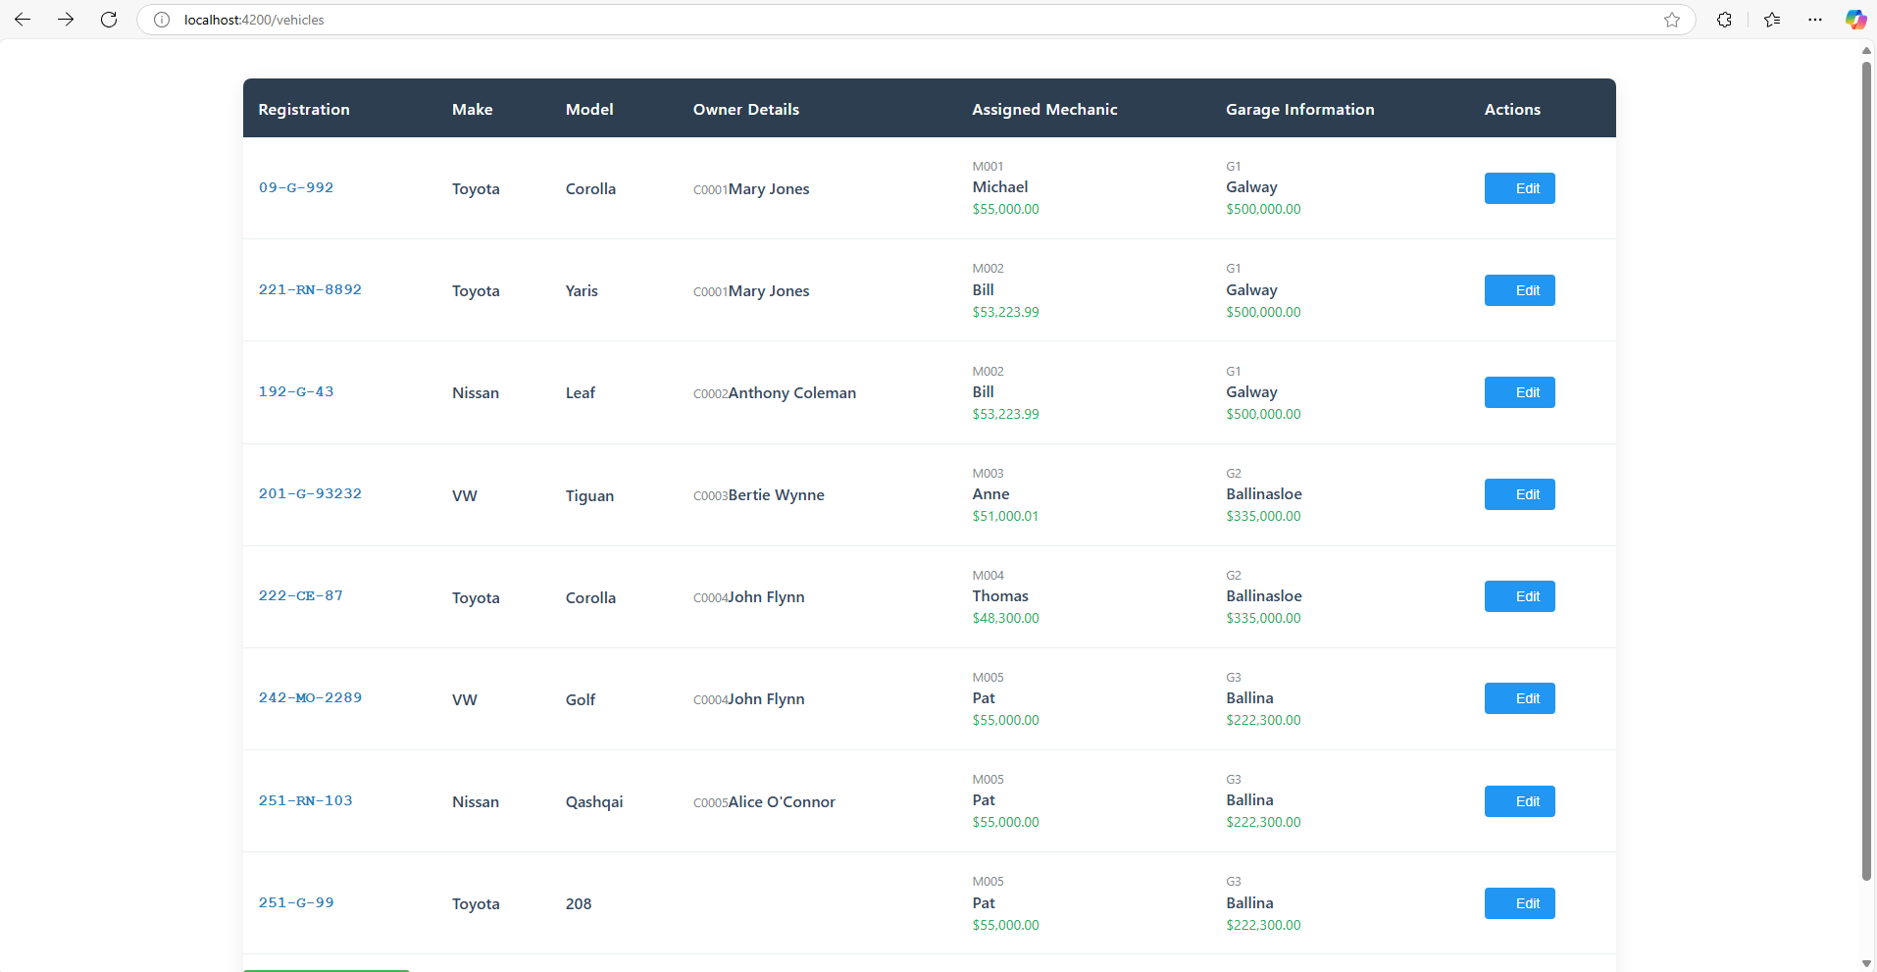

* Styled input fields, buttons, and forms for consistency and accessibility.

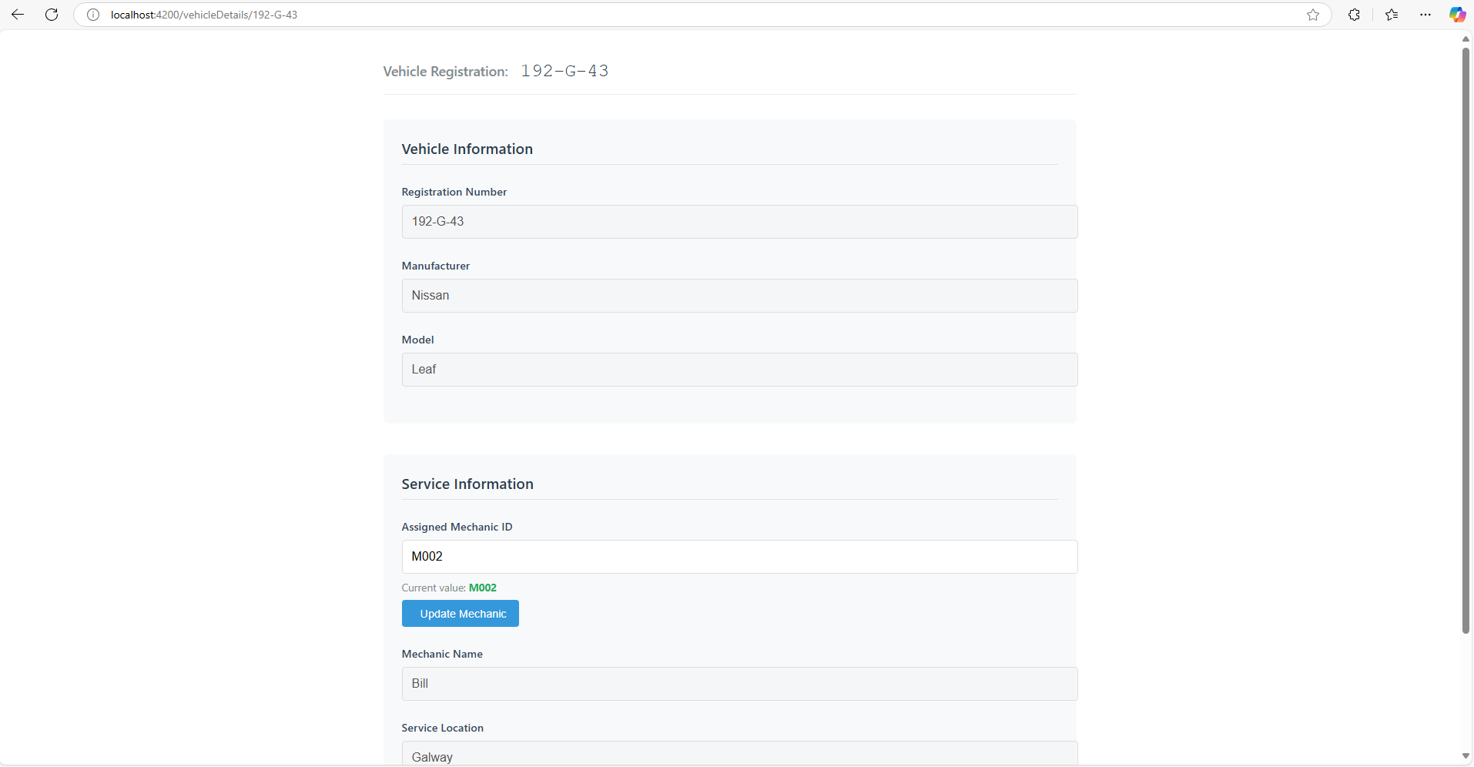

* Visual feedback on submission success or failure (e.g., color-coded messages).

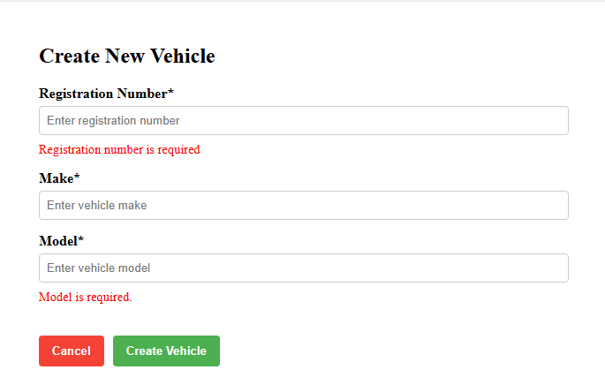

* Animation for Non-existent Registration

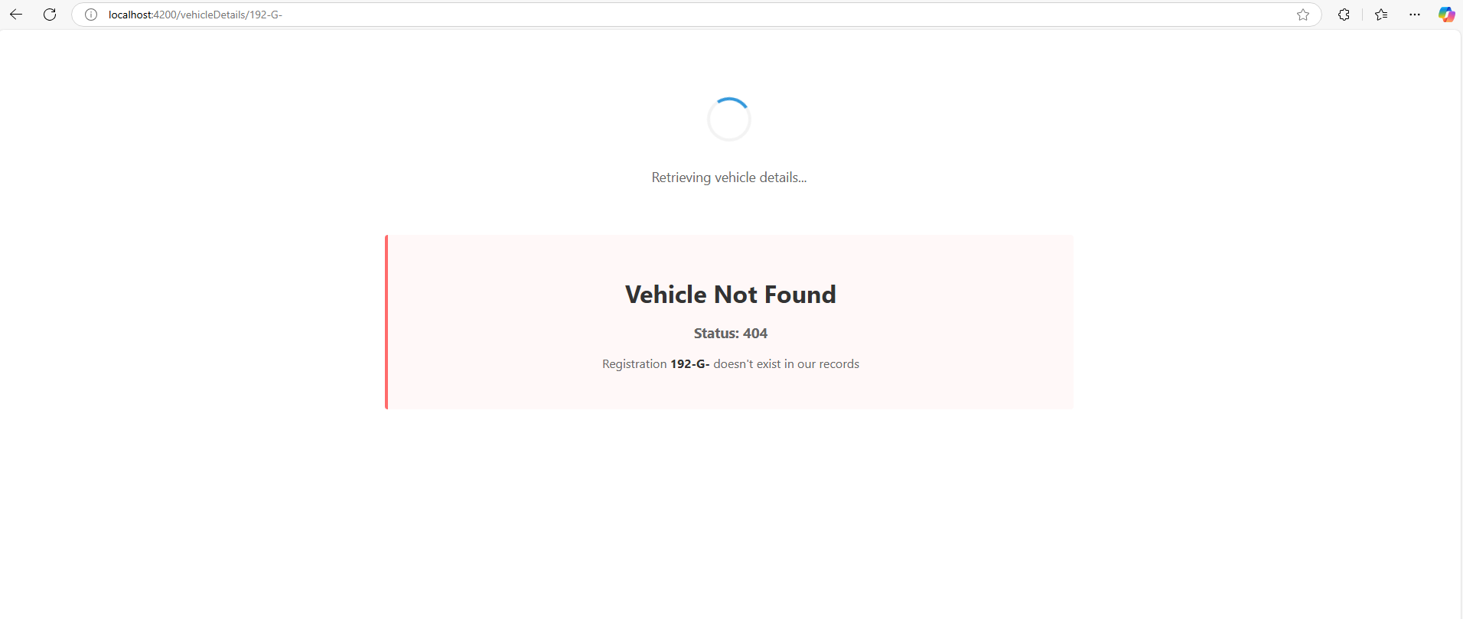

These changes make the application more visually appealing and user-friendly compared to the base requirements.

# Feature2: Create Functionality

Although not explicitly required, a full **create functionality** was implemented using Angular’s Reactive Forms and a backend service. This includes:

* Form validation to ensure all required fields are properly filled.
* Submitting new vehicle data via the GarageService.
* User feedback on successful or failed submissions.
* Auto-redirect to the vehicle list after a successful creation.

To create a new vehicle entry:

1. Navigate to the /create route.
2. Fill in all required fields:
   1. **Registration Number (reg)**: e.g.,251-G-123
   2. **Make**: e.g., Toyota
   3. **Model**: e.g.,208
3. Click the **Submit** button.
4. If successful:
   1. A confirmation message will be shown.
   2. The form resets.
5. If there's an error:
   1. An error message is shown detailing the issue.
   2. The user can correct the inputs and try again.
6. Assign MID on /vehicleDetails for the new Vehicle

This feature increases the completeness of the application and makes it fully interactive for CRUD operations.

