FUNCTION 1 – COUNT()
When it might be used:COUNT helps you see how many rows match a condition. You might use it to count customers, orders, or products in categories. It’s great for summaries and reports.

Alias:
CustomerCount

SQL statement:
SELECT Country, COUNT(*) AS CustomerCount
FROM Customers
GROUP BY Country;
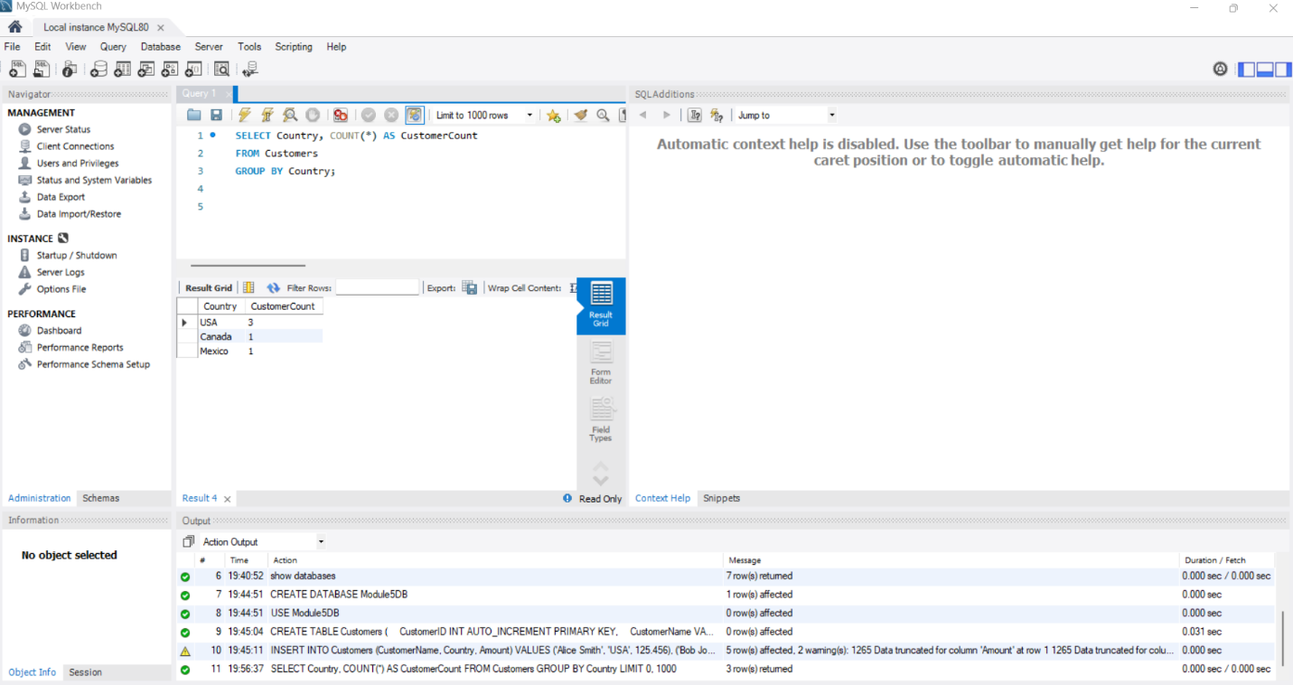

FUNCTION 2 – UPPER()
When it might be used:UPPER is used to standardize text. If data is entered in different cases, this lets you compare or display everything the same way.
Alias:
NameUpper
SQL statement:
SELECT CustomerName, UPPER(CustomerName) AS NameUpper
FROM Customers;
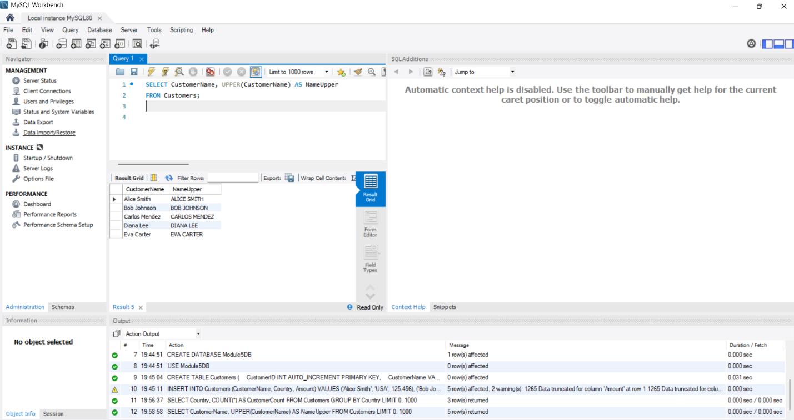

FUNCTION 3 – ROUND()
When it might be used: ROUND is useful when you want to clean up decimals, especially when dealing with money totals, taxes, averages, or calculated values.

Alias:
RoundedAmount

SQL statement:
SELECT CustomerName, Amount, ROUND(Amount, 2) AS RoundedAmount
FROM Customers;
