Assumptions and Notes:
- Each book can have many authors, and an author can write many books, so a junction table is needed.
- ISBN uniquely identifies a book, and serves as the primary key for the Book table.
- A surrogate AuthorID is introduced to uniquely identify authors.
- PublisherID uniquely identifies a publisher and is the foreign key on Book.
- All attributes are atomic and depend on the key, the whole key, and nothing but the key (3NF).
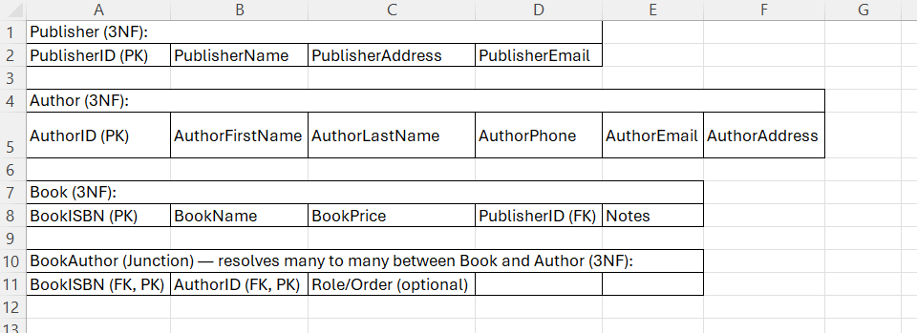

Normalization Rationale:
1NF: All fields hold single, indivisible values. No repeating groups. 2NF: Every non key column in each table depends on the full key. The junction table uses a composite key. 3NF: Non key attributes do not depend on other non key attributes. For example, PublisherEmail depends only on PublisherID, and AuthorPhone depends only on AuthorID. BookPrice depends only on BookISBN.

