Red Team - Outland Adventures Database Project

Team Members
Matthew Rozendaal
Mickelly Audam
Tiffany Davidson

Case Study Selected
Outland Adventures

Key Business Decision Reporting Datasets (outland_adventures.py)
#1 Equipment Profit and Rental Performance
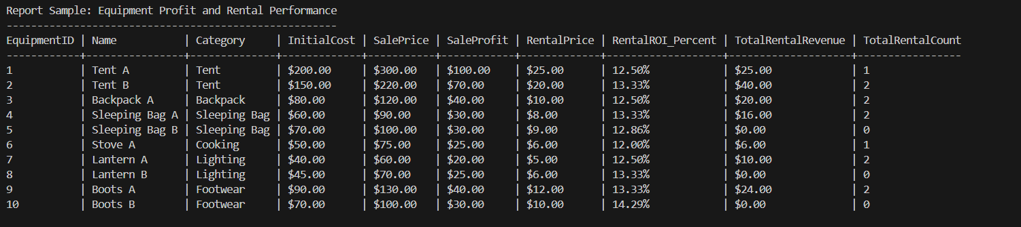

#2 Equipment Age and Inventory Status
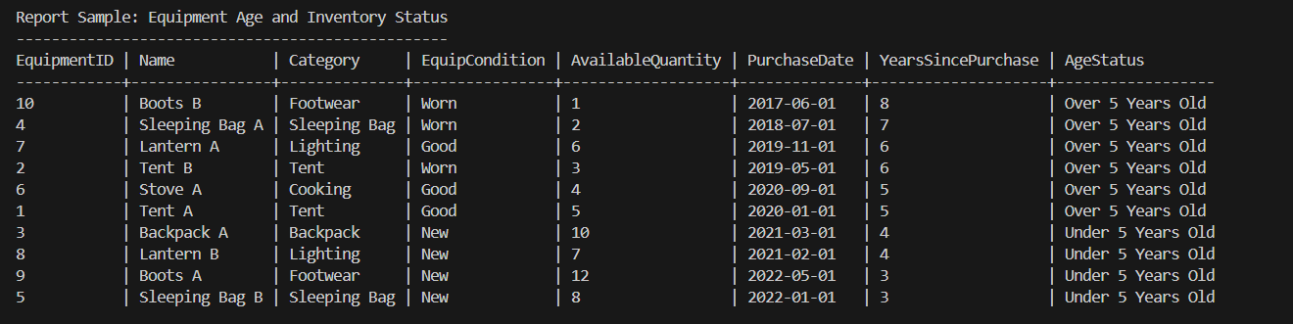

#3 Booking Trends by Region
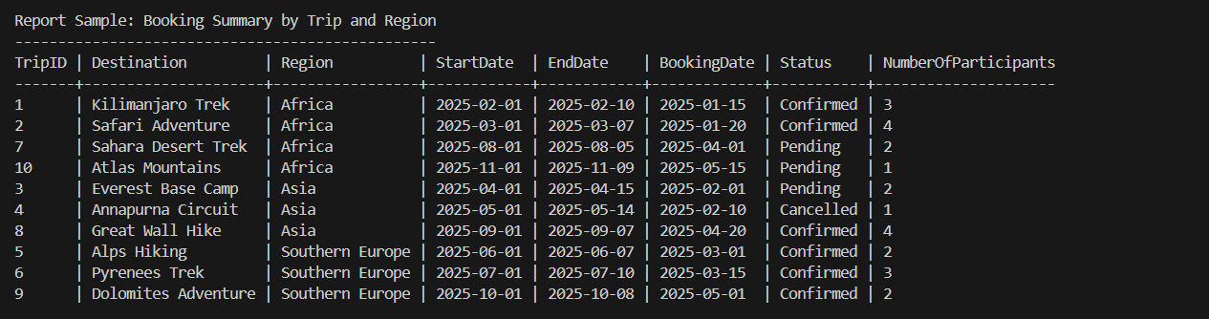
#4 Equipment Rental vs Purchase Totals
