https://github.com/Tiffanylaurine88/csd-310
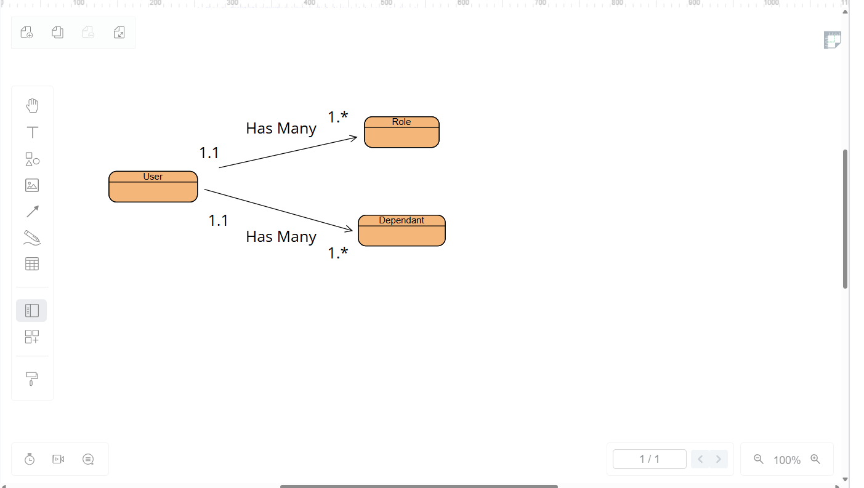

{
"user_id": 1,
"first_name": "Tiffany",
"last_name": "Davidson",
"birthdate": "1989-07-12",
"roles": [
{ "role_id": 1, "role_name": "Admin" },
{ "role_id": 2, "role_name": "Editor" }
],
"dependents": [
{ "dependent_id": 1, "name": "Evelyn", "relationship": "Daughter" },
{ "dependent_id": 2, "name": "Daniel", "relationship": "Spouse" }
]
}

