Flowchart for chohan_tld.py:
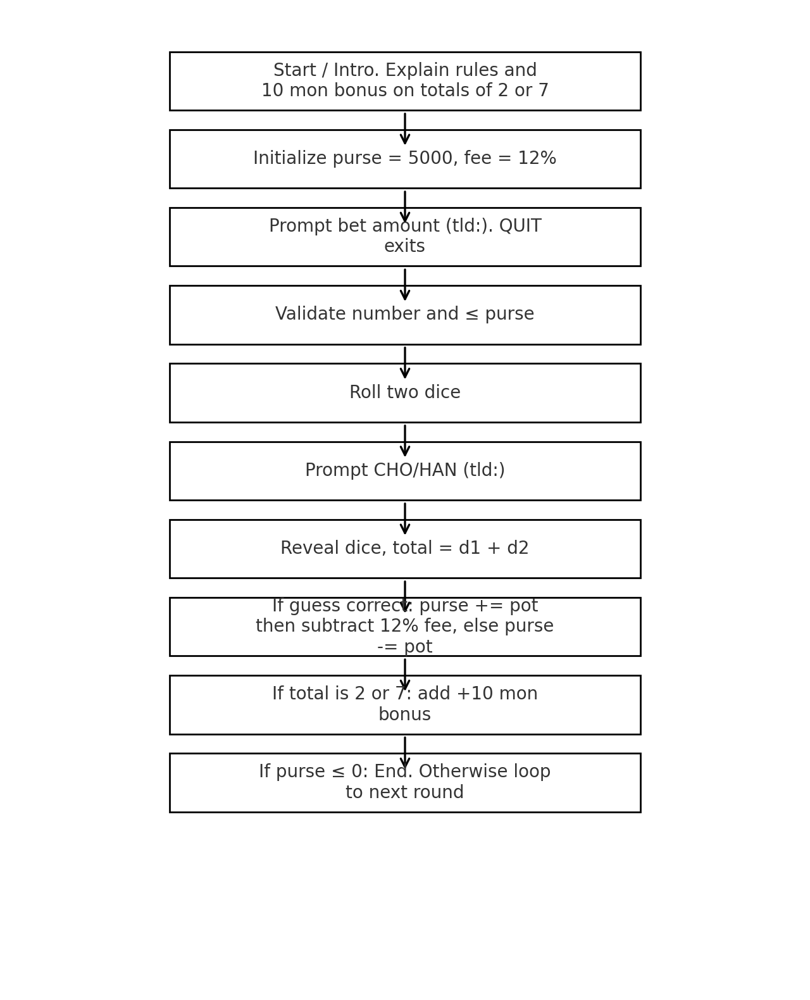

Notes on Changes:
- All input prompts changed to 'tld:'.
- House fee changed to 12 percent.
- Intro text now states bonus on totals of 2 or 7.
- After each roll, if total is 2 or 7, announce and add +10 mon to purse.
- File saved as chohan_tld.py with comments documenting changes.

