CAR WASH MANAGEMENT SYSTEM

AquaGleam Car Wash & Detailing
Smart Business Management System
Business Proposal & System Overview
Prepared for: | AquaGleam Car Wash & Detailing
Document Type: | Business Proposal
Date: | November 2026

____________________________________________________________
This document is confidential and prepared exclusively for AquaGleam Car Wash & Detailing.

Table of Contents

1 | Executive Summary | An overview of what this system does and why it matters.
2 | About the System | Platform overview, compatibility, and language support.
3 | Key Business Benefits | How the system improves revenue, operations, and customer experience.
4 | How It Works | Step-by-step customer journey from arrival to completion.
5 | Main Modules & Features | Detailed look at each major area of the system.
6 | System Screenshots | Real screenshots of the system in action.
7 | Security & Data | How your business data is kept safe and protected.
8 | Conclusion | Summary and next steps.

1. Executive Summary

AquaGleam Car Wash & Detailing is a modern, all-in-one car wash management platform designed specifically for professional car wash and detailing businesses. This system replaces manual, paper-based processes with a smart digital solution that makes your business faster, more accurate, and easier to manage — from the moment a customer walks in, to the moment they drive away satisfied.
This proposal presents an overview of the system's capabilities, the tangible benefits it delivers to your business, and what day-to-day operations look like with the system in place.
Complete POS  Full point-of-sale with multi-payment support | Live Reports  Real-time financial visibility for owners | Bay Control  Smart queue & bay workflow management | TV Display  Live customer queue on a waiting room screen

2. About the System

The AquaGleam Car Wash Management System is a web-based platform that runs on any computer, tablet, or smart device — no specialized hardware required. It was built to solve the everyday challenges that car wash businesses face: long queues, missed payments, unclear staff performance, and lack of real-time business visibility.
The system supports both English and Khmer languages, making it accessible to all staff regardless of their background. It is designed to work even without an internet connection, so your business never stops due to connectivity issues.
At a Glance
- Runs on any device — computers, tablets, smartphones
- Works offline — business continues during internet outages
- Full bilingual support — English and Khmer languages
- Accepts cash, KHQR bank transfer, and credit payments
- Real-time customer queue display on TV screen
- Detailed financial reports available to owners at any time
- Automatic daily data backups — your data is always safe

3. Key Business Benefits

The system directly addresses the most common pain points in car wash operations. Below are the core ways it benefits your business:
Eliminate Revenue Leakage
Every transaction is recorded automatically. The system prevents any car from entering the wash bay without confirmed payment — meaning no service is ever given away by mistake. Managers can void or discount orders, but only with an authorized PIN code, creating a clear audit trail for every exception.
Faster Service, Happier Customers
The POS system allows cashiers to create a complete order in seconds. Customers can track their position in the queue on a live TV display — so they always know how long they have to wait. If the wait is too long, the system suggests booking an appointment, reducing walk-outs.
Real-Time Business Visibility
Business owners have access to a live dashboard showing today's income, total orders, customers served, and bay utilization. Full financial reports covering revenue, expenses, staff commissions, and net profit are available at any time — by day, week, month, or custom date range.
Better Staff Management
The system tracks which staff member handled each order, records clock-in/clock-out times, and calculates commissions automatically. Each staff role (cashier, supervisor, owner) has defined permissions — everyone sees only what is relevant to their job.
Smarter Upselling — More Revenue Per Car
The system automatically suggests service upgrades at the right moment during checkout — such as offering a Premium Wash for an extra $5. These smart prompts are configured by the manager and displayed to cashiers, increasing average order value without any extra effort.
Customer Loyalty & CRM
The system maintains a customer database with vehicle history and service preferences. This lets your team recognize returning customers, apply loyalty rewards, and build long-term relationships that keep customers coming back.

4. How It Works — Step by Step

The customer journey through the system is smooth and transparent — from first arrival to final handover. Here is how a typical car wash order flows through the system:
Step 1 Customer Arrives — Order Created
The cashier opens the POS on any device and creates a new order. They select the vehicle type, choose the desired service (Standard Wash, Premium Wash, Detailing, etc.), and add any extras. The price is calculated automatically.
Step 2 Smart Upgrade Suggestion
If a service upgrade is available, the system automatically offers it at checkout — giving the customer the opportunity to upgrade for a small additional fee. This is fully automated and configured by the manager.
Step 3 Payment Collected
The customer pays by cash, KHQR bank transfer, or card. A digital receipt is generated immediately. Both KHR and USD are supported with real-time exchange rates.
Step 4 Queue Entry & Bay Assignment
Once payment is confirmed, the order enters the live queue. The system assigns the car to the best available bay based on service type and staff skills. The customer sees their queue position on the TV display in the waiting area.
Step 5 Wash & Quality Control
Staff complete the wash following the assigned task checklist. Before the car is released, a Quality Control inspection is performed to ensure consistent service quality for every vehicle.
Step 6 Car Handover & Order Complete
The car is handed back to the customer. The order is marked complete, and all data — time taken, staff involved, services delivered, and revenue — is automatically saved to the reports.

5. Main Modules & Features

The system is organized into specialized modules, each designed to handle a specific area of your business. Together they form a complete, integrated management platform.
Point of Sale (POS)  The front-line tool used by cashiers to create, manage, and collect payment for orders. Fast, simple, and error-proof — works on any screen and fully offline. | Bay & Queue Management  Gives supervisors a live view of every wash bay: which car is being serviced, by whom, and for how long. Intelligent bay assignment based on service type and staff skill.
Customer TV Display  A large-screen display in the waiting area shows all bays and the live queue. Customers can see exactly where their car is — in both Khmer and English. | Finance & Reports  Complete financial reporting for owners: net revenue, COGS, expenses, commissions, discounts, and true net profit. Filterable by day, week, month, or custom range.
Customer & Vehicle Database  Every customer and vehicle stored in a searchable database. Staff can look up returning customers, view service history, and apply loyalty benefits instantly. | Catalog & Pricing  Full control over services and products. Pricing per vehicle type. Promotional pricing. Add-on services and service bundles. All managed from the back-office.
Staff & Roles  Multiple roles: Owner, Supervisor, Cashier, Technician. Each role has defined permissions. Sensitive actions require a manager PIN for full accountability. | Backup & Cloud Sync  Automatic daily data backups. One-click restore. Optional cloud sync keeps data synchronized across multiple locations — data is never lost.

6. System Screenshots

The following screenshots show the actual system in action — exactly what your cashiers, supervisors, and management team will see every day.
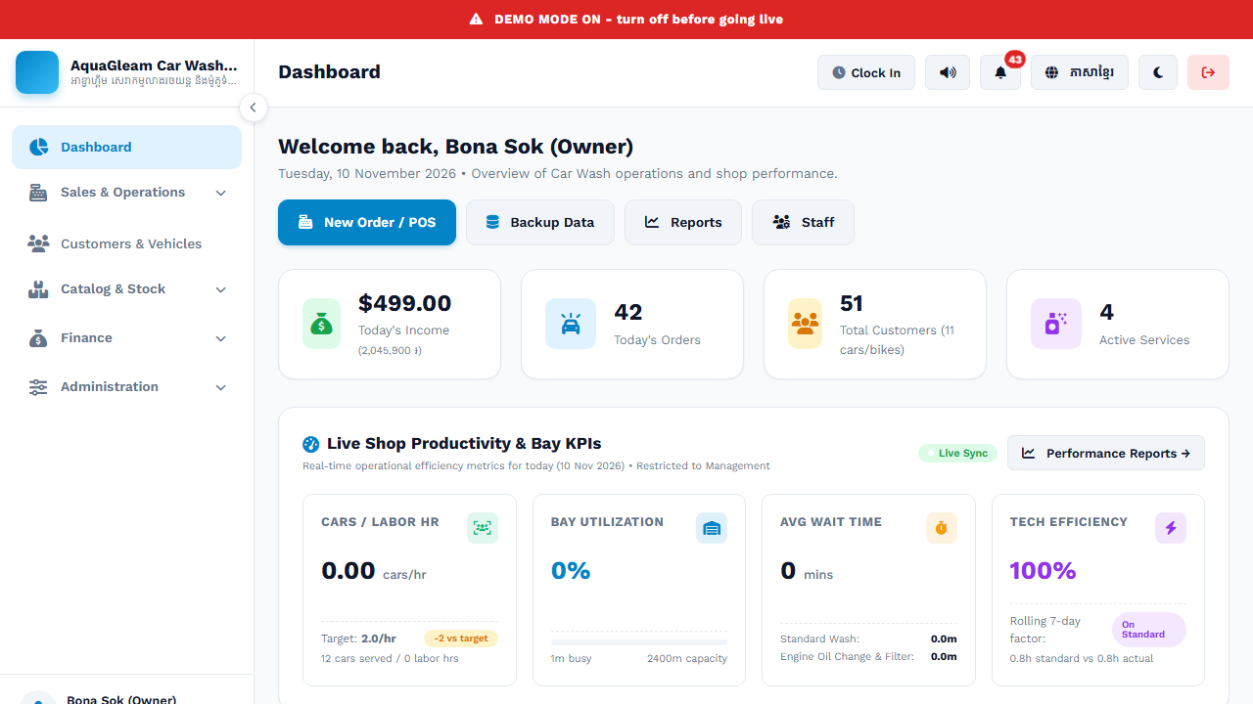
Owner Dashboard — Real-time business overview showing today's income ($499), total orders (42), customers served, active services, bay utilization, and live productivity KPIs.
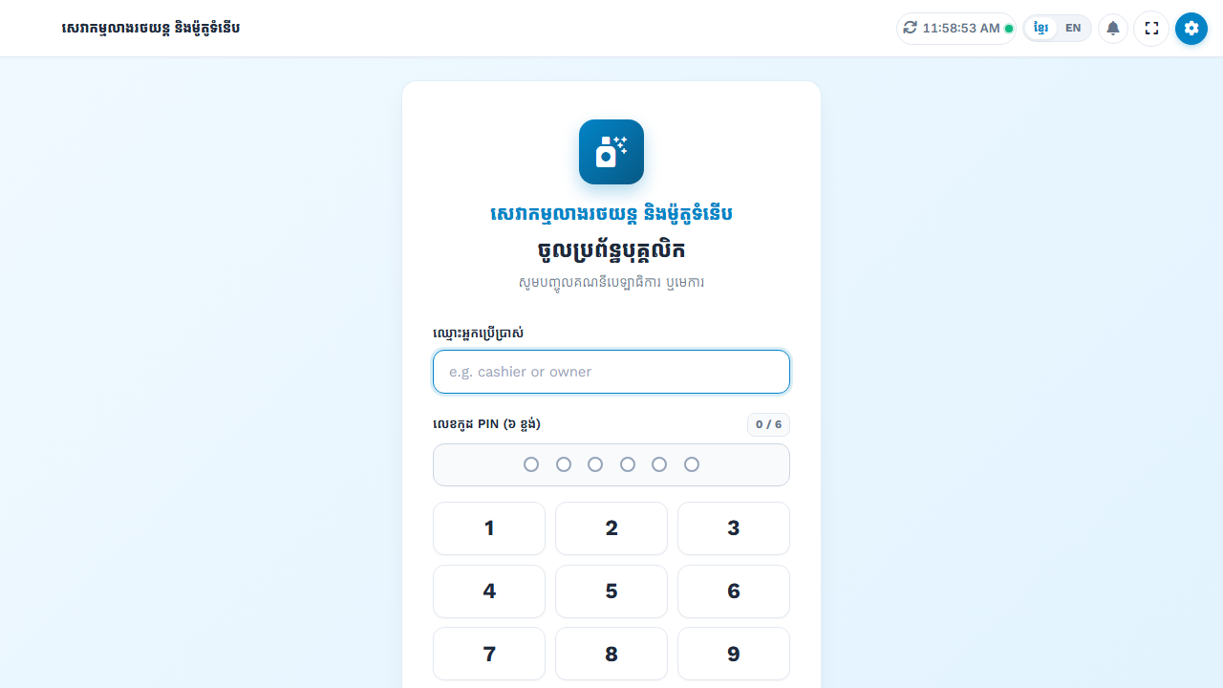
Cashier PIN Login — Every staff member accesses the POS with a secure personal PIN code, ensuring all transactions are always linked to a specific, accountable employee.
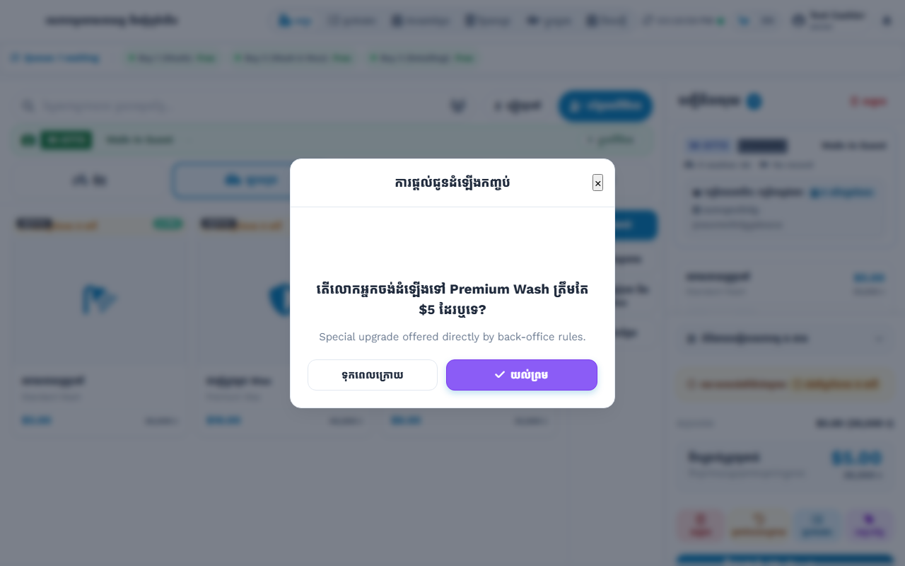
Service Catalog & Order Screen — Cashiers browse available services and add-ons with automatic price calculation. The order summary updates in real time on the right panel.
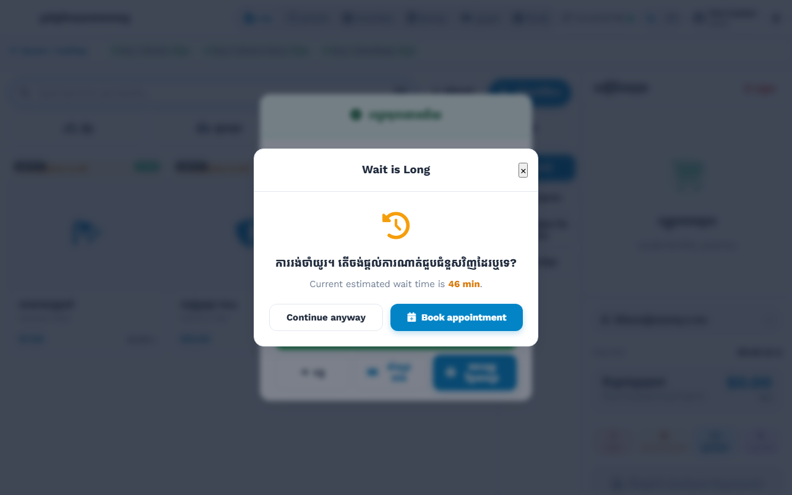
Smart Queue Notification — When wait time is high, the system informs the customer of the estimated wait and offers a convenient appointment booking option to reduce walk-outs.
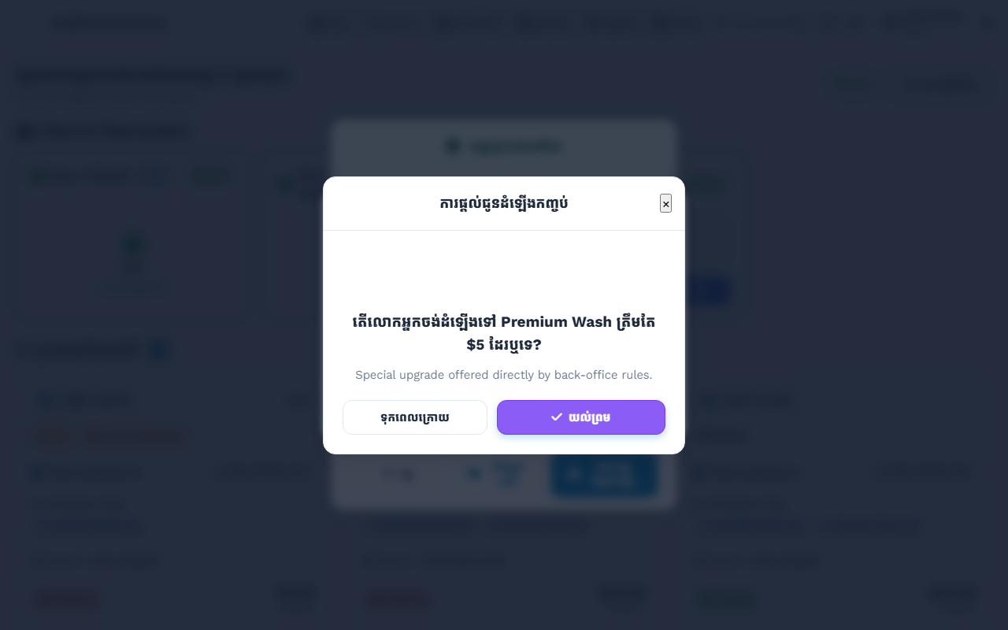
Bay Assignment & Queue Management — Supervisors have a live view of every bay. Cars are intelligently assigned to the most suitable available bay based on service type.
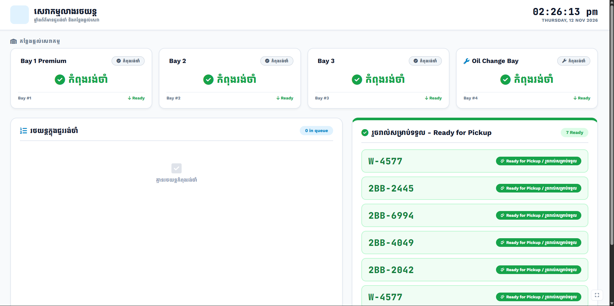
Customer TV Queue Display — A large-screen display in the waiting area shows the live status of all 4 service bays and the full customer queue, displayed in both Khmer and English.
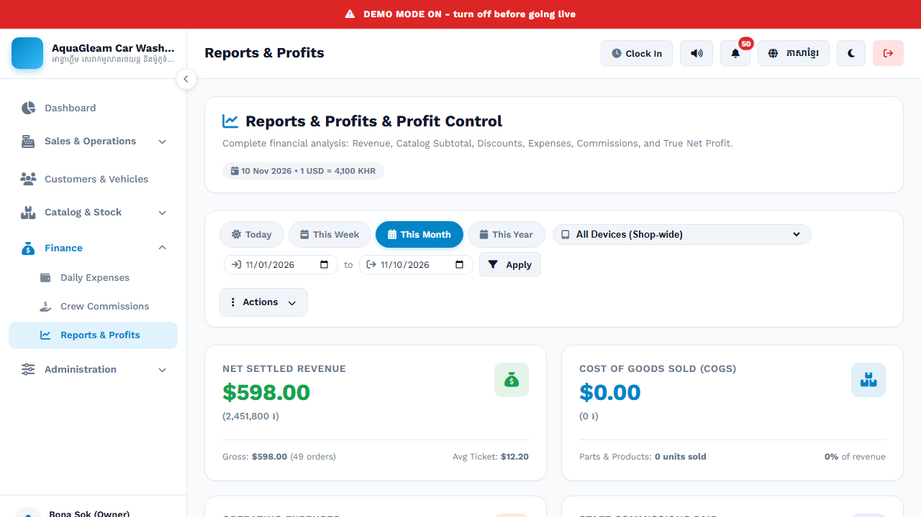
Financial Reports — The Reports & Profits module gives owners a complete view of business performance: net revenue, COGS, expenses, commissions, and true net profit — all filterable by date.
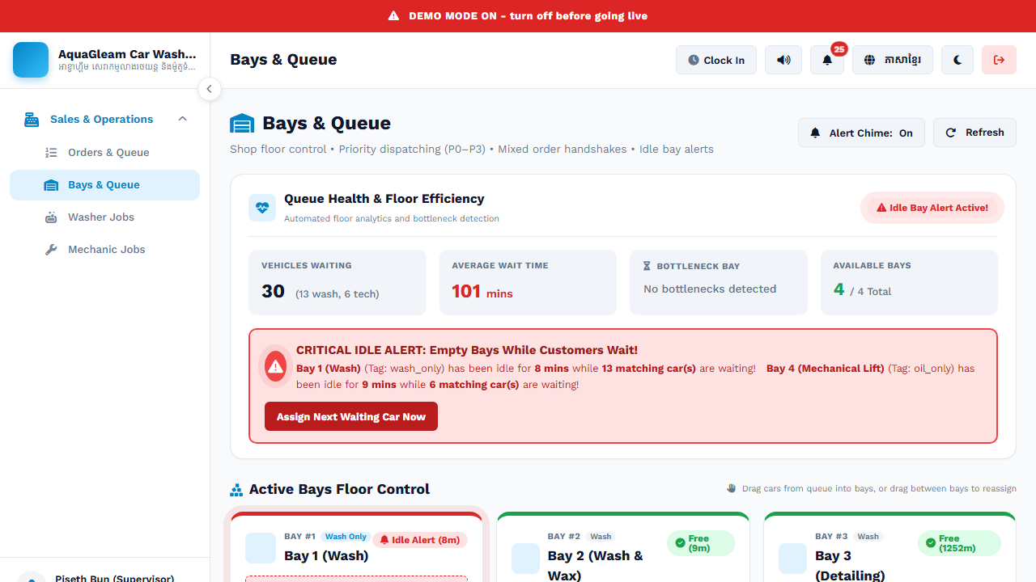
Multi-Role Access Control — The system supports distinct roles with different permissions. Supervisors and managers have additional controls not available to standard cashiers.

7. Security & Data Protection

Your business data is valuable. The AquaGleam system is built with multiple layers of protection to keep your financial records, customer data, and operational history safe at all times:
PIN-Protected Transactions
Every sensitive action — voiding an order, applying a discount, changing prices — requires a manager-level PIN code. This prevents unauthorized changes and builds full accountability.
Complete Audit Log
Every transaction and every change made in the system is permanently recorded with the user's name, timestamp, and action taken. Nothing can be hidden or quietly undone.
Automatic Daily Backups
The system backs up all business data automatically every day. Backups can be downloaded or restored at any time — so even if a computer fails, your data is never lost.
Immutable Financial Records
Once a transaction is finalized, the financial records are locked. Historical data cannot be altered or deleted — protecting you from internal fraud and data manipulation.
Role-Based Access Control
Staff only have access to the parts of the system relevant to their role. Cashiers cannot see financial reports; only owners can access sensitive business data.
Offline Operation
The system continues to function fully even when the internet is unavailable. All transactions are saved locally and synchronized automatically when connectivity is restored.

8. Conclusion

The AquaGleam Car Wash Management System is more than just software — it is a complete business upgrade. It brings professional-grade management to your car wash operation, giving you full control over every part of your business: from the moment a customer arrives, to the final accounting at the end of the day.
By adopting this system, you are investing in:
- More revenue — through smarter upselling, zero missed payments, and better capacity management
- Lower costs — through improved staff accountability and reduced operational waste
- Happier customers — through faster service, transparent queues, and professional digital receipts
- Peace of mind — through accurate financial reports, automatic backups, and complete audit trails
- Business growth — through data-driven decisions supported by real-time analytics

We are excited to support AquaGleam Car Wash & Detailing with a system that will grow alongside your business — making every day more organized, more profitable, and more enjoyable to run.
AquaGleam Car Wash & Detailing | Smart Management System | Professional Edition | November 2026

This document is confidential and prepared exclusively for AquaGleam Car Wash & Detailing.

