P206 EX4.2.1

1. S->rm -> SS* -> Sa* -> SS+ a* -> Sa+a* ->aa + a*

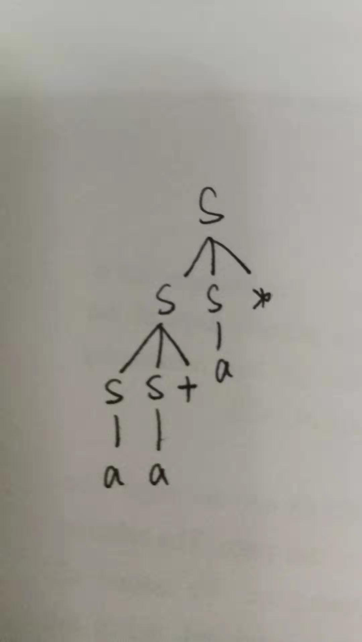

1. 因为语法分析树唯一，没有二义性。

P231 EX4.4.1

1. S -> SS | *SS | a

无左公因子，无左递归

预测分析表：

|  |  |  |  |  |
| --- | --- | --- | --- | --- |
| 非终结符号 | 输入符号 | | | |
| + | * | a | $ |
| S | S->+SS | S->*SS | S->a |  |

1. S->S(S)S | ε

无公因子，消除左递归：

S->A

A->(S)SA| ε

预测分析表：

|  |  |  |  |
| --- | --- | --- | --- |
| 非终结符号 | 输入符号 | | |
| （ | ） | $ |
| S | S->A | S->A | S->A |
| A | 1. >(S)SA   A->ε | A->ε | A->ε |

1. S->S+S|SS|(S)|S*|a

提取左公因子：

S->SA|(S)|a

A->+S|S|*

提取终结符：

1. >SA|T

A->+S|S|*

T->(S)|a

得到产生式：

S->TB

B->AB|ε

A->+S|TB|*

T->(S)|a

预测分析表：

|  |  |  |  |  |  |  |
| --- | --- | --- | --- | --- | --- | --- |
| 非终结符号 | 输入符号 | | | | | |
| ( | ) | + | * | a | $ |
| S | S->TB |  |  |  | S->TB |  |
| B | B->AB |  | B->AB | B->AB | B->AB | B->ε |
| A | A->TB |  | A->+S | A->\* | A->TB |  |
| T | T->(S) |  |  |  | T->a |  |