A Course-End Project Report
on

“Data Science Case Studies: Titanic Survival Prediction and Bank Marketing Classification”

for the course

Fundamentals of Data Science (22CSC59)
Submitted in partial fulfillment of the requirements for the award of degree
BACHELOR OF ENGINEERING
in
COMPUTER SCIENCE AND ENGINEERING

by
Sarapu Rushil (160124733197)
Section: CSE-3 Year: III Year / V Semester

Faculty:
S. Durga Devi
Assistant Professor


Department of Computer Science and Engineering,
Chaitanya Bharathi Institute of Technology (Autonomous),
(Affiliated to Osmania University, Hyderabad)
Hyderabad, TELANGANA (INDIA) –500 075
[2026-2027]

Abstract
This report presents two data-science case studies that apply the complete machine-learning workflow to real classification problems. The first predicts whether a passenger survived the 1912 Titanic disaster from 891 passenger records; the second predicts whether a customer of a Portuguese bank will subscribe to a term deposit from 41,188 telephone marketing contacts. In both studies the data was explored with descriptive statistics and visualisations, missing and unknown values were handled, categorical variables were one-hot encoded and numerical variables scaled, and models were trained on stratified 80/20 train–test splits. For the Titanic data, a logistic regression model achieved 84.4% accuracy and a ROC-AUC of 0.90; its coefficients and p-values showed that sex, passenger class and age decided survival, and the model was deployed as an interactive Streamlit web application. For the bank-marketing data, where only 11.3% of customers subscribed, Logistic Regression, Decision Tree, K-Nearest Neighbours and Random Forest classifiers were compared after excluding the post-call attribute duration; all reached about 90% accuracy, so precision, recall, F1-score and ROC-AUC were used instead, and Random Forest was selected for its best ROC-AUC (0.801) and its ability to raise recall to 59% with a tuned threshold. Calling the 20% of customers it ranks highest would reach 66% of all subscribers, about three times as efficient as random calling. Together, the studies show how choosing appropriate metrics and interpreting models turns historical data into reliable predictions and practical, evidence-based decisions.

Table of Contents
S.No | Title | Page
 | Title Page | i
 | Abstract | ii
 | List of Figures | iv
 | List of Tables | v
1. | INTRODUCTION | 1
 | 1.1 Overview of the Case Studies | 1
 | 1.2 Significance and Objectives | 1
 | 1.3 Concepts used in Methodology | 1
 | 1.4 Outline of the Results | 2
2. | PART A – TITANIC: PROBLEM AND DATA EXPLORATION | 3
 | 2.1 Problem Statement | 3
 | 2.2 Dataset and Summary Statistics | 3
 | 2.3 Missing Values | 3
 | 2.4 Visual Analysis | 4
3. | PART A – TITANIC: PREPROCESSING AND MODEL | 8
 | 3.1 Project Workflow | 8
 | 3.2 Data Preprocessing | 8
 | 3.3 Logistic Regression Model and Training | 8
4. | PART A – TITANIC: EVALUATION AND INTERPRETATION | 9
 | 4.1 Performance Metrics | 9
 | 4.2 Coefficients, Odds Ratios and Significance | 10
5. | PART A – TITANIC: DEPLOYMENT WITH STREAMLIT | 12
6. | PART B – BANK MARKETING: DATA UNDERSTANDING AND PREPROCESSING | 13
 | 6.1 Case Study and Problem Statement | 13
 | 6.2 Dataset Description | 13
 | 6.3 Data Quality: Unknown Values, Duplicates and Target | 13
 | 6.4 Preprocessing and Train–Test Split | 14
7. | PART B – BANK MARKETING: EXPLORATORY DATA ANALYSIS | 15
 | 7.1 Three Key Observations | 16
8. | PART B – BANK MARKETING: MODEL DEVELOPMENT AND COMPARISON | 17
 | 8.1 Model Configuration | 17
 | 8.2 Performance Comparison Table | 17
 | 8.3 Confusion Matrices and Classification Errors | 18
 | 8.4 ROC Curves | 18
 | 8.5 Identifying Actual Subscribers | 19
 | 8.6 Best-Performing Model | 19
9. | PART B – BANK MARKETING: INTERPRETATION AND RECOMMENDATIONS | 20
 | 9.1 Suitability of the Random Forest Model | 20
 | 9.2 Business Recommendations | 20
 | 9.3 Limitations | 20
10. | CONCLUSION AND REFERENCES | 21
 | 10.1 Conclusion | 21
 | 10.2 References | 21

List of Figures
S.No | Figure No. | Title | Page
1 | Figure 2.1 | Titanic – distribution of the target variable | 4
2 | Figure 2.2 | Titanic – survival rate by gender, passenger class and port | 4
3 | Figure 2.3 | Titanic – age distribution by survival | 5
4 | Figure 2.4 | Titanic – fare by class and survival (log scale) | 5
5 | Figure 2.5 | Titanic – correlation matrix of numeric features | 6
6 | Figure 2.6 | Titanic – pair plot of numeric features by survival | 6
7 | Figure 3.1 | Workflow followed in both case studies | 8
8 | Figure 4.1 | Titanic – confusion matrix | 9
9 | Figure 4.2 | Titanic – ROC curve | 10
10 | Figure 4.3 | Titanic – logistic regression coefficients with odds ratios | 10
11 | Figure 5.1 | Streamlit app – prediction and explanation for a 30-year-old man in 3rd class | 12
12 | Figure 7.1 | Bank – distribution of the target variable | 15
13 | Figure 7.2 | Bank – subscription rate by job, month, previous outcome and contact type | 15
14 | Figure 7.3 | Bank – numerical attributes by subscription outcome | 16
15 | Figure 8.1 | Bank – comparison of accuracy, precision, recall and F1-score | 17
16 | Figure 8.2 | Bank – confusion matrices of the four classifiers | 18
17 | Figure 8.3 | Bank – ROC curves of the four classifiers | 18

List of Tables
S.No | Table No. | Title | Page
1 | Table 1.1 | Overview of the two case studies | 1
2 | Table 2.1 | Titanic – summary statistics of numeric features | 3
3 | Table 3.1 | Titanic – preprocessing steps | 8
4 | Table 4.1 | Titanic – model performance on the test set | 9
5 | Table 4.2 | Titanic – statistical significance of features (statsmodels, unscaled) | 11
6 | Table 6.1 | Bank – attribute groups | 13
7 | Table 6.2 | Bank – categorical attributes containing “unknown” | 13
8 | Table 8.1 | Bank – classification algorithms and settings | 17
9 | Table 8.2 | Bank – final performance comparison on the test set (threshold 0.5) | 17
10 | Table 8.3 | Bank – Random Forest performance at different decision thresholds | 19

CHAPTER 1
INTRODUCTION

1.1 Overview of the Case Studies
Classification — predicting which of two or more categories a record belongs to — is one of the most common tasks in data science. This report applies it to two contrasting problems:
Table 1.1: Overview of the two case studies
 | Part A – Titanic | Part B – Bank Marketing
Question | Did a passenger survive? | Will a customer subscribe to a term deposit?
Records | 891 passengers, 11 attributes | 41,188 contacts, 20 attributes
Positive class | 38.4% survived | 11.3% subscribed (highly imbalanced)
Models | Logistic Regression | Logistic Regression, Decision Tree, KNN, Random Forest
Focus | Interpretation of factors and deployment | Model comparison and business recommendations

1.2 Significance and Objectives
Part A turns a historical narrative into measurable evidence, quantifying how gender and class affected the chance of survival. Part B addresses a practical business problem: telephone campaigns are expensive and most customers decline, so a model that identifies likely subscribers lets the bank call fewer people and sell more deposits. The objectives are to:
- explore both datasets and identify patterns related to the target;
- handle missing/unknown values and encode categorical variables;
- build a logistic regression model for Titanic survival, evaluate and interpret it, and deploy it with Streamlit;
- build and fairly compare four classifiers for bank-marketing prediction using metrics suited to imbalanced data;
- recommend the best bank-marketing model and explain how the bank can use it.

1.3 Concepts used in Methodology
- Exploratory data analysis: summary statistics, bar charts, histograms, box plots, correlation heatmaps and pair plots.
- Preprocessing: median/mode imputation, treating “unknown” as a category, one-hot encoding, standardisation, and scikit-learn pipelines that prevent data leakage.
- Algorithms: Logistic Regression (sigmoid of a linear combination), Decision Tree (recursive if–then splits), K-Nearest Neighbours (majority vote of the k most similar records) and Random Forest (average of many decision trees).
- Evaluation: confusion matrix, accuracy, precision, recall, F1-score, ROC curve and AUC, and threshold analysis.
- Interpretation and deployment: odds ratios and p-values, feature importances, and a Streamlit web application.

1.4 Outline of the Results
The Titanic logistic regression model reached 84.4% accuracy and 0.90 ROC-AUC, with sex, class and age as the significant factors. In the bank study, Random Forest achieved the best ROC-AUC (0.801); with a 0.2 threshold it finds 59% of subscribers, and its top-ranked 20% of customers contain 66% of all subscribers. Chapters 2–5 present Part A, Chapters 6–9 Part B, and Chapter 10 concludes. All code and outputs are in the Jupyter Notebook Data_Science_Case_Studies.ipynb.

CHAPTER 2
PART A – TITANIC: PROBLEM AND DATA EXPLORATION

2.1 Problem Statement
On 15 April 1912 the RMS Titanic sank after striking an iceberg; there were not enough lifeboats, and more than 1,500 of the roughly 2,224 people aboard died. The evacuation followed a “women and children first” policy, and upper-class cabins were closer to the boat deck. Problem: given a passenger's ticket class, sex, age, number of siblings/spouses and parents/children aboard, fare and port of embarkation, predict whether the passenger survived (1) or did not (0), and identify which factors mattered most.

2.2 Dataset and Summary Statistics
titanic.csv contains 891 passengers and 12 columns: PassengerId, Survived (target), Pclass (1 = upper, 2 = middle, 3 = lower), Name, Sex, Age, SibSp, Parch, Ticket, Fare, Cabin and Embarked (C = Cherbourg, Q = Queenstown, S = Southampton).
Table 2.1: Titanic – summary statistics of numeric features
Feature | Count | Mean | Std | Min | Median | Max
Age | 714 | 29.70 | 14.53 | 0.42 | 28.00 | 80.00
Fare | 891 | 32.20 | 49.69 | 0.00 | 14.45 | 512.33
SibSp | 891 | 0.52 | 1.10 | 0.00 | 0.00 | 8.00
Parch | 891 | 0.38 | 0.81 | 0.00 | 0.00 | 6.00
Survived | 891 | 0.38 | 0.49 | 0.00 | 0.00 | 1.00

Passengers were mostly young adults (mean age 29.7). Fare is strongly right-skewed (mean £32.20 vs median £14.45, maximum £512), most passengers travelled without family, and only 38.4% survived.

2.3 Missing Values
Cabin is missing for 77.1% of passengers and was dropped. Age is missing for 19.9% (177 rows) and was imputed with the median; Embarked is missing for only 2 rows and was filled with the most frequent port, Southampton.

2.4 Visual Analysis
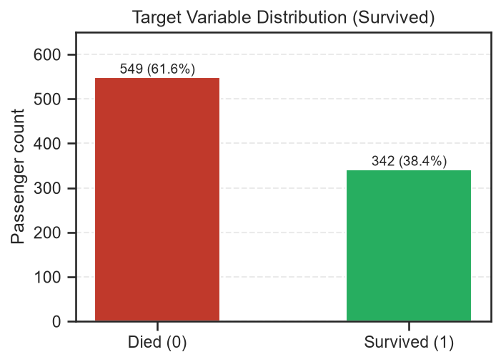
Figure 2.1: Titanic – distribution of the target variable
Interpretation: 549 passengers (61.6%) died and 342 (38.4%) survived. A model that always predicts “died” would be 61.6% accurate, so precision, recall, F1-score and ROC-AUC are reported alongside accuracy.
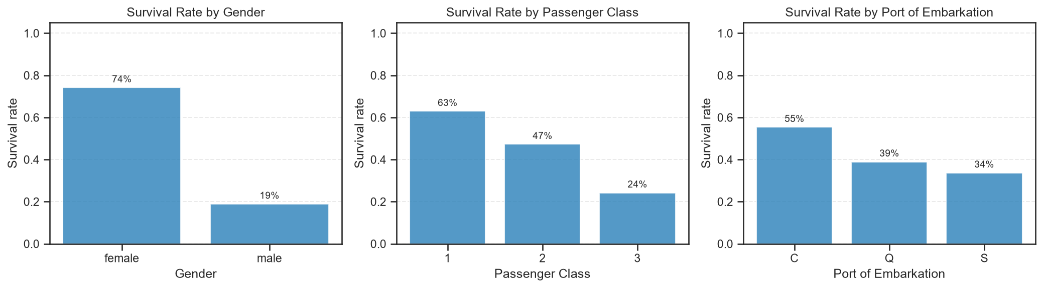
Figure 2.2: Titanic – survival rate by gender, passenger class and port
Interpretation: 74% of women survived versus 19% of men. Survival falls from 63% in 1st class to 47% in 2nd and 24% in 3rd. Cherbourg passengers survived more often (55%) than Southampton passengers (34%), mainly because more of them travelled 1st class. Women survived more often than men in every class (97%, 92% and 50% vs 37%, 16% and 14%), so gender and class act independently.
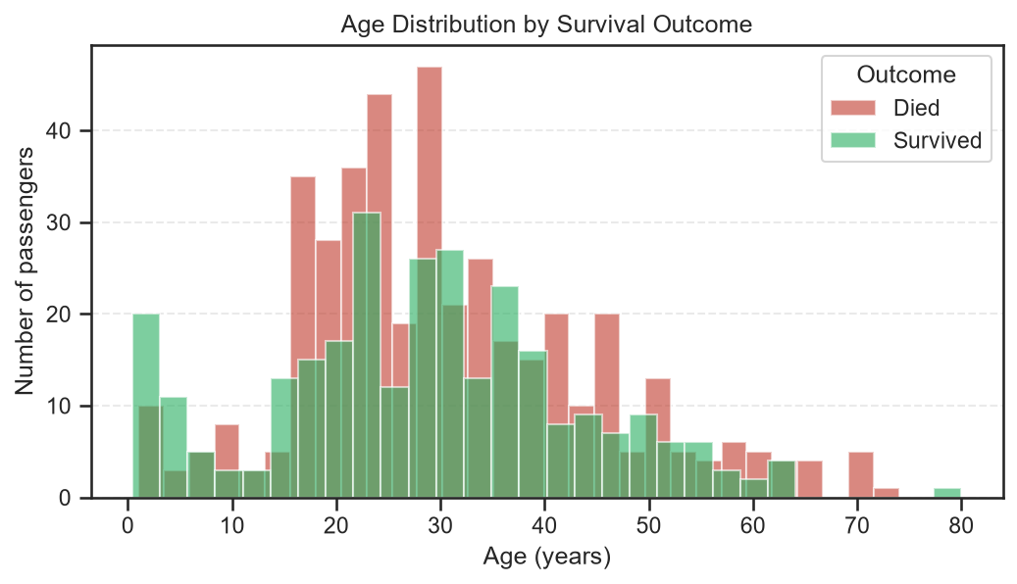
Figure 2.3: Titanic – age distribution by survival
Interpretation: Ages peak between 20 and 35. Children under 10 survived far more often (61%) than older passengers (39%), so the effect of age is concentrated among the very young (overall correlation only −0.08).
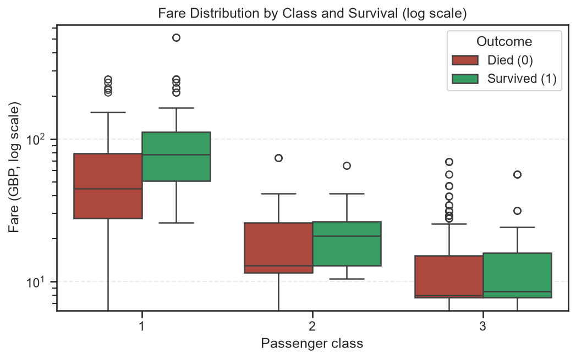
Figure 2.4: Titanic – fare by class and survival (log scale)
Interpretation: Fares rise sharply with class. Survivors paid a higher median fare (£26) than non-survivors (£10.50); because fare and class both reflect wealth, their effects overlap.
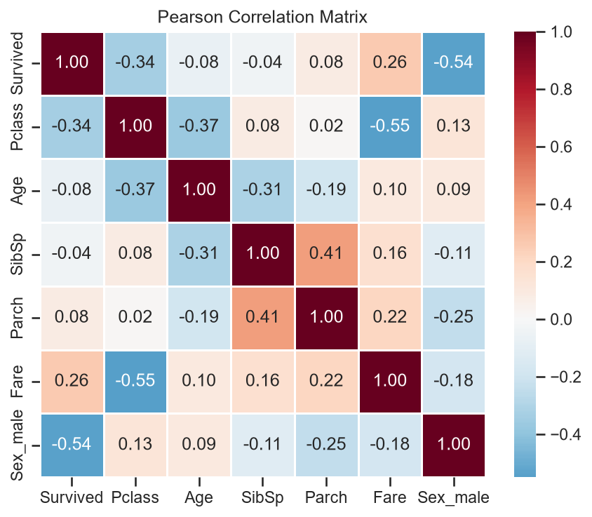
Figure 2.5: Titanic – correlation matrix of numeric features
Interpretation: Being male has the strongest correlation with survival (−0.54), followed by Pclass (−0.34) and Fare (+0.26). Pclass and Fare are correlated (−0.55), as are SibSp and Parch (0.41); no pair exceeds |0.8|, so multicollinearity is not a concern.
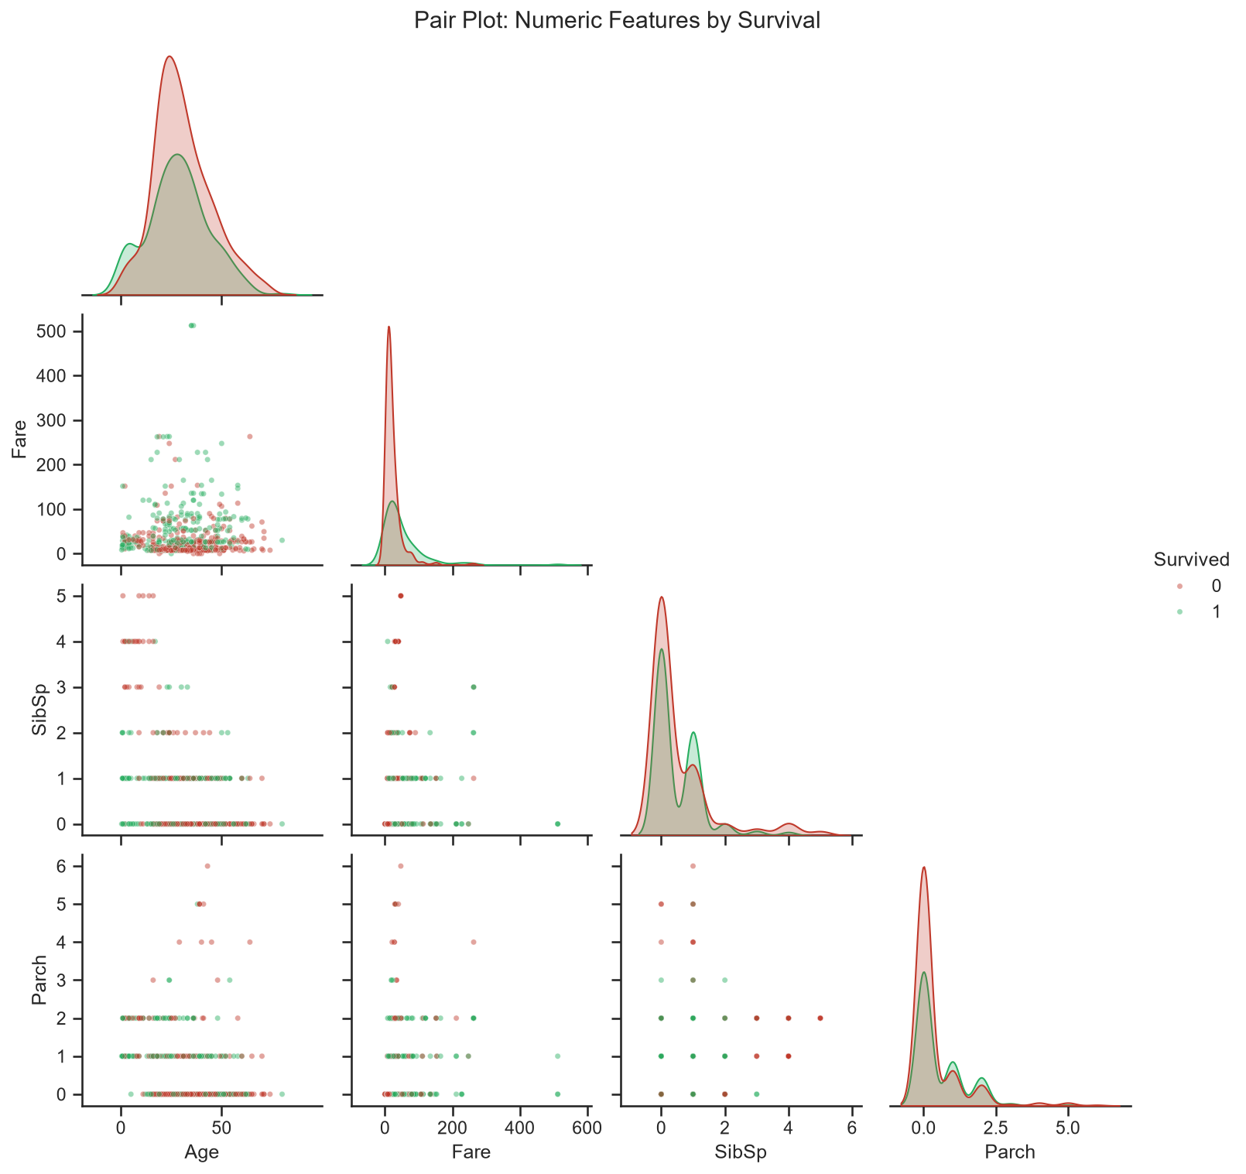
Figure 2.6: Titanic – pair plot of numeric features by survival
Interpretation: No numeric feature separates the classes alone, which is why Sex and Pclass are essential. Survivors cluster at higher fares, and passengers from very large families were almost all non-survivors.
Key findings: gender is the dominant factor, followed by socio-economic status (class and fare) and age (children were prioritised); small families fared better than solo travellers or large families.

CHAPTER 3
PART A – TITANIC: PREPROCESSING AND MODEL

3.1 Project Workflow
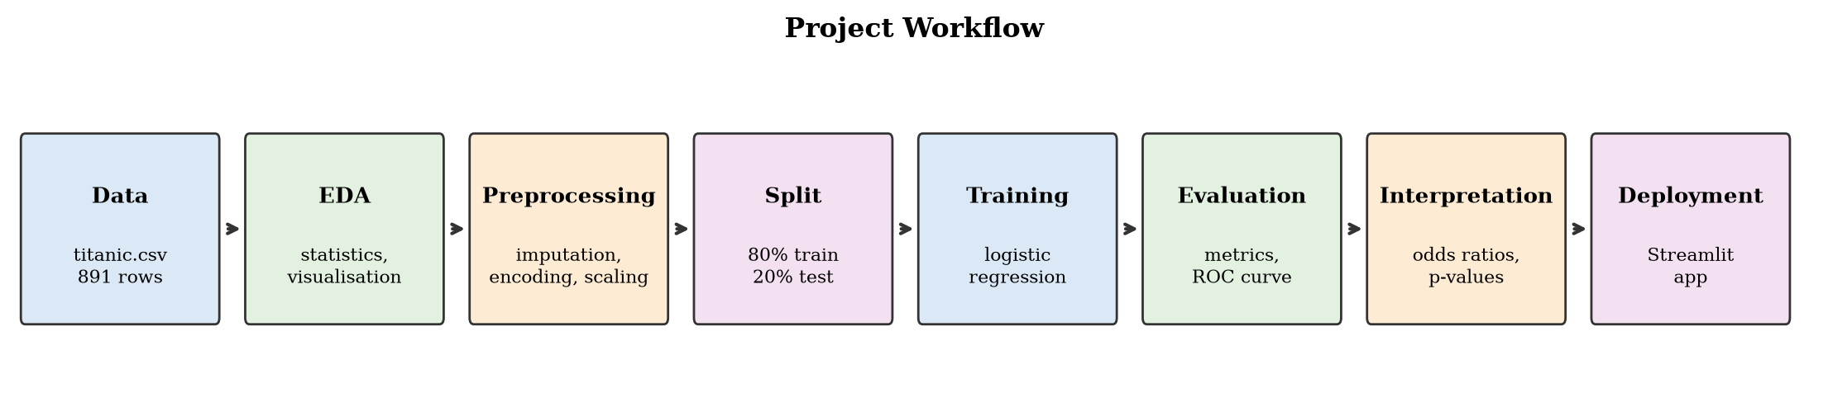
Figure 3.1: Workflow followed in both case studies

3.2 Data Preprocessing
PassengerId, Name, Ticket and Cabin were dropped, leaving Pclass, Sex, Age, SibSp, Parch, Fare and Embarked. The data was split 80/20 into 712 training and 179 test passengers, stratified on Survived. The split is made before imputation so no information leaks from the test set.
Table 3.1: Titanic – preprocessing steps
Step | Columns | Method | Reason
Imputation | Age, Fare | Median | Robust to skew and outliers (median age 28.5)
Imputation | Embarked, Pclass, Sex | Most frequent | Only 2 missing values (filled with “S”)
Scaling | Age, SibSp, Parch, Fare | StandardScaler | Comparable coefficients, faster convergence
Encoding | Pclass, Sex, Embarked | One-hot, drop first | 0/1 columns; avoids the dummy-variable trap

The 7 features become 9 model inputs; the baseline categories are 1st class, female and Cherbourg. All steps sit in a scikit-learn Pipeline, so training data, test data and app inputs are transformed identically.

3.3 Logistic Regression Model and Training
P(Survived = 1 | x) = 1 / (1 + e^(−z)), z = β₀ + β₁x₁ + … + βₖxₖ
z is the log-odds of survival; each coefficient β is the change in log-odds for a one-unit increase in a feature, and e^β is its odds ratio. Coefficients are estimated by maximum likelihood (lbfgs solver, L2 regularisation, C = 1.0). Training accuracy was 81.0%, close to the test accuracy, so the model does not overfit.

CHAPTER 4
PART A – TITANIC: EVALUATION AND INTERPRETATION

4.1 Performance Metrics
Table 4.1: Titanic – model performance on the test set
Metric | Value | Meaning
Accuracy | 0.8436 | Share of passengers classified correctly
Precision | 0.8060 | Of predicted survivors, the share who survived
Recall | 0.7826 | Of actual survivors, the share identified
F1-score | 0.7941 | Harmonic mean of precision and recall
ROC-AUC | 0.8978 | Probability of ranking a survivor above a non-survivor

The model is correct for 84.4% of unseen passengers, well above the 61.5% baseline. A precision of 0.81 means about four in five predicted survivors truly survived; recall (0.78) is lower because survivors who resemble typical victims (adult men, 3rd class) are missed. An AUC of 0.90 indicates good discrimination.
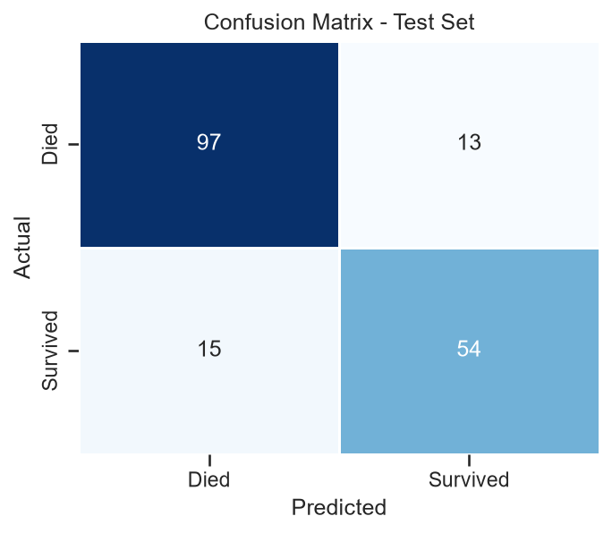
Figure 4.1: Titanic – confusion matrix
Interpretation: 151 of 179 test passengers were classified correctly (97 TN, 54 TP); there were 13 false positives and 15 false negatives, which explains the lower recall.
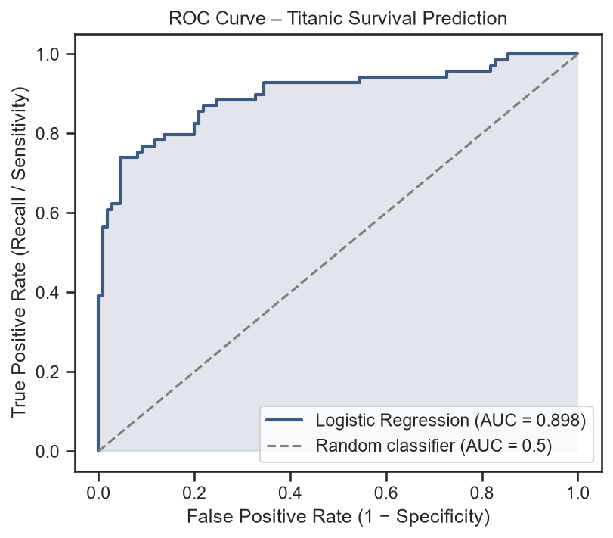
Figure 4.2: Titanic – ROC curve
Interpretation: The curve lies well above the random-classifier diagonal (AUC = 0.898); lowering the 0.5 threshold would raise recall at the cost of more false positives.

4.2 Coefficients, Odds Ratios and Significance
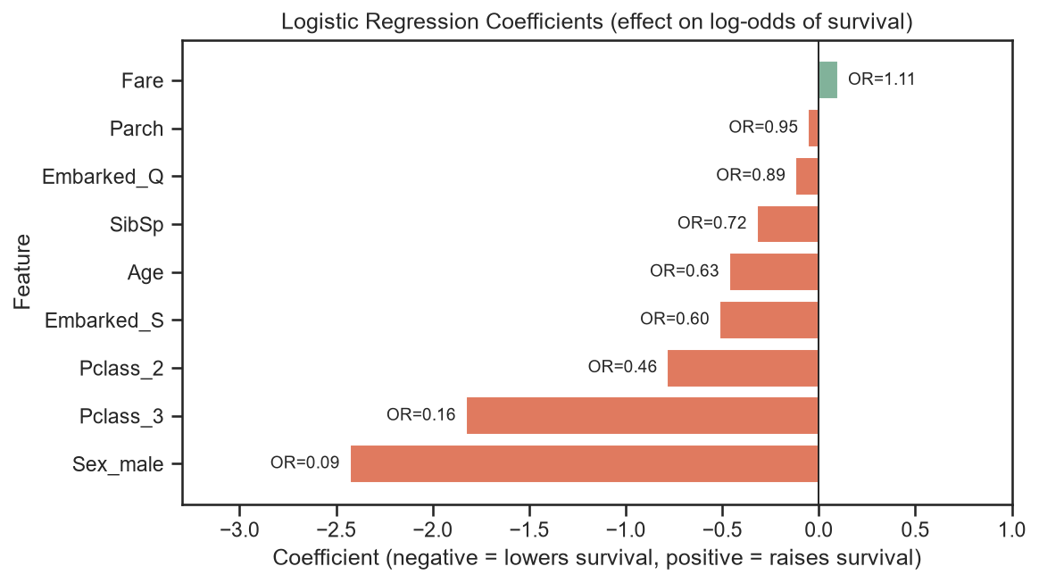
Figure 4.3: Titanic – logistic regression coefficients with odds ratios
Interpretation: Being male (OR ≈ 0.08) cut the odds of survival by about 92% relative to a comparable woman; 3rd class (OR ≈ 0.15) cut them by about 85% relative to 1st class and 2nd class roughly halved them (OR ≈ 0.48). Older age (OR ≈ 0.63 per 14.5 years) and more siblings/spouses (OR ≈ 0.77) also lowered the odds.
Table 4.2: Titanic – statistical significance of features (statsmodels, unscaled)
Feature | Coefficient | Odds ratio | p-value | Significant
Age | -0.0390 | 0.9617 | < 0.001 | Yes
Pclass_3 | -2.0800 | 0.1249 | < 0.001 | Yes
Sex_male | -2.5748 | 0.0762 | < 0.001 | Yes
Pclass_2 | -1.0013 | 0.3674 | 0.0019 | Yes
SibSp | -0.2983 | 0.7421 | 0.0102 | Yes
Embarked_S | -0.5434 | 0.5808 | 0.0385 | Yes
Parch | -0.0726 | 0.9300 | 0.5732 | No
Fare | 0.0010 | 1.0010 | 0.6787 | No
Embarked_Q | -0.1477 | 0.8627 | 0.7260 | No

Sex, Pclass_3 and Age are highly significant (p < 0.001) and Pclass_2 and SibSp significant (p < 0.05); each extra year of age multiplies the odds of survival by about 0.96. Fare, Parch and Embarked are not significant once class is known. The model confirms the historical account: being female, travelling in a higher class and being young determined survival.

CHAPTER 5
PART A – TITANIC: DEPLOYMENT WITH STREAMLIT

The trained pipeline is saved to model/titanic_logreg.pkl with joblib. The Streamlit app app.py loads it once, collects a passenger's details from sidebar widgets and returns the survival probability, the predicted outcome and a chart showing how each feature pushed the log-odds up or down. It runs locally with streamlit run app.py and can be deployed on Streamlit Community Cloud.
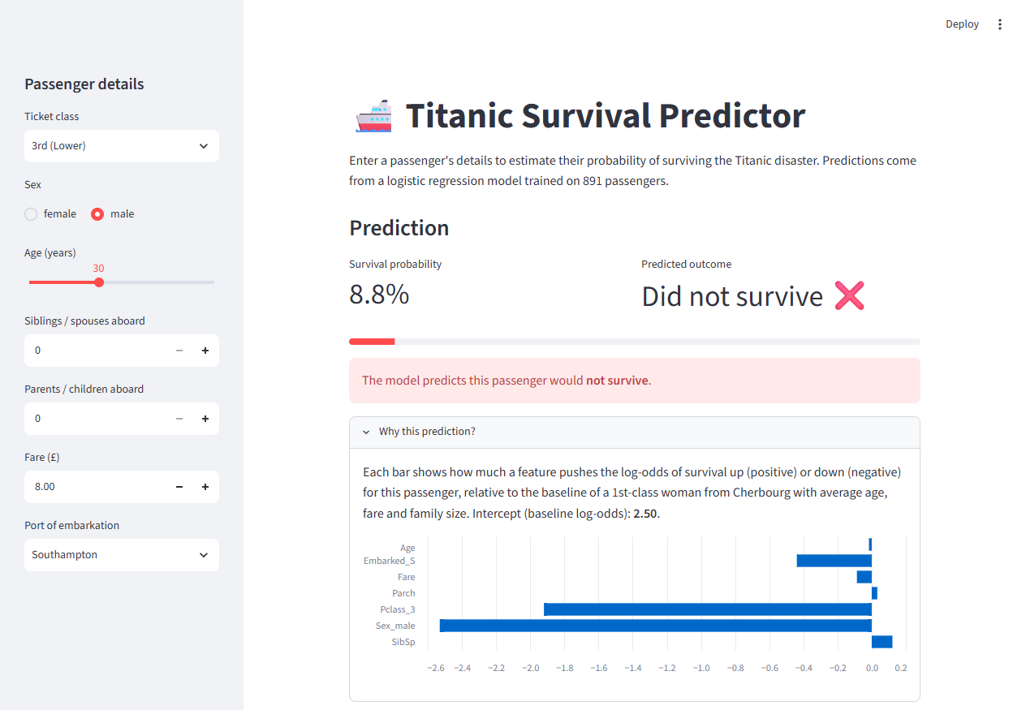
Figure 5.1: Streamlit app – prediction and explanation for a 30-year-old man in 3rd class
Interpretation: The predicted survival probability is 8.8%; the explanation chart shows that being male (Sex_male) and travelling in 3rd class (Pclass_3) push the prediction down the most. For a 28-year-old woman in 1st class the app returns 91.5%.

CHAPTER 6
PART B – BANK MARKETING: DATA UNDERSTANDING AND PREPROCESSING

6.1 Case Study and Problem Statement
A Portuguese bank runs telephone campaigns to sell term deposits and keeps records of customer characteristics, previous campaign interactions and outcomes. Different algorithms may give different results, so the bank needs to know which model predicts subscribers most usefully. Problem: develop and compare Logistic Regression, Decision Tree, K-Nearest Neighbours and Random Forest classifiers that predict whether a customer will subscribe (y = yes/no), and recommend the most appropriate model for the campaign.

6.2 Dataset Description
bank-additional-full.csv (UCI Machine Learning Repository, semicolon-delimited) contains 41,188 contacts from May 2008 to November 2010 with 20 input attributes and the target y.
Table 6.1: Bank – attribute groups
Group | Attributes | Type
Customer | age; job, marital, education, default, housing, loan | 1 numerical, 6 categorical
Current campaign | contact, month, day_of_week; duration, campaign | 3 categorical, 2 numerical
Previous campaign | pdays, previous; poutcome | 2 numerical, 1 categorical
Economic context | emp.var.rate, cons.price.idx, cons.conf.idx, euribor3m, nr.employed | 5 numerical
Target | y – subscribed to a term deposit (yes / no) | Binary

Customers are aged 17–98 (mean 40). The number of contacts in the campaign has a median of 2 but reaches 56, and pdays = 999 (never contacted before) for about 96% of customers.

6.3 Data Quality: Unknown Values, Duplicates and Target
Table 6.2: Bank – categorical attributes containing “unknown”
Attribute | Unknown entries | Percent
default | 8,597 | 20.87%
education | 1,731 | 4.20%
housing | 990 | 2.40%
loan | 990 | 2.40%
job | 330 | 0.80%
marital | 80 | 0.19%

There are no empty cells, but missing categorical information is coded as “unknown”. It was kept as a separate category, because deleting those rows would discard over 20% of the data and the absence of information may itself be informative. 12 duplicate rows were removed, leaving 41,176 customers.

6.4 Preprocessing and Train–Test Split
- duration excluded: it is the length of the last call, known only after the call (a 0-second call always means no); the UCI documentation states it must be discarded for a realistic pre-contact model.
- Target: yes → 1, no → 0. Categorical attributes: one-hot encoded, including “unknown”. Numerical attributes: standardised — essential for KNN, which is distance-based.
- Split: 80:20 stratified — 32,940 training and 8,236 test customers, both with an 11.3% subscription rate. The 19 predictors become 62 encoded inputs.
- The same split, preprocessing pipeline and target are used for all four models, ensuring a fair comparison.

CHAPTER 7
PART B – BANK MARKETING: EXPLORATORY DATA ANALYSIS

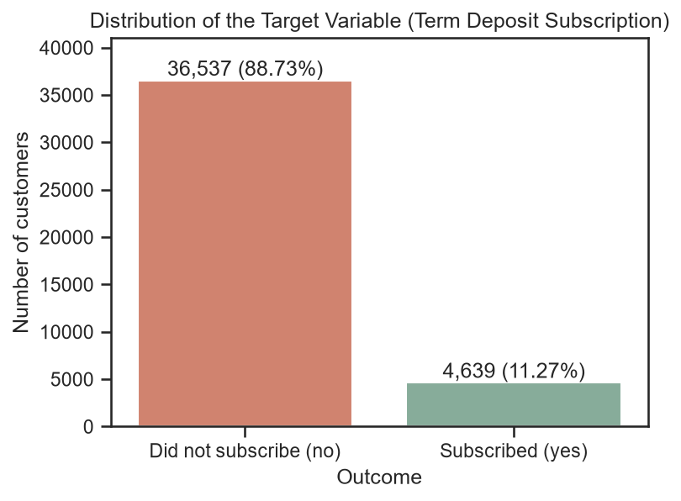
Figure 7.1: Bank – distribution of the target variable
Interpretation: Only 4,639 of 41,176 customers (11.27%) subscribed, while 36,537 (88.73%) did not. A model that always predicts “no” would be 88.7% accurate, so accuracy is misleading and the models must be judged on precision, recall, F1-score and ROC-AUC for the “yes” class.
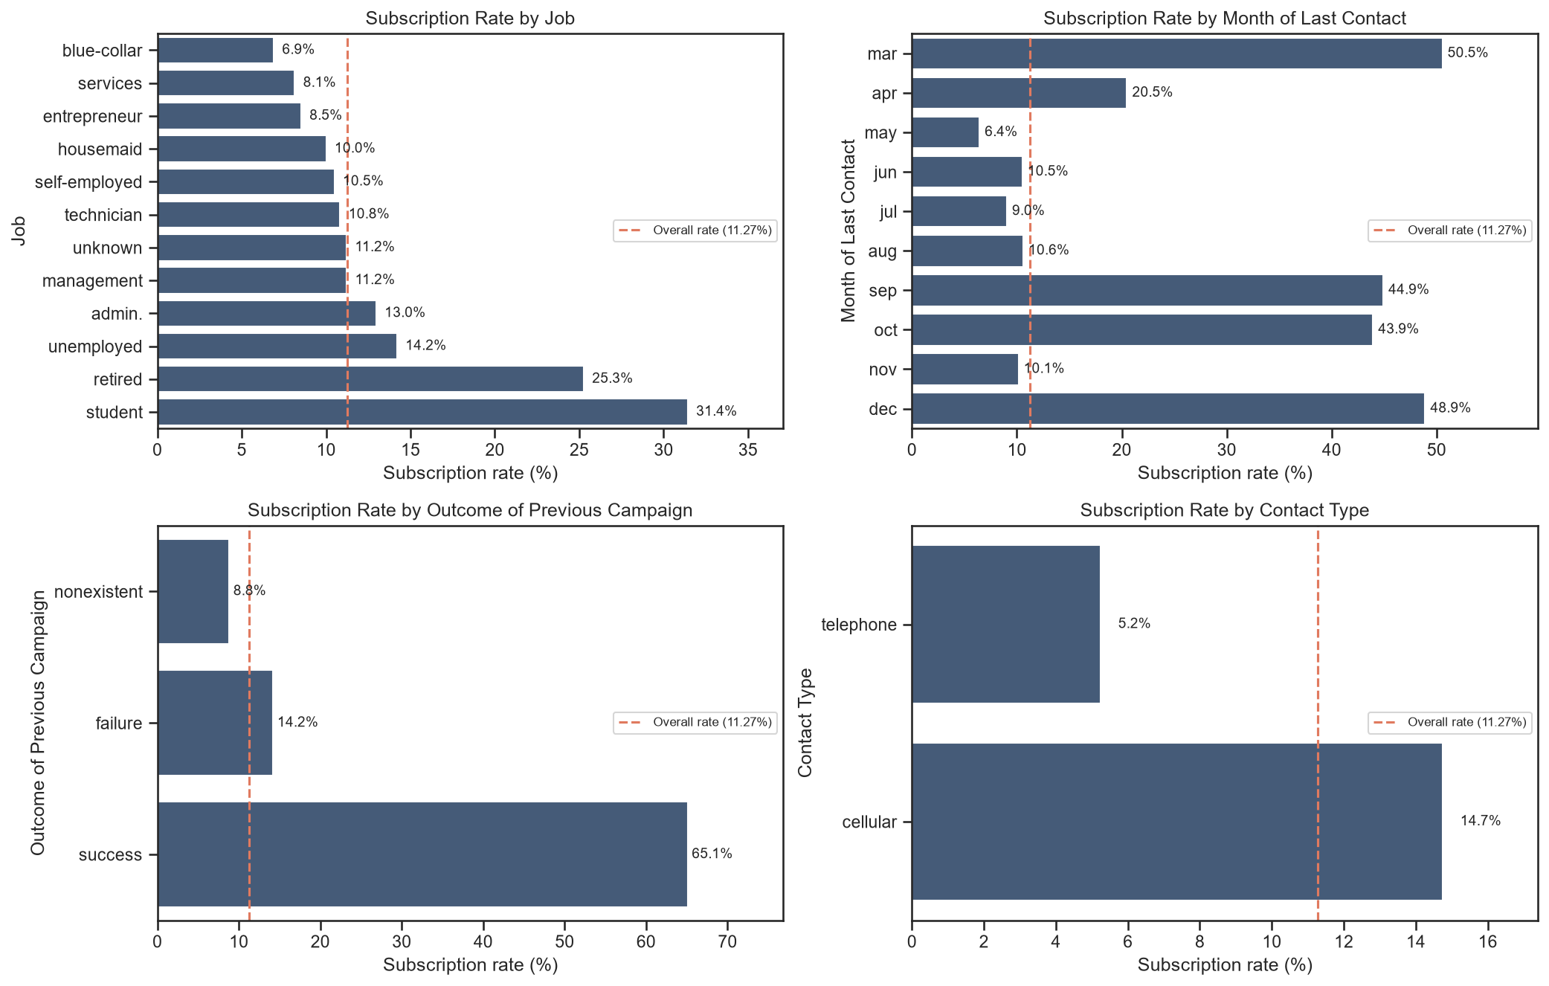
Figure 7.2: Bank – subscription rate by job, month, previous outcome and contact type
Interpretation: Customers whose previous campaign was a success subscribed at 65.1%, versus 14.2% after a failure and 8.8% for new customers. May, the busiest month, has the lowest rate (6.4%), while March, September, October and December reach 44–51%. Students (31.4%) and retired customers (25.3%) subscribe most, blue-collar workers least (6.9%), and mobile-phone contacts (14.7%) almost three times as often as landline contacts (5.2%).
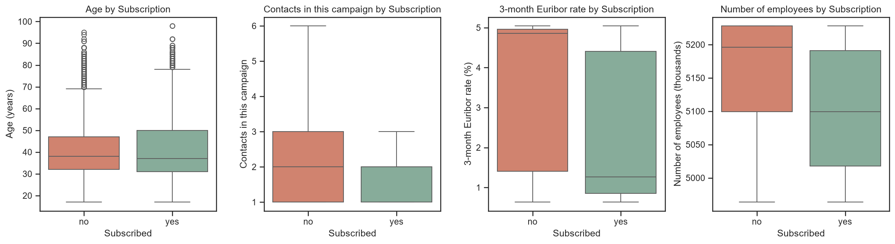
Figure 7.3: Bank – numerical attributes by subscription outcome
Interpretation: Subscribers were called when the Euribor rate was much lower (median 1.27% vs 4.86%) and employment was lower (median 5,099 vs 5,196 thousand). They also needed fewer calls (mean 2.05 vs 2.63); age medians are similar (37 vs 38) but customers aged 60+ subscribe at 39.6%. Correlations confirm this: nr.employed (−0.36), pdays (−0.33) and euribor3m (−0.31) are the numerical attributes most strongly related to subscription.

7.1 Three Key Observations
- Prior relationship matters most among customer attributes: customers with a previous successful outcome are about six times more likely to subscribe (65.1% vs 11.3% overall).
- Timing and economic conditions drive success: the subscription rate is 24.5% when the 3-month Euribor rate is below 2% but only 4.8% when it is 4% or more, and the busiest month (May) has the lowest success rate.
- Who and how you call matters: students, retired customers and mobile-phone contacts subscribe most often, while calling the same customer more than five times yields only 5.5% success compared with 13.0% for a single call.

CHAPTER 8
PART B – BANK MARKETING: MODEL DEVELOPMENT AND COMPARISON

8.1 Model Configuration
Table 8.1: Bank – classification algorithms and settings
Model | Settings | Reason
Logistic Regression | max_iter = 1000 | Linear, interpretable baseline
Decision Tree | max_depth = 6 | Prevents overfitting (an unrestricted tree: train 0.995, test AUC 0.631)
K-Nearest Neighbours | k = 5 | Predicts from the 5 most similar customers
Random Forest | 300 trees, min_samples_leaf = 5 | Averages many trees for stable, non-linear predictions

8.2 Performance Comparison Table
Table 8.2: Bank – final performance comparison on the test set (threshold 0.5)
Model | Accuracy | Precision | Recall | F1-score | ROC-AUC
Logistic Regression | 0.8983 | 0.6355 | 0.2274 | 0.3349 | 0.7973
Decision Tree | 0.8986 | 0.6004 | 0.2996 | 0.3997 | 0.7906
KNN | 0.8906 | 0.5257 | 0.2974 | 0.3799 | 0.7290
Random Forest | 0.8981 | 0.6226 | 0.2435 | 0.3501 | 0.8006

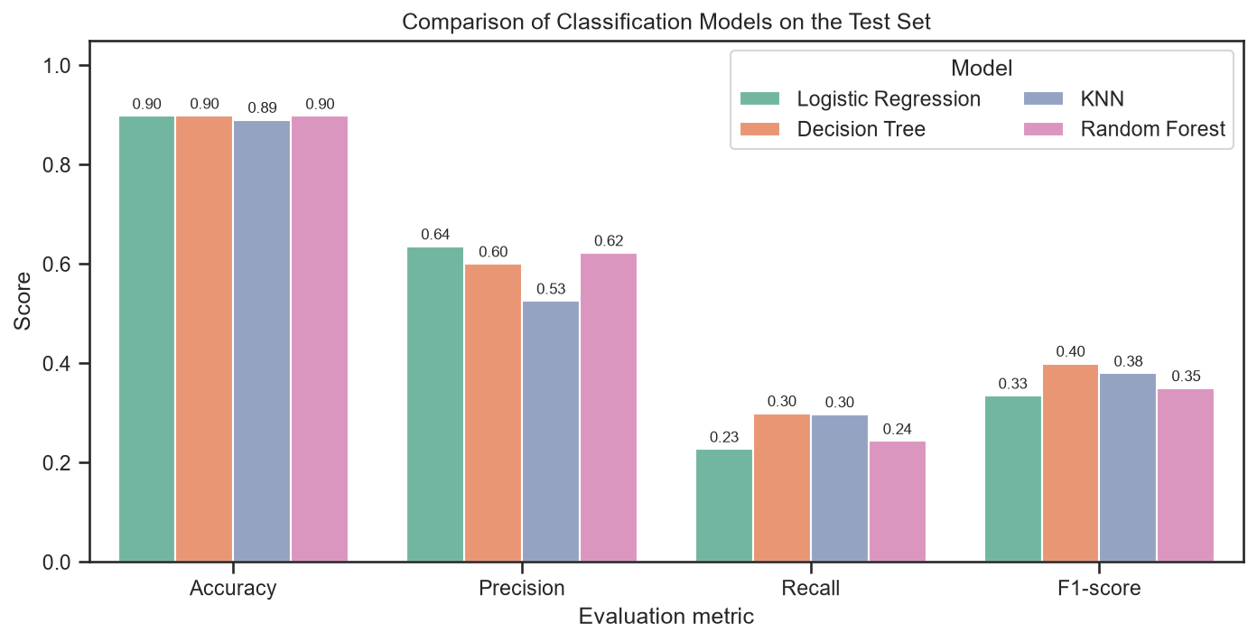
Figure 8.1: Bank – comparison of accuracy, precision, recall and F1-score
Interpretation: Accuracy is almost identical for all models (0.896–0.900), so it cannot separate them. Logistic Regression, Decision Tree and Random Forest have the highest precision (≈0.65); KNN has the highest recall (0.31) and F1-score (0.40) at the default threshold, but lower precision (0.57). All models miss most subscribers at the 0.5 threshold.

8.3 Confusion Matrices and Classification Errors
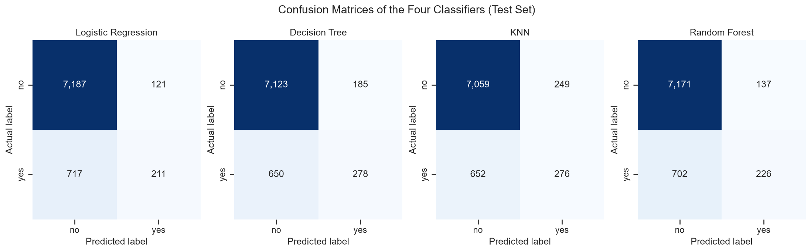
Figure 8.2: Bank – confusion matrices of the four classifiers
Interpretation: Of the 928 actual subscribers in the test set, between 652 (KNN) and 717 (Logistic Regression) are missed. These false negatives are lost sales and are the dominant error for every model. False positives are few — 121 to 249 — and cost only a wasted call. KNN finds the most subscribers (276) but with the most false positives; Random Forest finds 226 with only 137 false positives.

8.4 ROC Curves
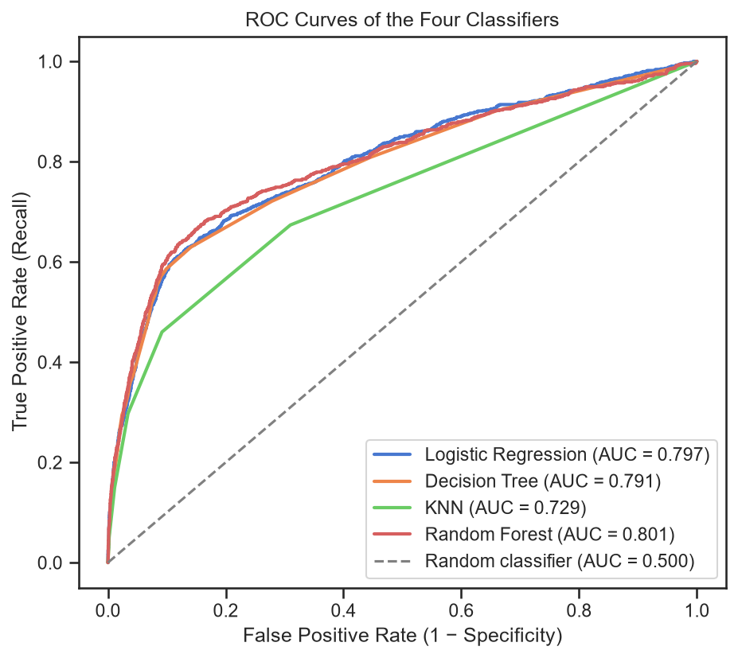
Figure 8.3: Bank – ROC curves of the four classifiers
Interpretation: Random Forest has the highest ROC-AUC (0.801), closely followed by Logistic Regression (0.797) and the Decision Tree (0.791), while KNN is clearly lower (0.729). Random Forest is therefore the best at ranking customers by their likelihood of subscribing, independent of any single threshold.

8.5 Identifying Actual Subscribers
Because the 0.5 threshold is too strict when only 11% of customers subscribe, the Random Forest threshold was varied:
Table 8.3: Bank – Random Forest performance at different decision thresholds
Threshold | Customers flagged | Precision | Recall | F1-score
0.50 | 363 | 0.623 | 0.243 | 0.350
0.40 | 590 | 0.564 | 0.359 | 0.439
0.30 | 945 | 0.491 | 0.500 | 0.495
0.20 | 1,238 | 0.446 | 0.595 | 0.510
0.15 | 1,410 | 0.410 | 0.623 | 0.494
0.10 | 2,007 | 0.319 | 0.691 | 0.437

Lowering the threshold to 0.2 raises recall from 0.24 to 0.59 while precision falls only to 0.45, and F1 rises to 0.51 — better than any model at the default threshold. Calling only the 20% of customers ranked highest by Random Forest would reach 66% of all subscribers with a 37% conversion rate, versus 11% for random calling.

8.6 Best-Performing Model
Random Forest is selected. It has the highest ROC-AUC (0.801) and high precision (0.62), and because it ranks customers best, lowering its threshold recovers most subscribers, giving the best F1-score (0.51). KNN's higher recall at 0.5 comes from a weaker ranking (AUC 0.729) and disappears once thresholds are tuned. Accuracy was not used to choose, because all models score about 90%. Its most important inputs are euribor3m, nr.employed, age, pdays and poutcome = success, consistent with the EDA.

CHAPTER 9
PART B – BANK MARKETING: INTERPRETATION AND RECOMMENDATIONS

9.1 Suitability of the Random Forest Model
- It ranks customers best (highest ROC-AUC), which is exactly how a call list is built.
- It captures non-linear effects (months, interest-rate levels) and is robust to outliers.
- It is stable and resistant to overfitting because it averages 300 trees.
- Its threshold can be tuned to the business costs: a false negative is a lost sale, while a false positive is only an extra call, so recall is worth more than raw accuracy.

9.2 Business Recommendations
- Score and rank customers before each campaign and call them in order of predicted probability — the top 20% contains about 66% of likely subscribers at roughly three times the conversion rate of random calling.
- Use a decision threshold of about 0.2–0.3 to capture 50–60% of subscribers instead of 24%, accepting moderately more calls because each missed subscriber is lost revenue.
- Target high-potential segments and time campaigns well: prioritise customers with a previous successful outcome, students, retired customers and mobile contacts; campaign when interest rates are low; and limit repeated calls to about three per customer.

9.3 Limitations
- Class imbalance: with only 11% subscribers, all models favour predicting “no” at the default threshold. Results depend strongly on the threshold, and techniques such as class weighting, SMOTE or cost-sensitive learning were not explored and could change the model ranking.
- Time period and economic indicators: the strongest predictors are macro-economic values from the 2008–2010 financial crisis, so the model may not generalise to different economic conditions and would need retraining.

CHAPTER 10
CONCLUSION AND REFERENCES

10.1 Conclusion
Both case studies followed the complete data-science workflow — understanding and cleaning data, exploratory analysis, preprocessing, modelling, evaluation, interpretation and communication of results. In Part A, a logistic regression model predicted Titanic survival with 84.4% accuracy and 0.90 ROC-AUC; its coefficients and p-values showed that sex, passenger class and age decided survival, and it was deployed as an interactive Streamlit app. In Part B, four classifiers were compared on highly imbalanced bank-marketing data. Accuracy was nearly identical for all of them, so the evaluation relied on precision, recall, F1-score and ROC-AUC together with the business costs of errors. Random Forest ranked customers best (ROC-AUC 0.801) and, with a tuned threshold, identified about 59% of subscribers, making it the recommended model for targeting the bank's campaigns. The main lesson across both studies is that the right evaluation metric and a clear interpretation of the model matter as much as the choice of algorithm.

10.2 References
[1] Kaggle, “Titanic – Machine Learning from Disaster” dataset. https://www.kaggle.com/c/titanic
[2] S. Moro, P. Cortez and P. Rita, “A data-driven approach to predict the success of bank telemarketing,” Decision Support Systems, vol. 62, pp. 22–31, 2014.
[3] UCI Machine Learning Repository, “Bank Marketing” dataset. https://archive.ics.uci.edu/dataset/222/bank+marketing
[4] F. Pedregosa et al., “Scikit-learn: Machine Learning in Python,” Journal of Machine Learning Research, vol. 12, pp. 2825–2830, 2011.
[5] L. Breiman, “Random Forests,” Machine Learning, vol. 45, pp. 5–32, 2001.
[6] S. Seabold and J. Perktold, “statsmodels: Econometric and statistical modeling with Python,” Proc. 9th Python in Science Conference, 2010.
[7] Streamlit documentation, “Deploy your app on Community Cloud.” https://docs.streamlit.io/streamlit-community-cloud/deploy-your-app

