A Course-End Project Report
on

“Data Science Case Studies: Titanic Survival Prediction and Bank Marketing Classification”

for the course

Fundamentals of Data Science (22CSC59)
Submitted in partial fulfillment of the requirements for the award of degree
BACHELOR OF ENGINEERING
in
COMPUTER SCIENCE AND ENGINEERING

by
Rushil Sarapu (160124733197)
Section: CSE-3 Year: III Year / V Semester

Faculty:
S. Durga Devi
Assistant Professor


Department of Computer Science and Engineering,
Chaitanya Bharathi Institute of Technology (Autonomous),
(Affiliated to Osmania University, Hyderabad)
Hyderabad, TELANGANA (INDIA) –500 075
[2026-2027]

Abstract
This report examines two classification tasks through the main stages of a machine-learning project. The first case study estimates survival among passengers aboard the Titanic in 1912 using 891 passenger records. The second predicts whether customers contacted by a Portuguese bank will take up a term deposit, using 41,188 marketing contacts. Both datasets were explored with summary measures and charts; missing or unknown entries were addressed; categorical fields were one-hot encoded; and numeric variables were scaled. Models were evaluated using stratified 80:20 training and testing partitions. For Titanic, Logistic Regression produced 84.4% test accuracy and a ROC-AUC of 0.90. Its coefficients and significance tests identified sex, passenger class and age as important factors, and the trained pipeline was made available through a Streamlit application. For bank marketing, only 11.3% of customers subscribed. Logistic Regression, Decision Tree, K-Nearest Neighbours and Random Forest were compared after excluding call duration, which is unavailable before a call takes place. As accuracy was close to 90% for every model, precision, recall, F1-score and ROC-AUC were considered as well. Random Forest was chosen for its leading ROC-AUC of 0.801; adjusting its classification threshold increased recall to 59%. Contacting the top-ranked 20% of customers was estimated to capture 66% of subscribers, around three times the yield of random selection. These studies demonstrate the value of suitable evaluation measures and interpretable results when converting data into practical decisions.

Table of Contents
S.No | Title | Page
 | Title Page | i
 | Abstract | ii
 | List of Figures | iv
 | List of Tables | v
1. | INTRODUCTION | 1
 | 1.1 Overview of the Case Studies | 1
 | 1.2 Significance and Objectives | 1
 | 1.3 Concepts used in Methodology | 1
 | 1.4 Outline of the Results | 2
2. | PART A – TITANIC: PROBLEM AND DATA EXPLORATION | 3
 | 2.1 Problem Statement | 3
 | 2.2 Dataset and Summary Statistics | 3
 | 2.3 Missing Values | 3
 | 2.4 Visual Analysis | 4
3. | PART A – TITANIC: PREPROCESSING AND MODEL | 9
 | 3.1 Project Workflow | 9
 | 3.2 Data Preprocessing | 9
 | 3.3 Logistic Regression Model and Training | 9
4. | PART A – TITANIC: EVALUATION AND INTERPRETATION | 9
 | 4.1 Performance Metrics | 10
 | 4.2 Coefficients, Odds Ratios and Significance | 10
5. | PART A – TITANIC: DEPLOYMENT WITH STREAMLIT | 13
6. | PART B – BANK MARKETING: DATA UNDERSTANDING AND PREPROCESSING | 15
 | 6.1 Case Study and Problem Statement | 13
 | 6.2 Dataset Description | 15
 | 6.3 Data Quality: Unknown Values, Duplicates and Target | 15
 | 6.4 Preprocessing and Train–Test Split | 16
7. | PART B – BANK MARKETING: EXPLORATORY DATA ANALYSIS | 17
 | 7.1 Three Key Observations | 19
8. | PART B – BANK MARKETING: MODEL DEVELOPMENT AND COMPARISON | 20
 | 8.1 Model Configuration | 20
 | 8.2 Performance Comparison Table | 20
 | 8.3 Confusion Matrices and Classification Errors | 21
 | 8.4 ROC Curves | 21
 | 8.5 Identifying Actual Subscribers | 22
 | 8.6 Best-Performing Model | 23
9. | PART B – BANK MARKETING: INTERPRETATION AND RECOMMENDATIONS | 25
 | 9.1 Suitability of the Random Forest Model | 25
 | 9.2 Business Recommendations | 25
 | 9.3 Limitations | 25
10. | CONCLUSION AND REFERENCES | 26
 | 10.1 Conclusion | 26
 | 10.2 References | 26

List of Figures
S.No | Figure No. | Title | Page
1 | Figure 2.1 | Titanic – percentage of missing values per column | 4
2 | Figure 2.2 | Titanic – distribution of the target variable | 4
3 | Figure 2.3 | Titanic – survival rate by gender, passenger class and port | 5
4 | Figure 2.4 | Titanic – survival rate by passenger class and gender | 5
5 | Figure 2.5 | Titanic – age distribution by survival | 6
6 | Figure 2.6 | Titanic – fare by class and survival (log scale) | 6
7 | Figure 2.7 | Titanic – correlation matrix of numeric features | 7
8 | Figure 2.8 | Titanic – pair plot of numeric features by survival | 7
9 | Figure 3.1 | Workflow followed in both case studies | 9
10 | Figure 4.1 | Titanic – confusion matrix | 10
11 | Figure 4.2 | Titanic – ROC curve | 11
12 | Figure 4.3 | Titanic – logistic regression coefficients with odds ratios | 11
13 | Figure 5.1 | Streamlit app – prediction for a 28-year-old woman in 1st class | 13
14 | Figure 5.2 | Streamlit app – prediction and explanation for a 30-year-old man in 3rd class | 14
15 | Figure 7.1 | Bank – distribution of the target variable | 17
16 | Figure 7.2 | Bank – subscription rate by job, month, previous outcome and contact type | 17
17 | Figure 7.3 | Bank – numerical attributes by subscription outcome | 18
18 | Figure 7.4 | Bank – correlation matrix of numerical attributes and subscription | 18
19 | Figure 8.1 | Bank – comparison of accuracy, precision, recall and F1-score | 20
20 | Figure 8.2 | Bank – confusion matrices of the four classifiers | 21
21 | Figure 8.3 | Bank – ROC curves of the four classifiers | 21
22 | Figure 8.4 | Random Forest – precision, recall and F1-score at different decision thresholds | 22
23 | Figure 8.5 | Bank – cumulative gains chart of the four classifiers | 23
24 | Figure 8.6 | Random Forest – top 12 feature importances | 24

List of Tables
S.No | Table No. | Title | Page
1 | Table 1.1 | Overview of the two case studies | 1
2 | Table 2.1 | Titanic – summary statistics of numeric features | 3
3 | Table 3.1 | Titanic – preprocessing steps | 8
4 | Table 4.1 | Titanic – model performance on the test set | 10
5 | Table 4.2 | Titanic – statistical significance of features (statsmodels, unscaled) | 12
6 | Table 6.1 | Bank – attribute groups | 15
7 | Table 6.2 | Bank – categorical attributes containing “unknown” | 13
8 | Table 8.1 | Bank – classification algorithms and settings | 20
9 | Table 8.2 | Bank – final performance comparison on the test set (threshold 0.5) | 20
10 | Table 8.3 | Bank – Random Forest performance at different decision thresholds | 22

CHAPTER 1
INTRODUCTION

1.1 Overview of the Case Studies
Classification assigns an observation to one of a set of categories and is a widely used data-science task. This project explores two applications with different goals:
Table 1.1: Summary of the two case studies
 | Part A – Titanic | Part B – Bank Marketing
Question | Did the passenger survive? | Will the customer open a term deposit?
Records | 891 passengers, 11 fields | 41,188 contacts, 20 fields
Positive class | 38.4% survived | 11.3% subscribed (imbalanced target)
Models | Logistic Regression | Logistic Regression, Decision Tree, KNN and Random Forest
Focus | Explain key factors and deploy a model | Compare models and guide campaign decisions

1.2 Significance and Objectives
The Titanic analysis uses historical passenger information to measure how survival varied with sex and ticket class. The bank-marketing analysis considers a business challenge: telephone campaigns require time and money, while most contacted customers do not subscribe. Predictive scores can help the bank prioritise people who are more likely to accept a term deposit. The project aims to:
- examine both datasets and discover relationships with their target outcomes;
- manage missing and unknown entries and convert categorical fields into model-ready features;
- train a Logistic Regression model for Titanic survival, assess and explain its predictions, and provide a Streamlit interface;
- train and compare four bank-marketing classifiers using measures appropriate for an imbalanced target;
- select a suitable bank-marketing model and outline how its predictions could support campaign planning.

1.3 Concepts used in Methodology
- Exploratory analysis: descriptive statistics and visual tools such as bar charts, histograms, box plots, correlation heatmaps and pair plots.
- Data preparation: median or mode imputation, retaining “unknown” as a valid category, one-hot encoding, standardisation and scikit-learn pipelines to reduce data leakage.
- Algorithms: Logistic Regression estimates probabilities through a sigmoid function; a Decision Tree applies sequential decision rules; K-Nearest Neighbours uses the labels of nearby records; and Random Forest combines predictions from multiple trees.
- Model assessment: confusion matrices, accuracy, precision, recall, F1-score, ROC curves, area under the curve (AUC) and decision-threshold testing.
- Model explanation and delivery: odds ratios, p-values, feature-importance scores and an interactive Streamlit application.

1.4 Outline of the Results
The Titanic Logistic Regression classifier achieved 84.4% accuracy and a ROC-AUC of 0.90; sex, passenger class and age were among the most influential variables. For bank marketing, Random Forest gave the highest ROC-AUC (0.801). At a threshold of 0.2 it identified about 59% of subscribers, while the 20% of customers with the highest scores included roughly 66% of all subscribers. Chapters 2–5 discuss the Titanic analysis, Chapters 6–9 cover bank marketing, and Chapter 10 presents the conclusion. The code and generated outputs are available in the Jupyter Notebook Data_Science_Case_Studies.ipynb.

CHAPTER 2
PART A – TITANIC: PROBLEM AND DATA EXPLORATION

2.1 Problem Statement
The RMS Titanic struck an iceberg and sank on 15 April 1912. Lifeboat capacity was insufficient, and more than 1,500 of approximately 2,224 people aboard lost their lives. The evacuation is commonly associated with a “women and children first” approach, while passengers in higher classes generally had better access to the boat deck. This study asks whether survival (1) or non-survival (0) can be predicted from ticket class, sex, age, family members aboard, fare and embarkation port, and which of these variables contribute most to the prediction.

2.2 Dataset and Summary Statistics
The file titanic.csv contains 891 passenger records and 12 fields: PassengerId, Survived (the target), Pclass (1 = first, 2 = second, 3 = third), Name, Sex, Age, SibSp, Parch, Ticket, Fare, Cabin and Embarked (C = Cherbourg, Q = Queenstown, S = Southampton).
Table 2.1: Descriptive statistics for Titanic numeric variables
Variable | Valid count | Mean | Standard deviation | Min | Median | Max
Age | 714 | 29.70 | 14.53 | 0.42 | 28.00 | 80.00
Fare | 891 | 32.20 | 49.69 | 0.00 | 14.45 | 512.33
SibSp | 891 | 0.52 | 1.10 | 0.00 | 0.00 | 8.00
Parch | 891 | 0.38 | 0.81 | 0.00 | 0.00 | 6.00
Survived | 891 | 0.38 | 0.49 | 0.00 | 0.00 | 1.00

The passenger group was largely made up of young adults, with a mean age of 29.7 years. Fares have a long right tail: the mean is £32.20, compared with a median of £14.45 and a maximum of £512.33. Most passengers had no accompanying family members, and the overall survival rate was 38.4%.

2.3 Missing Values
Cabin information is absent for 77.1% of records, so this field was removed. Age is missing for 177 passengers (19.9%) and was filled using the median. Only two Embarked values are missing; these were replaced with the most common port, Southampton.
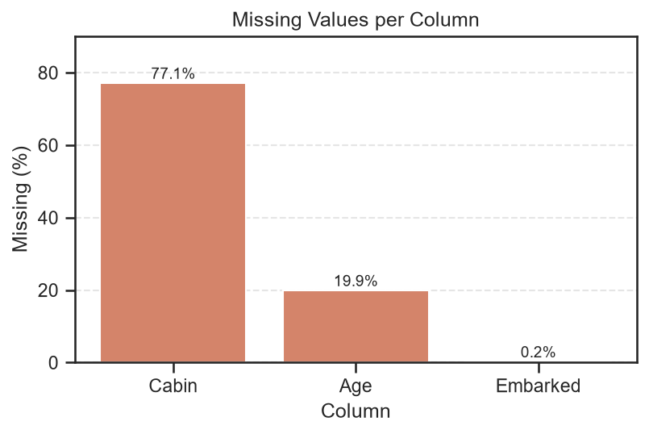
Figure 2.1: Share of missing entries in each Titanic column
Cabin has the largest amount of missing data (77.1%), followed by Age (19.9%); Embarked is missing in only 0.2% of records. These proportions support dropping Cabin, imputing Age with its median and filling Embarked with the most frequent category.

2.4 Visual Analysis
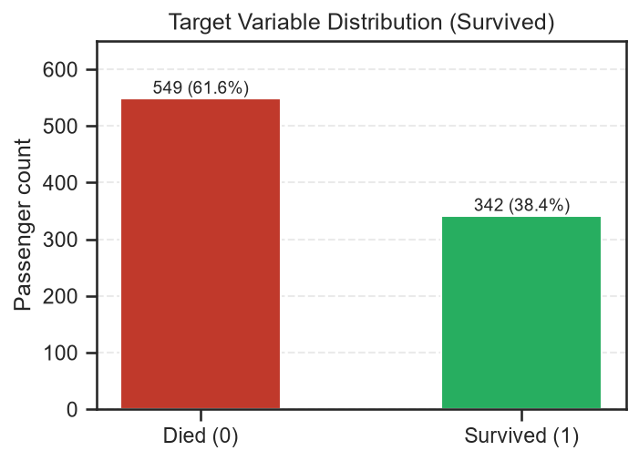
Figure 2.2: Counts for the Titanic survival outcome
There were 549 deaths (61.6%) and 342 survivors (38.4%). A classifier that labels every passenger as deceased would still achieve 61.6% accuracy. For this reason, precision, recall, F1-score and ROC-AUC are also needed to describe model quality.
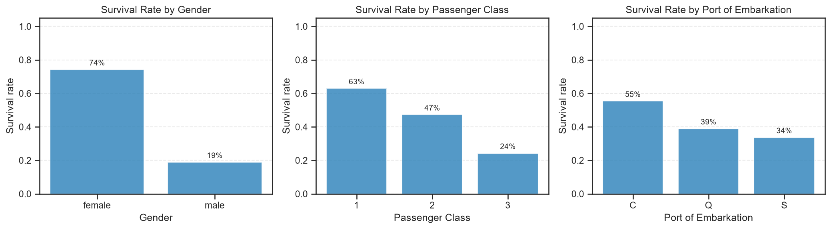
Figure 2.3: Survival percentages by sex, class and embarkation port
Survival was about 74% among women, compared with 19% among men. The rate declined from 63% in first class to 47% in second class and 24% in third class. Passengers embarking at Cherbourg had a higher survival rate (55%) than those embarking at Southampton (34%), partly reflecting the larger share of first-class travellers. Women had higher survival in every class (97%, 92% and 50%, compared with 37%, 16% and 14% for men), indicating that both sex and class were relevant.
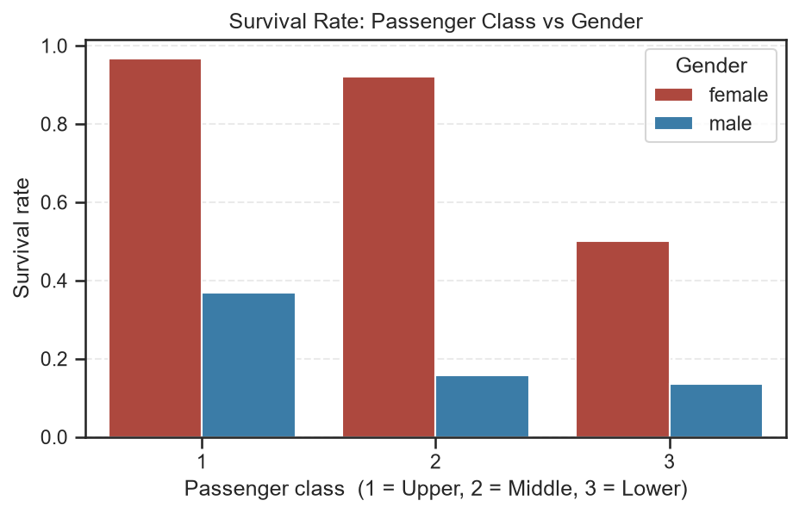
Figure 2.4: Survival percentages by class and sex
Across all ticket classes, women were more likely to survive than men: the approximate rates for women in first, second and third class were 97%, 92% and 50%, while the corresponding figures for men were 37%, 16% and 14%. Third-class women had lower survival than women in the upper classes, but their outcomes were still better than those of men in any class.
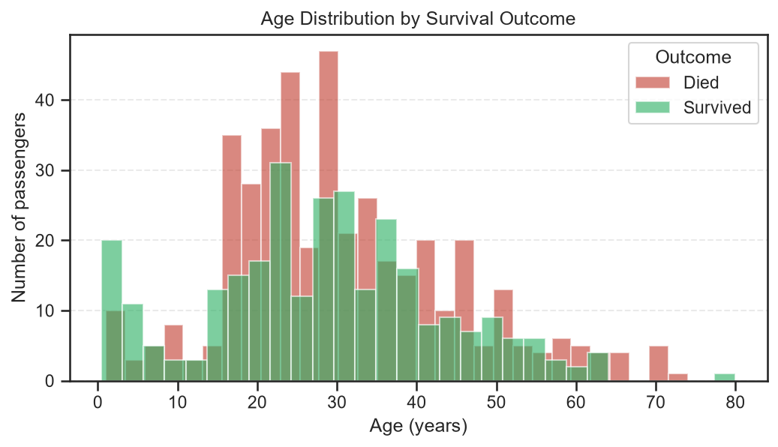
Figure 2.5: Passenger age distribution split by survival outcome
Most passengers were between 20 and 35 years old. Children younger than ten had a survival rate of about 61%, compared with 39% among older passengers. This suggests that the age relationship is especially visible among young children, even though the overall age correlation is only −0.08.
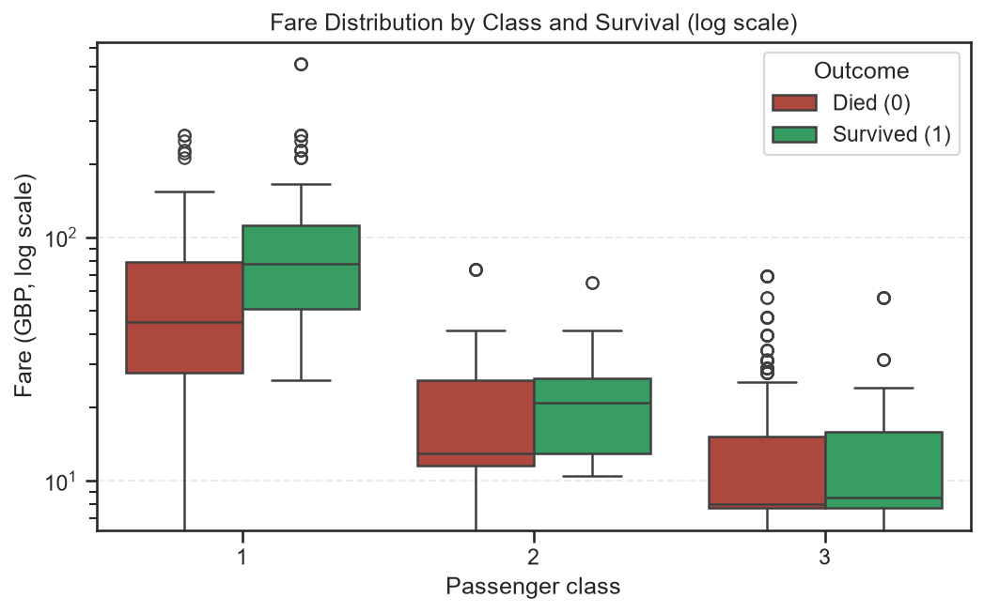
Figure 2.6: Fare distribution across class and survival (logarithmic scale)
Ticket prices increased substantially with passenger class. The median fare among survivors was £26, compared with £10.50 for those who died. Since both fare and class reflect socioeconomic position, they partly represent the same underlying effect.
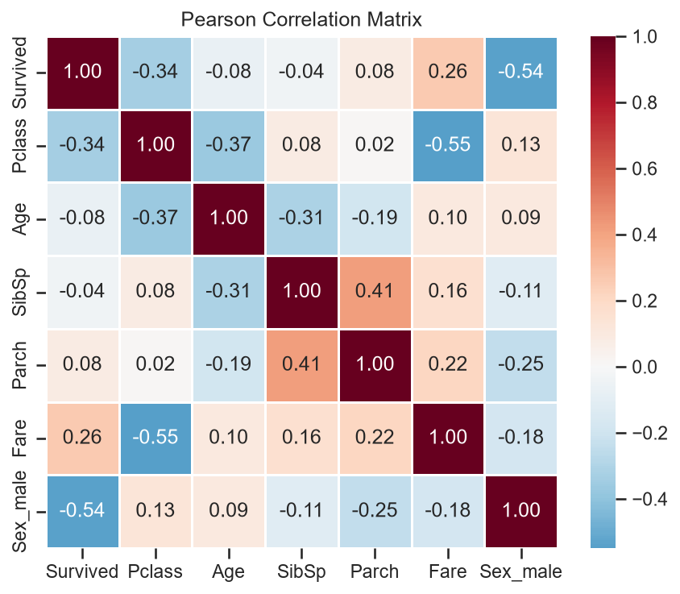
Figure 2.7: Correlations among numeric Titanic variables
The strongest numeric association with survival was for being male (−0.54), followed by passenger class (−0.34) and fare (+0.26). Passenger class and fare were correlated at −0.55, while SibSp and Parch had a correlation of 0.41. No pairwise correlation exceeded an absolute value of 0.8, suggesting that severe multicollinearity was not evident.
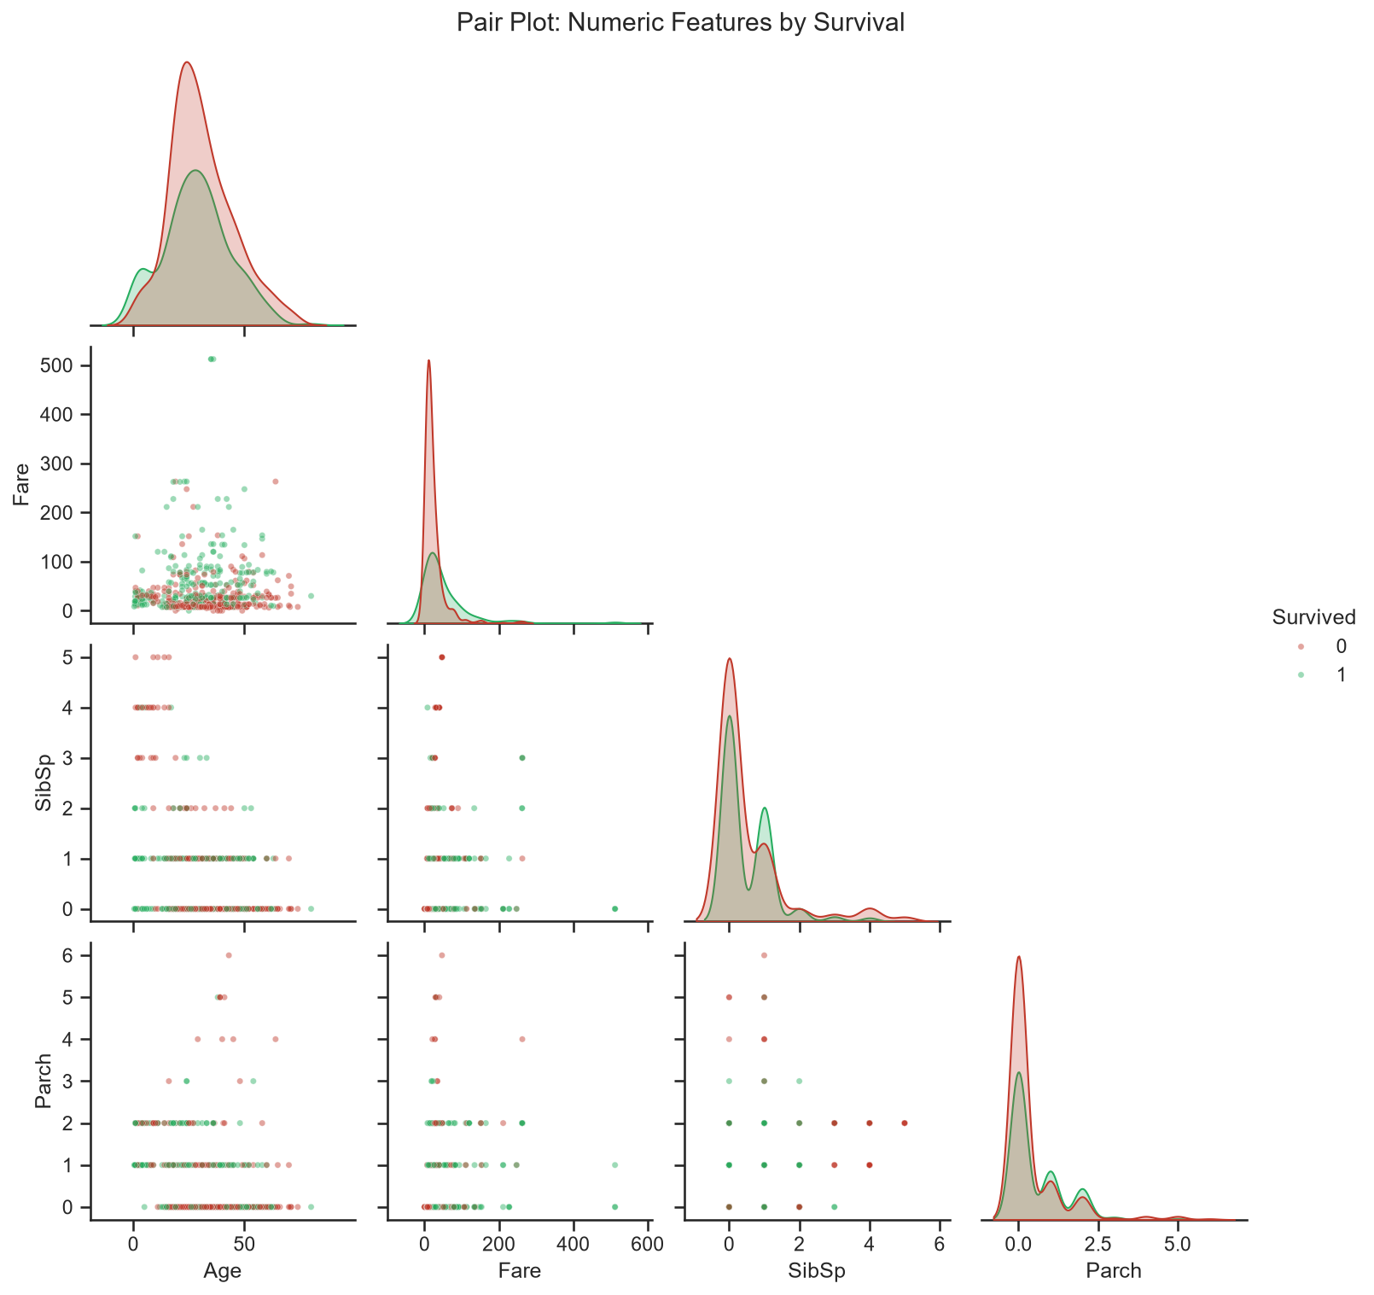
Figure 2.8: Pairwise plots of numeric features grouped by survival
No single numeric variable clearly separates survivors from non-survivors, which highlights the importance of including Sex and Pclass. Survivors tend to appear among passengers paying higher fares, whereas survival was uncommon among passengers travelling in very large family groups.
Overall, sex showed the clearest relationship with survival, followed by social position as represented by class and fare, and then age. Children had better outcomes, while passengers travelling alone or in large family groups generally fared less well than those in smaller family groups.

CHAPTER 3
PART A – TITANIC: PREPROCESSING AND MODEL

3.1 Project Workflow
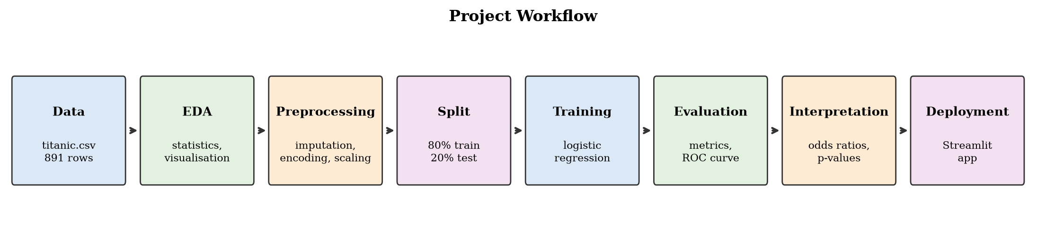
Figure 3.1: Shared workflow used for the two case studies

3.2 Data Preprocessing
PassengerId, Name, Ticket and Cabin were excluded from the predictor set. The remaining fields were Pclass, Sex, Age, SibSp, Parch, Fare and Embarked. A stratified 80:20 split produced 712 training records and 179 test records. The split was performed before fitting imputation steps so information from the test set could not influence preprocessing.
Table 3.1: Data preparation steps for the Titanic model
Step | Columns | Method | Reason
Imputation | Age, Fare | Median | Handles skewed values and outliers (median age 28.5)
Imputation | Embarked, Pclass, Sex | Most frequent | Only two records missing; filled with “S”
Scaling | Age, SibSp, Parch, Fare | StandardScaler | Makes numeric variables comparable and supports convergence
Encoding | Pclass, Sex, Embarked | One-hot, drop first | Creates binary features and avoids redundant dummy variables

The seven original predictors expand into nine encoded model inputs. The reference categories are first class, female and Cherbourg. All preparation steps are included in a scikit-learn Pipeline, ensuring that training records, test records and values entered in the application undergo the same transformations.

3.3 Logistic Regression Model and Training
P(Survived = 1 | x) = 1 / (1 + e^(−z)), z = β₀ + β₁x₁ + … + βₖxₖ
The value z represents the log-odds of survival. A coefficient β describes the change in log-odds associated with a one-unit increase in its feature, while e^β gives the corresponding odds ratio. Parameters were estimated by maximum likelihood using the lbfgs solver, L2 regularisation and C = 1.0. Training accuracy was 81.0%, reasonably close to test accuracy, which suggests limited overfitting.

CHAPTER 4
PART A – TITANIC: EVALUATION AND INTERPRETATION

4.1 Performance Metrics
Table 4.1: Test-set results for the Titanic classifier
Metric | Value | Interpretation
Accuracy | 0.8436 | Fraction of passengers correctly classified
Precision | 0.8060 | Share of predicted survivors who actually survived
Recall | 0.7826 | Share of actual survivors correctly identified
F1-score | 0.7941 | Harmonic average of precision and recall
ROC-AUC | 0.8978 | Ability to rank a survivor above a non-survivor

The model correctly classified 84.4% of passengers in the held-out set, exceeding the baseline of about 61.5%. Precision of 0.81 means that roughly four out of five people predicted to survive did survive. Recall was 0.78 because some actual survivors—particularly those with profiles associated with higher risk, such as adult men in third class—were not identified. The AUC of 0.90 indicates strong ranking ability.
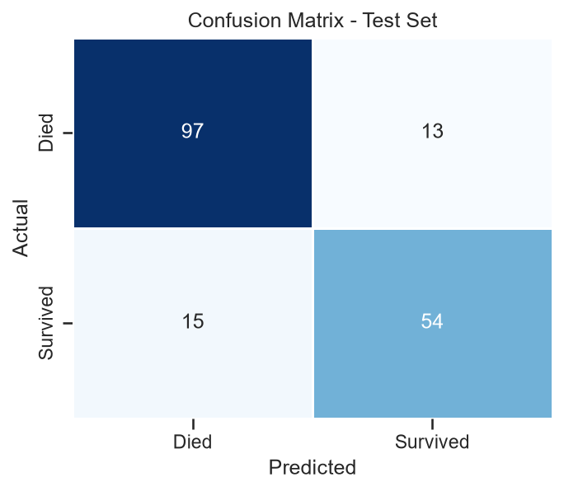
Figure 4.1: Titanic test-set confusion matrix
Out of 179 test passengers, 151 were classified correctly: 97 true negatives and 54 true positives. The model produced 13 false positives and 15 false negatives, contributing to the recall being below one.
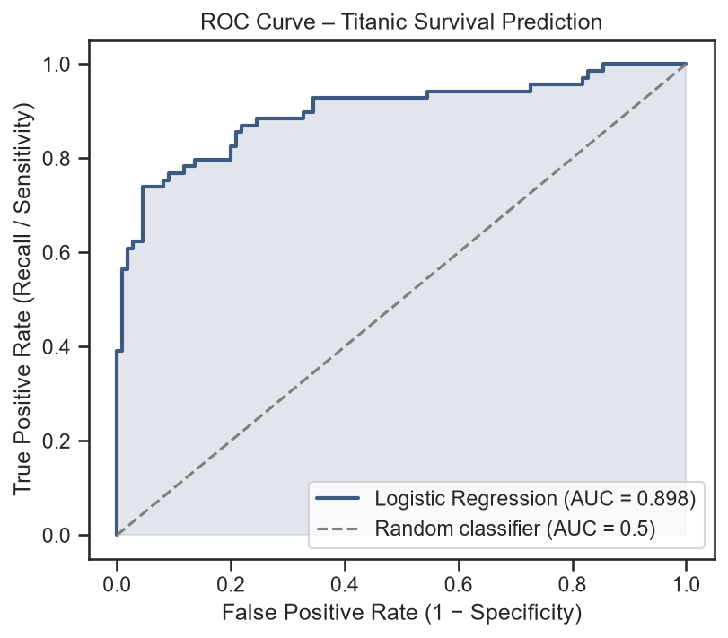
Figure 4.2: ROC curve for the Titanic classifier
The ROC curve remains clearly above the diagonal representing random classification, with an AUC of 0.898. Reducing the 0.5 decision threshold would identify more survivors, but would also increase false-positive predictions.

4.2 Coefficients, Odds Ratios and Significance
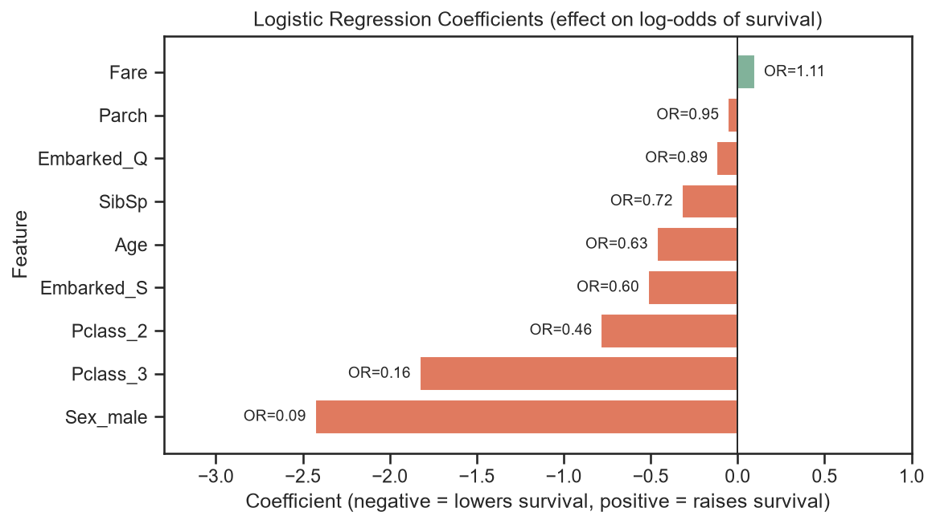
Figure 4.3: Logistic Regression coefficients and odds ratios for Titanic
Compared with an otherwise similar woman, a man had substantially lower estimated survival odds (OR approximately 0.08). Third-class passengers had odds around 0.15 times those of first-class passengers, while the odds for second class were roughly half as large (OR around 0.48). Greater age (OR about 0.63 per 14.5 years) and having more siblings or spouses aboard (OR around 0.77) were also associated with lower odds.
Table 4.2: Significance tests for unscaled Titanic model features
Feature | Coefficient | Odds ratio | p-value | Significant
Age | -0.0390 | 0.9617 | < 0.001 | Yes
Pclass_3 | -2.0800 | 0.1249 | < 0.001 | Yes
Sex_male | -2.5748 | 0.0762 | < 0.001 | Yes
Pclass_2 | -1.0013 | 0.3674 | 0.0019 | Yes
SibSp | -0.2983 | 0.7421 | 0.0102 | Yes
Embarked_S | -0.5434 | 0.5808 | 0.0385 | Yes
Parch | -0.0726 | 0.9300 | 0.5732 | No
Fare | 0.0010 | 1.0010 | 0.6787 | No
Embarked_Q | -0.1477 | 0.8627 | 0.7260 | No

Sex, third-class status and Age were strongly significant (p < 0.001), while second-class status and SibSp were significant at p < 0.05. Each additional year of age was associated with survival odds multiplied by roughly 0.96. After accounting for class, Fare, Parch and Embarked were not statistically significant in this analysis. The results broadly align with the historical pattern of higher survival among women, younger passengers and those in higher classes.

CHAPTER 5
PART A – TITANIC: DEPLOYMENT WITH STREAMLIT

The fitted pipeline is stored as model/titanic_logreg.pkl using joblib. The app.py Streamlit interface loads the model and lets a user enter passenger details through sidebar controls. It displays the estimated survival probability, the predicted class and a chart explaining how individual features shift the log-odds. The app can be launched locally with streamlit run app.py or hosted through Streamlit Community Cloud.
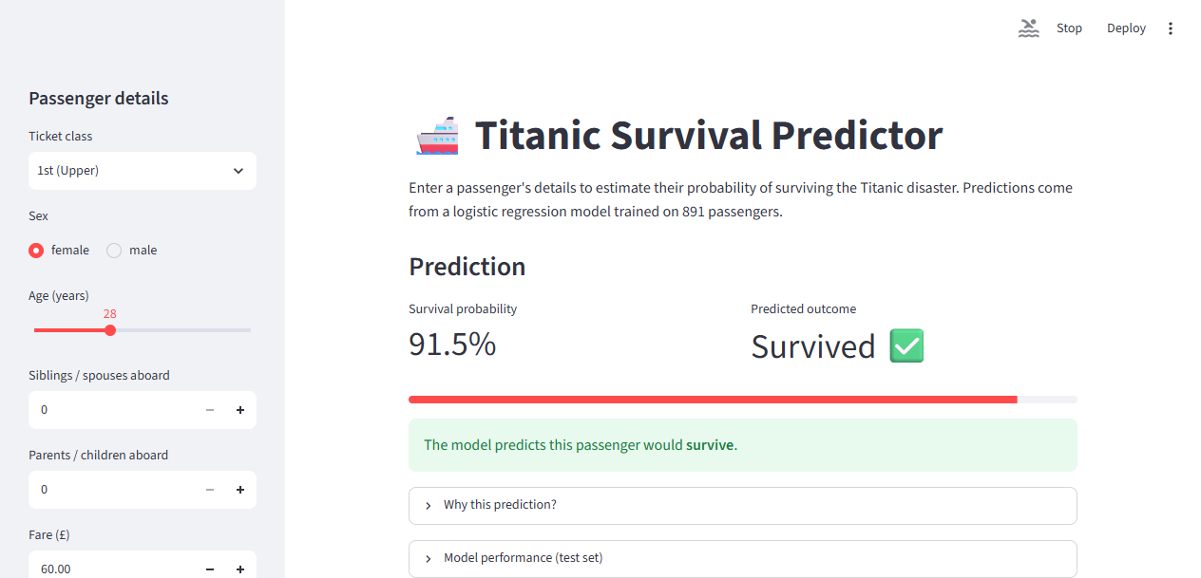
Figure 5.1: Streamlit output for a 28-year-old first-class woman
For a first-class woman aged 28 with a fare of £60, the application estimates a 91.5% chance of survival and predicts “Survived”. The interface also provides expandable sections titled “Why this prediction?” and “Model performance” for additional explanation.
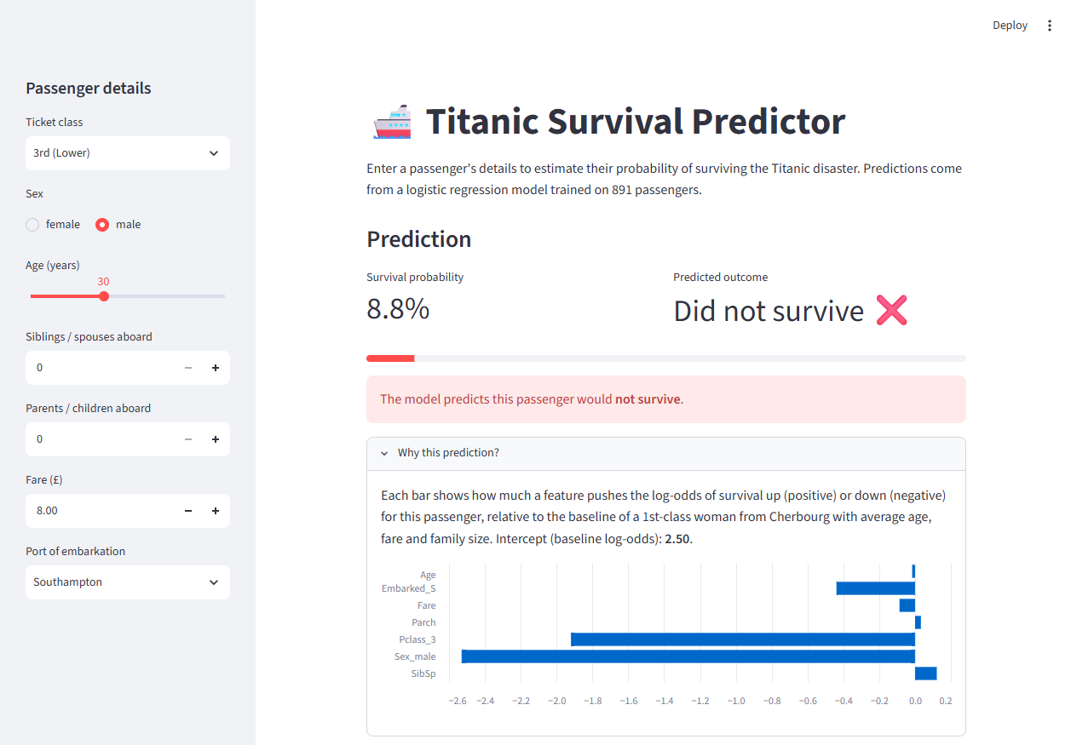
Figure 5.2: Streamlit output and explanation for a 30-year-old third-class man
For a 30-year-old man travelling in third class, the estimated survival probability is 8.8%. The explanation chart indicates that Sex_male and Pclass_3 contribute most strongly to lowering the prediction. In comparison, the example of a 28-year-old first-class woman receives a 91.5% probability.

CHAPTER 6
PART B – BANK MARKETING: DATA UNDERSTANDING AND PREPROCESSING

6.1 Case Study and Problem Statement
A bank in Portugal conducts telephone campaigns to promote term-deposit products and records customer details, campaign history and contact outcomes. Since different algorithms may identify likely subscribers with different levels of success, the bank needs a systematic comparison. This case study trains Logistic Regression, Decision Tree, K-Nearest Neighbours and Random Forest classifiers to predict the target y (yes/no) and determines which is most useful for campaign targeting.

6.2 Dataset Description
The semicolon-separated file bank-additional-full.csv, available from the UCI Machine Learning Repository, includes 41,188 contacts collected between May 2008 and November 2010. It provides 20 input attributes and the subscription outcome y.
Table 6.1: Bank dataset fields grouped by type
Category | Fields included | Data types
Customer | age; job, marital, education, default, housing, loan | 1 numerical, 6 categorical
Current campaign | contact, month, day_of_week; duration, campaign | 3 categorical, 2 numerical
Previous campaign | pdays, previous; poutcome | 2 numerical, 1 categorical
Economic context | emp.var.rate, cons.price.idx, cons.conf.idx, euribor3m, nr.employed | 5 numerical
Target | y – subscribed to a term deposit (yes / no) | Binary

Customer ages range from 17 to 98, with an average of about 40 years. The campaign-contact count has a median of two and a maximum of 56. For approximately 96% of customers, pdays is 999, indicating that they had not previously been contacted within the dataset's recorded campaign history.

6.3 Data Quality: Unknown Values, Duplicates and Target
Table 6.2: Bank categorical fields with unknown entries
Attribute | Unknown entries | Percent
default | 8,597 | 20.87%
education | 1,731 | 4.20%
housing | 990 | 2.40%
loan | 990 | 2.40%
job | 330 | 0.80%
marital | 80 | 0.19%

No cells are blank, but several categorical fields use “unknown” when information is unavailable. This label was retained as its own category because removing affected records would eliminate more than one-fifth of some data and the missingness itself may contain useful information. Removing 12 duplicate records left 41,176 observations.

6.4 Preprocessing and Train–Test Split
- duration was removed because it records the length of the most recent call and is only known after the call ends. A zero-second call always corresponds to a negative outcome, so including this field would leak information unavailable when selecting whom to call.
- The target was recoded as yes = 1 and no = 0. Categorical fields, including “unknown”, were one-hot encoded, and numeric fields were standardised. Scaling is particularly important for KNN because its predictions depend on distances between observations.
- A stratified 80:20 partition created 32,940 training cases and 8,236 test cases, with an approximately 11.3% subscription rate in each set. The 19 retained predictors expand to 62 encoded features.
- All four algorithms use the same target definition, data split and preprocessing pipeline, allowing their test results to be compared on a consistent basis.

CHAPTER 7
PART B – BANK MARKETING: EXPLORATORY DATA ANALYSIS

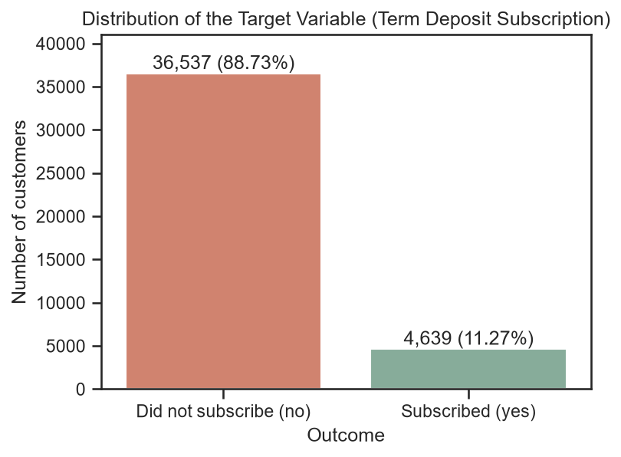
Figure 7.1: Distribution of the bank subscription target
Of the 41,176 records, 4,639 customers subscribed (11.27%) and 36,537 did not (88.73%). Predicting “no” for every record would yield 88.7% accuracy despite finding no subscribers. The positive class should therefore be evaluated with precision, recall, F1-score and ROC-AUC rather than accuracy alone.
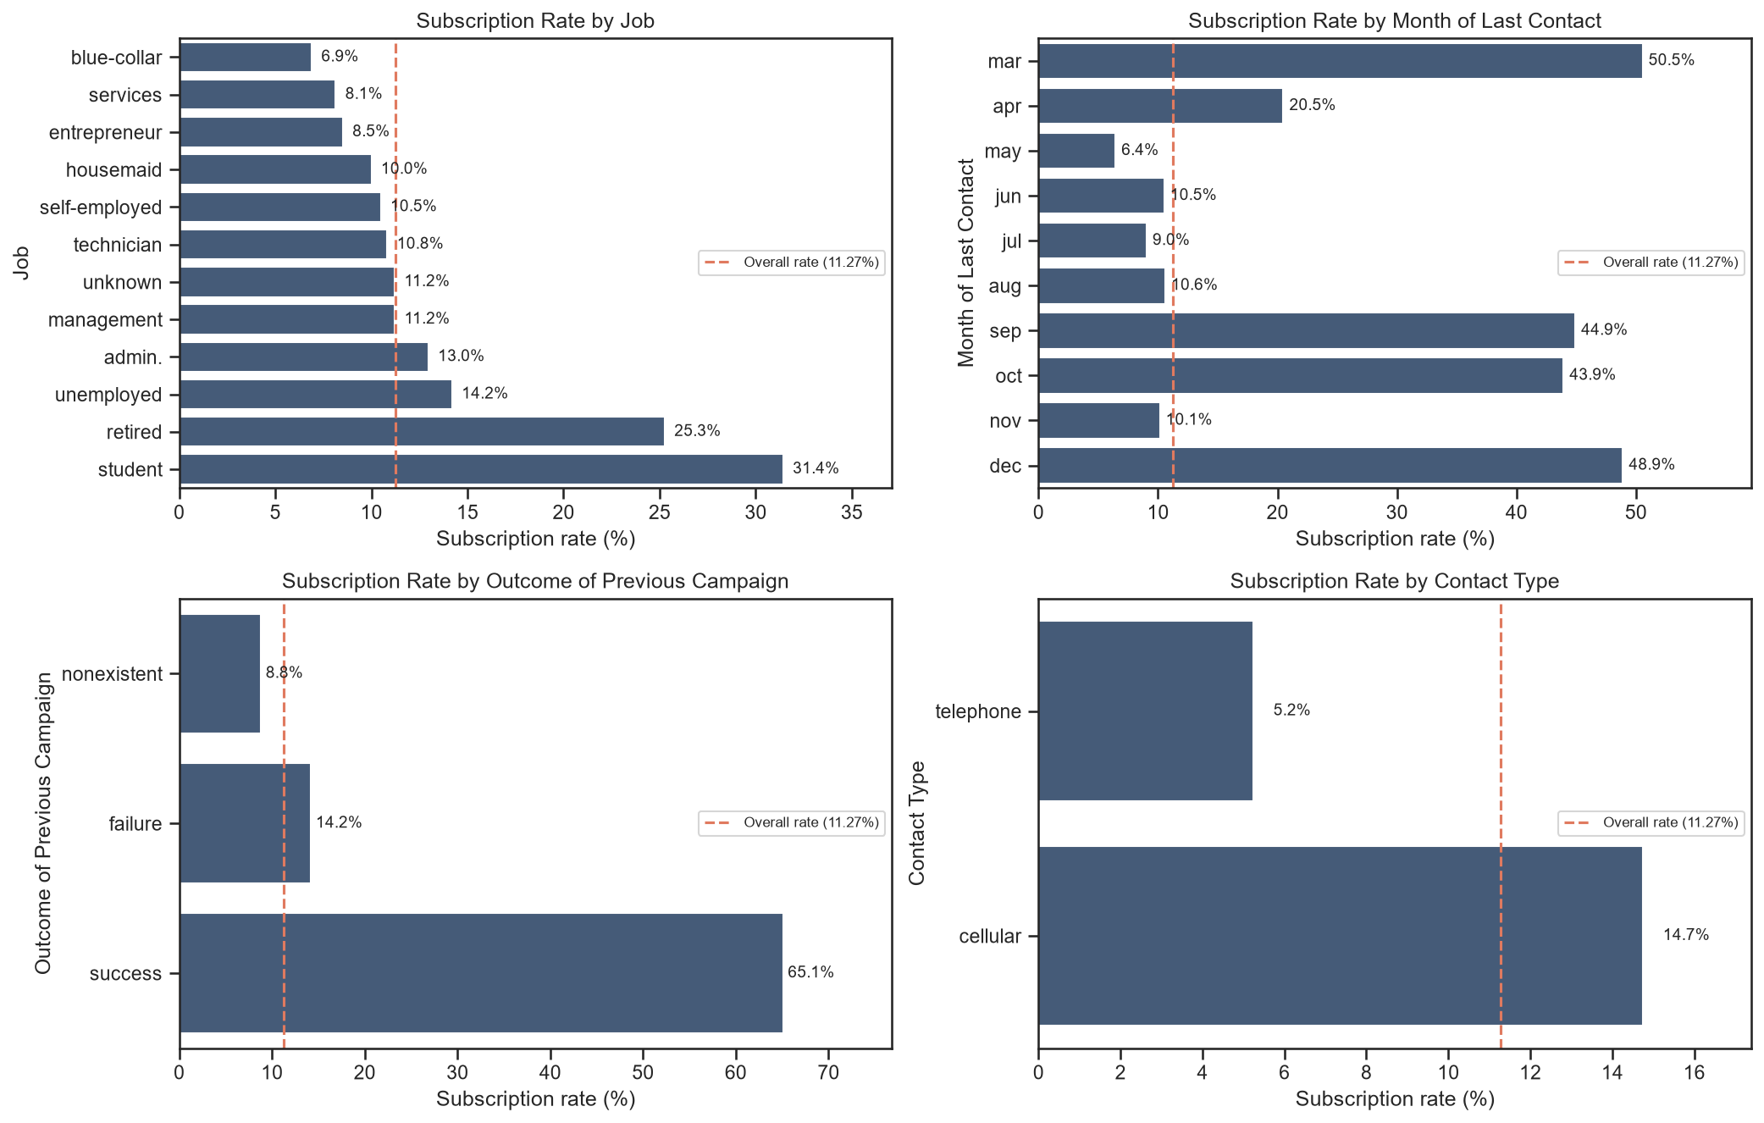
Figure 7.2: Subscription rates by occupation, month, prior outcome and contact method
The subscription rate was 65.1% among customers whose previous campaign ended successfully, compared with 14.2% after a previous failure and 8.8% among customers without that outcome. May had the lowest rate (6.4%) despite being the busiest month, whereas March, September, October and December reached approximately 44–51%. Students (31.4%) and retired customers (25.3%) subscribed most often, while blue-collar workers had the lowest rate (6.9%). Mobile contacts converted at 14.7%, almost three times the 5.2% rate for landline contacts.
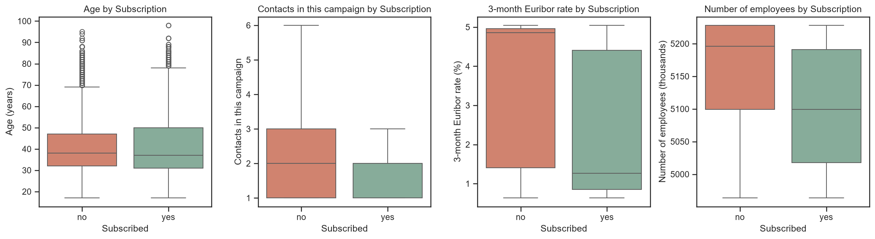
Figure 7.3: Numeric bank attributes grouped by subscription result
Subscribers were contacted when the median Euribor rate was lower (1.27% versus 4.86%) and employment levels were also lower (5,099 versus 5,196 thousand). They received fewer calls on average (2.05 compared with 2.63). Median ages were similar at 37 and 38, although the subscription rate for customers aged 60 and above was 39.6%. The strongest numeric associations with subscription included nr.employed (−0.36), pdays (−0.33) and euribor3m (−0.31).
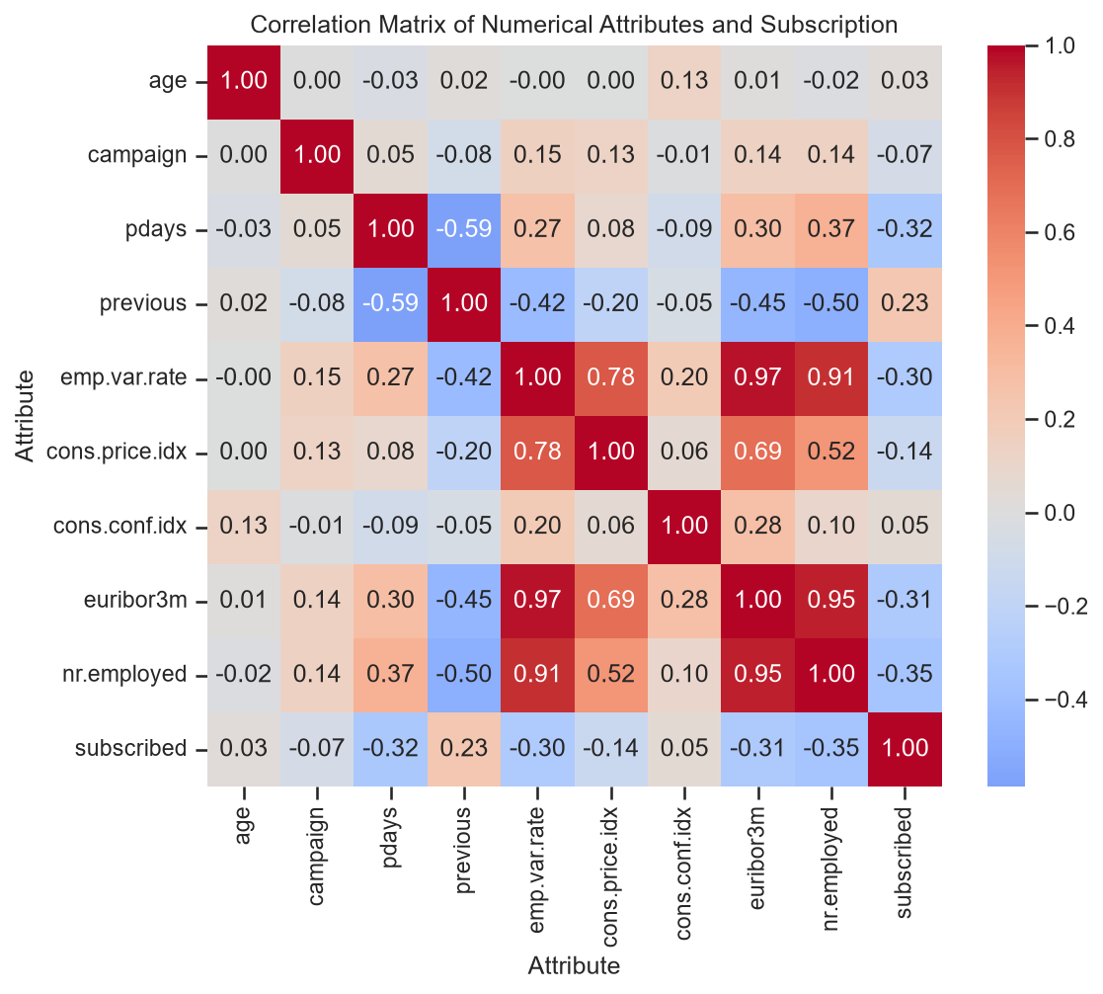
Figure 7.4: Correlations among numeric bank attributes and subscription
The strongest numeric relationships with subscription were observed for nr.employed (−0.35), pdays (−0.32), euribor3m (−0.31) and emp.var.rate (−0.30); previous contacts had a positive relationship (+0.23). Several economic variables were strongly correlated with one another—for example, euribor3m correlated 0.97 with emp.var.rate and 0.95 with nr.employed—so they contain overlapping information.

7.1 Three Key Observations
- A previous successful campaign is a particularly strong signal: these customers subscribed at 65.1%, roughly six times the overall rate of 11.3%.
- Campaign timing and economic conditions are associated with outcomes. Subscription reached 24.5% when the three-month Euribor rate was below 2%, but fell to 4.8% when the rate was at least 4%. May, the busiest month, recorded the lowest success rate.
- Customer segment and contact frequency also matter. Students, retired people and customers contacted by mobile had comparatively high subscription rates. When the same customer was contacted more than five times, success was only 5.5%, compared with 13.0% after a single call.

CHAPTER 8
PART B – BANK MARKETING: MODEL DEVELOPMENT AND COMPARISON

8.1 Model Configuration
Table 8.1: Algorithms evaluated and their configurations
Model | Settings | Purpose / rationale
Logistic Regression | max_iter = 1000 | Interpretable linear baseline
Decision Tree | max_depth = 6 | Controls complexity to reduce overfitting
K-Nearest Neighbours | k = 5 | Uses the five nearest observations
Random Forest | 300 trees, min_samples_leaf = 5 | Combines many trees for robust, non-linear predictions

8.2 Performance Comparison Table
Table 8.2: Test-set comparison of classifiers at threshold 0.5
Model | Accuracy | Precision | Recall | F1-score | ROC-AUC
Logistic Regression | 0.8983 | 0.6355 | 0.2274 | 0.3349 | 0.7973
Decision Tree | 0.8986 | 0.6004 | 0.2996 | 0.3997 | 0.7906
KNN | 0.8906 | 0.5257 | 0.2974 | 0.3799 | 0.7290
Random Forest | 0.8981 | 0.6226 | 0.2435 | 0.3501 | 0.8006

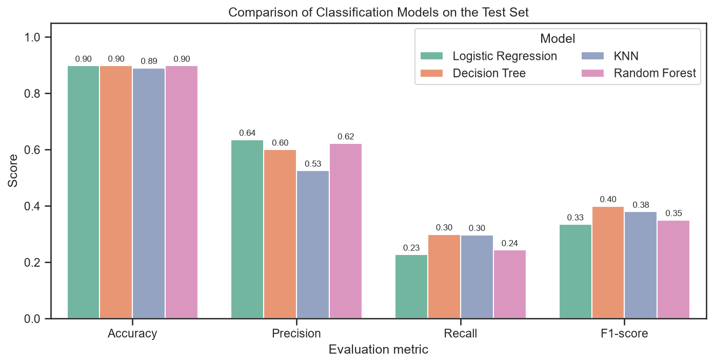
Figure 8.1: Accuracy, precision, recall and F1-score by model
All four classifiers recorded similar accuracy, between about 0.896 and 0.900, so this measure does not clearly distinguish their performance. Logistic Regression, Decision Tree and Random Forest had precision near 0.60–0.64, while KNN achieved the strongest recall and F1-score at the default threshold but with lower precision. At a threshold of 0.5, every model failed to identify many actual subscribers.

8.3 Confusion Matrices and Classification Errors
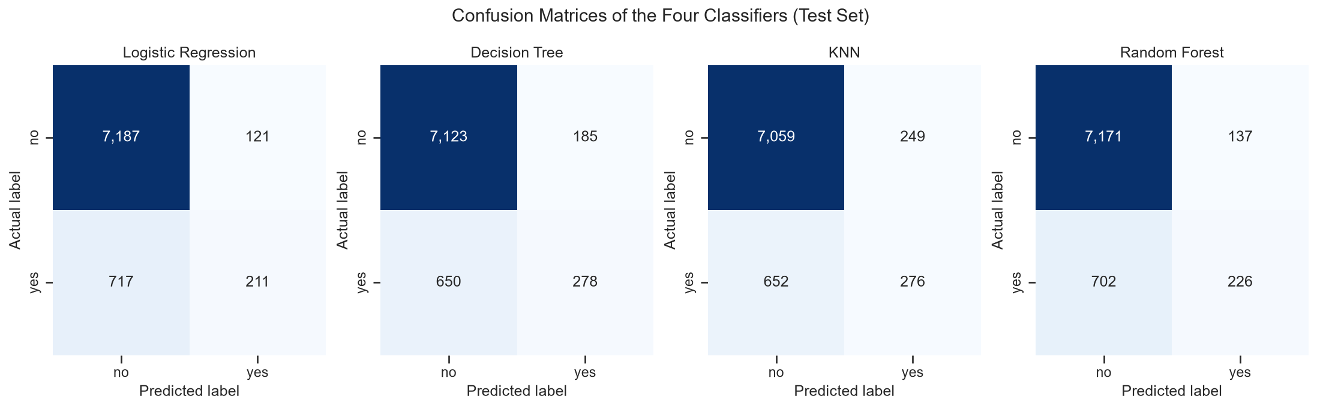
Figure 8.2: Confusion matrices for the four bank classifiers
Among the 928 subscribers in the test set, the models missed between 652 (KNN) and 717 (Logistic Regression). These false negatives represent potential sales that were not pursued and were the most common error type. False positives ranged from 121 to 249 and mainly represent calls made to customers who did not subscribe. KNN identified 276 subscribers but also generated the most false positives; Random Forest found 226 subscribers with 137 false positives.

8.4 ROC Curves
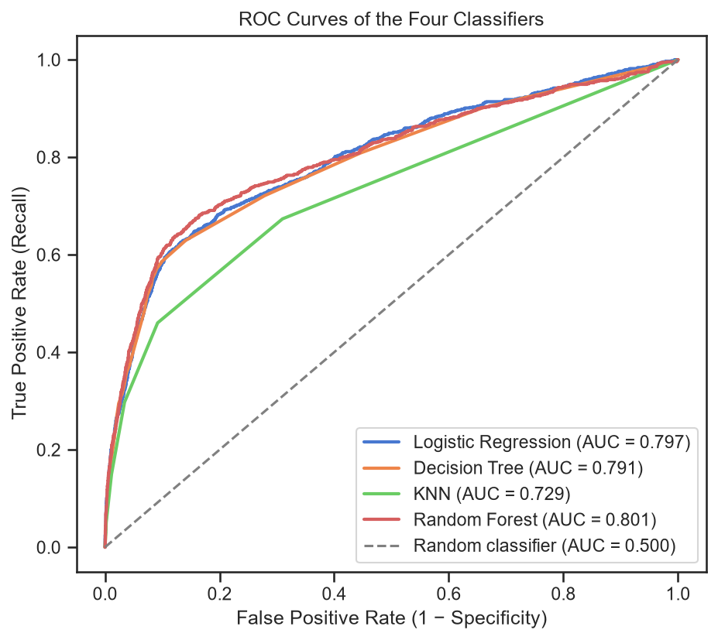
Figure 8.3: ROC curves for the bank classifiers
Random Forest produced the top ROC-AUC (0.801), with Logistic Regression close behind at 0.797 and Decision Tree at 0.791. KNN scored lower at 0.729. This suggests Random Forest is the strongest of the tested models at ordering customers by subscription likelihood across possible decision thresholds.

8.5 Identifying Actual Subscribers
Since only around 11% of customers subscribed, the default threshold of 0.5 may be too conservative. The decision threshold for Random Forest was therefore varied to examine the trade-off between finding subscribers and the number of customers flagged.
Table 8.3: Random Forest results at alternative thresholds
Threshold | Customers flagged | Precision | Recall | F1-score
0.50 | 363 | 0.623 | 0.243 | 0.350
0.40 | 590 | 0.564 | 0.359 | 0.439
0.30 | 945 | 0.491 | 0.500 | 0.495
0.20 | 1,238 | 0.446 | 0.595 | 0.510
0.15 | 1,410 | 0.410 | 0.623 | 0.494
0.10 | 2,007 | 0.319 | 0.691 | 0.437

At a threshold of 0.2, recall increases from 0.24 to approximately 0.59, while precision decreases to about 0.45. The resulting F1-score rises to 0.51, higher than the models' scores at their default thresholds. Calling the 20% of customers with the highest Random Forest scores could reach around 66% of all subscribers with a conversion rate near 37%, compared with about 11% for random calling.
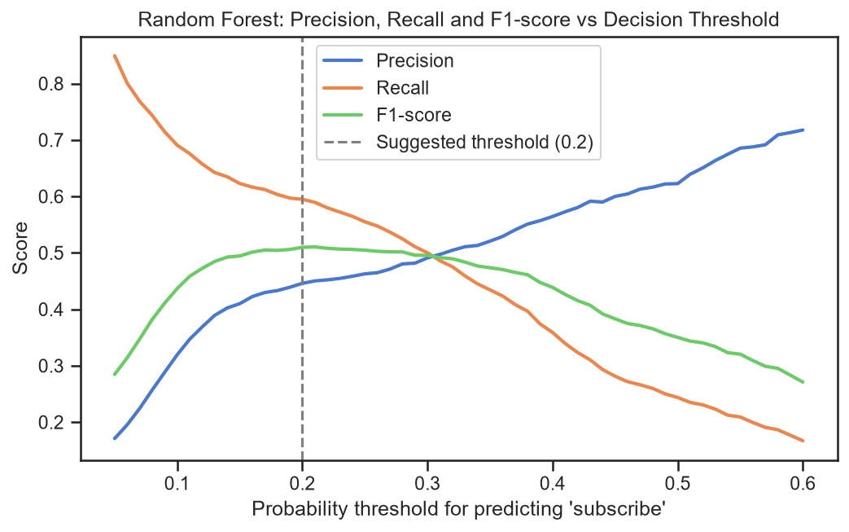
Figure 8.4: Random Forest precision, recall and F1 across thresholds
When the threshold is reduced from 0.6 to 0.05, recall rises from roughly 0.17 to 0.85, while precision drops from about 0.72 to 0.17. The best F1-score is around 0.51 near a threshold of 0.2, where recall is approximately 0.59 and precision is around 0.45.
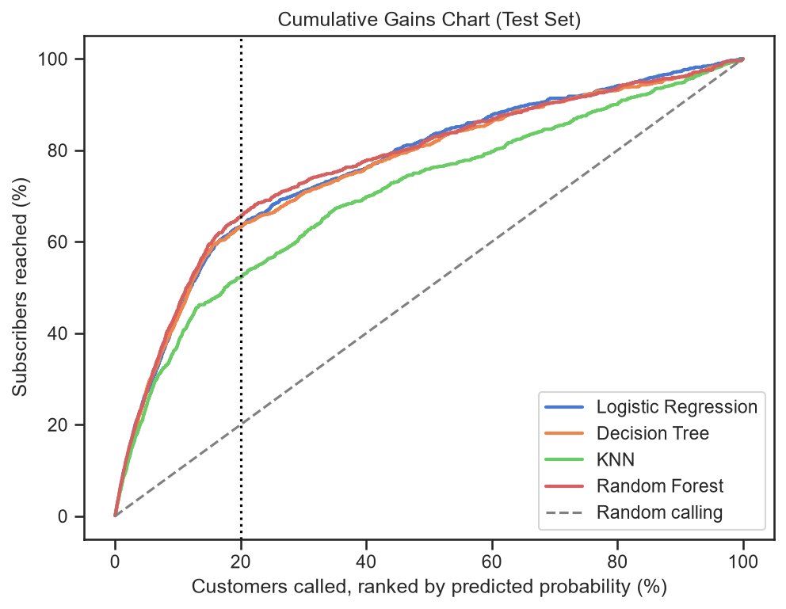
Figure 8.5: Cumulative gains for the four bank classifiers
Random Forest, Logistic Regression and Decision Tree show similar ranking performance and remain well above the random-selection baseline; KNN performs least well. Selecting the highest-scoring fifth of customers with Random Forest captures approximately two-thirds of subscribers, compared with one-fifth under random selection.

8.6 Best-Performing Model
Random Forest is recommended because it has the highest ROC-AUC (0.801) and good precision at the default threshold (0.62). Its ranking quality makes threshold adjustment effective, raising the F1-score to about 0.51. Although KNN has higher recall at 0.5, its weaker AUC (0.729) indicates poorer ranking ability. Accuracy was not decisive because all models were near 90%. The leading Random Forest features include euribor3m, nr.employed, age, pdays and a previous successful outcome, matching the patterns seen during exploratory analysis.
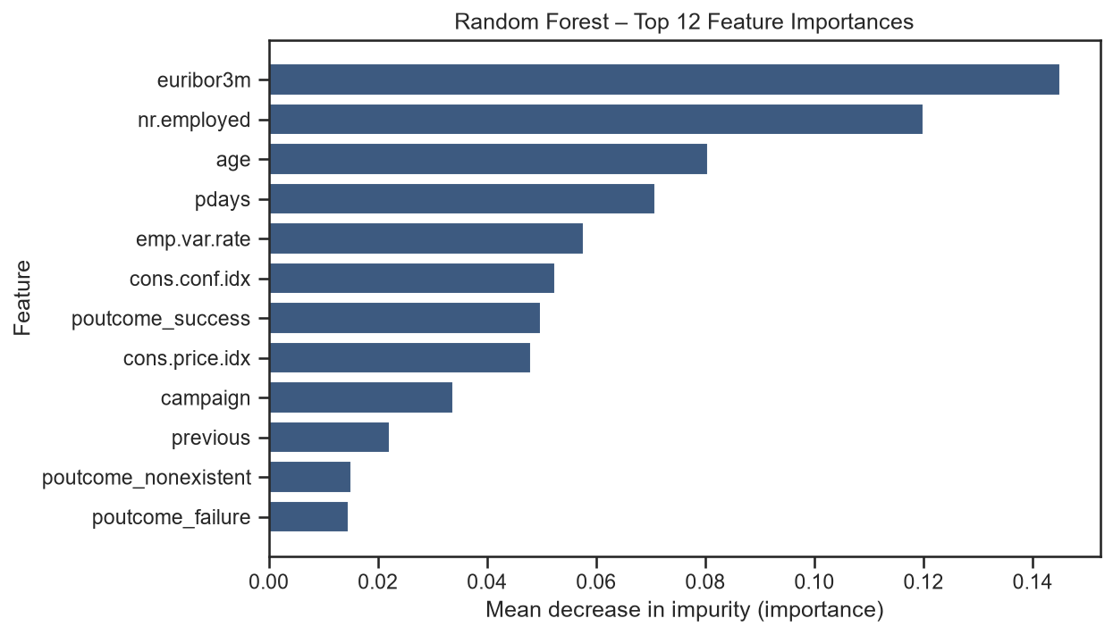
Figure 8.6: Twelve highest feature-importance scores for Random Forest
The most influential features were euribor3m (approximately 0.145) and nr.employed (around 0.12), followed by age, pdays, emp.var.rate, cons.conf.idx and poutcome_success. Economic conditions and the result of the previous campaign account for much of the model's predictive signal, consistent with the exploratory findings.

CHAPTER 9
PART B – BANK MARKETING: INTERPRETATION AND RECOMMENDATIONS

9.1 Suitability of the Random Forest Model
- It offers the strongest ranking performance by ROC-AUC, which is useful when creating an ordered list of customers for calling.
- It can model non-linear relationships, such as changes across months and interest-rate ranges, and is relatively robust to outlying observations.
- Averaging the results of 300 decision trees helps make its predictions more stable and limits overfitting.
- The decision threshold can be chosen according to campaign costs. Missing a likely subscriber may mean losing a sale, whereas a false positive usually means only an additional call; therefore, recall can be more valuable than maximising accuracy.

9.2 Business Recommendations
- Before each campaign, calculate a probability score for every eligible customer and contact people in descending score order. The highest-ranked 20% are estimated to contain about 66% of subscribers, producing roughly three times the conversion rate of random calling.
- Consider a threshold between 0.2 and 0.3 to identify about 50–60% of subscribers, compared with approximately 24% at the default threshold. This approach requires more calls, but may be worthwhile when the cost of missing a potential customer is high.
- Prioritise segments with stronger historical response, including customers with a previous successful campaign, students, retired customers and mobile-phone contacts. Schedule campaigns with economic conditions in mind and avoid repeatedly contacting the same customer; limiting attempts to around three is a reasonable starting point from these results.

9.3 Limitations
- The target is imbalanced, with subscribers representing only about 11% of observations. At the default threshold, every model tends to predict “no” frequently, and results vary when the threshold changes. Class weighting, SMOTE and cost-sensitive methods were not tested and could affect the relative ranking of the models.
- The strongest predictors include macroeconomic indicators from 2008–2010, a period affected by the financial crisis. Their relationships with subscription may differ in other economic environments, so the model should be validated and retrained on more recent campaign data before continued use.

CHAPTER 10
CONCLUSION AND REFERENCES

10.1 Conclusion
Both projects applied the main stages of data science: understanding the data, cleaning and preparing features, exploratory analysis, model training, evaluation, interpretation and presentation. In the Titanic study, Logistic Regression achieved 84.4% accuracy and a ROC-AUC of 0.90. Coefficients and p-values highlighted sex, ticket class and age, and the resulting model was integrated into an interactive Streamlit application. In the bank-marketing study, four classifiers were assessed on a strongly imbalanced target. Since their accuracy scores were similar, precision, recall, F1-score and ROC-AUC were considered alongside the business impact of prediction errors. Random Forest ranked customers most effectively, with an AUC of 0.801, and threshold tuning allowed it to identify approximately 59% of subscribers. It is therefore the preferred model for prioritising marketing calls in this analysis. Overall, meaningful metrics and an understandable explanation of predictions are as important as the algorithm selected.

10.2 References
[1] Kaggle, “Titanic – Machine Learning from Disaster” dataset. https://www.kaggle.com/c/titanic
[2] S. Moro, P. Cortez and P. Rita, “A data-driven approach to predict the success of bank telemarketing,” Decision Support Systems, vol. 62, pp. 22–31, 2014.
[3] UCI Machine Learning Repository, “Bank Marketing” dataset. https://archive.ics.uci.edu/dataset/222/bank+marketing
[4] F. Pedregosa et al., “Scikit-learn: Machine Learning in Python,” Journal of Machine Learning Research, vol. 12, pp. 2825–2830, 2011.
[5] L. Breiman, “Random Forests,” Machine Learning, vol. 45, pp. 5–32, 2001.
[6] S. Seabold and J. Perktold, “statsmodels: Econometric and statistical modeling with Python,” Proc. 9th Python in Science Conference, 2010.
[7] Streamlit documentation, “Deploy your app on Community Cloud.” https://docs.streamlit.io/streamlit-community-cloud/deploy-your-app

