Smart City Construction, Sustainable Urban Transition, and Carbon Emissions: Nonlinear Evidence from Chinese Cities

Abstract
Smart city construction is widely expected to support sustainable urban transition, but its carbon-emission implications remain ambiguous when digital infrastructure, spatial reorganization, and industrial restructuring advance together. This study examines the nonlinear association between multidimensional spatial coupling coordination and log carbon emissions using an observed city-level panel of 284 Chinese prefecture-level and above cities from 2006 to 2021. We extend the production-living-ecological framework by incorporating digital space and construct a spatial coupling coordination degree (SCCD) index. Two-way fixed-effects estimates show a significant inverted U-shaped relationship: the full-control observed-sample coefficients are 8.444 for SCCD and -8.091 for SCCD squared, implying a turning point of 0.522. Supplementary instrumental-variable estimates imply a turning point of 0.570. Mechanism-equation evidence indicates that industrial upgrading and green technological innovation are transition-related pathways rather than immediate emission-reduction channels. Digital economy development weakens the marginal emission cost of coordination. The findings suggest that smart-city coordination contributes to low-carbon transition only when governance shifts from expansion-led integration toward efficiency-oriented urban operation.
Keywords: smart city construction; sustainable urban transition; carbon emissions; spatial coupling coordination; digital economy; Chinese cities

1. Introduction
Cities concentrate population, infrastructure, production, energy use, and emissions, making them a central arena for sustainable transition and carbon mitigation [1-3]. In China, rapid urbanization has coincided with infrastructure expansion, industrial restructuring, and digital transformation, so the same process that improves urban coordination may also raise energy demand and emissions [4,5]. This creates a practical question for sustainable-city governance: can smart-city construction and spatial coordination reduce emissions, or do they first intensify expansion-related carbon pressure?
Prior studies show that urban form, compactness, polycentricity, land-use restructuring, and functional-zone organization shape energy use and carbon outcomes, but the direction of the effect varies by context and development stage [6-14]. A related literature argues that digitalization can improve information matching, climate adaptation, public-service delivery, and resource optimization, while also increasing electricity use, equipment demand, and rebound effects [15-18]. Evidence from Chinese cities further links the digital economy and digital city construction to carbon performance through efficiency, spatial spillovers, industrial upgrading, and innovation [19-22].
This paper contributes to this debate by treating digital space as a functional dimension of contemporary urban space rather than as an external technology variable. We extend the production-living-ecological framework to a production-living-ecological-digital framework and construct a spatial coupling coordination degree (SCCD) index for 284 Chinese prefecture-level and above cities. The main sample uses observed data from 2006 to 2021; fitted or extrapolated 2022-2024 observations are not used as the main evidence.
The empirical evidence points to a coordination paradox. Two-way fixed-effects estimates show an inverted U-shaped association between SCCD and log carbon emissions. In the full-control observed-sample specification, the SCCD coefficient is 8.444 and the SCCD squared coefficient is -8.091, both significant at the 1% level. The implied turning point is 0.522. Supplementary instrumental-variable estimates imply a turning point of 0.570. These results indicate that coordination is linked to emission pressure at low coordination levels but may support efficiency gains after coordination matures.
The paper also examines pathways and boundary conditions. Industrial upgrading and green technological innovation are positively associated with SCCD but do not operate as immediate emission-reduction channels in the observed period. Digital economy development attenuates the marginal emission cost of coordination, while polycentricity is retained only as a supplementary interaction check. The main contribution is therefore not a claim that coordination is automatically low-carbon, but a stage-specific interpretation of when and how smart-city coordination becomes compatible with sustainable urban transition.

2. Materials and Methods

2.1. Data and Sample
The main sample covers 284 Chinese prefecture-level and above cities from 2006 to 2021, yielding 4,544 observed city-year observations before regression-specific missing-value restrictions. The broader data file also contains fitted or extrapolated 2022-2024 observations, but those observations are not treated as real observed records in this Sustainability version of the manuscript. They are therefore excluded from the main sample.
Raw indicators are drawn mainly from the China City Statistical Yearbook, China Energy Statistical Yearbook, China Urban Construction Statistical Yearbook, China Rural Statistical Yearbook, China Industrial Statistical Yearbook, and China Environmental Statistical Yearbook. City-level carbon emissions are matched from EDGAR urban and gridded emission products [27,28]. The analysis uses city fixed effects and year fixed effects to absorb time-invariant city characteristics and common annual shocks.

2.2. Variables and SCCD Construction
The dependent variable is log carbon emissions, denoted lnCE. In the available Stata file, the log-transformed outcome is stored under the variable name CE, so the analysis uses CE as lnCE without applying an additional logarithmic transformation. The core explanatory variable is SCCD, which measures coordination across production, living, ecological, and digital spaces.
The SCCD index is built from four functional dimensions, 13 criterion-level dimensions, and 36 indicators. Indicators are normalized by direction, entropy weights are calculated within each functional subsystem, subsystem development scores are aggregated with equal weights, and the final coupling coordination degree is calculated as SCCD = sqrt(C x T), where C is the coupling degree and T is the comprehensive development index. Equal weights across the four functional dimensions prevent one dimension from mechanically dominating the composite index.
Table 1. Urban multidimensional spatial indicator system.
Functional space | Criterion layer | Representative indicators | Direction
Production | Agricultural, industrial, and service functions | Agricultural output; secondary-industry output; tertiary output; financial employment | +
Living | Basic conditions, medical services, education, science and technology, culture | Population density; medical beds; education resources; cultural facilities | +
Ecological | Environmental pressure, status, and response | Pollution pressure; green coverage; environmental infrastructure and response capacity | +/-
Digital | Informatization, digital-intelligent development, networked development | Telecommunication services; internet-related indicators; digital infrastructure proxies | +
Note: Detailed indicator definitions and weights should be retained in the supplementary appendix before submission.

2.3. Empirical Strategy
The baseline specification estimates a two-way fixed-effects model with SCCD and SCCD squared as the core regressors. The controls are OPEN, UR, URG, and GI, following the original empirical design. The main identifying variation is within-city change over time after controlling for year effects.
Robustness checks use winsorized variables and night-time light activity as an alternative outcome check. Supplementary endogeneity analysis instruments SCCD and SCCD squared with IV and IV squared, where IV is the pre-existing lagged SCCD instrument in the data file. The analysis does not recalculate or overwrite IV or c_SCCD.
Mechanism equations examine industrial upgrading (OIU) and green technological innovation (GTI). These estimates are interpreted as associated pathways rather than formal indirect-effect estimates because such estimates are not generated by the current workflow. Moderation models interact SCCD and SCCD squared with digital economy development (DEI), environmental regulation (ER), and polycentricity (POLY); the interpretation focuses on DEI, while POLY is treated as a supplementary interaction check.

3. Results

3.1. Descriptive Statistics
Table 2 summarizes the observed 2006-2021 sample. The average SCCD is 0.313, while the maximum value is 0.822. The observed sample contains no fitted observations, and the regression-specific full-control baseline uses 4,514 observations after missing controls are excluded.
Table 2. Descriptive statistics for the observed 2006-2021 sample.
Variable | N | Mean | S.D. | Min | Max
CE | 4544 | 4.528 | 1.292 | 0.000 | 8.325
SCCD | 4544 | 0.313 | 0.086 | 0.121 | 0.822
SCCD2 | 4544 | 0.106 | 0.068 | 0.015 | 0.676
OPEN | 4529 | 0.193 | 0.345 | -0.720 | 3.640
UR | 4544 | 53.912 | 15.862 | 6.491 | 100.000
URG | 4529 | 2.466 | 0.567 | 1.207 | 6.378
GI | 4544 | 0.185 | 0.101 | 0.043 | 1.027
DEI | 4544 | 0.056 | 0.077 | 0.000 | 0.940
POLY | 4544 | 0.347 | 0.194 | 0.000 | 0.963
OIU | 4544 | 2.278 | 0.149 | 1.163 | 2.836
GTI | 4544 | 3.931 | 1.863 | 0.000 | 9.872
IV | 4260 | 0.317 | 0.087 | 0.121 | 0.822
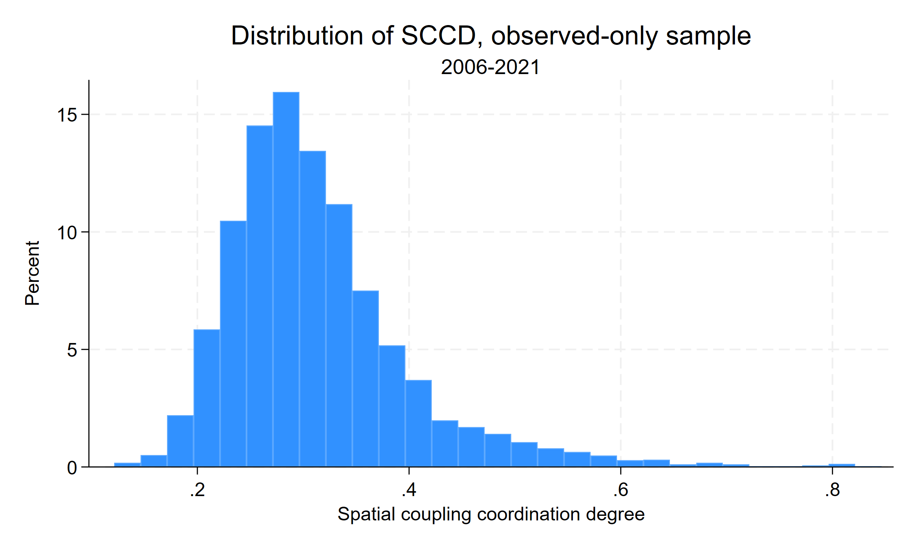
Figure 1. Distribution of SCCD in the observed 2006-2021 sample.

3.2. Baseline Nonlinear Relationship
Table 3 reports the baseline two-way fixed-effects estimates. Across specifications, SCCD is positive and SCCD squared is negative. In the full-control observed-sample specification, SCCD equals 8.444 and SCCD squared equals -8.091, both significant at the 1% level. The implied turning point is 0.521838, supporting an inverted U-shaped relationship between multidimensional spatial coordination and lnCE.
Table 3. Baseline regression results: observed-only sample, 2006-2021.
 | (1) | (2) | (3) | (4) | (5)
 | CE | CE | CE | CE | CE
SCCD | 12.957*** | 11.841*** | 9.007*** | 8.819*** | 8.444***
 | (1.445) | (1.421) | (1.305) | (1.348) | (1.338)
Spatial coupling coordination degree squared | -11.476*** | -10.296*** | -8.400*** | -8.125*** | -8.091***
 | (1.749) | (1.761) | (1.593) | (1.642) | (1.665)
OPEN |  | 0.456*** | 0.211** | 0.244*** | 0.276***
 | (0.108) | (0.083) | (0.083) | (0.082)
UR |  |  | 0.029*** | 0.027*** | 0.025***
 | (0.004) | (0.004) | (0.004)
URG |  |  |  | -0.116* | -0.101
 | (0.068) | (0.067)
GI |  |  |  |  | -1.953***
 | (0.546)
Constant | 1.203*** | 1.314*** | 0.629** | 1.053*** | 1.497***
 | (0.284) | (0.272) | (0.267) | (0.357) | (0.382)
N | 4544 | 4529 | 4529 | 4514 | 4514
Within R-squared | 0.592 | 0.601 | 0.640 | 0.641 | 0.650
Notes: City and year fixed effects are included. Robust standard errors clustered by city are in parentheses. *, **, and *** denote significance at 10%, 5%, and 1%, respectively.
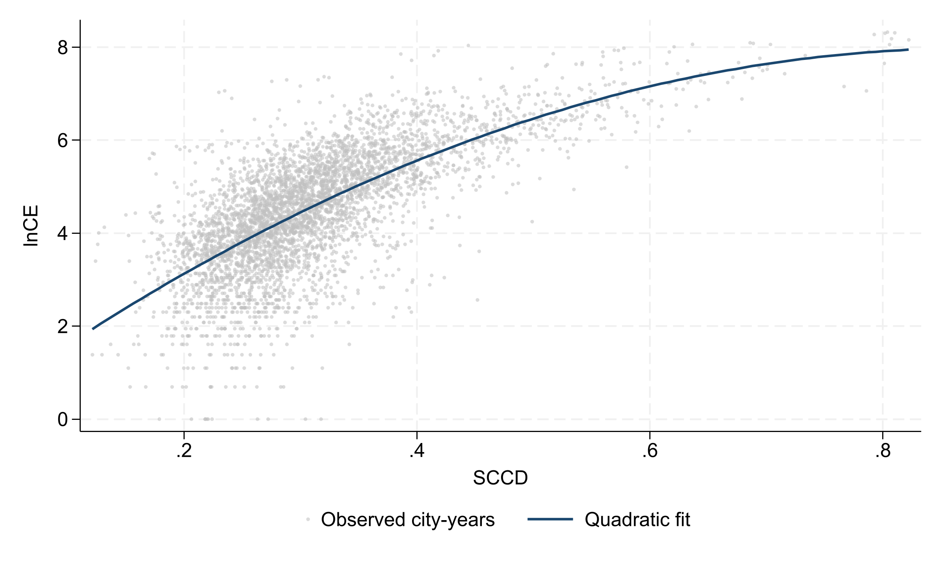
Figure 2. Observed SCCD-lnCE relationship and quadratic fit, 2006-2021.

3.3. Robustness and Supplementary IV Evidence
Table 4 shows that the nonlinear pattern remains under winsorization, the night-time light activity check, and supplementary IV estimation. The observed-only IV turning point is 0.570248. This estimate remains within the observed SCCD range, but it is interpreted as supplementary because the instrument cannot eliminate all threats to identification in an observational panel.
Table 4. Robustness and supplementary IV results: observed-only sample, 2006-2021.
 | (1) | (2) | (3) | (4)
 | w_CE | NTL | CE | CE
w_SCCD | 9.845***
 | (1.337)
w_SCCD2 | -10.134***
 | (1.648)
w_OPEN | 0.385***
 | (0.117)
w_UR | 0.025***
 | (0.004)
w_URG | -0.054
 | (0.068)
w_GI | -1.968***
 | (0.548)
SCCD |  | 3.601*** |  | 17.971***
 | (0.719) |  | (2.816)
SCCD2 |  | -2.765*** |  | -15.757***
 | (0.763) |  | (2.969)
OPEN |  | 0.264*** | 0.276*** | 0.176**
 | (0.090) | (0.082) | (0.080)
UR |  | 0.019*** | 0.025*** | 0.018***
 | (0.003) | (0.004) | (0.004)
URG |  | -0.055 | -0.101 | -0.078
 | (0.062) | (0.067) | (0.065)
GI |  | -1.668*** | -1.953*** | -1.587***
 | (0.362) | (0.546) | (0.564)
MCCD |  |  | 8.444***
 | (1.338)
MCCD2 |  |  | -8.091***
 | (1.665)
Constant | 1.122*** | -0.344 | 1.497*** | -0.179
 | (0.386) | (0.293) | (0.382) | (0.549)
N | 4514 | 4514 | 4514 | 4232
Within R-squared | 0.658 | 0.583 | 0.650 | 0.626
Notes: Column labels follow the generated Stata table. IV estimates use the pre-existing lagged SCCD instrument and its square.

3.4. Regional Heterogeneity
Table 5 indicates that the inverted U-shaped pattern is visible across major regions, but the magnitude differs. The central region shows the largest linear and quadratic coefficients, suggesting stronger emission responsiveness to changes in coordination during the observed period.
Table 5. Regional heterogeneity: observed-only sample, 2006-2021.
 | (1) | (2) | (3)
 | Eastern China | Central China | Western China
SCCD | 7.368*** | 12.447*** | 7.842***
 | (2.557) | (2.490) | (1.740)
SCCD2 | -6.905*** | -12.828*** | -8.152***
 | (2.543) | (3.179) | (2.102)
OPEN | 0.225*** | 0.416* | 0.258
 | (0.085) | (0.251) | (0.305)
UR | 0.027*** | 0.022*** | 0.024***
 | (0.006) | (0.006) | (0.007)
URG | -0.069 | -0.018 | -0.187*
 | (0.143) | (0.121) | (0.103)
GI | -1.098 | -2.292*** | -1.871**
 | (1.134) | (0.667) | (0.885)
Constant | 1.615** | 0.545 | 1.920***
 | (0.711) | (0.700) | (0.639)
N | 1537 | 1585 | 1392
Within R-squared | 0.731 | 0.645 | 0.624

3.5. Associated Mechanism Equations
Table 6 reports mechanism-equation evidence for OIU and GTI. SCCD is positively associated with both industrial upgrading and green technological innovation, while the squared terms are negative. When these variables enter the lnCE equation, the nonlinear SCCD pattern remains. The evidence is therefore consistent with stage-dependent restructuring pathways, not with an immediate or fully quantified indirect effect.
Table 6. Associated mechanism equations: observed-only sample, 2006-2021.
 | (1) | (2) | (3) | (4)
 | OIU | CE with OIU | GTI | CE with GTI
SCCD | 0.647*** | 7.561*** | 10.379*** | 5.290***
 | (0.160) | (1.254) | (1.402) | (1.115)
SCCD2 | -0.407* | -7.535*** | -5.775*** | -6.336***
 | (0.207) | (1.503) | (1.468) | (1.418)
OIU |  | 1.366***
 | (0.316)
GTI |  |  |  | 0.304***
 | (0.027)
OPEN | 0.008 | 0.265*** | 0.224*** | 0.208***
 | (0.012) | (0.077) | (0.085) | (0.071)
UR | 0.004*** | 0.020*** | 0.021*** | 0.019***
 | (0.000) | (0.004) | (0.004) | (0.003)
URG | 0.029*** | -0.141** | 0.028 | -0.109*
 | (0.006) | (0.066) | (0.064) | (0.063)
GI | -0.093* | -1.826*** | -2.102*** | -1.314**
 | (0.049) | (0.521) | (0.403) | (0.552)
Constant | 1.808*** | -0.972 | -0.725* | 1.718***
 | (0.041) | (0.697) | (0.411) | (0.325)
N | 4514 | 4514 | 4514 | 4514
Within R-squared | 0.622 | 0.658 | 0.826 | 0.686
Notes: These are pathway equations rather than formal indirect-effect estimates.

3.6. Moderation and Supplementary Interaction Checks
Table 7 reports observed-sample moderation estimates. DEI significantly attenuates the nonlinear SCCD-lnCE relationship, supporting the interpretation that digital economy development can flatten the emission cost of coordination. POLY is retained only as a supplementary interaction check and is not treated as a supported moderation mechanism.
Table 7. Moderation analysis: observed-only sample, 2006-2021.
 | (1) | (2) | (3)
 | ER | DEI | POLY
SCCD | 10.931*** | 8.869*** | 7.925***
 | (1.991) | (1.198) | (2.146)
ER | 61.643
 | (46.315)
SCCD # ER | -325.788
 | (228.112)
SCCD2 | -11.675*** | -7.977*** | -8.678***
 | (2.435) | (1.423) | (2.660)
ER | 0.000
 | (.)
SCCD2 # ER | 455.053*
 | (266.493)
OPEN | 0.278*** | 0.263*** | 0.277***
 | (0.082) | (0.083) | (0.082)
UR | 0.025*** | 0.025*** | 0.024***
 | (0.004) | (0.004) | (0.004)
URG | -0.097 | -0.090 | -0.090
 | (0.067) | (0.067) | (0.067)
GI | -1.962*** | -2.008*** | -1.954***
 | (0.536) | (0.544) | (0.532)
DEI |  | 5.874***
 | (2.226)
SCCD # DEI |  | -25.913***
 | (7.936)
DEI |  | 0.000
 | (.)
SCCD2 # DEI |  | 24.173***
 | (6.665)
POLY |  |  | -1.043
 | (0.941)
SCCD # POLY |  |  | 2.842
 | (4.782)
POLY |  |  | 0.000
 | (.)
SCCD2 # POLY |  |  | 0.159
 | (5.485)
Constant | 1.040** | 1.364*** | 1.763***
 | (0.486) | (0.370) | (0.487)
N | 4514 | 4514 | 4514
Within R-squared | 0.651 | 0.652 | 0.653
Notes: ER, DEI, and POLY are estimated in separate interaction models. Interpretation in the text focuses on DEI.
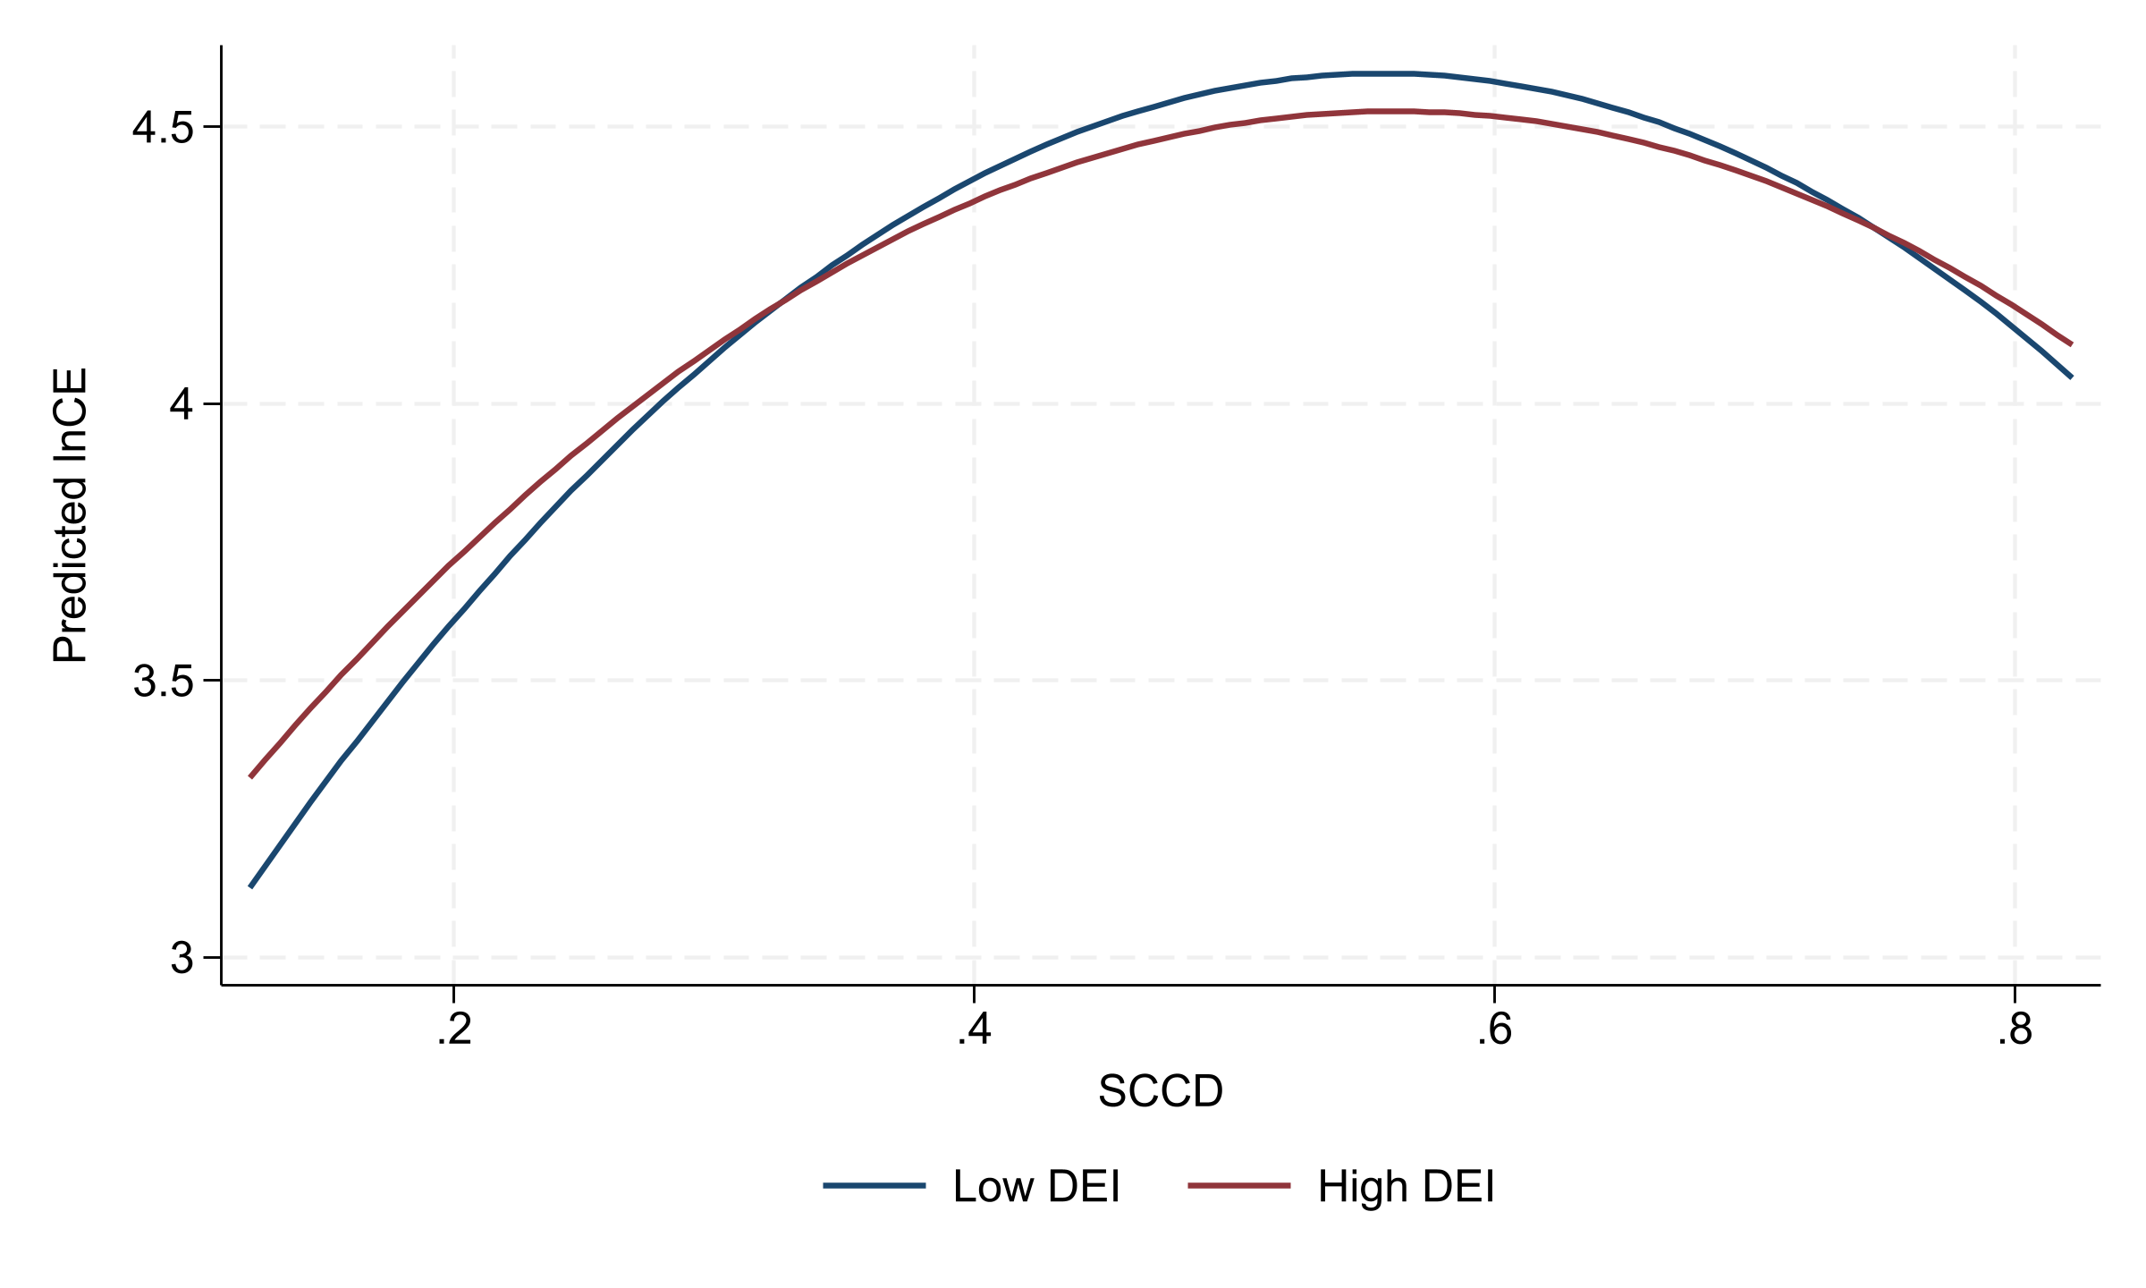
Figure 3. Predicted SCCD-lnCE curves at low and high DEI levels, observed sample.

4. Discussion
The results clarify why smart-city construction and spatial coordination do not automatically reduce emissions. At low coordination levels, cities often connect production, living, ecological, and digital functions through infrastructure expansion, industrial concentration, construction activity, and additional energy input. These expansion effects can dominate early efficiency gains, generating the upward side of the inverted U-shaped relationship.
At higher coordination levels, the same process can become more efficiency-oriented. Better information matching, integrated public services, smart transport, ecological monitoring, and cross-departmental governance can reduce redundant investment and improve resource allocation. The estimated turning point therefore has a governance interpretation: it marks the stage at which coordination is more likely to shift from expansion-led integration toward efficiency-oriented urban operation.
The mechanism-equation results help explain why the transition is gradual. Industrial upgrading and green technological innovation may support long-run low-carbon transition, but they also require new investment, equipment replacement, experimentation, and commercialization. These processes can create short-run carbon pressure before efficiency gains materialize. The paper therefore treats OIU and GTI as associated pathways rather than immediate emission-reduction channels.
The DEI results are especially relevant for Sustainability readers. Digital economy development appears to weaken the marginal emission cost of coordination, suggesting that digital capacity matters less as a slogan and more as operational capability. Cities need interoperable data systems, energy-management platforms, smart mobility tools, and governance routines that convert spatial coordination into efficiency rather than duplicated construction.
Several boundary conditions remain. The SCCD index captures key aspects of digital space, but it cannot fully observe platform governance, data mobility, algorithmic coordination, or digital public-service quality. The empirical design includes fixed effects, robustness checks, and supplementary IV estimation, but the analysis remains observational. The 2022-2024 fitted or extrapolated rows are excluded from the main evidence to avoid overstating data coverage.

5. Conclusions
Using an observed panel of 284 Chinese cities from 2006 to 2021, this study finds an inverted U-shaped association between multidimensional spatial coupling coordination and log carbon emissions. The full-control observed-sample turning point is 0.521838, and supplementary IV estimates imply a turning point of 0.570248. These results indicate that coordination is not inherently low-carbon; its emission implication depends on whether urban governance remains expansion-oriented or becomes efficiency-oriented.
The policy implication is straightforward. Cities below the turning point should avoid converting smart-city construction into duplicated infrastructure, land expansion, and energy-intensive restructuring. Cities approaching the turning point should strengthen data-enabled governance, energy management, integrated public services, and coordination between industrial and innovation policy. Regional strategies should also differ because central, eastern, and western cities display different responsiveness to SCCD.
Future research should build richer measures of digital urban governance, examine longer dynamic lags in industrial upgrading and green innovation, and test whether the SCCD framework travels to other national and metropolitan contexts. More direct causal designs would also help distinguish coordination effects from unobserved policy and development shocks.

Author Contributions
Conceptualization, methodology, software, validation, formal analysis, investigation, resources, data curation, writing-original draft preparation, writing-review and editing, visualization, supervision, project administration, and funding acquisition: to be completed by the authors before submission.

Funding
Funding information should be completed by the authors before submission.

Data Availability Statement
The study uses city-level statistical indicators and EDGAR emission data. The processed analytical file is not overwritten by this revision workflow. Data-access and replication details should be completed by the authors before submission.

Acknowledgments
Acknowledgments should be completed by the authors before submission.

Conflicts of Interest
The authors should declare any conflicts of interest before submission.

Supplementary Materials
Detailed SCCD indicator definitions, extended robustness checks, and any 2006-2024 fitted/extrapolated sensitivity results should be provided as supplementary material. The 2022-2024 fitted or extrapolated observations should not be described as real observed records.

References
1. Seto, K.C.; Guneralp, B.; Hutyra, L.R. Global forecasts of urban expansion to 2030 and direct impacts on biodiversity and carbon pools. Proceedings of the National Academy of Sciences of the United States of America 2012, 109, 16083-16088. https://doi.org/10.1073/pnas.1211658109
2. Dhakal, S. Urban energy use and carbon emissions from cities in China and policy implications. Energy Policy 2009, 37, 4208-4219. https://doi.org/10.1016/j.enpol.2009.05.020
3. Creutzig, F.; Agoston, P.; Minx, J.C.; Canadell, J.G.; Andrew, R.M.; Le Quere, C.; Peters, G.P.; Sharifi, A.; Yamagata, Y.; Dhakal, S. Urban infrastructure choices structure climate solutions. Nature Climate Change 2016, 6, 1054-1056. https://doi.org/10.1038/nclimate3169
4. Fang, C.; Wang, S.; Li, G. Changing urban forms and carbon dioxide emissions in China: A case study of 30 provincial capital cities. Applied Energy 2015, 158, 519-531. https://doi.org/10.1016/j.apenergy.2015.08.095
5. Yang, Z.; Gao, W.; Han, Q.; Qi, L.; Cui, Y.; Chen, Y. Digitalization and carbon emissions: How does digital city construction affect China's carbon emission reduction? Sustainable Cities and Society 2022, 87, 104201. https://doi.org/10.1016/j.scs.2022.104201
6. Gagne, C.; Riou, S.; Thisse, J.-F. Are compact cities environmentally friendly? Journal of Urban Economics 2012, 72, 123-136. https://doi.org/10.1016/j.jue.2012.04.001
7. Lee, S.; Lee, B. The influence of urban form on GHG emissions in the U.S. household sector. Energy Policy 2014, 68, 534-549. https://doi.org/10.1016/j.enpol.2014.01.024
8. Kaza, N. Urban form and transportation energy consumption. Energy Policy 2020, 136, 111049. https://doi.org/10.1016/j.enpol.2019.111049
9. Castells-Quintana, D.; Dienesch, E.; Krause, M. Air pollution in an urban world: A global view on density, cities and emissions. Ecological Economics 2021, 189, 107153. https://doi.org/10.1016/j.ecolecon.2021.107153
10. Hong, S.; Hui, E.C.M.; Lin, Y. Relationship between urban spatial structure and carbon emissions: A literature review. Ecological Indicators 2022, 144, 109456. https://doi.org/10.1016/j.ecolind.2022.109456
11. Shi, K.; Liu, G.; Cui, Y.; Wu, Y. What urban spatial structure is more conducive to reducing carbon emissions? A conditional effect of population size. Applied Geography 2023, 151, 102855. https://doi.org/10.1016/j.apgeog.2022.102855
12. Wang, C.; Zhang, Y.; Chen, J.; Li, D.; Zhu, M.; Gan, Z. The impact of urban polycentricity on carbon emissions: A case study of the Yangtze River Delta Region in China. Journal of Cleaner Production 2024, 442, 141127. https://doi.org/10.1016/j.jclepro.2024.141127
13. Zhang, B.; Xin, Q.; Chen, S.; Yang, Z.; Wang, Z. Urban spatial structure and commuting-related carbon emissions in China: Do monocentric cities emit more? Energy Policy 2024, 186, 113990. https://doi.org/10.1016/j.enpol.2024.113990
14. Tan, G.; Zhang, X.; Xiong, S.; Sun, Z.; Lei, Y.; Wang, H.; Du, S. Assessing the impacts of urban functional form on anthropogenic carbon emissions: A case study of 31 major cities in China. Ecological Indicators 2024, 167, 112700. https://doi.org/10.1016/j.ecolind.2024.112700
15. Balogun, A.-L.; Marks, D.; Sharma, R.; Shekhar, H.; Balmes, C.; Maheng, D.; Arshad, A.; Salehi, P.; Vyas, A. Assessing the potentials of digitalization as a tool for climate change adaptation and sustainable development in urban centres. Sustainable Cities and Society 2020, 53, 101888. https://doi.org/10.1016/j.scs.2019.101888
16. Anon Higon, D.; Gholami, R.; Shirazi, F. ICT and environmental sustainability: A global perspective. Telematics and Informatics 2017, 34, 85-95. https://doi.org/10.1016/j.tele.2017.01.001
17. Lange, S.; Pohl, J.; Santarius, T. Digitalization and energy consumption. Does ICT reduce energy demand? Ecological Economics 2020, 176, 106760. https://doi.org/10.1016/j.ecolecon.2020.106760
18. Obringer, R.; Rachunok, B.; Maia-Silva, D.; Arbabzadeh, M.; Nateghi, R.; Madani, K. The overlooked environmental footprint of increasing Internet use. Resources, Conservation and Recycling 2021, 167, 105389. https://doi.org/10.1016/j.resconrec.2020.105389
19. Zhang, W.; Liu, X.; Wang, D.; Zhou, J. Digital economy and carbon emission performance: Evidence at China's city level. Energy Policy 2022, 165, 112927. https://doi.org/10.1016/j.enpol.2022.112927
20. Cheng, Y.; Zhang, Y.; Wang, J.; Jiang, J. The impact of the urban digital economy on China's carbon intensity: Spatial spillover and mediating effect. Resources, Conservation and Recycling 2023, 189, 106762. https://doi.org/10.1016/j.resconrec.2022.106762
21. Hou, J.; Li, W.; Zhang, X. Research on the impacts of digital economy on carbon emission efficiency at China's city level. PLOS ONE 2024, 19, e0308001. https://doi.org/10.1371/journal.pone.0308001
22. Zhu, X.; Li, D.; Zhou, S.; Zhu, S.; Yu, L. Evaluating coupling coordination between urban smart performance and low-carbon level in China's pilot cities with mixed methods. Scientific Reports 2024, 14, 20461. https://doi.org/10.1038/s41598-024-68417-4
23. Tian, X.; Bai, F.; Jia, J.; Liu, Y.; Shi, F. Realizing low-carbon development in a developing and industrializing region: Impacts of industrial structure change on CO2 emissions in southwest China. Journal of Environmental Management 2019, 233, 728-738. https://doi.org/10.1016/j.jenvman.2018.11.078
24. Chang, H.; Ding, Q.; Zhao, W.; Hou, N.; Liu, W. The digital economy, industrial structure upgrading, and carbon emission intensity: Empirical evidence from China's provinces. Energy Strategy Reviews 2023, 50, 101218. https://doi.org/10.1016/j.esr.2023.101218
25. Du, K.; Li, P.; Yan, Z. Do green technology innovations contribute to carbon dioxide emission reduction? Empirical evidence from patent data. Technological Forecasting and Social Change 2019, 146, 297-303. https://doi.org/10.1016/j.techfore.2019.06.010
26. Lin, B.; Ma, R. Green technology innovations, urban innovation environment and CO2 emission reduction in China: Fresh evidence from a partially linear functional-coefficient panel model. Technological Forecasting and Social Change 2022, 176, 121434. https://doi.org/10.1016/j.techfore.2021.121434
27. European Commission, Joint Research Centre. EDGAR - The Emissions Database for Global Atmospheric Research. Available online: https://edgar.jrc.ec.europa.eu/ (accessed on 21 May 2026).
28. Crippa, M.; Guizzardi, D.; Pagani, F.; Schiavina, M.; Melchiorri, M.; Pisoni, E.; Graziosi, F.; Muntean, M.; Maes, J.; Dijkstra, L.; Van Damme, M.; Clarisse, L.; Coheur, P. Insights into the spatial distribution of global, national, and subnational greenhouse gas emissions in the Emissions Database for Global Atmospheric Research (EDGAR v8.0). Earth System Science Data 2024, 16, 2811-2830. https://doi.org/10.5194/essd-16-2811-2024

