ScorchCrafter C120
Virtual Guitar Amplifier Head
VST Plug-In

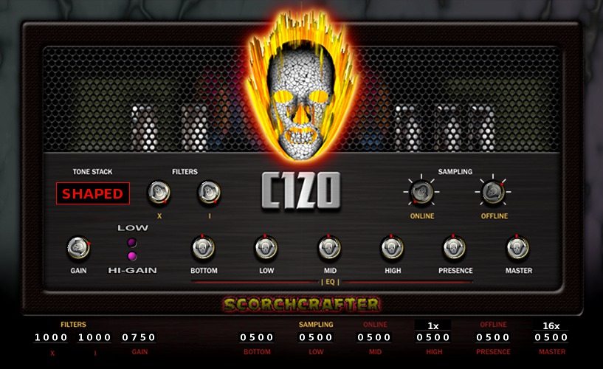
Version 3.x
GPL Version
Official Documentation

VST PlugIn Interface Technology by Steinberg Media Technologies GmbH
(This product uses the VST v2.4 SDK.)

License Notes:

OK, real quick, there are two issues regarding licensing – One is the license of the plug-in itself, the other is what you can do with audio that is rendered or processed with this plug-in in your DAW or VST Host.

First, the fun part: Any audio processed or rendered with the use of this software, such as a recorded dry guitar signal or otherwise, belongs COMPLETELY to the end-user using the software, which such an individual can release under ANY license or terms they want to. Yes, you can load this plug-in in your DAW and use it to make commercial music, for profit. You can also use it for any other projects you desire, as you see fit. (Isn't that nice?)

Now, for the plug-in itself: This software is released under the GPL license, revision 3. The source code is available from Sourceforge, and you are free to re-compile the software from that source code and even make changes, but if you do make changes you MUST distribute any altered source code along with any altered version of the software. Also, you may use parts or all of the source code for your own projects, but under the terms of the GPL license any such software using source code from the ScorchCrafter MUST also be released under GPL terms, with its own source code freely available. You cannot borrow source code from this plug-in and use it in a closed-source software product, that is not allowed. For the full terms and details of the license, please look up the GPL license terms, all of it is available on the Internet.

This GPL license does NOT apply to the VST SDK (which is protected and owned by Steinberg).

Please note that Steinberg did not create this plug-in, their SDK was just used to create it.

Installation:

Like most other common VST plug-ins, just place the DLL in your VST plug-in folder where your host or DAW will find it. The ScorchCrafter is self-contained, it shouldn't require any other files.

Rebuilding from source code:

At present there are project files for Visual Studio Express C++ 2008 in the Subversion repository at SourceForge. Most of what is needed to re-build the plug-in is found there, but you will also need the VST GUI SDK (also on SourceForge), as well as the VST 2.4 SDK from Steinberg's website. Steinberg requires that you create a developer account to get their SDK, AFAIK it is still free of charge. The GUI SDK version you want (unless you alter the code to use another version) is 3.6 RC2.

Hopefully someday soon a Mac and/or Linux programmer will contribute project files and code for building Linux and Mac versions of this software.

If you want to use any other compiler, and can make it work, by all means go for it.
How to use the ScorchCrafter:

Sampling Controls

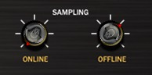
This controls the internal oversampling of the plug-in. The “Online” control is for live playback and recording in your VST Host, and the “Offline” is for non-live processing, when you mix-down a final, rendered product from your DAW. Please note that not all DAWs use off-line processing modes by default – An example is REAPER, which needs an option enabled in VST settings labeled “Inform plug-ins of off-line rendering state” that is not turned on with an out-of-the-box installation.

The controls are independent like this to save on CPU usage for live playback and recording, so if the online setting is at 1x (no oversampling) and the offline is at 16x (sixteen-times oversampling), the sound you hear during recording won't be oversampled (but will use little CPU power), and when you render a final mix offline the software will use full 16x oversampling for better quality sound.

The sampling controls also have “mute” and “bypass” settings. Please note the the “bypass” only bypasses the distortion stages, the plug-in will still process the input and output filters, EQ, and tone stack. If you want a true bypass you will need to switch off the plug-in in your regular DAW controls.

Master Output Volume

I won't insult your intelligence by explaining what this controls does. :)

Gain/Drive Controls
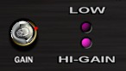
These of course control the amount of (guitar amp) distortion. The LOW setting reduces the signal volume level before it hits the distortion stages, and also changes internal tone settings a little bit.

Input Filters
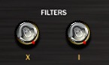
These two controls affect the input dry tone right before the signal hits the distortion stages. The “I” filter cuts out low-end bass sound, and the “X” filter boosts certain input frequencies. If you use a tube screamer effect in front of the amp you may want to turn these down a bit to get better sound. Turning them down all the way to zero disables them.

NOTE: This plug-in was really designed for use without anything in front of it, just a “straight-into-the-amp” type of set-up. You may therefore get better results withOUT any tube screamer in front of the amp, and I encourage you to at least TRY the ScorchCrafter this way before adding extra FX before and after it in your plug-in chain for the best sound.

EQ Controls
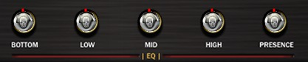
These alter the output tone. I won't go into any more detail, as anyone who has used a real guitar amplifier should know what each knob does.

Shape Control
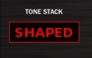
Controls the output tone in ways additional to the EQ controls. When set to EVEN, no EQ is applied at all if the EQ knobs are all at 12:00 (turning the SC into a pre-amp). When set to SHAPED, the output tone is altered somewhat more like that of an amp head.

Text Indicators
These simply help tell you what things are set at, for fine-tuning the controls.

NOTE: Most knobs and controls can be set to a 12:00 default setting by holding down CTRL and left-clicking once on the knob.

Other notes:

This plug-in uses 64-bit processing regardless of how it is compiled. Only the input filters and distortion stages can be oversampled internally. It runs at a MINIUMUM of 44,100 Hz sample rate, and the maximum supported sample rate can be set to almost anything reasonable in the source code.

- END -

