Car1:

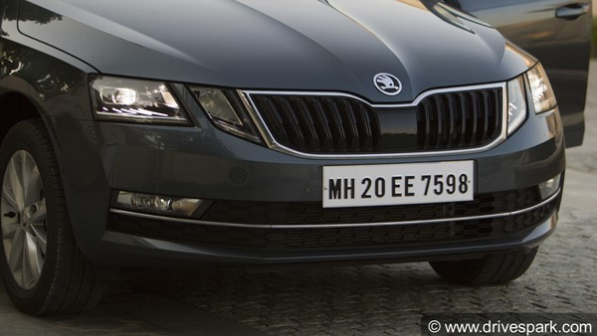

Manual Method:



Output

‘MH 20 EE 7598

Cascade



Output

H 20 EE 7598

Car 2

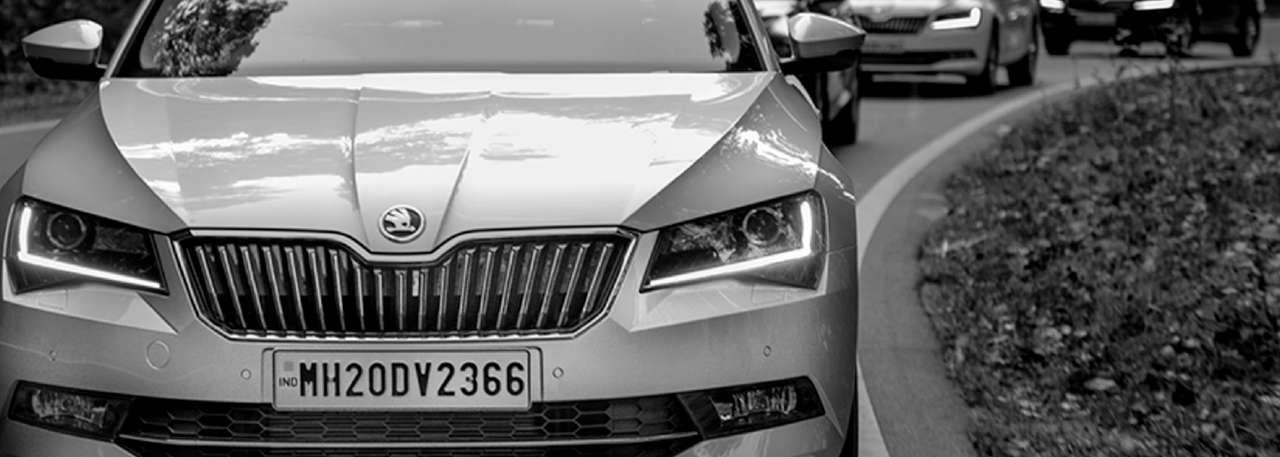

Manual Method:



Output

“~MH20D¥2366

Cascade

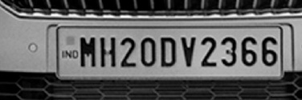

Output

——— ~MH20D¥2366]|

Car 3

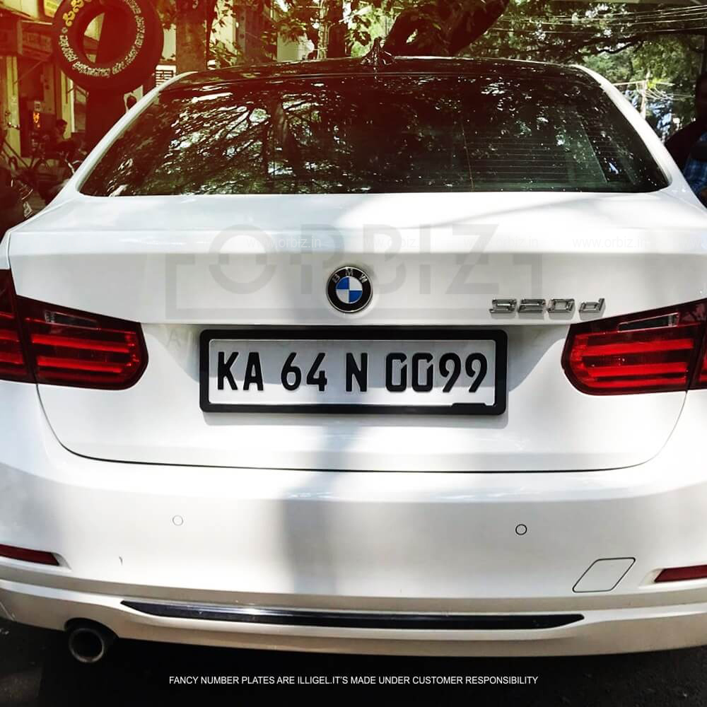

Manual Method:

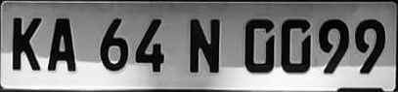

Output

KA 64N GO99

Cascade

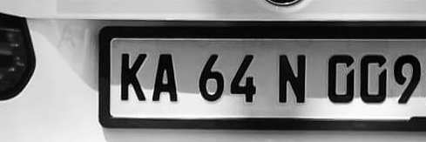

Output

(NO OUTPUT)

Car 4

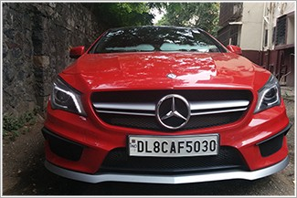

Manual Method:

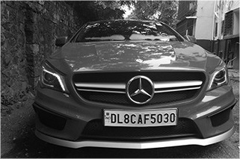

Output

SF i FOL SCAF5020 ae

Cascade



Output

(NO OUTPUT)

Car 5



Manual Method:



Output

‘MH 20 EE 7598

Cascade



Output

H 20 EE 7598

Car 6

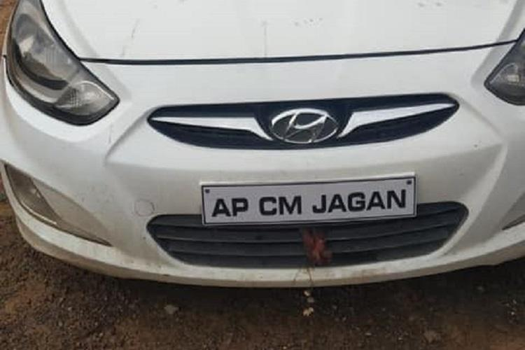

Manual Method:

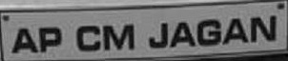

Output

SE ea ‘AP CM JAGAN

Cascade

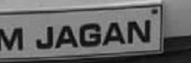

Output

Ml JAGAN |p

Car 7

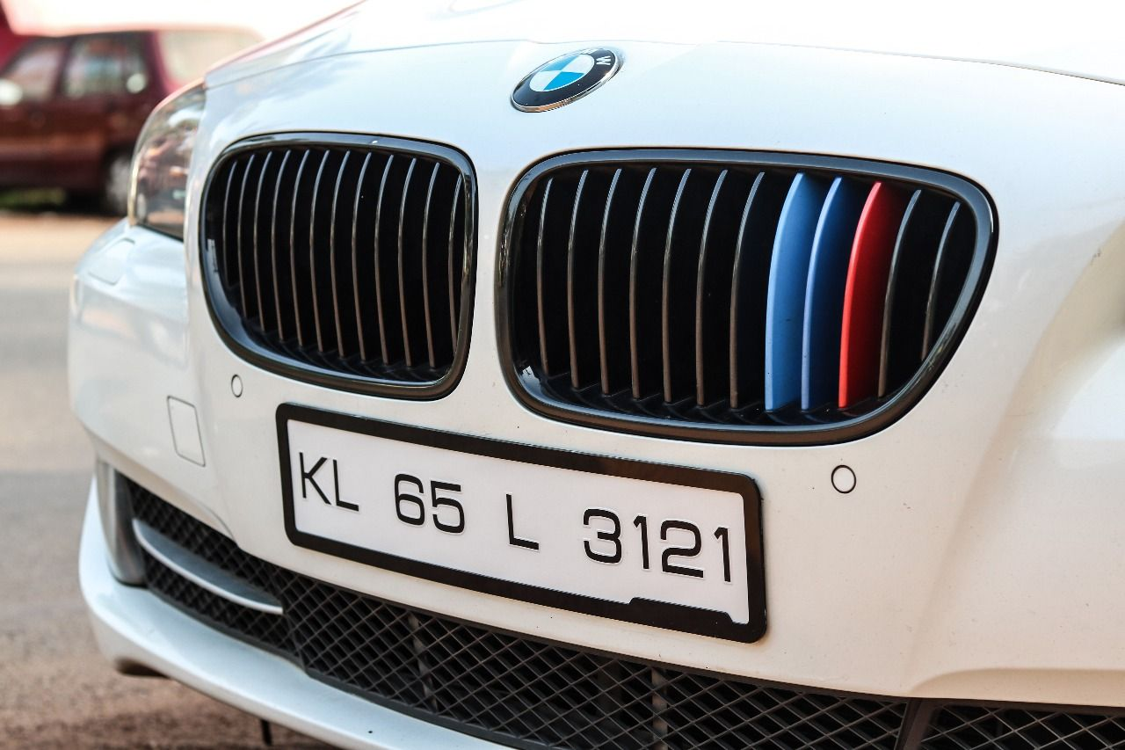

Manual Method:

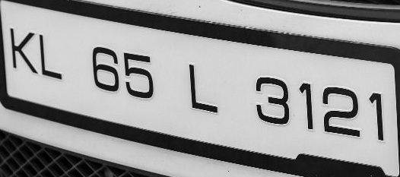

Output

(No OUTPUT)

Cascade



Output

Ml JAGAN |p

Car 8

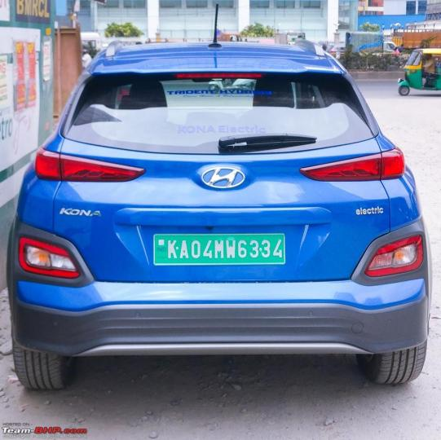

Manual Method:



Output

"KAOAMW6334

Cascade



Output

NO OUTPUT

Car 9

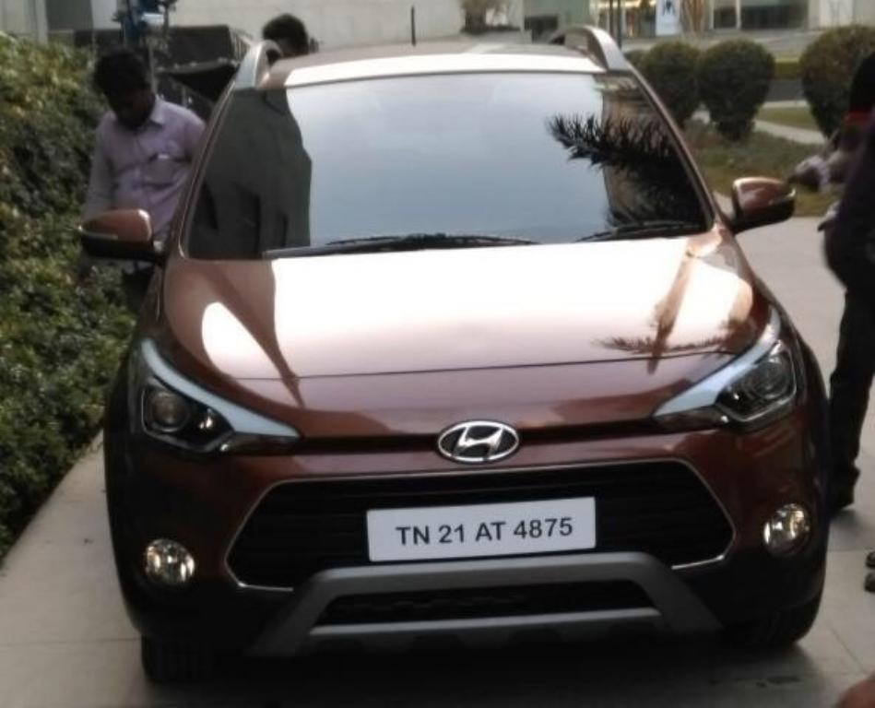

Manual Method:

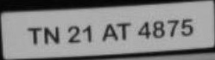

Output

No output

Cascade

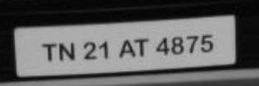

Output

No output

Car 10

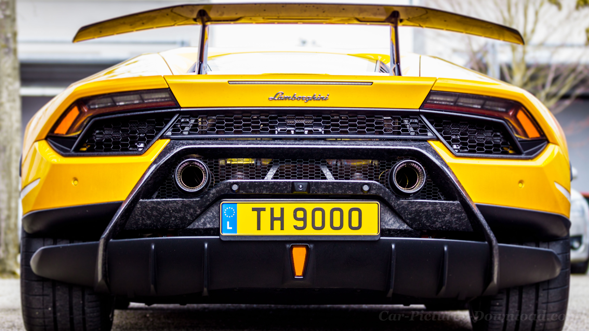

Manual Method:

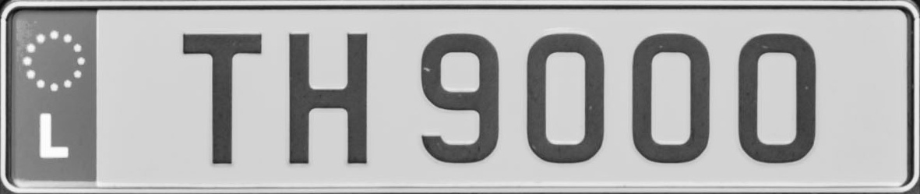

Output

No output

Cascade

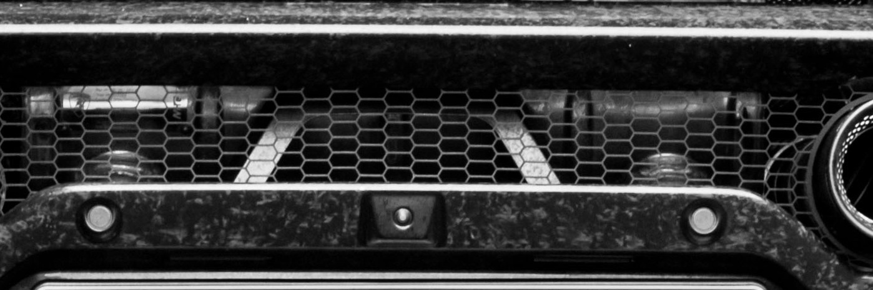

Output

No output