**Manual KAGGLE for question answering**

You can use 2 GPU on KAGGLE.

Go to this website: <https://www.kaggle.com/>

You can Sign in using a Gmail account

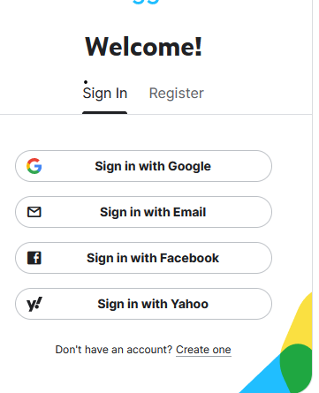

You have to complete some information (only the first time). Then, you can see options on the left-hand side.

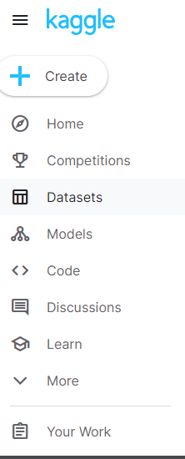

You have to click on Datasets option. Then, click on New dataset. You can upload your CSV file (put a name)

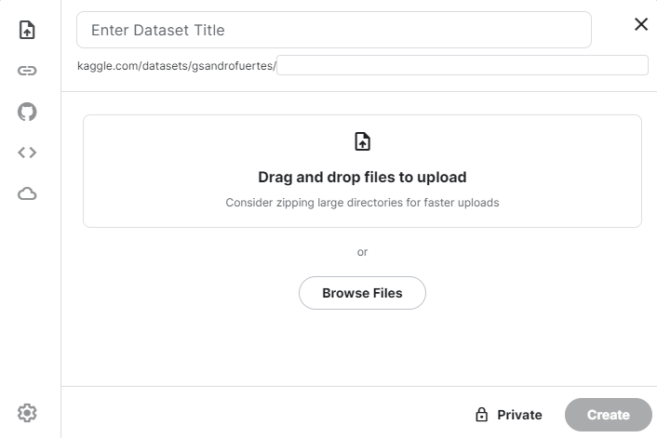

So, you can go to Code option and click on New Notebook. You can change the name on the top of the webpage.

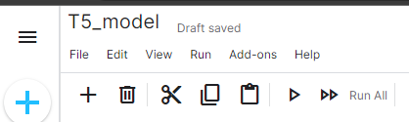

On the right hand side, you can add our dataset, click on Add data.

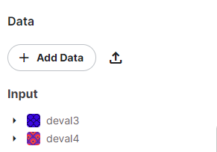

You can use 2 GPU, go to Notebook options and change

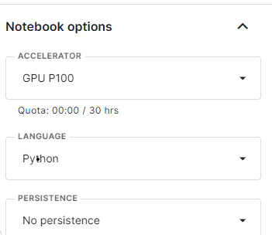

You have 30 hours per week. When you finish your code, you have to stop the session

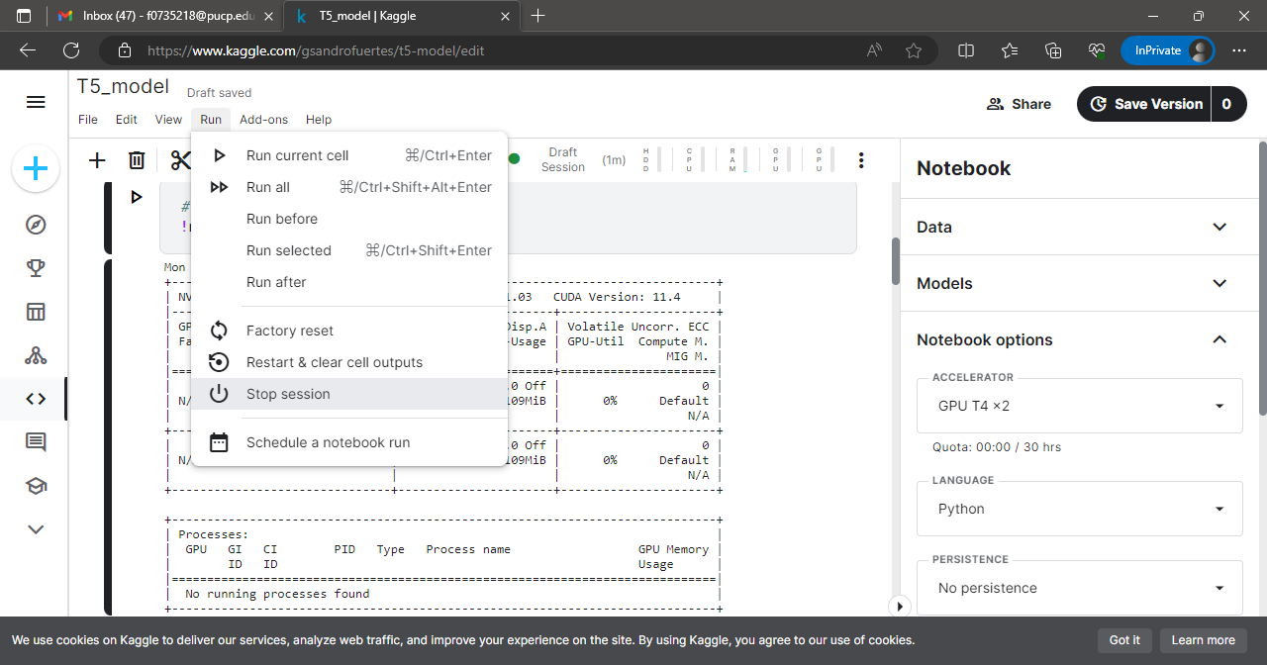

You can see the 2 GPUS

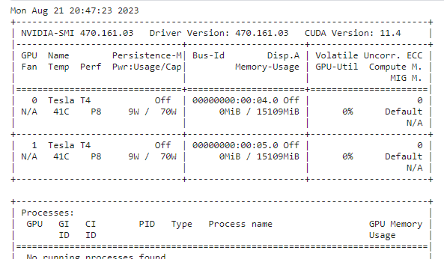

You can find an example how to fine tune a T5 model called qna-fine-tune.ipynb