# Data base

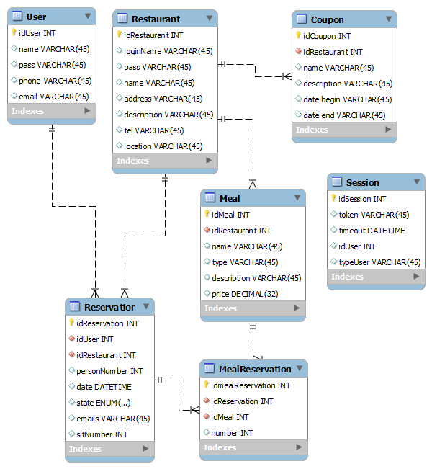

# Commands

Input, optional input, output new for sprint 2

* **Unlogged**
  + Create user account
    - *Name*
    - *Pass*
    - *Phone*
    - *Email*
  + Create restaurant account
    - *name*
    - *Pass*
    - *Address*
    - *phone*
    - *displayName*
    - *description*
    - *location*
  + Login
    - *Name*
    - *Pass*
  + Logoff
  + Get restaurants
    - *List of restaurant*
      * *ID*
      * *Name*
      * *Address*
  + Get menu
    - *Restaurant token*
    - ***OR*** *restaurant ID*
    - *List of meal*
      * *ID*
      * *Name*
      * *Type*
      * *Price*
  + Get Restaurant coupon
    - *Restaurant token*
    - ***OR*** *restaurant ID*
    - *List of coupon*
      * *ID*
      * *Name*
      * *Description*
      * *Date start*
      * *Date end*

**Logged as user**

* + Create reservation
    - *Id restaurant*
    - *Person number*
    - *Token*
    - *Date*
    - *Emails*
  + Get user reservation list
    - *token*
    - List of reservation
      * Reservation ID
      * Date
      * *Number*
      * *State*
      * *List of ordered meal*
        + *ID*
        + *name*
        + *number*
  + Add meal to reservation
    - *Reservation ID*
    - *Meal ID*
    - *token*
    - *Number*
  + Delete meal from reservation
    - *MealReservation ID*
    - *token*
  + Validate reservation
    - *Reservation ID*
    - *token*
  + Update user info
    - *token*
    - *Pass*
    - *Phone*
    - *Email*
  + Get User coupon
* **Logged as Restaurant**
  + Get restaurant reservation list
    - *token*
    - *Date (from)*
    - *Date (to)*
    - *state*
    - *List of reservation*
      * *ID*
      * *Date*
      * *Number*
      * *State*
      * *Sit number*
  + Get meal reservation list
    - *token*
    - idReservation
    - *List of ordered meal*
      * *ID*
      * *Name*
      * *Number*
      * *Price*
  + Confirm reservation
    - *token*
    - *Reservation ID*
    - *State (‘conf’ or ‘rej’)*
  + SetSit
    - *token*
    - Reservation ID
    - *sitNumber*
  + Check
    - *Token*
    - *Reservation ID*
  + Add meal
    - *Token*
    - *Name*
    - *Type*
    - *description*
    - *Price*
  + Delete meal
    - *Token*
    - *Meal Id*
  + Get restaurant info
    - *Token*
    - *Restaurant info*
      * *name*
      * *loginName*
      * *address*
      * *location*
      * *tel*
      * *description*
  + Update restaurant info
    - *token*
    - *Name*
    - *Pass*
    - *Address*
    - *Phone*
    - *Description*
    - *location*
  + Create Coupon
    - *Token*
    - *Name*
    - *Description*
    - *Date start*
    - *Date end*
  + Edit coupon
    - *Token*
    - *Coupon ID*
    - *Name*
    - *Description*
    - *Date start*
    - *Date end*
  + Delete Coupon
    - Token
    - Coupon ID
  + Get client list
    - *token*
    - *List of client*
      * *ID*
      * *Name*
      * *Number*
  + Get client meal list
    - *token*
    - *client ID*
    - *List of client*
      * *ID*
      * *Name*
      * *description*
      * *Number*