Software Requirements Specification

Version 0.2

March 04, 2019

Kamen Yosifov

Lili Nikolova

Valentin Ivanov

Kristina Ficheva(Missing)

Kristina Atanasova(Missing)

1. Hristov (missing)

# Table of Contents

Table of Content 1

List of Pictures 2

1.0 Introduction 3

1.1 Purpose 3

1.2 Scope of Project 3

2.0 Overall descriptions 3

2.1 System Environment 3

2.2 Vocabulary 3

2.2.1 Home page 3

2.2.2 Create article 4

2.3 Functional Requirements Specification 5

2.3.1 Use Case 1 (Accessing the system) 5

2.3.2 Use Case 2 (Navigation bar) 5

2.3.2.1 Navigation bar - user management 5

2.3.3 Use Case 3 (Home page) 5

2.3.4 Use Case 4 (Article page) 5

2.3.4.1 Article page - Edit 8

2.3.4.2 Article page - Delete 8

2.3.4.3 Article page - Back 8

2.3.5 Use Case 5 (My profile) 9

2.3.5.1 My profile - Change password 9

2.3.6 Use Case 6 (Footer) 10

# List of Pictures

Pic.1 4

Pic.2 4

Pic.3 4

Pic.4 5

Pic.5 6

Pic.6 6

Pic.7 7

Pic.8 7

Pic.9 8

Pic.10 9

Pic.11 9

# Introduction

## ***1.1. Purpose***

The purpose of this document is to present a detailed description of a Basic Blog which will be called SoftUni Blog or simply Project. It will explain some of the basic features because the blog has very little functionality.

## ***1.2. Scope of Project***

The document will cover the main functionality on a basic level regarding SoftUni Blog. The user-management system, the blog creation and operation and its respective details (hereinafter called Pictures). The administrative part – what the special user (hereinafter called Administrator or Admin) can and cannot do as well as the normal user.

# Overall Description

## ***2.1 System Environment***

The Store has two active actors and one cooperating system. All of them are accessing their parts from the internet. The Unregistered user can access the basic functionality of the project. This user can view and read only already created articles. The Registered user can access some of the basic CRUD operations over the articles. This user can create articles, edit or delete its own articles.

## ***2.2 Vocabulary***

***2.2.1*** ***Home page*** - A home page is the main information block regarding the articles. It consists of the Name and the Text of the created Articles on the left and right side. On the right side of every Article should be written the Name of the author. Register and Log in buttons for unregistered users on the very right side. The Home page button is on the left side.



*Pic. 1*

Create, Profile and Log off buttons for register users on the same place.



*Pic. 2*

## ***2.2.2 Create article*** – this is the main block regarding an article. It is separated in two boxes in the middle (one for the Title and one for the Content). Under this boxes there are two buttons “Cancel” and “Create”. After clicking on the “Create” button the article should appear on the Home page and it should contain Title, Content and an Author’s name.

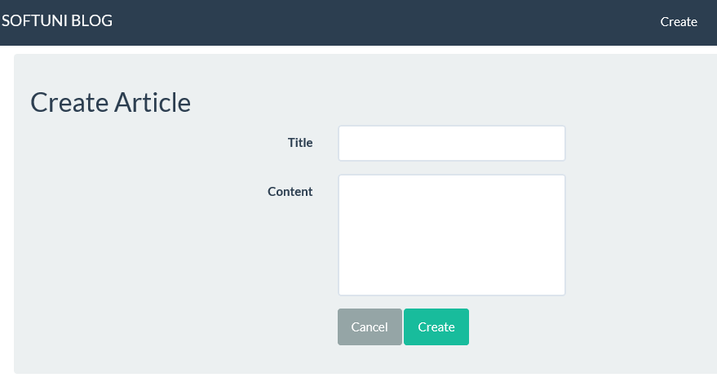

*Pic. 3*

## ***2.3 Functional Requirements Specification***

### *2.3.1 Use Case 1 (Accessing the system)*

The system is accessed through the internet from its initial URL. It loads header, navigation bar and a home page.

### *2.3.2 Use Case 2 (Navigation bar)*

The navigation bar has navigational hyperlinks to the Register and to the Log in. As well as it should have navigation to the Home page.



*Pic. 4*

*2.3.2.1. Navigation bar – user management*

When the visitor is unregistered, hyperlink navigating to the Register page and Log in page should be present.

Register page should contain information regarding Email, Full Name, Password and Confirmation password. Under the information boxes there should be also a “Register” button.

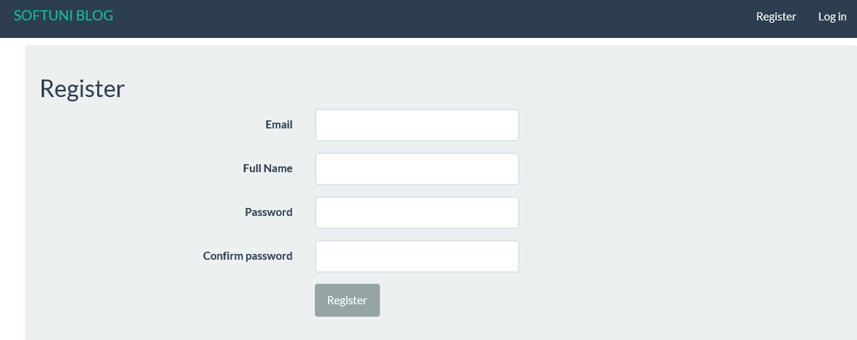

*Pic. 5*

Log in page should have Email and Password fields. A check box for “Remember me?” and “Log in” button under the fields.

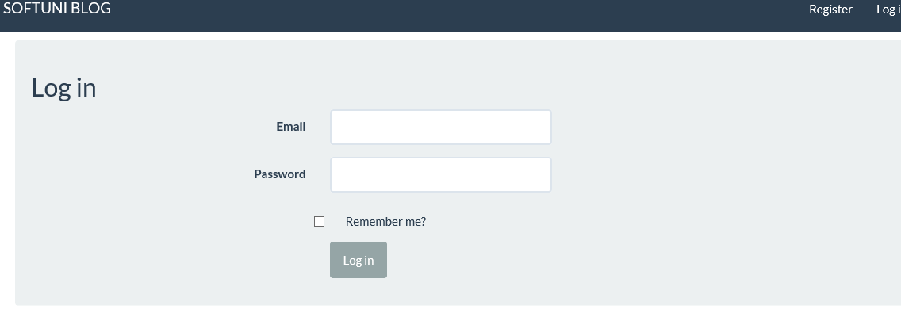

*Pic. 6*

When the visitor is registered hyperlink to the Profile page and Logout page should be present instead. When user is successfully logged out, there should be a redirect to the Home page.

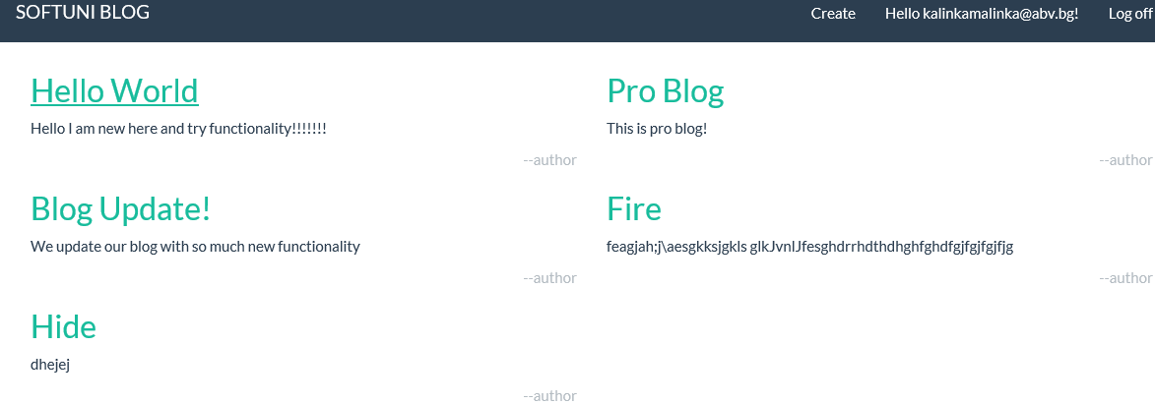

*Pic. 7*

### *2.3.3 Use Case 3 (Home page)*

The home page shows the Articles arranged within the order they occurred. Clicking on the chosen one leads to a new page with the article inside.

### *2.3.4 Use Case 4 (Article page)*

On the article page is shown the header and the content of the specific article. On the right side buttons for “Edit”, “Delete” and “Back” are available.

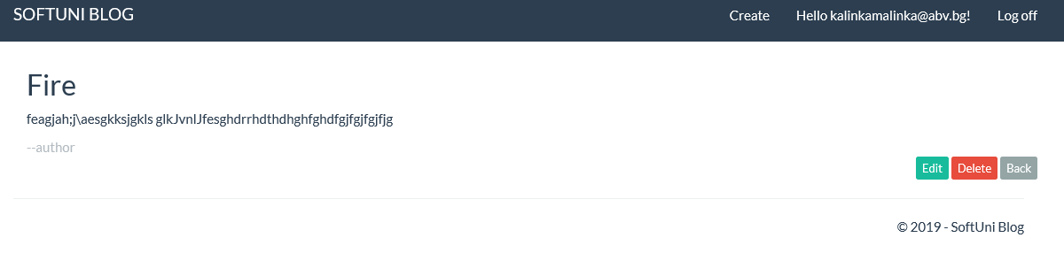

*Pic. 8*

### *2.3.4.1 Article page - Edit*

When the “Edit” button is clicked it redirects to the Edit page. This page should contains fields for “Title” and “Content”. Buttons for “Cancel” and “Edit” should be visible under the Content field. Clicking on one of the two buttons opened the Home page with all created articles.

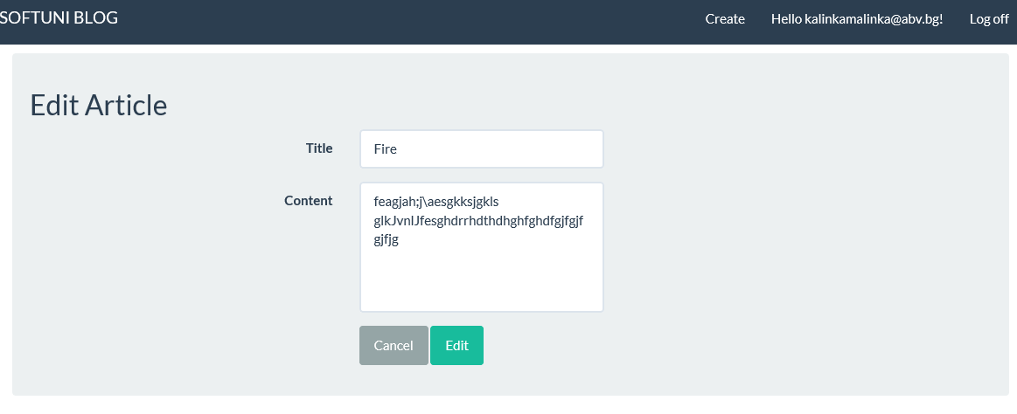

*Pic. 9*

An article can be edited only by its creator. In the other case the “Edit” button shouldn’t be visible.

### *2.3.4.2 Article page - Delete*

“Delete” button opened a new page where the article can be deleted. By clicking on the button the article disappeared and the Home page is loaded again.

An article can be edited only by its creator. In the other case the “Delete” button shouldn’t be visible.

### *2.3.4.3 Article page - Back*

This button allows you to go back to the Home page.

### 

### *2.3.5 Use Case 5 (My profile)*

Clicking on the Username hyperlink from the header navigates to the My profile page. The only action that can be done here is to change the current password.

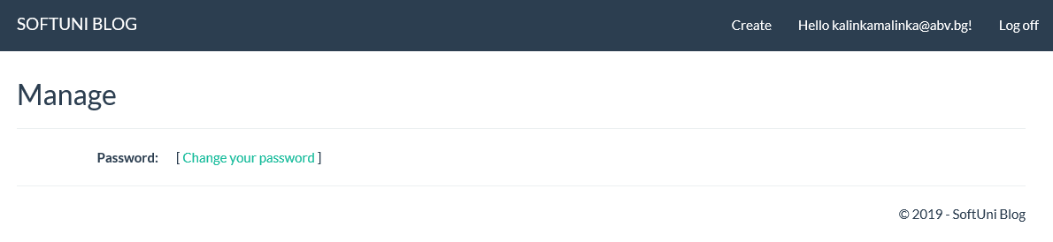

*Pic. 10*

### *2.3.5.1 My profile - Change password.* Byclicking on “Change your password” opens a new page with fields for the current password, new password and confirm new password. A button for change password is available under them. After changing the password the profile page is loaded again.

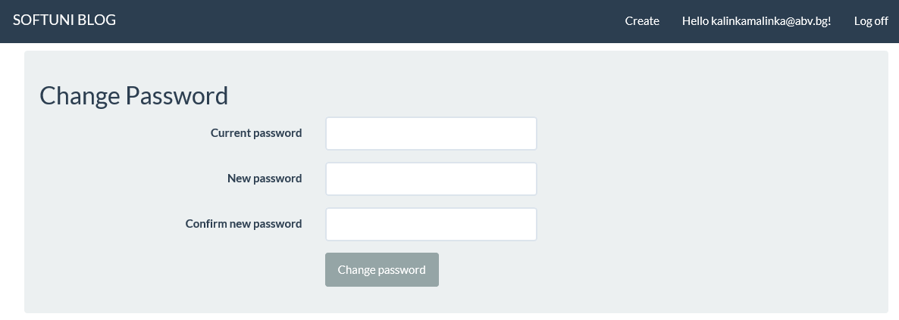

*Pic. 11*

### *2.3.6 Use Case 6 (Footer)*

Footer is visible on the very right side. There should be written: “© 2019 - SoftUni Blog”